Procurement and Supply Chain Management
Improving Supply chain performance using FMEA to highlight risks and vulnerability
Darryl Jackson, Student No:2219398
University Wales Trinity Saint David
Key Words – Supply Chain, FMEA, Relationships, Suppliers
Contents
- Introduction
- FMEA Analysis
15. Steps to make the supply chain more resilient
- Conclusion
- References

Introduction
The modern world would stop without supply chains, this may seem a dramatic statement but in reality our supply chains (SC) both local and global respresent critical processes by which our day to day lifes are impacted. These processes are often not visibly recognised by the public as they occur around us every day but in fact without these critical processes the food we eat from supermarkets, the spare parts required for our transportation and the fuel we use in our homes would not be available to the consumer.
Supply Chain Management (SCM) is not only critical to our way of life but extremly difficult to manage due to the amount of inputs, variables and unforseen circumstances that can occur, therefore the utilisation of risk analysis by way of Failure Mode Effect Analysis (FMEA) can highlight these risks and allow for suitable control measures to be put in place to reduce or remove these risks.
In the following literature the process of harvesting, conversion and transportation to the UK of wheat is reviewed as per figure 1, this process forms part of a critical supply chain for the manufacturing of corrugated paper whereby the converted starch is added to paper to increase the strength properties of the final box. FMEA will be used to highlight the risks and vulnerability of the supply chain followed by a critical review of the supply chain to emphasise potential improvements, strategies and management techniques which could be used to reduce the highlighted risks.
Figure 1 - Process Map of Wheat Starch


FMEA

PROCESS STEP | PESTLE | POTENTIAL FAILURE MODE | POTENTIAL EFFECTS OF FAILURE MODE | SEVERITY | POTENTIAL CAUSES OF FAILURE MODE | OCCURRENCE | CURRENT CONTROL MEASURES | DETECTION | RPN
What is the process step under investigation? | Which category of PESTLE does it fall under? | In what ways does the process step go wrong? | What is the impact of the failure on the output i.e., effects that the internal/external customer will notice? | SEVERITY | What causes the process step to go wrong? | OCCURRENCE | What are the existing controls and procedures that prevent either the cause or the Failure Mode? | DETECTION | RPN
Wheat Harvest in Ukraine | Political | Failure to produce raw material | Production of starch is reduced, potential for operational downtime | 8 | The country of growth enters into war | 1 | Regularly review regional political stability index | 10 | 80
Wheat Harvest in Ukraine | Political | Reduced production of raw material | Production of starch is reduced, potential for operational downtime | 6 | A new party takes control of the region and enforces new legislation | 2 | Regularly review regional political stability index | 5 | 60
Wheat Harvest in Ukraine | Environmental | Reduced production of raw material | Production of starch is reduced, potential for operational downtime | 6 | Poor Harvest as a result of draught | 5 | Monthly reviews of harvest yield and forecasts with supplier | 5 | 150
Wheat Harvest in Ukraine | Environmental | Reduced production of raw material | Production of starch is reduced, potential for operational downtime | 6 | Poor Harvest as a result of flood | 5 | Monthly reviews of harvest yield and forecasts with supplier | 5 | 150
Wheat Harvest in Ukraine | Environmental | Reduced production of raw material | Production of starch is reduced, potential for operational downtime | 6 | Types of fertiliser or chemical additives used are banned | 4 | Monthly reviews of harvest yield and forecasts with supplier | 5 | 120
Wheat Harvest in Ukraine | Social | Reduced production of raw material | Production of starch is reduced, potential for operational downtime | 6 | Resource Level to harvest drops | 3 | Monthly reviews of harvest yield and forecasts with supplier | 5 | 90
Wheat Harvest in Ukraine | Social | Reduced production of raw material | Production of starch is reduced, potential for operational downtime | 6 | Resource goes on strike | 3 | Monthly reviews of harvest yield and forecasts with supplier | 5 | 90
Wheat Harvest in Ukraine | Social | Reduced production of raw material | Production of starch is reduced, potential for operational downtime | 6 | Image of harvesting impacts production | 5 | Review political nature of harvesting quarterly with internal team | 4 | 120
Wheat Harvest in Ukraine | Technological | Reduced production of raw material | Production of starch is reduced, potential for operational downtime | 6 | Lack investment in harvesting technology reduces yield of harvest | 4 | Monthly reviews of harvest yield and forecasts with supplier | 5 | 120
Wheat Harvest in Ukraine | Economical | Raw Material becomes unaffordable | Production of starch is reduced, potential for operational downtime | 8 | Price of labour increase | 4 | Regular review with supplier | 7 | 224
Wheat Harvest in Ukraine | Economical | Raw Material becomes unaffordable | Production of starch is reduced, potential for operational downtime | 8 | Price of fuel increase | 3 | Regular reviews of global fuel index | 4 | 96
Wheat Harvest in Ukraine | Economical | Raw Material becomes unaffordable | Production of starch is reduced, potential for operational downtime | 8 | Taxes increase | 2 | Regular review of tax costs | 7 | 112
Wheat Harvest in Ukraine | Economical | Reduced production of raw material | Production of starch is reduced, potential for operational downtime | 6 | Equipment failure due to lack of maintenance | 6 | Monthly checks on OTIF deliveries | 3 | 108
Wheat Harvest in Ukraine | Legal | Reduced production of raw material | Production of starch is reduced, potential for operational downtime | 10 | Water usage limits change | 2 | Audit of supplier to ensure they meet legal and sustainability laws | 7 | 140
Wheat Harvest in Ukraine | Legal | Reduced production of raw material | Production of starch is reduced, potential for operational downtime | 10 | Employment regulation changes | 2 | Audit of supplier to ensure they meet legal | 7 | 140
Wheat Harvest in Ukraine | Legal | Reduced production of raw material | Production of starch is reduced, potential for operational downtime | 10 | Health and Safety Regulation changes | 2 | Audit of supplier to ensure they meet H&S regulations | 7 | 140
Wheat Separation and Distribution in Ukraine | Political | Wheat is damaged in storage | Wheat is not available to ship, potential operational downtime | 9 | The country of storage enters into war | 1 | Regularly review regional political stability index | 7 | 63
Wheat Separation and Distribution in Ukraine | Political | Wheat is stolen | Wheat is not available to ship, potential operational downtime | 9 | The country of storage enters into war | 1 | Regularly review regional political stability index | 7 | 63
Wheat Separation and Distribution in Ukraine | Environmental | Wheat storage is affected by force majeure | Wheat is not available to ship, potential operational downtime | 9 | Natural disaster damages storage facility or distribution transport link | 1 | Keep up to date with regional events & News | 10 | 90
Wheat Separation and Distribution in Ukraine | Environmental | Wheat store climate control | Wheat is a lower quality due to lumps formed by higher humidity | 6 | outside climate effects climate of silo | 5 | Audit supplier’s climate control in risk periods | 4 | 120
Wheat Separation and Distribution in Ukraine | Technological | Storage Silo is too small for quantities required | Potential for Operational downtime | 6 | No investment in larger silo | 3 | Review Supply and Demand capability of supplier vs Customer requirements | 4 | 72
Wheat Separation and Distribution in Ukraine | Technological | Transport not available | Potential for Operational downtime | 7 | No investment in new transport fleet | 3 | Monthly checks on OTIF deliveries | 3 | 63
Wheat Separation and Distribution in Ukraine | Economical | Storage equipment fails | Potential for Operational downtime | 6 | Lack of maintenance on equipment | 5 | Regular Supply chain audit | 7 | 210
Wheat Separation and Distribution in Ukraine | Economical | Transport becomes unaffordable | Potential for Operational downtime | 8 | Price of fuel increase | 3 | Regular reviews of global fuel index | 3 | 72
Wheat Separation and Distribution in Ukraine | Economical | Transport becomes unaffordable | Potential for Operational downtime | 8 | Transport cost increases due to resource shortage | 2 | Regular review with supplier | 7 | 112
Wheat Separation and Distribution in Ukraine | Economical | Transport becomes unaffordable | Potential for Operational downtime | 8 | Increase in import export tax | 2 | Regular review of tax costs | 3 | 48
Wheat Separation and Distribution in Ukraine | Legal | Distribution stopped | Potential for Operational downtime | 10 | Protests against transport | 2 | Keep up to date with regional events & News | 10 | 200
Wheat Separation and Distribution in Ukraine | Legal | Distribution stopped | Potential for Operational downtime | 10 | H&S compliance rules not met | 2 | Audit of supplier to ensure they meet H&S regulations | 7 | 140
Wheat Separation and Distribution in Ukraine | Legal | Distribution stopped | Potential for Operational downtime | 10 | Employment regulation changes | 2 | Audit of supplier to ensure they meet legal | 7 | 140
Wheat Separation and Distribution in Ukraine | Legal | Distribution stopped | Potential for Operational downtime | 8 | Product Transport notes non-compliant | 2 | Monthly checks on OTIF deliveries | 3 | 48
Transport Ukraine to Belgium | Political | Transport delayed | Potential for Operational downtime | 8 | The country of storage enters into war | 1 | Regularly review regional political stability index | 10 | 80
Transport Ukraine to Belgium | Environmental | Transport Stopped | Product doesn’t arrive in time in Belgium | 6 | Weather stops travel | 5 | Regular checks of weather during planning | 3 | 90
Transport Ukraine to Belgium | Environmental | Transport Stopped | Potential for Operational downtime | 8 | Transport crashes in bad weather | 5 | Regular checks of weather during planning | 3 | 120
Transport Ukraine to Belgium | Technological | Transport Delayed | Production arrives late, potential for operational downtime | 6 | Sat Nav Stops working | 4 | Routine maintenance on equipment | 4 | 96
Transport Ukraine to Belgium | Technological | Transport Delayed | Production arrives late, potential for operational downtime | 6 | Haulier communications fail resulting in lack of arrival or delay times | 4 | Routine maintenance on equipment | 4 | 96
Transport Ukraine to Belgium | Technological | Transport Delayed | Product sent to the wrong location | 5 | information on system paperwork is incorrect | 3 | driver checks paperwork before travel start | 3 | 45
Transport Ukraine to Belgium | Technological | Transport Delayed | Production arrives late, potential for operational downtime | 5 | Fuel pumps not working at station | 2 | Ensure suitable stops are arranged on the journey offering fuel | 2 | 20
Transport Ukraine to Belgium | Economical | Transport Delayed | Production arrives late, potential for operational downtime | 5 | Tyre fails | 2 | Routine maintenance and equipment check prior to travel | 8 | 80
Transport Ukraine to Belgium | Economical | Transport Delayed | Production arrives late, potential for operational downtime | 8 | Transport equipment fails | 2 | Routine maintenance and equipment check prior to travel | 7 | 112
Transport Ukraine to Belgium | Economical | Transport Delayed | Production arrives late, potential for operational downtime | 6 | Driver does not have payment for fuel | 2 | Travel checklist to be complete prior to travel | 2 | 24
Transport Ukraine to Belgium | Legal | Transport Delayed | Production arrives late, potential for operational downtime | 8 | Drivers’ passport non-compliant | 1 | Travel checklist to be complete prior to travel | 2 | 16
Transport Ukraine to Belgium | Legal | Transport Delayed | Production arrives late, potential for operational downtime | 8 | Product Transport notes non-compliant | 4 | Travel checklist to be complete prior to travel | 2 | 64
Transport Ukraine to Belgium | Legal | Transport Delayed | Production arrives late, potential for operational downtime | 8 | Transport equipment deemed unsafe | 2 | Routine maintenance | 3 | 48
Transport Ukraine to Belgium | Legal | Transport Delayed | Production arrives late, potential for operational downtime | 10 | Human traffic found aboard transport | 1 | Checks to be carried out after every stop prior to travelling again | 7 | 70
Drying Process | Political | Production Plant Closed | No Output from plant | 10 | Protests against transport | 2 | Regularly review regional political stability index | 10 | 200
Drying Process | Environmental | Production Plant Capacity reduced | Wheat is not dried at the normal rate | 7 | Draught causes boiler to reduced output | 5 | Regular reviews of regional weather forecasts | 4 | 140
Drying Process | Social | Production Plant Capacity reduced | Wheat is not dried at the normal rate | 7 | Workforce goes on strike | 3 | Regular updates from supplier | 6 | 126
Drying Process | Technological | Production Plant Capacity reduced | Wheat is not dried at the normal rate | 7 | Equipment failure due to lack of maintenance | 5 | Regular Supply chain audit | 5 | 175
Drying Process | Technological | Production Plant Capacity reduced | Wheat is not dried at the normal rate | 7 | equipment does not dry the wheat to the correct % moisture | 5 | Quality control on finished goods | 3 | 105
Drying Process | Economical | Production plant closed | No output from plant | 10 | inflation causes raw material and labour costs to increase resulting in commercial stops | 3 | Regular reviews of supplier accounts and credit checks | 3 | 90
Drying Process | Economical | Production plant closed | No Output from plant | 10 | increase in energy costs | 4 | Regular reviews of energy price index | 3 | 120
Drying Process | Legal | Production Plant Capacity reduced | Wheat is not dried at the normal rate | 7 | H&S compliance rules not met | 3 | Audit of supplier to ensure they meet H&S regulations | 6 | 126
Drying Process | Legal | Production Plant Capacity reduced | Wheat is not dried at the normal rate | 7 | Employment regulation changes | 2 | Audit of supplier to ensure they meet legal requirements | 3 | 42
Transport Belgium to UK | Political | Transport delayed | Potential for Operational downtime | 8 | The Country changes policy with neighbouring countries | 1 | Regularly review regional political stability index | 10 | 80
Transport Belgium to UK | Environmental | Transport Stopped | Product doesn’t arrive in time in UK | 6 | Weather stops travel | 5 | Regular checks of weather during planning | 3 | 90
Transport Belgium to UK | Environmental | Transport Stopped | Potential for Operational downtime | 8 | Transport crashes in bad weather | 5 | Regular checks of weather during planning | 3 | 120
Transport Belgium to UK | Technological | Transport Delayed | Production arrives late, potential for operational downtime | 6 | Sat Nav Stops working | 4 | Routine maintenance on equipment | 4 | 96
Transport Belgium to UK | Technological | Transport Delayed | Production arrives late, potential for operational downtime | 6 | Haulier communications fail resulting in lack of arrival or delay times | 4 | Routine maintenance on equipment | 4 | 96
Transport Belgium to UK | Technological | Transport Delayed | Product sent to the wrong location | 5 | information on system paperwork is incorrect | 3 | driver checks paperwork before travel start | 3 | 45
Transport Belgium to UK | Technological | Transport Delayed | Production arrives late, potential for operational downtime | 5 | Fuel pumps not working at station | 2 | Ensure suitable stops are arranged on the journey offering fuel | 2 | 20
Transport Belgium to UK | Economical | Transport Delayed | Production arrives late, potential for operational downtime | 5 | Tyre fails | 2 | Routine maintenance and equipment check prior to travel | 8 | 80
Transport Belgium to UK | Economical | Transport Delayed | Production arrives late, potential for operational downtime | 8 | Transport equipment fails | 2 | Routine maintenance and equipment check prior to travel | 7 | 112
Transport Belgium to UK | Economical | Transport Delayed | Production arrives late, potential for operational downtime | 6 | Driver does not have payment for fuel | 2 | Travel checklist to be complete prior to travel | 2 | 24
Transport Belgium to UK | Legal | Transport Delayed | Production arrives late, potential for operational downtime | 8 | Drivers’ passport non-compliant | 1 | Travel checklist to be complete prior to travel | 2 | 16
Transport Belgium to UK | Legal | Transport Delayed | Production arrives late, potential for operational downtime | 8 | Product Transport notes non-compliant | 4 | Travel checklist to be complete prior to travel | 2 | 64
Transport Belgium to UK | Legal | Transport Delayed | Production arrives late, potential for operational downtime | 8 | Transport equipment deemed unsafe | 2 | Routine maintenance | 3 | 48
Transport Belgium to UK | Legal | Transport Delayed | Production arrives late, potential for operational downtime | 10 | Human traffic found aboard transport | 1 | Checks to be carried out after every stop prior to travelling again | 7 | 70
Top 10 Ranking
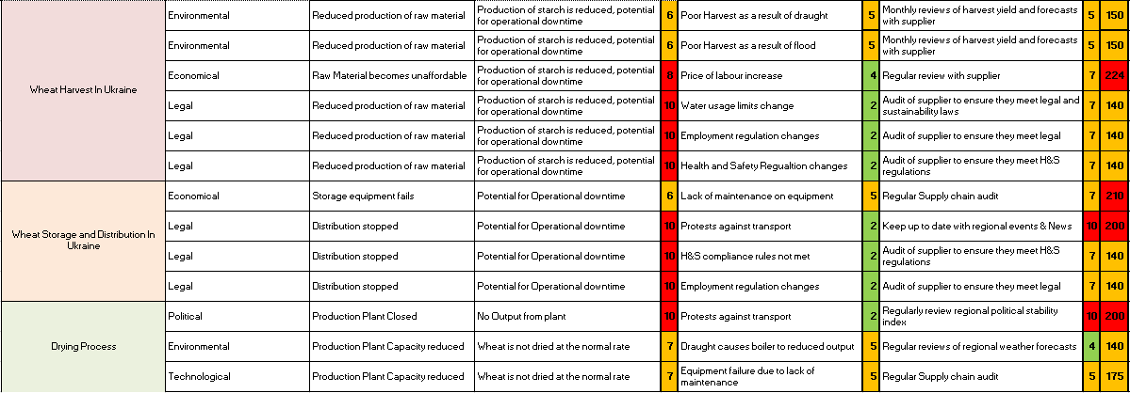
Steps to make the supply chain more resilient
The FMEA has demonstrated that there are still some clear risks that require improvement through the supply chain, the first common theme of the top 10 highest scoring elements is the potential for the supplier’s equipment to fail. The risk of this type of failure is that the UK plant could run out of stock therefore the production line would stop.
Safety Stocks
The first improvement to the supply chain would be to ensure there is enough flexibility by way of safety stock through the process, with the lead time currently at 3 days from order and the current maximum stock level in the UK at 7 days this therefore allows 4 days outage through the process if all silos were full.
(Stephen C Graves, 2003) demonstrated in their research the need for safety stocks through the supply chain but with the considerations of economic scale of the stock and elements such as cyclic demand on how large the safety stock should be. This demonstrates that although safety stocks are a remedy for cause they do come with additional costs and risks not only for the supplier but also the customer as additional stock requires an increase in working capital as well as a typical increase in insurance as larger quantities are now at risk.
(Horst Tempelmeier, 2015) give insight to the risk of increasing safety stock due to the potential for increased transportation costs in part due to the variability that safety stocks can bring to transportation requirements.
As previously stated, the current flexibility sits at 4 days if all silos are full, but the current reorder level of the silo’s is set at 70% which would then trigger 3 deliveries, increasing this reorder level to 80% would allow 1 more day potential downtime of the supplier therefore reducing the risk to the UK plant. The increase in working capital would be approximately £15,500 in contrast to the downtime for one day in the UK plant of approximately at £120,000 therefore the increase in stock level would be justified and risk level reduced.

Technology & Visibility
The supply chain could be improved by increasing the visibility of the process, currently there is very little information flowing between supplier and customer on the status of the supply chain therefore the communication becomes more reactive rather than proactive. Benefits of making the supply chain visible are information flow increases, decisions can be made before failure, stakeholders can be informed to adjust strategy, planning and logistics departments can adjust accordingly as well as working collaboratively.
(Maria Caridi, 2014) demonstrates a model that clearly defines the value of a visible supply chain by allowing a business to determine which Key Performance Indicators (KPI’s) are driving the supply chain performance, this in turn reduces waste in measuring less important metrics of the supply chain and allows focus on the true drivers of the supply chain.
The technology required to bring the supply chain to life and visible requires multiple layers of integration and calculations to allow a transparent process that is easily evaluated and adjusted to maximise the potential for the customer. A strong enterprise resource planning (ERP) system and customer relationship management (CRM) system allows for transparency of the supply chain assuming both supplier and customer have access to the same data and information.
(S.C. Lenny Koh, 2006) studied the integration of an ERP system into SCM and found strong links to improved supplier relationships, “This study suggested that good management of supplier involvement and an agile SC can lead to better supplier performance, improved manufacturing, and product and process improvements that in turn enhance customer satisfaction and firm performance”.
My recommendation based on the FMEA and the readily available technology would be to slowly integrate an ERP system into the SCM to allow more visibility and ultimately quicker, more accurate and collaborative decisions to be made. The speed of such an integration is critical to its success as the system would require acceptance from all stakeholders as this would be a new way of working, therefore speed of roll out is not critical but accuracy and system application becomes the measure of its success.

Supplier Relationship
The relationship with a supplier directly influences the performance of the supply chain as previously demonstrated by (S.C. Lenny Koh, 2006). When reviewing the FMEA of the wheat supply chain, the communication and relationship required to manage the risk of the harvest yield and elements such as labour agreements or health and safety regulations which could directly put the customer at risk must be controlled. Without a relationship based on trust, honesty, integrity and transparency the supply chain is left exposed to the risks highlighted in the FMEA as the supplier may not be forthcoming with negative information.
Regular audits are conducted as part of the current supplier agreement to check quality control, health and safety, maintenance routines and worker conditions as part of our ISO 9001 commitments, but this is a very formal and uncollaborative approach which can often be seen as a tool to demand lower prices or even seen as a tick box exercise.
To truly embrace the supplier and Customer relationship as one we must look towards the examples of Toyota and Honda who “believe they can create the foundations for partnerships only if they know as much about their vendors as the vendors know about themselves” (Jeffrey Liker, 2004) To demonstrate how this effects business and potential relationships a senior executive of a supplier to Ford in 2002 said “In my opinion, [Ford] seems to send its people to ‘hate school’ so that they learn how to hate suppliers. The company is extremely confrontational. After dealing with Ford, I decided not to buy its cars.” (Jeffrey Liker, 2004)
This shows how having a good supplier customer relationship can be beneficial for all stakeholders as the greater the partnership the greater the opportunity to succeed tends to be, another example this time from a Toyota supplier said “Toyota helped us dramatically improve our production system. We started by making one component, and as we improved, [Toyota] rewarded us with orders for more components. Toyota is our best customer.” —Senior executive, supplier to Ford, GM, Chrysler, and Toyota, July 2001. (Jeffrey Liker, 2004) Toyota not only asks for a supplier, they help their suppliers develop themselves to increase the performance of the parts they buy which demonstrates the power of a strong supplier customer relationship. The Toyota approach is demonstrated in figure 2 which discussed the need to turn rivalry into opportunity, develop supplier’s technical abilities and sharing of information

Figure 2- Toyota Supplier - Partnering Hierarchy
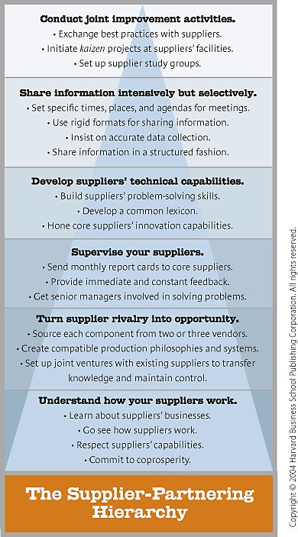
My recommendation to develop the supplier customer relationship into a partnership whereby we share our technical capabilities, information, risks of the supply chain and develop a understanding of how both businesses work.
With this new partnership this could lay the foundations for a more visible supply chain as previously discussed, the visibility of the supply chain with a new collaborative partnership leaves only opportunity to improve rather than finger pointing employees to blame for failures.
Measures
To ensure our supply chain is performing at the best possible rate we must use KPI’s to track this performance, without measures we have no indication if the supply chains is succeeding or failing.
The FMEA demonstrates high risk elements that could reduce production such as draught, equipment failure and late deliveries which could all be tracked more efficiently by implementing an effective measurement system. Measurement systems have been used widely in supply chains for many years but come under scrutiny from suppliers and customers alike due to the saturation of important KPI’s with less important KPI’s. Conventional KPI’s that are typically deemed the most important for a supply chain are On Time In Full (OTIF) which measures the process ability to deliver what you said and on time, Stock Outs which measures if the process failed, Customer complaints which measures the quality of the product, Product Spread measures the cost of the shipment and Production Vs Plan (schedule adherence) which measures if the supply chain made the correct product at the correct rate. All of the following KPI’s follow the 7 R’s of supply chain from (Transport, 2019) which are getting the Right product, in the Right quantity, in the Right condition, at the Right place, at the Right time, to the Right customer, at the Right price.
Key characteristics to consider when implementing measures through the supply chain are illustrated by (Beamon, 1999)
- directly related to overall strategy
- comprehensive (takes into account relevant variables)
- use also non-financial KPIs,
- adaptable to specific supply chain configuration and member companies,
- optimal number of KPIs,
- simple and easy to use,
- timely and actual,
- accurate and consistent,
- foster improvement, not just monitoring,
- represent information at different supply chain levels,
- provide analytical tools that offer multidimensional reporting,
- enable a proactive management, rather than reactive,
- provide insights into newly emerging trends, opportunities and problems,
- deliver information to right people at any time and on any device.
To develop our own measures, we need to critically analyse where we sit on the supply chain performance maturity model as shown in figure 3. Based on my own opinion and knowledge of the supply chain I believe the current measures are at the Internal level which do not help drive performance, therefore an opportunity to improve is real and should be adopted.
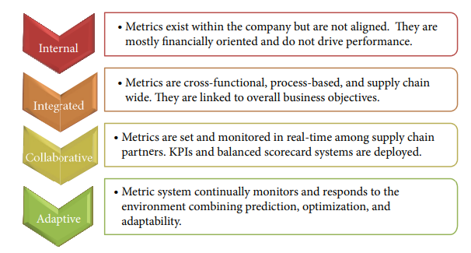
Figure 3- -Supply Chain Performance Measurement Maturity Model
My recommendation to improve the measures of the wheat supply chain is twofold, firstly identify the critical KPI’s that drive our supply chain and secondly in line with the previous recommendations for the supply chain strategy bring the data and information into a predictive visible model that helps the supply chain not only succeed but improve based on real life simulations that mitigate risk to the highest statistical value, such a model is represented in figure 4 by (Stefanovic, 2014)
Figure 4 - predictive supply chain performance management model
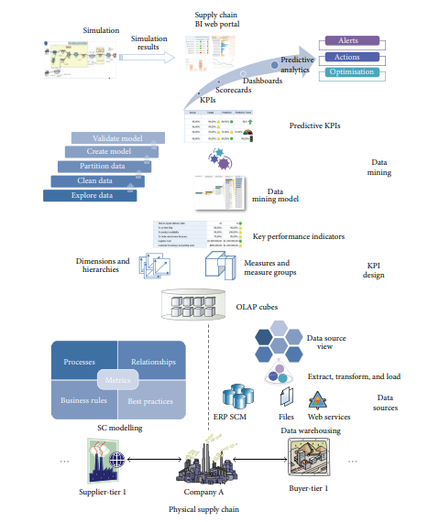

Supplier Assessment
The FMEA leaves me with some doubt that the current supplier would have the best offering from within Europe due to the high-risk nature of the raw material location. With Ukraine now entering into War with Russia this supply chain is at an even greater risk due to politics and potential force majeures such as raw material theft.
One tool we can utilise is supplier assessment to evaluate whether the risk is worth the reward with the current supplier, without any due diligence it would be easy to add another supplier to the supply chain to protect against the risks identified with the current supply chain but this lower risk option comes with significant financial implications.
From historical studies (Dickson, 1966) concluded that quality, delivery, and performance history are the three most important criteria when selecting a supplier where as (C.A. Weber, 1991) concluded price was the highest-ranked factor, followed by delivery and quality.
Taking these studies into consideration it is clear the delivery is always a high ranked factor in deciding supplier, therefore with the current wheat supply chain we must consider if increasing the percentage of supply to the secondary supplier should be increased to mitigate risk.
My recommendation following the FMEA would be to review the OTIF KPI of the deliveries before and after Ukraine entered into war to evaluate its impact on the supply chain and whether there is a deviation to target. Should any deviation to target be evident the supplier should first be approached to review a plan of action to prevent any further decline in performance or to discuss distribution options from other locations.

Strategy
The strategy employed by a business should be reflected in its supply chains, this is even more prevalent in todays world where sustainable practices and innovative use of technology is expected from the end consumer. The FMEA demonstrates a fairly unsustainable supply chain due to the high logistics movements which in part add risk to the total supply chain.
The strategy should be clear to both the supplier and the customer which then sets a clear direction for the supply chain, which is both transparent and understood by all stakeholders, this is not entirely clear from the results of the FMEA as the risks are not pinpointed to one area but in fact are throughout the supply chain.
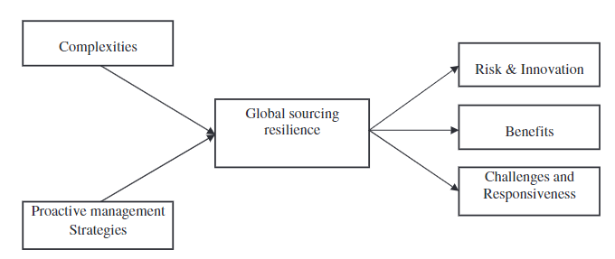
Strategic insight on how to manage the resilience of the supply chain are considered by (Angappa Gunasekarana*, 2015) in figure 5 whereby the inputs and outputs of the resilience are demonstrated. Understanding the complexities of the supply chain and how the SCM strategy is meant to work will add resilience and ultimately reduce risk for all involved.
Figure 5 - GS Resilience Framework
My recommendation for the strategic view following the FMEA is to form a supply chain steering committee to understand how the supply chain is currently developing versus the plan and how it should be developed further. The current supply chain and direction for development is not clear and should be developed with both internal and external stakeholders with a clear roadmap demonstrating each stage of improvement and expected results.

Conclusion
Within the review of the FMEA for the Wheat Supply chain it is clear that some basic principles of supply chain management are not being met which leads to risk and vulnerability of the supply chain. This supply chain has been in place for approximately 7 years with multiple managers taking control of the strategy which leads me to believe there could be a lack of ownership of the total supply chain. The supply chain’s current performance could be a result of historical controls that maybe do not consider current events such as the war in Ukraine, Transport Costs and market demand.
My improvement steps for the supply chain are as follows.
- Employ a strategy by which the supply chain will be managed with all development milestones understood by the stakeholders.
- In the short term increase the reorder level of the wheat as the war in Ukraine has added greater risk to the supply chain.
- Develop a greater relationship with the supplier to understand how we can help each other moving forward with technology, expertise and visibility
- Implement a KPI system for the supply chain that is transparent to both supplier and customer allowing for greater visibility and flexibility to adapt to deviations in the supply chain
- Invest in ERP and CRM systems to bring predictive supply chain methodology to life, with the current level of data available from both parties this could be a valuable tool moving forward.
- Review the OTIF of the current supply chain pre and post Ukraine war to evaluate the real impact of the greater risk to the supply chain.

With these measures implemented it is my belief the resilience of the supply chain would significantly increase allowing for a transparent, flexible and value add process whereby supplier and customer are in a partnership, not only to supply but to support, develop and thrive as one that can profit together.

References
Angappa Gunasekarana*, N. S. S. R., 2015. Supply chain resilience: role of complexities and strategies. Journal of production research, 53(22), pp. 6809-6819.
Beamon, B. M., 1999. Measuring supply chain performance. International Journal of Operations and Production Management, 19(3), pp. 275-292.
C.A. Weber, J. C. W. B., 1991. Vendor selection criteria and methods. European Journal of operational research, 50(1), pp. 2-18.
Dickson, G., 1966. An analysis of vendor selection systems and decisions. Journal of Purchasing, 2(1), pp. 5-17.
Hippold, S., 2020. 6 strategies for a more resilient supply chain. [Online]
Available at: https://www.gartner.com/smarterwithgartner/6-strategies-for-a-more-resilient-supply-chain
[Accessed 20 april 2023].
Horst Tempelmeier, O. B., 2015. Integrated optimization of safety stock and transportation capacity. European Journal of Operational Research, 16(1), pp. 101-112.
Jeffrey Liker, T. Y. C., 2004. Harvard Business Review. [Online]
Available at: https://hbr.org/2004/12/building-deep-supplier-relationships#:~:text=Toyota%20and%20Honda%20believe%20they,the%20suppliers%20and%20the%20manufacturers.
[Accessed 20 April 2023].
Maria Caridi, A. M. A. p. A. T., 2014. The benefits of supply chain visibility: A value assessment model. Internation Jounral Production Economics, Volume 151, pp. 1-19.
S.C. Lenny Koh, S. S. S. A., 2006. Competing in the 21st century supply chain through supply chain management and enterprise resource planning integration. International Journal of Physical distribution and logistical management, 36(6), pp. 455-465.
Stefanovic, N., 2014. Proactive Supply Chain Performance Management with predictive analysis. The Scientific World Journal, Volume 2014, p. 17.
Stephen C Graves, S. P. W., 2003. Supply Chain Design: Safety Stock Placement and Supply Chain Configuration. Handbooks in Operations Research and Management Science, Volume 11, pp. 95-132.
Transport, I. o. L. a., 2019. What are the 7R's of supply chain management. London: s.n.

Figures
Figure 1 - Process Map of Wheat Starch 2
Figure 2- Toyota Supplier - Partnering Hierarchy 14
Figure 3- -Supply Chain Performance Measurement Maturity Model 16
Figure 4 - predictive supply chain performance management model 16
Figure 5 - GS Resilience Framework 17

