


Research Competencies Portfolio and Reflective Log

Dominik Grunski (1901751)
MSc Applied Psychology



Contents Page

Evidence A: Group Work
Expression of Interest Form……………………………………...…….Pages 3-7
Gantt Chart……………………………………………………...……........Page 8

Evidence B: Study Materials Creation
Study Information Sheet……………………………………………...Pages 9-10
Study Consent Form……………………………………………………...Page 11

Evidence C: Study Advert Creation
Study Advert…………………………………………………………Pages 12-13

Evidence D: Development of Survey
Research Questions………………………………………………………Page 14
Qualtrics Setup………………………………………………………Pages 15-16

Evidence E: SPSS Preparation and Analysis
SPSS Codebook…………………………………………………..…Pages 17-22
SPSS Data Cleanup………………………………………………….Pages 23-24
SPSS Data Analysis…………………………………………………...…Page 25

Reflective Log………………………………………………………Pages 26-30

References…………………………………………………………….…Page 31

Evidence A: Expression of Interest Form
Version 1
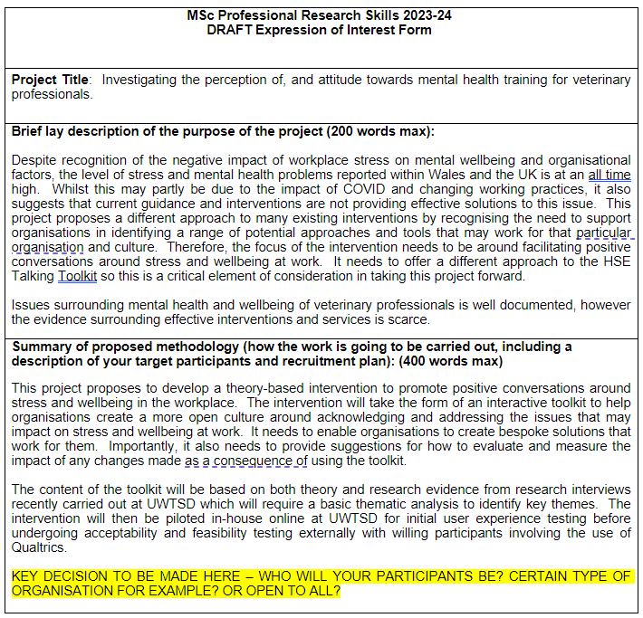
We had been indecisive whether to focus on veterinary professionals only or also veterinarians in training (such as university or in courses).

We had initially been overwhelmed by the choices of what information we should include to concisely convey the goals of the study within the word limit, thus started with a vague sentence as a start to build off of.

Expression of Interest Form
Upon further reading, we wanted to look at Wales as a target population considering the very scarce literature for Wales specifically, however we realised later that we could get more examples of good practice if we went wider throughout the UK with our online questionnaire, and our potential outcomes could become more widely generalizable.
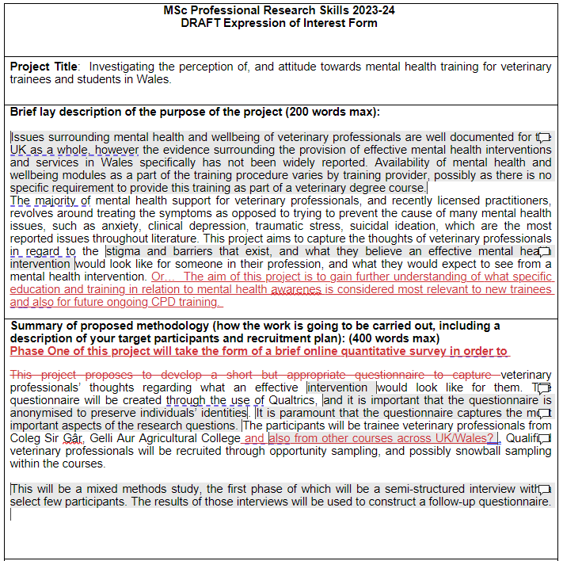
Version 3

Due to overthinking the extent of our goals for phase one, we got very confused about what methodology we would be employing.
At this point we had been overthinking our goals to the point where we were not sure what were the most important aspects we wanted to explore.
In this section, we were thinking too far ahead for the first phase of this project, as qualitative interviews could be one of the outputs of phase one, which consisted of a Qualtrics questionnaire.
Here we struggled to put our aims into clear and concise wording.

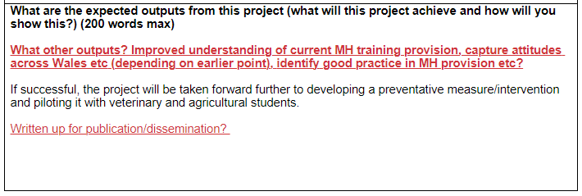
At this point in the project, it was difficult for me to think to the future of what outputs could possibly happen, other than the second phase, considering how undecisive we had been at this point with our goals.

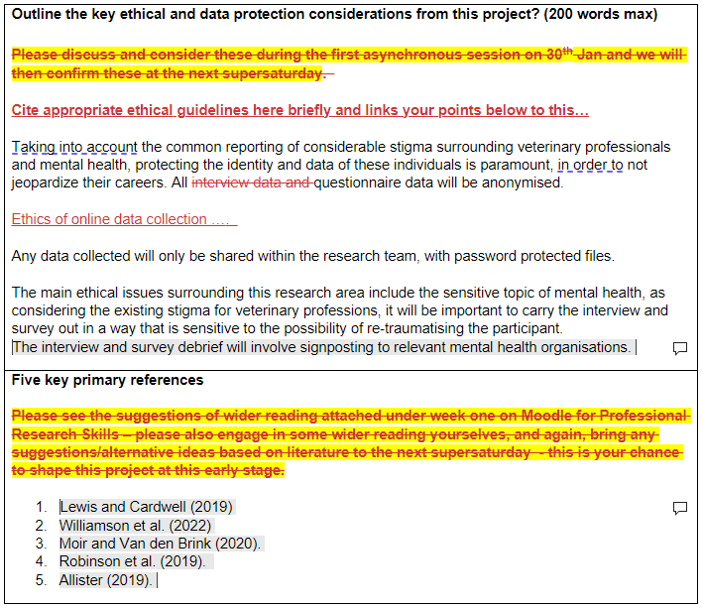

Here I had been uncertain what sort of organisations could possibly be cited for signposting, which prompted me to look further into MH organisations which offered help for veterinarians and try to determine which were appropriate to include for signposting.

Expression of Interest Form
I took the lead on finishing up the fourth version of the form, based on the feedback we received from version three.
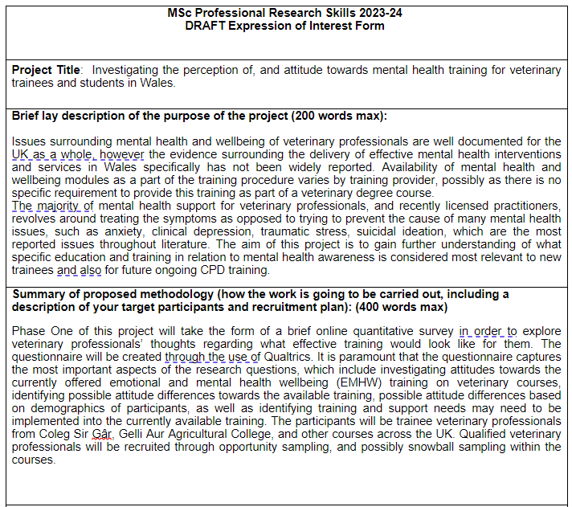
Version 4

Based on the literature that we chose as the five main references for the EOI, we decided that our main goal was to compile the evidence of most common issues from the literature, and explore how often veterinarians experienced them within 12 months.

After consolidating our main goals, we felt more confident as to what aspects we wanted to explore, and how we would go about recruiting participants.

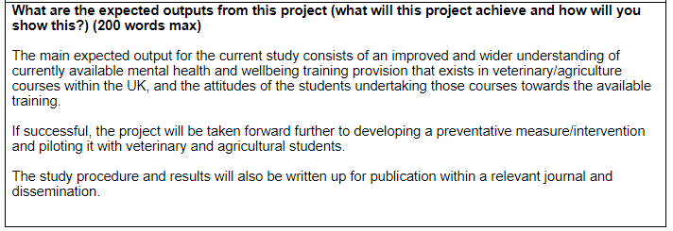

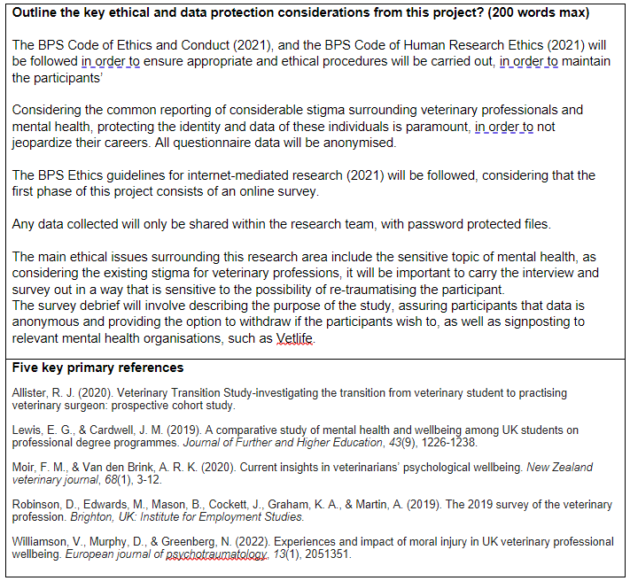
We had went back and included the sources for BPS guidelines and expanded upon the possible risks for the participants.

Evidence A: Gantt Chart
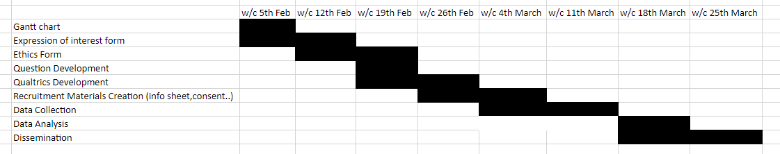

This was the first time I had attempted to make a Gantt Chart for one of my projects, and although it was simple, it helped me realize how helpful a tool like this can be to roughly visualize how long different aspects of the project can take, or how long we would expect them to take.
Jonathan, who uses excel often provided some tips while I was formatting this table, making me aware of useful features and shortcuts such as auto size, which can save time from manually formatting tables like this.

Evidence B: Study Information Sheet
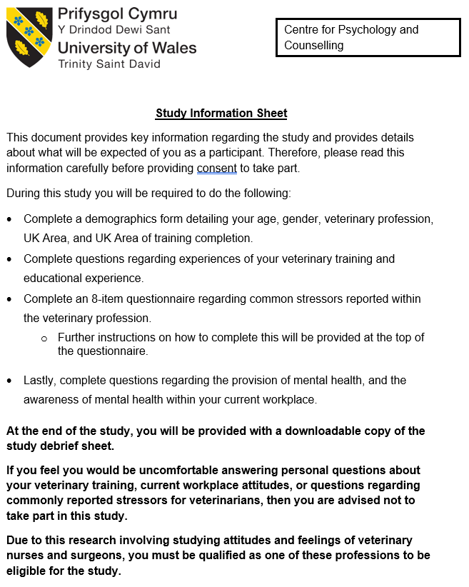
Version 1

I had taken the lead on creating the first version of the study information sheet. I had used the template that was often used throughout my undergraduate research.

I had realized after finishing this form that it looks rather clunky and far too wordy, which could turn off potential participants. Using this specific template was not required unlike the undergraduate, therefore began revising the information sheet following feedback from the rest of the group.

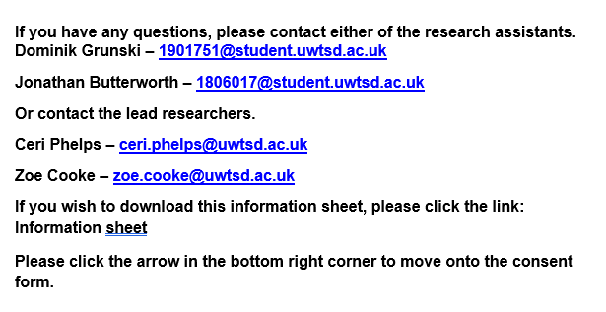

Study Information Sheet
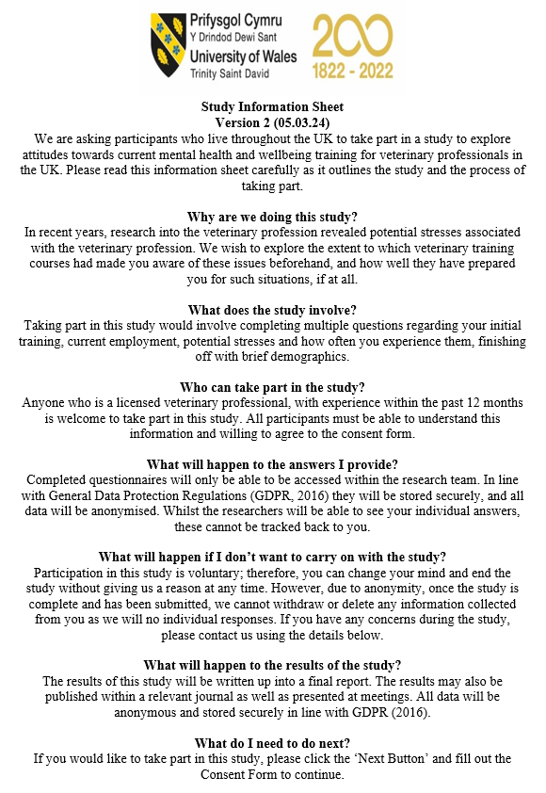
Version 2

With advice from the rest of the team, I revised the information sheet almost entirely to be much more readable and presentable.

Looking back on this version, it still felt too wordy, especially considering our target population, who are busy people that may not have the time or patience to participate in long questionnaires.

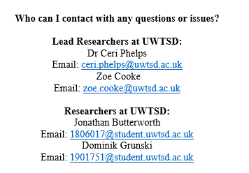

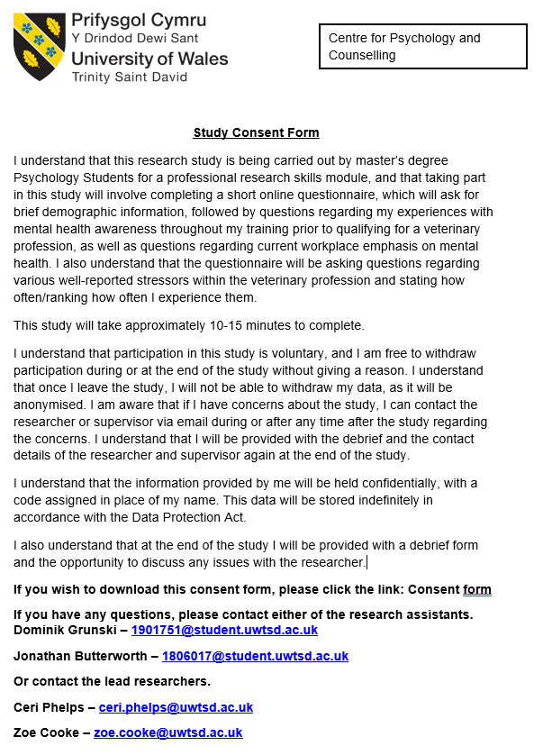
Evidence B: Consent Form

Similarly to the information sheet, I had also utilized a similar template that was used during my undergraduate studies. The problem of being overly wordy felt more prominent with this consent form, considering that this would be the first part of the questionnaire that is viewed by participants. For the questionnaire we elected to use a simple sentence to confirm consent and veterinary profession, with a tick box system.

Evidence C: Study Advert
Considering I had never made an advert before, the team suggested I should take the lead on creating one on PowerPoint.
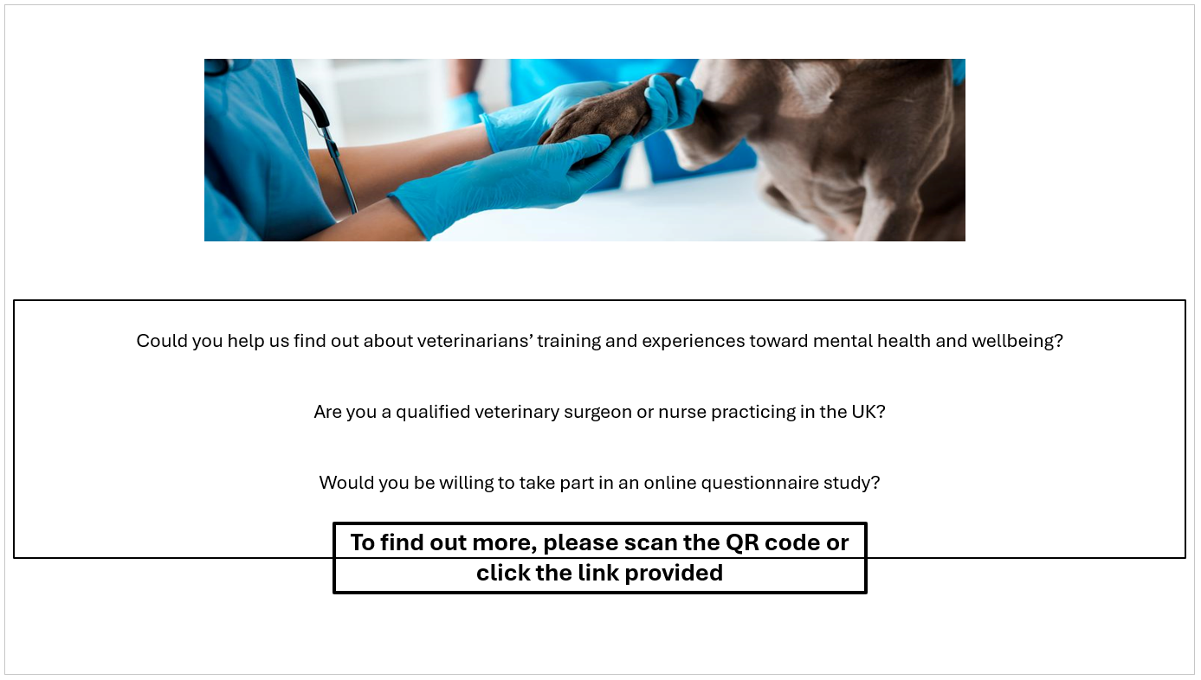
Version 1

I knew that adverts should be eye-catching, therefore I searched thoroughly for a copyright free image which would convey at a glance what our study is exploring, while also not being too personal.

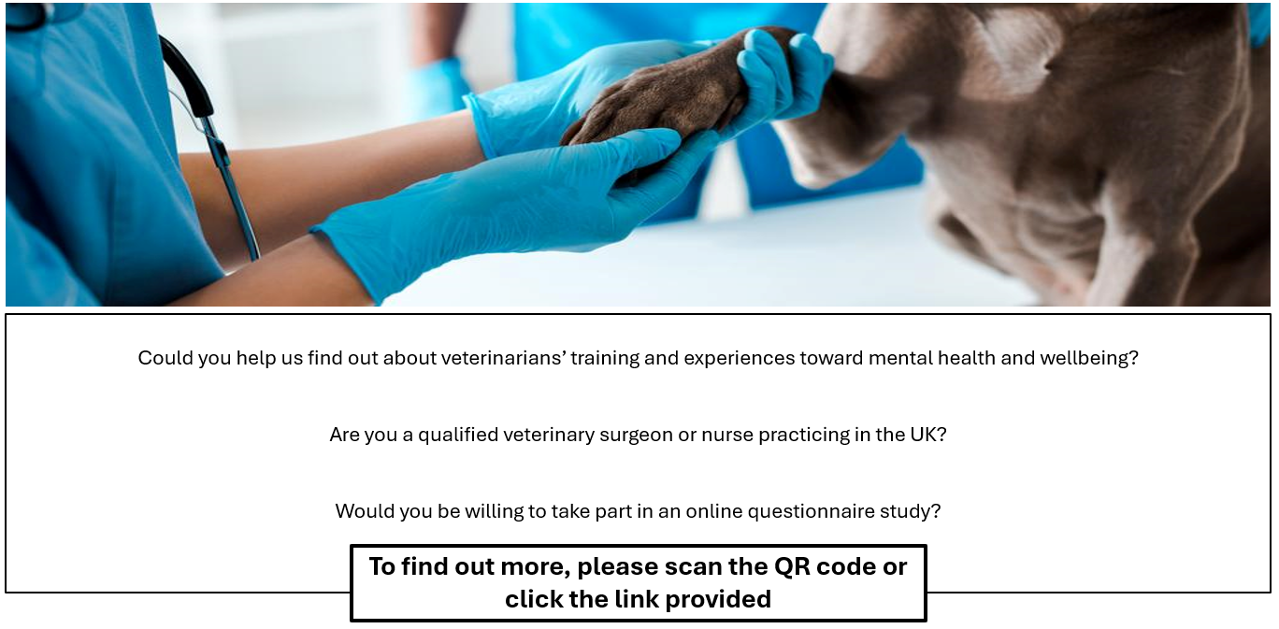
I had initially struggled with formatting and figuring out how to get the AD to look clean. In later versions I used the fill function to remove the line from the textbox.

Resized the main image to fill more of the advert to make sure it will grab attention.

Study Advert
Final Version
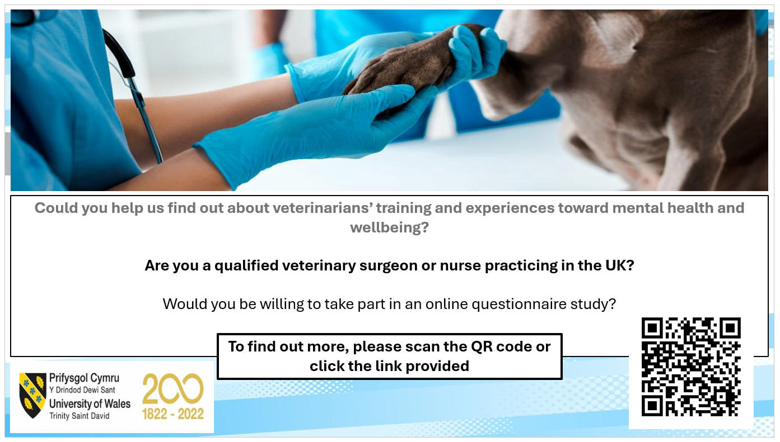

Had to decide which parts of the text to highlight, with bold implying the most important requirement, if a viewer is interested in participating.

Added an outline image to match the colours of the main image, which was flipped 180º to hide the watermark, creating a clean banner for the advert.
Was fiddling around for a considerable amount of time to try and centre the university logo and the QR code to be appealing and look clean.

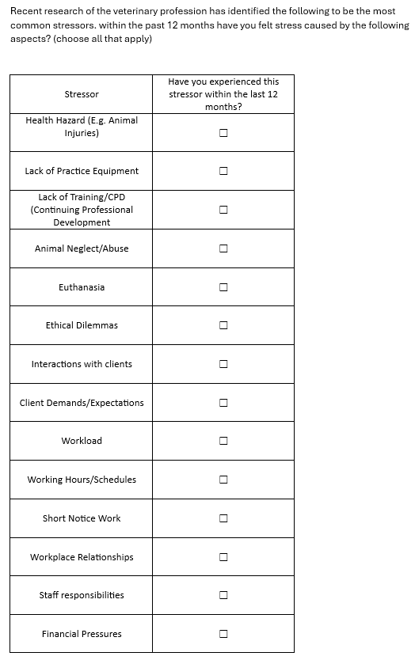
Evidence D: Research Questions

Following our literature searching, we began formulating questions we wanted to ask in the questionnaire, regarding commonly reported stressors for veterinarians.

I took the lead on creating a table of the most reported stressors within literature, searching for the most relevant sources, and noting the issues within this table. Some of these stressors were later combined within the Qualtrics survey as they were similar in nature.

Evidence D: Qualtrics Setup
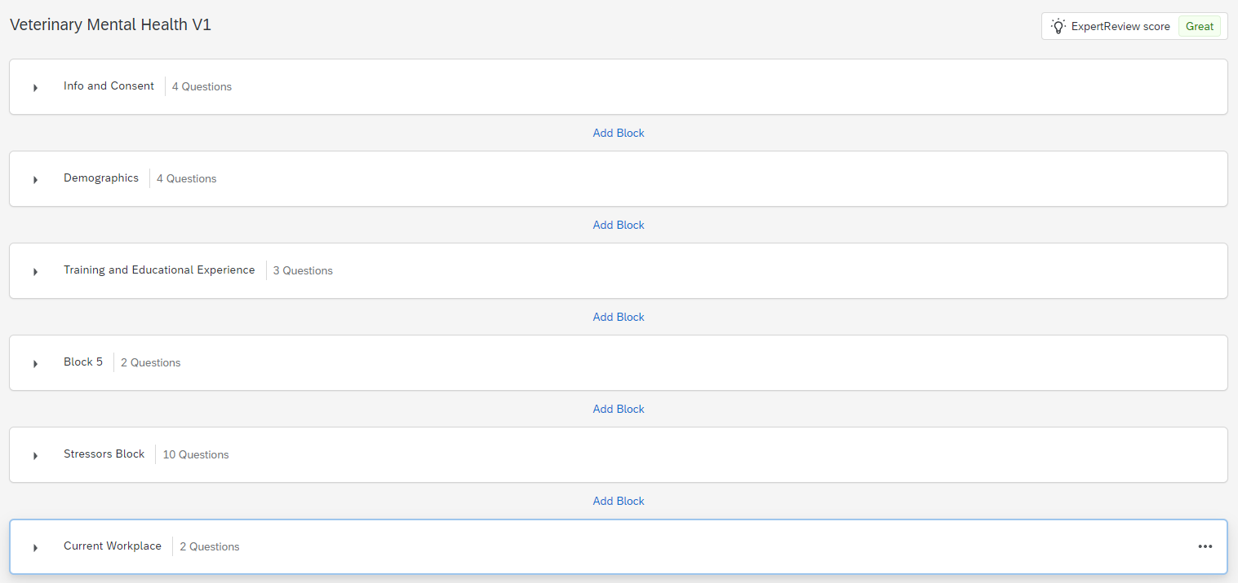

I had created the survey on Qualtrics and added Jonathan, Ceri, and Zoe as collaborators to work on it together.
We designed the sections and brainstormed the questions together as a team, with my main input being the person formatting and typing the sections and questions while livestreaming my computer screen for the team, to avoid issues with multiple people editing the survey at once.
Throughout creating our questions, it made me realize how important it was to get the wording of the questions just right, especially with our target population, in order to obtain the data we want, and to avoid non-completion.

Had also gone through to add appropriate skip logic and reminders for missed questions, to make sure that participants are fully aware when skipping a question.

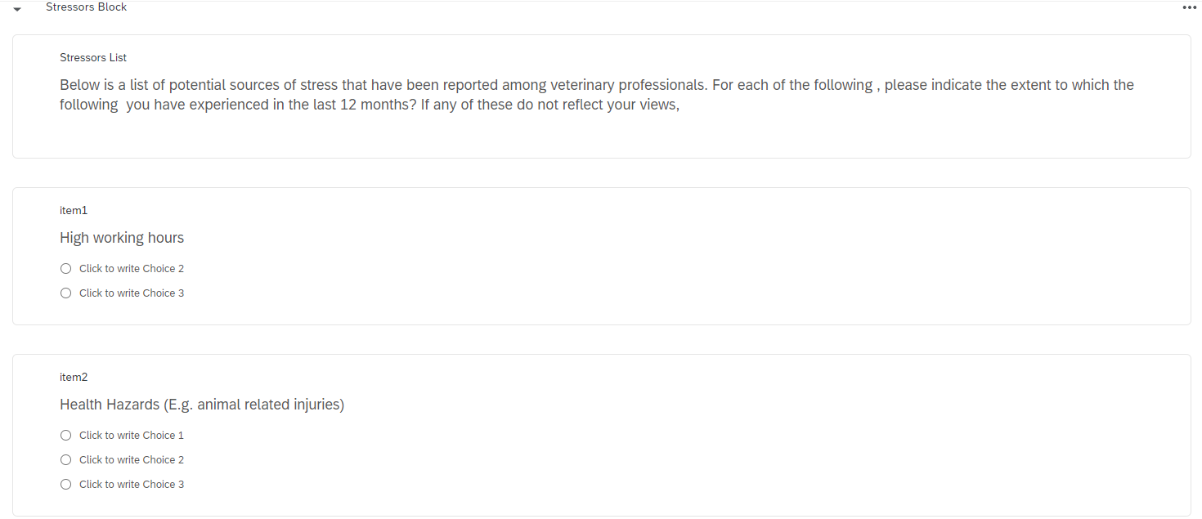
This was our initial formatting within Qualtrics for the table of stressors I created prior. We had spent the majority of two weekly sessions on trying to tweak and change the way we ask this question in just the right way, however we may have been overthinking the complexity of this question for the purposes of phase one of the project.

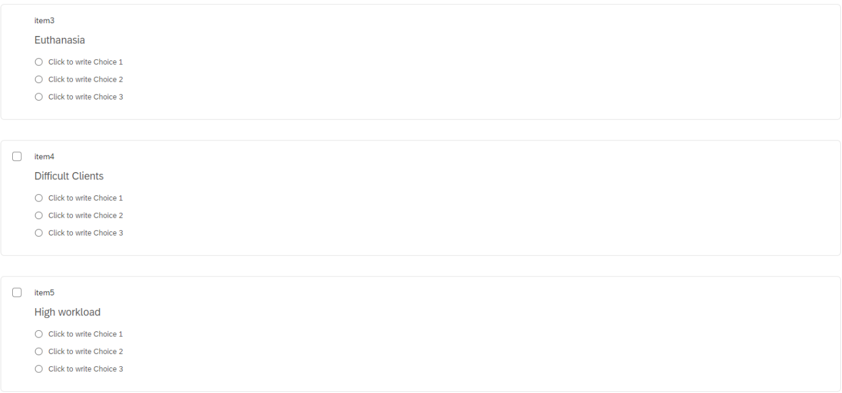

Evidence E: SPSS Codebook
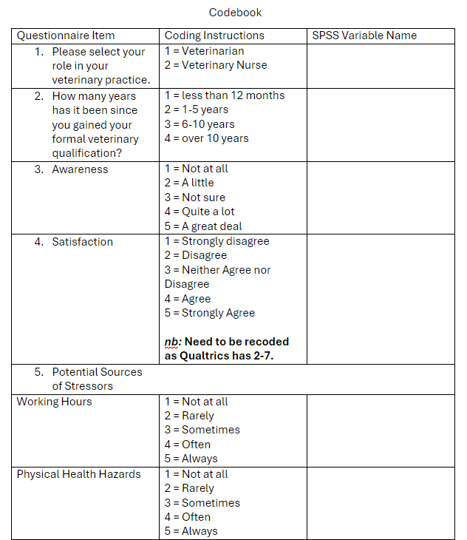
Version 1
As a group, we met up on campus and began to create a Codebook together. I took the lead on formatting and typing up the codebook.

We decided that giving year ranges would be more appropriate to ask, as some people may not remember what exact year they obtained qualifications.

I knew from using Qualtrics during my undergraduate dissertation that Qualtrics can often record numbers and information incorrectly, therefore after checking, made sure to note down required changes.

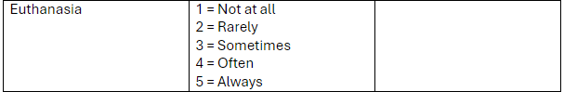

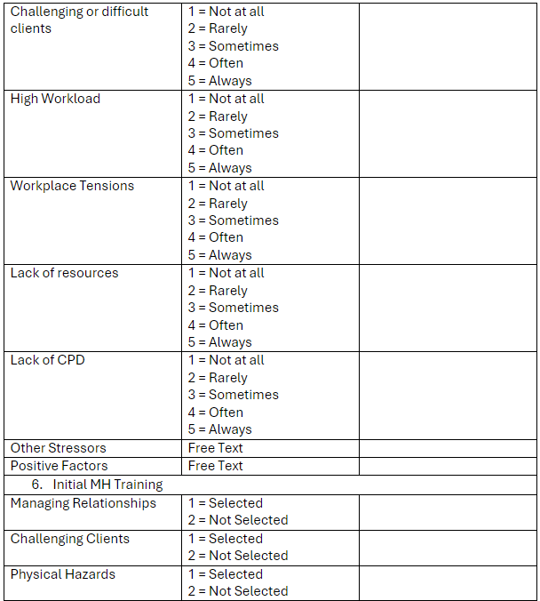

Within this version we had not yet established what SPSS variable names to use, as those are very strict, such as using underscores instead of spaces.

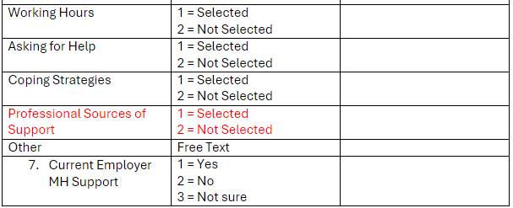
Decided to use red highlight as a reminder that this section needs to be revisited to reword and improve.

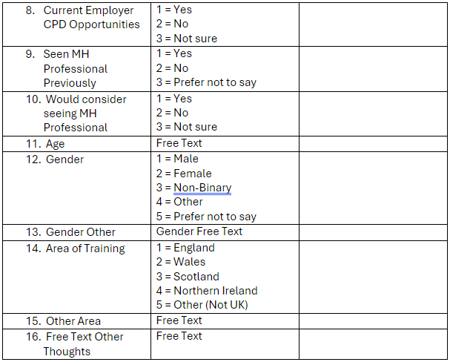
We thought that using the term ‘not sure’ for some questions was more appropriate than ‘prefer not to say’, as some people may not remember what is offered by employers.

SPSS Codebook
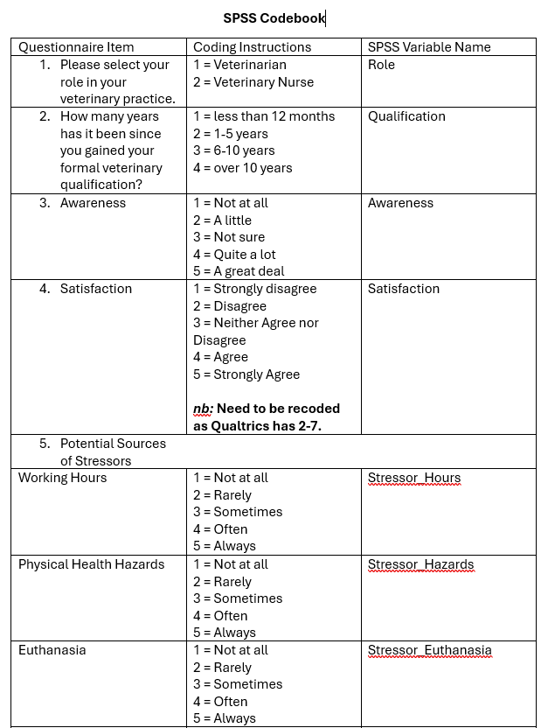
Version 2

I had worked on the second version of the codebook to add the remaining missing details.

I had created the variable names to align with SPSS requirements of no spaces and tried to make them as easy to understand as possible in regards to which section each variable belongs to.

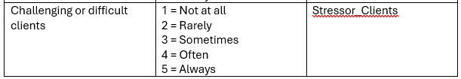

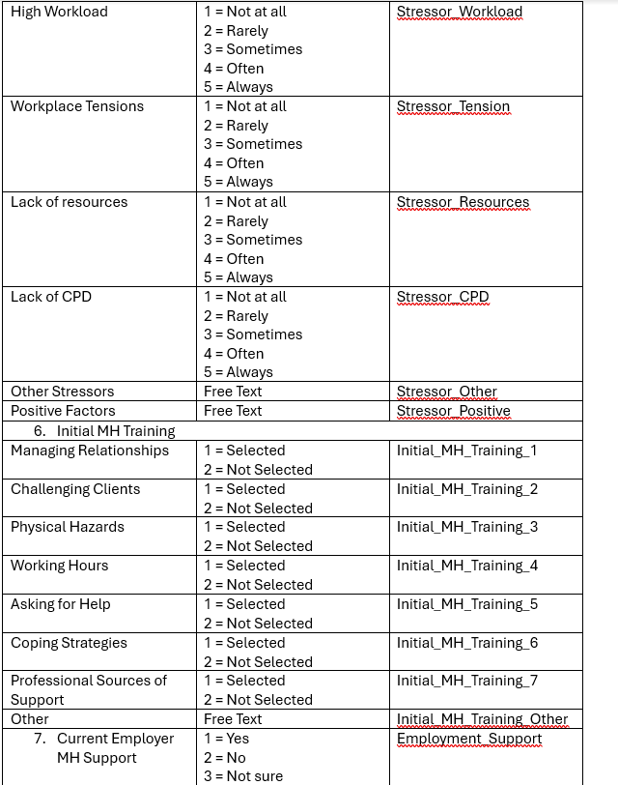

This section of variables in specific was changed multiple times, as Qualtrics did not score these the way we had intended, and therefore the variable name was changed based on the SPSS assigned name, for everything to flow nicely.

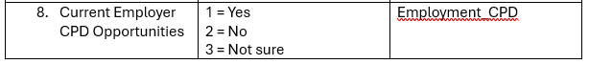

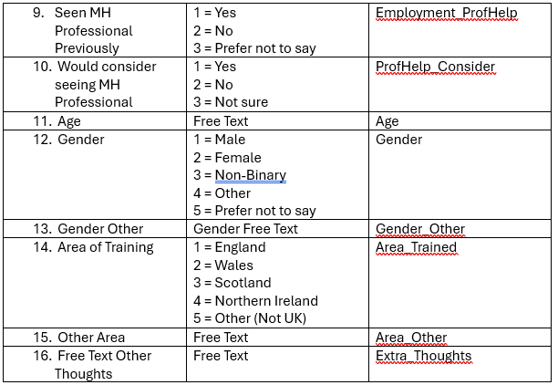
Had to note that SPSS had created two separate sections for free-text box answers, one with selection (e.g. 4 = Other selected), and another variable for the text itself.

Evidence E: SPSS Data Cleanup
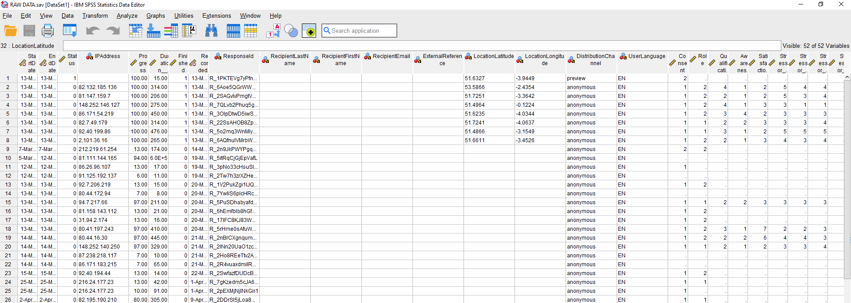
Raw Data Prior to Screening and Cleaning

This data set included data collected up to 28th April. Many of these sections could be deleted, as well as preview and incomplete datasets.

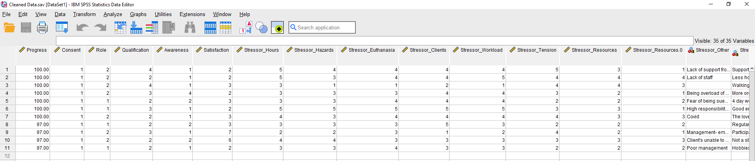
Cleaned SPSS Data Set

The cleaned dataset consisted of 11 valid participants. With the majority being veterinary nurses.

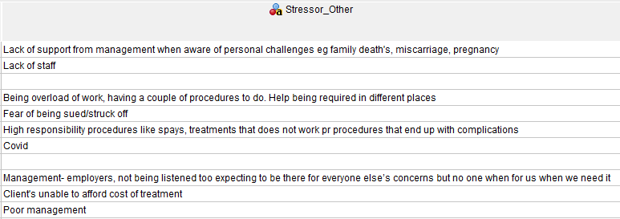
The responses provided to our stressors table suggested that perhaps our items were not clear enough as to the scope of each item.

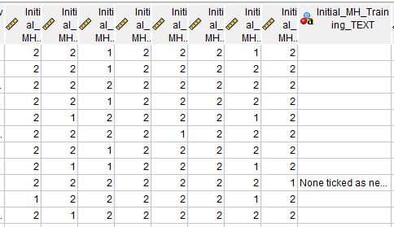
Had to recode missing values into 2, in order to keep it consistent with our codebook, as 2 = not selected on the initial training table on the Qualtrics survey.

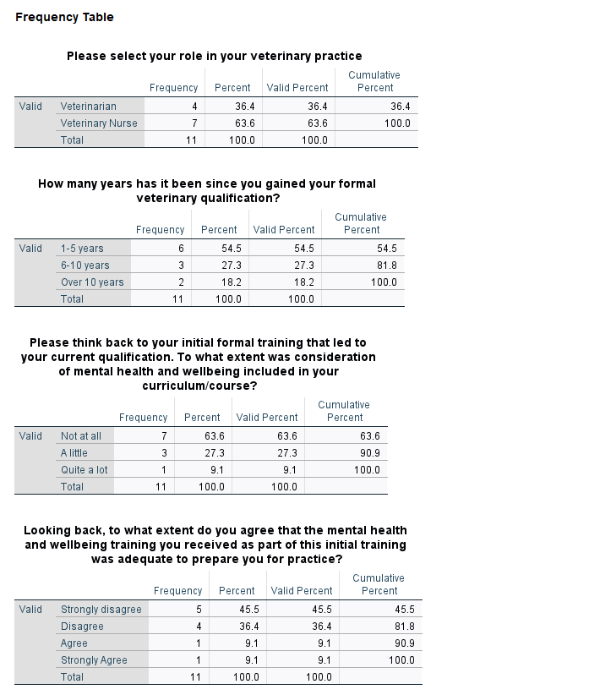
Evidence E: SPSS Data Analysis
The sample had almost twice the number of veterinary nurses, although considering the small sample size, the difference is not that major in the context of 11 participants.

It appears that the sample we have up until this point are mostly recently qualified veterinarians, which likely means they remember their training more accurately compared to participants who obtained their qualification earlier.

As we had predicted from our literature searching, majority of participants did not feel prepared from their training.

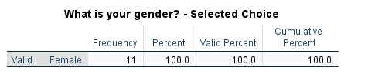
The valid sample was made up of entirely of female participants, which would line up with the literature we had found during our searches.

Reflective Log
During my MSc in Applied Psychology, I had taken part in the Professional Research Skills module, which aimed to improve my skills as a member of a professional psychology research team, working on a project with a topic of our choosing. The module required collaboration between the members of the research team to conduct a real-world applied research project, initially based on the topic creating a toolkit for creating positive conversations around stress and wellbeing in the workplace. This initial suggested topic for the project was vague but also broad at the same time, which made me slightly worried, as I was not sure what sort of suggestions to contribute to the group for narrowing down the focus of the research, not to mention that it also sounded like a boring topic to me personally. It appeared that the rest of the group also was not too excited about the suggested topic, and after a thorough discussion, we had decided on a broad topic of investigating the mental health needs of agricultural workers who work with animals, which made me much more enthusiastic to do good research for this topic, considering I have also recently become a pet-owner myself.
Our research team consisted of two students, including myself and Jonathan, as well as Ceri, the research supervisor. In our initial discussion, we had talked about farmers and veterinarians, and I had felt out of my depth as the field was relatively new to me. Based on our discussions, I had assumed that we will be focusing mainly on farmers and began my literature search on UK farmers’ mental health to get a good understanding of what has already been done for this group, however the literature I found suggested that veterinarians were more in need of better mental health support options.
Following this session, I had carried out the same literature searching procedures to get a good understanding of the main issues for veterinarians and form a good evidence base for how we should proceed. Based on the combined literature we found, we had decided that our rough aim would be to investigate attitudes towards mental health training for veterinary professionals.
Once we had agreed upon this rough aim, the first thing we worked on was a Gantt chart (Evidence A), in order to map out how much time we have to complete the project. Initially, I was anxious about how we would be able to carry out an entire project with such a small group, although according to Haugland et al. (2022), working in small groups, which are consistent with the same members appears to be highly beneficial to completing and delivering complex assignments or tasks, such as our project.
The first material to get started on was the expression of interest (EOI) form, however we made little progress during our first session, therefore me and Jonathan agreed to meet during the weekend to continue working on the EOI. Jonathan was very knowledgeable on the topic of agriculture and veterinary work and was really able to make a start on our brainstorming around how to do this research and things to consider, which combined with my layman perspective on the subject, allowed us to bounce a lot of ideas off each other. On the other hand, I was slightly more confident in efficiently handling applications such as Microsoft Word and Teams to make our process smoother. Thanks to our weekend session, I felt like our group roles fell into place, as we acknowledged each other’s strengths and how to work together to help make the project proceed smoother, which according to Forsyth (2021), is one of the most crucial aspects to strengthening group cohesion.
Although we made a lot of progress during the weekend session, without the guidance of Ceri to keep on track and not go on too many tangents, we ended up overthinking the scope of our research, and veering from investigating the UK as a target population, to only focusing on Wales, as we had found a significant scarcity of literature around veterinarian mental health within Wales specifically. We had also gotten confused about what sort of methodology we would be going for, as initially we had agreed to carry out a survey, but now we were not certain whether to also include a qualitative mixed-methods aspect to the survey. I had felt a bit anxious, as it felt like we were going in circles, however through our shared confusion I felt like we had gotten closer and better at communicating together, as well as grew our awareness of the topic area, which ultimately helped us to carry out a successful project (Majeed et al., 2021).
After feedback on our third version of the EOI, we decided to carry out an online survey, to ask veterinarians and veterinary nurses about their experiences within the last 12 months, as well as asking about the provision of mental health and wellbeing within their training for their qualification. Following this, we had started on formulating research questions for our Qualtrics survey. I had taken the lead on finding what the main mental health issues surrounding veterinarians were, which I compiled into a table of most common ‘stressors’ (Evidence C).
Although this table was not perfect, and not extensively representative of the wider literature on the topic, I felt that it gave a good start for us to brainstorm possible questions for the survey. As I had not documented which sources I had drawn those stressors from exactly as well as justifications for why those papers specifically. This was frustrating, as I should have kept a record throughout creating the table, and that extra time could have been used to start work on the survey, and for the next time I do a similar task, I will be cognizant of the importance of not only keeping records, but also spending a bit more time with each paper, to see whether it is justified to include it as evidence for the study.
As we were beginning to create the survey, I had thought back to the experiences I had throughout my undergraduate degree, to the modules which consisted of group work on a research proposal/idea, however those were much different experiences, as all the research in those modules were theoretical and not applied to the real-world, as opposed to this research project, which involved interviewing real veterinarians and nurses, and I was mindful of the fact that the ethical considerations, wording of questions, and study materials had to be made with much more thought, care and consideration for our future participants, while also making sure to follow the BPS Code of Ethics and Conduct (2021). Despite this, throughout the three scheduled sessions we had spent on improving the survey, I had realised that formulating appropriate questions, for such a complex group such as veterinarians was much more nuanced than expected, as veterinarians are scientifically trained, which made it hard for me to find the right balance between scientific and lay wording for our questions (Evidence C).
After the first session for designing our survey, I had taken the lead on starting the consent, information and debrief forms (B). I had utilized the templates that I used during my undergraduate research, however I did not consider that the templates were tailored to only student participants, and were not fitting for other samples, considering these templates were very wordy, as well as somewhat clunky. I had revised the consent and information forms to be less frustrating to read, and much more to the point, in order to not turn off possible participants from the study.
Considering that I had never made an advertisement before, I decided to challenge myself and attempt to make a good online advert for our study using PowerPoint (Evidence B). It was difficult to know where to start with making an eye-catching advert, therefore I started with an image which set the theme for the AD and communicated the topic at hand at first glance. With more minor tweaks, such as adding a fitting border and QR code. It was fun to develop a new skill, and I felt that for my first advert is was a good effort, though when it comes to graphic design I could certainly improve upon this skill, such as utilizing dedicated software to make the process smoother and create a more professional advert in the future.
Once our survey went live, we had begun creating the SPSS codebook for our future analyses (Evidence D), which was a joint effort, with me taking the lead on formatting and writing the table up. I had later used the codebook to carry out some basic analyses on the data we had collected up to the 28^{th of} April, to get an idea of what our data looked like, although at that point we had a very small sample size of eleven, although the data did reveal some interesting trends at this point in time (Evidence D).
In conclusion, I feel that thanks to this module I was able to further develop my existing research skills, as well as various professional skills by studying an applied, real-world topic, as well as developing some new skills like basic graphic design for a survey advert. I had also been able to experience what it is like to be part of a research team, which helped develop my teamwork skills further, and helps me feel more confident for my future professional endeavours.

References
British Psychological Society. (2021) BPS Code of Ethics and Conduct. DOI: https://doi.org/10.53841/bpsrep.2021.inf94 (Accessed: 01/05/2024)
Forsyth, D. R. (2021). Recent advances in the study of group cohesion. Group Dynamics: Theory, Research, and Practice, 25(3), 213.
Haugland, M. J., Rosenberg, I., & Aasekjær, K. (2022). Collaborative learning in small groups in an online course–a case study. BMC Medical Education, 22(1), 165.
Majeed, H., Kayani, U. N., & Haider, S. A. (2021). The project communication and trust nexus as an antecedents of project success: Moderating role of authentic leadership. International Journal of Business Communication, 23294884211019098.

