Enterprise & Innovation Group Project
Assignment 2: Report - ACCA5014
Connor Ellement 1803452
Web Development

Contents
1) Introduction 3
2) The Market and Competitors 3
2.1) The Industry/Market 3
2.2) Competitors 4
2.2.1) NetBop 4
2.2.2) RhysWelsh 4
2.2.3) Thomas-Design 5
2.3) The USP 5
2.4) Analysis of the environment 5
3) Development 6
3.1) Research 6
3.2) Design process 7
3.3) Prototype requirements 8
3.5) Front-End & Back-End Development 8
3.5.1) Front-End 8
3.5.2) Back-End 11
3.6) Personal Development 14
4) References 15
5) Appendix 15
5.1) Reflection 15
5.2) Networking 16
5.3) Team-working 17

Introduction
For this assignment, the task has been set to come up with a New Product Business plan in a group (Div Digital), and split the sections of that plan up and give them to different members of the group to individually contribute to the plan as a whole.
In this report, you will see the research and findings of the Market and Competitors section of the Product Business plan, as well as a documentation of the development of the prototype, which will include outlines of the key features and the implementation procedure.

The Market and Competitors
When creating a project, product, business, or anything in a specific industry, research is a must to be able to identify if there is a market for the product you want to create. What this means is to ask the questions “Do people need this?” and “Will people buy this?”.
Research into competitors is also very important as it gives you an idea of the range of the market you are dealing with. Do you have many competitors? Then you’ve got a wide market and your product is probably in demand. However, if you don’t have many competitors, it doesn’t mean your product isn’t in demand, it just means that maybe the market hasn’t been cornered yet.

2.1) The Industry/Market
The product this business plan is centred around is a website, but not just a simple website, a website that is influenced based on innovative web design techniques. The web design industry is a massive one. According to a report done by IbisWorld [1], there are a around 76,000 web development/design companies in the US alone with a total revenue of $38 billion which is continuing to rise and there was a growth of 6.6% in the market from the years 2014 to 2019, a rate which is expected to increase again by 2024.
In the modern world, the number of website users is constantly growing. In a report done by Darina Lynkova with Techjury [2], that stats speak for themselves with the number of websites and website users there are. There are around 1.9 billion active websites in the world, and this number keeps rising, and to go along with this, there are around 4 billion of the earths 7 billion population that use the internet.
New websites and web design techniques are coming out daily, so when creating a website, it is best to be unique (More on that later on in the report). At the moment, there is a gap in the market for support dedicated websites, and we know this from the report done with medium.com by Dave Sloan [3]. I the report he conducted, 31% of businesses/people asked would prefer a dedicated account management system, which means dedicated support from the designer themselves, rather that maintaining the website themselves after the website is finished. This gap can be quite easily cornered by offering maintenance packages/charges to a business once the designer has completed the website.

2.2) Competitors
The competitors to this business plan would be other Web Development/Web Design companies offering similar products and features. A few companies that have been identified are in the south wales and they are NetBop, RhysWelsh, Thomas-Design and SGOR.

2.2.1) NetBop
NetBop are a company based in Swansea who specialize in SEO, Cloud Hosting, Digital Transformation, Domains, Digital Robots, and most importantly, E-commerce and Web Development. NetBop would be one of the foremost competitors as they offer very similar products. Unfortunately, NetBop’s prices aren’t available for general view. The name NetBop does give an idea of a computer-based business as they have the word Net in the name, this is a good advertisement technique. Their website is sleek and looks professional. However, for a user who might just want to look at prices, they are unable to.

2.2.2) RhysWelsh
Rhys Welsh is a Web Developer based in Cardiff, who has started his own business and has put a small team together. They specialize in Web Design and Graphic design. An attempt to contact RhysWelsh was made to try and get some price information, however, they didn’t respond. Their website appears quite innovative and sleek when it is first loaded, however, on the other pages other than the home page, they look like a bog-standard website. All pages should stand out and be visually pleasing.

2.2.3) Thomas-Design
Thomas-Design are a company that operate in Swansea and Cardiff who offer Web Development services starting from different prices. It is £500+ for basic websites, and £1200+ for an ecommerce website with multiple added features. These prices are considered to be quite high, so being able to offer similar services at lower price points would be more attractive to customers.

2.3) The USP
The website being created must be innovative as the web design market is continuously changing with new features and websites popping up every day. If a business wants a top website in today’s market, it has to have something about it to make it unique innovations are the perfect way to make a website unique and individual to the business creating it. As writer for the Iron Paper put it [4], ”In a crowded market, having a website that simply serves as a brochure is no longer competitive”.
On top of a website being memorable and innovative, it is still important to make the website that is nicely designed and engaging with the user, as according to a survey done by Adobe, around 59% of people would prefer to use an attractive website compared to a bland one [4].
The USP for the business plan is making websites viewable in 360-degree environments and including augmented reality (AR) on the websites created and offering services similar to the competitors at cheaper prices so smaller businesses can afford the services.

2.4) Analysis of the environment
In modern day society there a many political and social issues that effect the world, and this is the same in the case of the online world. With the proposed business plan being centralised around an online business it is important to be aware of the issues that are around the online world so that the issues can be dealt with responsibly and in accordance with the law. This can be kept on top of by using the PEST framework:
Political: With computers, there are many laws to protect data and users online, the biggest, most well-known and most important being the GDPR. It is up to businesses to keep on top of legislation and law changes to their given sector of business. If not kept on top of, companies could face massive repercussions that will lead to lawsuits, lost of respect, and loss of business.
Social: With the age of computers ever growing, more social issues arise. Nicolas Lanquetin says [5], “One of the negative effects is that today’s society has become very dependent on the internet”. Users of internet are spending more time of computers rather than going out and socialising. However, it must be noted, than even though not face to face, the online world has given us access to more communication techniques, such as emails and video calls.
Economic: Computers and the internet bring ups and downs to costs. They offer people the opportunity to work and talk from home which reduces money spent of travel and fuel. They also have a positive effect on the environment by reducing paper waste. However, as programs and computers get more advanced, it could mean less jobs available, and more server space required, which means more electricity is going to be needed.
Technological: Technology is advancing further and further every year, and if anything, this will only benefit web developers as more innovations and methodology will become available and make the process easier. However, this could lead to more automation, meaning less need for Web Developers.

Development

3.1) Research
Before a prototype could be designed, research had to be performed so that Div Digital could get an idea of what is regarded as a good website. Many websites were looked at, and pros and cons of each site were noted so that the group could look to include the pros, without including the cons. 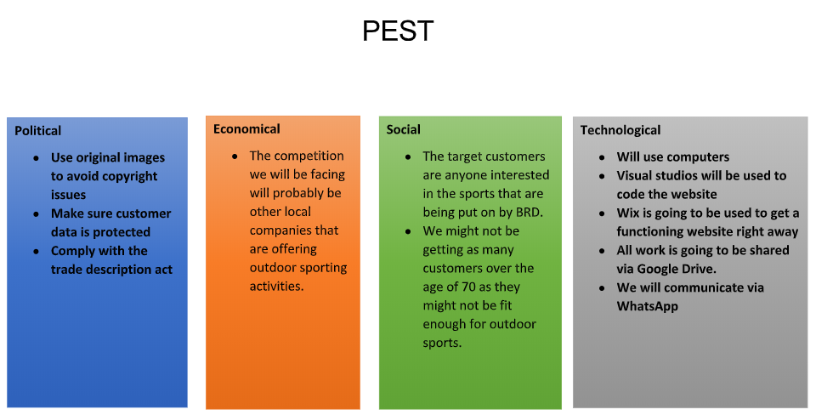

3.2) Design process
By researching, it was found out that One-Page websites were on the rise in terms of popularity due to the fact of them being relatively new, so initially this idea was set on.
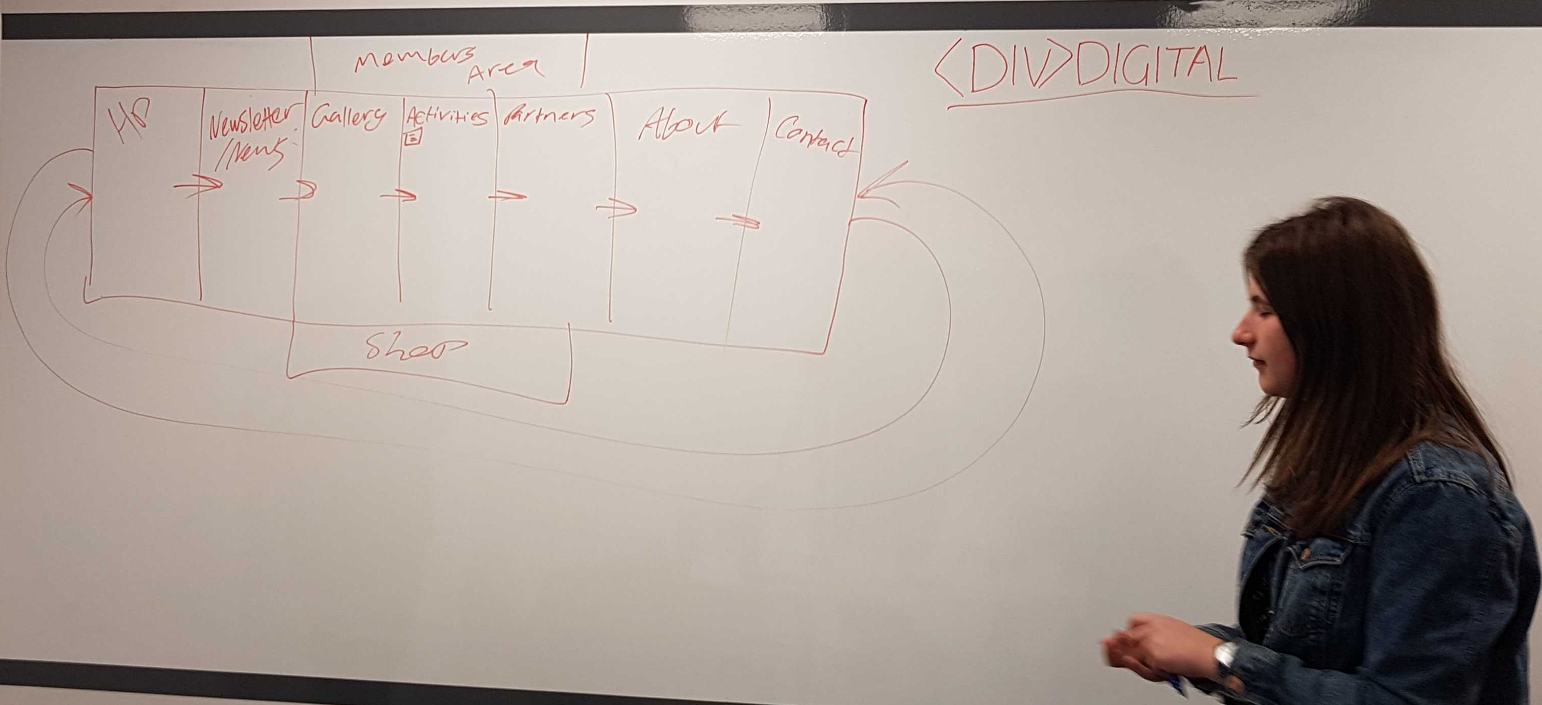
However, this idea changed. One of the aims of the prototype was to be able to view the website produced in VR, and one of the biggest features of VR is 360-Degree environment, so the idea was changed to a 360-degree website viewable on all platforms.
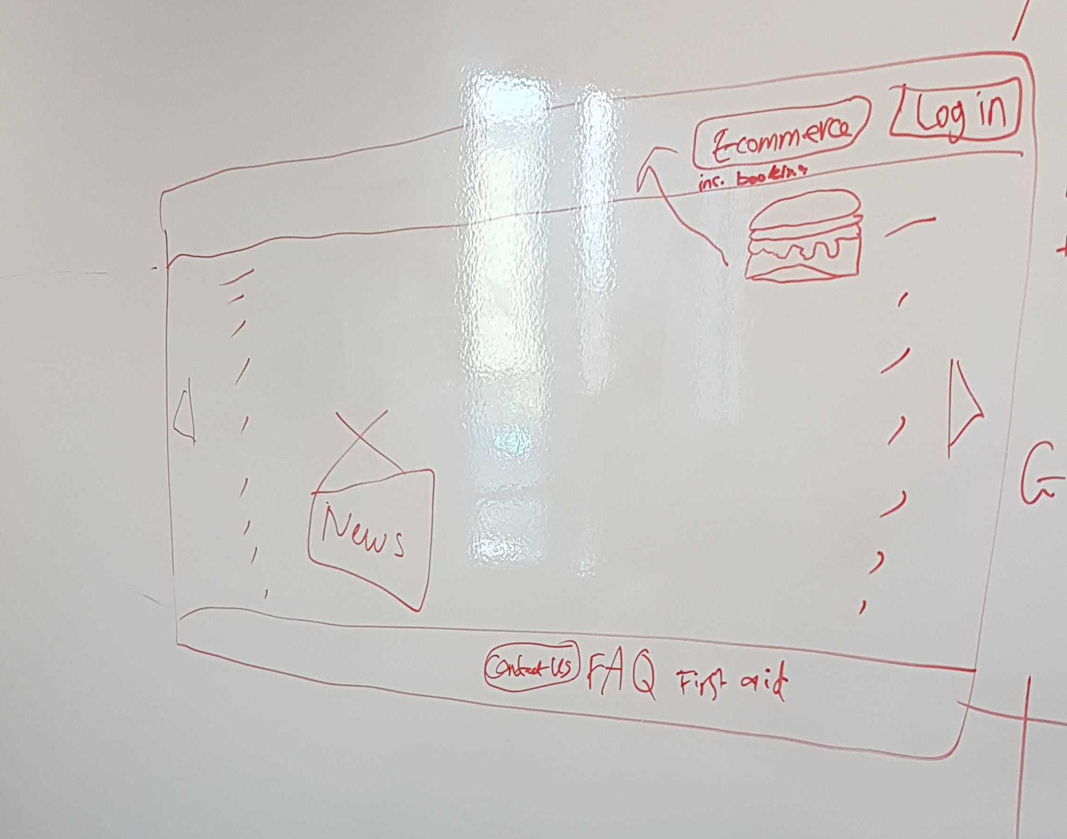

3.3) Prototype requirements
As the prototype is based on a website for a company (BRD Sports), the CEO had requirements they wanted for the website. The CEO, Ben Room specified that he wanted a member’s area with a loyalty points, an e-commerce shop, online session bookings and an online gallery. Ben himself takes a lot of photos and wanted to make sure a lot of them were displayed on the website.
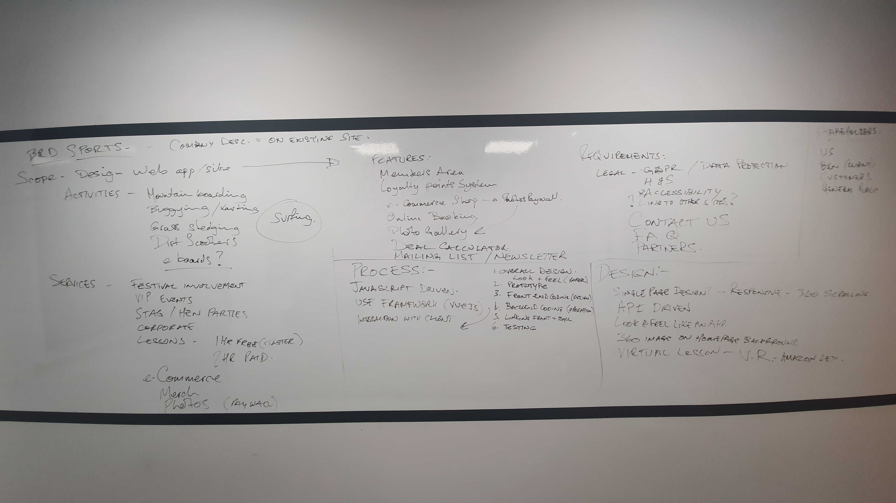
In terms of general requirements for the website, it needs to be responsive so that is viewable on any device and still looks visually pleasing. It also needs to be innovative, which is where the 360-Degree, Augmented Reality and VR aspect come in.

3.5) Front-End & Back-End Development
The group was split into different sides of development depending on each members strengths/weaknesses. The front-end is all about how to website looks to the users and the back-end is the functions of the website and making sure things work.

3.5.1) Front-End
As mentioned above, the front-end is all about making the website look good from a user’s standpoint. The idea is to have the website look visually pleasing so that it makes users want to use it as well as remember it. The front-end is also where the innovation comes into play, well at least the 360-degree and AR side of it. As you can see in the photos below, the website uses different 360-degree photos of the three primary sites that BRD Sports use for their business, and the + symbols on the screen are points users can click on for extra links.
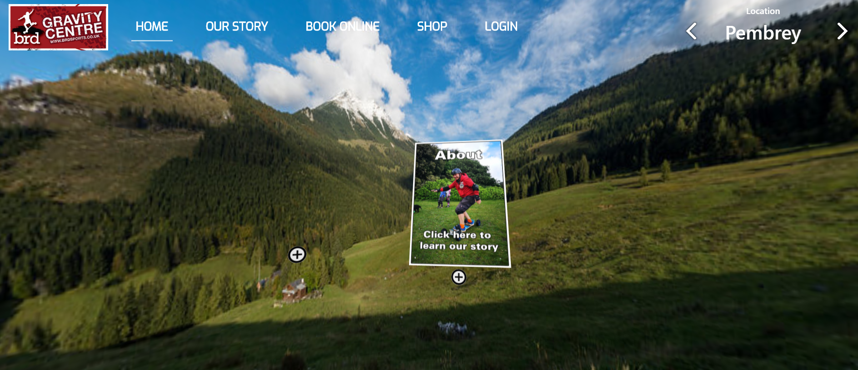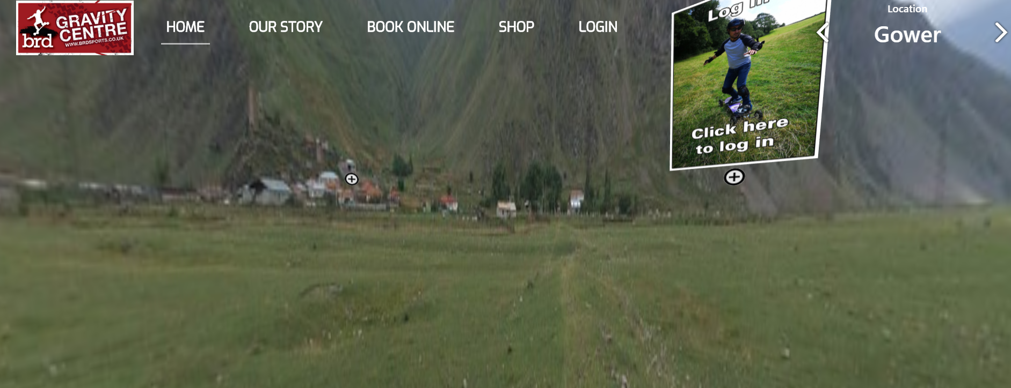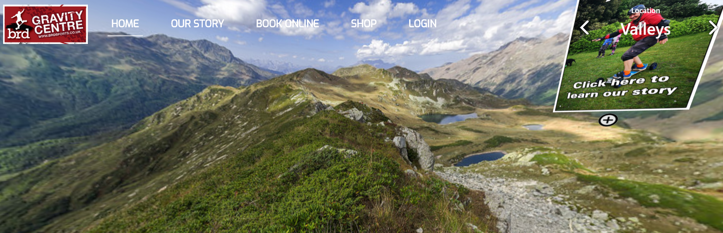
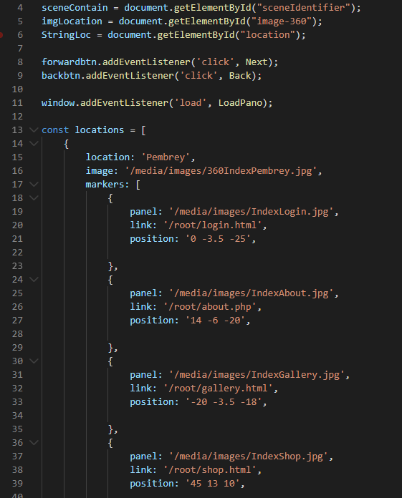
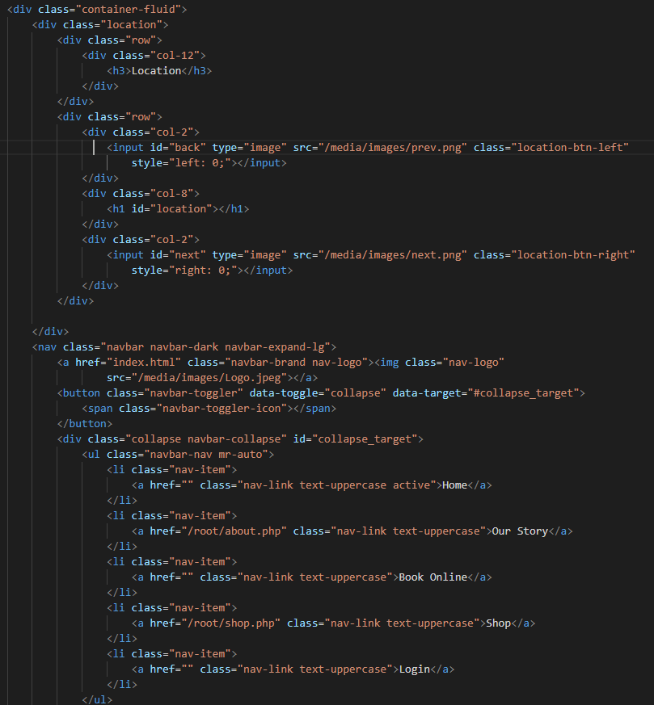

3.5.2) Back-End
The back-end of a website, it essentially the functionality of pages. Making sure users can login, purchase items from an e-commerce shop, and even basic code like making sure a button takes you to a specific page. The photos below are from the signup, login and payment pages respectfully, as well as the websites database, which is filled with test data.
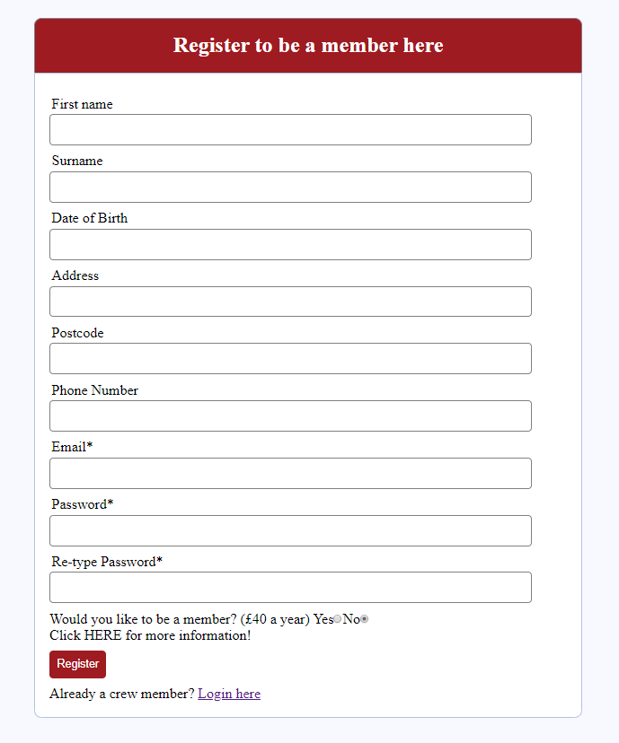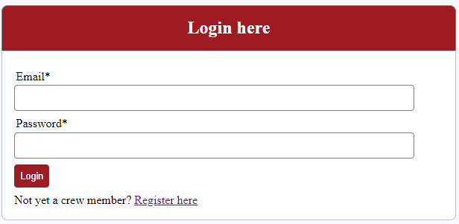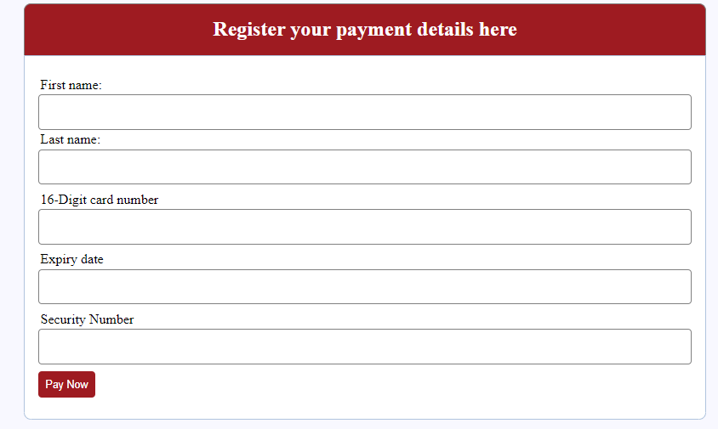
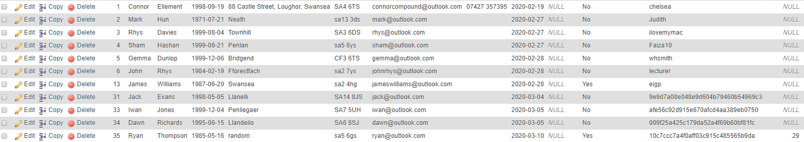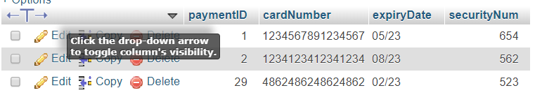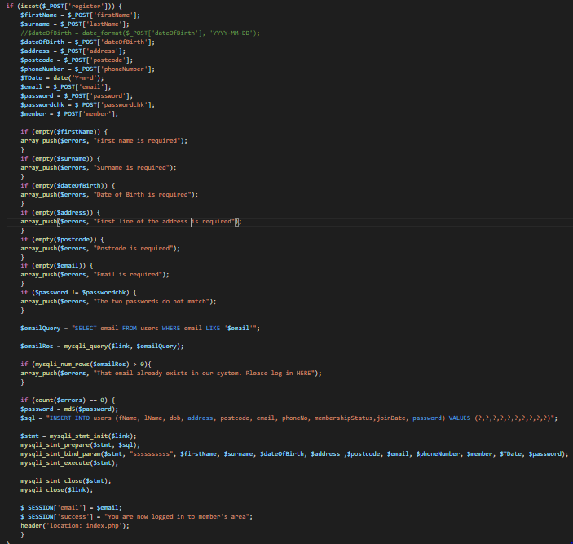

3.6) Personal Development
In the group, the author of this report was responsible for part of the back-end development. There was a realisation that the product would need databases for the websites, so the author took to learning the coding language PHP to be able to use it with HTML websites. The author created the Payment page, and a lot of the signup/login pages with help from a fellow team member, by collaborating and using their individual knowledge to solve the problems they faced.

References

[1] | IbisWorld, “Web Design Services Industry in the US - Market Research Report,” IbisWorld, Los Angeles, 2019.
[2] | D. Lynkova, “Website Design Industry Statistics: All You Need To Know In 2020,” techjury, 17 April 2019. [Online]. Available: https://techjury.net/stats-about/website-design-industry/#gref. [Accessed 05 03 2020].
[3] | D. Sloan, “Why hasn’t the web development market been platformized by DIY tools?,” medium.com, San Francisco, 2016.
[4] | “Web Design Statistics for 2017,” 08 January 2017. [Online]. Available: ironpaper.com/webintel/articles/web-design-statistics-2017/. [Accessed 13 March 2020].
[5] | N. Lanquetin, “Political and Social Issues,” University of Abertay Dundee, Dundee, 2006.

Appendix

5.1) Reflection
Throughout the length of this project, the author has improved his skills and knowledge ten folds. By working collaboratively as a team, team working, listening and communication skills have progressed well, which will help with finding employment when entering the working world. Business management skills have also been acquired via the learning of certain aspects of controlling a business and working with a team towards one goal, which will help if the author goes of to start their own business and self employment.

5.2) Networking
Below are photos from when a few members of Div Digital (and another separate group went to Cardiff for an Amazon Web Services meeting.
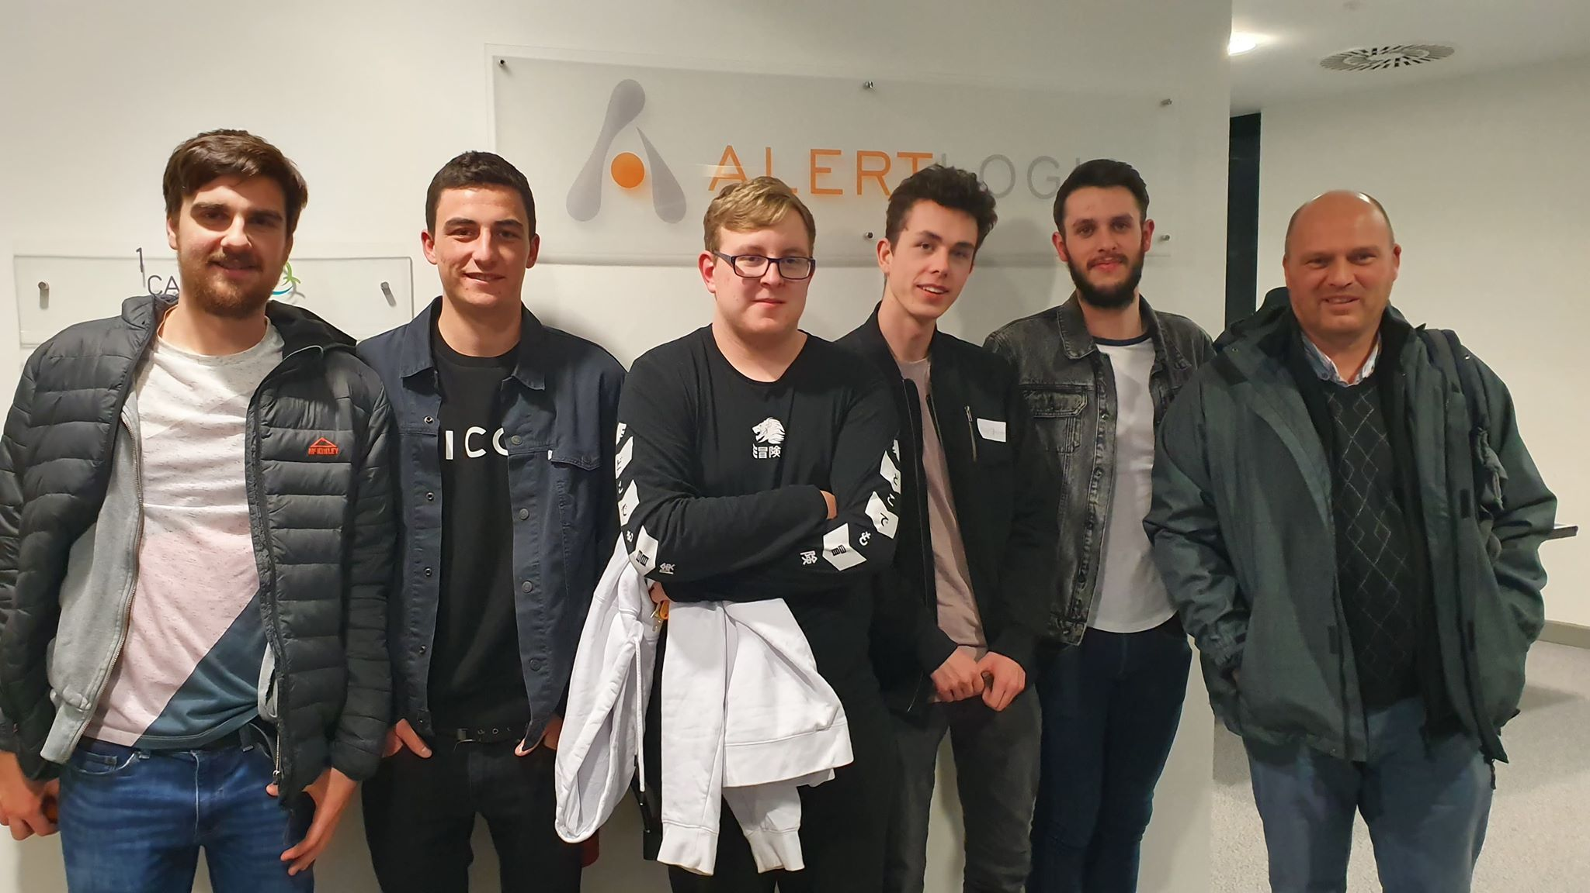
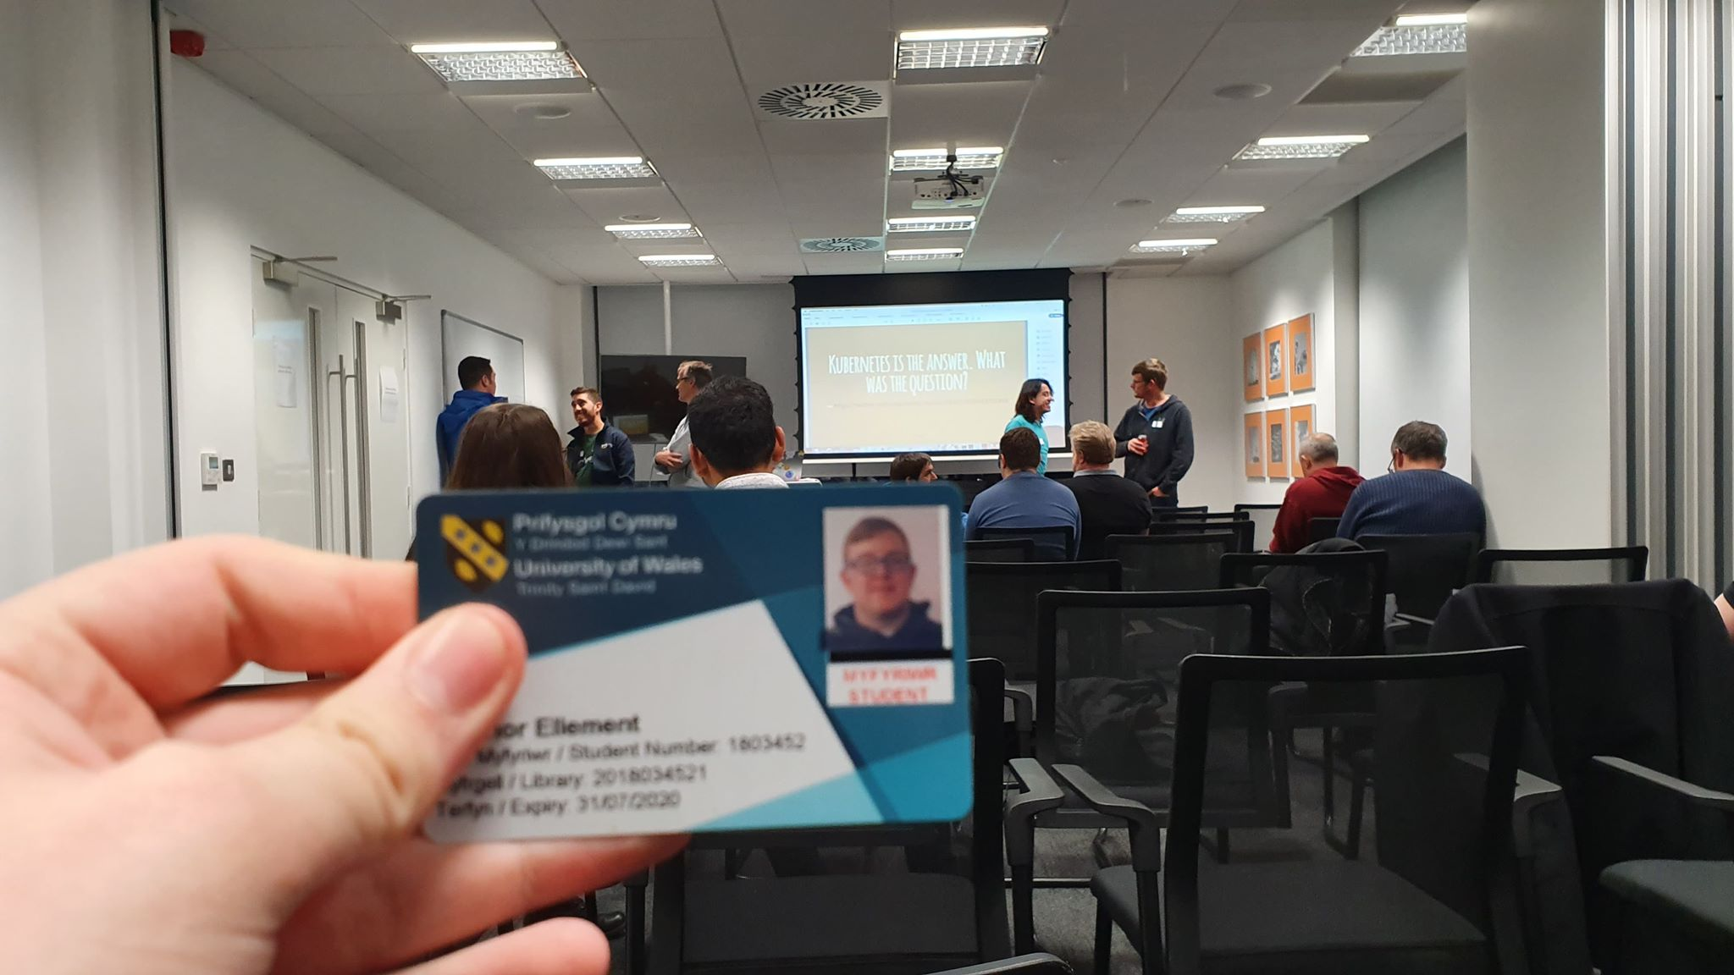

5.3) Team-working
------------------- TEAM PROGRESS SHEET -------------------------
Team Name: Diverse Digital
Team Member Names & Roles:
GD: Gemma Dunlop
MH: Mark Huntly
RD: Rhys Davies
IJ: Iwan Jones
CE: Connor Ellement
SH: Shamuel Hashan
------------ ---------- ----------- ------------- ------------- ------------ ----------- ------------
Weekly Progress report 1:
Date: 13/11/19
In-Attendance: GD, CE, SH. Apologies: MH, RD. Absent: IJ
Team Goals:
To create a innovative website for the company BRD Sports, meeting specifications and requirements stated by the CEO Ben Room.
> Individual Updates:
GD Update: Researching innovative web technologies to include in our website.x
CE Update: Has been studying other websites, similar to what Ben has asked of us, for ideas and design tips.
SH Update: Began on a rough mark-up on how the website will look.
> Team discussion:
We are very early into our project development and with various absences over previous weeks, we are a little behind where we should be. However, in the forthcoming weeks, we intend on making time to organise meetings at Uni to work on the bulk of the project.
> Individual Actions:
GD Actions: To find and choose a specific innovative web tech to implement
CE Actions: To have a list of features that we can include in the website along with who is best to implement them.
SH Actions: To have a completed mock-up of the website.

------------------- TEAM PROGRESS SHEET -------------------------
Team Name: Diverse Digital
Team Member Names & Roles:
GD: Gemma Dunlop
MH: Mark Huntly
RD: Rhys Davies
IJ: Iwan Jones
CE: Connor Ellement
SH: Shamuel Hashan
------------ ---------- ----------- ------------- ------------- ------------ ----------- ------------
Weekly Progress report 2:
Date: 20/11/19
In-Attendance: GD, CE, SH, MH, IJ, RD
Team Goals:
To create an innovative website for the company BRD Sports, meeting specifications and requirements stated by the CEO Ben Room.
> Individual Updates:
GD Update: Collected photos Ben wants on his website.
MH Update: Deciding on what the legal clarification of start-up our team wants to set up.
CE Update: Has been researching website applications and web development trends for ideas and design tips.
SH Update: Finished PEST analysis.
IJ Update: Thought up any design ideas for the website.
> Team discussion:
We have made sure everyone is clear about what Ben wants for his website, making sure everyone understands the task at hand and knows what they are doing for it.
> Individual Actions:
GD Actions: Organise the team and make sure our planning is complete.
CE Actions: Continue researching web development trends and finding ideas from other website applications.
SH Actions: To have a completed mock up of the website

------------------- TEAM PROGRESS SHEET -------------------------
Team Name: Diverse Digital
Team Member Names & Roles:
GD: Gemma Dunlop
MH: Mark Huntly
RD: Rhys Davies
IJ: Iwan Jones
CE: Connor Ellement
SH: Shamuel Hashan
------------ ---------- ----------- ------------- ------------- ------------ ----------- ------------
Weekly Progress report 3:
Date: 27/11/19
In-Attendance: GD, CE, SH, MH, IJ, RDC
Team Goals:
To create an innovative website for the company BRD Sports, meeting specifications and requirements stated by the CEO Ben Room.
> Individual Updates:
GD Update: Created a clear view of the design and content of the website.
MH Update: Researched into competitor mountain boarding companies.
CE Update: Researched other competitor website developers in our area, made initial template for the website.
SH Update: Created a few different versions of logos, documented in photos previous work.
RD Update: Began creating slogan, added design features to the website.
IJ Update: Contributed to design discussions.
> Team discussion:
We have created a main idea of the design for the website that we want to follow. We have worked as a group to create the presentation.
> Individual Actions:
GD Actions: Organise the team and make sure our planning is complete.
ALL- To complete specifically delegated slides for presentation

------------------- TEAM PROGRESS SHEET -------------------------
Team Name: Diverse Digital
Team Member Names & Roles:
GD: Gemma Dunlop
MH: Mark Huntly
RD: Rhys Davies
IJ: Iwan Jones
CE: Connor Ellement
SH: Shamuel Hashan
------------ ---------- ----------- ------------- ------------- ------------ ----------- ------------
Weekly Progress report 4:
Date: 11/12/19
In-Attendance: GD, CE, SH, MH, IJ, RDC
Team Goals:
To create an innovative website for the company BRD Sports, meeting specifications and requirements stated by the CEO Ben Room.
> Individual Updates:
GD Update: Started to look at design plan of the website.
MH Update: Started researching PHP and scroll functionality.
CE Update: Started creating design of prototype.
SH Update: Helped with the design of the prototype.
RD Update: Started researching 3js.
IJ Update: Started researching backend.
> Team discussion:
We mostly discussed the prototype and how we are going to design it, each giving our own individual input on ideas.
> Individual Actions:
GD Actions: Organise the team and make sure the planning is complete.
ALL- Work on the prototype

------------------- TEAM PROGRESS SHEET -------------------------
Team Name: Diverse Digital
Team Member Names & Roles:
GD: Gemma Dunlop
MH: Mark Huntly
RD: Rhys Davies
IJ: Iwan Jones
CE: Connor Ellement
SH: Shamuel Hashan
------------ ---------- ----------- ------------- ------------- ------------ ----------- ------------
Weekly Progress report 5:
Date: 18/12/19
In-Attendance: GD, CE, SH, MH, IJ, RDC
Team Goals:
To create an innovative website for the company BRD Sports, meeting specifications and requirements stated by the CEO Ben Room.
> Individual Updates:
GD Update: Discussed new ideas decided by Ben and how we are going to implement them.
MH Update: Organised a meeting with Ben to discuss updates on website. Explained meeting with Ben with rest of the group.
CE Update: Met with Ben to discuss the website.
SH Update: Wrote down new objectives of our website.
RD Update: Met with Ben to discuss the website.
IJ Update: Met with Ben to discuss the website.
> Team discussion:
We discussed Ben’s update on the website, including his approval of a 360-degree design and additional features he would like on the website.
> Individual Actions:
GD Actions: Organise the team and make sure the planning is complete.
ALL- Work on prototype.

------------------- TEAM PROGRESS SHEET -------------------------
Team Name: Diverse Digital
Team Member Names & Roles:
GD: Gemma Dunlop
MH: Mark Huntly
RD: Rhys Davies
IJ: Iwan Jones
CE: Connor Ellement
SH: Shamuel Hashan
------------ ---------- ----------- ------------- ------------- ------------ ----------- ------------
Weekly Progress report 6:
Date: 08/01/20
In-Attendance: GD, CE, SH, MH, IJ, RDC
Team Goals:
To create an innovative website for the company BRD Sports, meeting specifications and requirements stated by the CEO Ben Room.
> Individual Updates:
GD Update: Helped decide the features we need to include in the website.
MH Update: Started research on backend development and organising how to implement it.
CE Update: Discussed features we need to include in the website, including those which aren’t clearly shown on the prototype.
SH Update: Took notes during the meeting by recording features we want to use for the website.
RD Update: Started researching backend.
IJ Update: Started researching front end.
> Team discussion:
Discussed the features needed to be included on the website that have been approved by Ben.
> Individual Actions:
GD Actions: Organise the team and make sure the planning is complete.
ALL- Work on prototype.

------------------- TEAM PROGRESS SHEET -------------------------
Team Name: Diverse Digital
Team Member Names & Roles:
GD: Gemma Dunlop
MH: Mark Huntly
RD: Rhys Davies
IJ: Iwan Jones
CE: Connor Ellement
SH: Shamuel Hashan
------------ ---------- ----------- ------------- ------------- ------------ ----------- ------------
Weekly Progress report 7:
Date: 12/02/20
In-Attendance: GD, CE, SH, RD
Apologies: MH, IJ
Team Goals:
To create an innovative website for the company BRD Sports, meeting specifications and requirements stated by the CEO Ben Room.
> Individual Updates:
GD Update: Helped decide the features we need to include in the website.
MH Update: Started research on backend development and organising how to implement it.
CE Update: Discussed features we need to include in the website, including those which aren’t clearly shown on the prototype.
SH Update: Took notes during the meeting by recording features we want to use for the website.
RD Update: Started researching backend.
IJ Update: Started researching front end.
> Team discussion:
Discussed the features needed to be included on the website that have been approved by Ben.
> Individual Actions:
GD Actions: Organise the team and make sure the planning is complete.
ALL- Work on prototype.

------------------- TEAM PROGRESS SHEET -------------------------
Team Name: Diverse Digital
Team Member Names & Roles:
GD: Gemma Dunlop – Project manager
MH: Mark Huntly – Communications Liaison
RD: Rhys Davies – Full stack developer
IJ: Iwan Jones – Front end developer
CE: Connor Ellement – Back end developer
SH: Shamuel Hashan – Graphics designer
------------ ---------- ----------- ------------- ------------- ------------ ----------- ------------
Weekly Progress report 8:
Date: 26/02/20
In-Attendance: GD, MH, SH, RD
Apologies: CE, IJ
Team Goals:
To create an innovative website for the company BRD Sports, meeting specifications and requirements stated by the CEO Ben Room.
> Individual Updates:
GD Update: Created and runs the social media for the company. Started developing C#.
MH Update: Organised meetings with client. Started working on the database
CE Update: Started working on the database.
SH Update: Took notes during the meeting with client. Finished logo. Created some graphics for website. Helps run the social media
RD Update: Continued developing the front end. Started developing c# for the website. Created a discord server that allows us to work together and talk to each other.
IJ Update: Continued to develop the front end.
> Team discussion:
We had another meeting with Ben where we presented the 360 feature of the website and discussed the possibility for him to send more photos and some extra features he would like added to the website.
We also had a team meeting where discussed how the website will be developed and what all the members will need to do.
> Individual Actions:
GD Actions: Work on the C# for the website and work on the social media as well as managing the group.
SH Actions – Continue to produce graphics and post on the social media
IJ Actions – Continue to develop the about and login page
RD Actions – Continue to develop the website.
CE Actions – Develop the database
MH Actions - Develop the database

------------------- TEAM PROGRESS SHEET -------------------------
Team Name: Diverse Digital
Team Member Names & Roles:
GD: Gemma Dunlop – Project manager
MH: Mark Huntly – Communications Liaison
RD: Rhys Davies – Full stack developer
IJ: Iwan Jones – Front end developer
CE: Connor Ellement – Back end developer
SH: Shamuel Hashan – Graphics designer
------------ ---------- ----------- ------------- ------------- ------------ ----------- ------------
Weekly Progress report 9:
Date: 26/02/20
In-Attendance: GD, MH, SH, RD, CE
Apologies: IJ
Team Goals:
To create an innovative website for the company BRD Sports, meeting specifications and requirements stated by the CEO Ben Room.
> Individual Updates:
GD Update: Managing everything. Starting on div digital website.
MH Update: Doing backend of the website. Working on websites php. Working on Login Page. Helped sort out a sever for the webpage. Helped create the databases for the BRDsports website.
CE Update: Doing backend of the website. Working on the php and the log in page. Created the databases for the BRDsports website.
SH Update: Created some graphics for div digital. Interacting with potential customers. Managing marketing and social media.
RD Update: Continued developing the front end. Finished the home page, Working on shop page. Sorted out a server for the webpage.
IJ Update: Continued to develop the front end. Finished the about page.
> Team discussion:
We held a team meeting to look at everyone’s progress. We discussed the design of the BRDsports website.
> Individual Actions:
GD Actions: Work on the C# for the website and work on the social media as well as managing the group. Will continue to develop the div digital website.
SH Actions – Continue to produce graphics and post on the social media and work on marketing.
IJ Actions – Continue to develop the front end of the website
RD Actions – Continue to develop the website.
CE Actions – Continue to develop the database
MH Actions - Continue to develop the database

