ANALYSIS OF AN RLC NETWORK

17/11/24

ELETRICAL ENGINEERING

ACDA5001

RHYS JONES

DR.STALIN JACOBS
Contents

1.1 Abstract 3
2.1 Introduction 3
3.1 Background Information 3
4.1 Method 4
5.1 Results 6
6.1 Discussion 10
7.1 Conclusion 12
8.1 Refrences 13

1.1 Abstract

The work in this assignment is to produce an RLC circuit with power factor correction. There are 3 tasks in this work that have been done including calculating the power factor of the circuit, calculating the power factor correction of the circuit and finally how the circuit performs at resonance. The results show that at resonance the circuit becomes in phase and the current drops to its minimum value which in turn makes the impedance its maximum value due the cancellation of the reactive elements. The power factor correction worked as intended and shortened the time difference between the voltage and current making the system more efficient as the reactive elements reduced in the circuit.

2.1 Introduction

The task given was to create a RLC circuit in parallel and analyse how changing the values and input effects the components values. Some of the components were taken from our personal student numbers. Using all the information from the task description we can find the power factor and the capacitor value to give power factor correction and get a higher power factor. The source was a sine wave set at 300Vrms and 50Hz. The following report will elaborate on the calculation and the formulas used to find the resonance frequency and how the value of the capacitor changes the power factor.

3.1 Background Information

Alternating current is when electrons are constantly changing direction over time with changing magnitudes which is why it usually appears as a sinusoidal wave. An RLC circuit has a; resistor, inductor and a capacitor which can be connected in series or parallel. In a parallel circuit the current is split between the components evenly, while in a series circuit the current goes the components 1 after another [1]. The RLC circuit can be used in lots of ways and the most common of this is filtering circuits as a band pass filter which can block out unwanted frequencies which are used in radio transmitters and receivers. The power factor in the circuit can be calculated and tells us the phases of the current and voltages over the entire circuit and the individual components in the circuit. A power factor can never go above 1 as this means that the circuit is running as efficiently as possible, but this cannot happen in a real setting as energy will be lost to energy transfers in the circuit like heat which can build up in the wires. At resonance the circuit will have the highest impedance and the smallest amount of current because the reactance of the inductor and capacitor will be the same and will stop each other from affecting the circuit [2]. The maximum power transfer of power that can be used by a circuit is when the supply resistance is equal to the load resistance. If the resistance of the load is higher or lower than the supply resistance the power will always be less than the maximum power transfer of the circuit [3].

4.1 Method
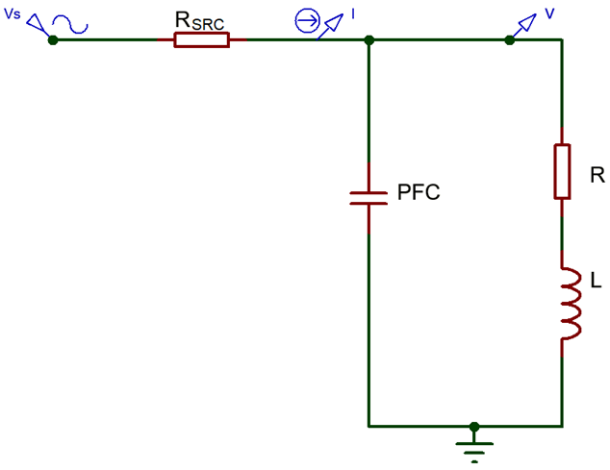
To start this assignment, we were given the circuit to the left (Figure 1). The values of the components came from our personal student number. For my component values I had
Figure 1
Rsrc = 2.4 Ω
Load inductor value = 199 mH
Load resistor value = 98 Ω
Along with these values we were told to connect the circuit to a 300Vrms and 50Hz sin wave source.

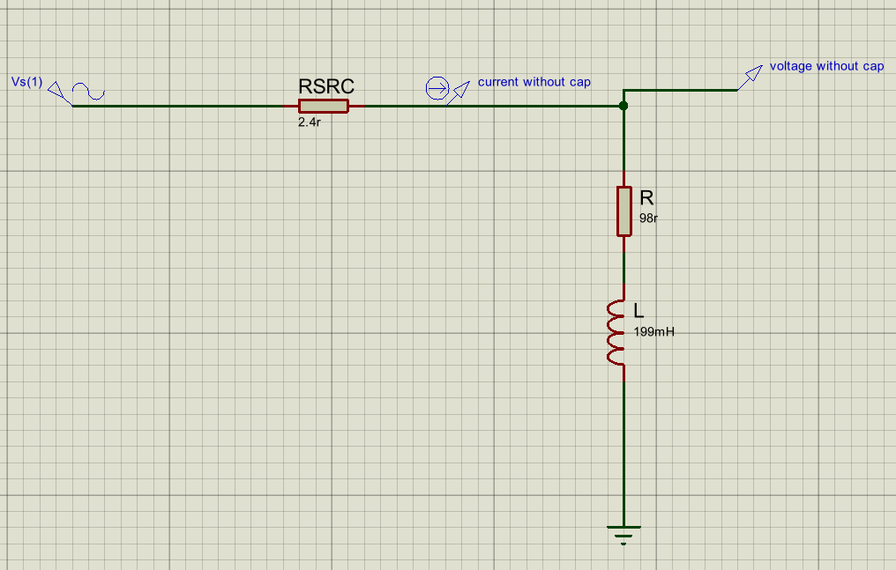
This is how the circuit looked before any power factor correction is applied to the circuit (Figure 2). This was the start of the assignment and from this a circuit with a power factor correction value of 0.95 can be made just by adding a capacitor into the circuit as shown in (Figure 1). With no capacitor in the circuit to correct the power factor we get a graph that looks like (Figure 3) which
Figure 2

shows the current and load voltage over time. The voltage is leading the current
as the current is being stored as magnetic energy in the inductor. The time difference between the voltage and current at this stage is 0.002 seconds.
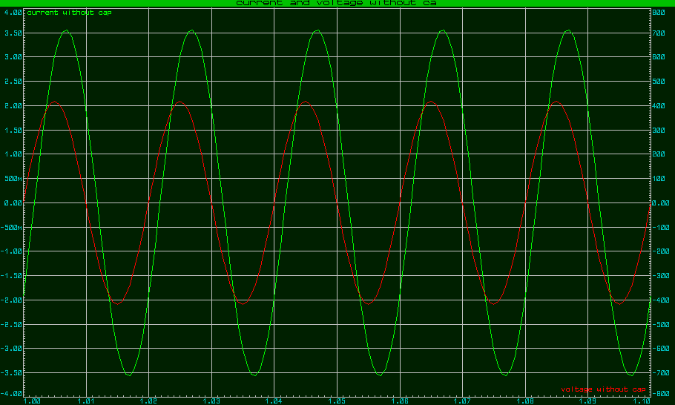
Figure 3
To find the correct value for the capacitor we would first need to calculate some other variables such as the impedance and the phase angle. First the calculation XL = 2πFL
was calculated to get the reactance of the inductor and the value of XL is 62.52Ω. Using the value of XL the value for the impedance can be calculated by $Z=\sqrt{R^{2}+X_{L}^{2}}$. The value of the impedance(Z) is found to be 116.24Ω. The phase angle can also be calculated with $ϕ=\tan^{-1}\left(\frac{X_{L}}{R}\right)$. The phase angle is calculated to be 32.54˚. With the phase angle being calculated we can find the; Active, Reactive & Apparent power for the circuit along with the power factor.
The calculations and the values calculated for the power triangle and the power factor can be found in (Figure 4).
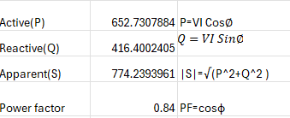
Figure 4

Next, we can do all the calculation for the capacitor itself. We need to have multiple elements to find the capacitor value like the new power factor. In (Figure 5) is all the calculation needed for the capacitance to be calculated with the formulas next to the values calculated. 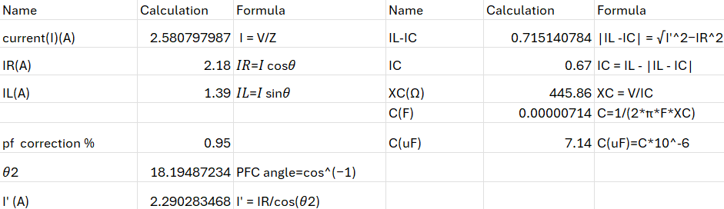
Figure 5

With the capacitor value calculated we can insert it into the circuit to get the new power factor and see how the voltage and current have been changed. With the capacitor we get the new circuit that looks like this (Figure 6) and gives us a power factor of 0.95.
Figure 6
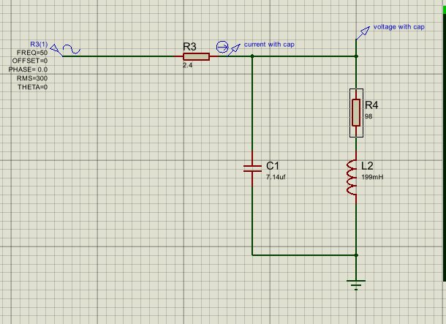

The phase difference between the voltage and current now is 0.001 seconds. The graph in (Figure 7) shows the relation between the voltage and current at 0.95 power factor. They aren’t expected to be in phase as there is still some
difference between the capacitor and inductor reactance.

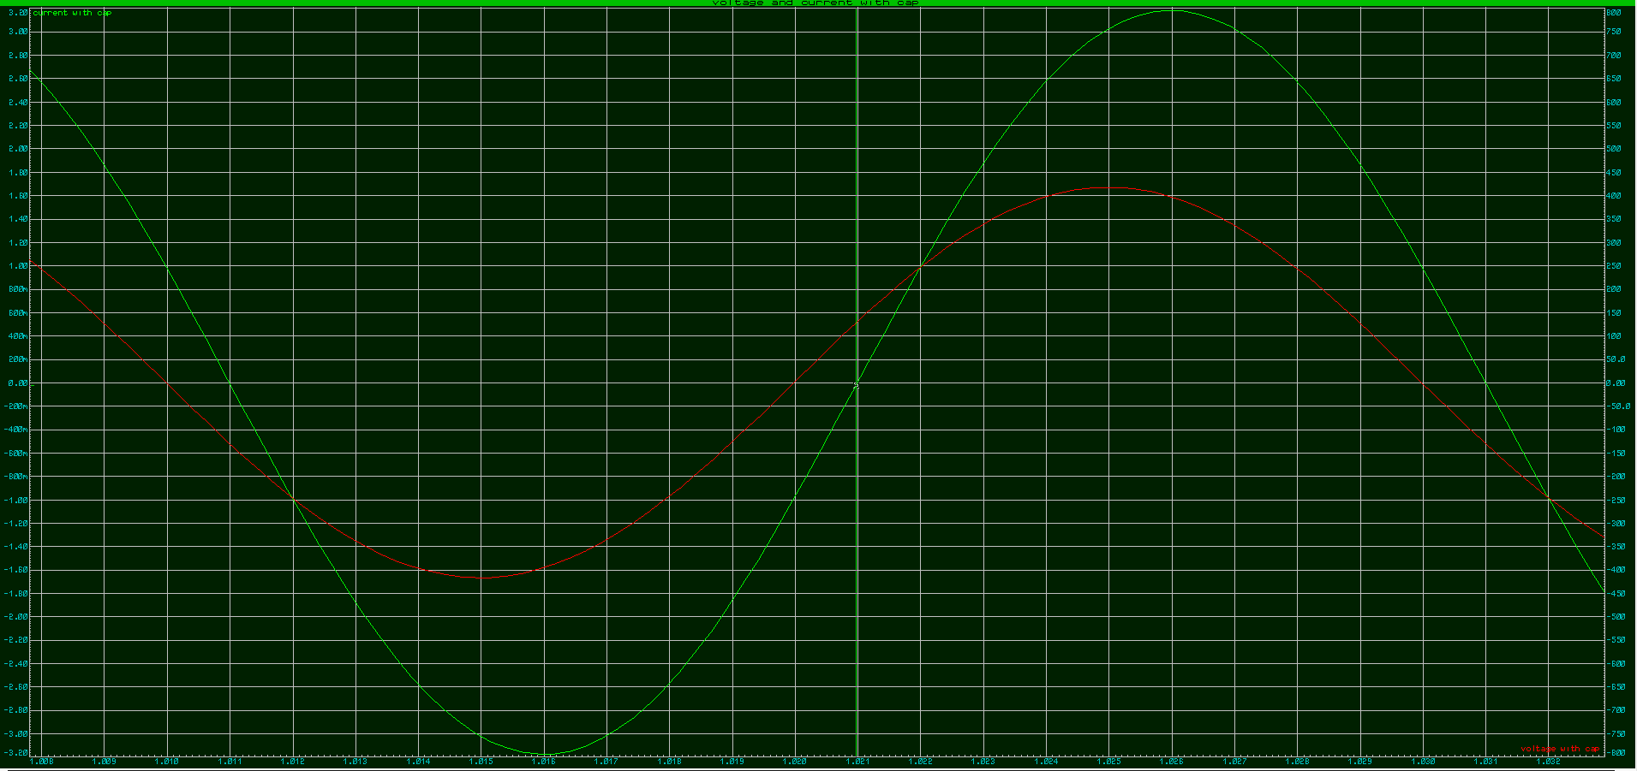
Figure 7

5.1 Results

The image below (Figure 8) is the phasor diagram for the circuit with the frequency being set at 50hz. Below is the voltage and current phase difference which is around 0.001 seconds time difference because of the capacitor bringing the phase angles closer together with a power factor of 0.95. The voltage leads the current as displayed in graph (Figure 9).
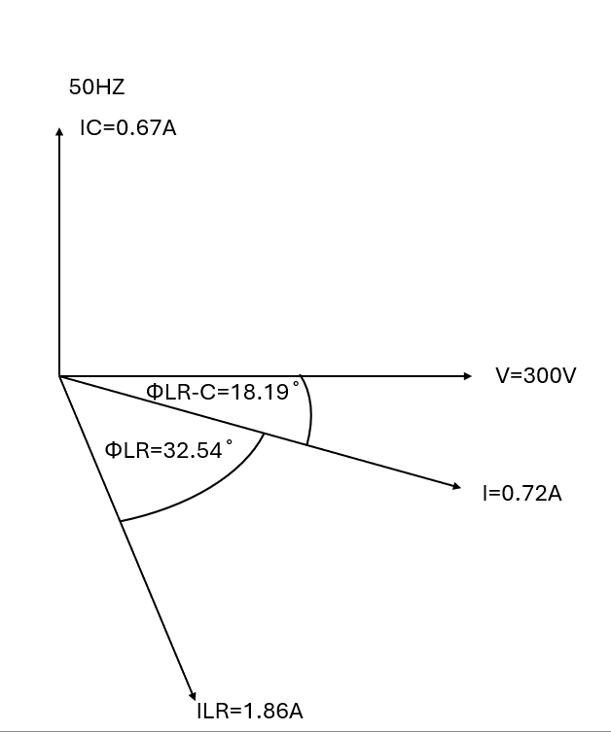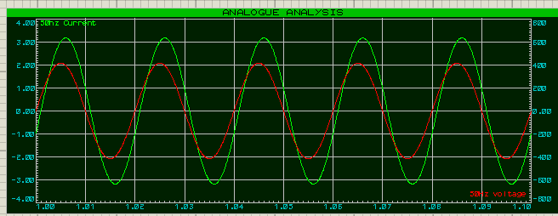
Figure 9
Figure 8

At 25hz below resonance the phases are closer together but aren’t in line because the reactance of the capacitance and inductance are not equal the impedance is getting closer to the maximum value which gives a smaller value of current because of the higher value of impedance. The phasor diagram shows the difference between the circuit without the capacitor vs when there is no capacitor in the circuit (Figure 10). The difference in phase angle between the voltage and current is now 0.0005 seconds. The voltage is leading the current in graph (Figure 11).

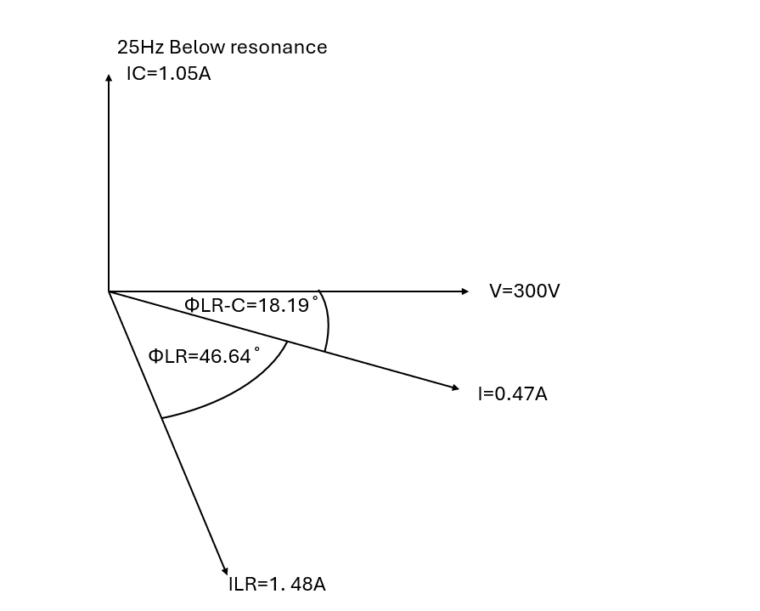
Figure 10
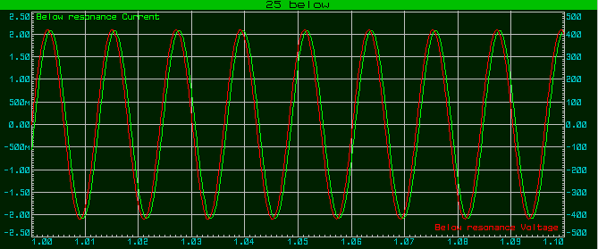
Figure 11

When the frequency is 25hz above resonance the current leads the voltage as the reactance of the capacitor and inductor is not equal the current leading is by having a larger capacitor reactance than inductor reactance (Figure 12). This has the same effect as when the 25hz is below resonance as the impedance is not at its maximum which means that the current cant be at its minimum. The current is leading the voltage by 0.0006 seconds this is not very noticeable but does influence the circuit (Figure 13).

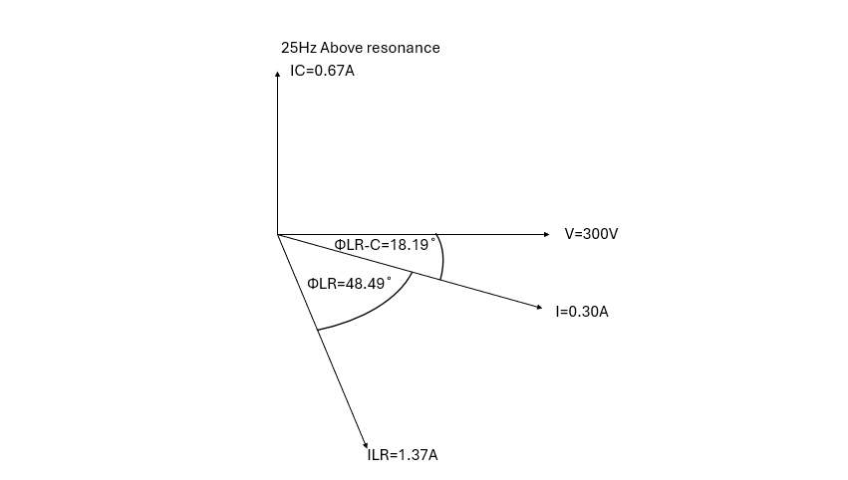
Figure 12

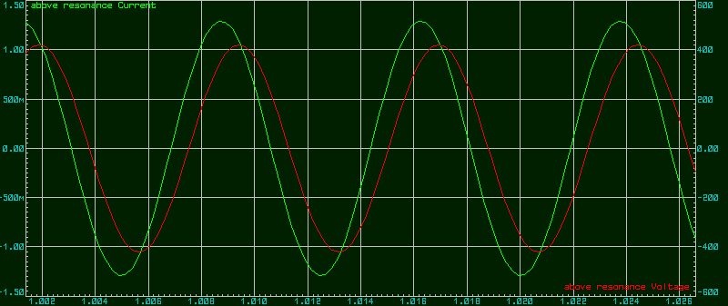
Figure 13

The final Circuit is the when the frequency is at resonance. To calculate the frequency for resonance the following calculation is used.

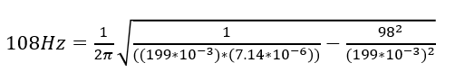

With this calculation the value of 133hz was found to be the resonance frequency this should mean that at this frequency the reactivity of the inductor and capacitor

is the same (Xl = Xc). This would make the circuit purely resistive and give us a maximum impedance and a minimum current (Figure 14). While the circuit is only resistive the voltage and current will be in phase this is because there is equal charging and discharging between the capacitor and inductor (Figure 15).

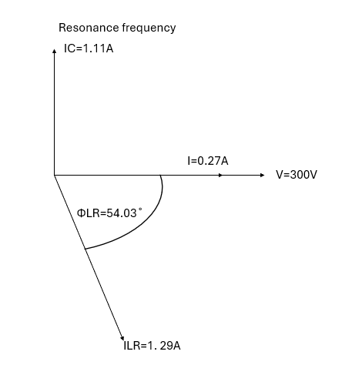
Figure 14
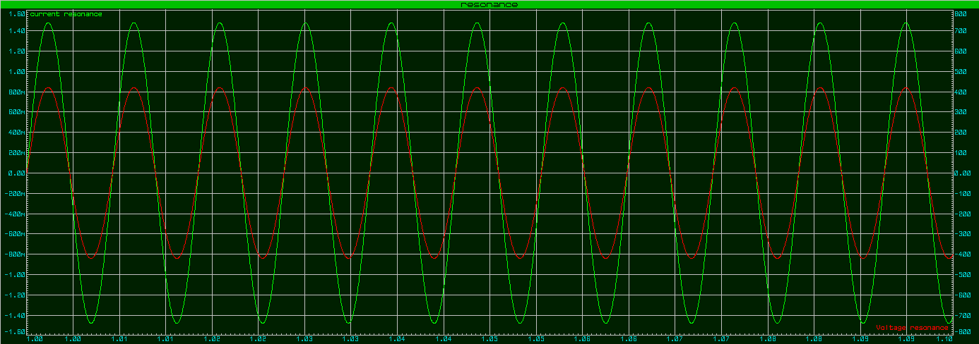
Figure 15

6.1 Discussion

The results from the circuits are as expected and the calculations prove this. At resonance the circuit has become purely resistive which means that XL and XC are equal this would mean that the discharging and charging cycle of the circuit is the same between both components. We can also see that the current is smaller than when at any other frequency. The maximum power transfer is achieved when at resonance for the same reason because of the reactive components cancelling each other the load resistance becomes equal to the resistance of the parallel resistance. The energy efficient of this circuit is efficient

because of the power factor being 0.95, this could be more efficient but not by a lot as it is impossible to get a power factor of 1 this is because energy will be lost to heat created by the circuit and from resistances in the wires themselves.

The Uk runs on three phases to transmit electricity this is because each phase is 120 degrees offset from each other and gives a smooth power delivery which is also very efficient. Going higher than 3 phases required massive infrastructure cost because of the extra wires and unnecessary complexity because of the increase of breaks and substations needed. Having more than 3 phases does create smoother ac waveforms again but would also not increase the efficiency by a lot to make it worth the cost of the infrastructure needed to create this new power delivery system. With 3 phases we can tap into a single phase, and this is how most homes in the UK have electricity delivered to them. Tapping into a single phase gives a voltage of 230V which is used by the consumer unit in houses and can give electricity to all lighting and sockets in a house. 3 Phase supplies are also very useful for industrial applications because of its capacity to handle high electrical loads and the efficiency and stability of it. There is no need for starting circuits with 3 phases as the three-phase induction is already there. Three phase induction motors are superior in every way to the single-phase motor of the same rating as they are simpler and more efficient due to the lower energy losses due to the balanced load distribution the three phases can deliver during transmission.

The term power factor is how efficient a circuit is by finding the ratio of useful power to the apparent power the circuit is being supplied with. The wasted energy is caused by reactive power and these desyncs the current and voltage in waveforms. When getting closer to 1 in power factor the less energy is wasted in transmission making the system more efficient. A low power factor leads to higher current and higher costs from energy companies due to the losses that will be occurred in the wiring. The way to solve this is with Power Factor Correction this brings the power factor closer to 1 and improved the electrical systems efficient by reducing the reactive power. With the better power factor the system capacity is increase because any losses that were happening have been reduced and this in turn stabilizes the voltages. The power factor can be shown to increase with the capacitor size but decrease when the capacitor size becomes to large for the circuit as shown in (Figure16)

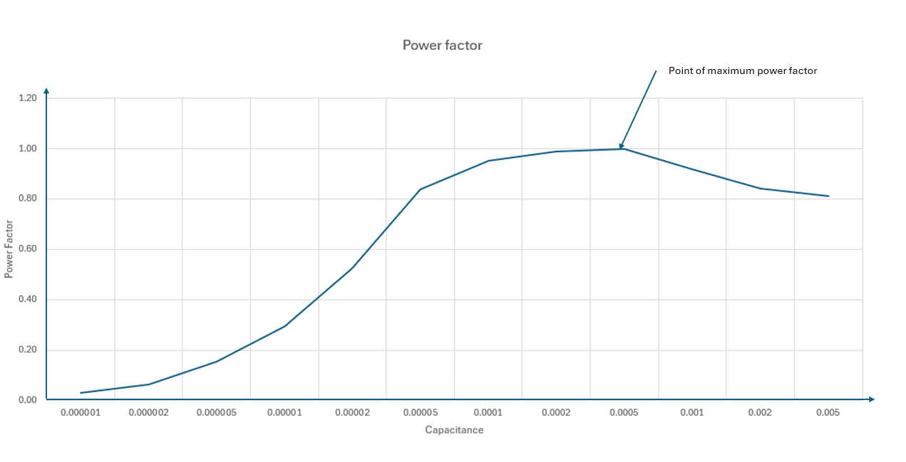
Figure 16

7.1 Conclusion

An RLC circuit is a very important piece of knowledge to have in electronics for its multiple uses such as being able to filter frequencies and in oscillators. The power factor of one of these circuits is highly important as the more efficient the circuit can be the less cost will be occurred due to less power being needed to power the circuit. When the circuit is at resonance the circuit becomes purely resistive and impedance is at its maximum this is a very useful as it becomes a rejector circuit that can block current at certain frequencies. I found that in certain branches of the circuit the current can be many times higher than in the source current which could lead to damaged components if not calculated correctly.

8.1 Refrences

References
[1] "RLC Circuit: Series and Parallel, Applied circuits." Tech Web. Accessed: 28/11 2025. [Online]. Available: https://techweb.rohm.com/product/circuit-design/electric-circuit-design/23194/
[2] Amna Ahmad. "Understanding Resonance In Parallel RLC Circuits." EE power. Accessed: 28/11 2025. [Online]. Available: https://eepower.com/technical-articles/understanding-resonance-in-parallel-rlc-circuits/#
[3] Tony R. Kuphaldt, Lessons In Electric Circuits, 5th Ed. Design Science License, 2006.

