Student name: Lisa Ellam
Student number: 2014962
Lecture name: Gillian Weaver
Module name: Introduction to Physiology
BMHP5003_BIRM
Assignment 1- Poster

Contents

- Title page…………………………………………………………………………………..
- Contents……………………………………………………………………………………
- Poster……………………………………………………………………………………....
- References…………………………………………………………………………….......
- Image references………………………………………………………………………….

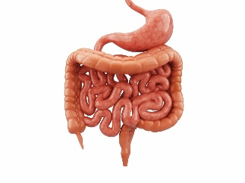
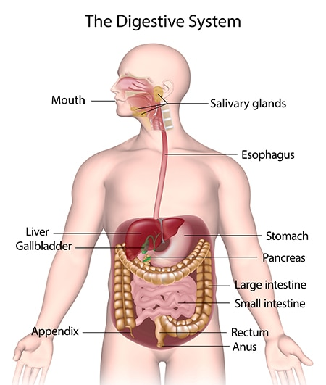
Structure
7
3

1
The Digestive system
(Li and Hu, 2023) The structure of the digestive system in the human body contains ten organs and ancillary glands, which create the GI Tract (Gastrointestinal Tract), and includes the following:
Oral cavity (mouth), Oropharynx, Esophagus, Stomach, Gallbladder, Small intestine, Large intestine, Rectum, Anal, Colon, Ancillary glands: Pancreas, Salivary and Liver.

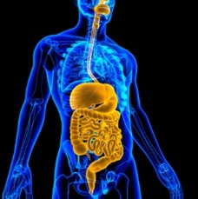
Function
(Kong and Singh, 2010) The pancreas produces a digestive fluid that contains enzymes and breaks fats, carbohydrates and proteins. Digestive juice is transferred to the small intestine through duct small tubes. (Housset and Chretien, 2016) The liver produces bile that helps digest fats, oils and vitamins. (Maldonado-Valderrama and Wilde, 2011) bile ducts transfer bile from the liver to the small intestine or to the gallbladder for later usage. The gallbladder stores and concentrates bile.
(Zoetendal and Raes, 2012) The small intestine absorbs most nutrients in food and mixes pancreatic fluid and bile to break down protein, carbohydrates, oils and fats. And absorbs water with nutrients. The small intestines transfer water from the blood into the GI Tract to help complete the food breakdown.
(Helander and Fandriks, 2014) The large intestine consist of three sections and transfers additional water from the GI tract into the bloodstream. Nutrients and vitamins such as Vitamins K’s and B’s are produced due to bacteria breakdown, and indigestible food becomes a stool.
(Flaviana and Monica, 2023) The colon is where water is reabsorbed from the food waste, and the rectum is where faeces are stored. Finally, food waste exists the body through the alimentary canal in the anus.

2
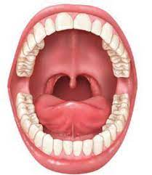
(Udavani and Wibawa, 2021) The progress/ function of the human digestive system begins in the mouth with mechanical digestion. (Gropper and Smith, 2013) The teeth break food into smaller pieces through chewing. Broken-down food is then mixed with saliva, that moistens food and contains a chemical enzyme- (Amylase) that breaks starches into glucose and carbohydrates into sugar, which the body can easily absorb.
(Pinto, 2010) when swallowing, the tongue pushes food into the throat, and the epiglottis (a small piece of tissue) covers the opening of the windpipe to prevent an individual from choking as food travels through the esophagus.
(Yu and Gail, 2014) the esophagus is a fibromuscular tube that connects the mouth and the stomach together and uses a muscular motion, peristalsis, to push food into the stomach. The lower esophageal sphincter opens to allow food to pass into the stomach, preventing food and chemicals from travelling back up the esophagus.
(Ferrua and Singh, 2010) The stomach is a muscular organ where gastric juices are mixed with food and liquid. The stomach breaks down protein to acids to kill and prevent harmful bacteria. The stomach gradually transfers waste into the small intestine.

5
\

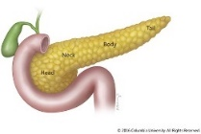
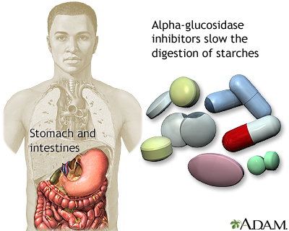
4
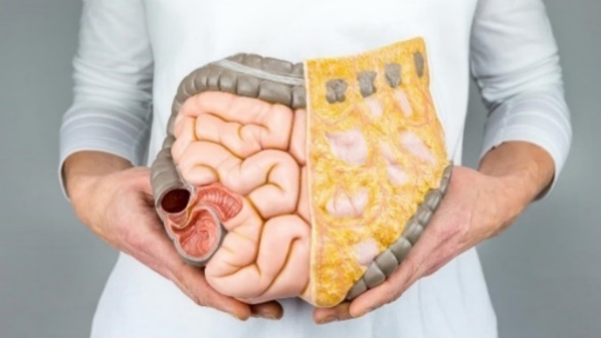
A health complication or problem which could occur within the digestive system is Diabetes. (Hikisz and Jacenik, 2023) Diabetes is a health condition that causes an individual's blood sugar to rise too high or too low, which could cause confusion, dizziness, nausea and vomiting, heart attack, kidney failure or death. There are three types of diabetes. They are known as type 1, where the body does not produce any insulin, a hormone that the body needs to transfer sugar from the bloodstream into the cells of the body. Type 2 diabetes is when the body can produce insulin but cannot transfer and use insulin efficiently. Gestational diabetes only occurs during pregnancy in women who did not have diabetes prior. Depending on the type, diabetes affects the regular movement of insulin in the bloodstream, which causes sugar to build up and harden, preventing essential nutrients from being absorbed.

Health problem

6
(Kim and Egan, 2008) Diabetes is managed through treatment and lifestyle changes such as insulin, medication, islet cells transplants, diet or exercise and monitoring sugar intake can be helpful.
References

Ferrua, M.J. and Singh, R.P., (2010) Modeling the fluid dynamics in a human stomach to gain insight of food digestion. Journal of food science, 75(7), pp.R151-R162.
Flaviana, C., Monica, P., Terenzio, C., Raffaele, M., Valentina, A., Giulia, C., Peter, V.E., Giorgio, L.N., Massimo, C., Ferdinando, C. and Germano, O., (2023) L1CAM expression in human gastrointestinal tract development: From tongue to colon-rectum. Journal of Public Health Research, 12(2), p.22799036231165624.
Gropper, S.S. and Smith, J.L., (2013) Advanced nutrition and human metabolism. Cengage Learning.
Helander, H.F. and Fändriks, L., (2014) Surface area of the digestive tract–revisited. Scandinavian journal of gastroenterology, 49(6), pp.681-689.
Housset, C., Chrétien, Y., Debray, D. and Chignard, N., (2016) Functions of the Gallbladder. Compr Physiol, 6(3), pp.1549-77.
Hikisz, P. and Jacenik, D., (2023) Diet as a Source of Acrolein: Molecular Basis of Aldehyde Biological Activity in Diabetes and Digestive System Diseases. International Journal of Molecular Sciences, 24(7), p.6579.
Kim, W. and Egan, J.M., (2008) The role of incretins in glucose homeostasis and diabetes treatment. Pharmacological reviews, 60(4), pp.470-512.
Kong, F. and Singh, R.P., (2010) A human gastric simulator (HGS) to study food digestion in human stomach. Journal of food science, 75(9), pp.E627-E635.
Li, C., Hu, Y., Li, S., Yi, X., Shao, S., Yu, W. and Li, E., (2023) Biological factors controlling starch digestibility in human digestive system. Food Science and Human Wellness, 12(2), pp.351-358. Li, C.,Hu, Y., Li, S., Yi, X., Shao, S., Yu, W. and Li, E., (2023) Biological factors controlling starch digestibility in human digestive system. Food Science and Human Wellness, 12(2), pp.351-358.
Maldonado-Valderrama, J., Wilde, P., Macierzanka, A. and Mackie, A., (2011) The role of bile salts in digestion. Advances in colloid and interface science, 165(1), pp.36-46.
Pinto, J.F., (2010) Site-specific drug delivery systems within the gastro-intestinal tract: from the mouth to the colon. International journal of pharmaceutics, 395(1-2), pp.44-52.
Udayani, N.K.R.T.K., Wibawa, I.M.C. and Rati, N.W., (2021) Development Of E-Comic Learning Media On The Topic Of The Human Digestive System. Journal of Education Technology, 5(3), pp.472-481.
Yu, G., Gail, M.H., Shi, J., Klepac-Ceraj, V., Paster, B.J., Dye, B.A., Wang, G.Q., Wei, W.Q., Fan, J.H., Qiao, Y.L. and Dawsey, S.M., (2014) Association between upper digestive tract microbiota and cancer-predisposing states in the esophagus and stomach. Cancer epidemiology, biomarkers & prevention, 23(5), pp.735-741.
Zoetendal, E.G., Raes, J., Van Den Bogert, B., Arumugam, M., Booijink, C.C., Troost, F.J., Bork, P., Wels, M., De Vos, W.M. and Kleerebezem, M., (2012) The human small intestinal microbiota is driven by rapid uptake and conversion of simple carbohydrates. The ISME journal, 6(7), pp.1415-1426.

Image reference

1. Type 2 diabetes Information | Mount Sinai - New York
2. Organs and Function of the Digestive System (verywellhealth.com)
3. Your Digestive System & How it Works - NIDDK (nih.gov)
4. digestive system pancreas - Google Search
5. G6_PSE_U7_L4_FLS.pdf (hdsb.org)
6. How Does Diabetes Affect the Digestive System? (everydayhealth.com)
7. Teaching About the Digestive System (carolina.com)

