Digital Strategy Development -Introduction of a Digitised Vision Assessment as Part of a Falls Reduction Strategy.

Introduction

The World Health Organisation (2021) identified falls as the second leading cause of deaths from unintentional injury. With an estimated 684,000 individuals dying and 37.3 million individuals requiring medical attention following a fall each year. The Office for Health Improvement and Disparities (2022) calculated that around 220,160 hospital admissions in England each year are associated with falls, with around a third of people over 65 and approximately half of people aged 80 or over falling at least once a year. Within Swansea Bay University Health Board (SBUHB), Darcy (2022) identifies the reduction of falls as a priority for improvement, citing 6220 inpatients fall in SBUHB, resulting in two deaths between 2019-2021.

The National Institute Clinical Excellence (NICE, 2013) published guidelines on the management of falls across England and Wales. This guidance introduced a new national priority of preventing falls in older people during a hospital stay. As part of the focus on reducing inpatient falls, NICE (2013) recommended that all hospital inpatients aged 65 or older and all hospital inpatients aged 50 to 64 who are identified as having a higher risk of falling are assessed for visual impairment as part of a multifactorial assessment to identify individual risk factors which can modified to reduce their falls risk.

The importance of assessing patients vision as part of a comprehensive multifactorial risk assessment is further supported by Public Health England (2017), they found that including a vision assessment could reduce the rate of falls by 24%, and the Royal College of Physicians (RCP), (2022) suggest that patients with poor vision fall twice as much as those with normal vision. RCP (2021a) as part of their statutory National Audit of Inpatient Falls (NAIF) across England and Wales found that vision assessments had been undertaken on 44% of patients who had fallen and sustained an injury, with 41% of those patients being assessed as having a visual impairment.

The RCP (2021a) identified the early detection and management of risk factors to tailor interventions as vital in reducing falls. From January 2022, the RCP (2017b) added a field to NIAF asking if the patient had a documented vision assessment. The RCP (2021b) state that this vision assessment must include questions relating to the use of visual aids as well as the simple testing of the patients’ distance and near vision.

The RCP (2017a) in collaboration with several organisations designed Look Out! Bedside Vision Check for falls prevention tool (BVC Tool). The RCP (2017b) identifies BVC Tool as providing a practical standardised solution to vision assessments for use by nurses, doctors and allied health professionals. They suggest that BVC Tool requires little training and is designed for use as part of a multi factorial falls assessment aiming to reduce inpatient trips and falls. This tool includes questions about visual aids, and incorporates a simple test of the patients’ distance and near vision. This is observed as being in excess of any current nursing documentation relating to vision in Wales.
The Welsh Government (2015) identifies a ‘Once for Wales’ approach which develops innovative digital solutions and sets national standards as a key enabler for transformational change. NHS England (2019) recognise the use of health information technology (HIT) as key to the NHS meeting it quality and safety targets. This once for Wales approach is evident in the transformation of nursing documentation which is taking place across Wales. The standardised inpatient multifactorial falls assessment tool forms the basis of an inpatient falls prevention plan and is completed on all patients within 6 hours of admission, Beadle, Pinkney and James (2018). The digital version of this document is held within Welsh Nursing Care Record (WNCR), on discharge a copy of the WNCR record is available in Welsh Clinical Portal (WCP) which is then accessible by any NHS Wales employee with a valid NHS Email account.

It is proposed that developing a digitised vision assessment tool which matches the data standards of the RCP (2017a) BVC Tool will enable health boards to meet the standards set out by NICE (2013), four options will be explored-

- Commission the development of a stand-alone digital vision assessment tool for SBUHB use.
- Purchase an off the shelf digital vision assessment tool.
- Develop an All Wales Vision Assessment tool within –
    - The WNCR Project.
    - The WCP Project.

Method
In order to establish the current situation throughout Wales a Gap Analysis (see figure 1) was undertaken with data collated to establish where we are now, where we want to be, and to analyse the gap between both as well as gathering any technical requirements-

- Current Documentation
The Quality and safety team, frailty teams and falls team for SBUHB were contacted to establish the use of vision assessments as part of a multi factorial falls assessment. An audit of forty sets of SBUHBs digital and paper nursing documentation was undertaken to establish compliance with the current vision assessment contained within nursing documentation. To understand the Wales wide picture, the informatics nursing teams from all other Welsh Health Boards and Digital Health Care Wales were contacted to establish the existence or plans for future development of a paper or digital tool vision assessment tool for nursing staff.

- Literature Search
To establish the feasibility of introducing a digital vision assessment tool a computerised literature search of electronic databases was performed, it was limited to literature published between 2016-2022. An initial search of title and abstract using the keywords Nursing and vision assessment in PubMed accessed via Medline found 39 documents, a further search of Science Direct found 149 articles using the same search criteria. An iteration of the key words using falls and vision tool, digital eye test and nursing found no further relevant articles, on review all articles were discounted as irrelevant.

- Existing Digital Platforms and Hardware
To establish the requirements for interoperability and availability of hardware, the Clinical informatics nursing teams from each health board were asked about existing digital systems and go live plans with WNCR and WCP within their heath boards, as well as details about the types of digital hardware they had available to them.
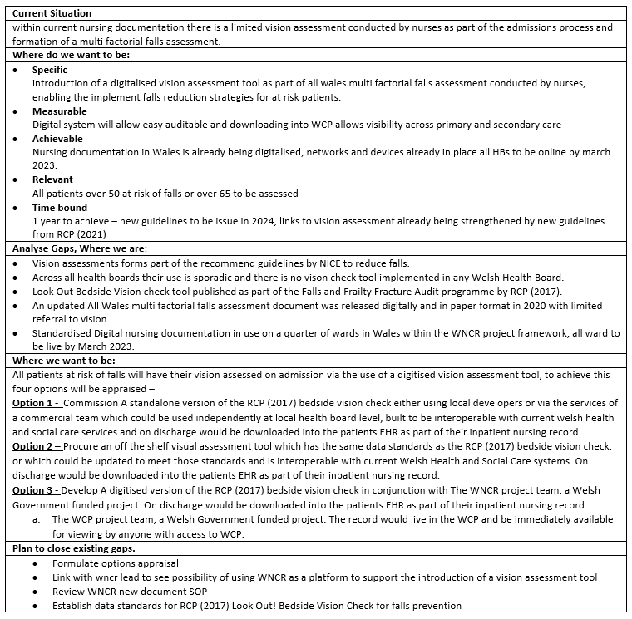
Figure 1 – GAP Analysis

- Existing Tools
Discussions with Digital Health Ecosystem Wales (DHEW), described by DHCW (2022) as providing the infrastructure for digital innovations in Wales, established no pre-existing work had been undertaken on a vision assessment tool and provided several methods to establish funding, DHEW were also able to provide support with developing ideas, research and development and helping to scale up or sell projects, as well as access to the NHS Wales architecture and application programming interfaces (APIs) to enable access to national digital systems.

A search of the NHS Wales (2022) data dictionary revealed that the only data standards relating to vision for adult inpatients related to the existing multifactorial falls assessment, thus new standards would need to be established to enable the standardisation of the vision assessment tool.

- Users Story
Scaled Agile (2021) describe the use of user stories as a primary means of expressing needed functionality, replacing the traditional requirement specification. Whilst, Visual Paradigm (2022) define a user’s story as a tool used to capture a description of software features from the end users’ perspective which describes the type of users, what they want and why, enabling developers to better understand the needs of the end-user. To establish user stories end users were sent an email explaining the purpose of the user story with structured question for completion - as a (ROLE) I want to (ACTION) so that (BENEFIT) for completion.

Results

- Existing documentation on vision and fall
Within current nursing documentation the multifactorial falls assessment contains a limited assessment of vision, as illustrated in figure 2 and does not include simple testing of the patients’ distance and near vision.
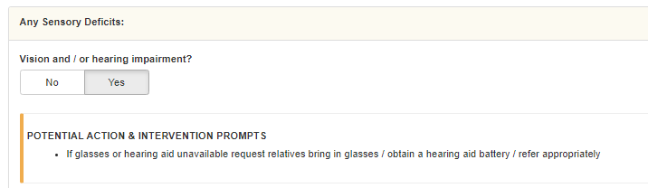
Figure 2 –Multifactorial Falls Assessment, WNCR SWOT Analysis

Within SBUHB it was confirmed that the assessment of vision is referred to in the local falls prevention policy, however, there is no visions assessment tool in use. Compliance with the existing vision assessment locally was good, and above the national standard of 44%, RCP (2021b), with 74% of patients having the vision assessed on admission.

Feedback from across Wales reflected the local position, with an awareness of the need to implement the tool as part of a multi factorial falls assessment. The WNCR team confirmed that BVC Tool as something which had been on their agenda for future development and something they would be happy to support.

- Existing Digital Platforms and Hardware
The informatics nursing teams confirmed they had a mixture of hand held, mobile and static digital devices available for use on all wards. Within SBUHB some areas had chosen to have only mobile and static devices so would need the redistribution of devices to ensure at least one hand held device was available on each ward. Across Wales multiple digital systems, in house and nationally developed were found to be in use. There was commonality with WCP and WNCR in use or planned for use by all health boards by the end of this financial year.

- Existing Tools
An internet search for grey literature to identify exiting digital eye assessments found multiple webpages and apps to assess vision. These were mainly designed use by the general public. One validated tool was found, Rowe et al. (2018) developed a Vision Screening Assessment Tool (VISA) in conjunction with the University of Liverpool. This tool was designed to screen for visual problems post neurological events, and whilst it was unsuitable for a use as part of a falls assessment, it provided evidence that a vison tool had been successfully implemented in a digital format, with Rowe et al. (2020) finding the tool worked effectively and integrating well within acute care settings.

- Users Story
Replies to request for user stories were correlated and the following stories complied -
- As a nurse either substantive staff or temporary staff I want to be able to access the vision assessment tool easily. I want it to automatically update WNCR and reduce duplication, to enable the formation of a multifactorial falls assessment and action plan. I want the system to prompt me to complete the assessment if my patient is over 50 and at risk of falls. I also want autonomy to complete this assessment if the patient is under that age. This should form part of the patient’s permanent record

- As a medic or allied health professional I want to be able to access the vision assessment tool and to be able to easily view a completed vision assessment. I also want the ability to complete the assessment tool.

- As a ward manager or matron, I want to be able to audit the tool and see who completed it, when it was completed and if any sections have been omitted or changed. I want the tool to send an alert to our electronic whiteboards to inform staff if the patient is deemed at risk of falls.

- As the lead on quality and safety and falls prevention I want to be able to extract data which illustrates how many patients had vision assessments completed as part of a falls assessments, how many patients were assessed as having visual impairment and who had a multifactorial falls action plan implemented in order to reduce the risk of falls. I also want to audit non-compliance with the tool and subsequent falls.

Digital Technology Requirements
Requirements of a digital system were compiled based on users’ stories, observations from working with NHS Wales digital systems and the requirements of the tool -
Functional requirements
- Intuitive user interface that requires little or no training
- Ability to import demographic information from Welsh Patient Administration System (WPAS) and WCP
- Accessed via NHS Wales login and have the ability to provide temporary user access
- Tool must be able to contain both text and images.
- Ability to alert if vision assessment has not been completed
- Have the ability to print an assessment
- Users should be able to reuse the vision assessment tool as part of a multifactorial falls assessment if readmitted with set time
- Ability to lock the assessment on discharge
- Has the ability to support pop up hints and tips to aid completion
- Built in Spell check
- Should have the ability to save in draft if assessment is not fully completed.

The Non-functional requirements
Non-functional requirements were adapted from the non-functional requirements for WNCR, as described by the projects principle digital architect, Kennedy (2022).
• Usability – should be device agnostic, developed for use on handheld devices, mobile devices and desktop PCs with the ability to adapt to different screen sizes and maintain functionality through the use of responsive design programme, such as use Bootstrap UI framework to lock the size and ensure the tool is displayed at the right zoom.
• Availability – application should be deployed across multiple servers and ideally two data centres to allow back up storage if there is system outage.
• Reliability – the tool should be reliable and have a plan for business continuity in the event of system down time.
• Recoverability – backed up on two servers, with the use of transaction logs to prevent data loss.
• Scalability – regular maintenance and testing of servers to ensure the database storing the tool is optimised.
• Performance – the tool should perform in real time with no time delay between opening and storing assessments.
• Supportability – dedicated support team 8-4, 7 days a week, with the ability to log a call out of hours.
• Security – have a designated active user directory to ensure only authorised NHS Wales accounts have access, only elevated accounts should be able to make changes to the active user directory. Must meet the standards set out by Welsh Government (2017) on cyber security, including regular penetration tests to ensure protection from cyber-attack.
• Capacity – designed for use by 1000s of users, with the ability to store 100,000s of assessments.

Technical Standards
- Must have interoperability with existing NHS Wales digital systems and Digital Architecture
- An API should be available to allow communication with local health boards in-house systems.
- Must use SNOWMED CT terminology
- Must use open source data enabling future iterations of the software
- Must be able to meet the medical and legal requirements for documentation as set out by the Nursing and Midwifery council and the Royal College of Nursing

Data Collection and Analysis
Should support audits, investigations and quality assurance –
- Daily report at 8.30 am showing completion of the tool for each patient.
- Monthly high level report on the 1st of each months detailing how many assessments completed over the reporting period compared to patients admitted per ward.
- Ability to extract bespoke ad hoc reports allowing all data relevant to falls to be pulled together in a falls report for each patient or ward.

Knowledge Management
- A record on discharge should be stored in the national data repository (NDR) and be viewable in WCP.
- Should use cloud storage with regular release of data to individual health boards data warehouses.

Options Appraisal

In order to make a procurement decision an option appraisal was undertaken to establish if are there better ways to achieve the objective, better ways to uses NHS resources or a better way to achieve the desired outcome. Local Partnerships (2021) a government and treasury body identify ten key steps to an options appraisal, which have been used to formulate the following appraisal–
- Identify strategic need
The strategic need for the service is established within the NICE (2013) guidelines and further supported by RCP (2017b) audit requirements.

- Key objectives
The key objective is the introduction of a digitised vision of RCP (2017A) BVC Tool, which is available to nursing, medical and allied health professionals

- Establish the level of risk and control your authority may be willing or able to transfer.
Nationally Wales is standardising documentation, the corporate team in SBUHB encourage all new developments to be part of the wider national developments with the support of Digital Health Care Wales.

- Identify the different options available to you –

Option 1 - Commission A standalone version of the RCP (2017a) BVC Tool either using local developers or via the services of a commercial team which could be used independently at local health board level, built to be interoperable with current welsh health and social care services, downloaded on discharge into the patients EHR.
Option 2 – Procure an off the shelf visual assessment tool which meets the data standards established for the RCP (2017a) BVC Tool, and is interoperable with current Welsh Health and Social Care systems. On discharge would be downloaded into the patients HER.
Option 3 - Develop A digitised version of the RCP (2017a) BVC Tool in conjunction with
- The WNCR project team, a Welsh Government funded project. On discharge would be downloaded into the patients EHR as part of their inpatient nursing record.
- The WCP project team, a Welsh Government funded project. The record would live in the WCP and be immediately available for viewing by anyone with access to WCP.

- Who will undertake the options appraisal?
Options appraisal to be undertaken by Nursing and Midwifery Board in conjunction with the corporate nursing team.

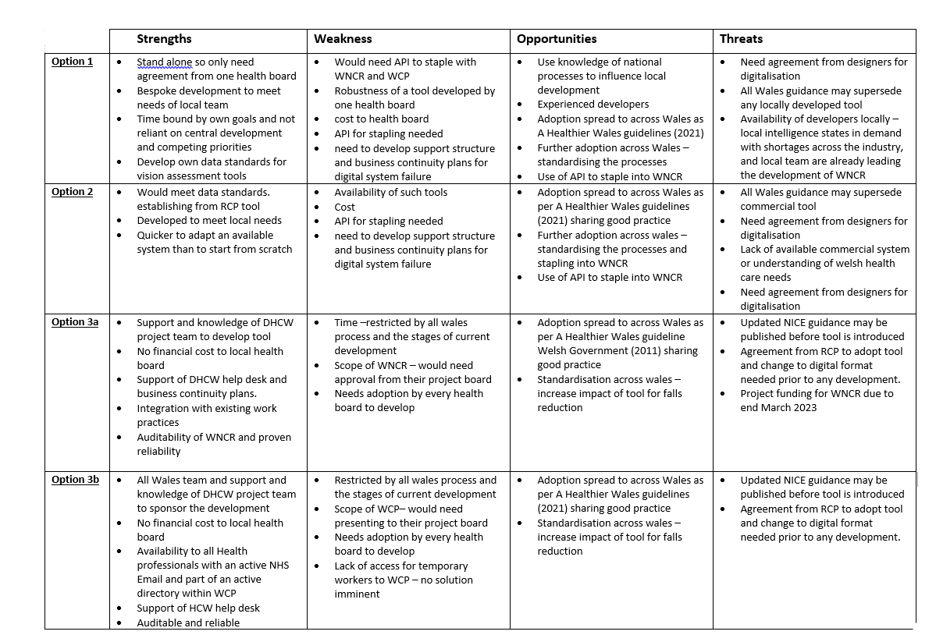
Figure 3 –SWOT Analysis

- Develop the evaluation criteria
An Evaluation Criteria was established for the development of a minimally viable product, table 1 –
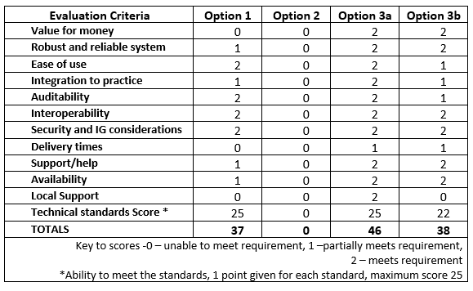
Table 1 – Evaluation Criteria Score Chart

- Gather information you need to inform your assessment
A swot analysis of the four options as proposed from the gap Analysis was undertaken, see Figure 3.
- Conduct the high level options appraisal
Using the results of the gap analysis, evaluation criteria scores, user stories and evaluating the SWOT analysis, a high level options appraisal was conducted –
- Option 2 – no suitable system found, no support from local health board.
- Options 1 – no support from corporate team, unlikely to receive funding or support at board level.
- Option 3b – good score, however temporary workers are unable to access WCP. It has been observed that the nursing workforce is currently being heavily subsidised with temporary workers, accounting for upto 50% of the total workforce in some areas, doesn’t not work well on smaller devices, this option is not feasible.
- Option 3a –highest score, primarily nursing system but access is available to allied health professionals and doctors. Can be used by temporary workers. Live access in WNCR with audit trail, viewable in WCP on discharge. Centrally funded and supported by DHCW. Development supported by WNCR project leads– will form part of the WNCR business plan for 2023/24.

- Identify a short list of options.
Options 3 recommended for adoption

- Determine next steps – Business Case
The project would be presented to the WNCR National Project Board for acceptance within their business plan for 2023/24.

Discussion

The findings from the Options Appraisal identify the introduction of RCP(2017a) BCV Tool as part of WNCR as the preferred option. This would provide a Wales wide solution, something which is supported by the Welsh Government (2021), who identify the ability to spread good practice to national level as vital in achieving their vision of a whole systems approach to health and social care.

WNCR was released as Minimum Viable Product in April 2021 and has since been developed and updated to meet the needs of nurses in Wales, Pinkney (2022). The project has experienced national and local teams in place to aid design and development, with rigorous testing of the system in SIT and UAT by developers, digital teams and informatics nurses.

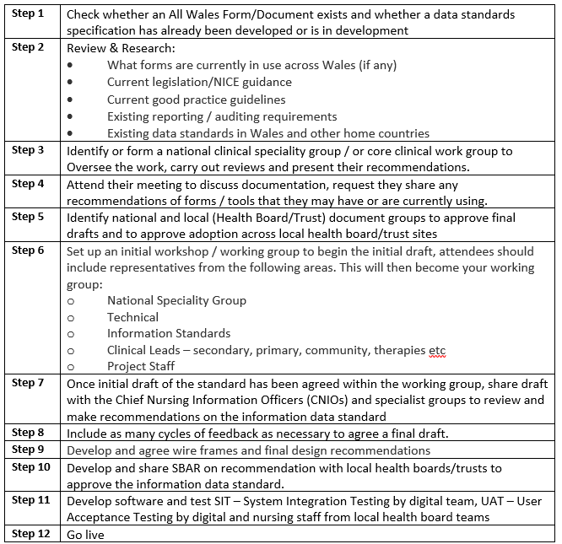
Figure 4 – Flow chart for standardisation of documents from SOP by Gittins (2021)
Once accepted for development a standardised procedure in the form of a standard operating procedure (SOP) needs to be followed. Designed by Gittins (2021), this framework provides a step by step guide to the standardisation and development of clinical documents for use across the NHS Wales, see figure 4 .

Implementation of Strategy
Prior to the Go Live, virtual training sessions are held for the ward staff by local digital teams, these include informatics nurses, digital product specialists and IT trainers. The training provides the rationale and background to the assessment and a demo of the new document. An E learning packages is made available on local intranet sites. Implementation following a big bang approach, with digital teams based clinically to enable further hands on training when needed.

Evaluation of Strategy
Coiera (2015) suggests that there are two basic goals to evaluation the effectiveness of a Health Informatics systems, firstly is the system fit for purpose and secondly is this system the best to solve the problem at hand, so the best choice among alternatives.

- Fitness for Purpose
Ammenwerth, Iller and Mahler (2006) provide the FITT framework as a tool to analyse the ‘FIT’ between HIT and users. A previous fit analysis by Jones (2022) found that the WNCR fitted well, and that staff found it was a positive contribution to their nursing workload. An evaluation of the RCP (2017a) BCV Tool to identify the fit between the individual and the task, the individual and the technology and task and the technology could be undertaken using staff and patient surveys and direct field observation of the tool in use.

- Is the system the best choice to meet the Goal?
Coiera (2015) described the information value chains model as illustrated in figure 5, the benefits of using WNCR to facilitate this tool, how it informs the nursing process and the subsequent care delivery can be clearly demonstrated. The interaction with the digital vison assessment tool creates new information, this information informs the falls assessment and the development of subsequent care plans, so that the support the patients receives is altered e.g. placed in areas of high visibility, thereby, reducing the risk of falls.
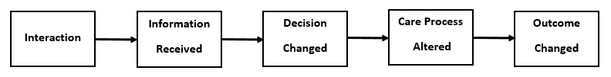
figure 5 – Coiera (2015)

Further analysis of clinical effectiveness could be demonstrated by the use of a triangulated approach including compliance with use of the tool, compared with reported falls and degree of harm across Wales, ensuring patient acuity and nurse staffing levels are also reviewed to ensure comparison of similar patient groups and staffing levels. The benefits of collecting such ‘big data’ to inform health care practice is widely discussed, with Lawson (2020) highlighting the usefulness of big data to identify trends in health care outcomes and nursing strategies and Adibuzzaman et al. (2017) suggesting that whilst still in its infancy big data use can reduce costs and improve patient outcomes.

In conclusion the use of a digitised vision assessment tool designed to meet the needs of nurse in Wales will facilitate health boards to be compliant with the NICE (2013) guidelines. Including it within the WNCR will enable the formation of multifactorial falls care plans, accessible by all health board staff. With the ability to extract ‘big data’ from the vision assessment tool and falls assessments, which could be used to influence future falls strategies across Wales and improve patient outcomes.

Word Count 3808

Reference List

- Adibuzzaman, M.et al.(2017) 'Big data in healthcare - the promises, challenges and opportunities from a research perspective: A case study with a model database', AMIA ... Annual Symposium proceedings, 2017, pp. 384-392 available at https://pubmed. ncbi.nlm.nih.gov/29854102/ (accessed on 23/04/2022)
- Ammenwerth, E. Iller, C. and Mahler, C. (2006) 'IT-adoption and the interaction of task, technology and individuals: a fit framework and a case study', BMC Medical Informatics and Decision Making, 6(1), pp. 3. doi: 10.1186/1472-6947-6-3. (Accessed: 12 January 2022)
- Beadle. F, Pinkney. J, James. L (2018) Project Initiation - The digitisation of Nursing Documents (NHS Wales), (unpublished)
- Coiera, E. (2015) Guide to Health Informatics. London: CRC Press.
- Darcy, E. (2022) Service Group Falls Report, SBUHB, (unpublished)
- DHCW (2022) Digital Health Ecosystem Wales (DHEW), available at https://digitalhealth.wales/dhew/what-we-do, (accessed on 12/05/2022)
- Gittins, R. (2020) Standard Operating Procedure, Standardisation Of National Documents / Data, Cardiff; DHCW, (unpublished)
- John, C. (2022) Email to Tracy Jones, 24/04/2022
- Jones, T. (2022) ‘Welsh Nursing Care Record, A functionality Report using the FITT Criteria’, Assignment for BMDS7000, MSc. Digital Skills for the Health and Care Professions, University of Wales, Trinity St David, Unpublished
- Kennedy, W. (2022) Email to Tracy Jones, 12/05/2022
- Lawson, C. (2020) 'Big data: challenges and opportunities for cardiovascular nursing care', British Journal of Cardiac Nursing, 15(5), pp. 1-2. doi: 10.12968/bjca.2020.0031. (accessed on 23/04/2022)
- Local Partnerships (2012) Options Appraisal Workbook, available at https://www.local.gov.uk/sites/default/files/documents/pas-options-appraisal-wor-7f5.pdf, (accessed on 20/04/2022)
- NHS England (2019) A Digital Framework for Allied Health Professionals. NHS England. Available at: https://www.digitalhealth.net/2019/04/digital-framework-allied-health-professionals/#:~:text=NHS%20England%20has %20published%20its %20irst%20digital%20framework,a%20local%20plan%20of%20delivery%E2%80%9D%2C%20the%20report%20said. (Accessed: 17/04/2022).
- NHS Wales (2022) NHS Wales Data Dictionary, available at http://www.datadictionary.wales.nhs.uk/ (accessed on 12/05/2022).
- NICE (2013) Falls Assessment and prevention of falls in older people, Clinical guideline [CG161], available at https://www.nice.org.uk/Guidance/CG161, (accessed on 26/04/2022).
- Office for Health Improvement and Disparities (2022) Guidance Falls: Applying All Our Health, available at https://www.gov.uk/government/ publications/falls-applying-all-our-health/falls-applying-all-our-health (accessed on 16/04/2022)
- Pinkney, J. (2022) Email to Tracy Jones 17/05/2022
- Public Health England (2017) Falls and Fracture Consensus Statement Resource pack, available at https://assets.publishing.service.gov.uk/government/uploads/system/ uploads/attachment_data/file/586382/falls_and_fractures_consensus_statement.pdf, (accessed on 26/04/2022).
- Rowe, F.J. et al. (2018) 'Visual Impairment Screening Assessment (VISA) tool: pilot validation', BMJ Open, 8(3), pp. e020562. doi: 10.1136/bmjopen-2017-020562. (accessed on 18/04/2022)
- Rowe, F.J. et al. (2020) 'Vision Screening Assessment (VISA) tool: Diagnostic accuracy validation of a novel screening tool in detecting visual impairment among stroke survivors', BMJ Open, 10(6), pp. e033639. doi: 10.1136/bmjopen-2019-033639. (accessed on 18/04/2022)
- Royal College of Physicians (2017a) Look Out! Bedside Vision Check for Falls Prevention, available at https://www.rcplondon.ac.uk/file/5551/download (accessed on 7/04/2022)
- Royal College of Physicians (2017b) Bedside Vision Check for Falls Prevention: Assessment Tool, available at https://www.rcplondon.ac.uk/projects/outputs/ bedside-vision-check-falls-prevention-assessment-tool, (accessed on 17/04/2022).
- Royal College of Physicians (2021a) Clinical Audit Dataset Review, available at https://www.rcplondon.ac.uk/file/33541/download, (accessed on 17/06/2022).
- Royal College of Physicians (2021b) National Audit of Inpatient Falls (NIAF) Annual Report 2021, available at https://www.hqip.org.uk/wp-content/uploads/2021 /11/REF-221-NAIF-2021-annual-report-FINAL.pdf', (accessed on 17/04/2022).
- Scaled Agile (2021) Story, available at https://www.scaledagileframework.com/ story/#:~:text=Story%2020Scaled%20Agile%20Framework%20Stories%20act%20as,of%20desired%20functionality%2C%20written%20in%20the%20user%E2%80%99s%20language., (accessed on 14/05/2022)
- Visual Paradigm, (2022), What is a User Story? available at https://www.visual-paradigm.com/guide/agile-software-development/what-is-user-story/ (accessed on 14/05/2022)
- Welsh Government (2015) Informed Health and Care A Digital Health and Social Care
Strategy for Wales. OGL. Available at: https://gov.wales/sites/default/files /publications/2019-03/informed-health-and-care-a-digital-health-and-social-care-strategy-for-wales.pdf (Accessed on 26/04/2022)
- Welsh Government (2017) Welsh Health Circular - Guidance on Cyber Security and Information Governance Requirements Relating to Suppliers and the supply-chain, (WHC (2017) 025). available at - https://gov.wales/ sites/default/files/publications/2019-07/guidance-on-cyber-security-and-information-governance-requirements-relating-to-suppliers-and-the-supply-chain.pdf, (accessed on 28/04/2022)
- Welsh Government (2021) A Healthier Wales: our Plan for Health and Social Care. OGL. Available at: https://gov.wales/ sites/default/files/publications/2021-09/a-healthier-wales-our-plan-for-health-and-social-care.pdf (Accessed: 11/04/2022).
- World Health Organisation (2021) Falls: Key Facts, available at https://www.who.int/news-room/fact-sheets/detail/falls, (accessed on 14/04/2022)

