Work-based
Learning Project

Research Question:
A Strengths Perspective, an appreciative enquiry as to what makes Social Workers stay in the same organisation.

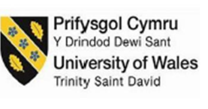

Module: BMPF7006
Name: Patricia Jane Rhianydd Barnes (1303300)

Contents Page
Content Page …………………………………………………………………… Page 2
Project Proposal ……………………………………………….………………. Page 3
Introduction ………………………………………………………………..…… Page 5
Literature Review …………………………………………………………….... Page 6
Methodologies …………………………………………………………………. Page 9
- Survey …………………………………………………………………… Page 10
- Focus Group ……………………………………………….…………… Page 10
Ethical Approach …………………………………………….………………… Page 11
- Confidentiality ………………………………………………………..… Page 11
- Compliance ……………………………………………………… ……... Page 11
- Integrity ………………………………………………………………….. Page 12
- Informed Consent ……………………………………………………… Page 12
- Minimising Harm ……………………………………………………..… Page 12
Findings ……………………………………………………………………….… Page 12
- Survey ……………………………………………………………………….. Page 13
(Quantitative Findings) …………………………………………………..…… Page 13
(Qualitative Findings) …………………………………………………….,,,… Page 26
(b) Focus Group ……………………………………………………………… Page 39
(Qualitative Findings) ………………………………………………………… Page 40
Analysis …………………………………………………………………….…… Page 44
Theme 1 – Engagement with the Research ………………………………. Page 45 Theme 2 – Work/Home-Life Balance & Flexibility ……………………. Page 46
Theme 3 – Supportive Management & Leadership …….…..……. Page 47
Theme 4 – Feeling Valued & Appreciated …………………………. Page 48
Theme 5 – Career Progression & Development.……………….... Page 50
Theme 6 – Organisational Culture & Team Dynamics ………….. Page 50
Theme 7 – Innovation & Future Readiness ……………………… Page 52
Conclusion …………………………………………………………………...…. Page 52
Recommendations …………………………………………………………….. Page 54
References ……………………………………………………………………… Page 56
Ethics From …………………………………………………………………….. Page 62
Appendices …………………………………………………………………….. Page 82

Project Proposal
The organisation has a statutory duty under the Social Services and Well-being (Wales) Act 2014 (SSWB(W)A), to ensure they employ a sufficient number of qualified and registered professionals to assess the needs of individuals who may need care and support, including children. Although Social Workers are not directly named within the SSWB(W)A 2014, Social Workers play a critical role in the assessment, care planning, safeguarding and supporting individuals.
The recruitment and retention of qualified and registered Social Workers has been a global challenge for many years (Baugerud et al., 2018; de Panfilis and Zlotnik., 2008; Russ et al., 2009; Ravalier et al., 2021). Furthermore, nationally (UK) Brexit (2020) and the Covid-19 pandemic (2021) have further impacted on the recruitment and retention of Social Workers, resulting in increased number of vacancy rates, recorded increase of 11.4% in 2022-2023 (Pulman and Fenge, 2024). This is also the trajectory reported across Wales and experienced directly by the organisation (Youle, 2022). Social Care Wales indicate a small gradual decline in Registered Social Workers in the county of Carmarthenshire between 2021 (600) and 2025 (584). However, it is important to not these are not organisation figures but overall figures for every registered Social Worker employed and linked to the county of Carmarthenshire (Social Care Wales, 2025).
When considering the retention of employees, the organisation’s workforce policy stipulates that all employees will be sent an exiting survey on receipt of their resignation, these are not mandatory to complete. Furthermore, exit interviews are only conducted on request. However, there is no mandatory process in place to capture the views of employees who have chosen to leave the organisation (CCC Policy). There is much research that questions the validity of exit surveys/interviews. They explore the positives and negatives of undertaking exiting surveys/interviews, particularly exploring a number of bias factors from both employer and employee, such as the ability to be honest without repercussions (Giacalone, Knouse and Montagliani, 1997; Lefkowitz and Katz 1969).
When considering the use of an exiting surveys the questions generally follow a pattern of data gathering such as; reason for departure, overall experience of working for the organisation and any recommendations for improvement (Naser, 2024). Furthermore, the use of exit surveys is only provided once the Human Resources (HR) department has received a formal letter of resignation from the employee. Thus, missing the opportunity to retain the employee and gather feedback retrospectively.
Overall, the style of questioning within an exit survey does not follow a strengths perspective in the form of identifying what the organisation does well, generally exit surveys focus on the reason for departure and scope out the level of support received by management. Whilst it is important to gather feedback in many forms to understand employee’s experiences. The author questions why this is only done once the employee has made the decision to leave the organisation, rather than providing an opportunity to retain employees.
With an increase in Social Work vacancies that have steadily increased year on year, one would argue the retention of Social Workers is more important than recruitment. When experienced employees leave, organisations lose institutional knowledge and practice wisdom that is difficult to replace (Cook, 2024). Given that the organisation generally intervenes retrospectively once a Social Worker has made the decision to leave the organisation via an exit interview/questionnaire, this piece of research aims to consider retention from a strength’s perspective (what is working well) currently, and to then further build on identified strengths, which appears to be a current gap.
It must be acknowledged that this research project is being undertaken within the researcher’s organisation of employment. This gives the researcher, insider status. Being an insider researcher has many advantages and challenges. An insider researcher will benefit from pre-established relationships which will have harvested trust, the insider researcher will understand contextual knowledge within the organisation, and the insider researcher has direct access to participants and organisational data, which can enhance the depth and relevance of findings (Brannick and Coghlan, 2007). However, this also introduces ethical considerations and methodological implications. For example, the insider researcher will need to be aware of their own bias, as the researcher’s familiarity with organisational culture and relationships may influence data analysis (Mercer, 2007). Insider status can also create role conflict, where the researcher must balance professional responsibilities with academic objectivity, potentially compromising neutrality (Unluer, 2012). Furthermore, participants may feel constrained in sharing honest feedback due to perceived power dynamics or fear of repercussions, which can affect data validity and participation (Asselin, 2003). To mitigate these risks, research advises reflexivity is adopted, encouraging the researcher to be self-aware and critically reflect on how insider status shapes their interpretations (Berger, 2015). The insider researcher must uphold integrity and ethical guidelines by maintaining transparency and securing informed consent, to ensure they mitigate the potential of causing harm to participants.
This research project will explore what contributing factors and motivators aid the retention of qualified and registered Social Workers in the long-term. The overall aim of the research project is to apply any learning or good practice identified to support the future retention of qualified and registered Social Workers within the organisation. The identified objectives as follows:
- To be able to identify the strengths and barriers to retaining qualified and registered Social Workers and support the organisation to implement learning identified by the research.
- To continuously improve the work environment for qualified and registered Social Workers which in turn will positively impact retention and employee well-being.
The researcher hopes to achieve the following as a result:
- The overarching aim of the research project is to continuously improve the work environment for qualified and registered Social Workers in the hope that this will positively impact retention.

Introduction
This research paper will begin by analysing qualitative and quantitative data gathered from a survey and focus group session developed to engage with the organisation’s qualified and registered Social Work workforce.
The research paper will provide a comprehensive critical analysis of methodologies adopted to undertake the research, as well as the ethical implications that have been considered as part of undertaking the research project. Furthermore, the research paper aims to identify strengths within the organisation that can be further built on to improve and encourage the long-term retention of qualified and registered Social Workers within the organisation.
The research project will adopt a strengths perspective via an Appreciate Inquiry (AI) approach to explore the viewpoints of qualified and registered Social Workers themselves, identifying strengths already in place within the organisation, as well as factors they feel contribute to them remaining in the same organisation long-term.
Several recent literature reviews highlight the positives of adopting a strengths-based approach such as, AI when considering organisational development and Social Work practice (Lewis, 2025; Research in Practice, 2025; Lee, 2025).

AI is a strengths-based approach developed in the 1980s by Cooperroder and Srivastva. The foundation of the AI approach is to identify what is working well, and to then further build on identified strengths to develop an individual/organisation or to aid change. Thus, moving away from a crisis management approach, which often focuses on the issue at hand and trying to solve it (Cooperroder & Srivastva, 1987).
As an insider researcher adopting a strengths-based approach via the implementation of AI, the researcher hopes to obtain a critical understanding of retention motivators to aid the organisation in its ambition for retaining our qualified and registered Social Work workforce in the short-term and long-term.

It is hoped that the research project will give the qualified and registered Social Work workforce an opportunity to share what strengths the organisation possesses and how these can be further developed or disseminated across the organisation with the aim of improving retention. Furthermore, given retention of qualified and registered Social Workers is a global issue, this research project has the potential to impact on the Social Work profession, locally, regionally, nationally and/or internationally.

Literature Review
Prior to undertaking this research project, a thorough literature review has been undertaken to explore the findings from other academic sources in line with the long-term retention of registered and qualified Social Workers. Furthermore, the literature review will explore whether a strengths perspective or an Appreciate Inquiry (AI) was undertaken to explore these findings, as well as acknowledging the research methods utilised to undertake their findings.

When considering the literature reviewed, and the fact that most insights into retention usually occur retrospectively (Naser, 2024). The starting point for this literature review was to establish whether literature available descends from a strength’s-based perspective or from a hindsight perspective gathering the data retrospectively. Of the literature reviewed it was pleasing to see that three pieces of research did adopt a strengths-based approach. Chiller & Crisp (2012) explored the use of supervision to aid well-being and resilience, rather than focusing on past failures. Blosser et al (2010) adopt a strengths-based approach, as their focus was organisational culture, leadership, and career development, and using these strengths to enhance retention. Wermeling et al (2013) leaned towards a strengths-based approach, as they explored how strong educational preparation and mentorship can promote retention, focusing on proactive strategies such as better training opportunities and realistic expectations to support retention, rather than concentrating on past failings. Webb & Carpenter (2012) on the other hand have reviewed a number of existing data sets to identify gaps. Their analysis of past research has allowed them to identify what has worked well historically rather than looking to build on strengths within current practice.

When considering the methodologies adopted by the reviewed academic sources, it was a surprise to learn that each one had adopted a different methodological approach. Webb & Carpenter (2012) implemented a systematic review, which entailed the review of existing literature, such as peer-reviewed journals and policy documents. Overall, Webb & Carpenter (2012) implemented an inclusion and exclusion criteria, they assessed the methodological quality of literature available and then synthesised their findings. This method allowed them to review a number of interventions and identify gaps in evidence. However, it is important to note the limitations to this method which includes limited empirical data, and the quality of the review is only as good as the quality of existing data available. Chiller & Crisp (2012) implemented a qualitative study; they utilised a semi-structured interview approach with both Social Workers and supervisors. By adopting this approach, it allowed for the gathering of rich qualitative data based on the participant experiences, allowing them to analyse the impact of supervision on a sample group. By applying thematic analysis to data gathered Chiller & Crisp (2012) were able to explore the use of supervision as a retention strategy. A limitation to consider with this approach is the fact the research study was based on a small sample group, which means findings may not consider a broad view. Wermeling et al (2013) adopted a quantitative method with the use of a survey, which was directed at a sample group of accredited Social Work programmes. This method allowed them to carry out a statistical analysis of the empirical data gathered and identify whether there was any correlation between education and retention. A limitation to this method was, the data gathered was self-reported data, which has potential for response bias. Blosser et al (2010) chose to use a mixed methods approach, using a combination of a quantitative survey and qualitative interviews. They analysed the quantitative data from the survey to establish merging themes; then used interviews to triangulate their data and gain rich understanding of factors influencing retention. There are many positives to adopting a mixed methodology such as a holistic overview of the topic, an opportunity to further explore themes and to gather rich data to support or disprove emerging themes. Furthermore, the triangulation of data gathering solidifies findings and enhances the validity of the research project. Limitations for the use of a mixed methodology can include time constraints to ensure a thorough data collection. Furthermore, the efficiency and skill required to merge qualitative and quantitative findings into a cohesive narrative are imperative to ensure findings are thorough and not superficial or fragmented.

The literature review has highlighted a number of findings and recommendations made to retain qualified and registered Social Workers. Webb & Carpenter (2012) highlighted the importance of organisational support, supervision quality, work/home-life balance and manageable caseloads as critical to the job satisfaction and retention of Social Workers. Chiller & Crisp (2012) suggest reflective supervision fosters professional identity, professional resilience and contributes to reduced burnout and increased job satisfaction. The authors advocate that structured, consistent, regular reflective supervision could be used as a core retention strategy. Wermeling et al (2013) found that graduates who were provided with varied placements and mentorship during their training period felt better prepared and were more likely to remain in the field long-term. Blosser et al’s (2010) mixed method approach revealed; continued professional development, supportive leadership, career progression opportunities, and regular positive feedback are vital in enhancing commitment to the organisation. Furthermore, retention is closely tied to opportunities for professional growth and a positive team culture. It is likely a number of these findings will be highlighted within this research project. However, by adopting a strengths perspective and applying an appreciate inquiry approach, the overall aim is to build on existing strengths of the organisation, rather than identifying gaps and applying strategies to fill them.
In conclusion, it is clear from this literature review that the topic of Social Work retention is an important area to be researched, and academics are undertaking regular research in this area in order to support the profession. Furthermore, the adoption of a strengths-based perspective when undertaking research is far more common than anticipated.

When considering the methodologies adopted by each data source, the positives and limitations explored confirm that a mixed methodology is the best suited method for this research project. The use of a survey to gather quantitative data to establish merging themes, followed by focus groups to gather rich qualitative data to triangulate data analysis will strengthen the validity of the research. The limitations of a mixed method that will need to be considered are time limitation, bias that maybe present as an insider-researcher and ensuring data is analysed thoroughly to avoid fragmented findings.

The overall findings and emerging themes to come out of this literature review are cross cutting and it is evident that the retention of registered and qualified Social Workers is a multi-faceted and complex area to resolve. This literature review will support the shaping of this research project’s survey, in particular the findings have provided a number of key retention strategies that can be included in a scaling question to establish what Social Workers themselves identify as important employee motivators to aid retention.

Methodologies
This research study will adopt a mixed methodology approach, encompassing both quantitative and qualitative methods. The mixed methodology approach for this research will include the use of the following methods: survey and focus group. Research suggests that adopting a mixed method will provide a more in-depth data set for analysis. Different methods of data collection have their strengths and limitations. However, by adopting a mixed method approach, and using methods that complement each other, this will strengthen the research and data gathered (Byrne & Humble, 2007).

- Survey
The use of a survey will allow the researcher to target a wide audience, in a quick time scale, whilst keeping costs to a minimum (Mcleaod, 2023). The structure and design of the survey will allow the researcher to gather quantitative data to establish themes in related to sex, roles, age and continued service. Whilst also gathering qualitative data from participants by encouraging them to share their experiences and views from a strength’s perspective.

The survey will be designed via the Microsoft Forms application, and all participants will be sent an email inviting them to participate in either English or Welsh language, depending on their preference. The Microsoft Forms application will allow participants to access the survey via their laptops, computes and mobile phones. It is hoped that the choice of language and a variety of accessibility will encourage a higher number of registered and qualified Social Workers to participate.

The organisation has approximately 300 registered and qualified Social Workers employed. Ideally a response rate between 25%-30% is anticipated, in line with the traditional range associated with email surveys (Menon & Muraleedharan, 2020). The survey is anonymised, and participants are made aware from the outset, should they wish to withdraw from the research study, they are able to do so at any time. The survey has been designed to take between 10-15 minutes to complete.

All data gathered via the survey will be analysed thematically and all emerging themes or patterns identified will be presented by visually pleasing graphs to aid the reader when deciphering the data gathered.

- Focus Group
The use of focus groups will allow the researcher to gather a deeper understanding of how participants feel or think about themes that have emerged from the survey. The purpose of the focus group is to gather rich qualitative data to support or challenge emerging themes and patterns. The focus group must be a non-judgemental environment built on mutual respect to allow participants to feel safe and comfortable to reflect and share their experiences honestly (Krueger & Casey, 2015).

The focus group will aim to host 5-8 participants to ensure all participants can participate in a meaningful way. The focus group will meet in a neutral building, geographically central to maximise attendance and support a comfortable and safe environment. The session will aim to last no more than 1 hour, and responses will be captured via flip chart feedback/notes and handwritten notes taken by the facilitator. The design of the questions for the focus group will align with the survey, offering an opportunity to triangulate and strengthen data collection. This will be achieved by using open-ended and clarifying questions to the participants.

The rich data gathered via the focus groups will be thematically analysed providing stronger insight to support or disprove any hypothesis or conclusions made as a result of the survey.

Ethical Approach
It is of paramount importance that every research project takes a holistic view of the ethical well-being and safety of its participants. The researcher has a duty to mitigate any potential risks identified from the outset, to protect all participants from experiencing significant harm (Gajjar, 2016). Below all ethical considerations and mitigating measures taken will be outlined.
- Confidentiality
The participation in the survey is anonymous, and a confidentiality statement will feature at the beginning of the Microsoft Forms, survey. It is important to have open and honest lines of communication with participants, transparency is key when reassuring participants of how their information is going to be used, stored and shared. It is only in the event that information shared places a participant or others at risk, the Safeguarding Procedures 2019 will override their anonymity.

- Compliance
There are many aspects to consider ensuring compliance is adhered to. The researcher will need to consider; legislative frameworks (GDPR, Data Protection) governing bodies (Codes of Professional Practice, British Educational Research Association) and organisational guidelines (Policy). To ensure compliance is adhered to the research will be submitting an ethical application to the university’s ethic’s board for approval prior to undertaking any data gathering.

- Integrity
Integrity is a vital ethical consideration as the integrity of the researcher can impact on the overall findings of the research project. It is important that the researcher is aware of any bias they may hold and ensure that their views do not impact on the research project by ensuring data is analysed accurately and methodically. This will include the research being aware of their epistemology, prior to undertaking the research project.
- Informed Consent
Informed consent requires open and honest communication between the researcher and participants. Participant must be fully informed of the purpose, duration, risks, benefits and data usage/storage of the research project form the outset, allowing them to make an informed decision as to whether they would like to participate. Furthermore, all participants must be aware that they hold the right to withdraw from the research project at any time (Gajjar, 2016). All information in line with informed consent will feature in the opening statement on the Microsoft Forms survey and the email inviting participants to participate in the research project.
- Minimising Harm
All the ethical considerations listed above contribute to minimising harm to participants. When considering harm in research, it can take many different forms, such as from researcher to participant or from participant to researcher.
It is the researcher’s responsibility to identify and mitigate potential harm to themselves or to participants. The researcher has considered the nature of the research study and feels that the mitigating steps highlighted above are suffice in minimising risk to themselves and others.

Findings
This research paper aims to adopt a strengths perspective through the use of an appreciative inquiry to explore why qualified and registered Social Workers remain in the same organisation long-term. The research paper will include a thematic analysis of fundings gathered via a survey, with a view of identifying a number of themes and patterns within the responses submitted by participants. The themes identified will then design the agenda for the focus group, with the aim of gathering rich narrative data to strengthen or disprove hypothesis.

- Survey
The primary research method used within this research paper is the use of an employee survey. This is a predominantly qualitative method that allows the researcher to gather data from a large sample group improving scalability, gather responses in a timely and efficient manner, with very little to no cost. Furthermore, the use of a survey allows the researcher to design and develop the questionnaire to target a specific topic, allowing the participant to share their opinions, personal experiences, behavioural trends and personal attitudes/values (Mcleoad, 2023). One of the main limitations identified with the use of surveys, is survey fatigue or respondent fatigue, whereby people simply become overwhelmed by the number of surveys and questionnaires they are faced with on a daily basis. This can negatively impact a piece of research in many ways, including; participants may not engage with the survey at all, they may lose interest in completing the survey and provide less thoughtful answers, they may skip questions, skip any narrative responses requires or select default answers (Ghafourifard, 2024).

The use of surveys to gather quantitative data is very common and seen as a fundamental tool when conducting market research. Crick (2024) states that surveys are at the forefront of the broader marketing discipline – mostly because they are relatively cheap, can quickly reach a large number of people, and are likely to generate findings that advance theory and practice. Nevertheless, it must also be acknowledged that surveys have their limitation. Huebner & Zacher (2021) found that organisations often fail to act on survey results, making the process ineffective and creating employee cynicism, which in turn can affect future response rates. However, Gillespie & Reader (2024) argue that traditional surveys are limited and can miss critical cultural issues, suggesting over-reliance is risky.

Taking into consideration the identified limitations, the survey developed for this research project will incorporate both quantitative and qualitative questions, with the aim of taking a holistic approach. By adopting mixed methods and strategically integrating both qualitative and quantitative questions into the survey it is hoped the limitations to each method alone will counterbalance. Furthermore, this will offer the opportunity to validate findings through triangulation, and provide a more comprehensive, reliable and credible research project (Creswell, 2014).

The survey for the purpose of this research project has been designed on Microsoft Teams (Appendix) and distributed electronically via email, with an attached link. The email was sent to the Director of Social Services, the 3 Heads of Service and 4 Service Managers to be circulated within their divisions with the view of reaching all 300 registered and qualified Social Workers employed by the organisation. A total of 13% (38) of the workforce engaged with the survey over a two-week window.

The purpose of the survey is to identify a number of themes and to gain valuable insight into the participant’s experiences by conducting a thematical analysis. It is hoped that good practice or strengths identified can be further explored and expanded upon to strengthen retention within the organisation.
Quantitative Questions | Qualitative Questions
Question 1 | Question 10
Question 2 | Question 12
Question 3 | Question 14
Question 4 | Question 15
Question 5 | Question 16
Question 6 | Question 17
Question 7 | Question 18
Question 8 | Question 19
Question 9
Question 11
Question 13

Quantitative Data
Question 1 – What Service Area do you work in?

Diagram 1 illustrates the following data:
- The highest number of participants who engaged with the survey identify themselves as working for Adult Services, with 40% (15) completion rate.
- Followed by Children & Family Services whereby 26% (10) participants completed the survey.
- Less participants engaged with the survey from Integrated Services with only 21% (8) completion rate.
- Lastly, 13% (5) of participants identified themselves as working in other service areas with the organisation.
- The majority, accounting for nearly half of all participants who engaged with the survey work within Adult Services division.
- The data shows a cross-section of participants form different services areas, but representation is not evenly distributed, with Integrated Services being considerably underrepresented in comparison to Adult Services.

Question 2 – What Sex do you identify as?

Diagram 2 illustrates the following data:
- More females participated and engaged with the survey than males, with a total of 79% (30) being female.
- In contrast, 21% (8) of participants were male, a considerable percentage lower than that of females.
- In total, 58% less males completed the survey in comparison to females.
- The ratio of males to female participation equates to 1 male to every 3.8 female.

Question 3 – How old are you?
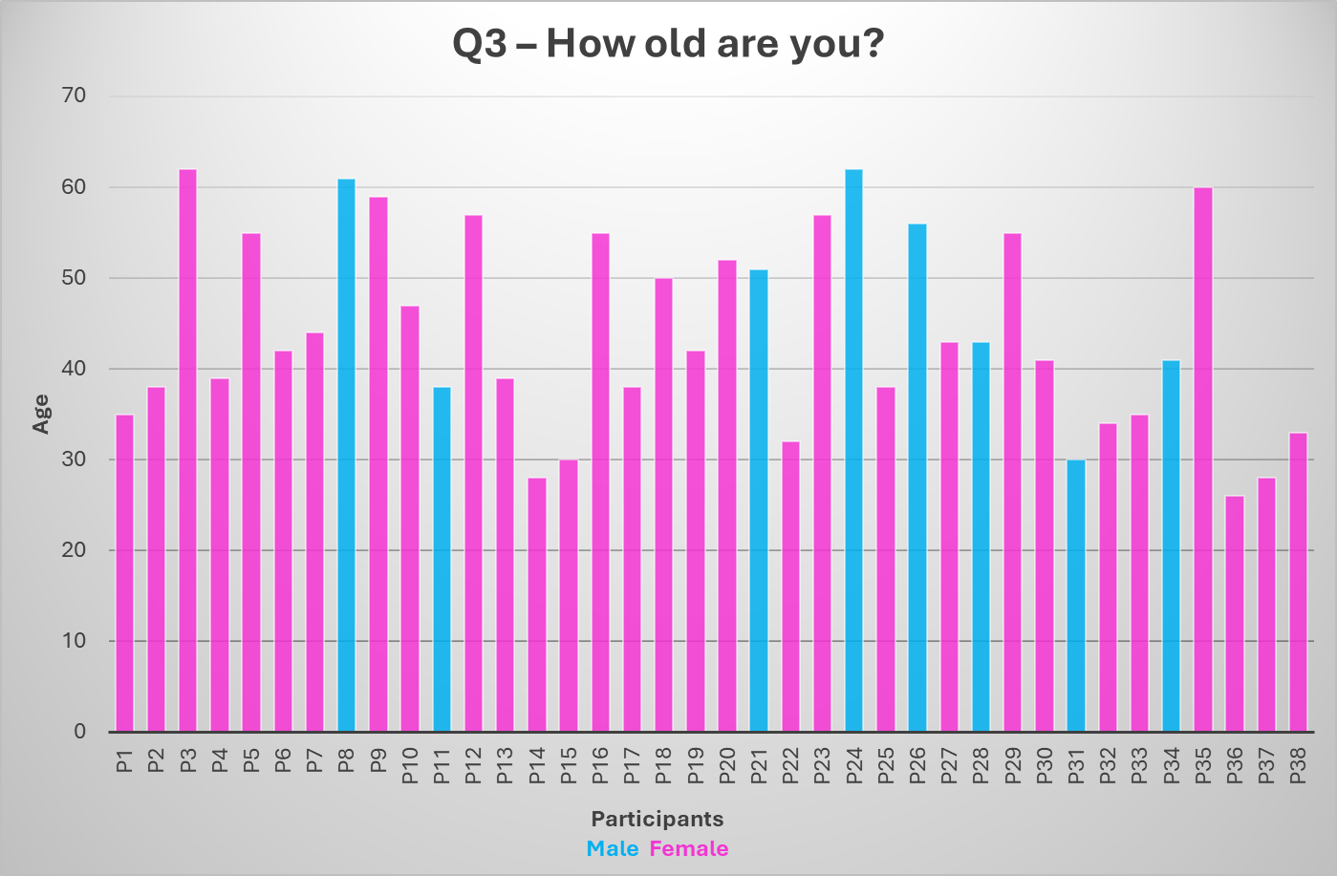

Diagram 3 illustrates the following data:
- This diagram illustrates the age distribution of participants by gender.
- Ages vary widely, roughly between mid-20s and early 60s.
- There is no single dominant age group, but many participants cluster around 35–55 years, with 71% (27) of participants in this age group.
- Female participants appear more frequent (more pink bars), aligning with earlier data showing a female-majority workforce.
- A few participants, (3) female and (1) male are in their 60s, suggesting some older professionals remain active.

Question 4 – How many years qualified are you?
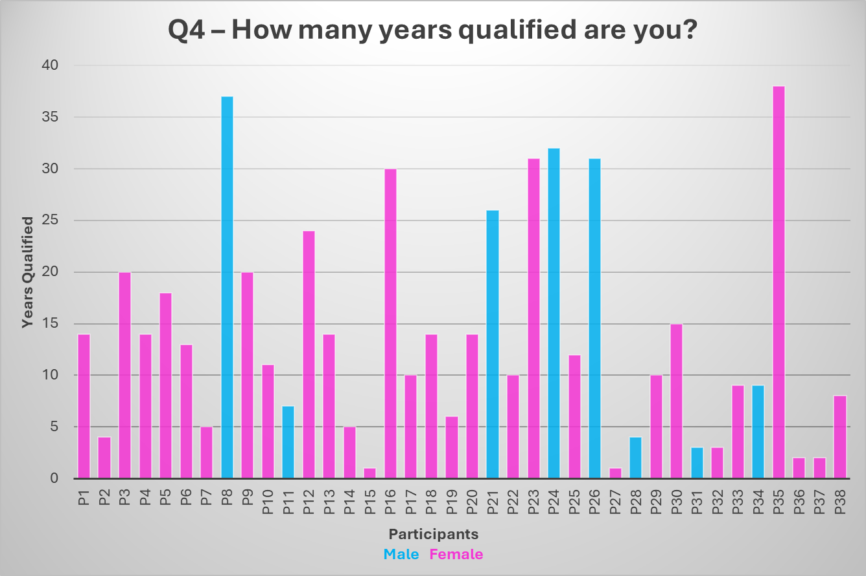

Diagram 4 illustrates the following data:
- This diagram illustrates the number of years each participant has been professionally qualified, broken down by gender.
- Number of years qualified ranges from 1 year to 38 years.
- Several participants have been qualified for over 30 years: (3) Males and (3) Females, equating to 16% of all participants.
- 36.8% (14) of participants cluster between 10–20 years qualified, indicating a strong mid-career representation.

Question 5 – What Social Work qualification do you hold?

Diagram 5 illustrates the following data:
- This diagram illustrates the distribution of social work qualifications held by participants.
- The most common qualification held by participants is the BSc Hons in Social Work with 50% (19) of participants holding the degree qualification.
- DIPSW represents nearly a quarter at 24% (9), indicating some experienced practitioners with older qualifications.
- A significant proportion 21% (8) have postgraduate qualifications (MSc/MA).
- Lastly, 5% (2) of participants identified themselves as holding an alternative qualification in Social Work.

Question 6 – Were you seconded to chieve your qualification?

Diagram 6 illustrates the following data:
- This diagram illustrates whether participants were seconded by their employer to achieve their social work qualification.
- At 79% (30) respondents funded or arranged their qualification independently.
- Only about one-fifth 21% (8) benefited from employer secondment.

Question 7 – How many years’ continued service do you have with the organisation?
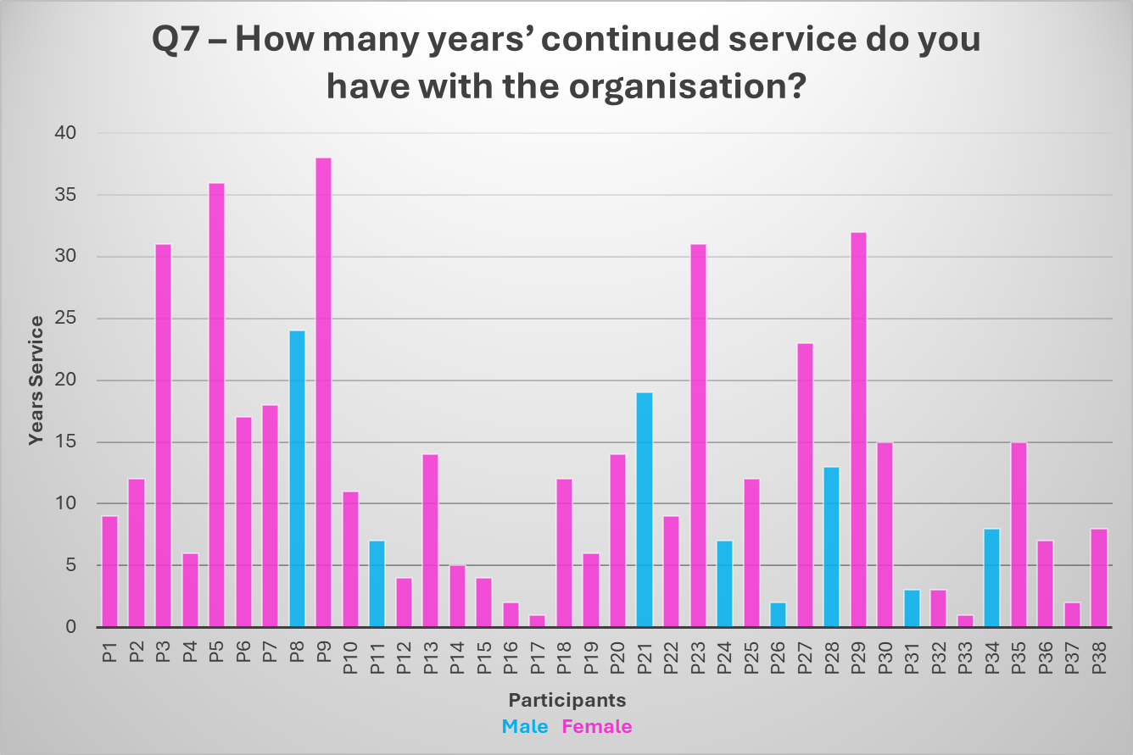

Diagram 7 illustrates the following data:
- This diagram illustrates the number of years each participant has worked continuously for the organisation, broken down by gender.
- Continued service to the organisation ranges from 1 year to 38 years.
- Several participants 11% (4) have very long service 30+ years, these participants are all female.
- The longest serving male participant has 24 years of continued service.
- Many participants 32% (12) cluster between 10–20 years of continued service, indicating strong mid-career representation.
- Female participants dominate in number and also hold the longest service records.

Question 8 – What role do you currently hold?
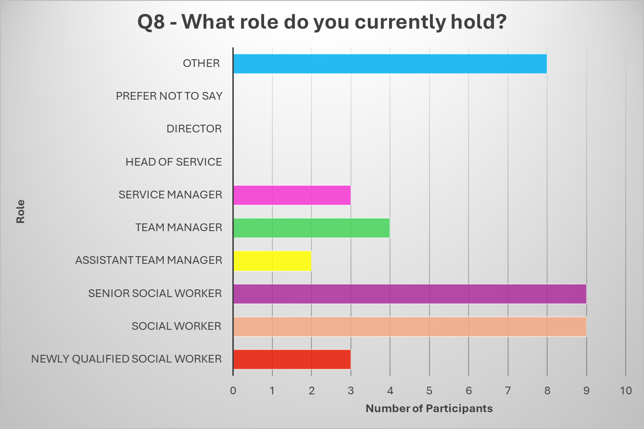
Diagram 8 illustrates the following data:
- This diagram illustrates the distribution of current roles held by participants.
- The largest groups are Senior Social Workers 24% and Social Workers 24%, whereby (9) participants identified as working in these front-line roles.
- Other roles also have a significant response with 21% (8) of participants identifying their role as other.
- Management roles (Assistant Team Manager 5% (2), Team Manager 10% (4) and Service Manager 8% (3) are less common.
- Newly Qualified Social Workers equated for 8% (3) of participants.
- No participants who hold senior leadership positions (Head of Service (0), Director (0)) engaged with the survey.
- This suggests the sample is heavily weighted toward frontline and senior practitioner roles, with limited representation from higher tier management.

Question 9 - Please rate on a scale of 1-5 (1 Unhappy – 5 Very Happy) how happy you are in your current role?
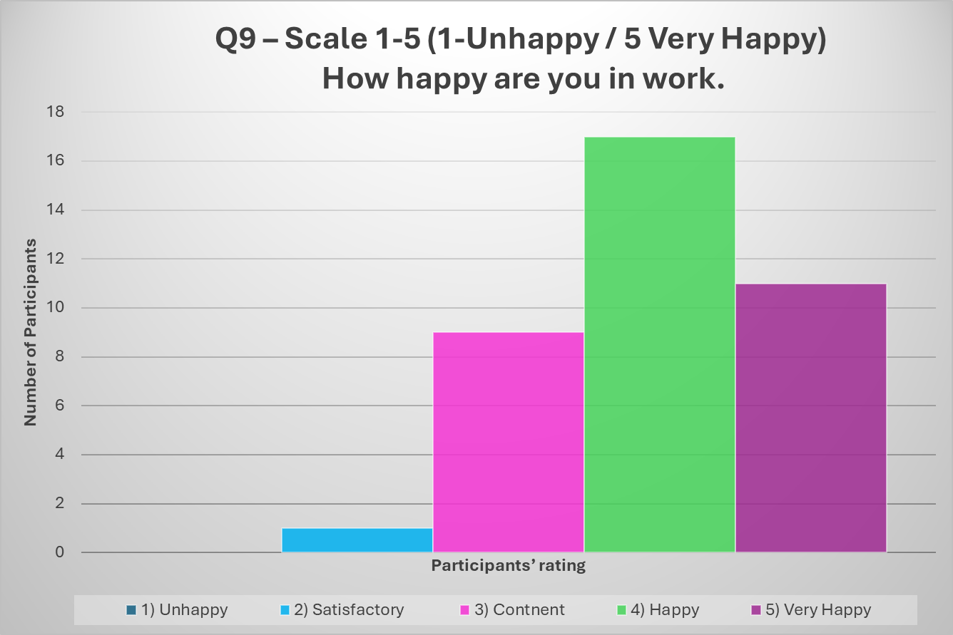
Diagram 9 illustrates the following data:
- This diagram illustrates how happy participants are in their current role.
- The majority of respondents expressed that they feel Happy 44% (17) or Very Happy 29% (11) at work, with a total of 73% (28).
- A smaller group of participants feel Content at work with 24% (9) of participants ticking no 3.
- Very few rated that they are only Satisfactory (0) or Unhappy 3% (1) in their current role.
- The overall average for how happy participants are in their current role is 3.97, this suggests a strongly positive workplace sentiment.

Question 11 – Have you considered leaving the organisation?
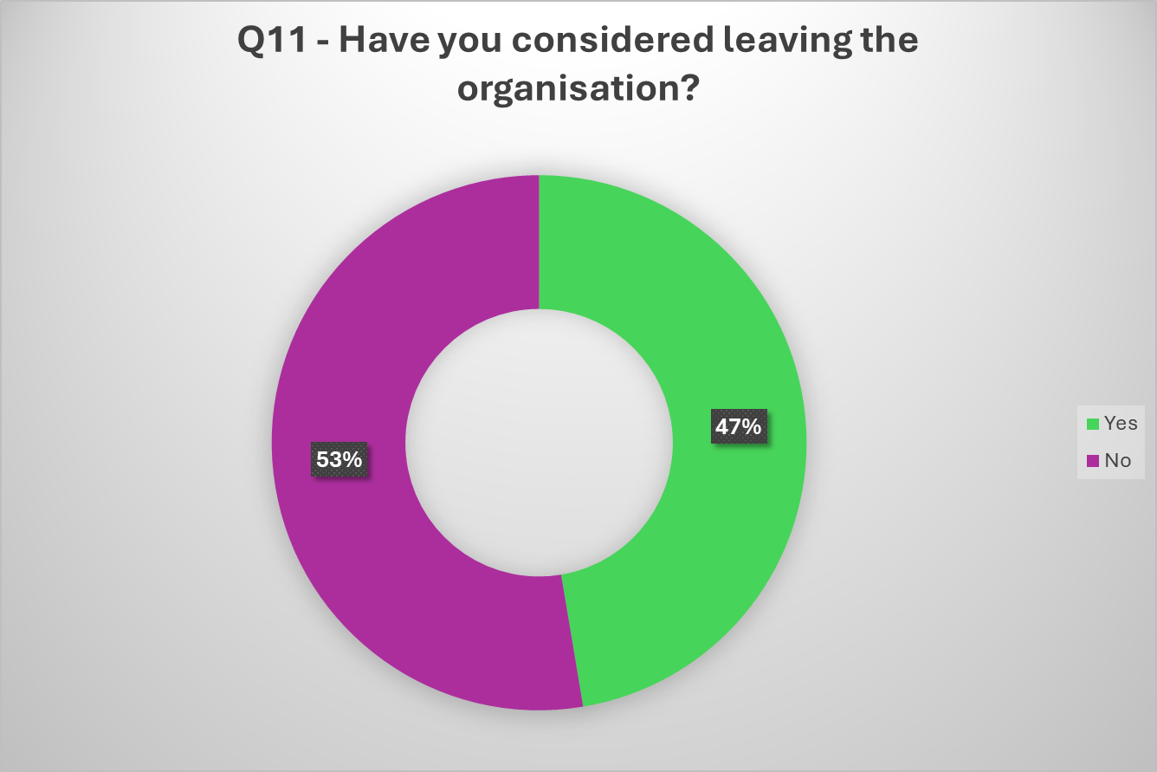
Diagram 10 illustrates the following data:
- The diagram above visually represents the proportion of participants who have considered leaving versus those who have not.
- A slight majority at 53% (20) have not considered leaving the organisation.
- However, a significant proportion 47% (18) have considered leaving, which indicates potential retention concerns.

Question 13 – Please put the following employee motivators in order of important to you.
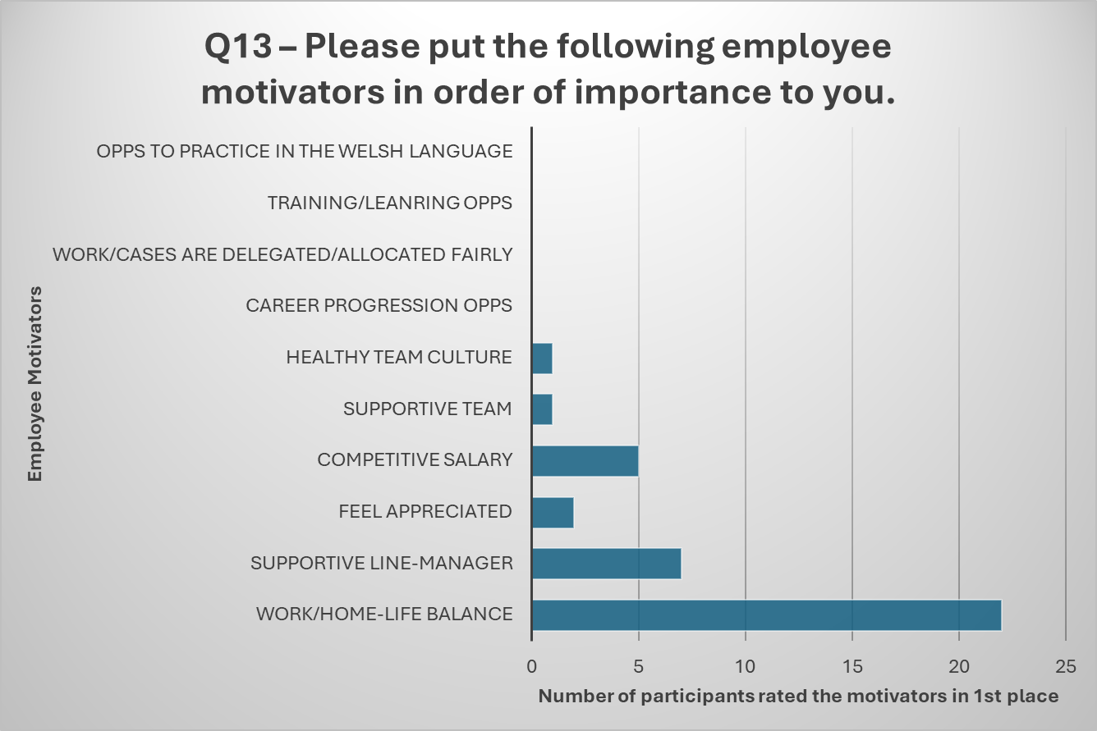
Diagram 11 illustrates the following data:
- The diagram illustrates the motivators placed in first place of importance to participants.
- Work/home-life balance is the highest priority for 58% (22) of participants.
- Supportive line manager ranks second, with 19% (7) of participants listing it as their most important motivator.
- 13% (5) of participants identified a competitive salary as their most important motivator to them.
- Other motivators such as feeling appreciated (2), healthy team culture (1), and supportive team (1) were prioritised only by one or two participants.
- Motivators like career progression, training opportunities, and Welsh language practice received no votes for first place, which suggests they are lower down on the priority list for our participants.
- This diagram highlights that work-life balance is overwhelmingly the most important motivator, followed by having a supportive line manager and competitive salary. Other factors are considered far less critical as a top priority.

Qualitative Data
Question 10. Please justify your rating above. (Question 9 - Please rate on a scale of 1-5 (1 Unhappy – 5 Very Happy) how happy you are in your current role?)
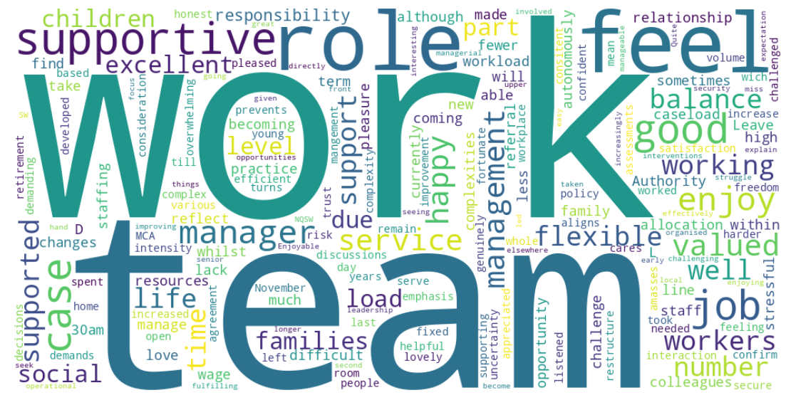
Diagram 12 illustrates the following:
- When justifying their ratings 34% (13) of participants identified having a supportive team and or supportive manager as a positive to justify their high rating.
- 39% (15) of respondents’ express enjoyment within their role and feeling valued by the organisation as positives.
- Work-Life Balance and flexibility around family life was identified as a justification by 13% (5) participants.
- On the other end of the spectrum, 24% (9) responses mentioning overwhelming demands, high caseloads, and increasing complexity.
- Resource Constraints: Lack of resources and staffing shortages are recurring issues.
- With a high number of participants feeling valued by the organisation, in contrast 8% (3) participants expressed feelings of being undervalued and being considered “just a number”.
- While 39% (15) of respondents’ express fulfilment within their job and team, 34% (13) identify stress and workload pressures temper overall satisfaction.

Question 12. Please expand on your answer above (why?).
(Q11. Have you considered leaving the organisation?) 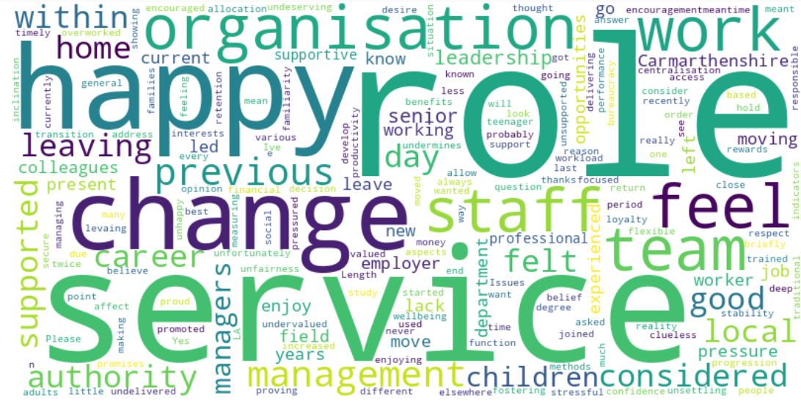
Diagram 13 illustrates the following:
Not Considered Leaving (No):
- The 53% (20) of participants who have not considered leaving the organisation expressed a number of positive sentiments towards the organisation, for example, “I feel a deep loyalty to Carmarthenshire… encouraged to believe in myself and return to study…”
- 55% (11) participants who have not considered leaving the organisation expressed job satisfaction as a motivator to stay. For example, “I do feel valued in my role and am proud to work for the local authority I work in.”
- Stability and loyalty came through as a strong theme as to why participants have not considered leaving the organisation with 90% (18) participants expressing comments linked to stability and loyalty, for example, “Length of service – supportive management and familiarity.”
- The 10% (2) who did not express stability and loyalty were new to the organisation, they had not considered leaving due to being new employees to the organisation.
Have Considered Leaving (Yes):
- The 47% (18) of participants who have considered leaving the organisation expressed a number of reasons for this including financial pressure, external offers, career development opportunities and a lack of flexibility.
- 22% (4) of those who had considered leaving the organisation expressed feeling undervalued and overworked as reasons to leave, for example, “I consider leaving my job every day... There is too much pressure and little thanks or rewards”.
- 44% (8) respondents identified stress (or stress-related factors) as a reason they had considered leaving the organisation. Example, “Because I've thought there is less stressful jobs for more money, that doesn't affect wellbeing”.
- Service/team instability was identified as a reason participants considered leaving the organisation, with 22% (4) participants directly mentioning it. For example, “Do not feel that secure, or supported. There is a lack of stability within the service where so many experienced social workers, managers, service managers left the LA”.

Question 14. Please explain/elaborate on the above. (eg - why are your top 3 motivator important to you? what could the organisation do strengthen your most important motivators) (Q13. Please put the following employee motivators in order of importance to you (Most at Top – Least at the Bottom).
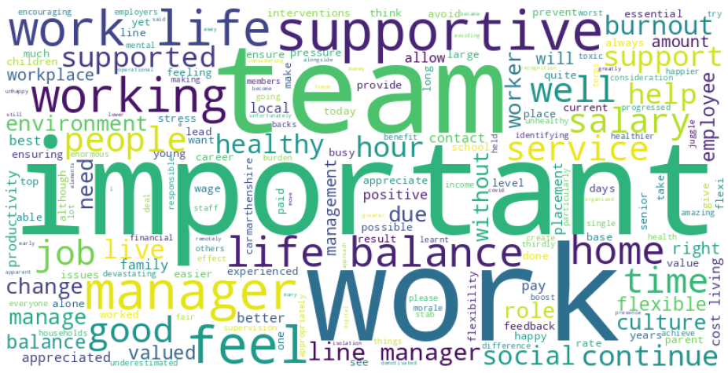
Diagram 14 illustrates the following:
A number of themes emerged from this feedback each will be addressed in turn.
- Supportive Management and Team Culture
- Many participants emphasise the importance of supportive managers which was mentioned by (19) participants and healthy team environments mentioned by (15) participants.
- Positive experiences include managers who are approachable, trust staff, and provide flexibility.
- Negative experiences highlight toxic team cultures and poor leadership, which significantly impact morale and retention.
- Healthy team dynamics and time for team-building activities are seen as essential. Example: “Giving teams time out to look at teamwork and establish healthy teamwork would help.”

- Work-Life Balance and Flexibility
- There is a strong focus on flexible working arrangements (e.g., remote work, flexitime) to manage family responsibilities and reduce stress, 42% (16) participants mentioned work-life balance is some capacity.
- Work-life balance is seen as essential to prevent burnout and maintain wellbeing.
- Several participants linked flexibility to productivity and job satisfaction.
- Example: “Having the correct work/life balance is essential.”

- Salary and Financial Pressures
- Salary is mentioned as a motivator and a necessity, especially given the cost-of-living crisis.
- Some respondents note that pay is fair, while others compare it unfavourably to other local authorities.
- Financial stress is particularly highlighted by single-income households.
- Example: “Salary is important due to struggling to manage financially.”

- Recognition and Feeling Valued
- 24% (9) of participants want to feel appreciated and recognized for their contributions.
- Lack of recognition leads to demotivation and dissatisfaction.
- Positive feedback from managers and acknowledgment of effort are seen as critical for morale.
- Example: “Being appreciated goes a long way.”

- Caseload and Workload Management
- Heavy caseloads and unrealistic expectations are recurring concerns.
- Participants mention burnout risk and the need for better workload distribution.
- Budget constraints and resource shortages exacerbate stress among participants.
- Example: “Caseload is also important to avoid burnout.”

- Career Progression and Development
- Opportunities for career growth and professional development are important for retention.
- Some participants express frustration over limited progression opportunities.
- Example: “I would like more of a challenge and opportunity to progress.”

- Organisational Culture and Leadership
- Leadership sets the tone for workplace culture.
- Positive leadership fosters trust and collaboration; poor leadership creates toxicity and stress.
- Calls for better planning and people skills among managers.
- Strong emphasis on supportive managers, approachable leadership, and compassionate leadership style.
- Concerns about senior management being overloaded and sometimes unresponsive.
- Example: “Senior management responses can be non-existent, inappropriate and at times aggressive.”

Question 15. What are the contributing factors or the reason you have been with the organisation for the length of time you have stated above?
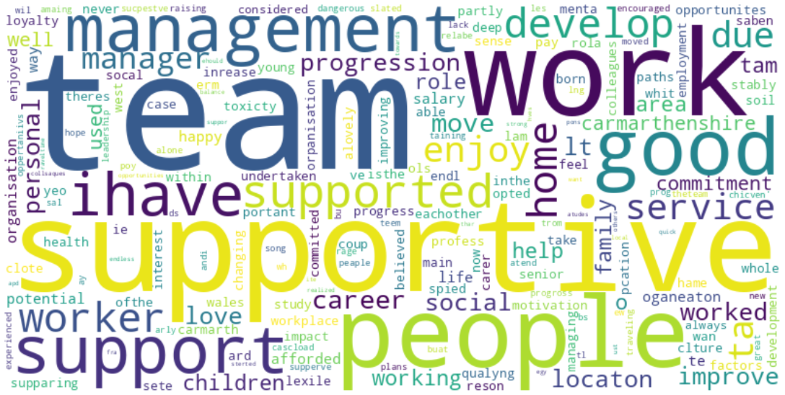
Diagram 15 illustrates the following:
The participants have highlighted a number factors that have contributed to them remaining with the organisation. A number of themes have been identified and will be addressed in turn.

- Work/Home Life Balance
- 21% (8) of participants noted location convenience (close to home) and reduced travel time are strong motivators to remain with the organisation.
- 13% (5) of participants value flexible working arrangements, such as working from home a few days a week as a reason thy have remain with the organisation long term.
- 21% (8) participants mentioned stability for family life and ability to manage personal commitments were contributors to remining with the organisation.

- Salary and Financial Stability
- Competitive pay and incremental increases (e.g., senior social worker pay rise) are cited as reasons for staying.
- While salary is important, it often appears secondary to supportive team culture. development opportunities and flexibility which weigh more heavily for participants.

- Career Development
- Opportunities for training, progression, and development are major retention factors, with 16% (6) of participants stating those development opportunities have aided their retention.
- Participants mentioned being supported to study (seconded) and encouraged to progress, which fosters strong loyalty to the organisation.
- Internal mobility (moving between teams or services) is seen positively when it improves support and workload.

- Supportive Culture and Management
- A supportive team and approachable managers are dominant reasons for staying long-term with 37% (14) of participants citing it as a reason to remain with the organisation.
- Positive team culture, collaboration, and feeling valued are critical to aid retention.
- Negative experiences (e.g., toxic environments) were mentioned as reasons for leaving previous roles, reinforcing the importance of good leadership.

- Personal and Professional Alignment
- Passion for Social Work and commitment to improving lives is a strong intrinsic motivator with 16% (6) participants identifying it as a reason they have remained with the organisation.
- Sense of giving back to the local community and alignment with personal values also play a role.

Question 16 What do you appreciate the most about working for the organisation?
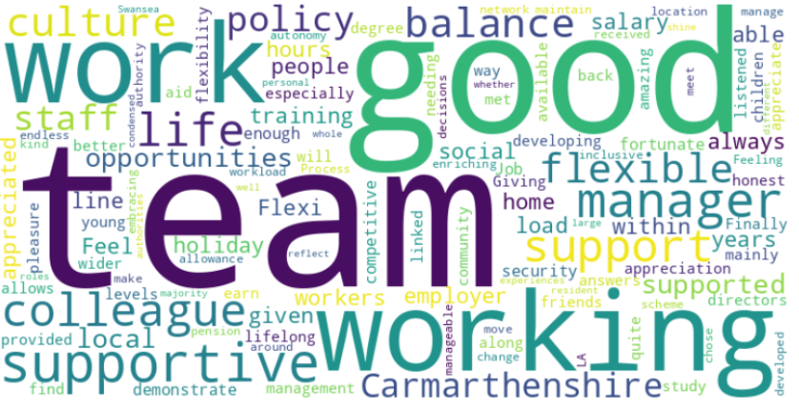
Diagram 16 illustrates the following:
Several themes have been identified and will be addressed in turn.
- Supportive Environment:
- The support relates to a number of themes including supportive managers, supportive colleagues, and supportive teams.
- 39% (15) participants highlight positive relationships that have been built with some being fostered into friendships.

- Work-Life Balance & Flexibility:
- Flexibility is mentioned repeatedly throughout, with a focus on workforce policies, condensed hours, working from home, and remote work options being highly valued by 18% (7) of participants.

- Career Development:
- 16% (6) participants identified opportunities for training, studying for a degree, and internal progression and lateral moves across service divisions as areas they appreciate about the organisation.

- Culture & Appreciation:
- 11% (4) of participants mention the culture of the organisation as something they appreciate about the organisation. Particularly how inclusive the organisation is, the kind culture within the organisation and the way the organisation makes them feel appreciated.
- Word like “inclusive,” “kind,” and “enriching” stand out.

- Job Security & Benefits:
- 13% (5) of participants appreciate the many benefits the organisation has to offer such as; good pension, holiday allowance and competitive salary.

Question 17 Can you share an example of a time you felt truly valued by the organisation?
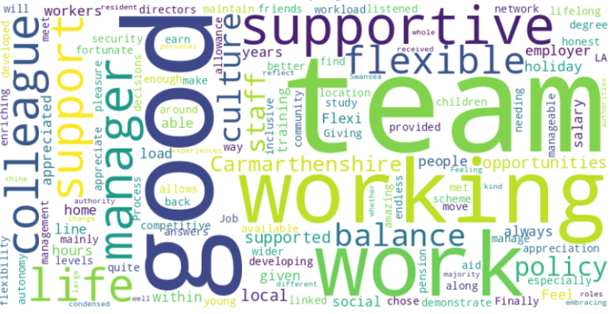
Diagram 17 illustrates the following:
Several themes have been identified and will be addressed in turn.

- Positive Feedback and Recognition
- 45% (17) of participants state they have felt valued when receiving positive feedback from management and stakeholders. Feedback provided via emails of congratulations, acknowledgement from senior managers, praise from families or praise during team meetings are mentioned.
- Example: “Praise from my supervisor and families I work with.”

- Feeling Valued Through Career Development
- A small number relate feeling valued with being seconded for study (degree or MSc) and provided with progression opportunities.
- Example: “Via progression to forensic social worker post.”

- Support During Challenging Times
- Recognition of support when experiencing challenges in home life or a decline in personal health/mental health.
- Example: “Support received when I went off on stress.”

- Autonomy and Trust
- Participants mentioned feeling valued when entrusted with additional responsibilities, asked to participate or facilitate projects or special roles.
- Example: “Responsibility entrusted to me to lead projects makes me feel valued.”

- Appreciation from Service Users
- 8% (3) of participants emphasised value from positive feedback from the individuals and families they support, particularly when they achieved positive outcomes, rather than internal recognition from the organisation.
- Example: “I have only really felt valued by the people I support when they achieve positive outcomes.”

- Regular Feedback
- 11% (4) of participants identified that regular feedback from managers and during supervision or team meetings made them feel valued.
- Example: “Regular feedback surrounding my progress and work.”

- Lack of Recognition
- 16% (6) participants indicated they were unable to recall a time whereby they felt truly valued by the organisation.
- Examples: “I can’t.” and “I cannot share anything that comes to mind.”

Question 18 What are the organisation’s greatest strengths?
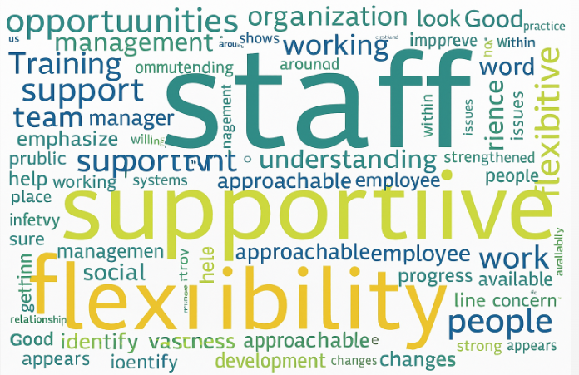

Diagram 18 illustrates the following:
Several themes have been identified linked to the organisational strengths and will be addressed in turn.

1) Flexibility
- Flexibility is a recurring theme highlighted throughout the research project, 11% (4) of participants mentioned flexibility as a strength of the organisation. However, one participant did note flexibility as an area the organisation could enhance further.

2) Staff Commitment & Quality
- There is a strong emphasis on the organisations biggest asset is its employees, with 50% (19) of participants making reference to it.
- Examples: “its people,” “frontline staff,” “passion of staff,” and “employees who work so hard.”
- Recognition of exceptional Social Workers and knowledgeable staff.

3) Supportive Leadership and Culture
- 13% (5) of participants state supportive and approachable managers are a strength of the organisation.
- There is also an emphasis on the organisation listening to staff and acknowledging feedback. Although, this is area also identified as in need of further improvement, listening is recognised as essential for maintaining trust.

4) Training & Development
- 11% (4) of participants feel the organisation offers a good range of opportunities for learning and professional growth, adding to its strengths.
- The investment in staff development is recognised as a positive means to support retention and should continue.

5) Strong Value Base
- Participants made reference to the organisation having a strong value base, investing in a culture of kindness and treating staff with respect.
- The organisation places great focus on collaboration and teamwork.

Question 19 Any other comments you would like to make?
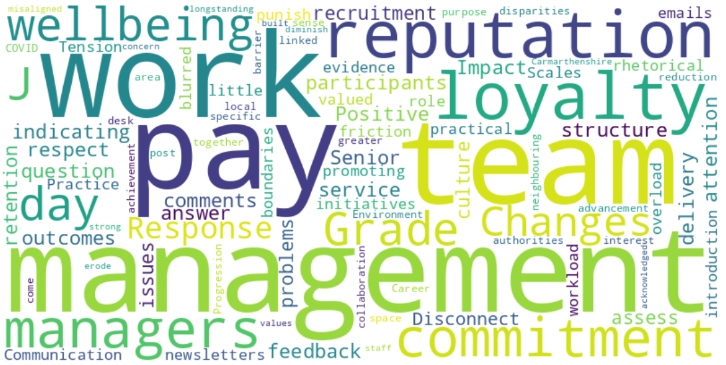
Diagram 19 illustrates the following:
An open-ended question was posed to the participants to offer them the opportunity to provide qualitative feedback in addition to the structured survey. The findings has been themed, each theme will be addressed below.

1) No Response
- 66% (25) of participants did not answer this question, indicating that many participants either had no further comments to make, or chose not to provide further feedback.

2) Management Impact
- Positive management structure is seen as crucial for respect, commitment, and positive service delivery.
- In total 19% (7) of participants made additional comments about management impact, positive and negative.
- Example: “Good management structure breeds respect and commitment from staff.”
- A participant has made a suggestion: “Senior managers should pay attention to recruitment and retention issues and assess whether problems stem from management or team culture”.

3) Disconnect Between Communication and Practice
- one participant feels that wellbeing initiatives are more rhetorical than practical.
- Example: “There are often newsletters or emails sent which provide a rhetoric about promoting wellbeing or being valued and then in person or day to day there is little evidence of this.”

4) Pay Scales & Grade J Tension
- The introduction of pay grade J role has reportedly caused friction, with concerns about blurred boundaries and workload allocation.
- Example: “It honestly feels like the managers want to punish you and overload you with work because you are a grade J.”
- A small number of staff considered leaving the organisation due to pay disparities with neighbouring local authorities.

5) Work Environment Changes
- Desk space reduction post-COVID is seen as a barrier to team collaboration by one participant.
- Example: “If we all want to come in as a team… we can’t.”

6) Reputation & Loyalty
- Carmarthenshire’s strong reputation is acknowledged by two participants, but there is concern that changes misaligned with staff values could erode loyalty.
- Example: “The reputation of Carmarthenshire is longstanding… but if changes aren’t supportive, loyalty may diminish.”

b) Focus Group
Combining survey data with qualitative insights from a focus group creates methodological triangulation, improving the robustness and credibility of the research findings. It is hoped that the focus group in this instance will allow further exploration of the survey findings, allowing the researcher to dig deeper into themes identified, uncovering the reasons behind responses and clarifying ambiguities. Furthermore, the focus group aims to validate and refine quantitative results and capture context as collective meaning can not be captured within a survey (Amir et al, 2024).
The use of focus groups in mixed methods research can face a number of limitations such as; managing group dynamics, social acceptance, and facilitator influence. To overcome group dynamic difficulties, the facilitator will need to ensure all participants have an equal opportunity to participate to ensure findings are not dominated by a single participant (Morgan, 1997). When considering social acceptance, the facilitator will need to be mindful that participants may alter their contributions to appear socially acceptable which may reduce data validity (Krueger and Casey, 2015). Barbour (2007) states that the facilitator’s skills and behaviour can significantly influence discussion quality, caution should be taken as inconsistent facilitation could threaten the reliability of data gathered. In order to mitigate the issues that could arise from group dynamics, the number of participants will be limited to 5-8 participants to ensure equitable participation. To mitigate any issues with regard to social acceptance, a confidentiality statement will be read, reassuring participants they are able to participate their differing views in a non-judgemental environment. Finally, to mitigate facilitator influence, the focus group will be semi-structured with questions prepared in advance to offer structure to the session.
Out of 38 participants 16% (6) stated they would participate in a focus group. Contact was made with all 6 participants, 3 participants agreed immediately to attend, 1 participant was unable to make a number of dates provided and 2 participants did not respond to the contact made. The focus group progressed with 3 participants, and a suitable venue was sourced to facilitate a face-to-face interaction in a convenient location for ease of attendance.
The purpose of the focus group is to gain clarity and rich data to validate or refute the themes and findings of the survey. It is hoped that the focus group will be able to provide in-depth views on a range of themes to come out of the service as well as share their lived experiences to strengthen the survey findings.
Focus Group Questions
- What is good home/work life balance?
- What Qualities / Skills / Values do Supportive Manager have?
- What can realistically be done given the data we have to retain staff?
- How do we build on the strengths?

Qualitative Data
Question 1 - What is good home/work life balance?

- Flexibility a Core Enabler
- All 3 participants identified flexibility as key to enabling good home/work life balance.
- Participant C expanded that the organisation or managers need to be flexible to aid and support employees to achieve good home/work life balance.
- Participant A shared an example of supporting a member of staff with flexible start and finish times and the use of TOIL (Time Off in Lieu) to accommodate caring responsibilities. Participant A explained that the flexible approach was central to the employee achieving good home/work life balance and remaining in work.
- Participant B shared that flexibility enables employees to manage personal pressures without sacrificing work performance, using up all their annual leave or going on sick leave due to stress.
- All 3 participants agreed that hybrid working supports the health and well-being of the workforce by allowing employees to be more present at home to meet the needs of their children and extended family.

- Role of Supportive and Compassionate Management
- Participant C expressed that a supportive manager is critical in achieving good home/work life balance. Participant C elaborated that if the manager is not supportive, flexibility is not possible.
- Participant B stated that compassionate leadership focuses on “how can you be supported to carry on working” rather than being rigid and adherence to policy, which can be a barrier to flexibility. Participant B further explained that compassionate leadership fosters trust and loyalty, reducing stress and improving retention.

- Changing Expectations of Well-being
- Participant B reflected that historically, flexible working considerations were limited to emergencies only. However, now, they are integrated into everyday work practices. Participant B further acknowledged; employees now expect proactive measures to maintain their health and well-being, not just a reactive response to crisis.

- Hybrid Working: Benefits and Challenges
- All 3 participants discussed the benefits to hybrid working and the impact on good home/work life balance. These include.
- Greater presence at home allows a parent to manage childcare without having to reduce their working hours (school runs) or take a career break. Especially women who would historically have to take a career break, put their career on hold or reduce their hours to meet their childcare needs.
- Challenges discussed included, the negative impact of isolation when working from home, lack of informal “off-the-cuff” conversations, reduced opportunities for team bonding and support. Participant A related this specifically to new staff or newly qualified social workers who would rely on more support early on in their careers.
- Participant C explained that hybrid working has had a negative impact on staff wanting to work face to face, now face to face work requires deliberate effort to maintain team cohesion.

- Impact on Efficiency and Boundaries
- Participant C also expressed concern about remote working and its negative impact on boundaries. Participant C explained that working from home can lead to fewer breaks, unsocial working hours and working excessive hours over contracted hours, impacting negatively on employee well-being and blurring boundaries. Office-based work naturally includes social breaks and informal support from colleagues.

Question 2 - What Qualities / Skills / Values do Supportive Manager have?
Category | Items
Qualities | - Human touch  - Compassion  - Fair and consistent  - Approachable  - Positive energy  - Stable and emotionally intelligent  - Experienced and credible  - Encouraging  - Present and available.
Skills | - Decision-making  - Accountability  - Practical support in difficult times  - Leadership without favouritism  - Ability to manage unpredictability.
Values | - Mutual respect  - Equity for all  - Trust between worker and manager  - Integrity
Negative Behaviours to Avoid | - Favouritism (creates toxic environment)  - Power hungry / Power hierarchies  - Avoiding difficult decisions  - Unpredictable moods taken out on staff
Diagram 20.
Qualities
- The participants further elaborated that the qualities above are important as they create a safe environment where employees feel valued and respected.
- The need for emotional intelligence, compassion and stability helps to maintain team morale and reduce stress during challenges.
- Being approachable and physically present fosters open communication and mutual trust.
- They clearly identified favouritism, unpredictable moods and not being present during difficult times as qualities to avoid, ensuring a toxic working environment is prevented.

Skills
- The three participants identified that strong decision-making and being accountable ensures clarity and progress for all.
- Practical support demonstrates hands-on leadership, which builds confidence in the manager for staff. Furthermore, it demonstrates leading by example.
- Managing unpredictability helps maintain team stability and reduces anxiety within the team.
- Points to avoid include, avoiding difficult decision making, leading from a stance of power and a lack of professional responsibility.

Values
- Participants were clear that values are the foundation of ethical leadership and organisational culture.
- Having a sound values base aligns with the Codes of Professional Practice for Social Workers and they promote fairness, inclusion, and long-term trust.
- Integrity is vital as it creates credibility and consistency in actions, further strengthening strong working relationships.
- Participants identified the following pitfalls within someone’s value base to avoid; a lack of respect or fairness (particularly in case allocation), breaching trust, not promoting team well-being.

Question 3 - What can realistically be done given the data we have to retain staff?
A thematic analysis of the information gathered from the three participants included:

- Career Development & Progression
- Issues: Limited progression opportunities due to young management team and organisational structure.
- Implication: Staff feel stuck, leading to disengagement and retention challenges.
- Recommendation: Explore structured career pathways, mentoring, and secondment opportunities.

- Flexible Working & Work/Home-Life Balance
- Issues: Flexi policy too restrictive (only one day every 2 months). Compressed hours not widely accessible/promoted. Flexi should cover full day, not just 7am–7pm.
- Implication: Current policy does not meet staff expectations for flexibility.
- Recommendation: Expand flexi options, pilot compressed hours across services, and review time bands.

- Manager Presence & Support
- Issues: Managers need to be physically present in the office for decision-making and support. Newly Qualified Social Workers require face-to-face experience and guidance to develop.
- Implication: Lack of presence impacts confidence and learning for new staff.
- Recommendation: Set clear expectations for manager visibility and structured support sessions.

- Workplace Accessibility & Safety
- Issues: Parking challenges (location of car park, uphill walk not lit). Feeling undervalued and unsafe when commuting.
- Implication: Physical barriers discourage office attendance and affect morale.
- Recommendation: Improve parking access or provide alternative solutions (shuttle, permits).

- Compassionate & Bereavement Policies
- Issues: Bereavement currently linked to sickness policy (cold letters, lack of sensitivity). Compassionate leave capped at 10 days, then sickness applies.
- Implication: Policies feel rigid and lack empathy, causing distress during sensitive times.
- Recommendation: Separate bereavement from sickness policy, empower managers with discretion, and adopt compassionate practices.

Question 4 – How do we build on the strengths?
Suggestions provided by all three participants through group discussion.

- Integrated Working & Consistency
- Introduction of POD working across Adults and Children’s services for consistency. This will strengthen partnerships across teams, especially integrated health and social care teams.
- Promotes seamless service delivery and collaboration.
- Reduces duplication and improves outcomes for service users.

- Technology & Innovation
- Magic Notes (Artificial Intelligence tool) – potential impact on well-being, requires human oversight (“human in the loop”).
- Magic Notes is not ready for the Welsh language – need inclusivity in tech solutions.
- We need to strengthen the use of tools to reduce bureaucracy in an ethical and inclusive way.
- Analysis of Artificial Intelligence impact needed.

- Training & Skills Development
- Training to use and understand Artificial Intelligence tools as they evolve quickly.
- Analysis training – staff have lost analytical skills.
- We need to ensure training keeps our workforce competent and adaptable.

- Flexible Policies & Empowered Leadership
- Policies should support flexibility and allow managerial discretion (remove red tape). We should be empowering managers to respond to individual needs, not promoting rigid policies that undermine trust.
- Managers appointed based on qualities/values, not tenure or favouritism. All managerial appointments should be made based on merit and not based on whether your “face fits”.
- Compassionate leadership should be the golden thread of all leadership training.
Compassionate leadership improves retention and workforce morale.

Analysis

The 10 themes below have been established as a result of the data gathered via the quantitative staff survey (which included qualitative questions) and qualitative focus group as illustrated above. A thematic approach has been applied as it will allow this research project to identify patterns, meanings, and relationships within the complex datasets gathered. Furthermore, a thematic approach will provide structure to the analysis, by integrating multiple subjects to build deeper understanding and make connections between the data sets gathered. Braun & Clarke (2006) argue that adopting a thematic analysis offers an accessible and theoretically flexible approach, as themes are easily understood by academics and non-academic audiences. Furthermore, Braun & Clarke (2006) state a thematic approach offers depth and richness to a research project as insights into a participant’s experiences are explored. The limitations of using a thematic approach must also be acknowledged. Hecker & Kalpokas (n.d.) state that a thematic analysis is inherently subjective, as theme identification depends heavily on the researcher’s interpretations and perspectives. This subjectivity can lead to inconsistencies and bias, where different researchers may identify different themes from the same dataset.

Theme 1 - Engagement with the Research
The organisation employs approximately 300 qualified and registered Social Workers, yet only 13% (38) participants engaged with the survey and 6 participants agreed to be contacted to participate in the focus group, with only 3 being available on the scheduled date. This low engagement reflects two main challenges: survey fatigue and the demanding nature of Social Work roles. Survey fatigue, defined as the decline in response quality or participation due to overexposure to surveys, is well-documented in research (Ghafourifard, 2024). Respondents experiencing fatigue may ignore surveys, provide superficial answers, or abandon completion, undermining data validity. Furthermore, repeated survey completion without visible action exacerbates scepticism and disengagement (Huebner & Zacher, 2021), which may explain the limited uptake despite efforts to ensure the survey was accessible to all and reassurance provided that confidentiality would be upheld.
In addition the intensity of Social Work practice, which often prioritises crisis management over routine tasks which may be considered secondary, such as research participation. Social Workers operate in high-pressure environments characterised by complex caseloads, safeguarding responsibilities, and statutory duties and deadlines. Literature consistently highlights that social work is a “high-stress profession” where time scarcity and emotional labour limit engagement in non-essential activities (McFadden et al, 2015; Ravalier et al, 2021). A number of themes highlighted from the survey reinforce this, for example: workload pressures and resource constraints were recurring themes, with 24% of respondents citing overwhelming demands. When professionals are managing crises, participation in research, even when aimed at improving retention can feel secondary to service delivery demands.
The Appreciative Inquiry approach adopted in this research study set out to mitigate disengagement by embracing a strengths perspective rather than focusing on the organisation’s shortfalls. However, the limited response rate suggests that structural and cultural barriers, such as rigid policies and insufficient managerial presence, may have impacted negatively on participation. Future strategies could include embedding research activities into reflective supervision sessions or allocating protected time for engagement, aligning with evidence that organisational support and flexibility enhance participation and retention (Chiller & Crisp, 2012; Webb & Carpenter, 2012).

Theme 2 – Work/Home–Life Balance and Flexibility
Work/home-life balance and flexibility has been a core theme identified throughout this research project. Work/home-life balance was ranked as the top motivator for retention by 58% of participants (Diagram 11) who engaged with the survey. Flexibility (hybrid working, flexitime, compressed hours) is consistently identified as critical for well-being, retention, and job satisfaction. All three participants who attended the focus group agreed that flexibility is a core enabler to achieve good work/home-life balance. Furthermore, participants from the survey linked flexibility to productivity and stress reduction: “Having the correct work/life balance is essential.” Haar et al (2014) found that a good balance between work/home-life is strongly associated with job satisfaction, well-being, and retention in Social Work and other high-stress professions.
When considering flexible working arrangements and hybrid working models, research suggests that they can improve performance and well-being but require clear boundaries and supportive leadership to reduce the risk of isolation and being overworked (Chung & van der Lippe, 2020). The focus group participants expressed that compassionate leadership is critical for enabling flexibility, with managers being empowered to exercise their discretion to adapt policies to meet individual needs identified as crucial to working flexibly. Furthermore, the current organisational flexi-policy in place is perceived as too restrictive (only one day every two months) and a lack of managerial autonomy prevents managers to respond compassionately which is likely to undermine trust and negatively impact on the benefits of flexibility such as retention (Braun & Clarke, 2006). Grant et al (2013) expressed caution to flexible working arrangements, they state that while flexibility promotes well-being, poorly implemented remote working practices can lead to isolation and blurred boundaries, increasing stress and placing pressure on staff to over work. This is further supported by the focus group findings whereby the participants identified a number of challenges to working from home such as isolation, a lack of informal “off-the-cuff” conversations/support, reduced opportunities for team bonding and informal support. Participant A related this specifically to new staff or newly qualified Social Workers who rely on more support early on in their careers.
A further consideration for good work/home-life balance and hybrid working practices is the praise it gets for allowing staff to manage home-life responsibilities. This is especially notated when it comes to females who historically would be the ones to reduce their working hours or take career breaks to carry out caregiving responsibilities. The survey shows that 79% of participants were female, confirming the workforce is female-majority, which aligns with national data for Social Work in Wales (82% female) (Social Care Wales, 2023). It is important to note that Social Work in the UK (including Wales) is widely considered a female-majority profession, with scholars stating it is a “female-majority and male-dominated” profession, because males often hold more institutional power through holding more senior positions (Hicks, 2015). This demographic context is important to note as flexible working policies often disproportionately impact females due to their caregiving responsibilities.

Theme 3 – Supportive Management and Leadership
A key retention factor for 37% (14) of participants was having a supportive manager. On further exploration with the focus group participants several qualities, skills and values were identified and linked to being a supportive manager, giving context as to what being a supportive manager looks like practically. These included: qualities such as being approachable, compassionate and fair. Skills such as being accountable, strong decision maker and offering practical support in time of need. Values such as integrity, trust, equitable and mutual respect. Roulston et al (2025) found that leadership support, supervision quality, and positive organisational culture are among the strongest predictors of Social Work retention particularly among newly qualified Social Workers. These findings clearly highlight the need for managerial physical presence within the office to offer support and guidance to the workforce, which in turn will strengthen team moral and retention.
It is also important to recognise the value placed on receiving regular sincere positive feedback from managers. 45% (17) of participants made reference to feeling valued when provided with positive feedback during supervision or during team meetings. Chiller & Crisp (2012) echoes these findings and states that supervision should be more than just a compliance process. They go on to further explain that when regular, high-quality supervision is provided it can be considered a strategic tool to aid retention. Supervision is a limitation within this research project, only a small number of participants have made reference to supervision given the design of the survey questionnaire provided. On reflection, supervision should have featured as an employee motivator (Diagram 11) allowing further exploration to take place, given it is linked to Social Work retention. It is difficult to consider supervision as a strength to further build on, given the limited data gathered.
While exploring the strengths of good management and leaders, the focus group participants also made reference to a limited number of negative behaviours that should be avoided by managers and leaders (Diagram 20). These included: favouritism (creates toxic environment), power hungry / power hierarchies, avoiding difficult decisions and unpredictable mood swings. The focus group participants linked these behaviours to creating a toxic work environment which is likely to undermine trust and contribute to staff burnout and high staff turnover. Cimino et al (2013) explored unethical or harmful behaviours exhibited by line managers and highlighted many of the same behaviours identified by the focus group participants with the addition of boundary violations whereby managers developed inappropriate relationships or misused their authority. These findings offer an insight into organisational cultures and demonstrate the varied spectrum of team cultures that can exist within one organisation.

Theme 4 - Feeling Valued & Appreciated
The importance of feeling valued and appreciated has been a constant theme linked to retention in all data sets gathered. Although, not identified as important as work/home-life balance or having a supportive manager in the motivator rankings (Diagram 11) it was the fourth most important employee motivator with (2) participants putting it in first place. Furthermore, 24% of participants explicitly stated that recognition and appreciation were critical for morale and retention. This is evidenced by qualitative findings which state, “being appreciated goes a long way.” Storm (2023) argues that feeling appreciated and valued is critical for staff well-being, which in turn influences retention and job satisfaction as it fosters engagement and loyalty from the workforce.
When considering what feeling valued and appreciated looks like, a number of themes have emerged on what supports a participant to feel valued and appreciated by the organisation. The themes identified are; receiving regular feedback/recognition, with 45% of participants reported feeling valued when receiving praise from managers, senior leaders, or service users. Career development opportunities, including secondment opportunities was another theme identified. Rose (2025) confirmed these findings and states; training and development opportunities as critical for resilience and retention. Being supported through difficult times was a further theme linked to feeling valued and appreciated, with one participant stating, “Support received when I went off on stress”. Evidencing emotional and practical support during personal crises or health challenges reinforced feelings of being valued. Finally, autonomy and trust, entrusting staff with responsibilities and involving them in projects was perceived as recognition of competence which in turn made them feel valued. Karim (2023) found that empowerment and autonomy are essential for ethical practice in Social Work, and when trust and shared decision-making is a shared priority, it strengthens retention. It was evident to see that participants who felt valued by the organisation often cited loyalty and pride in working for the organisation as reasons for staying.
When asked to reflect on a time they had felt truly valued by the organisation a staggering 19% (7) of participants ((2) Integrated Services, (1) Child and Family Services, (4) Adult Services) we unable to recall a time they had felt truly valued by the organisation. This suggests a gap in regular, meaningful feedback being provided consistently across the organisation. Of those that were unable to recall a time they felt truly valued, only (3) had considered leaving the organisation. This data conflicts with other findings that state that lack of appreciation and recognition is a major driver of turnover, with evidence showing that employees who do not feel valued are significantly more likely to leave an organisation (Wahl et al, 2025). It is important to note that (3) of the (4) participants that had not considered leaving the organisation had less than four years of continued service with the organisation, whereas all (3) participants who had considered leaving the organisation had over ten years continued service. Gitnux (2025) indicates the average burnout period for Social Work is three years, before Social Workers either change roles or exit the profession completely. These findings align with the quantitative data gathered as part of this research project.
Theme 5 - Career Development and Progression
Career development and progression opportunities are often seen as critical factors influencing long-term retention in the Social Work profession (Mor Barak, 2001). The findings from the survey showed that 0% of participants ranked training/learning and development opportunities in their top three motivators (Question 13). Although training and career development are valued by participants, these findings would suggest they are not perceived as immediate priorities compared to factors that directly impact well-being and daily work experience (e.g., flexibility or supportive managers). This suggests that while professional development is important for long-term retention, short-term motivators that are focused on reducing stress and improving work/home-life balance are deemed more of a priority to participants.
Progression opportunities and internal mobility (building skills by moving to other specialist areas) are seen as long-term retention motivators. The focus group highlighted frustration over the lack of clear career pathways, citing organisational structure and a young management team as barriers. Direct frustration at a lack of progression opportunities was rare in the survey findings and only expressed by (1) participant, who stated: “Would like more of a challenge and opportunity to progress.” However, qualitative themes collated from the focus group indicate this is a broader concern that could impact on long-term retention. It must be acknowledged that staff who see a future within the organisation are less likely to leave, suggesting the importance of clear structured career pathways to aid long-term retention (Mor Barak et al, 2001).
Theme 6 - Organisational Culture and Team Dynamics
Organisational culture and healthy team dynamics was identified as a particular strength of the organisation, with participants describing the organisational culture as “kind,” “inclusive,” and “enriching.” Furthermore, 39% of participants indicated that supportive managers and healthy teams are critical to overall moral and retention. The focus group findings reinforced the survey findings with participants stating supportive managers and team cohesion are important for moral and retention. 39% of participants also mentioned positive working relationships and collaboration as key retention factors, with some participants referring to their colleagues as friends; “The colleague I have met along the way who have and will be lifelong friends.” And
“My team is amazing, supportive and I hope to be here a long time.” These findings echo Geisler et al’s (2019) findings who concluded high-quality team dynamics and supportive organisational culture significantly reduce turnover among social workers.

When participants were asked about the organisation’s greatest strengths (Diagram 18) 50% of participants explicitly highlighted staff commitment, passion and quality as the organisation’s biggest asset. This was closely linked to the findings (receiving regular, meaningful feedback) related to question 17 whereby participants were asked to reflect on a time they felt truly valued by the organisation. 45% of participants valued receiving recognition from managers, colleagues and stakeholders. McFadden et al’s (2015) study found that recognition and feeling valued by management and the organisation significantly enhance resilience and job satisfaction. Furthermore, they highlight that when Social Workers feel appreciated and supported, they demonstrate greater commitment and willingness to go beyond their formal duties, even under high-stress conditions. Their study also echoes findings within this study as they state positive organisational culture and positive working relationships were identified as critical factors in fostering commitment and loyalty to the organisation.

In contrast a number of themes have emerged throughout the research project of behaviours to avoid which may contribute to burnout and undermine team trust. These include gaps in leadership such as a lack in transparency, managers are noted to be overloaded, not present, inconsistent in decision making and sometimes aggressive. For example, “Senior management responses can be non-existent, inappropriate and at times aggressive.” Behaviours associated with avoiding toxic team cultures include, favouritism, particularly around workload allocation and unrealistic expectations. The impact of these negative behaviours was further highlighted by a participant who expressed concern since the introduction of the J pay grade. Example: “It honestly feels like the managers want to punish you and overload you with work because you are a grade J.” In total (30) participants a staggering 79% made some reference or mentioned unhealthy culture in some form. However, out of them only (2) participants had stated they had considered leaving the organisation.

Theme 7 - Innovation and Future Readiness
As a direct result of question 4 - How do we build on the strengths? that was put to the focus group participants, it was evident to see that the organisation is aware of emerging technologies and their potential benefits and risks to practice. Focus group participants identified that the introduction of Magic Notes (Artificial Intelligence tool) had had a positive impact on the reduction of bureaucracy. However, they also expressed caution and emphasised the importance of ethical artificial intelligence use. A study by Badillo-Diaz (2025) found that artificial intelligence tools can automate administrative tasks, which in turn allows Social Workers time to focus on direct work. However, he also expressed caution as algorithms generated making assumptions, and ethical considerations around informed consent and privacy are ongoing challenges when using artificial tools.
A further consideration to emerge from the focus group to ensure the workforce is future ready is the need for ongoing training, particularly linked to the use of artificial intelligence tools and lost skills such as; analytic skills “people have lost the skills to analyse”. Identifying this as an area to further strengthen positively aligns with valuing the workforce. Participants have been clear throughout this study that they value development opportunities and opportunities to grow professionally. This clearly demonstrates that the organisation has a clear future readiness mindset through prioritisation of further training and development opportunities.

Conclusion
In conclusion, this research project set out to explore motivators that contribute to the long-term retention of qualified and registered Social Workers by adopting a strengths-based approach through adopting an Appreciative Inquiry (AI). By combining insights from the literature review, quantitative survey, and qualitative focus group, the study aimed to explore what motivates Social Workers to remain with the organisation long-term whilst identifying what organisational strengths can be further developed to aid long-term retention.
The literature review highlights retention is a multi-faceted challenge influenced by several themes such as good work/home-life balance, organisational culture, supportive leadership, manageable workloads, and opportunities for professional development/progression. Studies such as Chiller & Crisp (2012) and Blosser et al. (2010) advocate for reflective regular supervision, flexible and supportive leadership, and career progression as critical long-term retention strategies. More importantly, the literature confirms that adopting a strengths-based approach by focusing on what the organisation does well rather than an over emphasis on organisational shortfalls, fosters resilience and support sustainable improvements for the workforce.

The findings have also identified that some motivators are seen as essential, whilst others are secondary. Essential motivators focus on immediate well-being and relational support, while secondary motivators relate to recognition, development, finances and cultural factors that influence long-term engagement. Participants identified the organisation’s greatest strength is its people/workforce, and this was a core theme acknowledged by 50% of participants who cited staff commitment and passion as its most valuable asset. However, gaps with rigid policies, lack of recognition, and unclear career pathways present a risks to sustaining long-term retention of the Social Work workforce.

This research project demonstrates that a strengths-based approach is not only effective in identifying what works well but also provides a platform for the workforce to shape the future with actionable strategies for improvement. By building on existing organisational strengths such as; supportive organisational/team culture, committed workforce, and openness to innovation. The organisation can create a sustainable environment that fosters loyalty, resilience, and professional growth. Ultimately, to achieve this, retention strategies must balance essential well-being motivators (flexibility, supportive leadership) with secondary long-term development goals (career progression, finance/salary) to ensure the workforce remains engaged and future-ready.

Recommendations
The recommendation below aim to offer the organisation suggestions to take forward to further strengthen the retention of qualified and registered Social Workers employed by the organisation.
- Policy Review
- Flexi policy – review policy with the view of broadening the flexi-time bands, advertise/promote compressed hours, and pilot flexible options across Social Work services.
- Bereavement policy – develop a policy for bereavement leave and support, that is not linked to the sickness policy.
- Empower managers to use their discretion to allow compassionate and flexible support to be offered to the workforce.

- Embed Compassionate Leadership
- Make it the “golden thread” in all leadership development programs.
- Include modules on empathy, emotional intelligence, and ethical decision-making.
- Training for managers to provide regular, meaningful feedback to workforce.
- Training for managers on maintaining team connection remotely and balancing flexibility with accountability.

- Increase Manager Visibility and Presence
- Set clear expectations for managers to provide face-to-face support, especially for newly qualified Social Workers.
- Introduce structured “manager availability hours” to open the door for all to access support.

- Address Negative Leadership Behaviours
- Introduce leadership competency and behavioural standards.
- Use 360-degree feedback and audits to identify and address issues early.

- Merit-Based Recruitment and Progression
- Ensure transparent recruitment processes for managerial roles (e.g. Assessment Centre)

- Build Team Culture and Collaboration
- Allocate time for team-building activities and reflective practice sessions.
- Promote inclusive, respectful environments.

- Mentorship and Leadership Development
- Implement mentoring programs pairing experienced leaders with aspiring leaders, like the mentoring programme available to newly qualified social workers.

- Flexible Career Options
- All Social Work divisions to work in partnership to offer more lateral moves to support progressional growth, development opportunities and maintain workforce engagement.

- Strengthen Organisational Culture
- Address pay scale issues (e.g. Grade J) and clarify J grade boundaries.
- Formalise recognition frameworks to aid regular, meaningful and consistent approach to workforce feedback.

- Enhance Team Dynamics
- Consider the implementation of caseload monitoring tools and ensure equitable allocation systems are in place.
- Schedule regular in-person team days to reduce risk of isolation.
- Promote zero tolerance for favouritism and toxic behaviours within the workplace.

- Policy and Structural Changes
- Separate bereavement leave policy from sickness policy to support a
compassionate approach to management and leadership.
- Empower managers to apply discretion for compassionate leave.

- Include Supervision in future research
- To address the limitation of this study, a recommendation of exploring the role of supervision and its impact on retention in future research is suggested.

- Invest in Future Readiness
- Provide training in Artificial Intelligence tools and analytical skills, ensuring ethical and inclusive implementation, keeping the workforce future ready and upskilled.

References
- Amir, N., Guha, C., Carter, S. & Jauré, A (2024) Focus Groups. In: J.E. Edlund & A.L. Nichols, eds. The Cambridge Handbook of Research Methods and Statistics for the Social and Behavioral Sciences. Cambridge: Cambridge University Press, pp.640–664. DOI: https://doi.org/10.1017/9781009000796.029.
- Asselin, M.E. (2003) ‘Insider research: Issues to consider when doing qualitative research in your own setting’, Journal for Nurses in Staff Development, 19(2), pp. 99–103.
- Badillo-Diaz, M. (2025) ‘The Impact of AI Technology on the Social Work Profession: Benefits, Risks, and Ethical Considerations’, CW360° Spring Edition, Centre for Advanced Studies in Child Welfare. Available at: https://cascw.umn.edu/cw360deg-spring-2025/impact-ai-technology-social-work-profession-benefits-risks-and-ethical (Accessed: 18 November 2025).
- Barbour, R (2007) Doing Focus Groups. London: SAGE
- Baugerud, G. A., Sille Vangbæk, S. and Melinder, A. (2018) ‘Secondary traumatic stress, burnout and compassion satisfaction among Norwegian child protection workers: Protective and risk factors’, British Journal of Social Work, 48(1), pp. 215–35.
- Berger, R. (2015) ‘Now I see it, now I don’t: Researcher’s position and reflexivity in qualitative research’, Qualitative Research, 15(2), pp. 219–234.
- Blosser, J & Cadet, D & Down Jr, L (2010) Factors that Influence Retention and Professional Development of Social Workers, Administration in Social Work, Vol 42, Issue 2, pp. 168-177
- Brannick, T. and Coghlan, D. (2007) ‘In defence of being “native”: The case for insider academic research’, Organizational Research Methods, 10(1), pp. 59–74.
- Braun, V. & Clarke, V (2006) ‘Using thematic analysis in psychology’, Qualitative Research in Psychology, 3(2), pp. 77–101. doi:10.1191/1478088706qp063oa
- Byrne, J. and Humble, A.M. (2007) An Introduction to Mixed Method Research, Available at: https://www.researchgate.net/profile/Aine-Humble/publication/237658796_An_Introduction_to_Mixed_Method_Research/links/5d41847f299bf1995b59b888/An-Introduction-to-Mixed-Method-Research.pdf (Accessed 15/07/2025)
- Chiller, P & Crisp, B, P (2012) Professional Supervision: A Workforce Retention Strategy for Social Work?, Australian Social Work, Volume 65, Issue 2, pp. 232-242.
- Chung, H. & van der Lippe, T. (2020) ‘Flexible working, work–life balance, and gender equality: Introduction’, Social Indicators Research, 151(2), pp. 365–381.
- Cimino, A.N., Rorke, J. and Adams, H.L. (2013) ‘Supervisors Behaving Badly: Witnessing Ethical Dilemmas and What To Do About It’, Journal of Social Work Values and Ethics, 10(2), pp. 1–14.
- Cook L (2024) Strengthening the workforce: Retention in social work, Research in Practice. Available at: https://www.researchinpractice.org.uk/media/jo2plmhz/strengthening-the-workforce-retention-in-social-work-sb-web.pdf
- Cooperrider D. L. and Srivastva, S (1987) Appreciative inquiry in organisational life, Research in Organisational Change and Development, Vol. 1, pp 129-69.
- de Panfilis, D. and Zlotnik, J. L. (2008) ‘Retention of front-line staff in child welfare: A systematic review of research’, Children and Youth Services Review, 30(9), pp. 995–1008.
- Creswell, J.W (2014) A concise introduction to mixed methods research. Thousand Oaks, CA: SAGE Publications.
- Crick, J.M (2024) Analysing survey data in marketing research: A guide for academics and postgraduate students. Journal of Strategic Marketing, 32(2), pp.203–215.
- Gajjar, N.B. (2016) ‘Ethical Consideration in Research’, International Journal for Research in Education, 2(7), pp. 8-15. Available at: https://www.raijmr.com/ijre/wp-content/uploads/2017/11/IJRE_2013_vol02_issue_07_02.pdf (Accessed 16/07/2025)
- Giacalone R. A., Knouse S. B. and Montagliani A. (1997) Motivation for and Prevention of Honest Responding in Exit Interviews and Surveys, The Journal of Psychology, Volume 131, Issue 4, pp 438-448. https://www.tandfonline.com/doi/epdf/10.1080/00223989709603531?needAccess=true
- Gitnux (2025) Social Worker Burnout Statistics: What’s the Average Duration Before Leaving? Gitnux Market Data Report. Available at: https://gitnux.org/social-worker-burnout-statistics (Accessed: 17 November 2025).
- Ghafourifard, M (2024) Survey Fatigue in Questionnaire Based Research: The Issues and Solutions, Available: jcs-33287.pdf (accessed 21/10/2025)
- Gillespie, A. & Reader, T (2024) Still using the staff engagement survey? It’s time to get down into the data. LSE Executive Education Insights. Available at: https://www.lse.ac.uk/study-at-lse/executive-education/insights/articles/still-using-the-staff-engagement-survey-its-time-to-get-down-into-the-data.
- Gonzalez, R., P., Faller, K., C., Ortega,. R., M and Tropman, J (2009) Exit Interviews with Departed Child Welfare Workers: Preliminary Findings, Journal of Public Child Welfare, Volume 3, Issue 1, pp. 40-63. https://doi.org/10.1080/15548730802690833
- Haar, J.M., Russo, M., Suñe, A. & Ollier-Malaterre, A. (2014) ‘Outcomes of work–life balance on job satisfaction, life satisfaction and mental health: A study across seven cultures’, Journal of Vocational Behaviour, 85(3), pp. 361–373.
- Hecker, J. & Kalpokas, N. (n.d.) ‘Disadvantages of Thematic Analysis | Challenges & Weaknesses’, ATLAS.ti Guides. Available at: https://atlasti.com/guides/disadvantages-of-thematic-analysis (Accessed: 16 November 2025).
- Hicks, S. (2015) ‘Social work and gender: An argument for practical accounts’, Qualitative Social Work, 14(4), pp. 471–487. doi: 10.1177/1473325014558665.
- Huebner, L.-A. & Zacher, H (2021) Following up on employee surveys: A conceptual framework and systematic review. Frontiers in Psychology, 12, Article 801073. Available at: https://doi.org/10.3389/fpsyg.2021.801073.
- Karim, S. (2023) ‘Power-informed practice in social work’, Journal of Social Work, 23(6), pp. 1062–1079. doi:10.1177/14680173231180307.
- Krueger, R.A. and Casey, M.A. (2015) Focus Groups A Practical Guide for Applied Research. 5th Edition. Thousand Oaks, California: SAGE
- Lefkowitz., J and Katz, M., L (1969) Validity of Exit Interviews, Personnel Psychology, vol. 22, pp. 445-544. https://www.researchgate.net/profile/Joel-Lefkowitz-2/publication/229516641_Validity_of_exit_interviews/links/5f19999645851515ef422586/Validity-of-exit-interviews.pdf
- McFadden, P., Campbell, A., & Taylor, B. (2015). Resilience and Burnout in Child Protection Social Work: The Role of Supervisory Support and Organisational Culture. British Journal of Social Work, 45(7), 2086–2105.
DOI: 10.1093/bjsw/bcu073
- Mcleod, S. (2023) Questionnaire Method In Research, Available at: https://www.simplypsychology.org/questionnaires.html
- Menon, V and Muraleedharan, A (2020) Internet-based surveys: Relevance, methodological considerations and troubleshooting strategies, vol. 33, pp. Available at: https://pmc.ncbi.nlm.nih.gov/articles/PMC7398086/
- Mercer, J. (2007) ‘The challenges of insider research in educational institutions: Wielding a double‐edged sword and resolving delicate dilemmas’, Oxford Review of Education, 33(1), pp. 1–17.
- Mor Barak, M.E., Nissly, J.A. and Levin, A. (2001) ‘Antecedents to retention and turnover among child welfare, social work, and other human service employees: What can we learn from past research? A review and meta-analysis’, Social Service Review, 75(4), pp. 625–661. doi:10.1086/323166.
- Morgan, D.L (1997) Focus Groups as Qualitative Research. 2nd end. Thousand Oaks, California: SAGE
- Murphy, C (2025) Where are they now? An appraisal of former child protection social workers employment status and reasons for leaving child protection work, British Journal of Social Work, Volume , Issue, pp. 1-20. https://doi.org/10.1093/bjsw/bcaf064
- Naser, M (2024) What is an Exit Survey?, Smart Survey, https://www.smartsurvey.co.uk/blog/what-is-an-exit-survey
- Pulman, A. and Fenge, L. (2024) The Evolving Workplace: The Possible Impacts of Hybrid Working and Hotdesking on Retention of Social Workers, The British Journal of Social Work, Volume 54, Issue 8, pp 3755-3772. https://doi.org/10.1093/bjsw/bcae120
- Ravalier, J. M., McFadden, P., Boichat, C., Clabburn, O. and Moriarty, J. (2021) ‘Social worker well-being: A large mixed-methods study’, The British Journal of Social Work, 51(1), pp. 297–317.
- Roulston, A., Mackle, D., Ross, J., Montgomery, L., MacDermott, D., Boyle, S., McFadden, P. and Hayes, D. (2025) ‘Promoting staff retention in social work: Identifying the ‘push’ and the ‘pull’ factors from the perspective of newly qualified social workers’, The British Journal of Social Work. Advance online publication. doi:10.1093/bjsw/bcaf152.
- Russ, E., Lonne, B. and Darlington, Y. (2009) ‘Using resilience to reconceptualise child protection workforce capacity’, Australian Social Work, 62(3), pp. 324–38.
- Social Care Wales (2023) Our annual equality report: What we did in 2022 to 2023. Available at: https://socialcare.wales/our-annual-equality-report-what-we-did-in-2022-to-2023 (Accessed: 12 November 2025).
- Social Care Wales (2025) Total number of Qualified Social Workers. Available at: National Social Care Data Portal For Wales (Accessed: 18 November 2025)
- Social Services and Wel-being (Wales) Act 2014
- Storm, P. (2023) ‘Lived Experiences as a Starting Point for Social Work Research—Possibilities and Challenges’, The British Journal of Social Work, 53(3), pp. 1801–1808. doi:10.1093/bjsw/bcad035.
- Tham, P (2007) Why Are They Leaving? Factors Affecting Intention to Leave among Social Workers in Child Welfare, The British Journal of Social Work, Volume 27, Issue 7, pp. 1225-1246. https://doi.org/10.1093/bjsw/bcl054
- Unluer, S. (2012) ‘Being an insider researcher while conducting case study research’, Qualitative Report, 17(29), pp. 1–14.
- Wahl, I., Stranzl, J., Ruppel, C. and Einwiller, S.A. (2025) ‘Employee appreciation: a systematic review and research recommendations’, Annals of the International Communication Association. Advance online publication. doi:10.1093/anncom/wlaf024.
- Webb, C. M., & Carpenter, J (2012) What Can Be Done to Promote the Retention of Social Workers? A Systematic Review of Interventions, The British Journal of Social Work, Volume 42, Issue 7, pp. 1235-1255.
- Wermeling, L & Hunn, V, & McLendon, T (2013) Social Work Education's Effect on Retention, The British Journal of Social Work, Volume 49, Issue 2, pp. 222-234.
- Youle, R. (2022) Wales is facing a social worker shortage and some councils are spending millions plugging the gaps. Available at: Wales is facing a social worker shortage and some councils are spending millions plugging the gaps (nation.cymru) (Accessed: 03/04/2023)

APPLICATION FOR ETHICAL APPROVAL

RESEARCH STUDENTS
This form is to be completed by the student within SIX months for full-time students and TWELVE months for part time students, after the commencement of the research degree or following progression to Part Two of your course.

Once complete, submit this form via the MyTSD Doctoral College Portal at (https://mytsd.uwtsd.ac.uk).

This document is also available in Welsh.

RESEARCH STAFF ONLY
All communications relating to this application during its processing must be in writing and emailed to pgresearch@uwtsd.ac.uk , with the title ‘Ethical Approval’ followed by your name.

STUDENTS ON UNDERGRADUATE OR TAUGHT MASTERS PROGRAMMES should submit this form (and receive the outcome) via systems explained to you by the supervisor/module leader.

In order for research to result in benefit and minimise risk of harm, it must be conducted ethically. A researcher may not be covered by the University’s insurance if ethical approval has not been obtained prior to commencement.

The University follows the OECD Frascati manual definition of research activity: “creative work undertaken on a systematic basis in order to increase the stock of knowledge, including knowledge of man, culture and society, and the use of this stock of knowledge to devise new applications”. As such this covers activities undertaken by members of staff, postgraduate research students, and both taught postgraduate and undergraduate students working on dissertations/projects.

The individual undertaking the research activity is known as the “principal researcher”.

Ethical approval is not required for routine audits, performance reviews, quality assurance studies, testing within normal educational requirements, and literary or artistic criticism.

Please read the notes for guidance before completing ALL sections of the form.

This form must be completed and approved prior to undertaking any research activity. Please see Checklist for details of process for different categories of application.

SECTION A: About You (Principal Researcher)
1 | Full Name: |  | Patricia Jane Rhianydd Barnes
2 | Tick all boxes that apply: |  | Member of staff: | ☐ | Honorary research fellow: | ☐
 | Undergraduate Student | ☐ | Taught Postgraduate Student | ☒ | Postgraduate Research Student | ☐

3 | Institute/Academic Discipline/Centre: | Professional Practice Framework
4 | Campus: | Carmarthen (UWTSD)
5 | E-mail address: | PJRBarnes@carmarthenshire.gov.uk
6 | Contact Telephone Number: | 07814399234
 | For students:
7 | Student Number: | 1303300
8 | Programme of Study: | MA in Professional Practice
9 | Director of Studies/Supervisor: | Sarah Loxdale / Lowri Harries

SECTION B: Approval for Research Activity
1 | Has the research activity received approval in principle?  (please check the Guidance Notes as to the appropriate approval process for different levels of research by different categories of individual) |  | YES | ☐ | NO | ☒
 |  |  |  |  | Date
2 | If Yes, please indicate source of approval (and date where known): Approval in principle must be obtained from the relevant source prior to seeking ethical approval | Research Degrees Committee |  | ☐
2 |  | Institute Research Committee |  | ☐
2 |  | Other (write in) |  | ☐

SECTION C: Internal and External Ethical Guidance Materials
 | Please list the core ethical guidance documents that have been referred to during the completion of this form (including any discipline-specific codes of research ethics, location-specific codes of research ethics, and also any specific ethical guidance relating to the proposed methodology). Please tick to confirm that your research proposal adheres to these codes and guidelines. You may add rows to this table if needed.
1 | UWTSD Research Ethics & Integrity Code of Practice | ☒
2 | UWTSD Research Data Management Policy | ☒
3 | Codes of Professional Practice (Social Care Wales) Social Workers  Handling Personal Data Policy  Corporate Equality and Diversity Policy | ☒

SECTION D: External Collaborative Research Activity
If there are external collaborators then you should gain consent from the contact persons to share their personal data with the university. If there are no external collaborators then leave this section blank and continue to section E.
1 | Institution | N/A
2 | Contact person name
3 | Contact person e-mail address
4 | Is your research externally funded? |  | YES | ☐ | NO |  | ☐
5 | Are you in receipt of a KESS scholarship? |  | YES | ☐ | NO |  | ☐
6 | Are you specifically employed to undertake this research in either a paid or voluntary capacity? | Voluntary | YES | ☐ | NO | ☐
7 |  | Employed | YES | ☐ | NO | ☐
8 | Is the research being undertaken within an existing UWTSD Athrofa Professional Learning Partnership (APLP)? | If YES then the permission question below does not need to be answered. | YES | ☐ | NO |  | ☐
9 | Has permission to undertake the research has been provided by the partner organisation? | (If YES attach copy)  If NO the application cannot continue | YES | ☐ | NO |  | ☐

Where research activity is carried out in collaboration with an external organisation
10 | Does this organisation have its own ethics approval system? | YES | ☐ | NO | ☐
 | If Yes, please attach a copy of any final approval (or interim approval) from the organisation (this may be a copy of an email if appropriate).

SECTION E: Details of Research Activity
1 | Indicative title: | A Strengths Perspective, an appreciative enquiry as to what makes Social Workers stay in the same organisation.
2 | Proposed start date: | February 2025 | Proposed end date: | February 2026
Introduction to the Research (maximum 300 words per section)
Ensure that you write for a Non-Specialist Audience when outlining your response to the points below:
- Purpose of Research Activity
- Proposed Research Question
- Aims of Research Activity
- Objectives of Research Activity
Demonstrate, briefly, how Existing Research has informed the proposed activity and explain
- What the research activity will add to the body of knowledge
- How it addresses an area of importance.
3 | Purpose of Research Activity  The researcher has been a qualified and registered Social Worker for the last 12 years. More recently since the Brexit campaign and the Covid-19 pandemic the recruitment and retention of registered and qualified Social Workers has been a challenge, locally, regionally, and nationally (Williams, 2022).  When considering the retention of Social Workers, the organisation conducts exit interviews to establish reasons why Social Workers choose to leave their posts. However, the purpose of this piece of research is to adopt a strengths perspective via appreciate inquiry to establish reasons why Social Workers remain in the organisation. I am hopeful this piece of research will enable the organisation to use the data to firstly identify why Social Workers chose to remain within the organisation, and whether it is possible to use the qualitative data gathered to then replicate good practice across the organisation to support the retention of registered and qualified Social Workers.  Appreciative Inquiry is a strengths-based approach to creating change rather than identify a problem and look at how to solve it. Appreciative Inquiry involves exploring what is already working and how to build on that. It is used to support organisational and individual change (Clouder & King, 2015).  The recruitment and retention of registered and qualified social workers is a global issue that has resulted in several literature reviews and research on the topic being undertaken. Here are a few examples of relevant pieces of research linked to wanting to understand how best to retain Social Workers from a variety of standpoints (Chiller & Crisp, 2012).  - Webb, C. M., & Carpenter, J (2012) What Can Be Done to Promote the Retention of Social Workers? A Systematic Review of Interventions, The British Journal of Social Work, Volume 42, Issue 7, pp. 1235-1255.  - Chiller, P & Crisp, B, P (2012) Professional Supervision: A Workforce Retention Strategy for Social Work?, Australian Social Work, Volume 65, Issue 2, pp. 232-242.  - Wermeling, L & Hunn, V, & McLendon, T (2013) Social Work Education's Effect on Retention, The British Journal of Social Work, Volume 49, Issue 2, pp. 222-234.  - Blosser, J & Cadet, D & Down Jr, L (2010) Factors that Influence Retention and Professional Development of Social Workers, Administration in Social Work, Vol 42, Issue 2, pp. 168-177  - Williams, S. (2002) Public attitudes to social care in Wales following the COVID-19 pandemic.  - Clouder, L & King, V (2015) What Works? A Critique of Appreciate Inquiry as a Research Method/ology, Theory and Method in Higher Education, Volume 1, pp. 169-190.  (this box should expand as you type)
4 | Research Question  A Strengths Perspective, an appreciative enquiry as to what makes Social Workers stay in the same organisation.  By adopting a Strengths-Based perspective, it is hoped that the research will identify what factors (work environment, culture, support, progression opportunities and job satisfaction) contribute to the retention of Social Worker within the same organisation.  (this box should expand as you type)
5 | Aims of Research Activity  The aim of this piece of research is to:  - Understand what contributing factors supports Social Work retention within an organisation long term, taking into consideration factors such as: work environments, team culture, organisational pay structure and home/work life balance etc.  - To apply any learning or good practice identified to support the future retention of qualified and registered Social Workers within my organisation.  (this box should expand as you type)
6 | Objectives of Research Activity  The objective of this piece of research is:  - To apply any learning to come out of the research into the organisation, and replicate good practice identified, in the hope of retaining qualified and registered Social Workers long-term.  - To be able to identify barriers to retaining qualified and registered Social Workers and support the organisation to avoid any identified within the research.  - The overarching objective of the research project is to continuously improve the work environment for qualified and registered Social Workers which in turn will positively impact retention.  (this box should expand as you type)
Proposed methods (maximum 600 words)
Provide a brief summary of all the methods that may be used in the research activity, making it clear what specific techniques may be used. If methods other than those listed in this section are deemed appropriate later, additional ethical approval for those methods will be needed. You do not need to justify the methods here, but should instead describe how you intend to collect the data necessary for you to complete your project.
7 | The purpose of this research study is to gather an individuals' experience, due to this a subjectivist ontology will be adopted as the research requires qualitative data to delve deeper into the participant’s story/experience. Furthermore, adopting an interpretivism epistemology is relevant as the aim of the research study is to collate rich data with insight into the participants’ experience (Alharahsheh and Pius, 2020). The research study will require the use of both quantitative and qualitative methods, quantitative data to analyse trends/patterns and qualitative data to provide rich data on individuals’ experiences. The Methodological Approach to be adopted will be a mixed-method approach, incorporating both quantitative method via a survey and qualitative method of using a focus group (Byrne & Humble, 2007).  There are approximately 300 registered and qualified Social Workers employed by the organisation across three service areas.  - Child and Family  - Adult Social Care  - Integrated Services  To ensure ethical considerations have been adhered to, the participants will be provided with a comprehensive brief of the research study prior to providing informed consent to engage. This will outline the purpose of the research study, the aims and objectives, the means in which data will be gathered/stored (GDPR) as well as any means of minimising potential harm identified.  Survey:  The purpose of the survey is to gather predominantly quantitative data to provide an overview of the workforce, for example, age, sex, service area, years in service. Furthermore, the purpose of the survey is to carry out a thematic analysis related to the retention of Social Workers, which will include questions around work motivators, suggestions to improve and perceived advantages and disadvantages. Once themes have been established via the survey, the findings will then inform the focus group to gather rich qualitative data to support the findings from the survey.  The use of surveys will allow the researcher to offer an anonymised means of engagement and to target a wide audience (Approx 300 people) in the hope of gaining as many responses as possible. The survey will be easily accessible and sent to all registered Social Workers within the organisation via email. The survey will be developed and designed to take no longer than 10 minutes to complete, to support maximum engagement and responses.  Responses will be evaluated using different values including percentages and a Likert scale. The data will then identify themes to support the focus group. All themes identified will be presented in graphs/chart form for ease of deciphering the data (Robbins & Heiberger 2011).  Focus Group:  The purpose of the focus group is to capture the rich qualitative data from participants in line with themes that have established from the survey. To aid engagement the focus group will be held face to face in a natural venue to offer the participant reassurance that they can express themselves in an open and honest way without disruptions. The focus group will allow the researcher to gather qualitative data as well as the opportunity to consider dynamics among the participants. The focus group will have between 5-8 participants, depending on level of engagement up to 3 focus groups may need to be facilitated. Due to time constraints on participants each focus group will last no more than 2 hours allow each participant the opportunity to engage and contribute to discussions. The use of headings (themes) will be provided to the focus group to aid discussions with supplementary open-ended questions should they be required. Responses will be collated via flip chart paper notes and notes taken by the facilitator for the focus group.  Responses will be subject to a thematic analysis of all qualitative data gathered. This will allow the researcher to closely examine the data to identify common themes, topics, ideas and patterns (Clarke & Braun, 2016)  Potential risks to mitigate:  - Consent from line managers to engage with focus group.  - Ensure confidentiality and shared views remain in the room.  - Provide high level of communication to support, assist and reassure participants.  - Ensure no bias is present if participants are known to the researcher.  - Ensure clear boundaries are set with participants known to the researcher (no collusion)  - Be mindful of bias and pre-determined views the researcher may have.  - Ensure the integrity of the focus group by noting the data factual, refraining from including the researcher’s own views/interpretations.  - To select the focus group participants from an impartial stance to ensure data is clean and uninfluenced.  Alharahsheh, H.H., and Pius, A. (2020) ‘A Review of key paradigms: positivism VS interpretivism’, Global Academic Journal of Humanities and Social Sciences, 2(3), pp. 39-43. DOI: 10.36348/gajhss.2020.v02i03.001  Byrne, J. and Humble, A.M. (2007) An Introduction to Mixed Method Research, Available at: https://www.researchgate.net/profile/Aine-Humble/publication/237658796_An_Introduction_to_Mixed_Method_Research/links/5d41847f299bf1995b59b888/An-Introduction-to-Mixed-Method-Research.pdf (Accessed 29/03/2024)  Clarke. V and Braun. V (2016) Thematic Analyss, The Journal of Positive Psychology, 12(3), pp 297-298.  Robbins N. B and Heiberger, R. M (2011) Plotting Likert and Other Rating Scales, available at: Plotting Likert and Other Rating Scales  (this box should expand as you type)
Location of research activity
Identify all locations where research activity will take place.
8 | Survey:  The survey will be an electronic Microsoft Teams form, sent via email to all registered Social Workers within the organisation. Responses will collate electronically on the Microsoft database.  Focus Group:  The focus group is likely to take place in the following venues;  - Ty Parc Yr Hun, Ffordd Y Rhyd, Ammanford SA18 3EZ  - Parc Myrddin, Richmond Terrace, Carmarthen SA31 1DS  - The Beacon Centre of Enterprise Dafen Llanelli SA14 8LQ (this box should expand as you type)
Research activity outside of the UK
If research activity will take place overseas, you are responsible for ensuring that local ethical considerations are complied with and that the relevant permissions are sought. Specify any local guidelines (e.g. from local professional associations/learned societies/universities) that exist and whether these involve any ethical stipulations beyond those usual in the UK (provide details of any licenses or permissions required). Also specify whether there are any specific ethical issues raised by the local context in which the research activity is taking place, for example, particular cultural and/or legal sensitivities or vulnerabilities of participants. If you live in the country where you will do the research then please state this.
9 | N/A  (this box should expand as you type)

10 | Use of documentation not in the public domain: Are any documents NOT publicly available? | NO | ☐
10 |  | YES | ☒
11 | If Yes, please provide details here of how you will gain access to specific documentation that is not in the public domain and that this is in accordance with the current data protection law of the country in question and that of England and Wales.  Internal documents held by the organisation (policies & procedures) may not be available to the public. Should any internal documents be utilised, these can be included within the appendices if appropriate.  (this box should expand as you type)

 | Does your research relate to one or more of the seven aims of the Well-being of Future Generations (Wales) Act 2015? | YES | NO
12 | A prosperous Wales | ☒ | ☐
13 | A resilient Wales | ☒ | ☐
14 | A healthier Wales | ☐ | ☒
15 | A more equal Wales | ☐ | ☒
16 | A Wales of cohesive communities | ☐ | ☒
17 | A Wales of vibrant culture and thriving Welsh language | ☐ | ☒
18 | A globally responsible Wales | ☐ | ☒
19 | If YES to any of the above, please give details:
A Prosperous Wales:
Social Work is a statutory requirement for the organisation. Should the research highlight good practice or innovative practice that can be replicated across the organisation, this will ensure a resilient and experienced workforce is available to support individuals and their families within the community. If we are able to sustain Social Work teams with a good balance of experience and newly qualified Social Workers, this will support the future workforce as well as support service delivery to a high standard.

A Resilient Wales:
The future workforce in Social Work is currently a national crisis. This piece of research may highlight good practice that could potentially be replicated throughout the organisation to support the retention of registered Social Workers, giving us a strong and resilient workforce for the future. Thus, allowing us to capitalise and retain experienced practitioners to nurture the next generation of Social Workers.

(this box should expand as you type)

SECTION F: Scope of Research Activity
 | Will the research activity include: | YES | NO
1 | Use of a questionnaire or similar research instrument? | ☒ | ☐
2 | Use of interviews? | ☐ | ☒
3 | Use of focus groups? | ☒ | ☐
4 | Use of participant diaries? | ☐ | ☒
5 | Use of video or audio recording? | ☐ | ☒
6 | Use of computer-generated log files? | ☐ | ☒
7 | Participant observation with their knowledge? | ☐ | ☒
8 | Participant observation without their knowledge? | ☐ | ☒
9 | Access to personal or confidential information without the participants’ specific consent? | ☐ | ☒
10 | Administration of any questions, test stimuli, presentation that may be experienced as physically, mentally or emotionally harmful / offensive? | ☐ | ☒
11 | Performance of any acts which may cause embarrassment or affect self-esteem? | ☐ | ☒
12 | Investigation of participants involved in illegal activities? | ☐ | ☒
13 | Use of procedures that involve deception? | ☐ | ☒
14 | Administration of any substance, agent or placebo? | ☐ | ☒
15 | Working with live vertebrate animals? | ☐ | ☒
16 | Procedures that may have a negative impact on the environment? | ☐ | ☒
17 | Other primary data collection methods. Please indicate the type of data collection method(s) below. | ☐ | ☒
 | Details of any other primary data collection method:  (this box should expand as you type) | ☐ | ☒
If NO to every question, then the research activity is (ethically) low risk and may be exempt from some of the following sections (please refer to Guidance Notes).

If YES to any question, then no research activity should be undertaken until full ethical approval has been obtained.

SECTION G: Intended Participants
If there are no participants then do not complete this section, but go directly to section H.

 | Who are the intended participants: | YES | NO
1 | Students or staff at the University? | ☐ | ☒
2 | Adults (over the age of 18 and competent to give consent)? | ☒ | ☐
3 | Vulnerable adults? | ☐ | ☒
4 | Children and Young People under the age of 18? (Consent from Parent, Carer or Guardian will be required) | ☐ | ☒
5 | Prisoners? | ☐ | ☒
6 | Young offenders? | ☐ | ☒
7 | Those who could be considered to have a particularly dependent relationship with the investigator or a gatekeeper? | ☐ | ☒
8 | People engaged in illegal activities? | ☐ | ☒
9 | Others. Please indicate the participants below, and specifically any group who may be unable to give consent. | ☐ | ☒
 | Details of any other participant groups:  (this box should expand as you type) | ☐ | ☒

Participant numbers and source
Provide an estimate of the expected number of participants. How will you identify participants and how will they be recruited?
10 | How many participants are expected? | Survey:  The survey will be sent out to approximately 300 registered and qualified Social Workers employed by the organisation.  Focus Group:  3x Focus Groups with 5-8 participants at each.  (this box should expand as you type)
11 | Who will the participants be? | Registered and qualified Social Workers employed within three service areas:  - Child and Family  - Integrated Services  - Adult Social Care Services  (this box should expand as you type)
12 | How will you identify the participants? | An email with a link attached to the Microsoft Form will be sent out to all registered Social Workers in the organisation. However, participants will engage on a voluntary basis. (this box should expand as you type)

 | Information for participants: | YES | NO | N/A
13 | Will you describe the main research procedures to participants in advance, so that they are informed about what to expect? | ☒ | ☐ | ☐
14 | Will you tell participants that their participation is voluntary? | ☒ | ☐ | ☐
15 | Will you obtain written consent for participation? | ☒ | ☐ | ☐
16 | Will you explain to participants that refusal to participate in the research will not affect their treatment or education (if relevant)? | ☐ | ☐ | ☒
17 | If the research is observational, will you ask participants for their consent to being observed? | ☐ | ☐ | ☒
18 | Will you tell participants that they may withdraw from the research at any time and for any reason? | ☒ | ☐ | ☐
19 | With questionnaires, will you give participants the option of omitting questions they do not want to answer? | ☒ | ☐ | ☐
20 | Will you tell participants that their data will be treated with full confidentiality and that, if published, it will not be identifiable as theirs? | ☒ | ☐ | ☐
21 | Will you debrief participants at the end of their participation, in a way appropriate to the type of research undertaken? | ☒ | ☐ | ☐
22 | If NO to any of above questions, please give an explanation
 | (this box should expand as you type)

 | Information for participants: | YES | NO | N/A
24 | Will participants be paid? | ☐ | ☒ | ☐
25 | Is specialist electrical or other equipment to be used with participants? | ☐ | ☒ | ☐
26 | Are there any financial or other interests to the investigator or University arising from this study? | ☐ | ☒ | ☐
27 | Will the research activity involve deliberately misleading participants in any way, or the partial or full concealment of the specific study aims? | ☐ | ☒ | ☐
28 | If YES to any question, please provide full details
 | (this box should expand as you type)

SECTION H: Anticipated Risks

Outline any anticipated risks that may adversely affect any of the participants, the researchers and/or the University, and the steps that will be taken to address them.

If you have completed a full risk assessment (for example as required by a laboratory, or external research collaborator) you may append that to this form.
1 | Full risk assessment completed and appended? |  | Yes | ☐
1 |  |  | No | ☒
2 | Risks to participants  For example: sector-specific health & safety, emotional distress, financial disclosure, physical harm, transfer of personal data, sensitive organisational information
 | Risk to participants:  - Breach of Data/Confidentiality.  - Discrimination  (this box should expand as you type) | How you will mitigate the risk to participants:  - The researcher will need to ensure she adheres to the Data Protection legislation including GDPR. This will also include allocating numbers to each participant to protect their identities and ensure all identifiable information is redacted from all published research papers.  - The researcher will need to ensure she adheres to the Equality Act 2010, respecting each participant’s protected characteristics. Furthermore, she will reiterate the importance of confidentiality to all participants prior to them participating in the focus groups, to allow each participant to feel safe to express themselves.  (this box should expand as you type)
3 | If research activity may include sensitive, embarrassing or upsetting topics (e.g. sexual activity, drug use) or issues likely to disclose information requiring further action (e.g. criminal activity), give details of the procedures to deal with these issues, including any support/advice (e.g. helpline numbers) to be offered to participants. Note that where applicable, consent procedures should make it clear that if something potentially or actually illegal is discovered in the course of a project, it may need to be disclosed to the proper authorities
There are no foreseen issues that may cause upset to the participants. However, should they arise, the researcher will manage the issue by adopting the organisation’s policies and procedures, as well as the Codes of Professional Practice for Registered Social Workers.

(this box should expand as you type)
4 | Risks to the investigator  For example: personal health & safety, physical harm, emotional distress, risk of accusation of harm/impropriety, conflict of interest
 | Risk to the investigator:  - Bias – From being an insider researcher (part of the organisation) and a qualified and registered Social Worker.  - Reputational Damage  (this box should expand as you type) | How you will mitigate the risk to the investigator:  - The researcher will need to ensure questions within the survey are developed fairly and allow participants to participate without being led. The researcher will also need to ensure participants for the focus groups are not chosen based on the answers provided in the questionnaire (leading one way or the other), but a random sample is chosen dependant on those who provide consent to participate in the focus groups.  - To ensure the researcher’s reputation is upheld, she will need to ensure is she fully committed to the research project and completes the research project to the highest of standards. When analysing the data, the researcher can only analyse the data provided in an open and honest manner. The organisation will have the research findings provided to them, it will be their decision as to whether or not they chose to take action on the findings.  (this box should expand as you type)
5 | University/institutional risks  For example: adverse publicity, financial loss, data protection
 | Risk to the University:  - Data Protection breach.  - Lack of Resources  (this box should expand as you type) | How you will mitigate the risk to the University:  - The researcher will need to ensure she adheres to the Data Protection legislation including GDPR. This will also include allocating numbers to each participant to protect their identities and ensure all identifiable information is redacted from all published research papers. All documents in relation to the research project will be saved to a secure location, mitigating the risk of a data breach.  - The researcher will be conducting the research project alongside of working full time. Commitment to the project is vital, ensuring support from the organisation is utilised as and when available (eg- transcribing support / focus group facilitation) to aid its completion.  (this box should expand as you type)
6 | Environmental risks  For example: accidental spillage of pollutants, damage to local ecosystems
 | Risk to the environment:  N/A  (this box should expand as you type) | How you will mitigate the risk to environment:  (this box should expand as you type)

 | Disclosure and Barring Service
 | If the research activity involves children or vulnerable adults, a Disclosure and Barring Service (DBS) certificate must be obtained before any contact with such participants. | YES | NO | N/A
7 | Does your research require you to hold a current DBS Certificate? | ☐ | ☒ | ☐
8 | If YES, please give the certificate number. If the certificate number is not available please write “Pending”; in this case any ethical approval will be subject to providing the appropriate certificate number.

SECTION I: Feedback, Consent and Confidentiality

1 | Feedback  What de-briefing and feedback will be provided to participants, how will this be done and when?
The insider researcher will include a covering letter with the survey outlining the purpose of the research project, information to ensure their participation is informed and how they can request access to the research results.
The research results will also be circulated within the organisation to ensure the findings are utilised to improve the retention of qualified and registered Social Workers in the future.

(this box should expand as you type)
2 | Informed consent  Describe the arrangements to inform potential participants, before providing consent, of what is involved in participating. Describe the arrangements for participants to provide full consent before data collection begins. If gaining consent in this way is inappropriate, explain how consent will be obtained and recorded in accordance with prevailing data protection legislation.
The covering letter included with the survey will clearly outline the purpose of the research project, timing, expectations and level of commitment.
The covering letter will also include a detailed paragraph outlining that participation is optional and all participants have the right to withdraw from the research project at any time.
Prior to each focus group a verbal confirmation will be obtained from each participant in the room that they wish to continue participation in the research project.

(this box should expand as you type)
3 | Confidentiality / Anonymity  Set out how anonymity of participants and confidentiality will be ensured in any outputs. If anonymity is not being offered, explain why this is the case.
Survey – The survey will be developed in Microsoft Forms, and it will be sent to participants via email from a list of qualified and registered Social Workers within the organisation. Responses received will be anonymous.

Focus Groups – The participants randomly selected to attend focus groups will be represented throughout the research project using alphabetical letters.

(this box should expand as you type)

SECTION J: Data Protection and Storage

 | Does the research activity involve personal data (as defined by the General Data Protection Regulation 2016 “GDPR” and the Data Protection Act 2018 “DPA”)? | YES | NO
1 | “Personal data” means any information relating to an identified or identifiable natural person (‘data subject’). An identifiable natural person is one who can be identified, directly or indirectly, in particular by reference to an identifier such as a name, an identification number, location data, an online identifier or to one or more factors specific to the physical, physiological, genetic, mental, economic, cultural or social identity of that natural person. Any video or audio recordings of participants is considered to be personal data. | ☐ | X
 | If YES, provide a description of the data and explain why this data needs to be collected:
2 | (this box should expand as you type)
 | Does it involve special category data (as defined by the GDPR)? | YES | NO
3 | “Special category data” means sensitive personal data consisting of information as to the data subjects’ –  (a) racial or ethnic origin,  (b) political opinions,  (c ) religious beliefs or other beliefs of a similar nature,  (d) membership of a trade union (within the meaning of the Trade Union and Labour Relations (Consolidation) Act 1992),  (e) physical or mental health or condition,  (f) sexual life,  (g) genetics,  (h) biometric data (as used for ID purposes), | ☐ | X
 | If YES, provide a description of the special category data and explain why this data needs to be collected:
4 | (this box should expand as you type)

 | Will data from the research activity (collected data, drafts of the thesis, or materials for publication) be stored in any of the following ways? | YES | NO
5 | Manual files (i.e. in paper form)? | ☐ | ☒
6 | University computers? | ☐ | ☒
7 | Private company computers? | ☒ | ☐
8 | Home or other personal computers? | ☐ | ☒
9 | Laptop computers/ CDs/ Portable disk-drives/ memory sticks? | ☐ | ☒
10 | “Cloud” storage or websites? | ☒ | ☐
11 | Other – specify: | ☐ | ☒
12 | For all stored data, explain the measures in place to ensure the security of the data collected, data confidentiality, including details of backup procedures, password protection, encryption, anonymisation and pseudonymisation:
All data gathered as part of the research project will be held within the organisation’s database (U drive) this is a password protected data base, only the researcher has access to.
The researcher’s laptop requires a username and password for access, only known by the researcher.
Furthermore, the organisation has a firewall in place to further protect access to all organisational systems.

(this box should expand as you type)

 | Data Protection
 | Will the research activity involve any of the following activities: | YES | NO
13 | Electronic transfer of data in any form? | ☒ | ☐
14 | Sharing of data with others at the University outside of the immediate research team? | ☐ | ☒
15 | Sharing of data with other organisations? | ☐ | ☒
16 | Export of data outside the UK or importing of data from outside the UK? | ☐ | ☒
17 | Use of personal addresses, postcodes, faxes, emails or telephone numbers? | ☐ | ☒
18 | Publication of data that might allow identification of individuals? | ☐ | ☒
19 | Use of data management system? | ☒ | ☐
20 | Data archiving? | ☐ | ☒
21 | If YES to any question, please provide full details, explaining how this will be conducted in accordance with the GDPR and Data Protection Act (2018) (and any international equivalents, where appropriate):
Electronic Transfer of Data – The research project will be sending out the Microsoft Forms Survey via email. To ensure mitigation of risk, the survey will be completed anonymously, and all email addressed on the distribution list will be ‘blind’ copied in.

Use of Data Management System – The researcher will be saving all data related to the research project on the organisation’s data base. The researcher has chosen to use the U Drive area to save all data relating to the research project as no other employees are able to access the U Drive which is linked to the researcher’s username and password.

(this box should expand as you type)
22 | List all who will have access to the data generated by the research activity:
Rhianydd Barnes (Researcher)

(this box should expand as you type)
23 | List who will have control of, and act as custodian(s) for, data generated by the research activity:
Rhianydd Barnes (Researcher)

(this box should expand as you type)
24 | Give details of data storage arrangements, including security measures in place to protect the data, where data will be stored, how long for, and in what form. Will data be archived – if so how and if not why not.
All data related to the research project will be saved to the organisation’s data base, namly the U Drive, which only permits access to the owner (the researcher). The U Drive is linked to the researcher’s username and password. The organisation also has firewall software to ensure no data breaches take place.
To further mitigate risk to a data breach, the researcher will ensure all data stored on the U Drive is anonymised.
Data will be stored on the organisation’s U Drive for the duration of the research project, once the research project has concluded and all findings have been submitted, and a final mark has been awarded by the University of Wales Trinity St Davids, all data will then be deleted from the U Drive.

(this box should expand as you type)
25 | Please indicate if your data will be stored in the UWTSD Research Data Repository (see https://researchdata.uwtsd.ac.uk/ ). If so please explain. (Most relevant to academic staff)
N/A
(this box should expand as you type)
26 | Confirm that you have read the UWTSD guidance on data management (see https://www.uwtsd.ac.uk/library/research-data-management/) | YES | ☒
27 | Confirm that you are aware that you need to keep all data until after your research has completed or the end of your funding | YES | ☒

SECTION K: Declaration
The information which I have provided is correct and complete to the best of my knowledge. I have attempted to identify any risks and issues related to the research activity and acknowledge my obligations and the rights of the participants.

In submitting this application I hereby confirm that I undertake to ensure that the above named research activity will meet the University’s Research Ethics and Integrity Code of Practice which is published on the website: https://www.uwtsd.ac.uk/research/research-ethics/
1 | Signature of applicant: |  | Date: 14/10/2024

For STUDENT Submissions:
2 | Director of Studies/Supervisor: |  | Date:
3 | Signature: |  | Date:

For STAFF Submissions:
4 | Academic Director/ Assistant Dean: |  | Date:
5 | Signature: |  | Date:

Checklist: Please complete the checklist below to ensure that you have completed the form according to the guidelines and attached any required documentation:
☒ | I have read the guidance notes supplied before completing the form.
☒ | I have completed ALL RELEVANT sections of the form in full.
☒ | I confirm that the research activity has received approval in principle
☐ | I have attached a copy of final/interim approval from external organisation (where appropriate)
☐ | I have attached a full risk assessment (where appropriate) ONLY TICK IF YOU HAVE ATTACHED A FULL RISK ASSESSMENT
☒ | I understand that it is my responsibility to ensure that the above named research activity will meet the University’s Research Ethics and Integrity Code of Practice.
☒ | I understand that before commencing data collection all documents aimed at respondents (including information sheets, consent forms, questionnaires, interview schedules etc.) must be confirmed by the DoS/Supervisor, module tutor or Academic Director.

RESEARCH STUDENTS ONLY
Once complete, submit this form via the MyTSD Doctoral College Portal at (https://mytsd.uwtsd.ac.uk).

RESEARCH STAFF ONLY
All communications relating to this application during its processing must be in writing and emailed to pgresearch@uwtsd.ac.uk , with the title ‘Ethical Approval’ followed by your name.

STUDENTS ON UNDERGRADUATE OR TAUGHT MASTERS PROGRAMMES should submit this form (and receive the outcome) via systems explained to you by the supervisor/module leader.

Appendices

