I confirm that I have not used any AI tools in the research and creation of this assignment. I confirm that I have not presented any AI generated materials as my own work. I confirm I have copies of my drafts, notes, and other resources I used, which I may be asked to provide in evidence.
Part 2- Academic Poster
Reference list

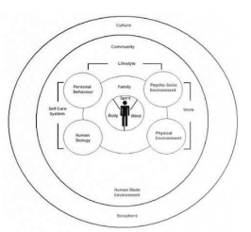
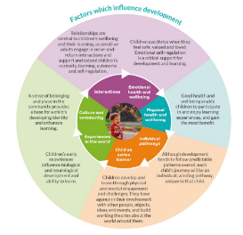
The Health Hexagon Model shows the child at the centre, with nature, exercise, meaning, relationships, diet and rest surrounding, the elements that make up the model have both long and short term impacts on health and well-being especially when implementing the six elements in a daily routine within an early years setting (Chan and Hazan, 2022). Public Health England (2019) states that offering a life course approach will increase overall health by improving the conditions into which people are born, live and work. Preserving purposeful ability, is the key outcome of the life course approach to health, then functional ability can be developed throughout life by an encouraging environment. The World Health Organisation (2021) also looks at the life-course approach, which takes a historical and social viewpoint on health and well-being, implementing the approach implies acting early in the life-course, suitably throughout life’s transitions and together as a whole culture. The Dahlgren and Whitehead model encourages people to think beyond health services, to the wider social, environmental condition and society, the model encourages people from different sectors of health to work together on a common goal (Dahlgren and Whitehead,2021). Other benefits of the model is each sector, to develop their own strategies for promoting health and reducing inequalities, whilst also still working in collaboration with other sectors.
Relevant Legislation: Welsh Government (2024b; NHS Wales, no date) introduced the Healthy Child Wales Programme (HCWP) in 2016. The function of the HCWP safeguards commitment to support the health, well-being and safety of all children aged 0-7 years and adheres to several priorities.
- To provide key public health messages from conception to 7 years, to make sure families are supported to make long term health improving decisions.
- To encourage bonding and attachment, to support positive parent-child relationships, developing secure emotional attachment for children.
- To boost positive maternal and family emotional health and resilience.
- To aid and enable families to make educated choices to provide a safe and nurturing environment.
- To help children meet all growth and development milestones.
- To keep children safe from avoidable childhood diseases through appropriate immunisations.
- To ensure correct screening programmes, for early recognition of physical, metabolic and developmental or growth concerns.
Lifestyles: A healthy lifestyle ideally should consist of several things incorporating nutritional foods and drink intake, good hygiene and exercise, both physical and mental, as well as an inclusive and safe environment both at home and within a setting (Barnardo’s, 2024). WHO (2019) issues new guidelines on physical activity for children under five years of age, for children to grow up healthy, WHO suggests that children need to spend less time sitting down and not doing anything and more time playing and having outdoor experiences. Practitioners have a duty of care set out by Welsh Government, that published the Early Childhood Play, Learning and Care Plan (ECPLC) in 2024. Porter (2024) states that the ECPLC plan describes a holistic approach to development, ensuring quality of the provision, and access to a provision. Welsh Government (2024) also links with Barnardos statement, the Welsh Government provides early years settings with a reflective practice toolkit, that warrants a positive approach to early childhood learning and care and to effectively support all children to thrive. Flying Start setting across Wales were set up to provide positive and inclusive environments for children to learn and grow, even in the deprived areas (Welsh Government (2024b). Children exposed to abuse, neglect or harm are more likely to grow up in households, where historically ACEs have been present in prior generations (Bellis et al., 2015).
Well-being: According to Madrid (2025) “the definition of a child’s well-being such as health, education, economic status, family or social life, or safety concerns. These areas can often include objective measurements for example poverty or morbidity rates, subjective indicators or the individual’s life assessment.” Child health and development are altered by conditions such as the surroundings children are brought up in, the connections the children build and the experiences the children have (NSPCC, no date). Linking with Maslow’s Hierarchy of Need (1943) Cortney (2024) acknowledges that children need shelter, food and love to be happy and healthy. However, Cortney also believes that financial factors, such as poverty and parent’s employment status, education factors, such as not being in school, other health related factors, for example low birth weight or lack of adequate health care in the early stages of development, could all have an overall impact on a child’s well-being.
Health: Dr. Otorkpa (2023), World Health Organisation (WHO) defines the concept of health as inclusive physical, mental and social well-being and not just the non-appearance of ailment or illness. Not only but also the Encyclopaedia Britannica (2025) agrees that health in humans, includes the level of any persons ongoing physical, emotional, mental and social capacity to cope with his or her surroundings. However, McDonald (2005), states that WHO’s definition of health is limited, as an individual is not actually healthy unless they have complete well-being. Even though McDonalds information is outdated, Lefrancois et al., (2025) also backs up McDonalds statement by saying WHO’s definition is restrictive since a more holistic approach is now necessary for the prevention and safeguarding of human health and well-being.

(Otorkpa, 2023)
(Birth to 5 matters, no date)
Practitioners’ role: Building positive relationships with the adults in the early years setting, will help children build upon their self-regulation skills. These skills that the children will learn are not only in the early years; by developing mentally healthy children, it will continue throughout their childhood, adolescence and into adulthood for future generations (Department for Education, 2025).
The role that practitioners have is to promote emotional well-being, which can improve children’s future development and mental health. Not only but also, establishing a nurturing, safe and enabling environment (Bruner,1961), which incorporates a sense of belonging, as well as identifying any issues with development and agreeing with the Department of Education, in building rapport with the children and their families, promotes health and well-being (Care Learning, 2024).
Early years practitioners can create a safe, healthy and secure environment, where each child is valued and listened to (UNCRC Articles 12 & 24, UNICEF, no date). Establishing daily routines within the setting, with visual timelines of what is happening throughout the day, implements constancy and sameness, reducing the anxiety some children feel, visuals are key for children with ALN, while also providing nutritional meals and snacks and rest periods, to enable the children to thrive naturally at their own pace (Hawkins, 2024).
The United Nations Convention on the Rights of the Child (UNCRC) “Article 24: states that children have the right to the best possible health care, clean water, nutritious food and a clean environment, thus enabling and promoting the child’s health and well-being (UNICEF, no date)”. Moreover, Bruner (1961, cited in Brodie, 2024b), incorporates key concepts that are still in use within early years education today. Bruner suggests a that children understand the world, through enabling experiences, revisiting concepts, reinforcing and through action and language. This theory from 1961 links with current guidelines, policies and curriculum, as previously mentioned.
. 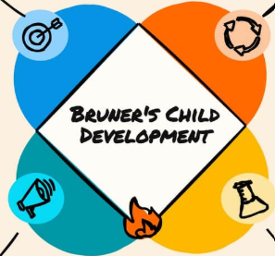 (Brodie, 2024a)
Multi-agencies: The objective is for all 2-year-olds to offer accessible funded childcare. Flying Start aims at delivering enhanced services to some of the most deprived areas in Wales (Welsh Government, 2024b). Poverty in Wales: More people are using food banks, are not capable to heat their homes, which then has an impact on health and education and strain on public services (Joseph Rowntree Foundation, 2025).
Following on, (Webster,2022) states that when children are exposed to Adverse Childhood Experiences (ACEs), such as abuse, neglect and family/household dysfunction, it then posses a risk for future problems. The Well-being of Future Generation Wales Act, 2015, is about improving the social, economic, environmental and cultural well-being of Wales, with local authorities working in collaboration to tackle poverty, health and well-being issues and by building healthier babies, children and adults (Welsh Government,2025).
Engaging with families: Regular engagement with parents and caregivers encourages the care of early years health and well-being, it helps families feel relaxed to talk about their concerns with practitioners (Hawkins, 2024). Parental engagement, encourages parents to read, talk and play with their children at home, as well as participate in activities within the early years setting. There are programmes that focus directly with parents in disadvantaged areas or families in crisis, with putting them in touch with the right support, for example Flying Start parenting workers, or Team around the family (Education Endowment Foundation, 2023).
Providing children with a connection to nature which can encourage a holistic approach to development has good outcomes, when children can learn through play outdoors, whether structured or un-structured it leads to a positive impact on health and well-being, ( Silva, Matos ,Marlene and Gonçalves, 2024). A study on children of Indigenous people, where positive early life experiences, promote their overall well-being, even though some had indicated the presence of ACEs, it was not associated with negativity more from benevolent childhood experiences (BCEs) and family satisfaction and receiving emotional support. High levels of BCEs reflects strongly with Indigenous families and the abundance of positive childhood experiences (Herman et al., 2024).

Welsh Curriclum: Area of Learning and Experiences (AoLE’s). The Health and Well-being AoLE’s provides a holistic structure to understanding health and well-being. The central structure of this AoLE is physical health and development, mental health and emotional and social well-being (Welsh Government, 2019). Public Health Wales (2022), states that with the AoLE’s it puts health and well-being at the centre of education in Wales. This links into the five What Matters statements:
- Developing physical health and well-being has lifelong benefits for children and young people.
- How children and young people process and respond to their experiences, affects their mental health and emotional well-being.
- Children and young people’s decision-making, impacts on the quality of the children’s lives and the lives of others.
- How children and young people engage with different social influences, shapes who they are and the children and young people’s health and well-being.
- Healthy relationships are fundamental to the sense of belonging and well-being.
Following on, Equal Education Partners (2023) also agrees with the holistic approach to the curriculum. Ensuring that children and young people are healthy and confident individuals, who are able to manage their daily lives as much as possible, without the need for adult intervention. This approach promotes independence in children, making a more resilient future generation of adults.
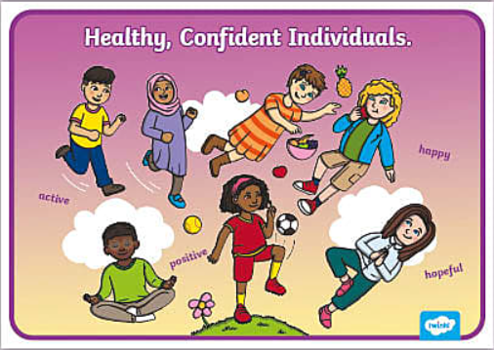
(Twinkl, 2024)

