ZERO – Waste Lifestyle Festival
Course : International Meeting Management for the Hotel Industry (BMIH6007)
Name :Anamaria Gabriela Tocila
Student id : 2120101
Lecture : Philippa Fitzgerald
Presentation link: https://uowtsd-my.sharepoint.com/personal/2120101_student_uwtsd_ac_uk/_layouts/15/stream.aspx?id=%2Fpersonal%2F2120101%5Fstudent%5Fuwtsd%5Fac%5Fuk%2FDocuments%2FRecordings%2FAssignment%201%20Presentation%2D20240208%5F110654%2DMeeting%20Recording%2Emp4&ga=1&referrer=StreamWebApp%2EWeb&referrerScenario=AddressBarCopied%2Eview
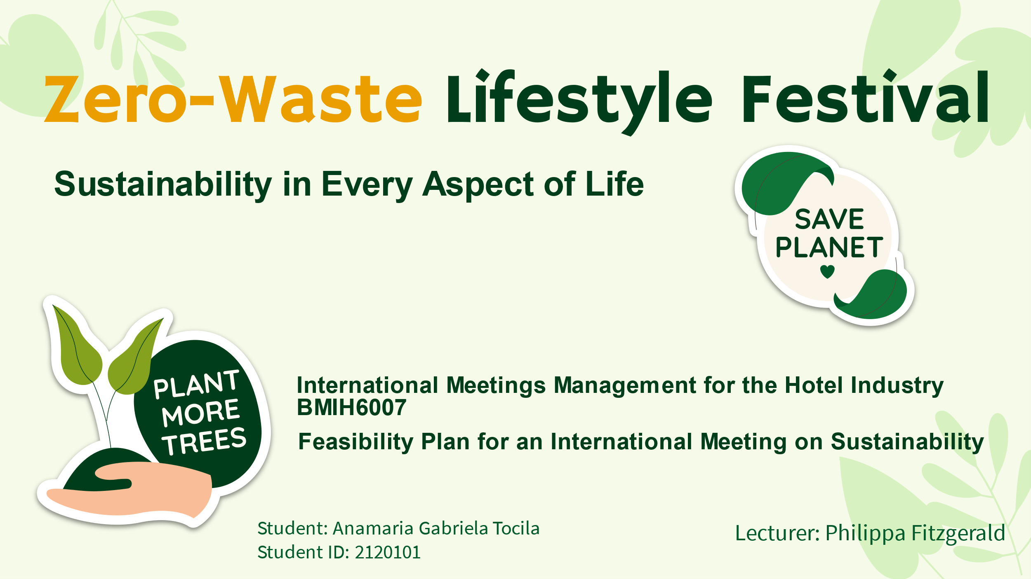

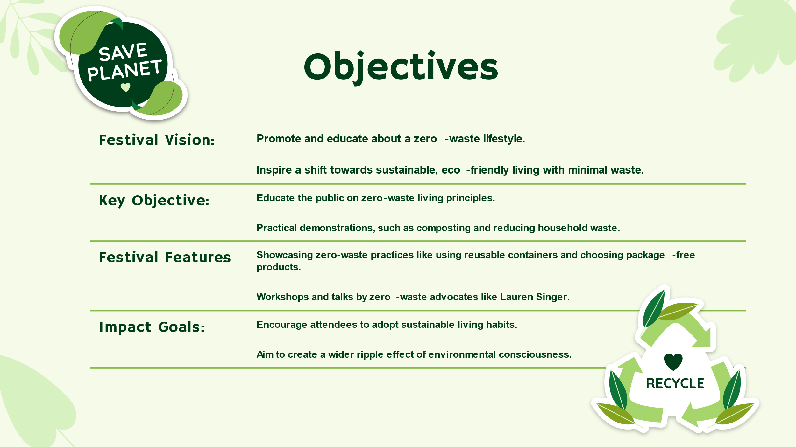
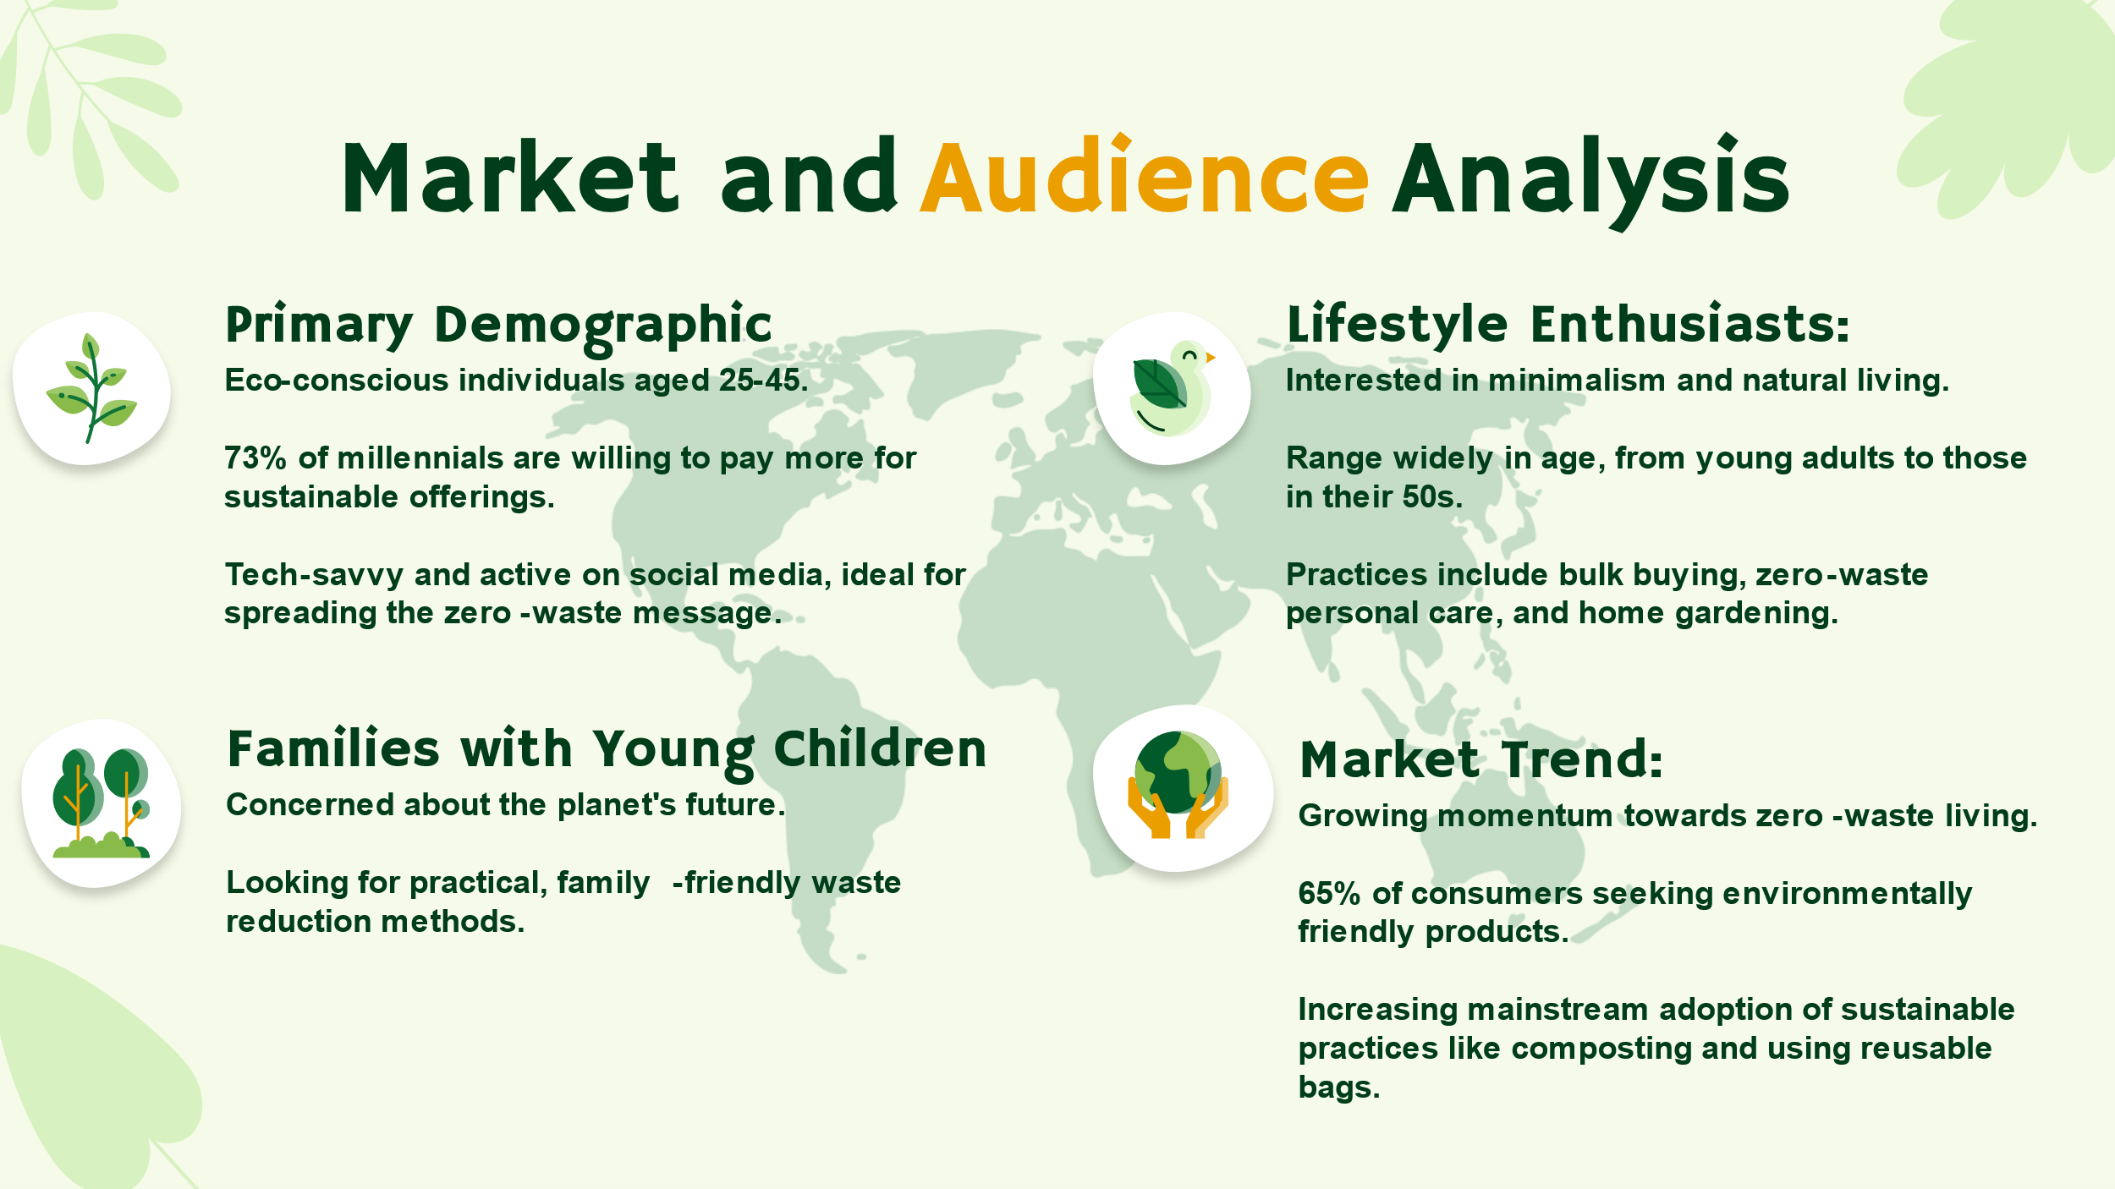
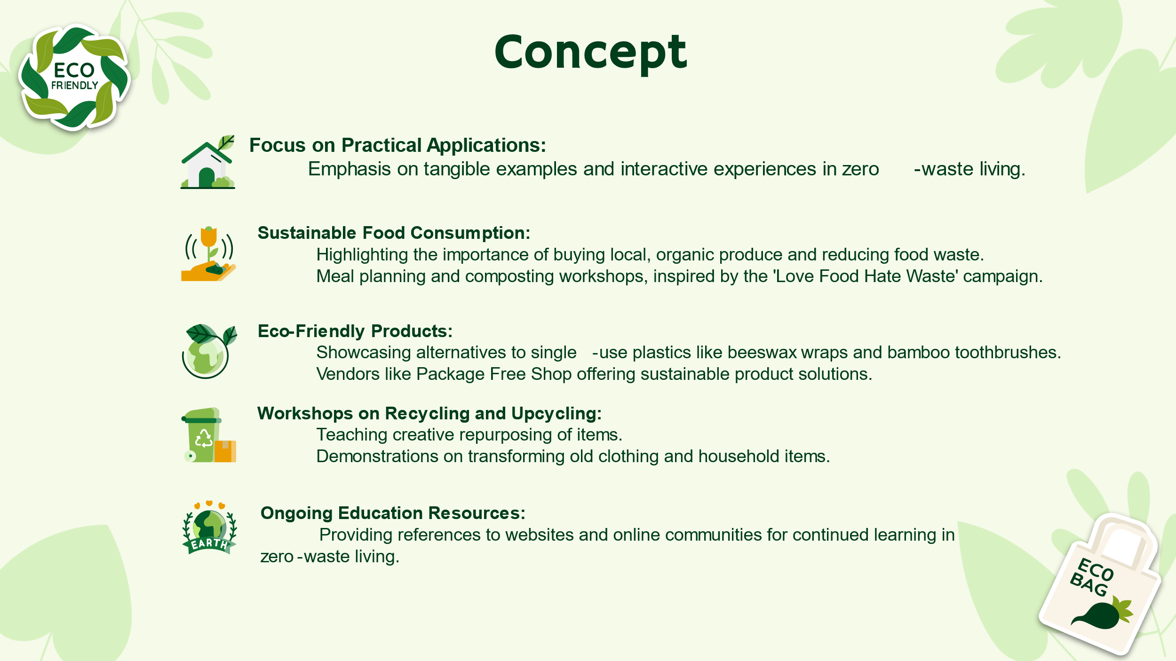
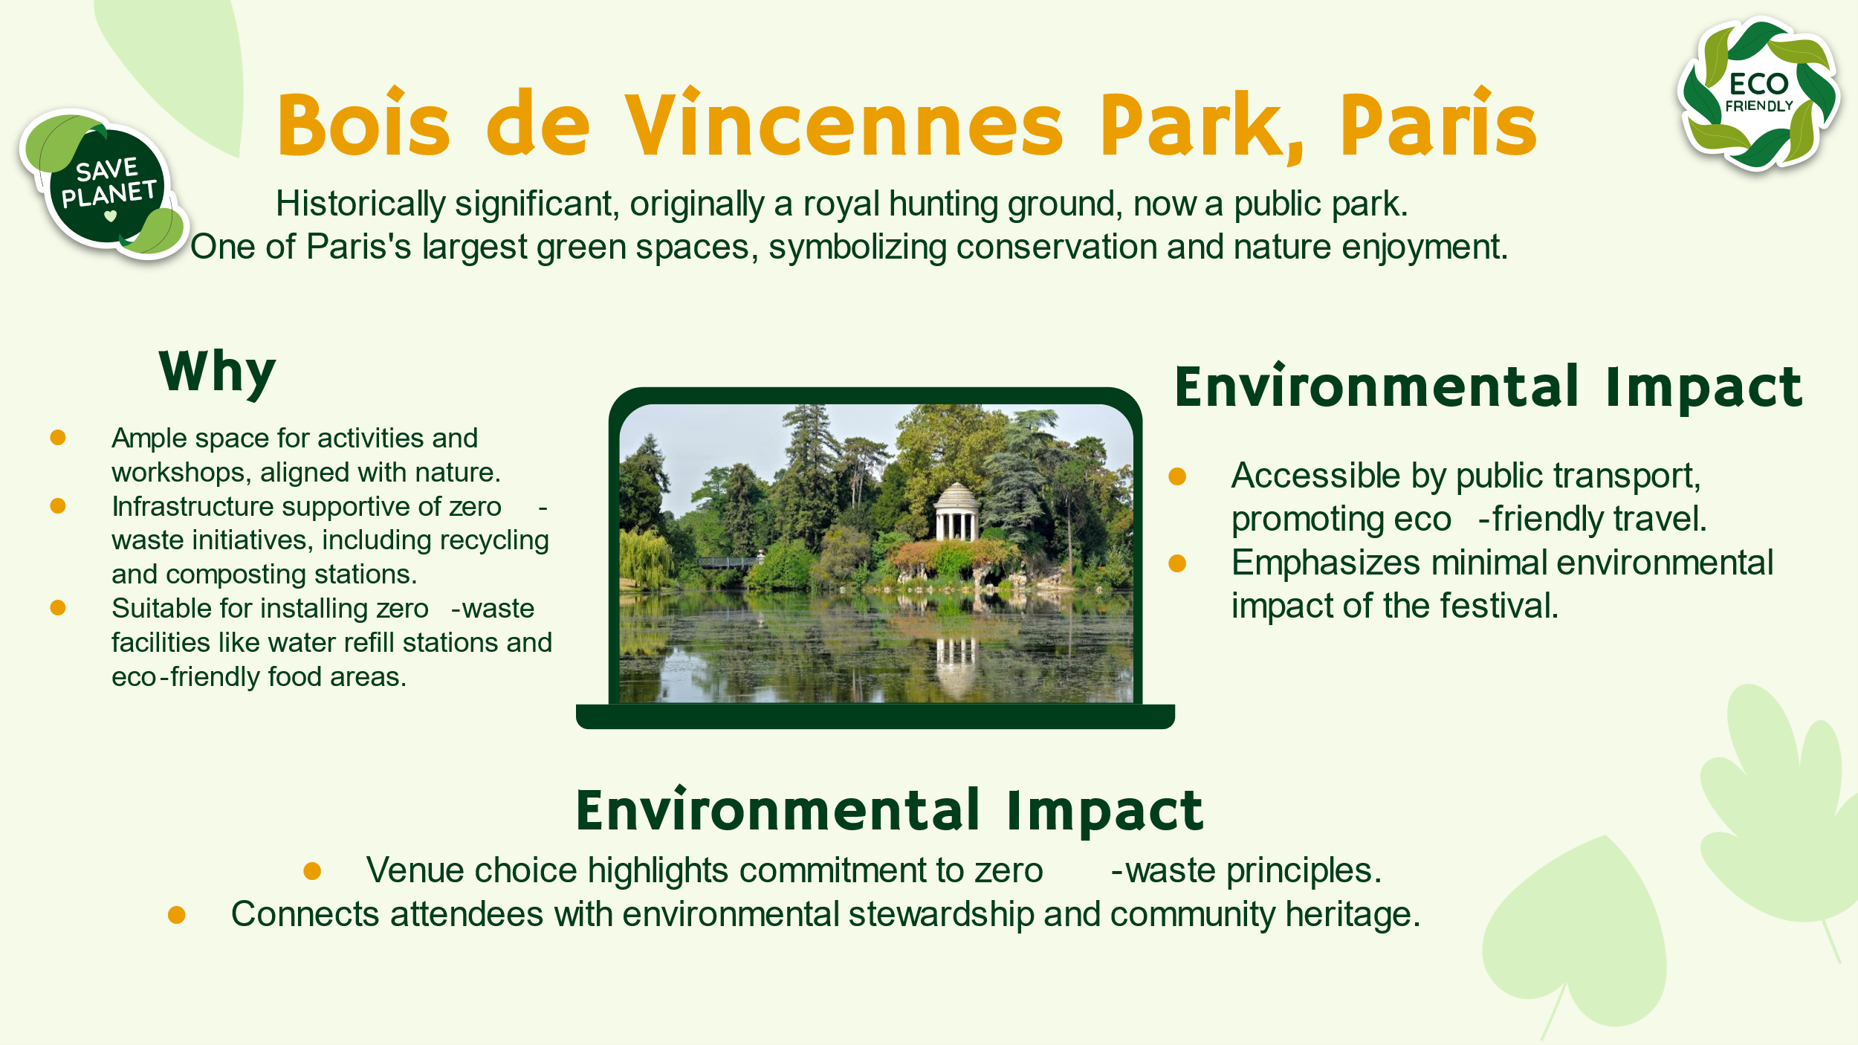
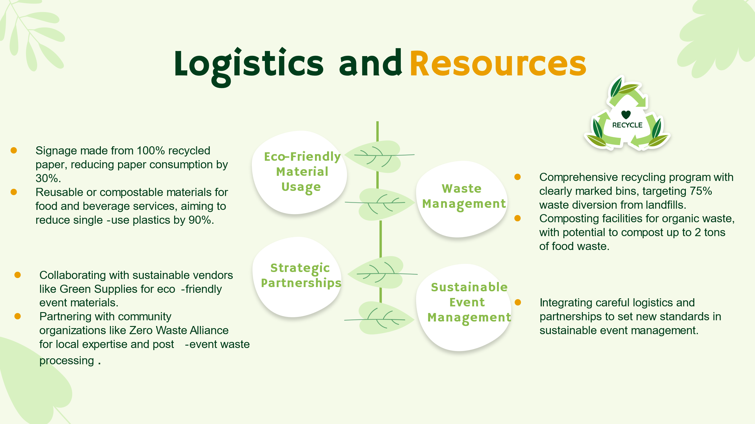
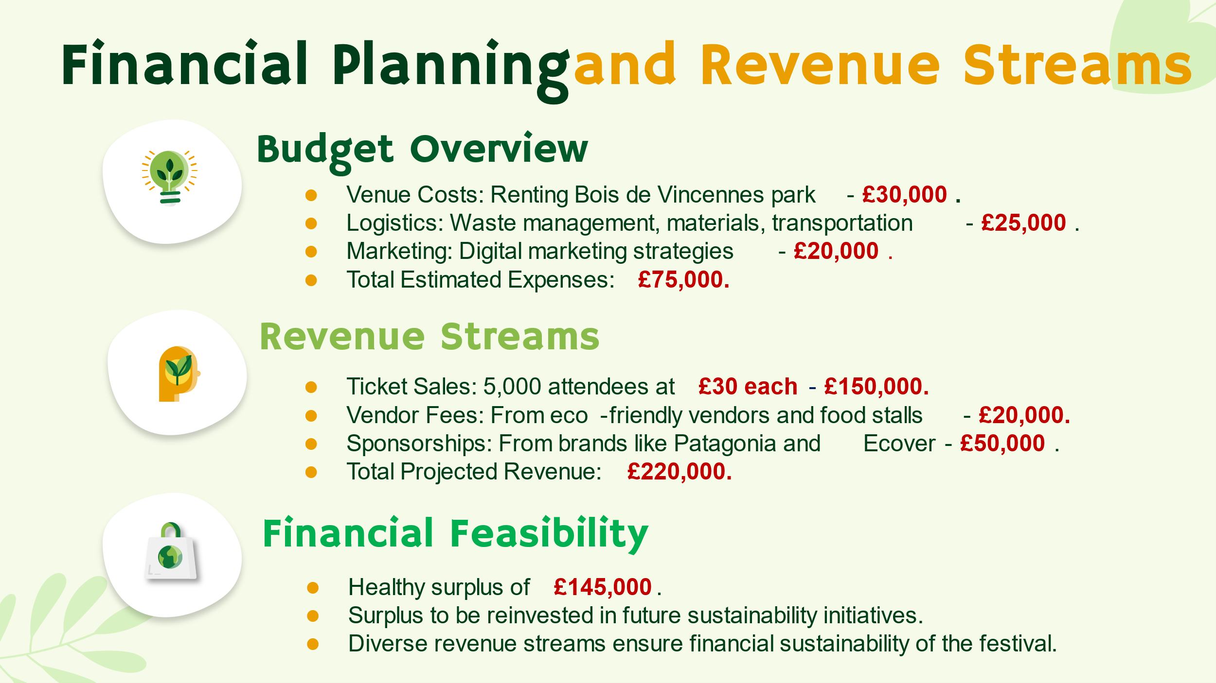
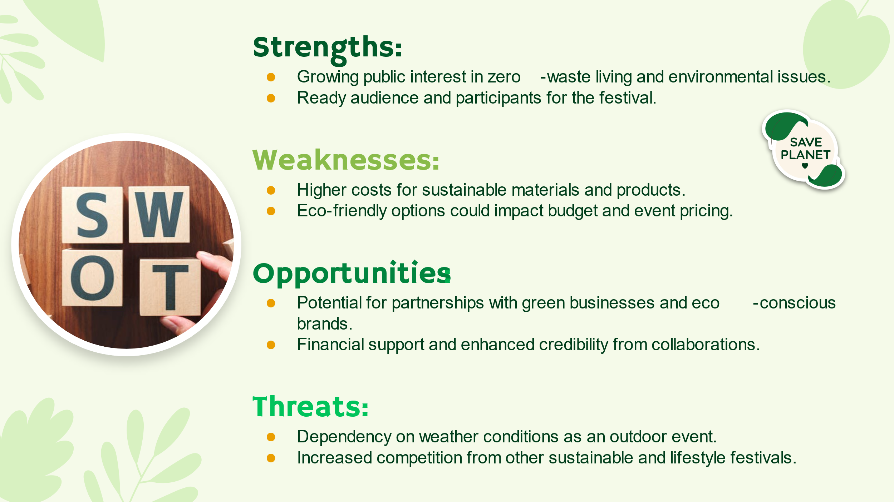
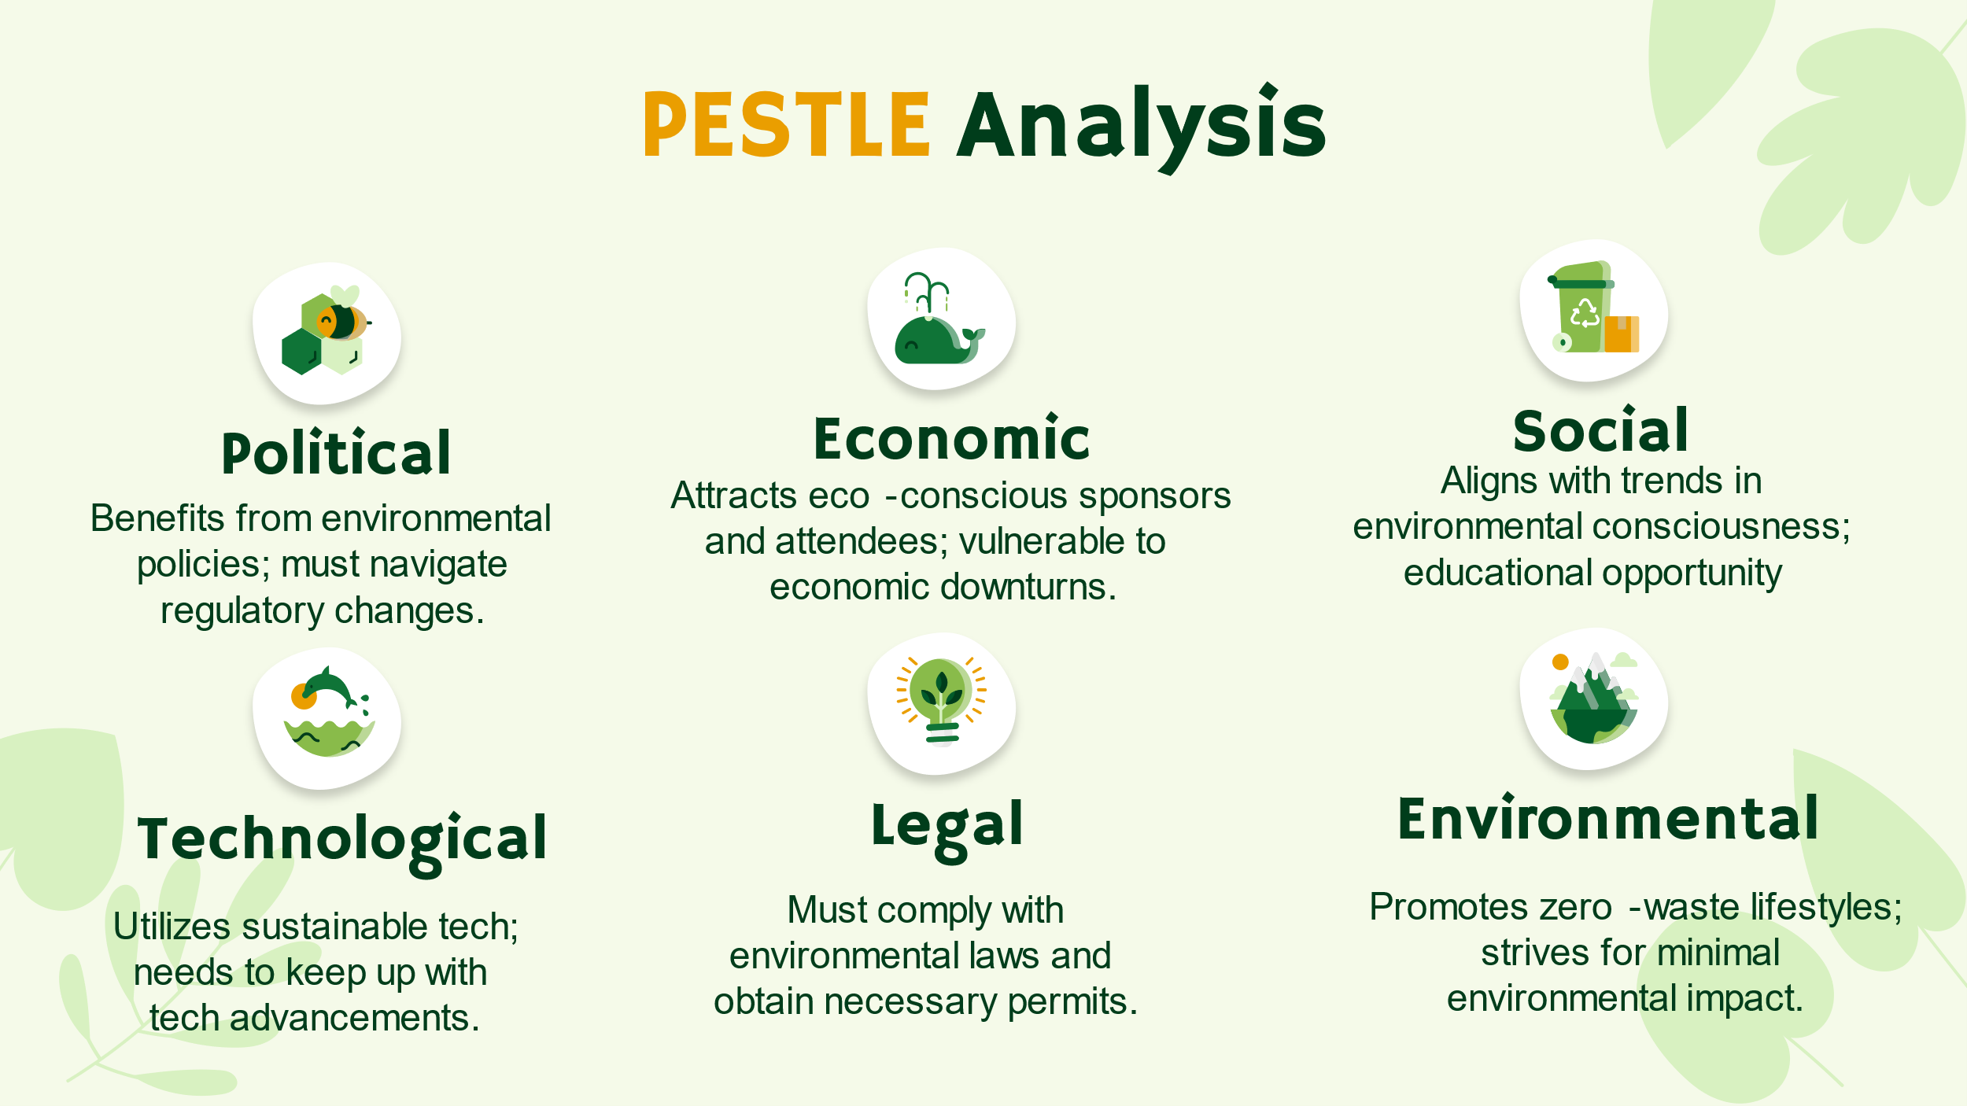
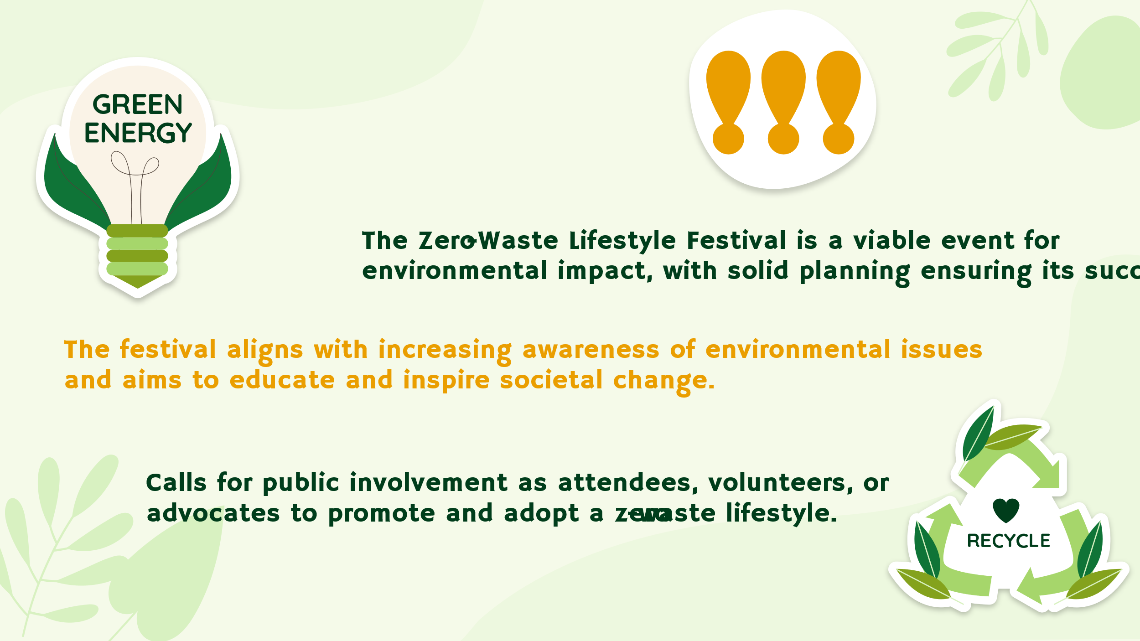

References
- 1. Angoh, M., 2023. Exploring the Feasibility of Zero Waste Approaches in Toronto’s Event Industry. https://yorkspace.library.yorku.ca/bitstreams/949cf90d-7484-4681-9a11-491cc2237f92/download
- 2. Bossek, D., Bach, V. and Finkbeiner, M., 2023. Lifestyle-LCA: Challenges and Perspectives. Sustainability, 15(14), p.11313. https://www.mdpi.com/2071-1050/15/14/11313
- 3. Chen, L., Matloob, S., Sunlei, Y., Qalati, S.A., Raza, A. and Limón, M.L.S., 2023. A moderated–mediated model for eco-conscious consumer behavior. Sustainability, 15(2), p.897. https://doi.org/10.3390/su15020897
- 4. Cheng, X.B., Liu, H., Yuan, H., Peng, H.J., Tang, C., Huang, J.Q. and Zhang, Q., 2021. A perspective on sustainable energy materials for lithium batteries. SusMat, 1(1), pp.38-50. https://doi.org/10.1002/sus2.4
- 5. Choi, H., 2023. Paris, origin of urban modernism. Urban, Planning and Transport Research, 11(1), p.2246541. https://doi.org/10.1080/21650020.2023.2246541
- 6. Crabtree, C.R., 2019. Parisian Parks Are a Pleasure Ground of Evolving Ideas About Human Nature. Culture Trip. https://theculturetrip.com/europe/france/paris/articles/the-enlightenment-of-parisian-parks
- 7. Darvishmotevali, M. and Altinay, L., 2022. Green HRM, environmental awareness and green behaviors: The moderating role of servant leadership. Tourism Management, 88, p.104401. https://doi.org/10.1016/j.tourman.2021.104401
- 8. Fromm, J., 2020. Sustainable Food Trends Will Become Center Of The Plate With Modern Consumers. Forbes. https://www.forbes.com/sites/jefffromm/2020/11/10/sustainable-food-trends-will-become-center-of-the-plate-with-modern-consumers/?sh=125fcf664fe6
- 9. Klug, K. and Niemand, T., 2021. The lifestyle of sustainability: Testing a behavioral measure of precycling. Journal of Cleaner Production, 297, p.126699. https://doi.org/10.1016/j.jclepro.2021.126699
- 10. Korsunova, A., Horn, S. and Vainio, A., 2021. Understanding circular economy in everyday life: Perceptions of young adults in the Finnish context. Sustainable Production and Consumption, 26, pp.759-769. https://doi.org/10.1016/j.spc.2020.12.038
- 11. Lammi, M., 2020. A Guide to organizing events and minimizing their environmental impacts. https://www.theseus.fi/bitstream/handle/10024/335542/Lammi%20Mette.pdf?sequence=2
- 12. Liu, M., Tan, S., Zhang, M., He, G., Chen, Z., Fu, Z. and Luan, C., 2020. Waste paper recycling decision system based on material flow analysis and life cycle assessment: A case study of waste paper recycling from China. Journal of environmental management, 255, p.109859. https://doi.org/10.1016/j.wasman.2019.10.041
- 13. Milfont, T.L., Poortinga, W. and Sibley, C.G., 2020. Does having children increase environmental concern? Testing parenthood effects with longitudinal data from the New Zealand Attitudes and Values Study. PLoS One, 15(3), p.e0230361. https://doi.org/10.1371/journal.pone.0230361
- 14. Moriki, E., 2023. Music management for new media events and festivals. https://repository.ihu.edu.gr/xmlui/bitstream/handle/11544/30186/Dissertation%20Moriki%20Eleni%20.pdf?sequence=1
- 15. Notaro, S. and Paletto, A., 2022. Attitude and willingness to pay of young generations toward bio-textile produced using wood fibers. Ann. Silvic. Res, 47, pp.10-23. https://www.researchgate.net/profile/Alessandro-Paletto/publication/360243894_Attitude_and_willingness_to_pay_of_young_generations_toward_bio-textile_produced_using_wood_fibers/links/632abfdb071ea12e364c5118/Attitude-and-willingness-to-pay-of-young-generations-toward-bio-textile-produced-using-wood-fibers.pdf
- 16. O’Callaghan-Platt, A. and O’Brien, M., 2021. No Home for Plastic. EPA Research Report. Johnstown Castle, Wexford: Environmental Protection Agency. https://www.epa.ie/publications/research/socio-economics/Research_Report_363.pdf
- 17. Package Free. Package Free Shop | Shop Zero Waste & Other Eco-Friendly Products. https://packagefreeshop.com/
- 18. Phelan, A.A., Meissner, K., Humphrey, J. and Ross, H., 2022. Plastic pollution and packaging: Corporate commitments and actions from the food and beverage sector. Journal of Cleaner Production, 331, p.129827. https://doi.org/10.1016/j.jclepro.2021.129827
- 19. Quinn, B., Colombo, A., Lindström, K., McGillivray, D. and Smith, A., 2021. Festivals, public space and cultural inclusion: public policy insights. Journal of Sustainable Tourism, 29(11-12), pp.1875-1893. https://doi.org/10.1080/09669582.2020.1858090
- 20. Rinaldi, C., Cavicchi, A. and Robinson, R.N., 2022. University contributions to co-creating sustainable tourism destinations. Journal of Sustainable Tourism, 30(9), pp.2144-2166. https://doi.org/10.1080/09669582.2020.1797056
- 21. Shahid, K. and Hittinger, E., 2021. Techno-economic optimization of food waste diversion to treatment facilities to determine cost effectiveness of policy incentives. Journal of Cleaner Production, 279, p.122634. https://doi.org/10.1016/j.jclepro.2020.122634
- 22. Shao, S., Hu, Z., Cao, J., Yang, L. and Guan, D., 2020. Environmental regulation and enterprise innovation: a review. Business strategy and the environment, 29(3), pp.1465-1478. https://doi.org/10.1002/bse.2446
- 23. Shridhar, A., 2021. Understanding the Path to Purchase. https://www.anuarioseguros.lat/admin/storage/files/aTipos_de_consumidores.pdf
- 24. Upcycle That. Upcycling Ideas And Inspiration. https://upcyclethat.com/
- 25. Vignesh, K.S., Rajadesingu, S. and Arunachalam, K.D., 2021. Challenges, issues, and problems with zero-waste tools. In Concepts of Advanced Zero Waste Tools (pp. 69-90). Elsevier. https://doi.org/10.1016/B978-0-12-822183-9.00004-0
- 26. Xie, L., Zhu, J. and Benson, D., 2022. Partnership building? Government-led NGO participation in China’s grassroots waste governance. Geoforum, 137, pp.32-41. https://doi.org/10.1016/j.geoforum.2022.10.004
- 27. Zhou, M., Govindan, K. and Xie, X., 2020. How fairness perceptions, embeddedness, and knowledge sharing drive green innovation in sustainable supply chains: An equity theory and network perspective to achieve sustainable development goals. Journal of Cleaner Production, 260, p.120950. https://doi.org/10.1016/j.jclepro.2020.120950

