1.Introduction
Before starting this report, we have to clear the meaning of the word “communication”. According to Cambridge Dictionary the word “communication” means “the process of sharing information, especially when these increases understanding between people or groups”. So, communication is one of the most important parts of the business, but to be effective it should be understandable and not in the end easy. Communication should be easy and understandable in all of its forms, it doesn’t matter if it will be verbal or non-verbal. Poor communication can lead to bad consequences for the team and the business. We cannot work as a team if we cannot talk to each other and if we cannot understand each other, we cannot reach our company goals and work together to build the prosperity of the company. In this report I will look at the different models of communication and what impact they have in working environment.

2. Models of Communication
2.1 Shannon and Weaver Model of Communication - 1949
Shannon and Weaver model of communication is defined as a mathematical theory of communication that is used for facilitating communication between a sender and a receiver. This model is designed to develop the effective communication between the sender and receiver and also describes how the message cannot be transmitted properly because of ,,Noise’’ (Mehta 2023). They are four main parts of this communication model: Sender, Message, Channel and Receiver. For example, if someone (the sender) wants to send a message (the message) over the phone (the channel) to another person (the receiver) and for some reason that someone is in a nosy place, the message may not be understood properly because of this noise. The example that was given in class to explain the case study is ‘’Maria and Pedro’’. Maria calls Pedro and tells him to get chicken, but since he works in a noisy place instead of chicken, he understands kitchen and the communication between them in not successful. There is misunderstanding of the message due to noise.
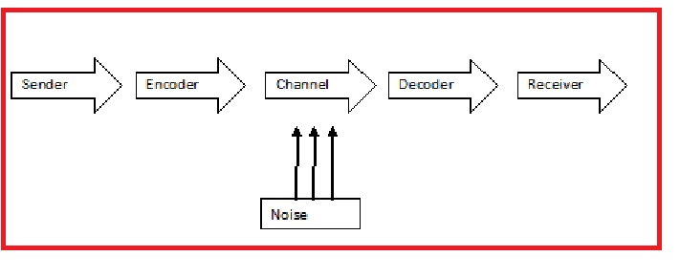

2.2 Schramm’s Model of Communication – 1954
According to Schramm's approach, communication occurs through a process including an encoder and a decoder. These two most crucial components of an efficient communication are necessary for information to move between two people. Schramm's concept states that a message is not complete until the sender receives feedback from the recipient to show that the massage has been received. Any communication that does not involve decoding or feedback is not complete or effective ( Feicheng, 2015). For example, if Pedro could have called Maria and asked what she meant when she said kitchen then there would be no misunderstanding and he would have understood the message correctly. In this way the mistake that Pedro made would have been prevented. 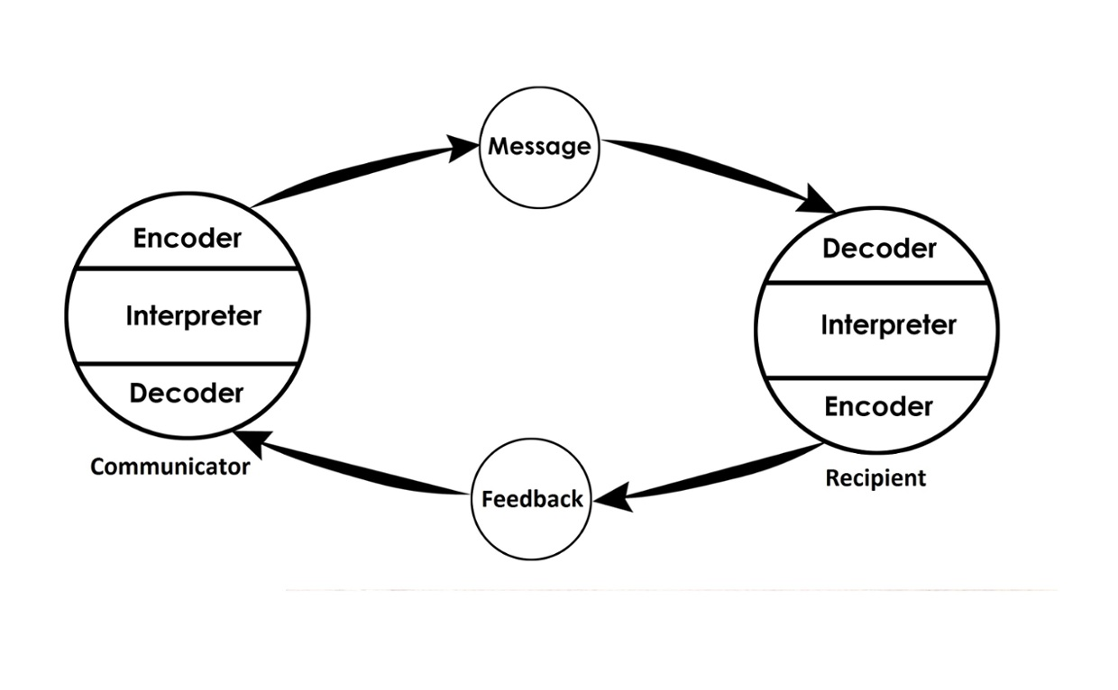

2.3 Berlo’s SMCR Model of Communication – 1964
From Shannon Weaver's Model of Communication, David Berlo proposed the Sender-Message-Channel-Receiver (SMCR) model of communication. He discussed the elements that affect each part of communication and improve its effectiveness. Sender, message, channel, and receiver are the four components which describe the communication preces. Many different elements have an impact on each component. Communication skills, Attitude, Knowledge, Social systems, Culture are the five factors that are relevant to the sender and are also relevant to the receiver. Communication skills- the message will be transmitted more effectively if the sender has high communication skills than if they are lacking. Similar to this, communication will not be successful if the recipient cannot understand the message. Attitude - the influence of the communication is created by the attitudes of the sender and the recipient. The meaning and impact of the message are altered by the sender's attitude toward themselves, the recipient, and the surrounding circumstances. Knowledge- understanding the topic of the communication increases the impact of the message that is communicated. Communication is effective when the communicator is knowledgeable about the issue. Social system- values, convictions, laws, regulations, religion, and a host of other social elements influence the sender's method of message delivery. It alters the way messages are generated. Culture -something that is hurtful to someone from one culture may not be offensive to someone from another one. With the example that was given in class to understand more about this model of communication ‘The Professor and the Village People’ in this case the professor addresses them and uses a very high level of speaking and they can not understand what he is saying to them. They have another level of language knowledge and the communication between them is not effective. In this communication model there is no two-way communication- communication is linear There is no concept of feedback or concept of noise.

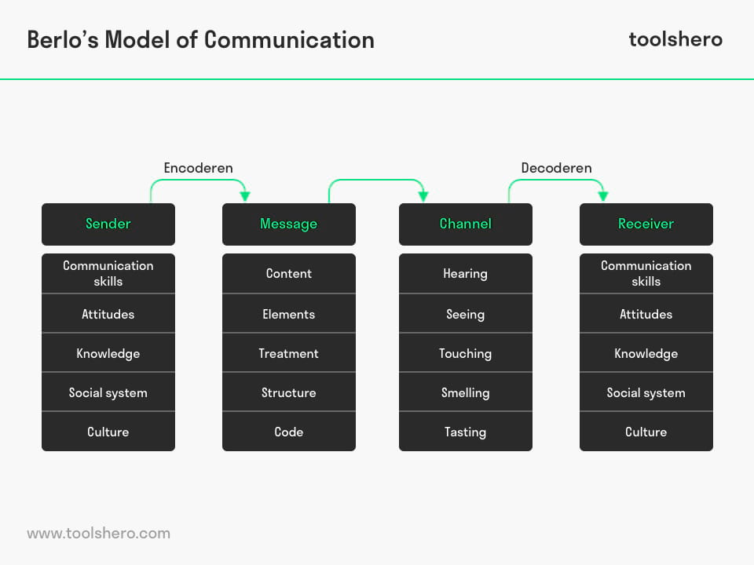
3.0 Communication skills
3.1 Verbal Skills
During talks, presentations, and casual conversations, people express themselves in a variety of ways through verbal communication. The effectiveness of this communication method can vary. It will depend on a variety of verbal communication abilities, including your voice loudness, tone of voice, speech clarity, and the quality of the words you employ. The response you get will probably give you a good indication of how effective your communication is. By thinking about your target audience and how you might modify your message so people will pay attention to you and understand you. You have a lot of control over verbal communication to change your message if necessary. Effective communication depends on both the speaker and the audience. Although you have no influence over the audience, you may make an effort to make your message as clear as you can.

3.2 Non-Verbal

Nonverbal cues are very important in conversation. People typically believe in visual images but not speech because of a psychological distinction between the two. Tone of voice, body language, and eye contact are the three key nonverbal cues that influence how others will interpret your message. Your posture, tone of voice, amount of eye contact, gestures, and other nonverbal behaviours all convey important messages. They can make people feel at ease, foster trust, and entice people to you, or they can irritate, confound, and undercut what you're trying to say. For example, if we look away from someone it shows uncertainly and disbelief in what we want to say.

3.3. Active Listening

Active listening is a very important skill. Active listening does not always entail listening for extended periods of time. It means listening attentively and being concentrated and fully concentrating on what is being said rather than just passively ‘hearing’ the message of the speaker. Active listening is a skill that can be acquired and developed with practice. However, active listening can be difficult to master and will, therefore, take time and patience to develop. Active listening is very important when working with more people. Everyone must be concentrated and listening carefully to what the leader wants say.

3.4. Empathetic Listening
Empathic Listening

4.0. The Advantages and Disadvantages of Communication Technology
In the modern world, communication has undergone significant change as personal touch has mostly been replaced by communication technology. Technology used for communication includes things like emails, cell phones, and social media. One advantages of communication technology is speed because communications are conveyed quickly and responses are given right away. Another advantage are tools like video conferencing, Skype, and social networks, the internet has also made it possible for many people to communicate face-to-face while living in separate places. Additionally, the cost of communication is reduced as compared to other methods, such as long-distance phone calls.

5. Conclusion
In conclusion I want to add that good communication can make the work environment much better, it can bring only positives to the team and company if it comes with good understanding. It doesn’t matter how big is the company, quality communication will positively impact your business productivity, staff, investors etc. Never forget that good communication is not only to be good at speaking, but to be a good listener and being able to understand what your colleagues and the business climate tells you. By using the proper communication tools and techniques, your business will grow and will be well prepared to face the challenges in today’s competitive business world.

