Fault Diagnostics and Condition Monitoring
The Concepts involved in Condition Based Monitoring
Finn Rees
16/01/20

Contents

Introduction 2

P-F diagrams and task frequency 3

Temperature measurements 3

Dynamic monitoring 4

Oil analysis 6

Corrosion monitoring 7

Conclusion 8

Bibliography 9

Introduction

This report will explain what condition based monitoring is, as well as discuss the following:
equipment failure,
potential failure and how to avoid it,
P-F diagrams and task frequency,
temperature measurements,
dynamic monitoring,
oil analysis,
corrosion monitoring,
non- destructive testing.

This report will endeavour to use an appropriate range of sources for information in order to alleviate any personal bias from authors. Credible (academic journals) and current (within the last 5 years) sources for reference will also be sought after to strengthen this report. These sources of information will have in text citations as well as a bibliography so that references can be reviewed when needed.
Condition based monitoring (CBM) is a predictive maintenance technique that includes quantitative measurement techniques that helps in the prediction of failure and calculating the life of a machine, which helps to prevent “unscheduled downtime” (Wenzel, 2019). When appropriately planned CBM “can be effective in improving equipment reliability at reduced costs” (Suzan Alaswad, 2016). Avoiding catastrophic failure is also beneficial because when something catastrophically fails more of the machine can be damaged as a result and the replacement parts will be more numerous and costly (employees can also be harmed if a catastrophic failure occurs and could even result in fatalities). Some CBM techniques allow data to be collected while the machine is in operation, therefore not missing out on production time. There are however draw backs to CBM. The cost of the monitoring equipment is usually expensive, employees must be trained to competent levels of CBM which will take time and cost money. A well planned CBM system can create “a safer workplace” (How to make condition-based maintenance more effective, 2019) as well as prevent equipment failure.

P-F diagrams and task frequency

Figure 1 is a basic diagram of the condition of a machine or part. As time passes the machine gets a fault that is undetectable. Later the fault can be detected if there is an appropriate CBM system in place. If there is not then the fault may be detected much later and possibly too close to the point of failure. If the fault is detected as early as possible then the maintenance can be planned, parts can be ordered and maintenance can occur before the machine degrades much further. Figure 1 is based on a bearing however the graph is for demonstrative purposes.
Figure 1 (Jovan Gligorijevic, 2015)

This basic graph shows the importance of detecting faults as early as possible as the condition of the machine will still be fairly good and will hopefully cost less and take less time to fix. Once source quotes the bearings are vibration checked “every two weeks” (Jovan Gligorijevic, 2015) by a hand held device. Another source suggests to have a frequency of “Monthly / Quarterly” (Kiley, 2016). This is a significantly lower frequency than the first suggestion and due to the nature of faults leading to greater more costly faults in the future it would be best to go with a higher frequency of monitoring rather than low. Frequency also depends on criticality of the machine and the expected wear rate. If it is expected that there will be low wear then a lower frequency of CBM may be more beneficial as then time is not wasted monitoring when it is not needed. If the change in wear is negligible from the last point of testing then perhaps consider decreasing test frequency.

Temperature measurements

Temperature measurement is a CBM method that measures the increase in temperature and therefore wear in moving systems. It is effective at detecting “lack of lubrication” (Moussa, 2014) however is less effective at finding physical damage. Figure 2 shows the detection horizons of different CBM methods. Temperature measurement has the smallest “detection horizon” (Moussa, 2014) out of the other CBM methods. This means that temperature measurement can detect a fault for the smallest amount of time. If temperature monitoring is to be used for CBM then a CBM method with a larger detection horizon would be desirable.
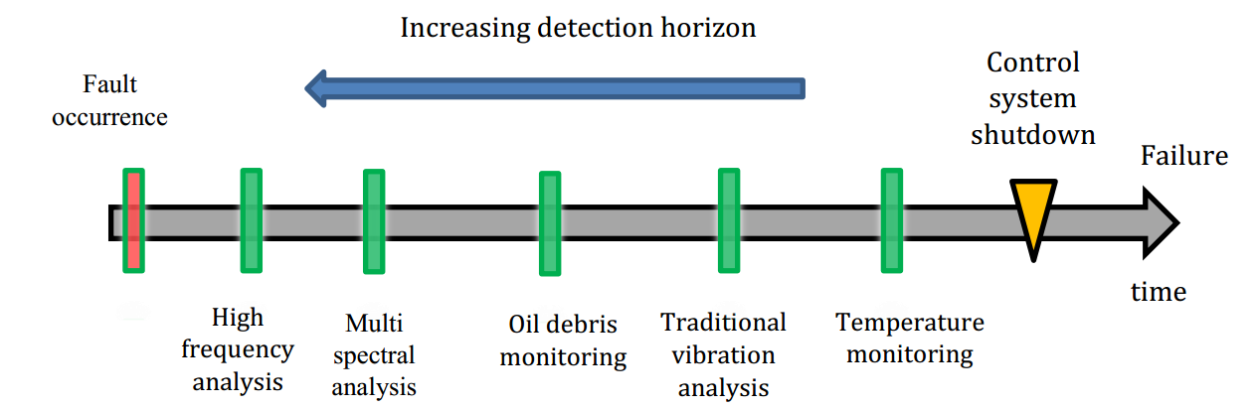
Figure 2 (Moussa, 2014)

Dynamic monitoring

“Most vibrations are adverse to human, machinery, and structural health” (Palazzolo, 2016). This is reason enough to attempt to reduce vibrations in machinery that is not meant to vibrate. Vibration in machinery can cause throwing. This throwing (as shown in Figure 4) causes “cyclic stress” (Palazzolo, 2016) that can cause more throwing or even fracture over time and damage other parts of the machine. The motor should however look as it does in Figure 3.
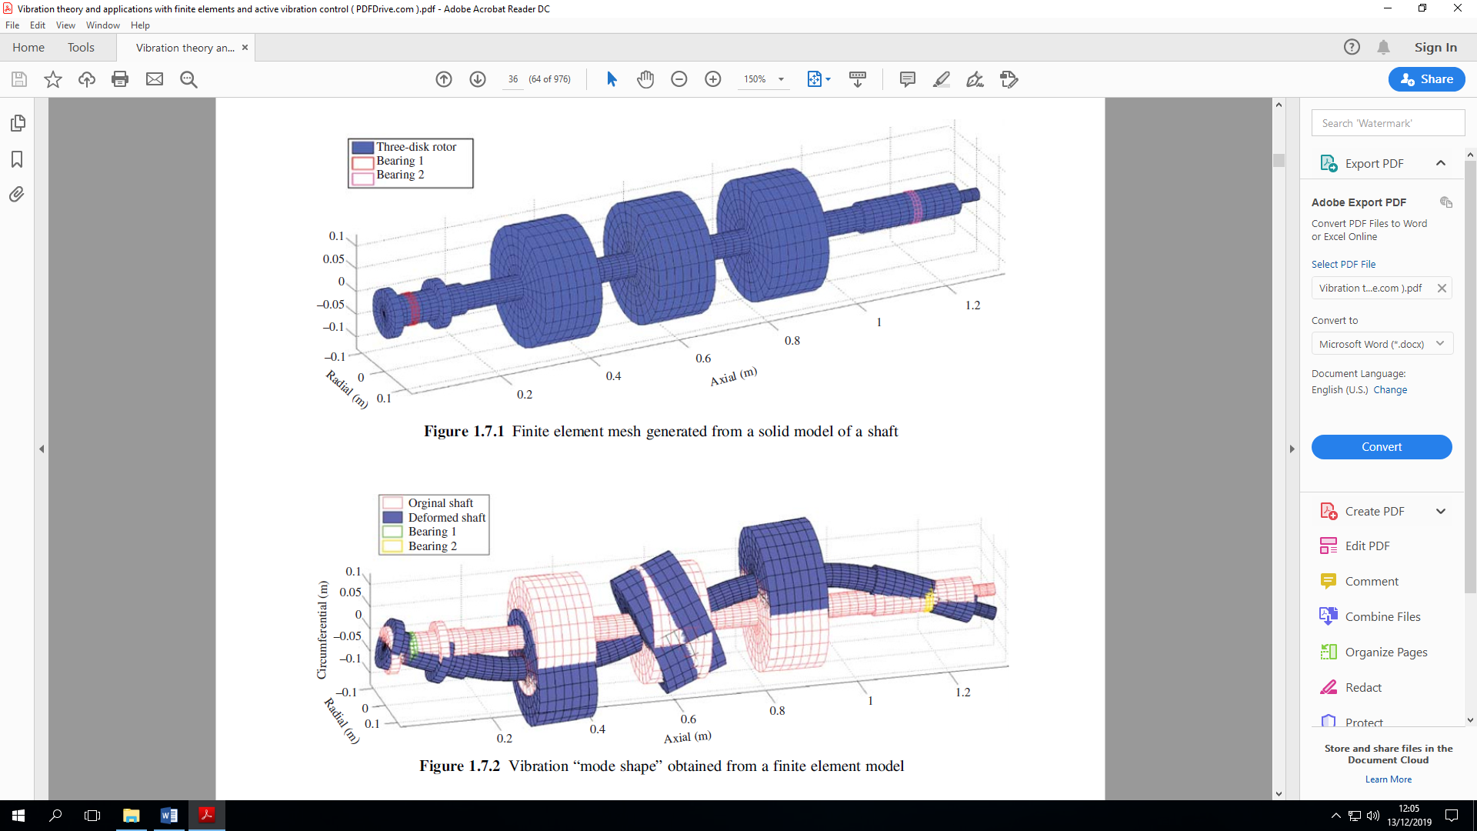
Figure 3 (Palazzolo, 2016)
Figure 4 (Palazzolo, 2016)
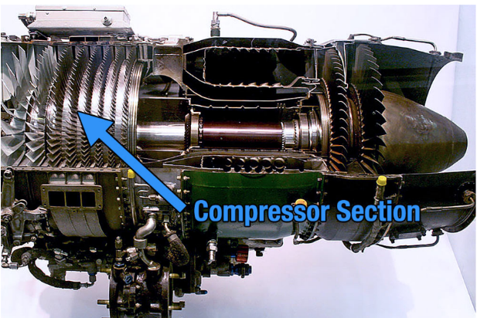
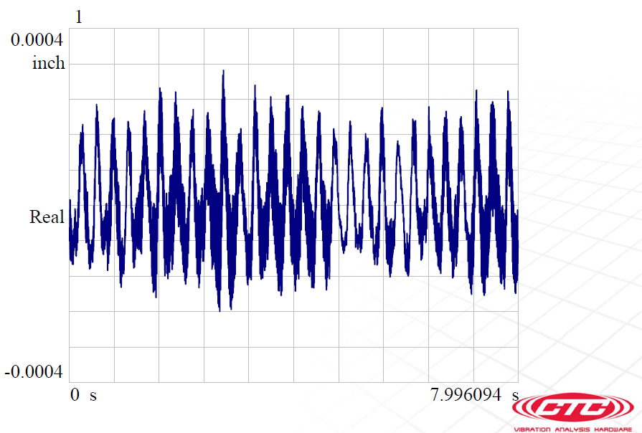
Figure 5 (Connection Technology Center, 2015) Figure 6 (Cutler, 2019)

Figure 5 shows a vibration graph that a vibration analysis monitor may pick up. The frequency (number of cycles per second or “Hertz” (Rouse, 2005)) can indicate where the problem is in a machine with several moving parts. As the diameter of the moving parts vary. Figure 6 shows an aeroplane engine with several rotating parts of different diameters. The different diameters emit a different frequency. If blades are fixed to a diameter and they are damaged they will emit a discernible frequency as shown in Figure 7. The first part of the wave of Figure 7 shows the vibration from the shaft and fan blades and the second half shows the vibration just from the fan blades. It was found that “33%” (Kiley, 2016) of the time vibration analysis detected faults.


Figure 7 (Tranter, 2018)

Oil analysis

Oil analysis is a type of condition monitoring where oil is sampled routinely to analyse the condition of the “oil along with the machine wear” (Kiley, 2016). It does this by analysing the oil for the following properties in Figure 8.
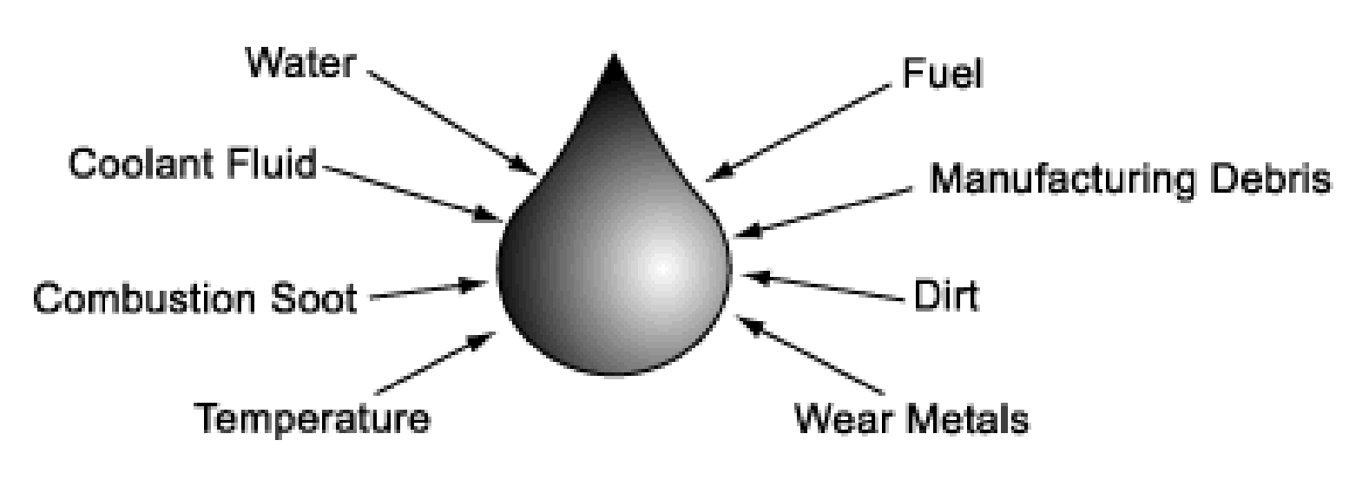
Figure 8 (Kiley, 2016)
Oil analysis is a very effective method of condition monitoring and can be “Complimentary” (Kiley, 2016) with vibration analysis. Fault detection of early bearing failure of “750 machines” (Kiley, 2016) was conducted and it was found that “40%” (Kiley, 2016) of the time oil analysis detected a fault (which is 7% more effective than vibration analysis). Despite oil analysis being more effective, “eventually vibration analysis would have detected these faults as the issue progressed” (Kiley, 2016). With the nature of faults however it is more beneficial if the fault is discovered as soon as possible as then action can be taken and the machine will not degrade further. Chemical analysis checks the chemical composition of the liquids in the system, such as oil or water. Corrosion is an “electrochemical phenomenon” (Schweitzer) which makes chemical analysis an effective tool for measuring corrosion. Corrosion causing properties can be measured such as CO₂ content or PH of the liquid. The more corrosive properties, the more corrosion is likely to take place. Metal quantities can also be measured. The metal in the fluids is a result from wear and this can then be measured.

Corrosion monitoring

Corrosion can be “costly and dangerous” (Schweitzer), corrosion not only affects machines but buildings and structures as well. This means that structural degradation of buildings could cause harm to employees and loss of life on a large scale. Corrosion can be minimised by the having knowledge and understanding the following factors:
“1. Mechanisms of corrosion
2. Corrosion resistant properties of various materials
3. Proper fabrication and installation techniques
4. Methods to prevent or control corrosion
5. Corrosion testing techniques
6. Corrosion monitoring techniques” (Schweitzer).
Once corrosion has been minimised to the greatest extent possible a proper CBM system can and should be implemented. Corrosion can be monitored through the following non-destructive testing techniques:

Radiography
Radiography is a form of x-ray that can detect flaws, such as cracks, porosity or “severe corrosive attack” (Schweitzer). It requires specialised equipment and trained personnel to work it and can not detect small amounts of corrosion because it has “accuracy limitations” (Schweitzer).

Ultrasonic Measurement
Ultrasonic measurement “provides a simple depth measurement from the exterior surface of a pipe or vessel to the next interface that reflects the sound waves” (Schweitzer). This can however be inaccurate as imperfections in the material can reflect the ultrasonic waves before they reach the wall that they are meant to giving a smaller reading of thickness. Some ultrasonic measurements can give 3-dimensional view of the component however the test equipment is very expensive and are very large.

Coupons
Coupons are used as a removable part of the system. The coupon is inserted into the system and then extracted after a certain amount of time. Wear is then measured usually by “weighing the coupon before and after” (Schweitzer) being in the system. The coupon must have the corroded surface cleaned down firstly so that the weighing is correct. When using coupons to measure for wear it is recommended that the exposure time is greater than 30 days. This is because greater wear is often experienced initially and once the coupon has “reached equilibrium” (Schweitzer) the wear decreases. Another reason to leave the coupon in the system for longer than 30 days is because when the coupon is cleaned often a small amount of un-corroded material is also removed. In a test that would last less than 30 days the “error” (Schweitzer) caused by this could render the test results useless. Coupons only show wear in the system where they are inserted. Because of this coupons should be placed in areas of interest where wear monitoring is critical.

Conclusion

In conclusion there would be a significant cost saving and employees will be safer if CBM was utilised by maintenance teams. Down time of machines would be reduced thus leading to a loss in processing time and subsequent profits. The time and investment that CBM demands is a far greater cost to pay than unforeseen catastrophic failure that will happen if CBM is not introduced. The best type of CBM is however a more difficult discussion. Temperature measurement has the smallest “detection horizon” (Moussa, 2014). It is however good at identifying lack of lubrication; however oil analysis would cover this as there would be a smaller volume of lubricant to sample. With regards to corrosion testing there are several different types of test that can be conducted: such as radiography, ultrasonic measurement and coupon analysis. All of these have their limitations however as radiography cannot detect small amounts of corrosion and requires specialist equipment and training. Ultrasonic measurement can be expensive, inaccurate and the machines can be very large. Coupon monitoring is inaccurate over small periods of time and can only show the corrosion where it was inserted into the system. Oil and vibration analysis complement each other however if only one was to be chosen the oil analysis would have to be selected as it detected “7%” (Kiley, 2016) more problems than vibration analysis and despite vibration analysis eventually being able to detect the problems the nature of wear can cause a more costly and time consuming repair. Therefore oil analysis would seem to be the most effective type of CBM method, as long as element analysis is measured from the oil. Regarding how frequently CBM should be performed, it would depend on the criticality and expected wear rate of the machine. If it is expected that the machine will wear quickly then a higher frequency will be desirable. If the machine has a high criticality to the process then a higher frequency would also be of benefit. The frequency will vary from a case to case basis and should be tailored to the machine and its needs.

Bibliography
Connection Technology Center, I. (2015). Beginning Vibration. Retrieved from www.ctconline.com: http://www.ctconline.com/pdf/pubTechPapers/01-Beginning%20Vibration%20Analysis.pdf
Cutler, C. (2019, 03 01). boldmethod. Retrieved from How Does a Turbofan Engine Work?: https://www.boldmethod.com/learn-to-fly/aircraft-systems/how-does-a-jet-engine-turbofan-system-work/
How to make condition-based maintenance more effective. (2019, 02 21). Retrieved from Fiix: https://www.fiixsoftware.com/blog/effective-condition-based-maintenance/
Jovan Gligorijevic, D. G.-G. (2015, 11 09). Research Gate. Retrieved from Online condition monitoring of bearings for improved reliability in packaging materials industry: https://pdfs.semanticscholar.org/0f1a/68e34b4a7c6b468cce5f1fa581e28b6483a0.pdf
Kiley, M. (2016, 16 09). Basics of Oil Condition Monitoring Through Oil Analysis. Retrieved from Vibration Institute: http://www.vibration.org/Presentation/Vibration%20Institute%20-%20Basics%20of%20OCM.pdf
Moussa, W. (2014, 04). Thermography-Assisted Bearing Condition . Retrieved from PDF Drive: https://ruor.uottawa.ca/bitstream/10393/31379/1/Moussa_Wael_2014_thesis.pdf
Palazzolo, A. (2016). Vibration Theory and Applications with Finite Elements and Active Vibration Control. Retrieved from PDF Drive: http://www.vibration.org/Presentation/Vibration%20Institute%20-%20Basics%20of%20OCM.pdf
Rouse, M. (2005). Hertz. Retrieved from SearchMobileComputing: https://searchmobilecomputing.techtarget.com/definition/hertz
Schweitzer, P. A. (n.d.). Corrosion of Linings and Coatings. Retrieved from PDF Drive: https://www.pdfdrive.com/corrosion-of-linings-and-coatings-cathodic-and-inhibitor-protection-and-corrosion-monitoring-corrosion-engineering-handbook-second-edition-d184984402.html
Suzan Alaswad, Y. X. (2016, 08 20). Reliability Engineering and System Safety. Retrieved from A review on condition-based maintenance optimization models: http://www.isihome.ir/freearticle/ISIHome.ir-26083.pdf
Tranter, J. (2018, 04 19). An Animated Introduction to Vibration Analysis by Mobius Institute. Retrieved from Youtube: https://www.youtube.com/watch?v=Vj1xmze3GlE
Wenzel, R. (2019, 12 10). How to utilize CBM tools to prevent equipment failures. Retrieved from Reliable Plant: https://www.reliableplant.com/Read/20795/how-to-utilize-cbm-tools-to-prevent-equipment-failures

