

Module Title: Introduction to Health and Social Care
Module Code: LCHS4003
(Portfolio – Two Tasks)

Student Name : Elizabeth Nuworkpor
Student ID : 2508597

Table of Contents
Task 1: Poster 3
Introduction 3
Explanation of the Service 4
Brief History of Residential Care Homes 4
Current Functioning of the Service 4
Challenges Faced by Residential Care Homes 5
Conclusion 5
Task 2: Essay 7
Introduction 7
Origins and Historical Context 7
Current Functioning of the Service 7
Significance for Quality of Life 8
Conclusion 8
References 9

Task 1: Poster
Residential Care Homes in the UK
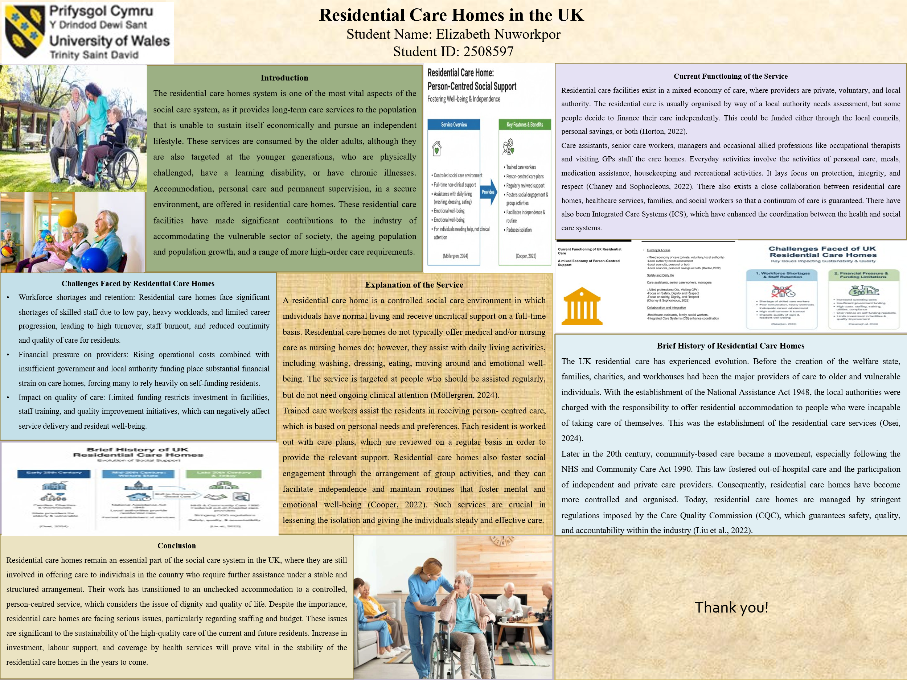

Introduction
The residential care homes system is one of the most vital aspects of the social care system, as it provides long-term care services to the population that is unable to sustain itself economically and pursue an independent lifestyle. These services are consumed by the older adults, although they are also targeted at the younger generations, who are physically challenged, have a learning disability, or have chronic illnesses. Accommodation, personal care and permanent supervision, in a secure environment, are offered in residential care homes. These residential care facilities have made significant contributions to the industry of accommodating the vulnerable sector of society, the ageing population and population growth, and a range of more high-order care requirements.

Explanation of the Service
A residential care home is a controlled social care environment in which individuals have normal living and receive uncritical support on a full-time basis. Residential care homes do not typically offer medical and/or nursing care as nursing homes do; however, they assist with daily living activities, including washing, dressing, eating, moving around and emotional well-being. The service is targeted at people who should be assisted regularly, but do not need ongoing clinical attention (Möllergren, 2024).
Trained care workers assist the residents in receiving person-centered care, which is based on personal needs and preferences. Each resident is worked out with care plans, which are reviewed on a regular basis to provide the relevant support. Residential care homes also foster social engagement through the arrangement of group activities, and they can facilitate independence and maintain routines that foster mental and emotional well-being (SCIE, 2020). Such services are crucial in lessening the isolation and giving the individuals steady and effective care.

Brief History of Residential Care Homes
The UK residential care has experienced evolution. Before the creation of the welfare state, families, charities, and workhouses had been the major providers of care to older and vulnerable individuals. With the establishment of the National Assistance Act 1948, the local authorities were charged with the responsibility of offering residential accommodation to people who were incapable of taking care of themselves. This was the establishment of the residential care services (The Health Foundation, 2022).
Later in the 20th century, community-based care became a movement, especially following the NHS and Community Care Act 1990. This law fostered out-of-hospital care and the participation of independent and private care providers. Consequently, residential care homes have become more controlled and organized. Today, residential care homes are managed by stringent regulations imposed by the Care Quality Commission (CQC), which guarantees safety, quality, and accountability within the industry (Care Quality Commission, 2022).

Current Functioning of the Service
Residential care facilities exist in a mixed economy of care, where providers are private, voluntary, and local authorities. Residential care is usually organized by way of a local authority’s needs assessment, but some people decide to finance their care independently. This could be funded either through the local councils, personal savings, or both (Age UK, 2022).
Care assistants, senior care workers, managers and occasional allied professions like occupational therapists and visiting GPs staff the care homes. Everyday activities involve the activities of personal care, meals, medication assistance, housekeeping and recreational activities. It focuses on protection, integrity, and respect (CQC, 2024). There also exists a close collaboration between residential care homes, healthcare services, families, and social workers so that a continuum of care is guaranteed. There have also been Integrated Care Systems (ICS), which have enhanced the coordination between the health and social care systems.

Challenges Faced by Residential Care Homes
1. Workforce Shortages and Staff Retention
A shortage of skilled care workers can be termed as one of the major challenges in residential care homes. Bad remuneration, heavy workloads, and inadequate career advancement have contributed to high staff turnover. This impacts the sustainability and quality of care since residents enjoy a stable relationship with familiar personnel. Staff shortages also put pressure on current staff, thereby causing stress and burnout, which may adversely affect the delivery of services and the well-being of residents (Bakerjian, 2022).
2. Financial Pressure and Funding Limitations
The financial pressure on residential care homes continues to be challenging, amid increased operations and a lack of government support in financing care homes. Improved staffing, training, utility, and regulatory compliance costs exert a big burden on providers. Funding by the local authorities is usually not sufficient to meet the actual cost of the care, and as a result, some homes must be overly dependent on self-funding residents. The lack of finances may restrict investment in facilities, staff development, and quality improvement, which may impact on the quality of care delivered (House of Commons Library, 2025).

Conclusion
Residential care homes remain an essential part of the social care system in the UK, where they are still involved in offering care to individuals in the country who require further assistance under a stable and structured arrangement. Their work has transitioned to an unchecked accommodation to a controlled, person-centered service, which considers the issue of dignity and quality of life. Despite the importance, residential care homes are facing serious issues, particularly regarding staffing and budget. These issues are significant to the sustainability of the high-quality care of the current and future residents. Increase in investment, labor support, and coverage by health services will prove vital in the stability of the residential care homes in the years to come.

Task 2: Essay

Introduction
The community antenatal midwifery services are key in contributing to the care of pregnant women during pregnancy in the local community settings, as opposed to the hospital environment. These services involve following up on the health of the mother and fetus, providing instructions, and detecting the risk early in development. Community-based antenatal care represents a wider shift in the healthcare system of the UK, which includes the transition to preventative care, ongoing support, and lessening the burden on hospital services. The knowledge of the beginnings, present operation, and worth of these services demonstrates that they are significant when it comes to bettering the results of mothers and babies.

Origins and Historical Context
The history of the antenatal midwifery services in the UK dates to the beginning of the 20 th century, when maternal and infant mortality rates were deteriorating. At this time, there was inadequate pregnancy care, and there were many women who delivered at home without the assistance of a professional (Chamberlain, 2006).
Antenatal care became available universally following the formation of the National Health Service (NHS) in 1948. Gradually, it became acknowledged that complications could be avoided in the case of regular checkups during maternity. Since the 1970s, policy changes have encouraged care near the home, resulting in the growth of community antenatal clinics.

Current Functioning of the Service
In the current situation, community antenatal midwifery services are provided as NHS maternity services and are usually provided at GP surgeries, children's centres, community clinics and in some cases, homes to the women. Midwives are charged with routine visits, sugar level checks, fetal development, screening and health education (NHS England, 2016).
One of the main aspects of today's practice is the orientation to continuity when women are followed by a small group of midwives during pregnancy. This will enhance interaction and promote trust between the service users and professionals. Continuity models, however, do not always get their support policies because of the shortages of staff and workload. Besides this, digital record-keeping and integrated care systems have enhanced coordination among midwives, GPs and hospitals, even though services may be different across different regions (NICE, 2021).

Significance for Quality of Life
A high-quality life of pregnant women can be achieved through community midwifery services, which are designed to offer personalised and supportive services using high-quality interventions. Constant communication with a midwife makes a woman feel knowledgeable and assured about how her pregnancy is proceeding, without having to feel as anxious and insecure. Appointments done by the community are more convenient, especially in the case of women with limited mobility, who have children, or who have transportation issues (Sandall et al., 2024).
These services are also extremely important in the elimination of health disparities. Midwives will be able to recognise social, mental health, or safety issues at an early stage and refer women to other support services. Proper nutrition, lifestyle, and birth preparation make women choose wisely, thus resulting in improved physical and emotional health.

Conclusion
Community antenatal midwifery services have been developed based on limited initial birth care and now represent a planned and necessary part of UK health care. These services are now determined by historical reforms and current policy priorities of the populace to early intervention, continuity, and accessibility in the community. Although the shortage of the workforce continues to be a challenge, they still play a huge role in maternal wellbeing and the early detection of risks. Community provision of antenatal midwifery services to women during pregnancy, by hosting them in comfortable environments, has maintained positive effects on the quality of life and safer births of mothers and babies.

References

- Age UK (2022). Paying for permanent residential care. Available at: https://www.ageuk.org.uk/information-advice/care/paying-for-care/paying-for-a-care-home/
- Bakerjian, D. (2022). The advanced practice registered nurse leadership role in nursing homes: Leading efforts toward high quality and safe care. Nursing Clinics, 57(2), 245-258. https://doi.org/10.1016/j.cnur.2022.02.011
- Care Quality Commission (2022). The state of health care and adult social care in England 2021/22. Available at: https://www.cqc.org.uk/sites/default/files/2022-10/20221024_stateofcare2122_print.pdf
- Chamberlain, G. (2006). British maternal mortality in the 19th and early 20th centuries. Journal of the Royal Society of Medicine, 99(11), 559-563. Available at: https://pmc.ncbi.nlm.nih.gov/articles/PMC1633559/
- CQC (2024). The fundamental standards of care. Available at: https://www.cqc.org.uk/about-us/fundamental-standards
- House of Commons Library (2025). Adult social care funding in England. Research Briefing CBP-7903. Available at: https://commonslibrary.parliament.uk/research-briefings/cbp-7903/
- Möllergren, G. (2024). The Home Care Home–An Un-Total Institution. When the Care Home Logic Permeates the Private Space. Socialinė teorija, empirija, politika ir praktika, 29, 39-55. https://doi.org/10.15388/STEPP.2024.29.3
- NHS England (2016). Better Births: Improving outcomes of maternity services in England – A Five Year Forward View for maternity care. Available at: https://www.england.nhs.uk/publication/better-births-improving-outcomes-of-maternity-services-in-england-a-five-year-forward-view-for-maternity-care/
- NICE (2021). Antenatal care. NICE guideline NG201. Available at: https://www.nice.org.uk/guidance/ng201
- Sandall, J., Fernandez Turienzo, C., Devane, D., Soltani, H., Gillespie, P., Gates, S., Jones, L.V., Shennan, A.H. and Rayment-Jones, H. (2024). Midwife continuity of care models versus other models of care for childbearing women. Cochrane Database of Systematic Reviews, 4(4), CD004667. Available at: https://pmc.ncbi.nlm.nih.gov/articles/PMC11005019/
- SCIE (2020). Dignity in care: Involvement and inclusion. Available at: https://www.scie.org.uk/dignity/care/involvement
- The Health Foundation (2022). The National Assistance Act 1948. Available at: https://navigator.health.org.uk/theme/national-assistance-act-1948

