Anna Murphy
Student Number: 1303267
Question Title:
“Is Britain a Nation of Lazy Scroungers?” (Randeep Ramesh, Wednesday, 24 April 2013 – The Guardian online). Critically discuss this statement and explore this in light of current statistics, policy and theory. (You can include images in your work).
Equality and Diversity: Power and Social (Re)Production of inequality
SJEQ7003

Contents:

Written Assignment SJEQ7003 Page: 2 - 7

Bibliography Page: 8

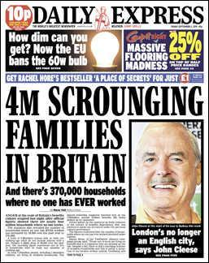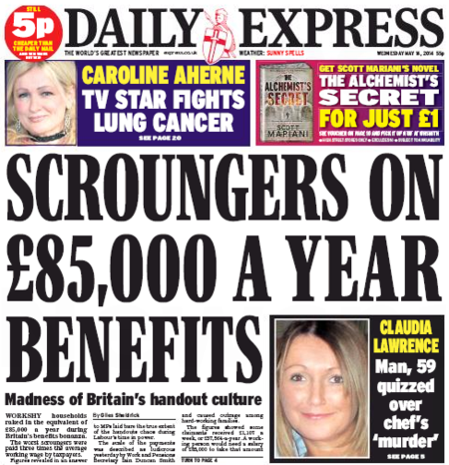
(Images taken from Google Searches, 2018)

These are just some of the images that we are seeing on a regular basis in our newspapers. We are constantly hearing reports about the number of people who are claiming benefits when they are fit enough to go to work. The media has the power to exclude people from society as they are able to portray them in a certain light which will influence people’s opinions. This is a form of social control which encourages the general public to form a picture of the type of person that claims benefits. They depict them as being of lower intelligence and having little to offer society. (Thompson, N. 2007). They attach labels to people such as the ones in the examples above – Scrounger and Skiving. These terms are used to get people’s attention and shock them with information which goes against our social norms. We, as a society, have certain expectations of behaviour such as obeying the law and caring for the vulnerable. It is interesting to look at the people who own the newspapers in the UK and to discover where their opinions come from. The majority of newspapers in the UK are owned by some of the most wealthy people in the country and indeed, the world. For example, The Daily Express is owned by Richard Desmond who, in 2014, is said to be the 78th richest man in Britain and worth £1.2 billion (Albion Mill, 2015). Some of them are part of publishing groups who own many newspapers around the world. This means that they are able to have the monopoly on what is published to the public and therefore have control of what the general public get to see and how it is portrayed. It is also interesting to look at what political views these owners have. Being some of the most affluent people in the world, they have considerable influence and the majority of the newspapers have affiliations with the Conservative government. This means that they do not represent the people, the workers, who would most likely vote for a Labour government and the people most likely to be reading these newspapers. The table below shows the number of people who read each of these daily newspapers. When looking at who these people are who control what the majority of the country see and read on a daily basis, it is clear that the very wealthy have the most power to influence our lives and how others treat us because of what they have read or seen in the media. This also continues to increase the gap in society between the rich and the poor. Those who are in the middle income range will most likely share the opinions of the wealthy without even realising that they are being controlled and manipulated into it.
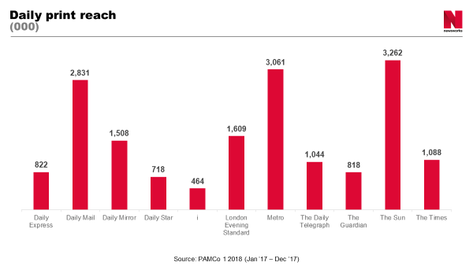
Newsworks (2018)

The three highest read newspapers in the UK are the Daily Mail, The Metro and Sun. Looking at who owns these newspapers, we can see how widespread the wealthy influences are:
- Daily Mail – Owned by Viscount Rothermere who inherited his media empire from his great grandfather.
- The Sun – Owned by Rupert Murdoch as part of a large conglomerate who also own The Times, The Sunday Times, Today, News of the World and The London Paper.
- Metro – is owned by the same media group who own the Daily Mail.

Due to their great wealth, there are able to impose their upper class views and opinions on the whole of the UK and yet the wealthy people are in the minority. When we look at Bronfenbrenner’s ecological system below, we see that the macro system contains the media amongst other things. With people living in poverty and claiming benefits, there are a number of issues which when put together result in a person suffering from exclusion along with other problems such as lack of self esteem. This shows that, although it is not directly connected to the individual, it still has a great influence on their lives. It could be said that this kind of media reporting is encouraging discrimination against people living in poverty. These issues also link with the work of Maslow (1943, 1954) where he developed his hierarchy of needs. Looking at the centre of the triangle we can see that this contains psychological needs such as a sense of belonging. This then leads to our self esteem and these issues are very important to a person who is already feeling marginalised by society. If they feel that they are not good enough, then they will not try to find employment. They may also have social issues such as difficulties when interacting with people, particularly in new surroundings or in more formal settings. All these anxieties can build up and result in a person having little or no confidence in their own abilities and therefore unable to put themselves into situations such as job interviews as they feel that there is no point in trying.

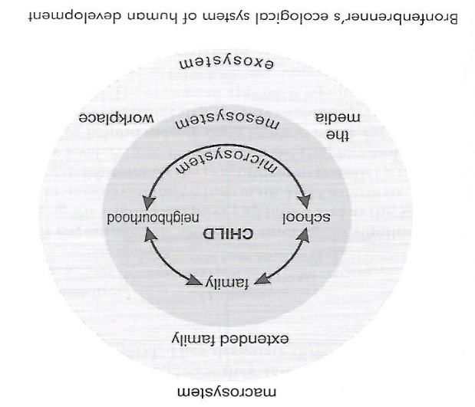 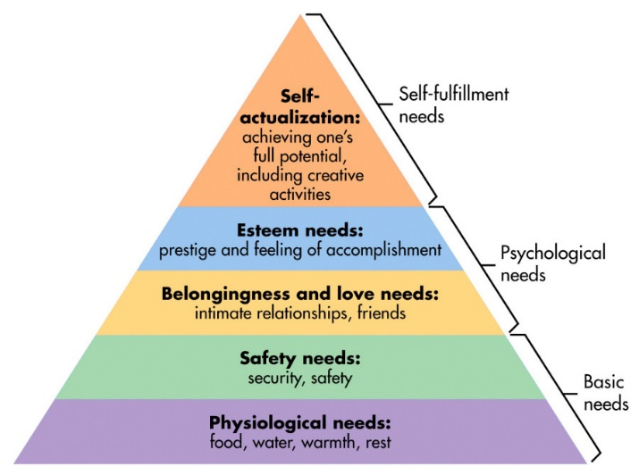 (Pierson, J. p. 27) (Maslow, 1943, 1954)

Along with the mass media, the Government also has power to influence other people’s lives, sometimes for good and sometimes not. In Wales, our Assembly Government is developing policies to help get more people into work and out of the benefit system. To do this they must look at the issues of poverty and how it affects the most vulnerable in our country, that is, our children. They are hoping to end child poverty by 2020 (Welsh Assembly Government, 2015). By doing this they aspire to give our children better prospects for the future and hopefully ensuring that statistics such as those which we will discuss below, will be a thing of the past and bring more of our young people into employment, further education or training. The chart below shows the number of unemployed people in Wales as recorded up until March 2018. This shows the rise and fall of unemployment over the last two years. Looking at the last column, you can clearly see a decrease between December 2017 and March 2018. We do not know as yet whether that decline will continue or, as in the previous years, it will increase.

Office for National Statistics (2018)

When looking further into the detail of these statistics, the age group with the highest number of unemployment is the 16 – 24 bracket of men, with a recorded 12,000 out of work young people. This means that 12,000 are coming out of education and not finding work, and this is a contributing factor of living in deprivation. The Welsh Assembly Government defines deprivation as ‘the lack of access to opportunities and resources which we might expect in our society’ (Welsh Assembly Government, 2014). One of their initiatives is the Tackling Poverty Action Plan (2016). They discuss issues of social justice and this will include looking at the needs of those in poverty and at risk of exclusion from society. The three main areas of focus are preventing poverty, helping people into work and improving the lives of people already living in poverty (Welsh Government, 2016).

Someone who is unemployed, has little chance of changing their situation without help. According to Thompson (2007) ‘empowerment is about enabling people to get out of poverty and work towards eradicating it’. Once living in poverty, it becomes very difficult to get out of it. Without good qualifications, some people will have less employment opportunities and will therefore only be able to access those jobs which have the least hours and lowest pay rates. This means that they will not be able to earn enough money to allow them to come off benefits. This is the reason that most people who have been living on benefits for many years are unable to leave the system. They are fit and able to work physically, but financially they cannot hope to earn enough money to cover their basic living costs of food, rent and utility bills, let alone be able to afford to spend any money on other items such as clothing and any socialising which is equally important.

People can face discrimination for many reasons. Some may find that they are discriminated against because of where they live. It could be an area which is known for having high levels of unemployment and high crime rates. This can mean that they may not be offered jobs as employers will class them among their local community as people who do not want to keep a job or associate with criminals in the area. They could have other forms of discrimination against them such as racism and this, linked with poverty, will further reduce their opportunities. This leaves them vulnerable and at risk of exclusion from society. Social interaction is an important part of life and according to Pierson (2006) ‘work provides social interaction and networks that are extremely difficult to find anywhere else’.

With all the negative media attention towards people who claim benefits, it could call into question the reasons behind the high numbers. Are the policies in Britain to blame for high unemployment rates? If benefits were lower or harder to obtain, then this may mean that more people would have to find work for themselves to be able to survive. As it is now, some people are financially better off receiving benefits than going to work. This would not be the case in other countries where there are no unemployment benefits, free healthcare or council housing. In the past, benefits were given on a means tested basis. The people we see portrayed in the media today are those who have a number of large televisions throughout their homes, contract mobile telephones, possibly smokers or drinkers. Some have pets including exotic ones which are expensive to buy and maintain. We see these people having cars and regular holidays abroad. For those who work long hours and would struggle to afford some of these things for their families, these images can easily cause anger and resentment towards these people. With the addition of seeing reports in newspapers and articles in magazines where this ‘benefits lifestyle’ is being flaunted, it is clear that most hard working people would find it upsetting. In recent years we have also had a great influx of people entering Britain and using our benefit system. Reports in the media show how, in some cases, these people are given good housing in expensive areas which some people who work full time cannot afford to get themselves. This could be seen by them as yet another injustice. Take the article below:
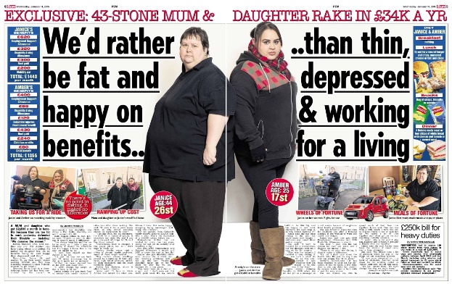
The Sun (2015)

This report is from a mother and daughter who claim that they are unable to work due to their weight problems. Their combined monthly benefits total £2795 which includes unemployment, disability and rent allowances. These are the sort of people who are seen as abusing the benefits system to allow them to stay out of unemployment for as long as possible. On a yearly basis, these two people are receiving around £33,540 compared to the average yearly earnings of a couple in the UK which is £32,247 (Statista, 2017). One must bear in mind that part of their benefits pays for their rent and as they are registered as disabled they receive a brand new car which they do not have to pay tax for. Clearly, it does not pay to go to work and this is where the people of the working world feel that there is a great injustice being done to them.

It must be noted that there are many people who are genuinely in need of help and have good reasons to be claiming benefits. There are those who are disabled, people with mental health issues, carers who would otherwise have no income at all, those who have lost jobs through redundancy and are finding it difficult to seek employment as they may have only been trained or have skills for specific work. We are all guilty of judging people either merely on appearance or by limited or bias information we have heard or seen. Unless you know the full details of a person’s circumstances, you cannot begin to understand how and why they live as they do. Some people are able to cope better in stressful situations and be more resilient, whereas others do not.

According to Pierson (2006) social exclusion is ‘a process that deprives individuals and families ……of the resources required for participation in the social, economic and political activity of society as a whole’. This means that every aspect of their lives is affected and most often it is due to poverty. It allows people to become isolated from society and miss out on opportunities which the majority of individuals experience. It is good that this country has a system which ensures that every person is able to have access to good health care, food, shelter and free education for all children. It is because of these changes and due to many policies regarding health and welfare that this country has been able to eradicate some diseases which in other countries are still claiming lives, particularly the very young and the elderly. These days, we need to concentrate more on the mental welfare of our nation. In Wales, the government has issued the Mental Health Measure (2010) which places states that our local health boards and authorities have a legal duty to support those in need by having more mental health services available, ensuring patients have a treatment plan individually set out and making certain that when patients are discharged that they are able to continue to receive treatment from these services. This support is vital to those who have mental health issues as without them being resolved they have no chance of becoming a fully participating member of society.

In Wales, the Welsh Assembly Government states that recent UK Governments reforms of benefits and tax will mean that more than 50,000 more children in Wales will then be living in poverty (Welsh Assembly Government, 2018). A number of ministers have written to the Secretary of State for Works and Pensions asking them to reconsider the changes due to the devastating effects they will have on some of the most poor and vulnerable in Wales, namely children. Welsh Assembly Government Minister for Children, Huw Irranca-Davies said ‘The Welsh Government’s efforts to tackle child poverty and improve the lives of low income families are being damaged by the UK Government’s package of tax and welfare reforms’ (Welsh Assembly Government, 2018). It is clear that the Welsh Government and the UK Government are trying hard to get the balance of benefits and encouragement to work right. At the moment, the system is not working as it should be and people, in particular young people, are not getting enough encouragement and incentives to go to work. Until this changes, some people will continue to abuse our benefit system, and this could result in those genuinely in need of help being punished by prejudice and exclusion from society by portraying the wrong images to the world.

Bibliography:
Albion Mill (2015) Who owns the UK Newspapers and who do they want you to vote for. http://www.albionmill.org.uk/?p=1476) [Accessed: 17th May 2018].
Newsworks (2017) Readership – The Latest UK newsbrand readership data from PAMCo. https://www.newsworks.org.uk/market-overview. [Accessed: 10th May 2018]
Office for National Statistics (15th May 2018) X02 Regional labour market: Estimates of unemployment by age. https://www.ons.gov.uk/employmentandlabourmarket/peoplenotinwork/unemployment/datasets/regionalunemploymentbyagex02 [Accessed: 21st May 2018].
Pierson, J (2006) Tackling Social Exclusion. Routledge: Oxon.
Simply Psychology (2018) Maslow’s Hierarchy of Needs. https://www.simplypsychology.org/maslow.html [Accessed: 7th May 2018].
Statista (2017) Mean annual household income in the United Kingdom (UK) from 2000 to 2016 (in GBP at 2016/2017 prices**). https://www.statista.com/statistics/591342/united-kingdom-uk-average-yearly-household-income/ [Accessed: 9th May 2018].
Thompson, N (2007) Power and Empowerment. Russell House Publishing Ltd: Dorset.
Welsh Assembly Government (2014) Welsh Index of Multiple Deprivation (WIMD) 2014 revised. https://gov.wales/docs/statistics/2015/150812-wimd-2014-revised-en.pdf. [Accessed: 7th May 2018].
Welsh Assembly Government (2015) Child Poverty Strategy for Wales https://gov.wales/docs/dsjlg/publications/150327-child-poverty-strategy-walesv2-en.pdf [3rd May 2018].
Welsh Assembly Government (2015) Mental Health (Wales) Measure 2010. https://gov.wales/topics/health/nhswales/mental-health-services/law/measure/?lang=en [Accessed: 11th May 2018].
Welsh Assembly Government (2016) Tackling Poverty https://gov.wales/topics/people-and-communities/tackling-poverty/?lang=en. [Accessed: 18th May 2018].
Welsh Assembly Government (2018) ‘We cannot allow damaging UK Government policies to plunge 50,000 more Welsh children into poverty’ – Huw Irranca-Davies. https://gov.wales/newsroom/people-and-communities/2018/we-cannot-allow-damaging-uk-government-policies-to-plunge-more-welsh-children-into-poverty/?lang=en [Accessed: 14th May 2018].
Wings Over Scotland (2015) The Sun newspaper article https://wingsoverscotland.com/wp-content/uploads/2015/01/sunfatties2.jpg [Accessed: 8th May 2018].

