Kara Thomas (2304862)
University of Wales Trinity Saint David
Research, build, and deploy, a Virtualised network

Table of Contents
Task 1 1
Research on Hypervisor 2
Research on IP Addressing 2
Research on Routing 3
Research on Network Services 4
Task 2 4
Choosing a Hypervisor 4
Installation of each ISO 5
Windows 10 5
Windows Server 6
Debian 7
Installing virtual machines 8
Windows 10 9
Windows server setup 12
Debain setup 18
Debian Server setup 20
IP address scheme 22
Windows LAN 22
Debian LAN 23
ClientS1 IP Addressing 23
S-DC IP Addressing 23
ClientC1 IP Addressing 24
C Server IP Addressing 25
Outcome 1: Successful connectivity within same networks. 25
Successful connectivity between ClientS1 and S-DC 25
Successful connectivity between ClientC1 and C Server 26
Reflection 27
References 27

Task 1

Research on Hypervisor
There are two main hypervisors, hypervisor type 1 and hypervisor type 2. According to the source “Hypervisor- vs. Container-based Virtualization” hypervisor type 1 is described as set directly on hardware while hypervisor type 2 is described as used on the operating system. [1]
Although the source “A review paper on hypervisor and virtual machine” specifies that hypervisor type 1 is on the physical layer. It also gives extra information about type 1 hypervisors mentioning that they have access to the hardware and in turn being able to manage its resources. It also provides examples of type 1 hypervisors which include Citrix Xenserver, Hyper-V, and Proxmox.
Furthermore, this source explains that type 2 hypervisors are installed onto the operating system. It states that the type 2 hypervisor allocates memory, CPU and network configurations for the virtual machine allowing it to have these resources. It provides two examples of Oracle VM VirtualBox and VMware Workstation. [2]
The source also explains the security features of hypervisors, one of the main ones being that attackers cannot access the host machine through the virtual machine. This is because the virtual machine on the hypervisor is not aware of or has any information about the host machine. In addition to that it can also back up snapshots of the virtual machine regularly, meaning if anything happens a backup can be used.
“Hypervisor- vs. Container-based Virtualization” is not a fully reliable source due to there not being many references and the majority of which consist of non-academic sources. “A review paper on hypervisor and virtual machine” is a reliable source due to the purpose of the paper being for a conference. Additionally, the source has 60 references all of which consisting of academic papers. It also goes more in depth on the explanation of hyper visors showing a greater understanding.
When comparing the two sources’ content, the source “Hypervisor- vs. Container-based Virtualization” only discusses the hypervisors architecture while the source “A review paper on hypervisor and virtual machine” has more information including the features of each hyper visor, examples of each and an explanation of security features.

Research on IP Addressing
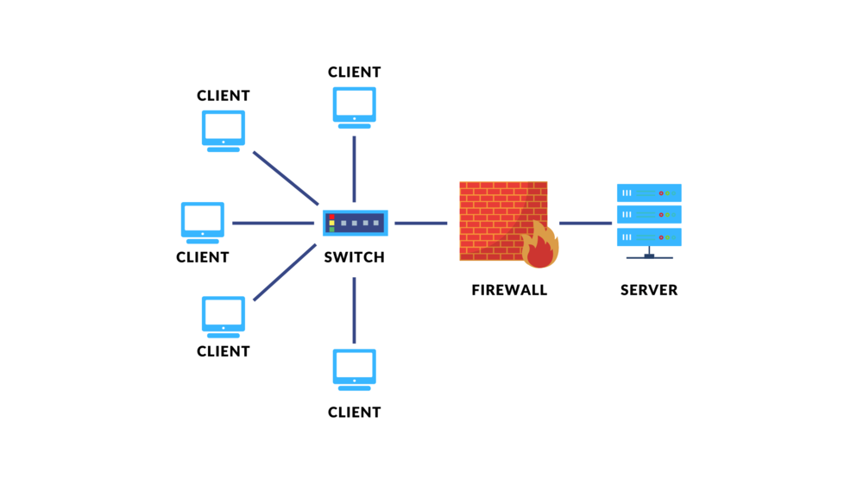
[3]

To get data to a computer over the internet, it starts with the data you want to send being turned into packets. These packets of data get sent from your computer to your router through TCP. The router has a public IP address which allows for it to communicate your internet service provider, which is needed to access the internet. The router decides on the best route for the data to be sent and from there forwards the data to your internet service provider. The internet service provider looks at the recipients public IP address and then sends the data there. [4]
Once it reaches the network the router, the information is passed to the switch. The switch locates the recipient device and forwards it on to them.
Routers act as a gateway for the network. They have the role of making sure that data coming from the network is going to the correct destination in an effective manner. They do this by assessing the best route for the data. Switches make sure that data within the network gets to the intended device. This is done by having a switch table that houses the devices’ IP addresses. Without this data can get lost. [5]
An IP address is made up of two parts, the network portion and the host portion. Within a network the network part of the IP address must remain the same on each device throughout the network. Although the host part of the IP address of each device in the network changes so each device has a unique identifier. Depending on class the amount of the IP address that is host or network can vary, to distinguish this a subnet mask is used. [6]
There are two versions of Ip address IPv4 and IPv6. IPv4 address is in decimal while IPv6 is in hexadecimal. IPv4 consists of 32 bits while IPv6 is made up of 128 bits which allows for enough Ip address for everyone globally. IPv6 has a built-in security protocol called IPSEC although IPv4 does not have one built in. [7]
Subnetting allows a class a, class b or class c network to be broken down into multiple smaller networks that are easier to manage. Since subnetting reduces the number of broadcasts it in turn reduces the network traffic. [8]

Research on Routing
[9] There are two main types of routing which are dynamic and static. Static routing is a router’s path is fixed by a configuration and can only be edited manually. An example of where static routing would be used if a network contains hardly any routers. This is because as dynamic routing allows for the router to choose the best path and with this situation there are minimal paths to take making it unnecessary.
Dynamic routing protocols are used to carry out network discovery and looking after and keeping routing tables up to date. Network discovery entails routers sharing data about networks it knows to other routers that also use network discovery. This information can contain the best path to get to these networks which is added to the routers routing table. Routers make the decision on which path is the best to take on its own based on the information in its routing table. Furthermore, not all routers in the network will have the same data in their routing tables.
There are a large variety of routing protocols. One crucial routing protocol is RIP (Routing Information Protocol) and it was the first one created with the purpose of routing IP packets. RIP has disadvantage as it does not work well on discontinuous networks. This is due to it being a classful routing protocol and those type of protocols do not store enough data for proper routing for discontinuous networks.
[10] Another crucial routing protocol is OSPF (Open Shortest Path First) which is an interior gateway protocol that uses a link state algorithm to find the best path to take. A benefit that OSPF brings is for company network’s as they can take a path that gives the company the lowest end to end cost.
Furthermore EIGRP (Enhanced Interior Gateway Routing Protocol) is a Cisco proprietary protocol that takes the benefits of both distance vector and link state algorithms to create a hybrid algorithm. This protocol can be used for all types of networks big or small. This is due to their low requirements as they use the lowest amount of CPU and memory.
A unique routing protocol is CDP (Cisco Discovery Protocol), it allows the user to gain information about Cisco devices. More specifically it allows for a summarisation on address and protocol data.[9]

Research on Network Services
According to “An Overview of Virtual Private Network (VPN): IP VPN and Optical VPN” VPNs are desired by companies as they can be used to expand their networks. This is because VPNs allow for employees to access the company’s network from any location with an internet connection, which all goes through an encrypted connection. It also states the protocols associated with VPNs which include GRE, IPSec, and L2TP. The report gave a concise and straightforward explanation on VPNs making it an accessible source. Although as the document was published in 2004 it has not got updated information about new advancements and discoveries meaning without looking at another relevant source new information is being missed. [11]
The source “AUTOMATED CONFIGURATION OF TCP/IP WITH DHCP” says that DHCP (Dynamic Host Configuration Protocol) servers are used to automatically assign network addresses to devices within a network. A DHCP server communicates with the client using UDP and when doing so sends messages to the client’s hardware address. DHCPv6 is the next version that is used to allocated IP version 6 addresses. This source is academic and in turn reliable due to it being written by Ralph Droms who is a professor at Bucknell University showcasing that the author is credible. [12]

The book “Mastering Active Directory” states that Active Directory Domain Services (ADDS) are one of five Active Directory server roles. This role can be installed through a PowerShell cmdlet. It also says that ADDS uses a hierarchical structure to sort objects, along with securely and effectively controlling the company’s resources. [13] The author of this book Dishan Francis is a Cybersecurity Senior Consultant. He has 21 years of experience which includes a role as a network engineer which is applicable to the writing of the book. This shows he is credible and knowledge about the topic. [14]

Task 2

Choosing a Hypervisor

Based on my previous research on the different hypervisors I am going to choose the type 2 hypervisor. This is due to how in comparison with hyper visor type 1 type 2 is easier to set up. This is crucial due to the time frame of the project as much time as possible needs to go into the configuration. Furthermore, using a type 2 hypervisor is more accessible as to set it up only requires the iso of the needed operating system and the download of virtual machine software which for this project will be virtual box.

Installation of each ISO

Windows 10
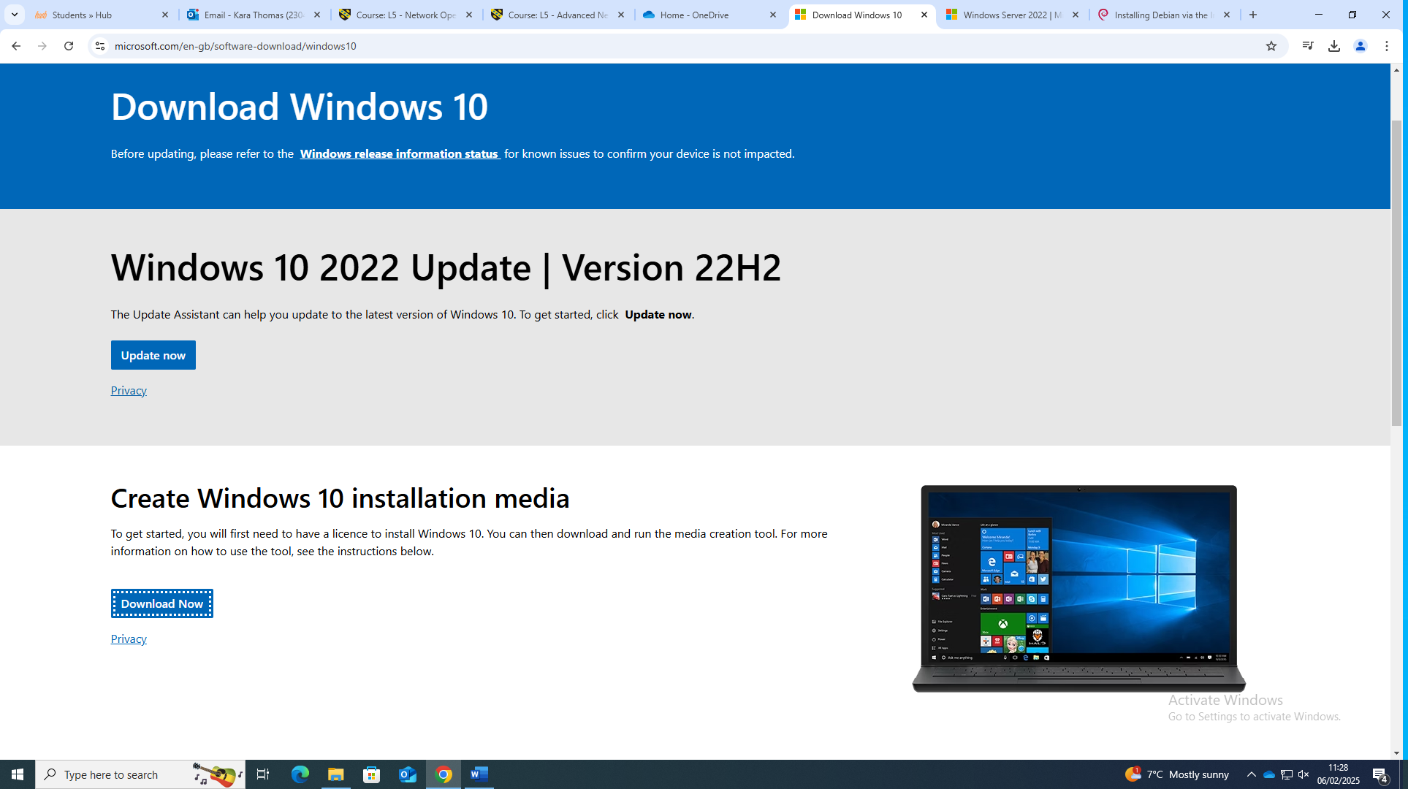
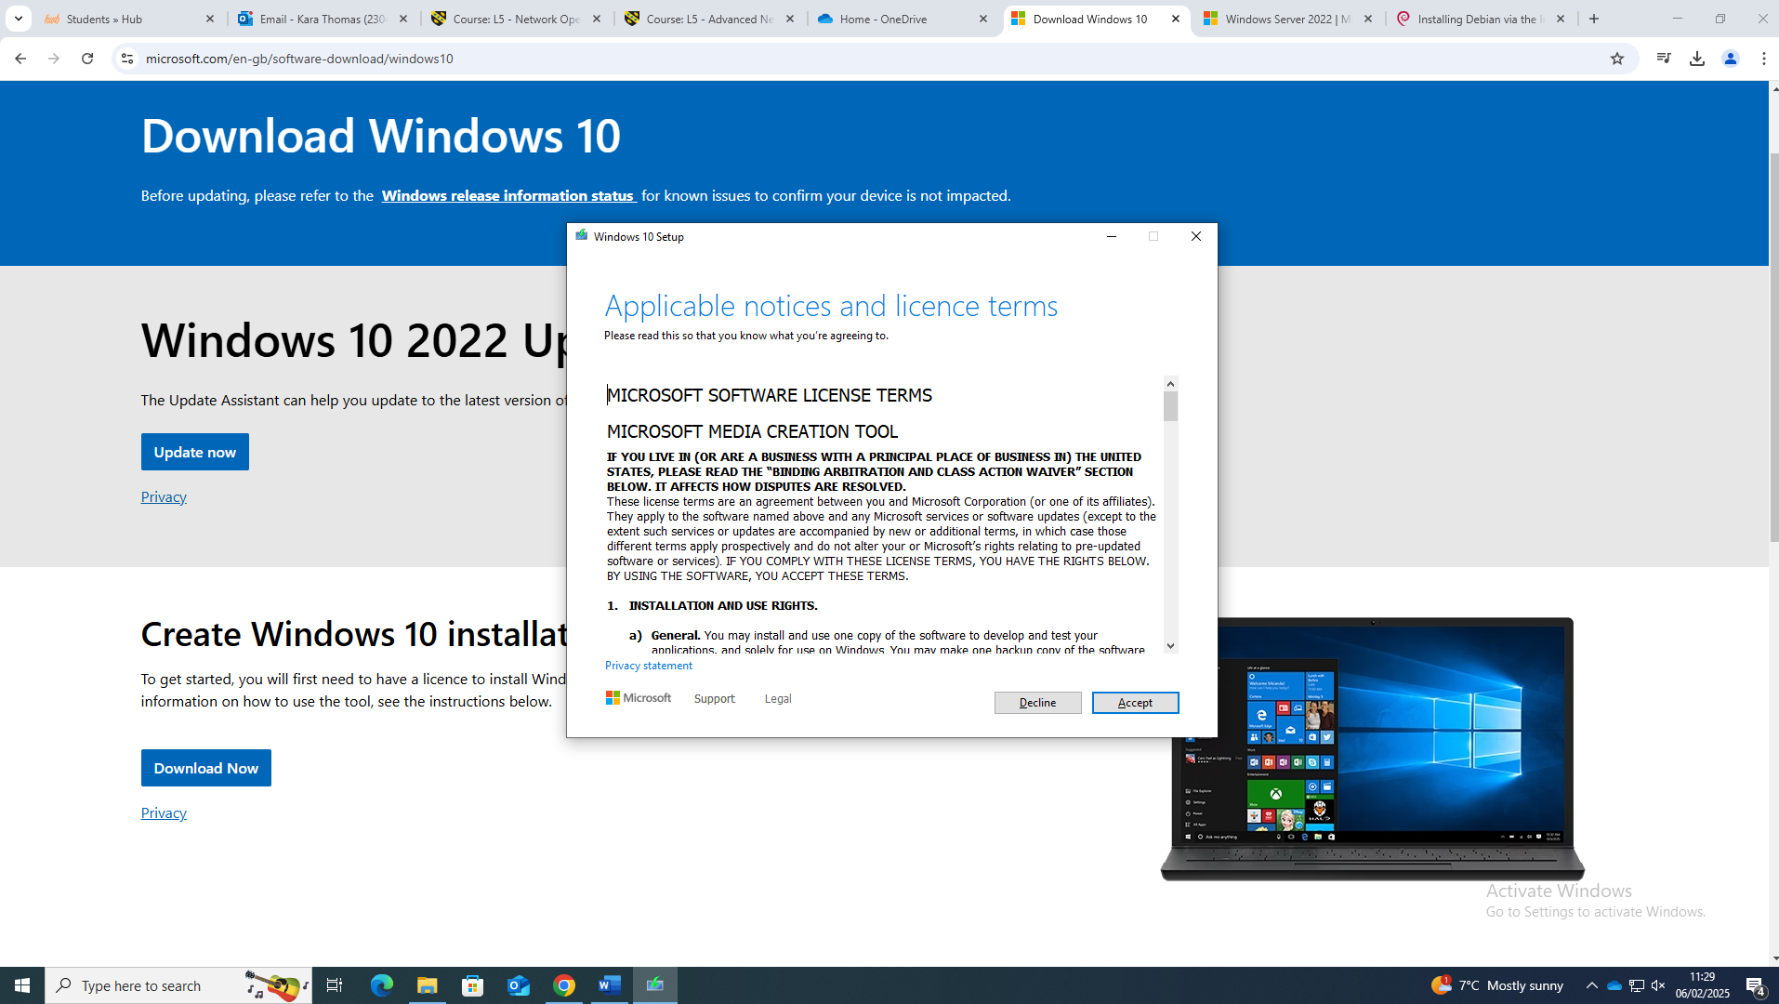

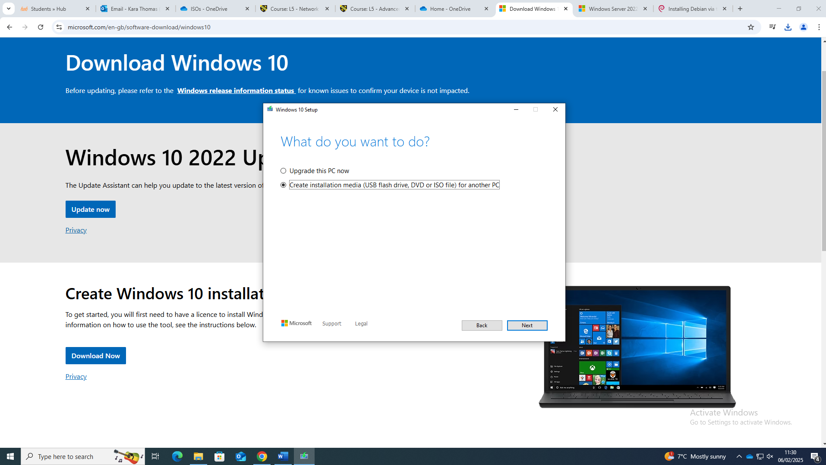

Windows Server

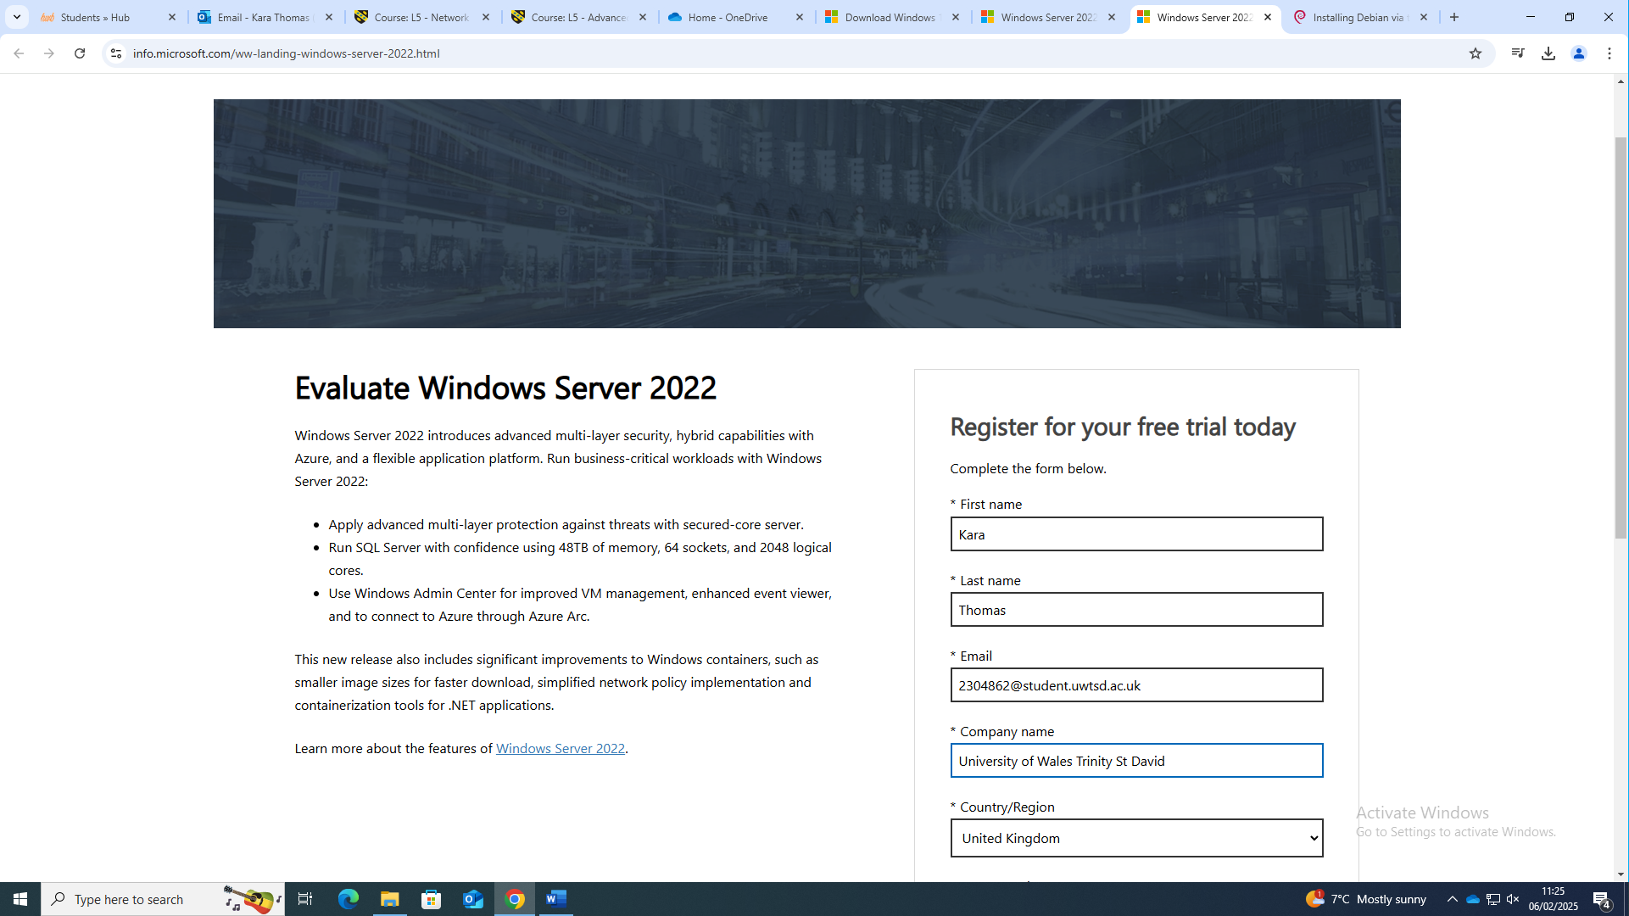
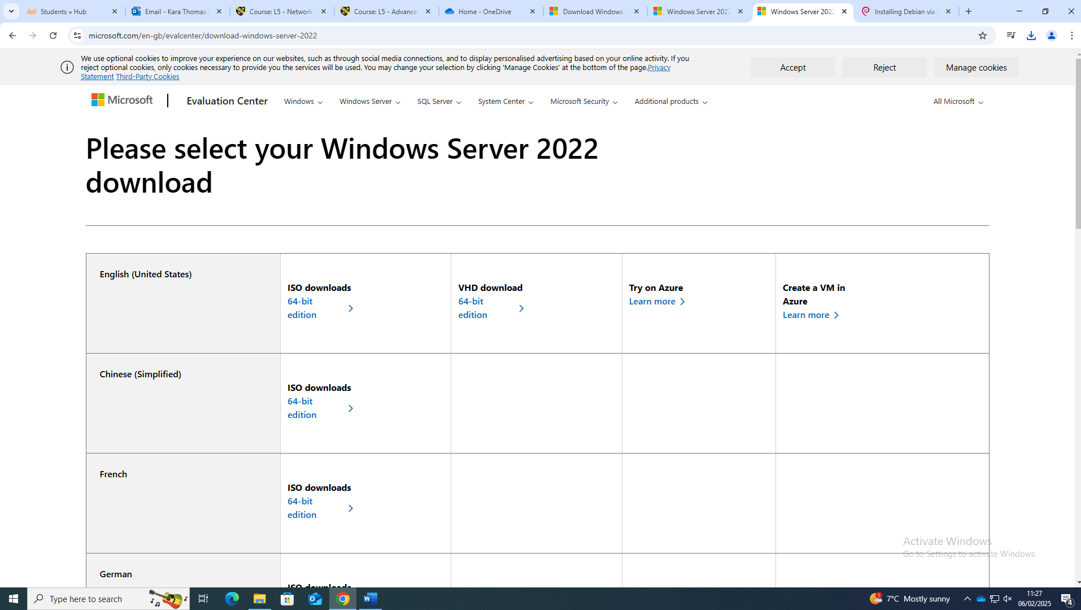

Debian

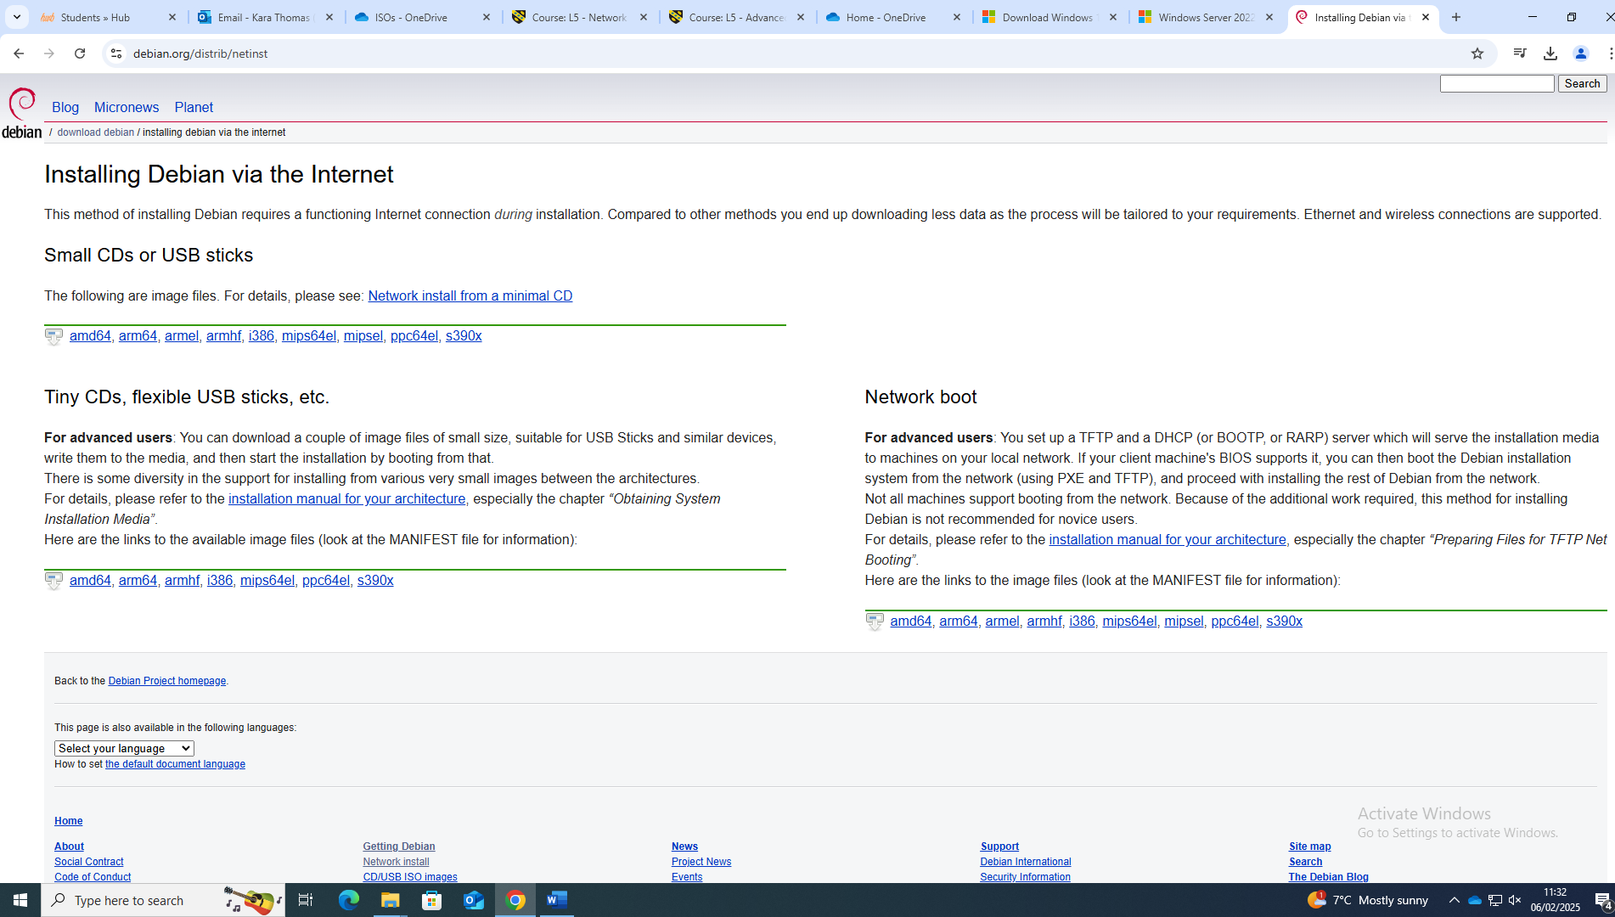
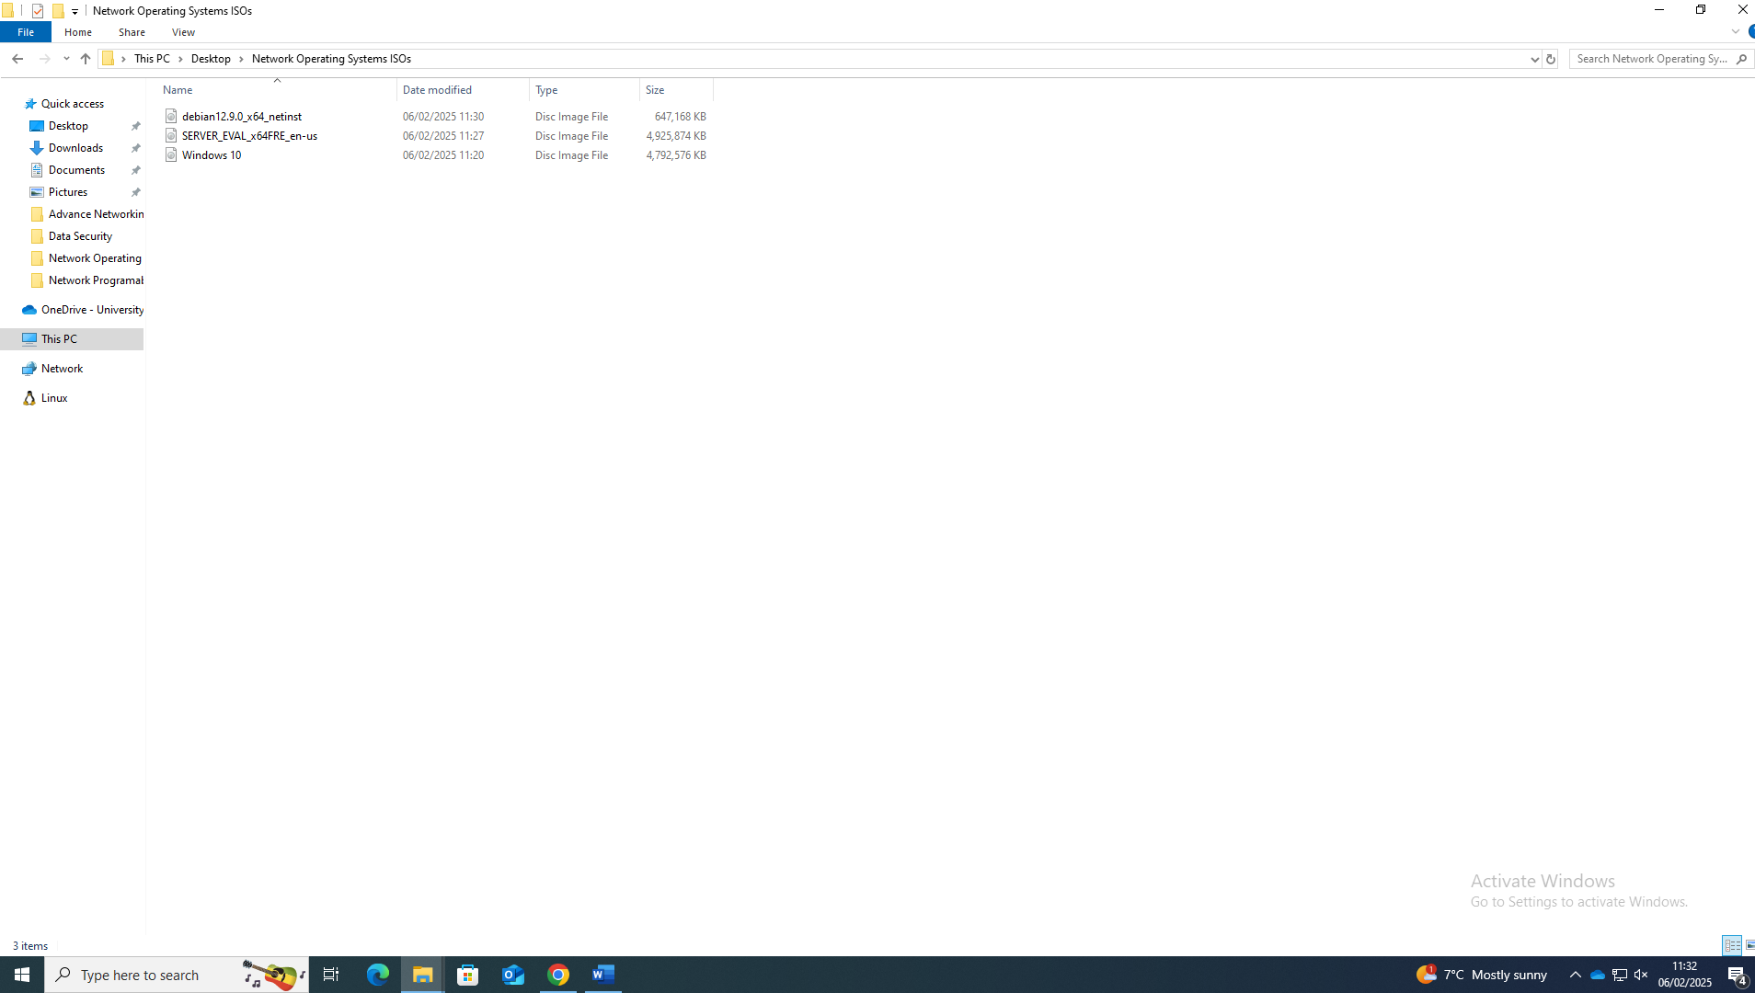

Installing virtual machines

Windows 10
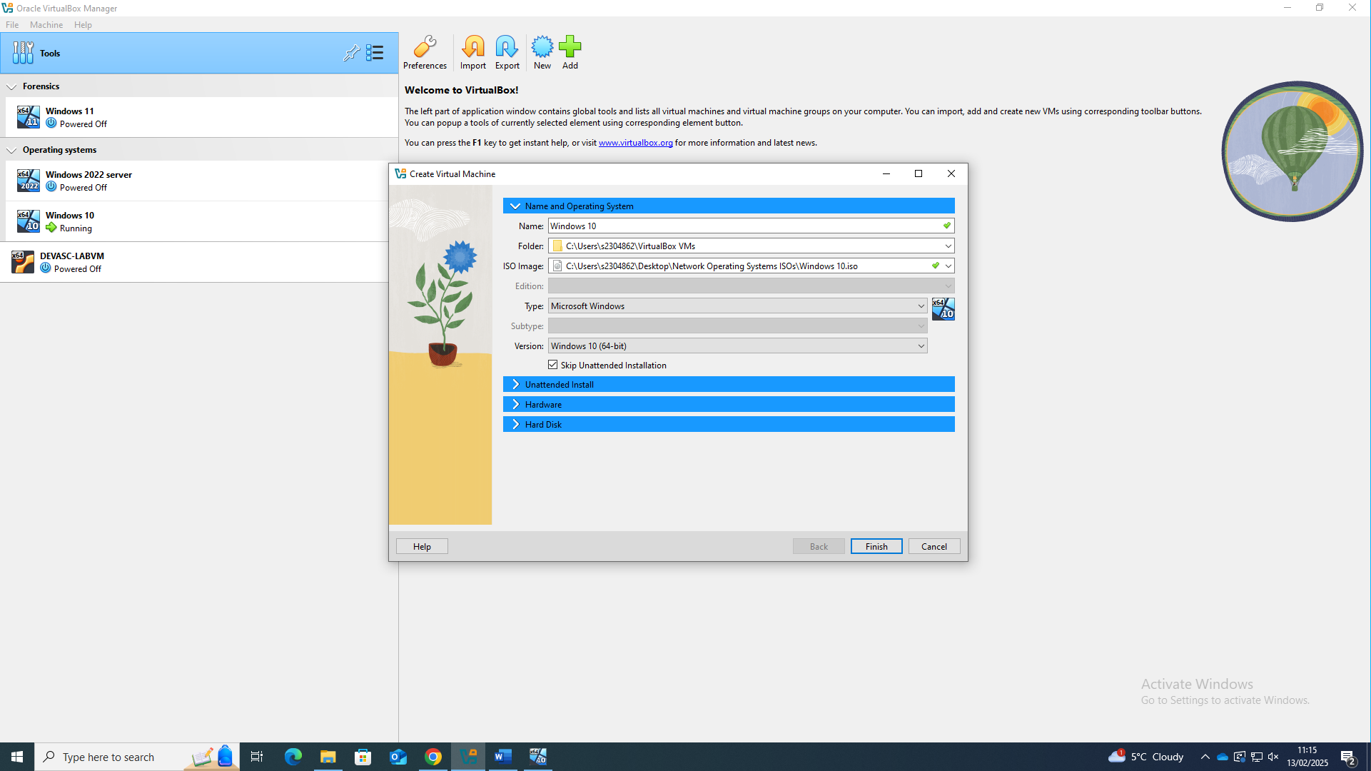

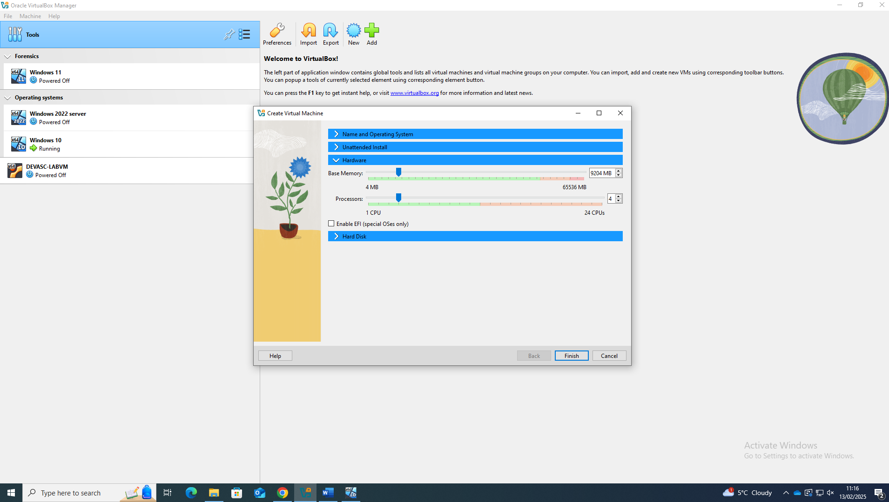

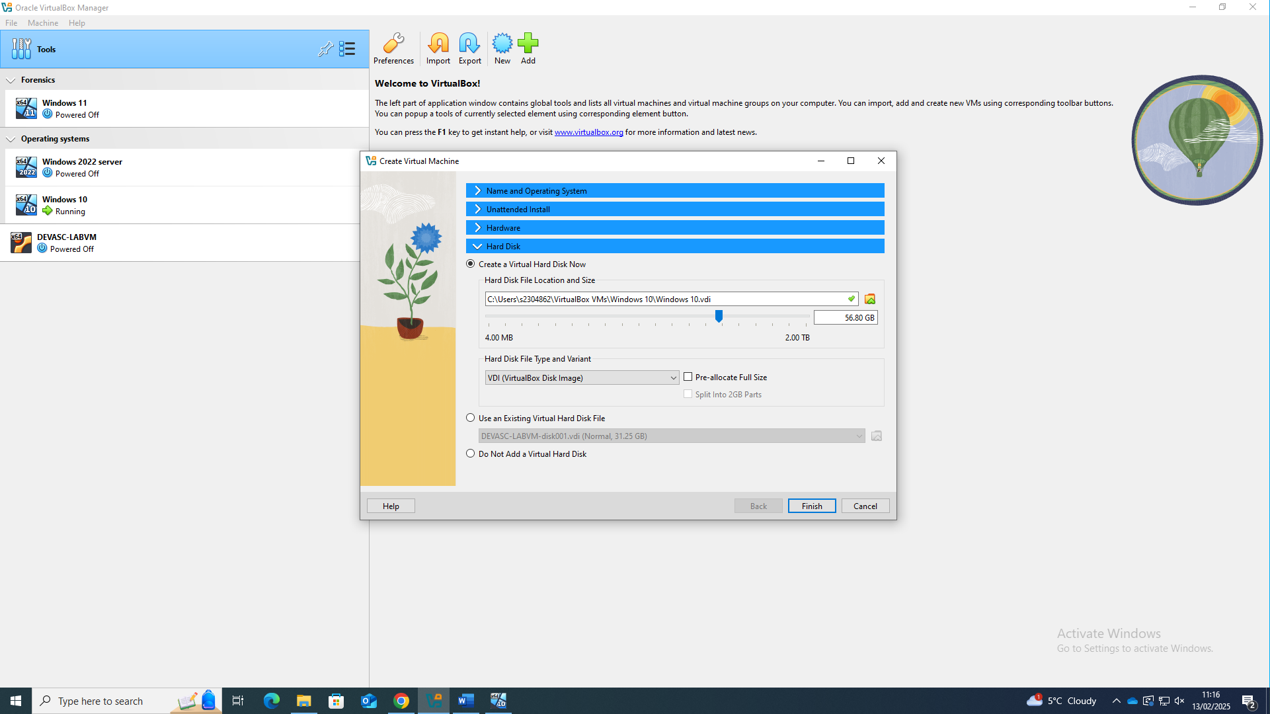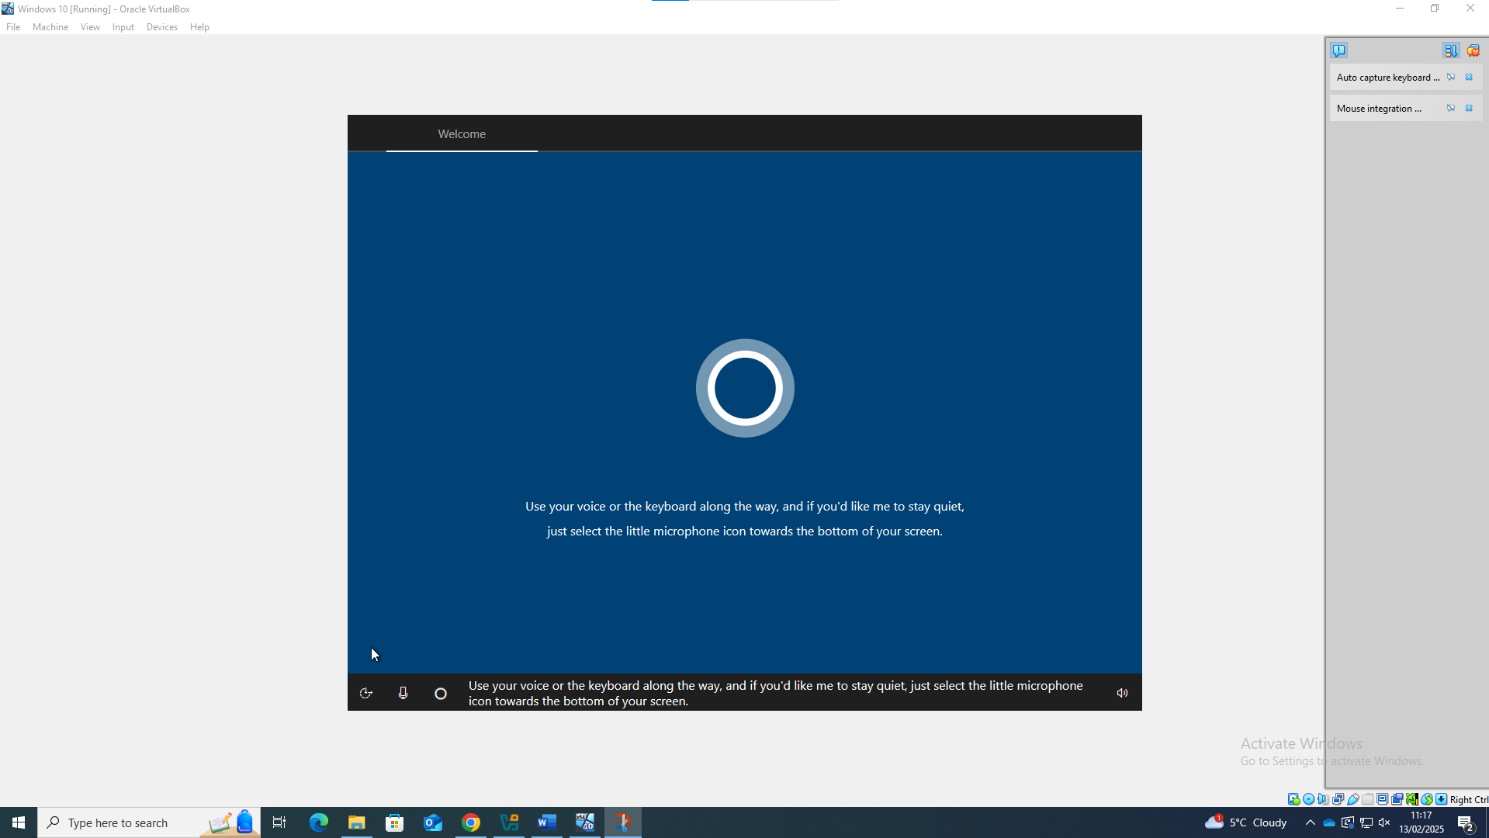

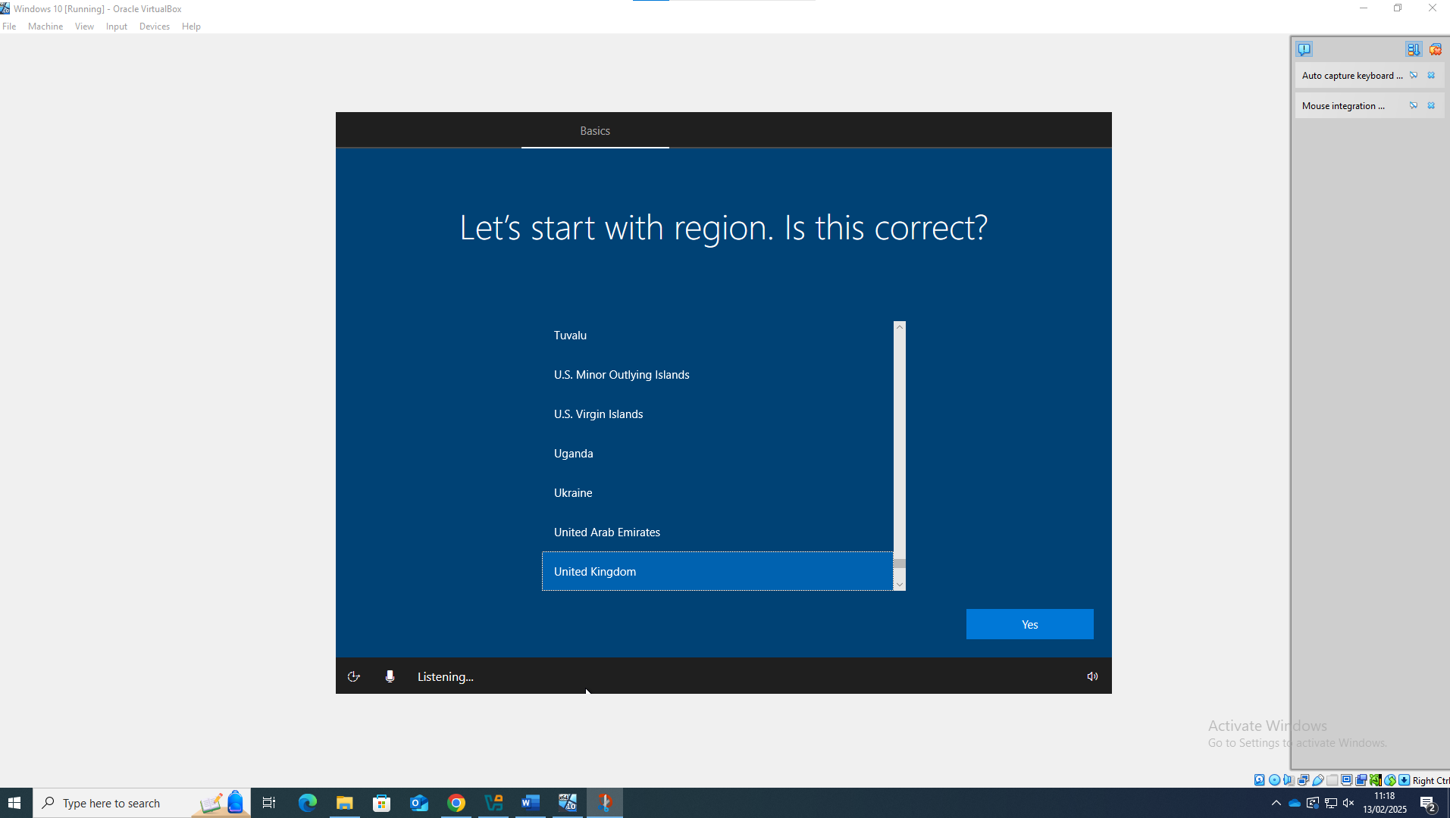
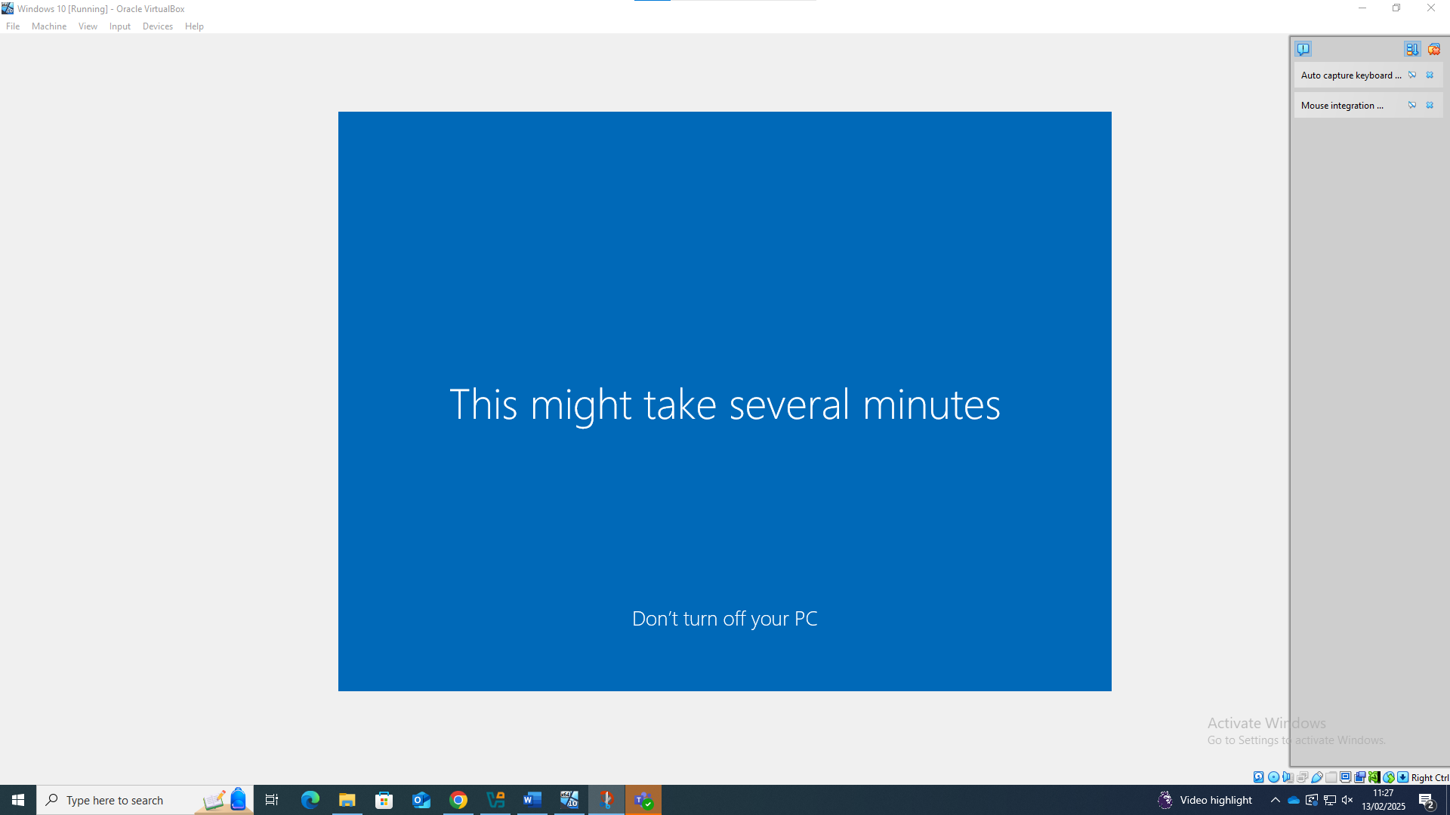

Windows server setup
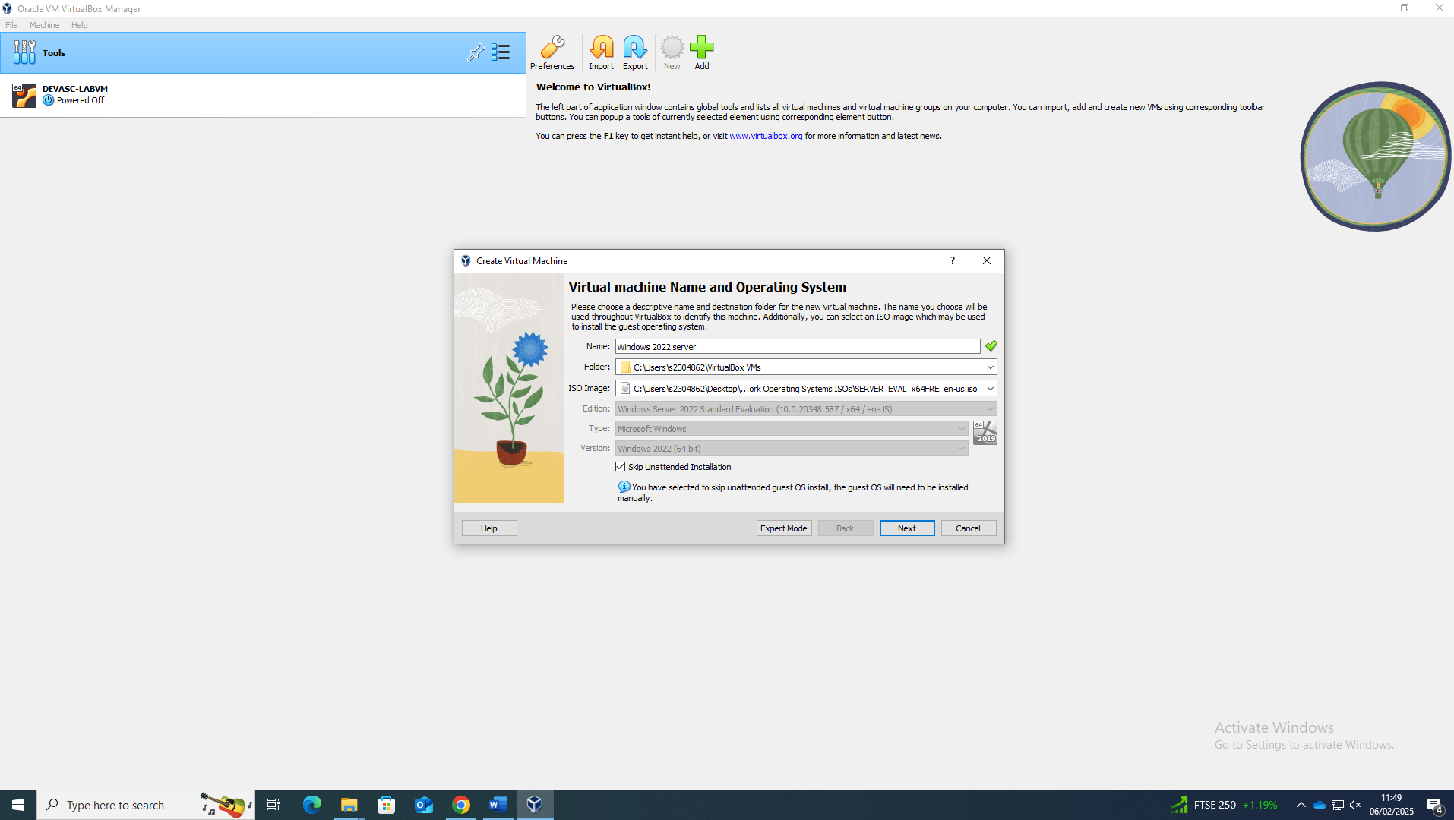

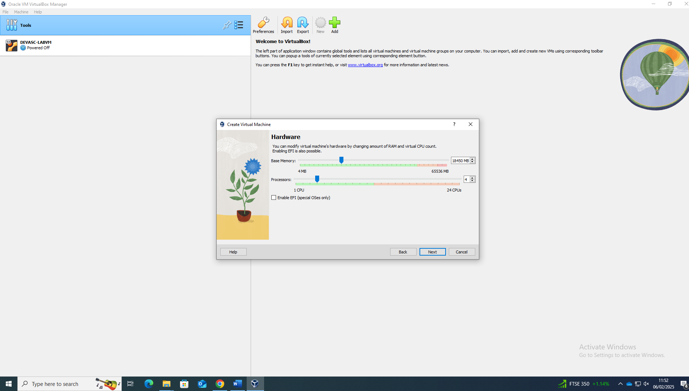
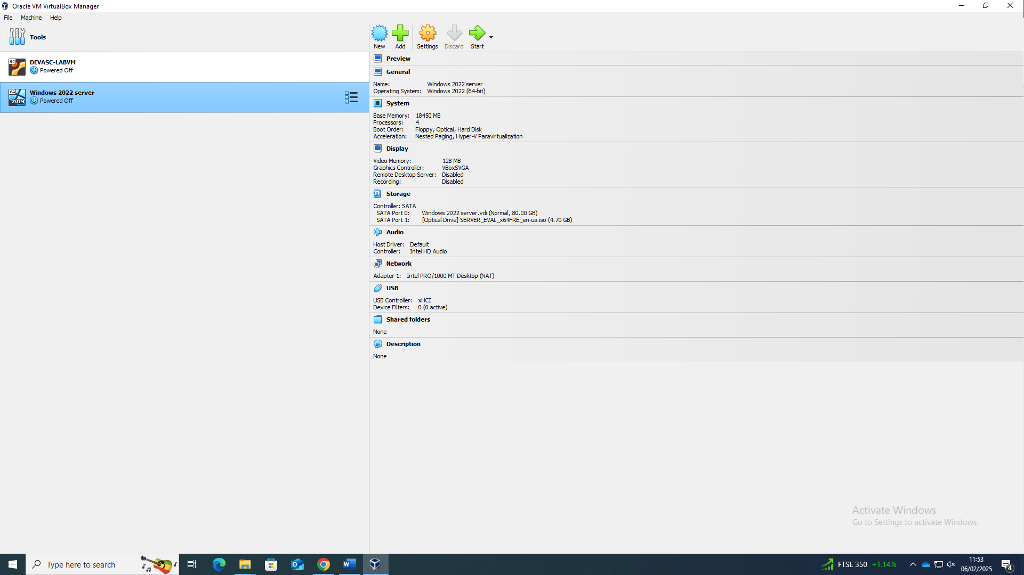

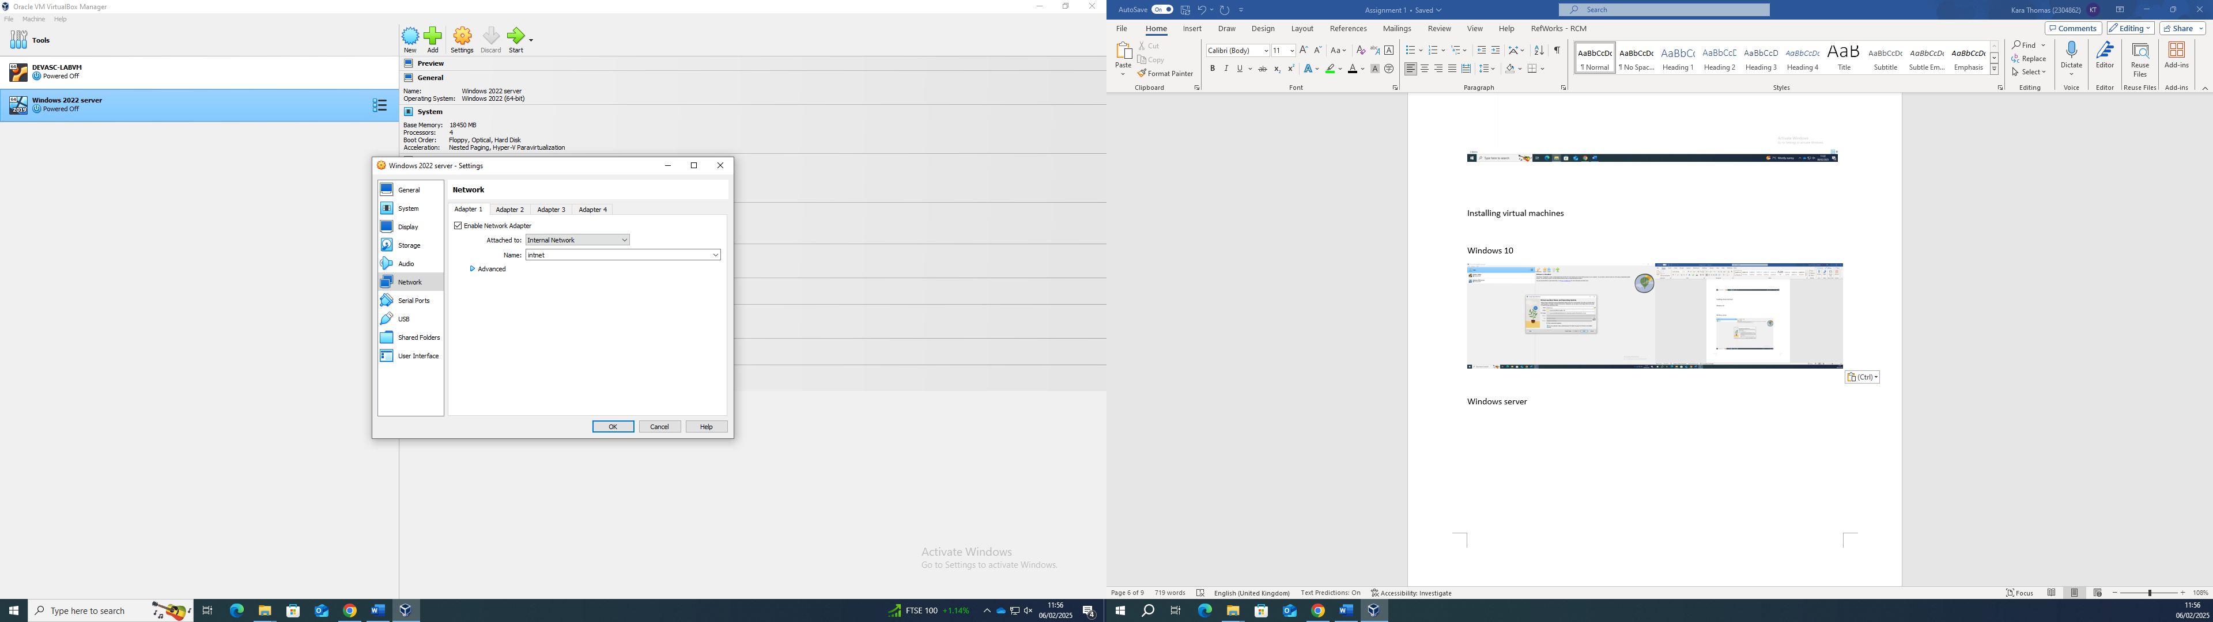

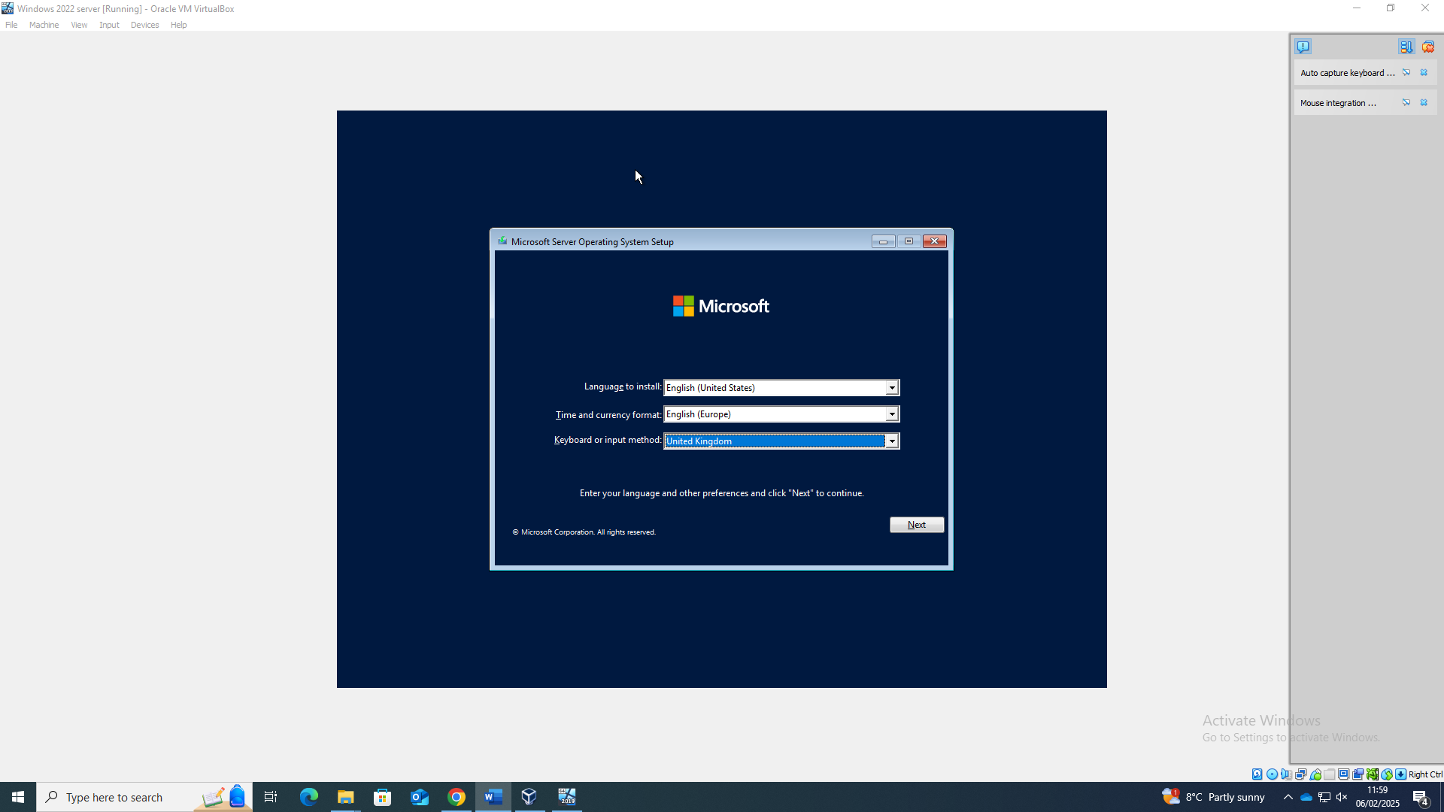

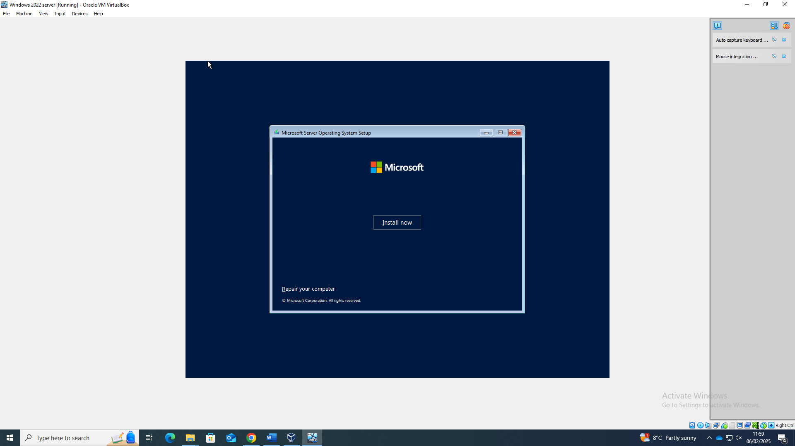
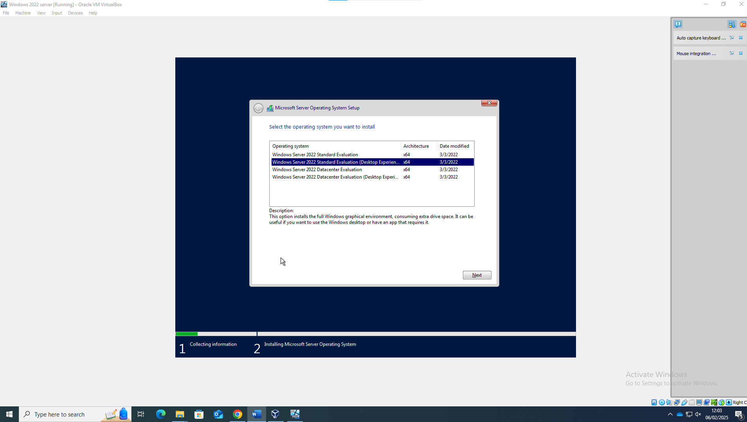
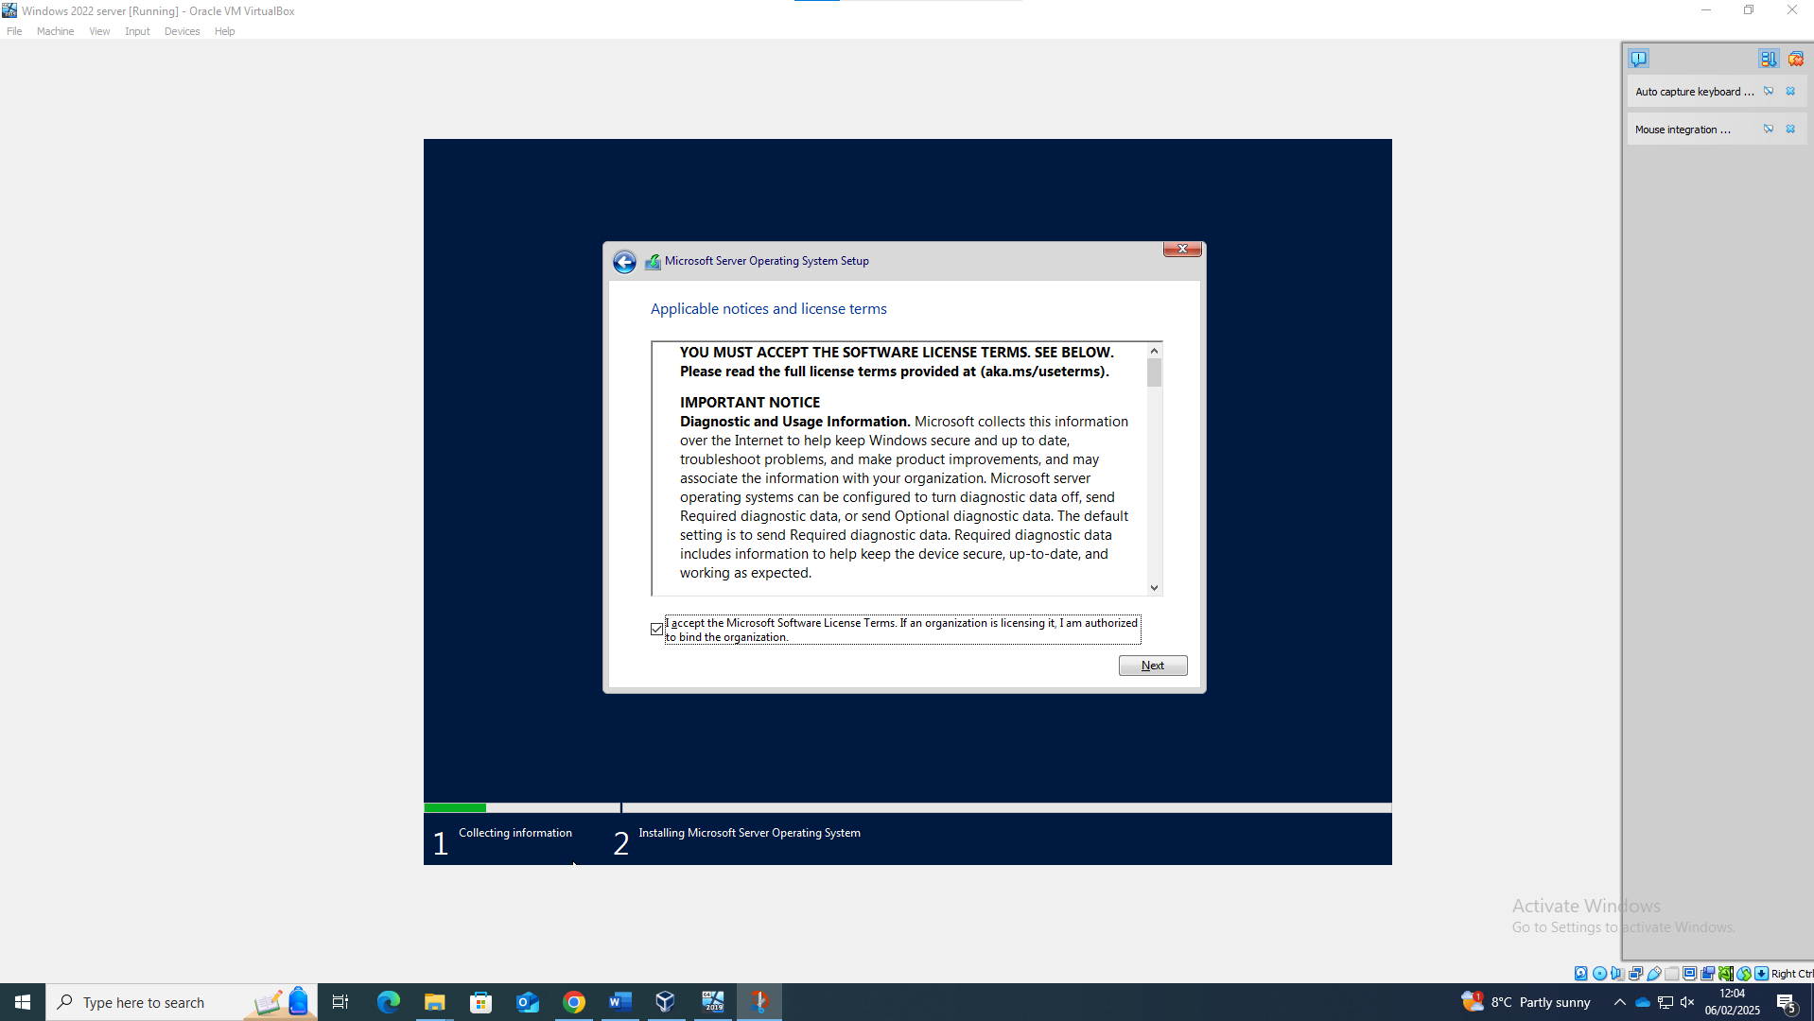
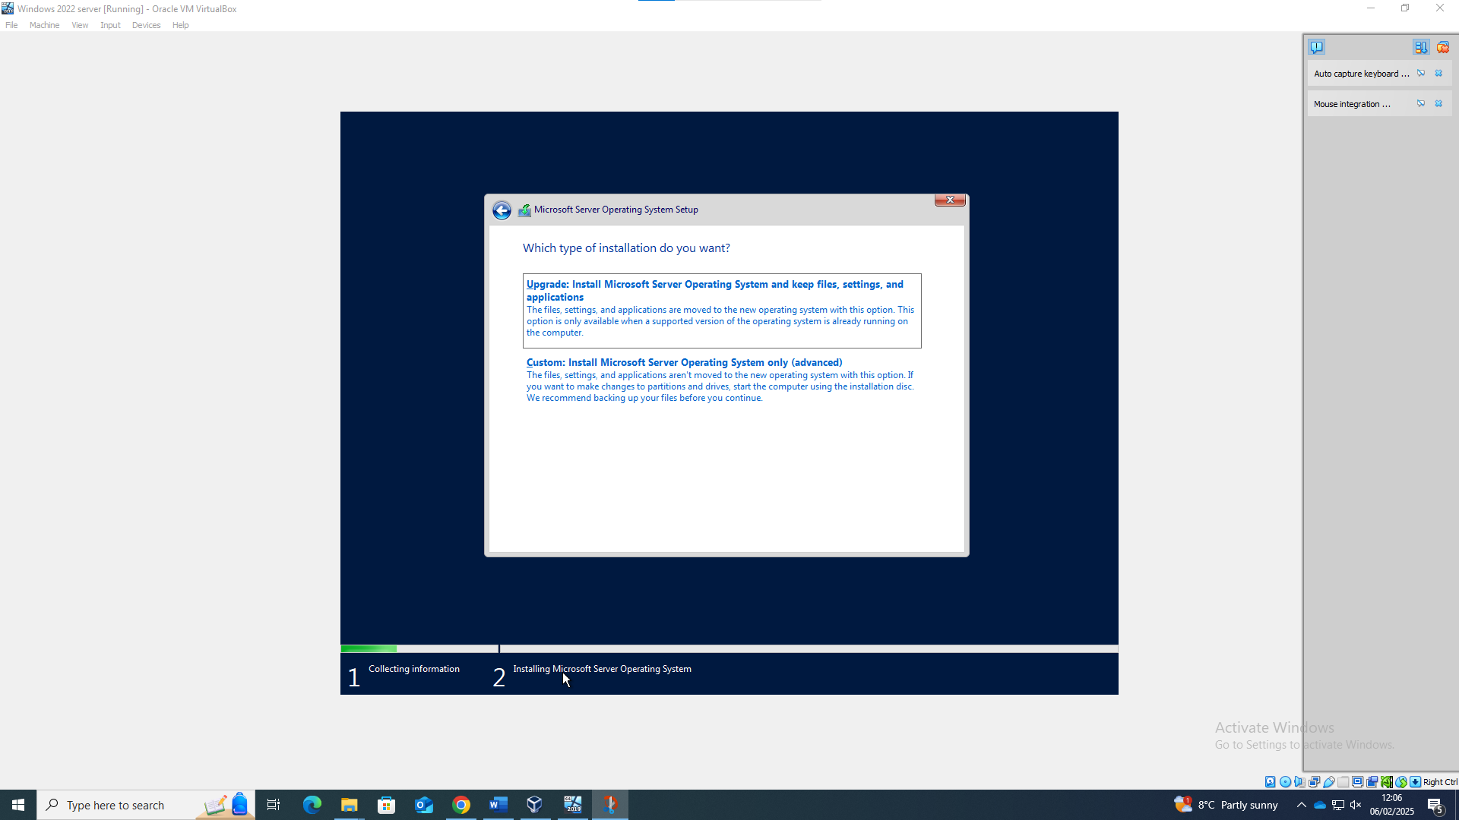
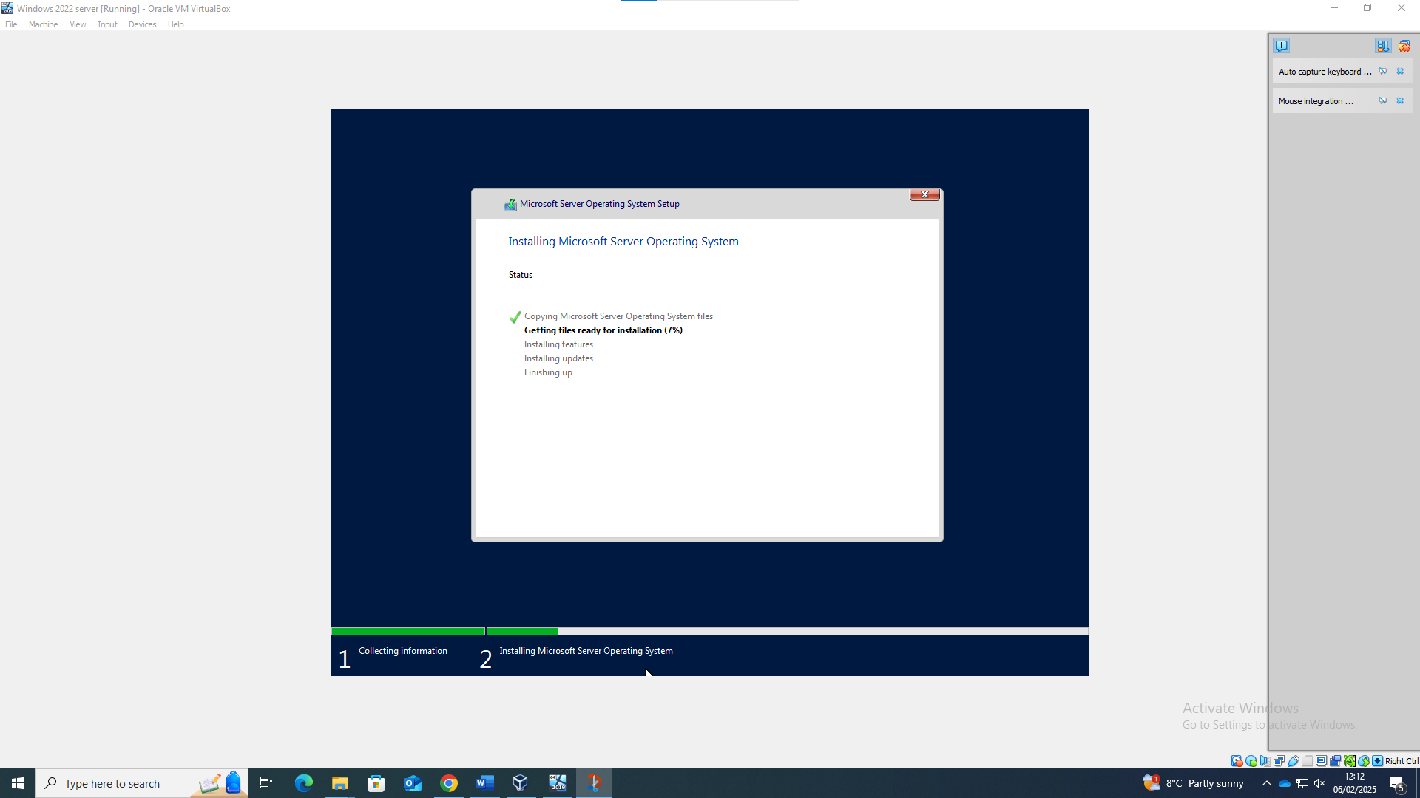
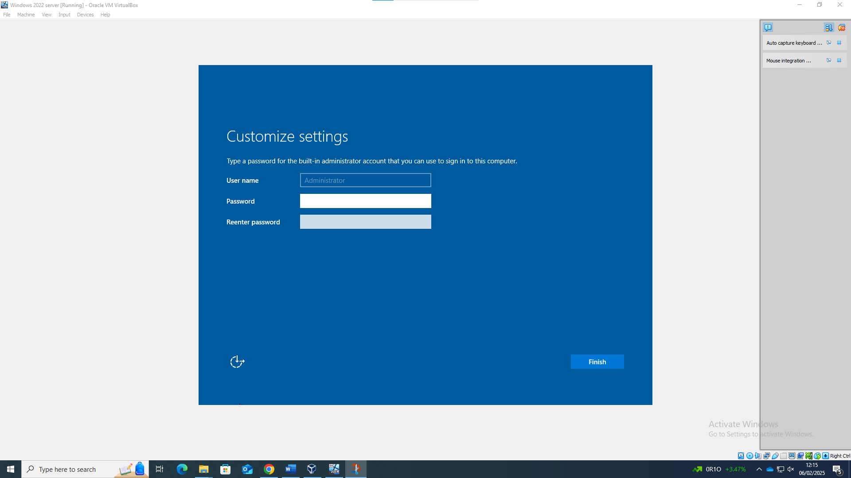

The password used is Cisco123

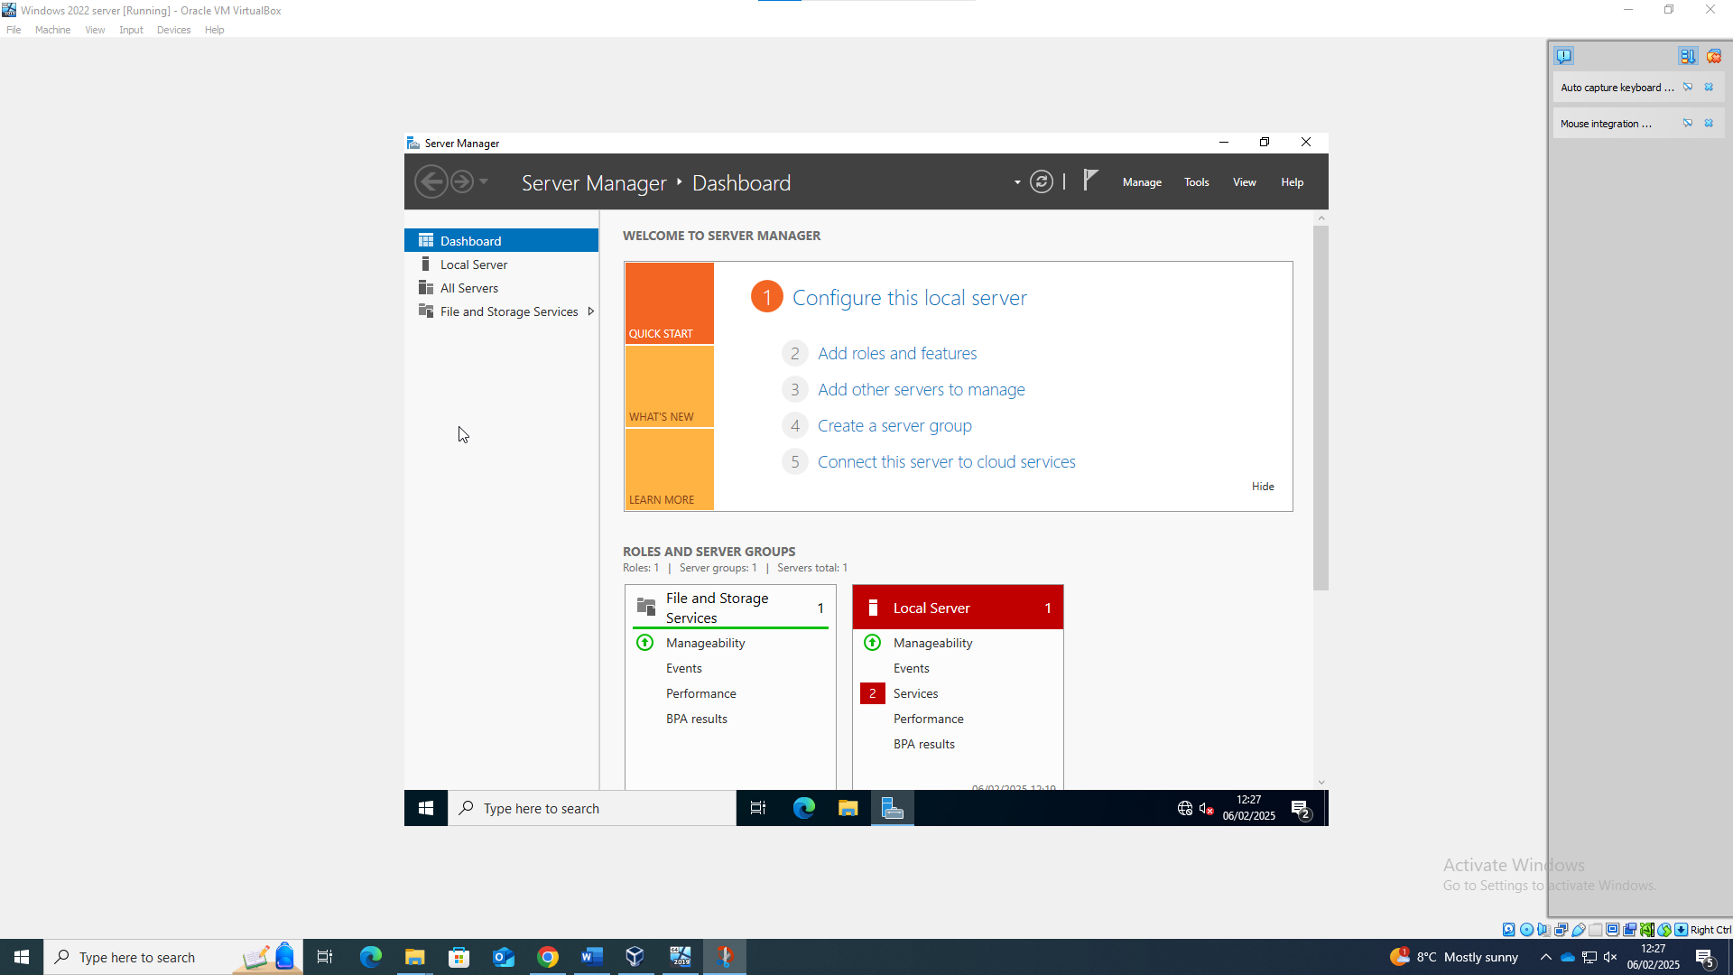

Debain setup
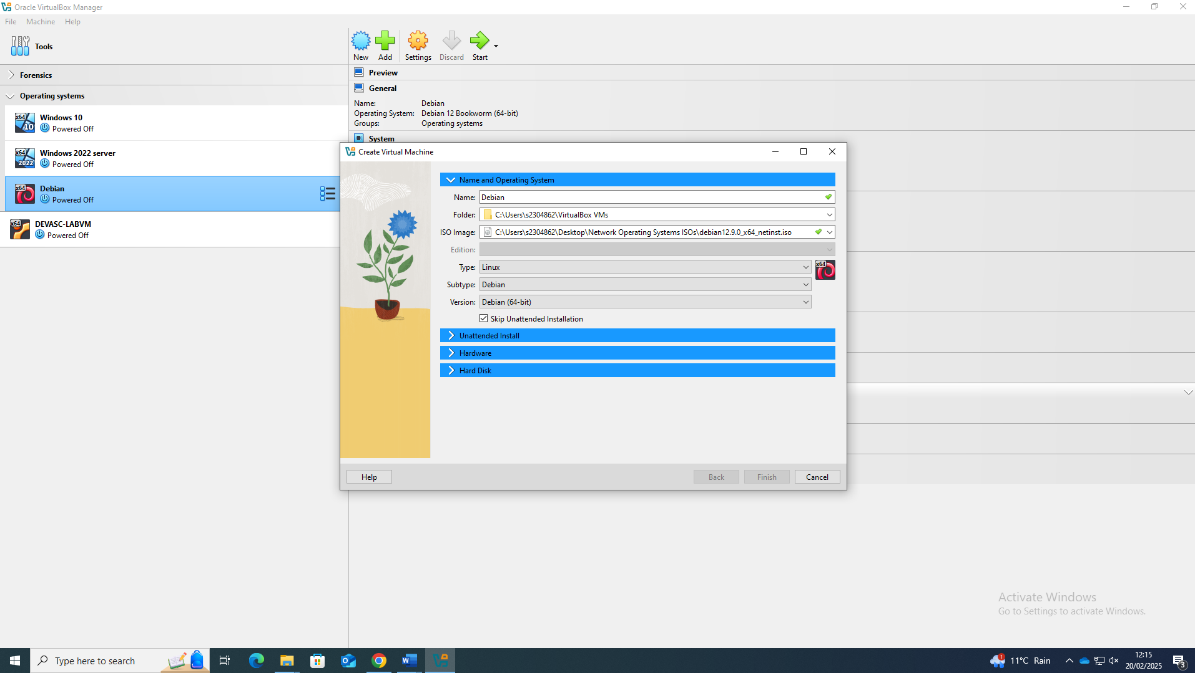

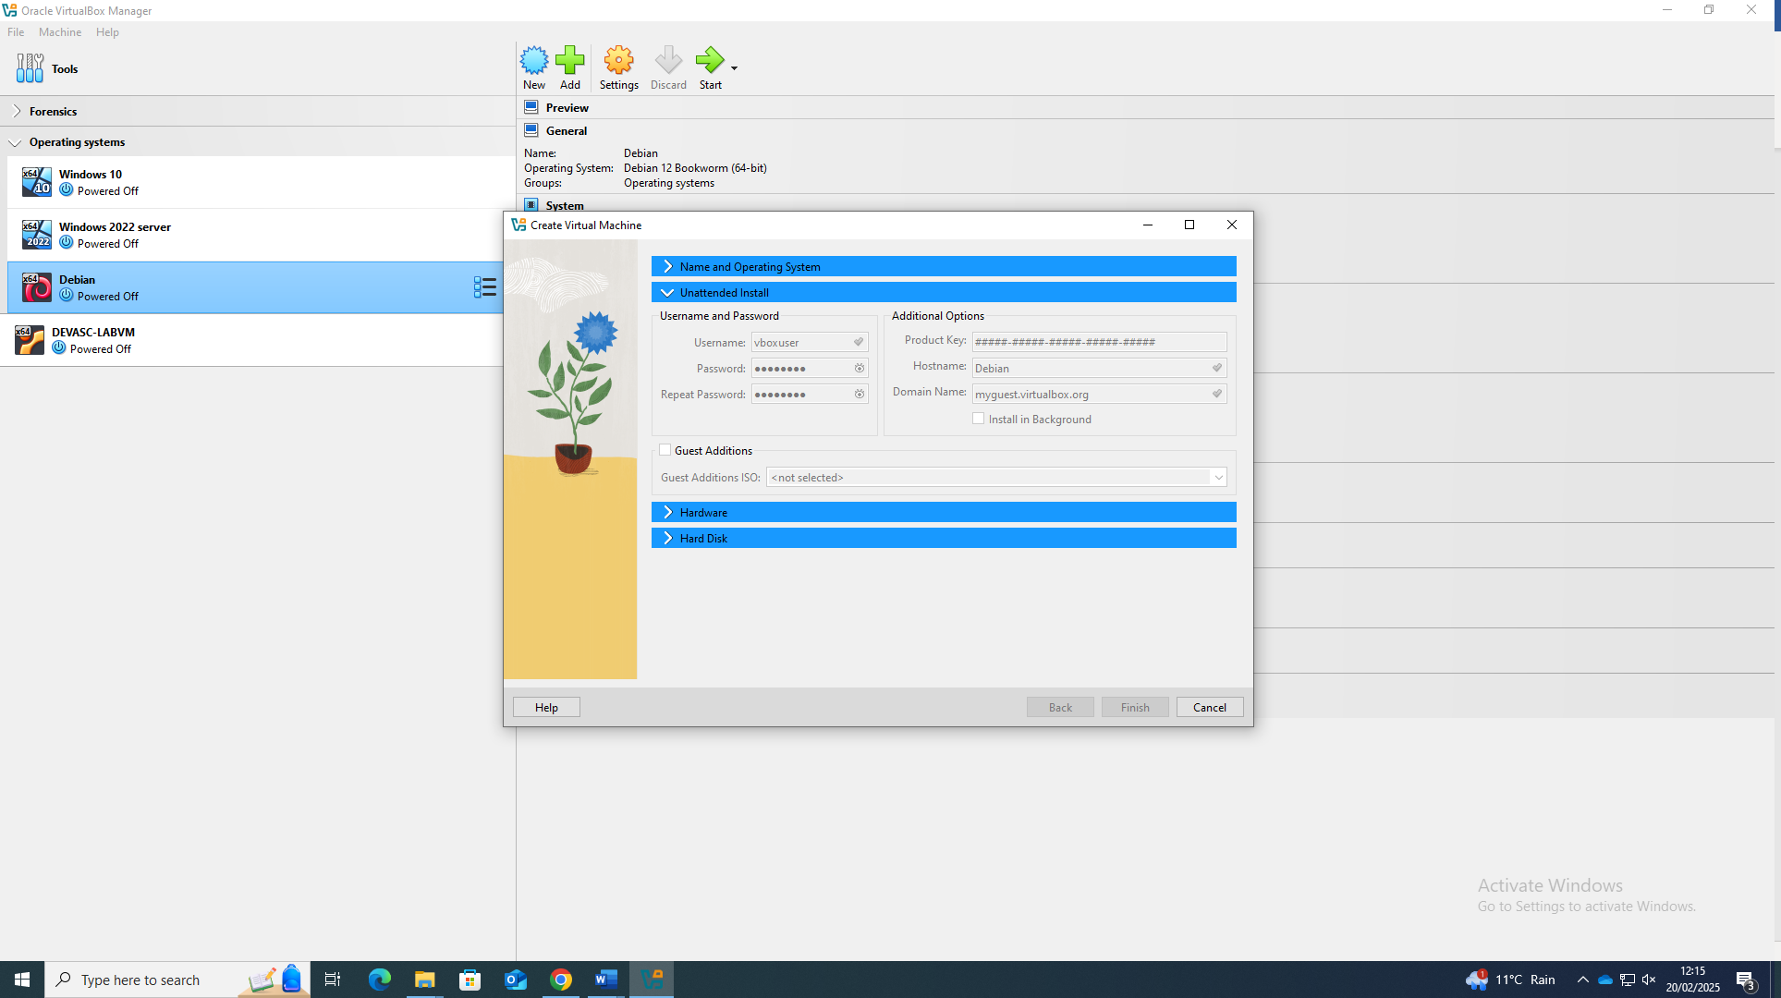

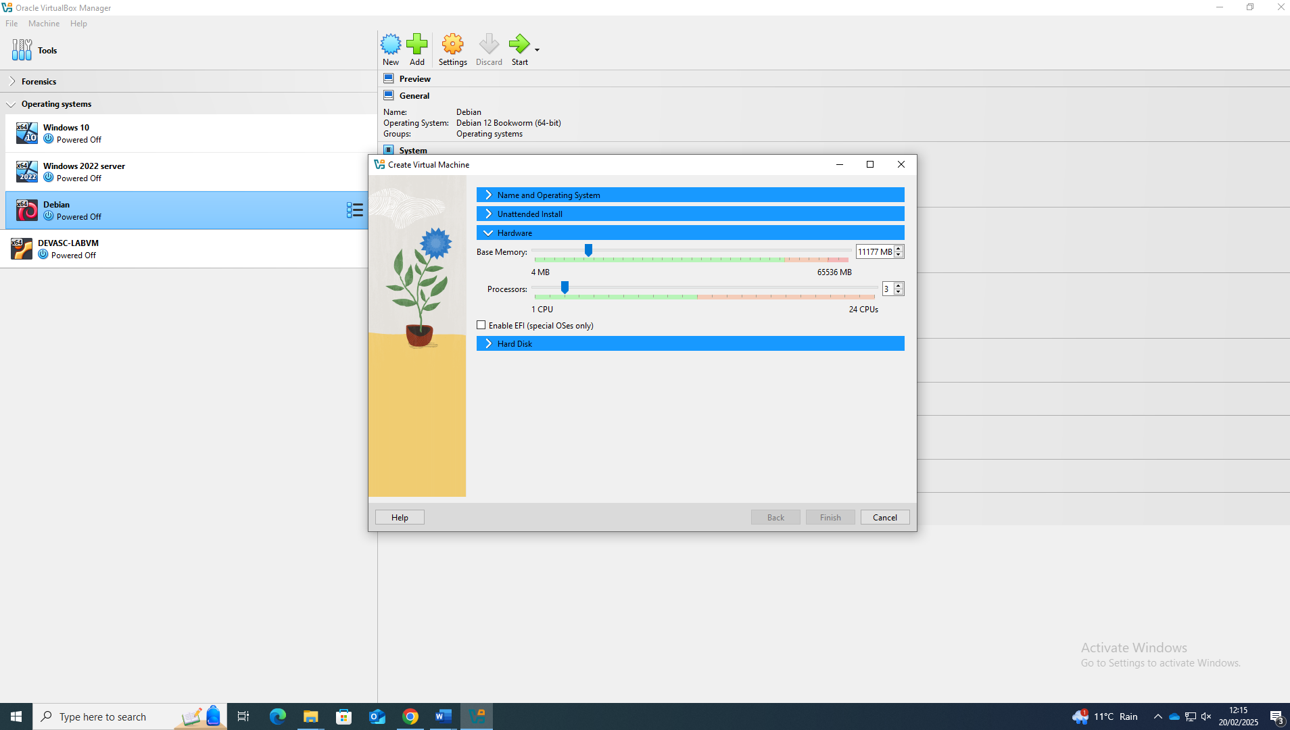

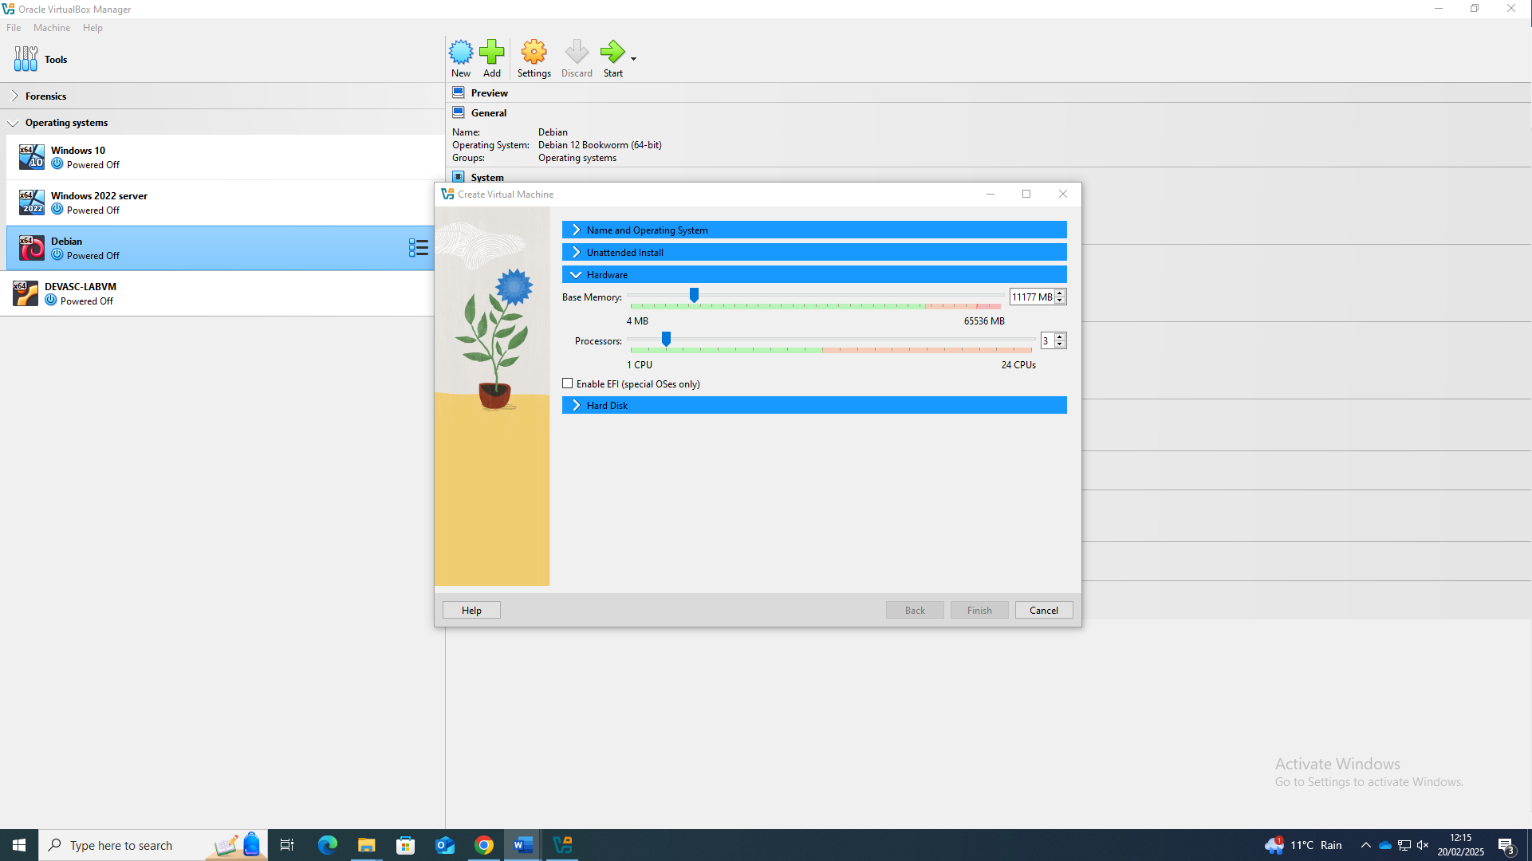

Debian Server setup

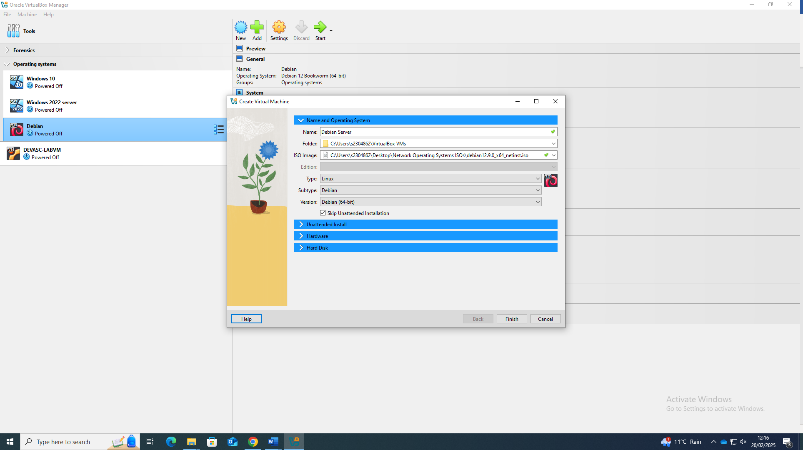
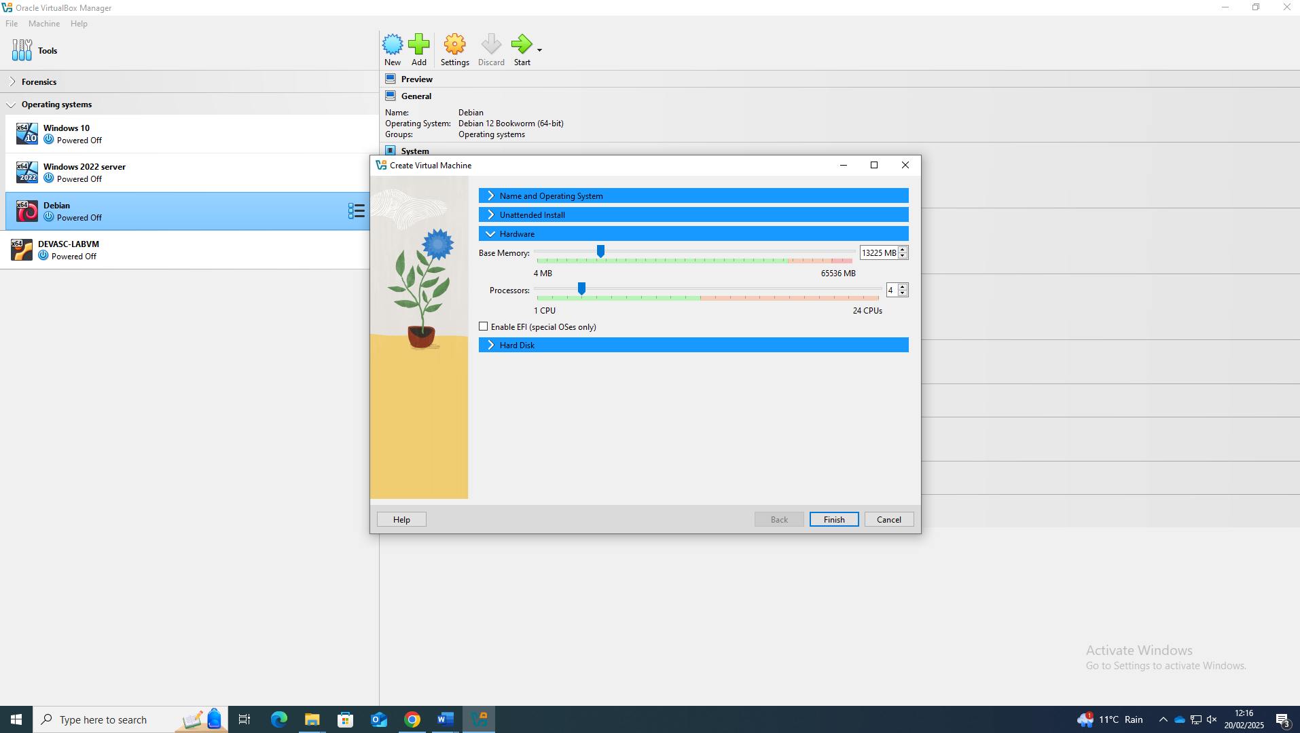

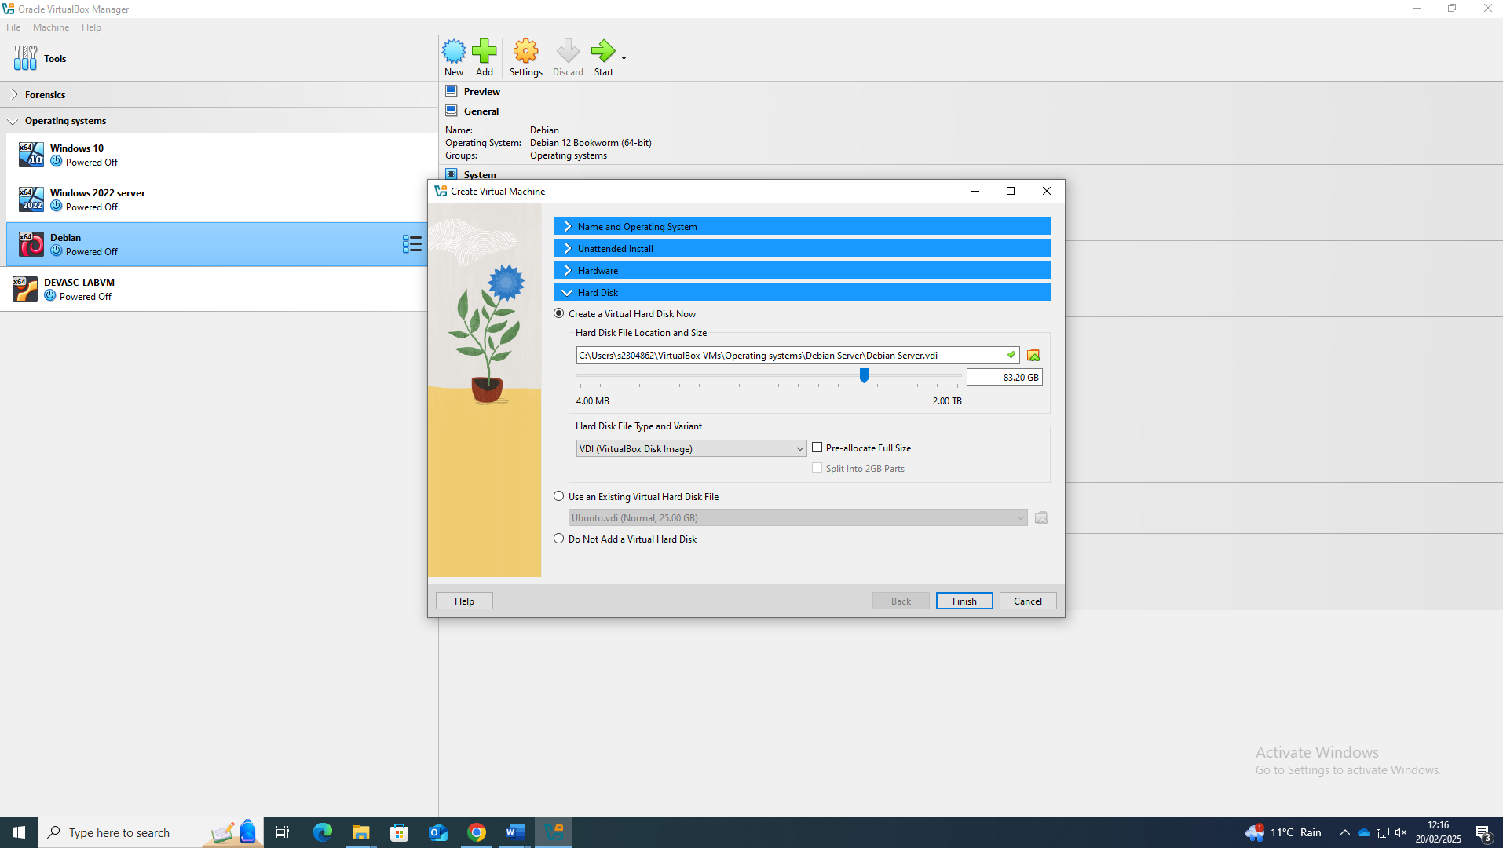
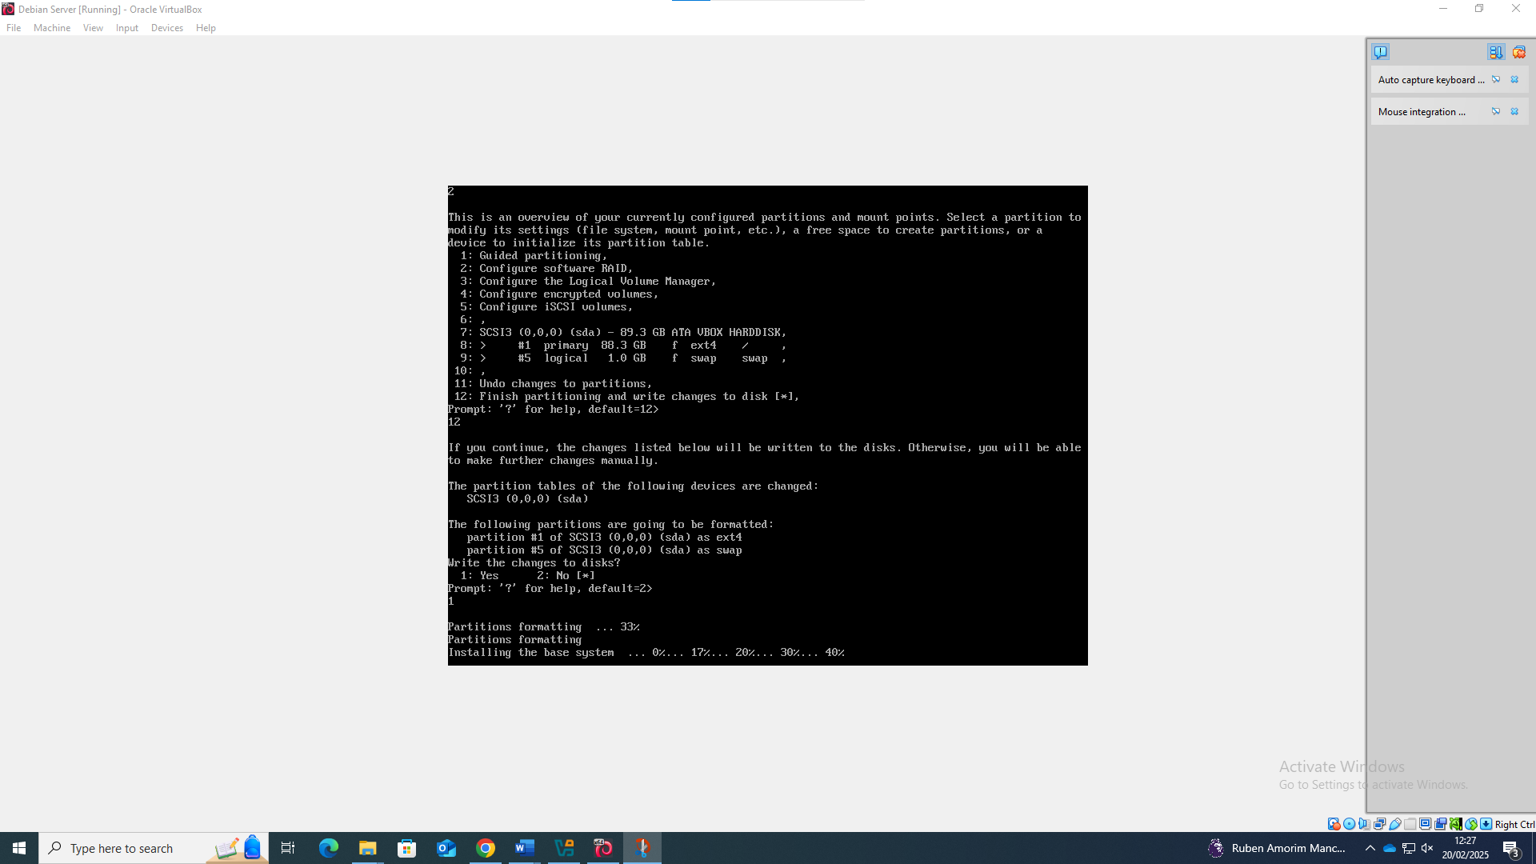
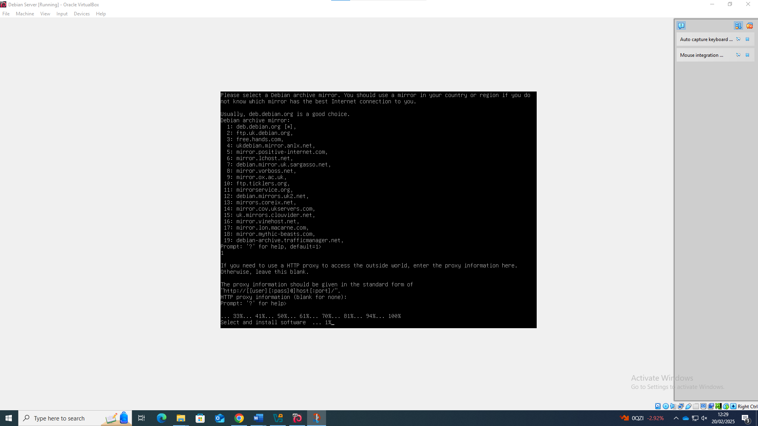

IP address scheme

Windows LAN

Network address:192.18.20.1
Subnet mask: 255.255.255.248 /29
ClientS1: 192.18.20.2
S-DC: 192.18.20.3

Debian LAN
Network address: 12.110.10.1
Subnet mask: 255.255.255.248 /29
ClientC1: 12.110.10.2
C Server:12.110.10.3

ClientS1 IP Addressing
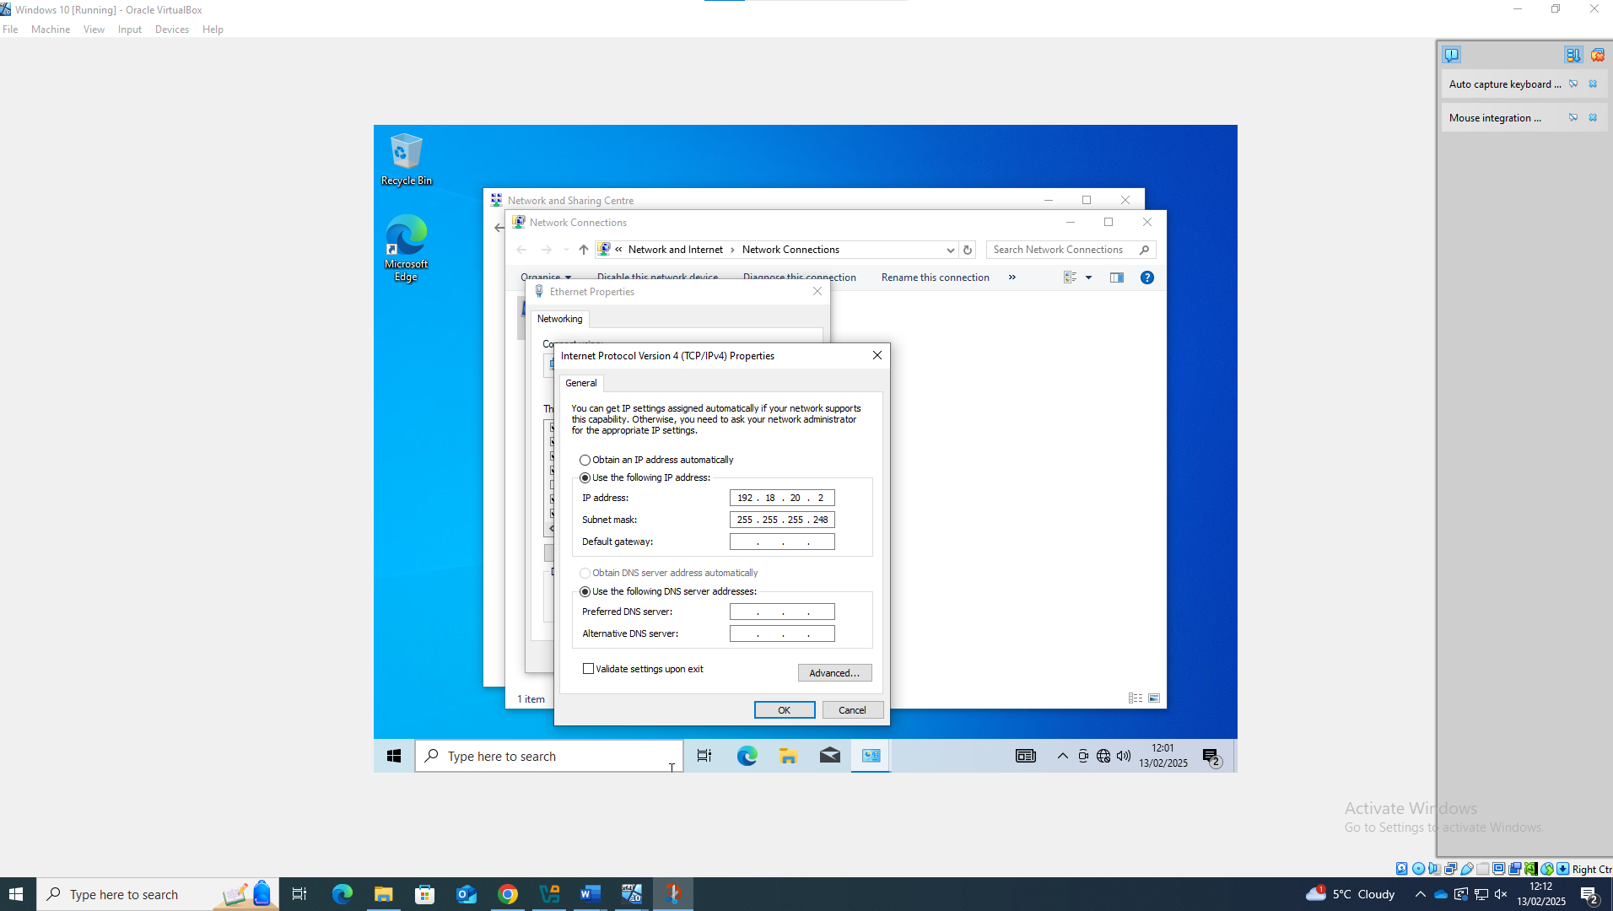

S-DC IP Addressing

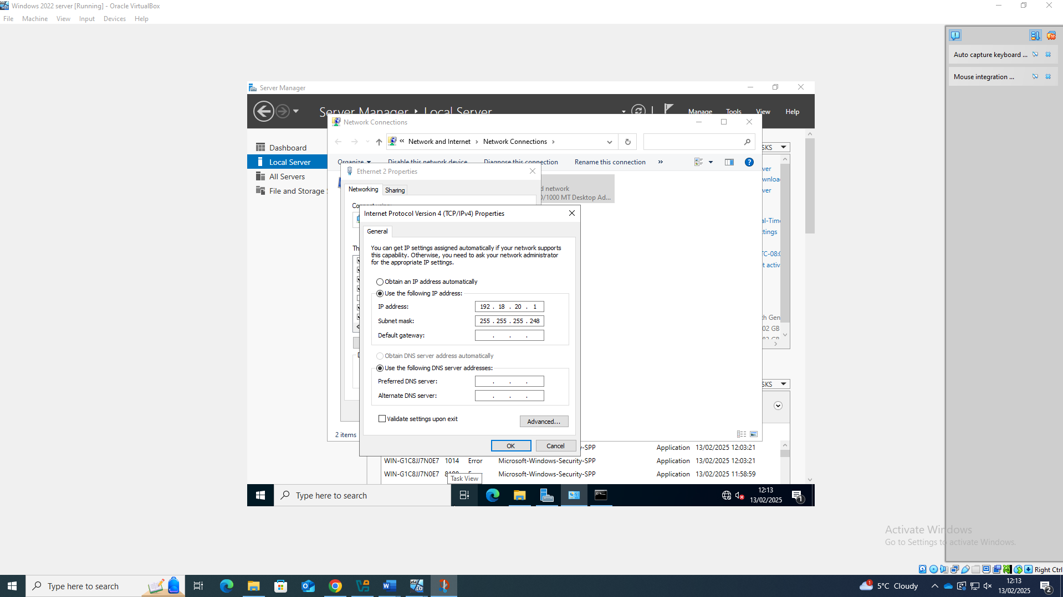

ClientC1 IP Addressing
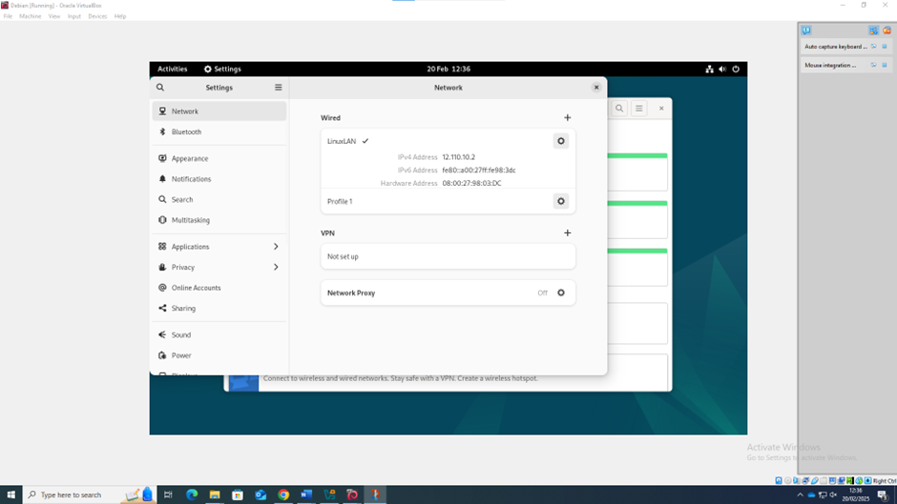

C Server IP Addressing
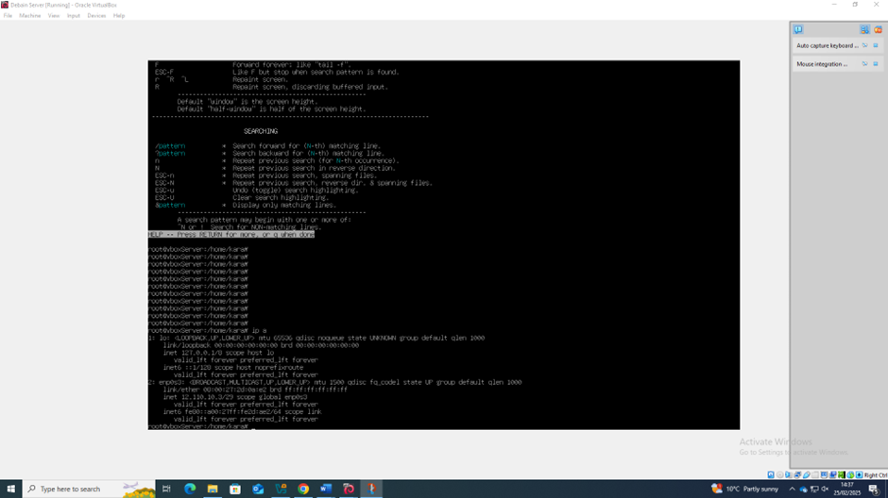

Outcome 1: Successful connectivity within same networks.

Successful connectivity between ClientS1 and S-DC
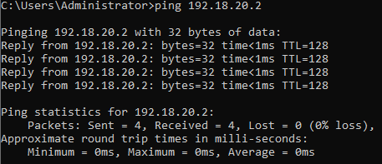

Successful connectivity between ClientC1 and C Server

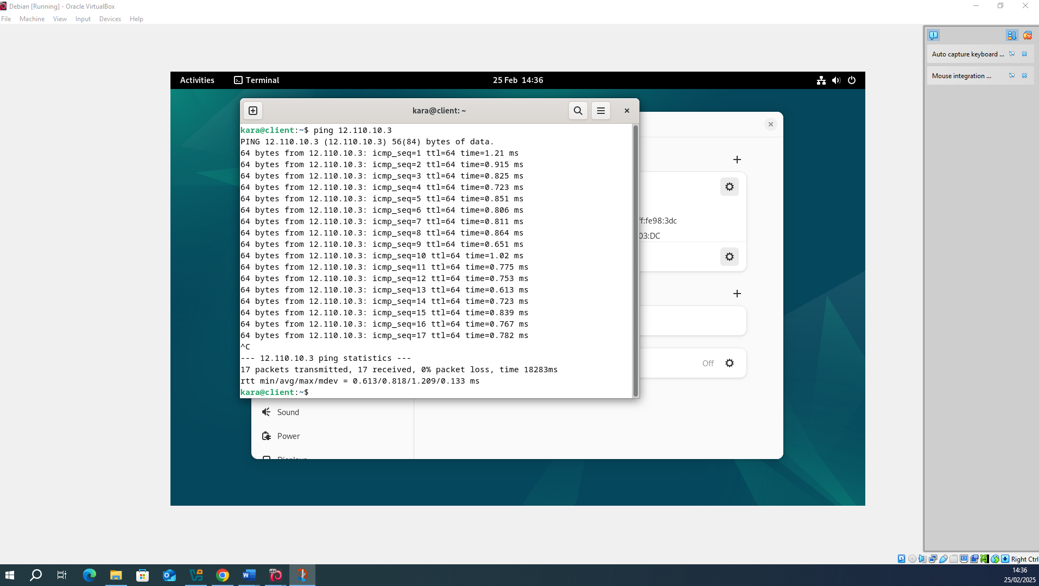

Outcome 2: Unsuccessful connectivity within different networks.

Pinging from 12.110.10.2 to 192.18.20.2
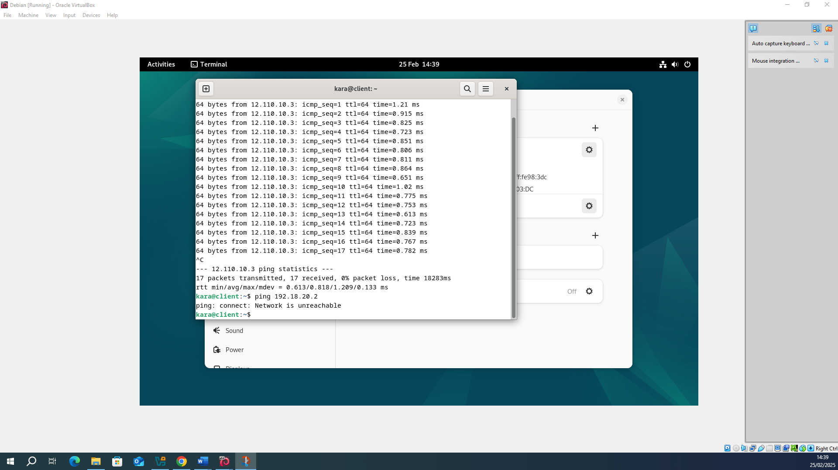

Reflection
My personal experience with creating the topology was good as with previous experience of configuring IP addresses on Windows systems made the Windows LAN easier to set up.
During the setup and configurations of the topology It went overall quite well, minimal issues occurred. Although despite my previous experience the main issue I faced was with the Windows LAN where I initially used the wrong adapter type. This was solved simply by the adapter type on both the S-DC server and the ClientS1 being changed to an internal adapter type which was named WindowsNet.

References

[1] | M. Eder, “Hypervisor- vs. Container-based Virtualization,” Technische Universität München, N/A. [Online]. Available: https://www.net.in.tum.de/fileadmin/TUM/NET/NET-2016-07-1/NET-2016-07-1_01.pdf. [Accessed 28 February 2025].
[2] | Zunaid Aalam, “A review paper on hypervisor and virtual machine,” Journal of Physics: Conference Series, vol. 1950, no. 012027, p. N/A, 2021.
[3] | H. Subedi, “Fundamentals Of Computer Network Security,” Jones IT, 1 September 2024. [Online]. Available: https://www.itjones.com/blogs/fundamentals-of-computer-network-security. [Accessed 28 February 2025].
[4] | P. Gralla, How the Internet Works, Indianapolis: Macmillan computer publishing, 1998.
[5] | Cloudfare, “How does the Internet work?,” Cloudfare, N/A. [Online]. Available: https://www.cloudflare.com/learning/network-layer/how-does-the-internet-work/. [Accessed 28 February 2025].
[6] | Cisco Networking Academy, “IPv4 Address Strucutre (11.1),” in Introduction to Networks Companion Guide CCNAv7, San Jose, Cisco Press, 2010, pp. 341-344.
[7] | Geeks For Geeks, “Difference Between IPv4 and IPv6,” Geeks For Geeks, 27 December 2024. [Online]. Available: https://www.geeksforgeeks.org/differences-between-ipv4-and-ipv6/. [Accessed 28 February 2025].
[8] | D. A. K. Singh, “Internet Protocol (IP) Address – Subnetting and Supernetting,” International Journal of Emerging Trends & Technology in Computer Science (I JETTCS) , vol. 4, no. 5(2), p. N/A, 2015.
[9] | Cisco, Routing Protocols and Concepts, Indianapolis: Cisco Press, 2011.
[10] | M. a. O. E. E. a. A. M. A. A. T. a. M. A. T. S. Usman, “Review of Interior Gateway Routing Protocols,” 15th International Conference on Electronics, Computer and Computation, pp. 1-5, 2019.
[11] | Y.-Q. Z. X. C. &. B. L. Zhensheng Zhang, “An Overview of Virtual Private Network (VPN): IP VPN and Optical VPN,” Photonic Network Communications, vol. 7, no. N/A, pp. 213-225, 2004.
[12] | R. Droms, “Automated Configuration of TCP/IP with DHCP,” Bucknell University, Lewisburg, N/A.
[13] | D. Francis, “N/A,” in Mastering Active Directory, N/A, Packt Publishing Limited, 2021, pp. 30-32.
[14] | D. Francis, “Dishan Francis,” Linkedin, N/A. [Online]. Available: https://uk.linkedin.com/in/dishanfrancis. [Accessed 28 Febuary 2025].

