Abstarct

This quatitiative study is to evaluate the impact of the driving experinece and the previous accident history on the motor insurance premium. The study is significant in the framwork of general insurance phenomena and the operationa of undewritiers and acturials. The study has been conducted by using the SPSS tools and the releavnt data have been alaysed by performing one-way ANOVA and Independent sapmle t-test tools, with releavnt testings such as Leven’s Statistics, Tukey HSD, and Game-Howell. Driving experience and the previous accident histpry have been considered as independent variables and the motor insurance premium has been considred as dependant variable. The descriptive statistics have been performed to undertsnad the basic status of the dataset after the recording according to the suitablity of the variables. The study has bee used a secodary dataset publicly availble in www.Kaggle.com with 500 responses. Further, the study has been supported by the contextualisation of the risk theory and experince pricing theory. Each test has been performed to investigate the relavncy of the hypothesis developed. Finally the outcome of the study emphasise that the driving experince is highly significant to determine the motor insurance premium and the risk- base insurance has a greater influence in the accuracy of the premium derminent of motor insurance. However the previous accident hisptry has not performed a significance which is a negligable amout and this finding was not supported the theoratical framwork of experinc pricing theory. Finally the outcome of the study has provided academic contributions to the academia and the indutsry and future recommendations for the improvement of the exisitng premium calculation practices and systems.
Keywords: motor insurance premium, driving experince, previous accident history, one-way ANOVA, Independent sample t-Test, Games-Howell test, Risk theory, Experince pricing theory

Chapeter 1

Introduction

1.1 Motor Insurance Industry
Global motor insurance segment is one of the most attractive insurance class in general insurance practice. The high frequency of the mandatory purchasing class lead to a massive industry growth annually which also effected by the various phenomenon like continous technilogical innovations and challngers global vehicle market. The global motor insurance market is worth of approximately USD USD 2.27 Trillion in 2026 and it ia acquiring a 6.65% CAGR (Mordor Intelligence, 2026). The market segment is mainly divided into two segments such as third party insurance share is 42.37% while the comprehensive market is share is 57.63% in 2025 (Mordor Intelligence, 2026).
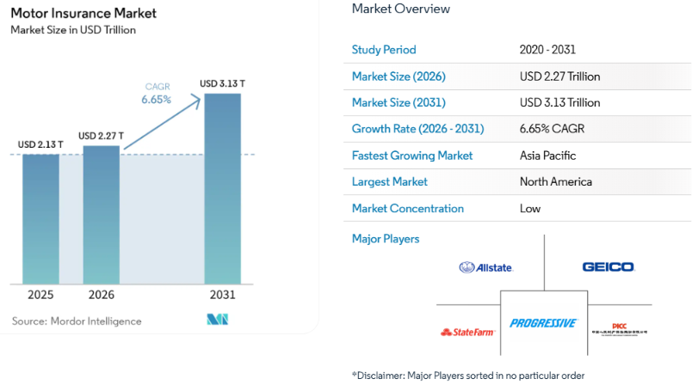
The global motor insurance market is effcetd by several key trends and drives. As a most influencial trend technology and telematics play a significant role in the market driven by the pase of digital transformation in AI, machine learning, telematics offering personlise risk and usage based risk evaluation practices (Schwab, 2023). The global trend of EV usage is shaping the global motor insurance market with new risk assessments couple with the repaire cost evaluation (Total Systems PLC, 2026). Furthermore, regulators also make major influence for the dynamics of the motor insurance market dispite of global geographical relevance (Mordor Intelligence, 2026).
Premium pricing is the most significant and paramount of motor insurance practice as it may cause influences for the profitability margin, risk managment capacity and the competitive advantage of the organisation (Mildenhall & Major, 2022). Motor insurance premium influence the bottom line of the company via several aspects; being the most compelling business class in every general insurance company, motor insurance acts as the primary cashflow intake supporting the financial stability and the solvency margin of the insurer (Ritho, et al., 2023), by funding claims, reserving adequate capitals to meet regulatory solvency ratios and protecting profit margins covering the operational costs and invetment returns. Proper premium pricing strategies in motor insurance may influence on risk differntiation and anti selection of risk, attracting hazarouds risk for a lower premium and also differentiation high cost for highier risk drivers and lower for lower rik drivers (Parodi, 2023). Usage based premium pricing in motor insurance may reduce the risk in fradulant and deterrence and risk reduction causing the behavioral modifications of drivers or telematics (Xie, 2023). Motor premium pricing also play crutial role in macroeconomic adapttaions such as inflation hedging and EV transitions (Mehrotra & Chadha, 2025).
In calculation of motor insurance premium, driving experince and the previous claim history are vital components in risk evaluation. Undewritiners and acturials consider the driving experince as a proxy for the risk exposure (Isimoya, et al., 2022) and previous accident history may consider as a future risk predictor which helps measure frequency over severity and the discount of NCD and acts as a behavioral mirror (Xiong, et al., 2026). In this quantitative explanatory resaerch it will find out how the driving experince and the previous accident history impact on the motor insurance premium.

1.2 Problem Statement
In motor insurance individual drivers and the risk associated with them are considered as the key factors in premium determinants. In practice that drivers with different level of expreince and accodent histories are calculated with different premium amounts and justified. In general the experince driver may offer a premium reduction simultaneously the driver with previous accident histroy may charged a loaded premium. Although there is an unclear understanding how these variables are statistically realted and the level of influence making on the insurance premium. Based on the available empirical evidance this study is focusing to evaluate the significant differnecs on premium amounts behave on the level of driving experience and the previous accident history by applying the risk theory and the experince pricing theory. The statistical analysis is conducted by using the SPSS, including the independent t-test and one-way ANOVA to exmaine the quantitative relationship on each variable.

1.3 Resaerch Aim
This aim of this study is to evaluate the impact of the level of driving experince and the previous accident history effect on the premium amount by anaysing the sugnificant differences based on the risk theory and the experince pricing theory. The reaserch is conducted by using the secondary data set which contains 500 cases using the appropriate SPSS tools.

1.4 Research Objectives
In order to evaluate the impcat of driving experince and the previous accident history on the premium paid, the resaerch is mainly focused on below three resarch objectives;
- To examine whether various levels of driving experience has a significant impact on motor insurance premium.
- To determine whether previous accident history significantly influences insurance premiums.
- To evaluate how risk-based pricing and experience-based pricing theories explain variations in insurance premium costs.
1.5 Resaerch Questions
This resaerch is mainly focusing to evaluate the impact of driving experince and the previous accident history by driving the resaerch on below resarch questions;
- Does driving experience significantly affect the insurance premium paid by drivers?
- Does previous accident significantly influence the insurance premium level?
- How well do Risk Theory and Experience Pricing Theory explain differences in insurance premiums among drivers?
1.6 Research Gap
Several empirical papaers have been published on impacts on motor insurance premiums by using various resaerch methadology focusing different geographical territories, and different factors. However, there a limited studies have been conducted to exmaine the combined impact on the driving experince and the previous accident history on the motor insurance premium using SPSS statistical evaluation by using one-way ANOVA and Independent t-Test methods. Furthermore, previous exisitng studies have not been linked specifically with the Risk theory and the Experince Pricing Theory. Hence, this study will bridge the gap by quantative analysis of how driving experince and the previous accident history impact on the motor insurance premium using the SPSS statistical tools.

1.7 Significance and the Actionalble Contribution
This study will provide a significant outcome of how the driving experinece and the previous accident history effect and influence on the motor insurance premium and upto a which degree. Further, the finding of the study will guide insurers to reconsider the risk based pricing factors and on motor insurance premium calculation. Simultaneously the academia also be benefited by refering the application of risk theory and the experince priicng theory on the motor insurance premium computation. The finding of the study also will provide a contribution for the customer awareness how the driving experince and previous accident history of the driver on the motor premium cost. The insurers may use the outcome of the study to strategise their premium pricing fundamentals and the academia will be guided to conduct a similar kind of reaecrh to evaluate the difrrent factor impact on the premium such as driver’s age, year of manufacture of the vehcile, usage of the vehicle and the geneder of the driver.
1.8 Scope of the Study
The study has been conducted by using the secondary data set available on a public source. The data set of 500 cases have been fileterd from a row dataset file with 1000 cases. This data set containes variables such as driver’s age, driver experince, previous accident history, annual milegae, car manufacture year and the insurance premium charged. The data was gathered by a survey conducted the UK drivers population (Kaggle, 2025).

Chapter 2

Litriture Review

2.1 Motor Insurance Pricing
Motor insurance pricing is a strategic process and a strict mechanical sequence of calculation to determine the risk premium paid by the customer (Parodi, 2023). Acturials are practicing different risk evaluation formula to maintain the competitive edge and the long-term solvencu margins of the insurance business (Ahmed, et al., 2022). In order to calculate the risk premium, the caturaials consider different criteria and the different aspects of the risk inculcated (Zhang, 2023) such as; scruitnising the pure risk portion (Kochenburger & Salve, 2023), applying the operational loadings and profit margins, and determinants of discounting factors (Worku, et al., 2024). In conventional insurance static historical data and genralised linear models (GLM) used to calculate motor insurance premiums (Rahmawati, et al., 2024). The model evaluates the historical data to determin future premium cost by multiplying baseline risk factor by various other demographic factors (Rahmawati, et al., 2023). According to the multiplicative structure (Acclavio & Maieli, 2024), final premium is calculated by using the formula; Final premium = Base premium x Factor _{age} x Factor _{gender} x Factor _{vehcile gorup} x etc., (Coutts, 1984). Motor insurance premium is mainly be rated by three derivatives; the proposer (driver’s / insured’s demographic), the risk (vehcile classification) and the exposure (territorial or usage constraints). However, there have been identified several limitation sin the conventional premium calculation practice. The nature of the proxy biaseness punishes the safe drivers as well even though if they fallen inside the proxy (Johnson, 2025). The static nature of the risk evaluation foresee the risk as it is for the entire annum and no opportunity for improved factors in between the policy period. Fraudlant vulnerablity and lagging in system data update may have an impact in real time risk analysis process in the conventional premium pricing models (Ahmmed, 2025). Underwriting principles play a vital role in bridging the gap between the acturial formulea and the actual risk perception in a business stratgey and it decides whether to accept the risk or the risk appetitie is aligned with the insurer’s capacity as well. There are five fundamental underwriting principles practiced by global insurance indutry in terms of pricing startegy (Alles, 2026). Firstly, the prinicple of utomost good faith or Uberrimae Fidei is the legal and ethical foundation of pricing to declare the every material fact related to the risk (Kaushish & Patnaik, 2025). Seconarily, the principle of mutual benefit and equity to ensure that the policy holder’s due premium refelects the fair share of the risk contribution and the risk classification disiplene (Sugden, 2024). Thridly, the principle of adverse selection is mitigated by the underwiters by doing the required inspections and screening test before selecting the risk (Dionne, et al., 2024). Forthly, underwriters main job is to select risk, classify and to decline any risk which is not fallen with the risk appatitie of the organisation (Isimoya, et al., 2022). Fifthly, underwriters ensure adequate rate making and financial soundness by evaluating the combined ratios for solvency protection and long-term consistancy (Maggioni & Turchetti, 2024).

2.2 Theoratical Perspective : Risk Theory
Risk theory was originally introduced by Filip Lundberg in 1903 as mathematical risk theory (Khairiati, et al., 2025). Lately it was extended in to concepts such collective risk theory and ruin theory providing the root course for insurance analystics (Alcoforado, 2022). In 1930 the Swedich mathematician Harald Cramér refined the risk theory into Cramér-Lundberg Model of inurers probabilty of insolvancy (Englund & Martin-Löf, 2001). Risk theory plays a pivotal role in insurance to uqnatify the risk on prababilty and managing portfolio from future financial loses. The risk theory models in insurance mainly focus on two areas; frequency and severity (Mildenhall & Major, 2022). Frequesncy is to evaluate how often claims occur and severity for evaluating the individual claim cost (Wang, et al., 2024). These two key elements combinely evaluate the total loss distribution in a risk portfolio to detimine the capital gaining or the future bankruptcy of the business in future (Fiveable, 2026). The primary action of motor insurance underwiring is classifying homogenous groups from diversified drivers, and the risk theory is providing validity for the said risk classification (EBSCO, 2021). By further explaining the homogenity and the variation, risk theory emphasises the level of frequncy and severity of a future expected claim (Boomhower, et al., 2024) and in the same time to illustate the statistically significant difference between frequency and the severity. In scrutinising the motor insurance risk acturies group the standard driversaccording to the frequency, by poisson distribution model (Rahmawati, et al., 2023) and simultaneously the high varience of personal driving behavior, lead acturies to apply negative binominal distribution (Zhang, et al., 2022). Risk theory ensures the equity of the premium by eleminating cross subsidisation (Supian, et al., 2022). The mathematical steps involved in the risk theory converts the statistcal data of a risk exposure into a financial value as a premium and it happens with the application of various mathematical steps and models. The collective risk model in the risk theory calculate the pure premium related to risk to ensure that right amount of money has been charged to cover a future claim cost (Springer Berlin Heidelberg, 2005). S = X₁ + X₂ + …..+ X_{n} , according to this formula, S represent the aggregate totla claim cost in a selected risk, n repesent the random number of claims and the X is the financial amount of the loss. Insurance premium cannot be charged only for the pure risk; it has to be loaded for the future claim cost and the volatility and the unpredicability of the claims. Insurers may either load a percentage value to the premium by following expected value principle (Mwigilwa, 2024) or loading depend on the varience following the varience prinicple method (Moriah, et al., 2023).

2.3 Theoratical Perspective : Experience Pricing Theory (EPT)
Experince pricing or rating theory is grounded on the credibility theory (Whitney, 2024). EPT is a framwork that calculate premiums on the previous claim history or variable history rather than the demographic classifications (Badescu & Lin, 2024). The theory emphasise how much of a weight (credibity) that an underwriter assign for the past claim history and records of the policyholder when scruitnising and risk assessment (Badescu & Lin, 2024). The fundamental credibilty formula is expressed as; if the credibity factor is represented by Z, Premium _{New} = Z . (Individual past experience) + (1-Z) . (Class base rate). As an example, if the driver has obtained the driving lisence not more than a one year his his individual statistical data set is too small to anayse the risk on past experince where a vehicle fleet operated for more than fiver years have a rich content in the past histroty to analyse. In the context of motor insurance the EPT is applied in two key frameworks such as; the Bonus – Malus system (BMS) (Ieosanurak, 2023) and Prospective experince rating. In here the bonus is represnting the no claim discount which is offered to the claim free policyhomder. Malus represent the panelty step back to remove the applied NCD when a faults accident occur. The prospective experince rating is applied for mainly the commercial fleets such as delivery netwroks and haulage providers. Acturials are calculating the mod factor or the experince modification factor by deviding the historical three years of losses by the expected losses (Parodi, 2023) and charge the discount or the premium loading accordingly. When comparing the EPT with conventional clasinc rating sustems and UBI, EPT is placing in the middle featuring, main data focus on the historical events and losses, number of accidents counted as primary variables, calculation time retrospect at the renewal and delay data dependency considering least 1-5 years. However, despite the technical guidance provided by the EPT, features of the framwork are being questioned by the novel risk calculation methods such as UBI for its own oeprational limitations. The lagging effect of EPT is uanble to assess the immidate behavioral change of a driver and it has no capacity to assess the safe driver who hits an accident with a totally uncontrolable facts (random voaltility).
2.4 Variable Review: Driving Experince on Insurance Premium
According to insurance acturies perspective, the driving experince is considered as a proxy and one of the most credible risk factor in pricing (Xie, 2024). Based on the hazaodous risk perspective less driving experince has a high claim probability which leads to a significantly high premium rates (Clemente, et al., 2023). The inverse relationship between the experince vs. cost follows a steepy inverse curve (Joeveer & Kepp, 2023).
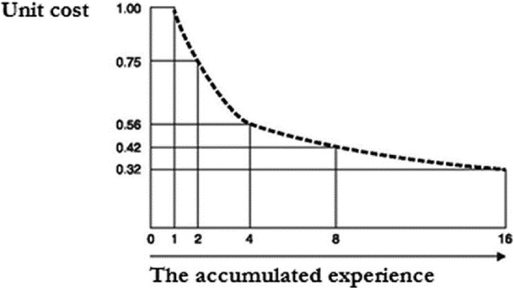
Inverse relationship between experince and cost
Source: (Rekettye, et al., 2025)
Majority of the newly qualified drivers during their first year involve in statistcally sever and frequent accidents (Rowe, et al., 2022) and this pace is named as novice premium peak (Xiong, et al., 2026). As the driver improving his defensive and manevuring skills from the 2nd year there will be a drastical drop in cost which calls experince drop in the curve. After reaching the fifth year of the experince level, at the plateau, the curve startes getting flatterned and the premium become steady and there onwards the premium will be evaluated on the previous claim history and other factors. Underwriters not generally penalise less experince drivers but investigate their loss history to calculate premium. According to the lack of hazardous perception, inexperince drivers take time in their cognitive processing skills about the developing hazards in the road (Cao, et al., 2022). Statistical resaerch publications show that new drivers are overconfident in their judjments about the road conditions, stopping gaps and traffic conditions which lead for accidents (Hu, et al., 2026). Drivers age has a significant impact with their age as young age inexperince (double risk profile) and old age inexperince (mature novice profile). The double risk profiles will be charged for the bilogocal imaturity and the low driving skills (Lee, et al., 2025) where mature novice profiles charge for lower baseline premium on statistical propensity of their reckless behavior (Isimoya, et al., 2022).

2.5 Variable Review: Previous Accident History on Insurance Premiums
Previous accident and claim history appreared to be similar in casual language, but in the technical aspect its is two different. The main difference lies between the capital financial movement and the physical occarance of the event (Poufinas, 2023). The past accident history directly involve with the physical occurance of the event regardless a financial pay out but it represent the raw physical exposure to the hazard (Lawrence, et al., 2023). Acturials consider that past accident history is a mathemetically accurate predicotor about the future event frequnecy and the anticipating severity of the financial loss (Zheng, et al., 2025). Further it signals the insured’s risk behavior and the enviornmental exposure that would cause for the future occurrence of claims. Acturies consider previous accident history as a ratiang variable to predict future loss frequency vs. severity, as a probability shift and a look-back window (Meng, et al., 2022). According to acturial logics, the frequency of the accident may stronger than the severity of the claim as it directly emphasis the moral hazard of the individual (Cevolini & Esposito, 2022).
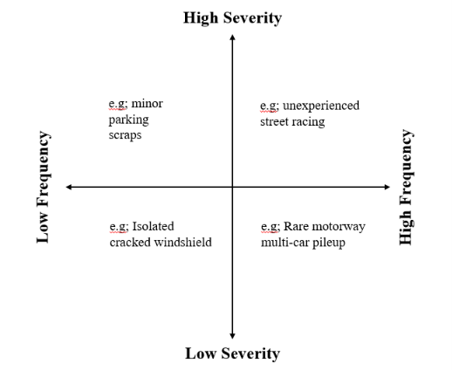
Core risk matrics illustarted by author
In the probability aspect, acturials expect that an insured who lodged claims within past three to five years may have a tendency of filing new cases in future as habit as well (Denuit, et al., 2007). In the accident occuarnce eventhough the insured is fault or non-fault the claim cost will have a direct impact in the renewal premium; if the insured is the fault he may be charged 20%-50% premium increase in the next renewal pricing (Engstrom, 2011). The accident histroy may infuluence the whole underwiring process by making impacts on NCD, compulsory excess and the risk appatite (Aeron-Thomas, 2022). As the previous accident history has a direct impact on the renewal premium, there is a high vulnerabilty of non-disclosure fraud, and therefore it is to be centrally tracked. In the UK context it is monitored by Claims and Underwriting Exchange (CUE) (Gill, 2021). The pure premium formula is based on these two elements and it is being calculated as; Pure premium = Accident frequency x Accident severity (Manurung, 2025). According to the statistical reasearches the high frequency penalise the premium more than the severity and it is the singles stongest indicator to predict the high severity catastrophic loss (Fackler, 2025). In an occurrence with a high frequency + low severity, underwriters may apply a minor surcharge and a compulsory excess (Selvakumar, et al., 2023). In an occurance of a low freqiency + high sverity, underwriters may load only a portion to reflect the loss in the renewal premium, and further if there is a no claim protecion, the premium will not be touched (Selvakumar, et al., 2023). In occurrence such as high frequency + high severity, the underwiters may decline the quoitng (Selvakumar, et al., 2023).
2.5 Empirical Studies
There are several empirical papaers that have conducted quantative researches on the similar resaerch interset to investigate the impact of driver’s experince and the previous accident histry on the motor insurance premium, and they have emphasised that driver;s characteristics have a dreict impact on the determination of the insurance premium. The empirical study of (Henckaerts & Antonio, 2022) on “the added value of dynamically updating motor insurance prices with telematics collected driving behavior data”, has conducted resaerch by using novel data set to examine the driving behavior of young policyholders on motor insurance pricing on theirparty portfolio. The research has done by using 400,000 participant for each year for entire period of three years. The research approach has been driven to analyse the UBI products and impact on the insurance premium which depend on the driver’s habit and the style. The finding of the research has emphasised the improvement of risk classification via telematic tools and managers insights about the profit and rating structures under UBI pricing startegy. Accoridng to (Cevolini & Esposito, 2022), in the study of “from actuarial to behavioural valuation; the impact of telematics on motor insurance”, has examined the impact of digital tools on the motor insurance indutry by the data extracted from telematic data rgerading the drivers life styels. This qualitative study has been designed as a qualtative reaserch by conducting interviews with three main insurance companies. this study focuses on the proactivity rather waiting reactive for claims to itigate the risks. This reaserch paper is mainly supported by the risk theory. In the reaserch publication of (Verschuren, 2022), on “frequency-severity experience rating based on latent Markovian risk profiles”, introduces novel rating on experince pricing theory. It explains that rsik premium is improved to a credible premium with a experince based pricing structure. This resaerch is based on the quanttaitive litriture review to prove the concept supported by Latent Markovian risk profiles. Therefore, considering the empirical papaers already published the resaercher has identified the gap of conducting a quantative resaerch to evaluate the impact of driving experince and the previous accident history on motor insurance premium guided by the risk theory and the experince pricing theory.

2.6 Conceptual Framework
In this conceptual model the resaercher is expecting to illustrate the dashboard of the relationship of each variable and their effect with each other. To evaluate the impact of the driving experince and the previous accident histroy on the motor insurance premium, the reasercher has selected two fundamental theories; risk theory and the experince pricing theory. Both theories have fundamental influence on each variable as driving experince and the previous accident history behave as the independent variable and the motor insurance premium as the dependant variable. Every behavior of the independent variable can penalise or reward the dependant variable. Further, it illustrates how other factors also impact on the dependant variable as controlled facts. Based on the theoratical fundamentals, the level of the driving experince (IV1) has a direct impact to the motor insurance premium (DV), due to the negative relationship of the effect to the percieved risk. When driver’s experince level is increased the effect to the percieved risk is decresed; therefore the risk premium also being decreased proportionately. The hisorty of precious accident (IV2) has a dreict positive relationship to the percieved risk which means when the number of previous accidents are being increased the motor insurance premium also being incresaed proportionalty.
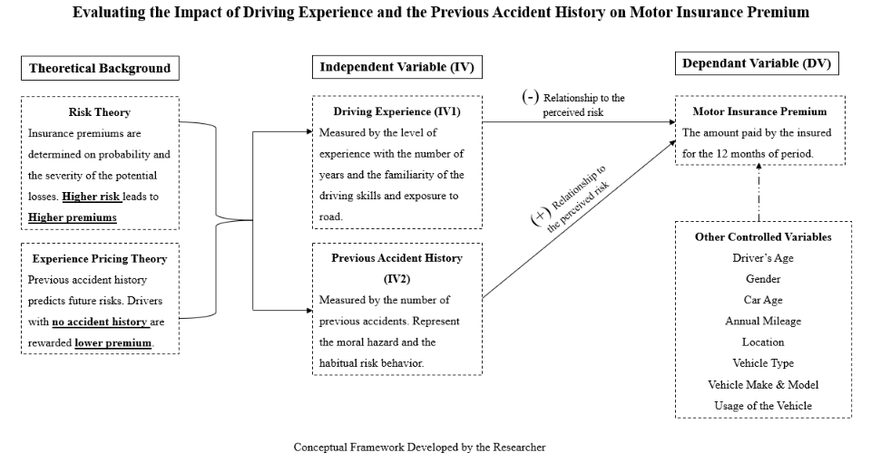
Further, it illustrates that the IV1 and IV2 are not only the independent variables impact on the DV, but there are other controlled variables as well, such as; driver’s age, gender, vehcile age, mileage used, geography or the location, vehcile type, vehicle make and model and the usage of the vehcile. However, in the framework it illustrates how the variables react on each other based on risk based prinicples and the experince pricing based prinicples.

Chapter 3

Methodology

3.1 Resaerch Philosophy
This quantitative resaerch of evaluating theimpact of driving experince and the previous accident history on the motor insurance premium follows the diciplen of positivism (Guba & Lincoln, 2005) and find the objective reality of how the variables influncing on each. The study will conduct a statistcal review to identify how the independent varaibale are influencing on the dpendant variable with the observed measurable data by developing hypothesis (Zumitzavan, 2026) to investigate the relationship between valriables. Positivism opens the screen to investigate objectively, how insurers apply risk based and experince basied pricing for determining the motor prmium by using the quantitative analysis.

3.2 Resaerch Approach
This study will be approached by the exisitng theories and knowledge such as risk thoery and the expeinec pricing theory; hence the study asopts a deductive approach (Ali, 2024). The hypothesis developed on the therotical background will be analysed by SPSS techniques. It also supports to accept or reject the developed hypothesis based on the exiting empirical facts and findings.
3.3 Research Design
This study analyse numerical data and statistically investigating the relationship with the variables by using SPSS applications in a quantitative research design (Fischer, 2023). The cross- sectional data (Hunziker, 2024) set gathered at a single time point from varius drivers with different experince level may eneable to compare the significance of the driving expernce level and the previous accident occurrence on the premium loading or the discounted level. The data is analysed by using SPSS tools to compare the reaserch hypothesis objectively. The relaibilty and validity of the data set is first assessed by using Cronbach-Alpha (Ahmad, et al., 2024) test to verify that the selected data set is appropriate for the study focus.

3.4 Data Collection Method
In order to conduct the reaserch in cost effective and time efficient manner it has gathered information by secondary data collection method (Ajayi, 2023). The dataset with 500 cases have been extracted from Kaggle (www.kaggle.com), the publicly accessible online platform which provides averagely rilaible dataset on academic, resaerch purposes and machine learning purposes.

3.5 Population and Sample Size
The dataset contain 500 cases with motor policyholders, inspired by real word facts, which provides adequate amount of data (Wutich, 2024) for statistcal analysis in quantitative data minimising sampling error (Harding, 2014). In order to feed SPSS, the dataset has been coded into categories such as driving experince as five level of experinces ranging from level 1(L1) as the lowest to level 5 (L5) the highiest experince level. The accident history has been coded into two categories such as drivers without previous accident histroy as No=0 and Yes=1. The motor insurance premium has been coded according to the five premium saving levels.

3.6 Variables
In the study there are two independent variables (IV) (LeLAURIN & Wolery, 1992); driving experince (IV1) and the previous accident hisotry (IV2). As discussed in section 3.5, these variables have been coded to categorical data represnting the driver’s experince level and the previous accident history as an event of occurrence. The level of driving experince has been analysed by using the one-way ANOVA to investigate wether insurance premium is differed on the level of experince groups. The previous accident history has been analysed by using independent t-Test to investigate wether the previous accident history can make a differnce on the motor insurance premium. The motor insurance premium considerd as the depnedant variable (DV) (Bosch & Revilla, 2022) to invesitage the premium amount which is influenced by the driver’s experince level and the frequency and severity over past accident history.

3.7 SPSS Tools and Statistical Tests in Data Analysis
In order to anayse the relationship between the level of driving experience and the impact of the previous claim history on the level of premium saving on the insurance premium that would cost to the policyholder. Therefore the resaercher has used below pointed SPSS anaytical test and tools to investigae the resaerch objectives.
- Descreptive Statistics – the study has conduscted the mean, minimum, maximum, sandard daviation and the varience as the measures. In the mean its has calculated the average of the level of experince level and the avarge range of the premium saved by the policyholder. The minimum value represent the lowest boundry of the level experince and the premium saving range in the recoded data set. The maximum value represent the upper boundry of the level of experince and the saved premium range of the given dataset. The standard daviation measures the variablity of the level of experince and the range of saved premium from the mean values of respective variables. The variance measured the squared daviation of data values each mean value by searching the degree of the dispersion of motor insurance premium.
- One-way ANOVA – This tool measured the significant difference of saved premium range in differnet groups of experince levels. This tool is more appropriate for analysing the IV1 the level of driving experience as it has been grouped into five different levels and measurable is the effect on the premium saving range. If the significance p-value is less than 0.05, that interpret a the statistically significance different on saved premium ranges on the respective driving experince levels, and the the p-value over 0.05 relresnt the opositve of the interpretation. A Tukey HSD post hoc test has been conducted to analys which group of driving experince level is most significant on the each saved premium range.
- Independent Sample t-Test – this tool has been used to examine the significance difference of saved premium range between the groupd of previous accident history. The IV2 or the previous accident history has two groups, No=0 / Yes=1 hence the independent t-test is appropriate for the examination. If the p-value is > 0.05, it means the mean premium of the saved premium range between the groups of previous accident history, has no significance difference and the same time if the p-value <0.05 , it means the group has a significance difference.

3.8 Hypothesis Development
In order to evaluate the impact of driving experince and the previous accident history on the motor insurance premium the resaercher has developed below hypothesis (Signoretta, et al., 2014) or statements predicating the relationship between variables. These hysposthesis have been developed according to the testing tool.
- Driving experinece level and the motor insurance premium
H0 – There is no significant difference in motor insurance premium on the groups of different driving experince levels
H1 – There is a significant difference in motor insurance on the groups of different experince levels
Since the data is categorical and consist of more than two graops the hypothesis has been tested using the one-way ANOVA.
- Previous accident history and the motor insurance premium
H0 – There is no significant difference in motor insurance premium on the previous accident history
H1 – There is a significant difference in motor insurance premium on the previous accident history
The hypothesis were tested to investigate the premium difference of motor insurance premium levels with the drivers who is with and without accident history. Since there are two indipendant groups such as with and without accident history, the independent t-Test has been used.

3.9 Ethical Consideration
Ethical consideration is one of the most key critera of a prefossional resaerch and it represent the scinetific ethics applied in the reaserch work. Ethical considertaion in methodology is maintaining truthfulness, reporting data, privacy and confidentiality (Hasan, et al., 2021). In this resaerch secondory data (Kaggle dataset) has been used and no direct involvement in human activitis. Further the dataset contains general numerical information and no personal information is gathered. The raw data has been used for necessary testing tools without manipulating on study purposes and honesty and the transparency have been maintained.

Chapter 4

Data Analysis and Results

4.1 Reliability testing
As we gather secondary data from a source already publicly available, it is important to test the reliability of the dataset in order to evalutae the consistency and the stability of the dataset. In this qualutative study the reliabilty is tested by using the SPSS tool Croncach’s Alpha (Amirrudin, et al., 2021).
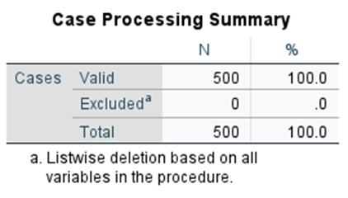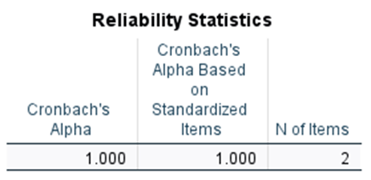
Two varibales have been performed for the test; groups of driving experince levels and the levels of premium saving groups for 500 cases. In this study the reliabilty test performed as 1.000 which suggest the dataset is appropriate for the purpose of the study and the perfect match between the variables measured.

4.2 Descriptive Statistics
Three main varaibles; coded driving experince (categorised levels of driving experinces), level of savings from the insurance premiums and the previous accident history show a high level of corelation among each.
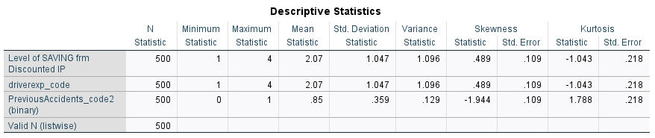

- Level of premium savings & level of driving experinces
Above variables demonstarte statistically identical behavior, therefore the data interpretaion is valued for both variables. The likert sacle is ranging from 1(minimum) to 4 (maximum) where the premium saving has been categoriesd in between GBP 478.00 and GBP 508.15 where the premium difference is GBP 30.15. Accordingly the premium savings have been grouped such as; level 1= GBP 500 or >, level 2= GBP 491 – 500, level 3 = GBP 481 – 490, level 4= 471- 480. The level of driving experinces have been grouped as; 1 = L1 {0-13year }, 2 = L2 {14 -20 years}, 3 = L3 {21-34 years}, 4 = L4 {35 – 40 years}. Mean value of 2.07 interprets that in the data set the average score just passed the half way of the scale. In the dataset the majority of the premium savings are grouped in between GBP 491-500 and the majority of the drivers have 14 to 20 years of driving experince compared to the avaiable data. The spread is measured by Std Deviation=1.047 and the Varience = 1.096, which interpret that the moderate amount of variation among 500 drivers are 1 point away from the mean value. Skewness = 0.489 (slightly positive skew) interprets that highier end of the scale has a longer tail and the lower end is concentrated between 1 and 2. Kurtosis = -1.043 indicates that the distribution has a thinner tail and flatter peaks means the responses are evenly distributed amoung the 1 to 4 scores.
- Previous accident history (binary coding)
The range of previous accident histpry is binary as 0 or 1. Generally the 0 represent drivers without accident history and 1 resprent drivers with accident histroy. In the mean = 0.85 interprets that 85% of the responses (425 out of 500 drivers) have previous accident hiroty and only 15% of the responses have no previous accident history. The Std. Deviation = 0.359 and Varience = 0.129 represent that vast majority of the responses scatterd around score 1.

4.3 One-way ANOVA with Post Hoc tests
In this test the level of driving experince and the premium paid coded information have been counted as variables.
- Group descriptives
In the group descriptives, out of 500 number of drivers the largest group represent L1 (n=199) and the smallest group L4 (n=59. Accordingl to the mean values it interpretes that average score of the premium paid has streadily effect on the different levels of driving experinces, such as; L1=1.03, L2 = 2.00, L3=3.00 and L4=3.92 ) [refer appendix 1].
- Homogeneity of varience
Based on the Levene Statistic measures on the “Based on mean” and “ Based on trimmed mean” have signifaicance (Sig.) if <0.001 and this happened when the group has no equeal varience. Therfore, in post hoc evaluation the Tukey HSD has been ignored and Games-Howell test has been considered which is specifically designed for unequal varience {refer appendix 2].
- ANOVA table
This table illustrates whether the mean value of each group has a statistically significance difference on the premium paid. The result shows F(3, 496) = 5196.288, Sig. < .001. Since the p=value is much below of 0.05 indicator the result is highly statistically significant meaning the premium paid has been definrlt different on the level of driving experince.
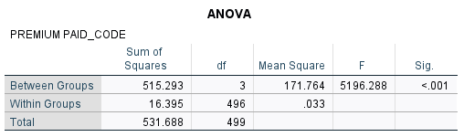
- ANOVA effect size
The ANOVA effect illustrates how much the varience of premium paid code reflect the driving experience level resulting Eta-squared = .969 ( Omega-squared fixed-effect = .969). This large effective size explains that 96.9% of the varience of premium paid code can be reflected on the driviers experince level [ refer appendix 3].
- Post-hoc tests / Multiple comparisons
As a result of the significant overall ANOVA outcome, the multiple comparison has been conducted to evaluate the which pair of groups being diffrentiated from one and other. Since the varience is unequeal, the Tukey HSD has been ignored and Games Howell test has been consider. Refer appendix 4 for the reslt illustration. In the resul every single pair was statstically significant (p<0.001) and among groups: L1 vs. L2 – L2 was significantly highier than L1 (mean difference = 0.970), L2 vs. L3- L3 is significantly highier than L2 (mean difference = 1.000) and L3 vs. L4 – L3 is significantly highier than L3 (mean differnece = 0.915). Please refer appendix 5 for Means plot illustration.

4.4 Independent Sample t-Test
The level of premium savings have been comperd among two groups; grouep 1 = drivers with no previous claim history and the groeup =2 drivers with accidnet history. According to the results there are n=76 participants have no previous accident history aout of 500 drivers and 424 has previous accident history.
- Group statistics
The mean value of the without previous accident result 1.91 whereas the Std. Deviation is 0.955 and the mean value of the with previous accident result 2.09 and the Std. Deviation is 1.061 respectively. However the mean value of the “with previous accident” results slightly highier value and the independent sample t-Test has been tested for deeper idea [ refer appendix 6].
- t-Test table
The t-Test table consist of three segments; Levene's Test for Equality of Variances, t-Test for equality means and confidence inetrval respectively. In the Leven’s test resulting Sig.=0.380 indicates that between the two groups the varience is equal. The p-value>0.05 interprets that the null hymothesis has been failed to reject.
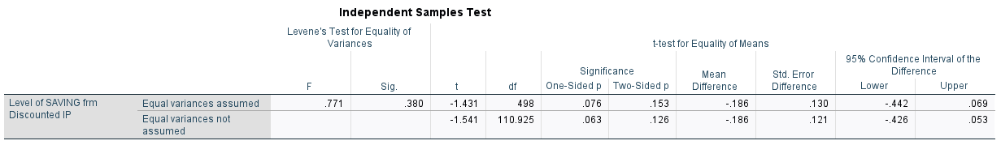
In the t-test resulting the equal varience displayed t-statistic (t)= -1.431, Degrees of Freedom (df)= 498 and Two-Sided p-value (Sig. 2-tailed)=0 .153. This reslut interpretes the standard threshold for significance is α = 0.05. and the two-sided p-value =0.153 is >0.05, the difference between the two groups is noot statistically significant. Even the one-side p value = 0.076 is not statistically significant. In the 95% Confidence Interval for the mean difference ranges from -0.442 to 0.069, the interval has passed zero, it further confirms that there is no true difference exists between the two groups in the population.
- Independent sample Effect size
The table interpret how large the difference is, regardless of sample size, Cohen's d= -0.178 and according to standard conventions, an effect size around 0.2 is considered which is small. A value of -0.178 indicates a very small effect, reinforcing that any observed difference between the two groups is practically negligible [refer appendix 7].

Chapter 5

Discussion

5.1 Interpretation of the Level of Driving Experince
The results from the one-way ANOVA revealed that the level of driving experince and the saving of the insurance premium levels are highly significant. The mean values over four groups of driving experince behave significantly difference reporting the p-value is <0.001. This information simply indicates that the level of driving experince has a major impact on insurance premium pricing. The descriptive statistics interprtes the mean values of the premium saving over the level of driving experinece has been progressively increased from L1 to L4. The lowest level of driving experince in the L1 {0-13 years}, related to the recoded group of lowest insurance premium saving level and the highiest driving experince level L4 {31-40 years} realted to the highiest level of premium saving level. Further, the result of Game-Howell post-hoc analysis confirmed that every paird within the groups of driving experince levels are statistically significant. The overall findings of the one-way ANOVA, indicates that insurers do practice systematically diferent pricing strategy according to the level of driving experince. The Eta-squared=0.969, which is a larger effect has a 96.9% varience on the level of savings by recoded premium pricing. Finally, according to the dataset the driving experince has a high impact on the premium pricing.
The findings endorse the Risk Theory, that indurance premium reflects the probability and severity of the future risks. By applying the risk theory insurers are evaluating the characteristics of the insured which could be leading to a future losses. The insurers predict that experinced drivrs are possessing, high level of road familiarity, improved understanding of the hazard, improved driving dexterity and low accident probabilty. Accordigly the findings direct insurers to practice risk-base pricing strategy in motor insurance premium computation.
The findings reflect the relevance to the empirical findings as well. As (Henckaerts & Antonio, 2022) explains that driver’s behavior and the driving-related risk has a high impact on the insurance pricing the final finding of this study also align with the findings of this empirical paper. Futher (Cevolini & Esposito, 2022) emphasis that insurers do heavily depend on the behavior and experince based indicators when systamise the motor insurance premiums. Therfore, the present fidnigngs demonstarte the relavance with the risk theory that the driving experince has a high impact level of determing the motor insurance premium and H1 is accapetd.

5.2 Interpretation of Previous Accident History
The significance differences between the two groups of “without accident histroy” and “with accident history” has been evaluated by isng the independent sample t-test in concern of the insurance premium saving levels. The mean value of the group “with accident history” = 2.09 is slightly higher than the value of “without accident history”=1.91. However the indepentant sample t-test readings; t= -1.431, df = 498, and p = 0.153 statistically indicate that in between two groups the significance difference is low. The p-value of the significance is > 0.05 and it interprtes that the null hypothesis (H0) is unable to be rejected. Accoridn to the sample population the study does not find a sunstancial evifence to support H1. Further, the 95% of the confidence interval ranging from -0.442 to 0.069 indicate that no proper population difference between two groups and the Cohen’s d effect size = -0.178 illustrates the difference between the two groups is small and negligable hence the H0 could be accapted.
The theory of experince pricing is not being supported by the original work of this study. According to the theory, the previous accidenthistroy has a direct impact in the future cliam prediction. This final output may indicate or assum several possibilties. From insirers perspective, the dataset may be more relaible to take decion upon the impact of the driving experince level on the premium pricing rather than consdiering the previous accident history. The recoded categories of premium saving levels may not capture the actual premium differentiation in the dataset or may be the dataset contains characteristcs of more homogeneous accident hisotry. Furthermore, the 85% of the drivers claiming the hisotry of accident history limited the variation between two groups which may deminish the performance of t-test to capture significant difference statustcally insightful. Accordingly the conceptual idea of the experince pricing theory is not sufficintly supported by the final outcome of this study.

5.3 Comparison of previous studies and the final outcome
The outcome of the one-wat ANOVA finds a statsiticallyd significant relationship between the level of drivng experince an the savings of motor insurance premiums which is strongly consistant with the findings of (Henckaerts & Antonio, 2022) and (Cevolini & Esposito, 2022). The both studies emphasise the driving bavior and experince risks have a driect impact the determination of premium. Accordingly to the previous studies they mentioned that insurers assess and classified drivers according to the charactristics of the behaviour and experince of the drivers.
Despite this, the outcome of the previous accident history is slightly differ from the findings of the previous studies. According to (Verschuren, 2022) and several prior studies, argue that the insurance premium is penalised by the record of accident histroy. These findings align with the experince pricing theory to predict the future loass based on the hispoty of frequency and the severity of the previous accident. Although the original finding of this stusy stlihjtly deviate from the key thoeriartical and the similar empirical evidence due to various reasons. The unusual precence of 85% drivers with accident history in the dataset has a direct influence on the final finding. Apart of this the resaercher believe there could be an effect of the coding structure and the sample distribution as well on the outcome of the previous accident histry. However even the negligable influence of the relationship of previous accident history on the insurance premium interprets there is statistically significant between two variable although it is not dominant on the factors of insurance premium pricing. Further, the researcher personally believs the financial impact on the differnce of the accident accident history and the claim histry may have a influence on the true premium factor may cause the slight varience of the significant differnce between two groups.

5.4 Practical Implications
Based on the findings there some practical impliactions being hughlited over the practice of insurers in terms of underwriting the motor insurance premium. The final outcome of the relationship between the driving experince and the motor insurance premium further emphsise, in the actural or underwriting practice the experince-based pricing upgrade the accuracy of the risk rate. Further, insurers may use the true picture of the varience from low to high risk drivers to design their business devlopment strategies including marketing activites. Also it proves the risk-base pricing strategies are more appropriate in motor insurance premium pricing. Eventhough the study outcome of the previous accident history does not support or align with the current practical premium pricing startegies, insurers may still rely on the majorty of the empirical evidence and the theortical purpspectives those positively support the concept. Also, the test could be repeated with different dataset to verify and validate the hypothesis. Furthermore, insurers may consider other demographic factors such as drivers age, car make and mode, annual mileage and previous claim history.

Chapter 6

Recommendations & Conclusion

6.1 Contribution of the study
This quantitative statistical study contributes several key findings for the importance of acadmia and industry as well. The outcome strenghten the existing empirical knowledge and the curent practice of the risk base pricing startegy as well. In the same time, it leads the underwiters to consider and investigate the other impact of the other demographic characteristics of the driver those can actualy make an influence of the premium pricing. The theortical frameowrk and the SPSS tools used (one-way ANOVA and Indepentant sample t-Test) in the study as a whole work may be used in the future academia to find out me relative facts in terms of riak base insurance and the user-base insurance applications. In the insurer’s perspective the outcome leads to think of the importance of the risk based and the experince based premium pricing is how influencial in the shaping the competeitive advanatge of the product. The level of drivng experince reveals the dynmics of the yaers of driving experince where insurers may more focus on their marketing activities and new product development to capture untapped maket segments. Further, regulators also may refer to the findings of this study on the to determine the regulaory influences on underwrign practices when imposng, excesses, policy terms conditionas in maintaing the transparency and fairness in the motor insurance pricing systems.

6.2 Future Recommendation
Primarily there are several recommendations could be introduce for insurance companies. Firstly, insurance companies should improve the experince base underiting sysytems and specifically how to refine the characterisc with new risk classifivcation models, to analyse the influence of driving experince on the premium pricing strategies. Secondly, in order to improve the pricing accuracy, insurers should improve preticitve data analysis models those have been intigrated with driver’s behavior, telematics data and driving patterns. This excerise is expected to be effective in future risk assemsnt models and useful in developing resileince startegies. Thirdly, insueres may revist their safer driving incentives to be competitive with the market by intridcing more attractive NCD schems, premium discounts and driver loyalty programmes.
Secondarily, there several recommendations could be introcued for the policy makers or the regulators as well. This study reveals that driving experince has a significance influence of the motor insurance pricing and terms and conditions applied to the motor policy shoud be more fairer for the indusrers and the insured both as well. Therefore, the unapprriate prmium discrimination and the laoding of unfair excesses could be closely monitored. Further, regulators may promote more technically advance digitally operated risk evaluation systems to improve the accuracy of the premium pricing. Also with the collaboration of the regulators and insurance companies, may develop high-quality risk evaluation models to identify the accident related risk and to predict future anticipated loss acordingly.

6.3 Limitations of the overall study
Finaly the study has managed to managed to achive its reaserch objectives and find out the reality for the reaserch questions successfully. However, it has been identified several limitations in the study that should be acknowldged for future improvements. The large number of drivers such as 500, would be sufficient according to the sample rules, but the generalisabity may fall into statistical pitfalls causing hypersensitivity of data. Another specific concern is that the dataset obtained from Kaggle is not exactly appropriate for the study in terms of the data quality, variable definitions and coding structures. Comparing to the availble dataset and the possible varibles, it has been tested only for the driving experince and the previous accident hisroty where other demographic variables such as driver’s age, car make and modle, the annual mileage also could be considered to test the impact on the motor insurance premiums. The premium paid had to recode and convert into categorical data otherwise the variables were flowing to the opposite directions which was not supported for the rilaibilty test creating a negetive indicator. Furether, the study could have been conducted for other testing tools such as regresssion analysis as well to identify the complexity of the relationship in variables.

6.4 Conclusion
This quantitiave study was to evaluate the impact of the driving experince and the previous accident histoey on the motor insurance premium by using statistical softwear of SPSS. The study has conducted by using the secondary dataset publicly availble on Kaggle.com and the descriptive statistics, one-way ANOVA and Independent sample t-Test has been performed to investigate the senario. The driving experince and the previous accident history have been considered as dependant variable and each of them has been assumed under hypothesis to findout the reality using the dataset. The study has been supported by the context of Risk theory and the experince pricing theory. From the findings it has been emphasised that the level of driving expeirnce is ighli significant in the premium dertminiation and the previous accident history has no significant relationship. Therefore the risk theory was supported by the final outcome but experince pricing theory was not supoorted as assumed. Overall the findings confirmed that the insurance pricing is strongly influenced by a risk-based classification system and it highlights the importance of a data-driven undweriting system as well to incresae the accuracy of the risk rating and the insights for the whole insutry.

Reflexive Report

This industry specified quantitaive reaserch on evaluating the impact of the driving experince and the previous accident history on the has provided me an invaluble academic and pratical learning experince. The allwed me to engage with a good practice of SPSS softwear by using the various data analysis tools, statistical data inetrpretationa and positivst reaserch methodology related to motor insurance market. Throughout the study it afforded me the opportunity to learn several learning insights pertained to quantative reasech methods, the deciplen of positivism and many academic and practical challnegrs when conducting a quantitiave study while maintaining the DBA (level 8 standard).
The primapry objective of this excersise is to get familairised with the statsical data analysis by using the SPSS tools while identifying the most appropriate testing tool. In that the principal learning outcome of this study is to prepare the secondary dataset to match the reaserch objectives by coding accurately was moderalty rigourous. The original dataset available in Kaggle was a raw set of data with 1000 responses. Assuming that large number of responses would be sensitive for statistical pitfall fo hypersensitivity, number of cases were filterd to 500 cases. The next challneging task was to recoding the variable accurately with the correct categorical scale as originally the variables operated to opposite directions causing the riliabilty test Conbach’s Alpha a negative reading. However converting the selected variables for the study the driving experince (IV1) was coded into 4 levels of driving experinces and transformed into categorical data and the previous accident history (IV2) was coded into binary variable as two groups drivers ‘with accident history” and “without accident history”. The dependant variable (DV) the premium paid was coded as the levels of premium saved in oder to match the scale direction by the relationship to each variable. For an example the highier number of experince level percive a lower risk in the insurance premium and the adjustments for the variables were done carefully to align with the statistical inetrpretaion accurately. This process highlights the most important competency in the SPSS analysis as even the smallest inconsistency in data may lead for a misconduct of one-way ANOVA and Indepentant sample t-Test inetrpretation. Through this activity that I learnet that SPSS analysis is not merely a number analysis but also a vast scope of logical raesoning and careful operation of variables.
At the beginning of this study due to the knowledge gap I had in terms of SPSS tools such as in one-way ANOVA and Independent sample t-Test, the functions such as descriptives data anaylsis, effect size analysis , skewness and kurtosis, and homogeneity varience were conceptually densed. However engaging with this study, allowed me better understand the main applications of each tool and their usablity in the statistical data analysis and how to interpret the outdome of the each test. At a moment the Leven’s test for wquality varince test was specially important when unequeal varince sidentified within the groups of ome-way ANOVA analysis and I learned in such instances the Tukey HSD post-hoc test should be replaces with Games-Howell tets. This made me realised the importance of selecting appropriate data anaysis technique according to the charactersitcs of the dataset.
Initially the interpretation of the test results proved challenging for me as I had a perception of that quantitiative data is full of numbers. Althogh, as I progess with the excesise I realied that not only each number and the result has a deeper meaning of its interpretation and this interpretation has a major impact for the final outcome of findings, but how to link the findings with the theoratical concepts of Risk theory and the Experince pricing theory.
In the scope of DBA studies I believe that qunatitive resaerch has a pivotal role to play. As the programme is structured more into the corporate world such as involving is business decisions, analysing operational performances, financial analysis, risk management and data driven decion making are fundamentally derived on quantitiave reaserch and outcomes. Further, as my specification in the insurance scetor, quantitave reaserch may relavnt massively in every aspects such as risk evaluation, assemments, developing strategies, performance management, evaluating customer experince , enetrprise and risk management and new product development all based on the quantitave resaerch findings. Therefore on my personal believe, as a DBA studne, the quantitative methodolgoes and the measurable objective findings may lead me to make evidence based managerial deciosn making that support organisational strategies and policy making.
Quntitaive reaserch allow to analayse the data vetu closely and to undertsand the better idea of the patterns and the relationships of the variables applied. These kind of numeric evidances highly useful in corporate sector in order to design pricing strategies, risk models and operational policies. Further, there should be a proper undertsanding when using a secondary dataset align with our reaserch objectives. The main limitation is that available data may hinder the real scope of the reaserch aims and objectives and the variable secetion, adding new and giving definintion for variables could be more challneging. In relation to this quantitative study, the other than the dring experince and accident historty, the demographic variables such as age, gender, vehcile tupe, usage of the vehcile and the past claim hirpty also may influnce the motor insurance premium with statistically significant measurable findings. Therfore, the quality of the outcome of the reaserch may unsubtatiated.
If the data collection was happened by collecting primary data by conducting data subject to a design of a comprehensive questionniar, the respons would have had more relavnct to the study and may obtained more accurate findings. Further, quantitive findings interpret the phenomneon upto a limit that numbers acould be interpretable. Although, I believe that when it comes to DBA level programme we need to explore the deeper meaning of the individual perception and other influences as well. Therefore, I suggest the pragmatism or the mix-method of reasrch methodoligy would be more ideal for a DBA leval thesis.
Overall this study allowed me to improve my competencies related to SPSS statistical analysis and the interpretaion skill of reasch fidning relation to the topic and the theories have been supported. The study also has given me the freedom to maintain the originality of the work even when previous accident histpry outcome was not align with the previous emprical results and the context of the experince pricing theory. I have learned about the general challengers, limitations, advantatges and disadvantages of a quantitive study and how to reinfoorce the qunatitive methods with the scope of DBA programme and in decision-making.

Bibliography
Acclavio, M. & Maieli, R., 2024. Logic Programming with Multiplicative Structures. arXiv preprint arXiv:2403.03032.
Aeron-Thomas, A., 2022. The role of the motor insurance industry in preventing and compensating road casualties. Scoping Study Final Report.
Ahmad, N., Alias, F. A., Hamat, M. & Mohamed, S. A., 2024. Reliability analysis: application of cronbach's alpha in research instruments. Pioneering the Future: Delving Into E-Learning's Landscape, pp. 114--119.
Ahmed, D., Yuantao, X. & Saeed Bhutta, U., 2022. Insurers' risk management as a business process: a prospective competitive advantage or not?. European Journal of Management and Business Economics, 31(3), pp. 345--366.
Ahmmed, M. J., 2025. Systematic Review and Quantitative Evaluation of Advanced Machine Learning Frameworks for Credit Risk Assessment, Fraud Detection, And Dynamic Pricing in US Financial Systems. International Journal of Business and Economics Insights, 5(3), pp. 1329--1369.
Ajayi, V. O., 2023. A review on primary sources of data and secondary sources of data. Universal Journal of Arts, Humanities, Science and Technology Education Research RESEARCH ARTICLE , 2(1).
Alcoforado, R. G., 2022. Theoretical and practical advances in actuarial science: risk, ruin theory and life pensions. PQDT-Global.
Ali, I. M., 2024. A guide for positivist research paradigm: From philosophy to methodology. Idealogy Journal, 9(2).
Alles, A., 2026. Insurance Mastery: Essential Knowledge for Insurance Practitioners. Colombo: s.n.
Amirrudin, M., Nasution, K. & Supahar, S., 2021. Effect of variability on Cronbach alpha reliability in research practice. Juornal Matematika, Statistika dan Komputasi, 17(2), pp. 223--230.
Badescu, S. {. V. L. & Lin, X. S., 2024. Effective experience rating for large insurance portfolios via surrogate modeling. Insurance: Mathematics and Economics, Volume 18, pp. 25-43.
Boomhower, J., Fowlie, M., Gellman, J. & Plantinga, A., 2024. How are insurance markets adapting to climate change? risk selection and regulation in the market for homeowners insurance. s.l.:National Bureau of Economic Research Cambridge, MA, USA.
Bosch, O. J. & Revilla, M., 2022. Is tracking all that it takes?. Exploring the validity of news media exposure measurements created with metered data. Available at, Volume 10.
Cao, S. et al., 2022. Hazard perception in driving: A systematic literature review. Transportation research record, 2676(12), pp. 666--690.
Cevolini, A. & Esposito, E., 2022. From Actuarial to Behavioural Valuation. The impact of telematics on motor insurance. Valuation Studies , 9(1), pp. 109-139.
Chelton, D. B., 1983. Effects of sampling errors in statistical estimation. Deep Sea Research Part A. Oceanographic Research Papers, 3(10), pp. 1083--1103.
Clemente, C., Guerreiro, G. R. & Bravo, J. M., 2023. Modelling motor insurance claim frequency and severity using gradient boosting. Risks, 11(9), p. 163.
Coutts, S. M., 1984. Motor insurance rating, an actuarial approach. Journal of the Institute of Actuaries, 111(1), p. 87–148.
Denuit, M., Mar{\'e}chal, X., Pitrebois, S. & Walhin, J.-F., 2007. Actuarial modelling of claim counts: Risk classification, credibility and bonus-malus systems. s.l.:John Wiley & Sons.
Dionne, G., Fombaron, N. & Mimra, W., 2024. Adverse selection in insurance. In: Handbook of Insurance: Volume II. s.l.:Springer, pp. 165--221.
EBSCO, 2021. Risk Theory and Credibility. [Online]
Available at: https://www.ebsco.com/research-starters/business-and-management/risk-theory-and-credibility
[Accessed 16 May 2026].
Englund, K. & Martin-Löf, A., 2001. Ernest Filip Oskar Lundberg. In: Statisticians of the Centuries. New York: Springer, pp. 308--311.
Engstrom, N. F., 2011. An Alternative Explanation for No-Fault's Demise. DePaul L. Rev., Volume 61, p. 303.
Fackler, M., 2025. Premium rating without losses: How to estimate the loss frequency of loss-free risks. European Actuarial Journal, 12(1), pp. 275--316.
Fischer, H. E. a. B. W. J. a. N. K., 2023. Quantitative research designs and approaches. In: Handbook of research on science education. s.l.:Routledge, pp. 28-59.
Fiveable, 2026. Fiveable. (2026, March 4). 5.3 Aggregate loss distributions and stop-loss reinsurance – Actuarial Mathematics. httaggregate-loss-distributions-stop-loss-reinsurance. [Online]
Available at: https://fiveable.me/actuarial-mathematics/unit-5/aggregate-loss-distributions-stop-loss-reinsurance/study-guide/z5N3FDreKMAxSkyr
[Accessed 16 May 2026].
Gill, K. A., 2021. Insurance fraud: causes, characteristics and prevention. s.l.:University of Leicester (United Kingdom).
Guba, E. G. & Lincoln, Y. S., 2005. Paradigmatic controversies, contradictions, and emerging confluences. s.l.:Sage Publications.
Harding, B. a. T. C. a. C. D., 2014. Standard errors: A review and evaluation of standard error estimators using Monte Carlo simulations. The Quantitative Methods for Psychology, 10(2), pp. 107--123.
Hasan, N. et al., 2021. Ethical considerations in research. Journal of Nursing Research, Patient Safety and Practise, 1(1), pp. 1-4.
Henckaerts, R. & Antonio, K., 2022. The added value of dynamically updating motor insurance prices with telematics collected driving behavior data. Insurance Mathematics and Economics , 105(2).
Hunziker, S. a. B. M., 2024. Cross-sectional research design. In: Research design in business and management: A practical guide for students and researchers. s.l.:Springer, pp. 187--199.
Hu, W., Sun, L. & Cheng, L., 2026. Effects of confidence level and hazard type on the visual search patterns and hazard response times of young drivers. Traffic Injury Prevention, 27(3), pp. 365--371.
Ieosanurak, W. a. K. B. a. M. A., 2023. Claim modeling and insurance premium pricing under a bonus--malus system in motor insurance. International Journal of Applied Mathematics and Computer Science, 33(4), pp. 637--650.
Isimoya, O. A., Ajemunigbohun, S. S. & Osasona, A. V., 2022. MOTOR INSURANCE POLICIES'UNDERWRITING FACTORS: EXPLORATORY ANALYSIS FROM MOTOR INSURANCE PROVIDERS IN NIGERIA. Economic \& Managerial Spectrum/Ekonomicko-mana{\v{z}}{\'e}rske Spektrum, 16(2).
Isimoya, O. A., Ajemunigbohun, S. S. & Osasona, A. V., 2022. MOTOR INSURANCE POLICIES'UNDERWRITING FACTORS: EXPLORATORY ANALYSIS FROM MOTOR INSURANCE PROVIDERS IN NIGERIA. Economic \& Managerial Spectrum/Ekonomicko-mana{\v{z}}{\'e}rske Spektrum, 16(2).
Isimoya, O. A., Ajemunigbohun, S. S. & Osasona, A. V., 2022. MOTOR INSURANCE POLICIES'UNDERWRITING FACTORS: EXPLORATORY ANALYSIS FROM MOTOR INSURANCE PROVIDERS IN NIGERIA. Economic \& Managerial Spectrum/Ekonomicko-mana{\v{z}}{\'e}rske Spektrum, 16(2).
Joeveer, K. & Kepp, K., 2023. What drives drivers? Switching, learning, and the impact of claims in car insurance. Journal of Behavioral and Experimental Economics, Volume 103, pp. 101-993.
Johnson, G. M., 2025. The hard proxy problem: proxies aren’t intentional; they’re intentional. Philosophical Studies, 182(5), pp. 1383--1411.
Kaggle, 2025. car-insurance-premium. [Online]
Available at: https://www.kaggle.com/code/govindaramsriram/car-insurance-premium/input
[Accessed 15 May 2026].
Kaushish, L. & Patnaik, P., 2025. Re-Evaluating the Principle of Utmost Good Faith in Indian Insurance Law: A Case for Legislative Reform. LawFoyer Int'l J. Doctrinal Legal Rsch., 3(1).
Khairiati, A., Budiarti, R. & Najib, M. K., 2025. Analysis of Ruin Probability in Insurance Companies Using the Cramer-Lundberg Model with Variations in Claim Distributions. ZERO: Jurnal Sains, Matematika dan Terapan, 9(2), pp. 386--395.
Kochenburger, P. & Salve, P., 2023. An introduction to insurance regulation. In: Research handbook on international insurance law and regulation. s.l.:Edward Elgar Publishing, pp. 247--280.
Lawrence, W. et al., 2023. Parametric insurance. In: The global insurance market and change. s.l.:Informa Law from Routledge, pp. 127--156.
Lee, W.-H., Hsiao, C.-L. & Wen, K.-L., 2025. Promoting Sustainability in Motor Insurance: A Novel Approach To Evaluating Driving Behavior. Information Systems Frontiers, pp. 1-13.
LeLAURIN, K. & Wolery, M., 1992. Research standards in early intervention: Defining, describing, and measuring the independent variable. Journal of Early Intervention, 16(3), pp. 275--287.
Maggioni, M. & Turchetti, G., 2024. Solvency of an Insurance Undertaking. In: Fundamentals of the Insurance Business. s.l.:Springer, pp. 601--631.
Manurung, T., 2025. Distribution Models of Claim Frequency and Claim Severity in Determining the Pure Premium of Car Insurance with the Application of a Deductible. ZERO: Jurnal Sains, Matematika dan Terapan, 9(2), pp. 662--670.
Mehrotra, R. & Chadha, S., 2025. Macroeconomic Resilience to Socioeconomic Challenges and Corporate Stability in the Automotive Industry: Impact on Dividend Policy. SocioEconomic Challenges, 9(2), pp. 180--189.
Meng, S., Gao, Y. & Huang, Y., 2022. Actuarial intelligence in auto insurance: Claim frequency modeling with driving behavior features and improved boosted trees. Insurance: Mathematics and Economics, Volume 106, pp. 115-127.
Mildenhall, S. J. & Major, J. A., 2022. Pricing insurance risk: Theory and practice. s.l.:John Wiley & Sons.
Mildenhall, S. J. & Major, J. A., 2022. Pricing insurance risk: Theory and practice. s.l.:John Wiley & Sons.
Mordor Intelligence, 2026. GLOBAL MOTOR INSURANCE MARKET. [Online]
Available at: https://www.mordorintelligence.com/industry-reports/global-motor-insurance-market
[Accessed 14 May 2026].
Moriah, M., Vermet, F. & Charpentier, A., 2023. Measuring and mitigating biases in motor insurance pricing. arXiv preprint arXiv:2311.11900.
Mwigilwa, W., 2024. Non-zero sum stochastic differential game between two insurance companies under the variance premium principle. Research Square.
Parodi, P., 2023. Pricing in general insurance. s.l.:Chapman and Hall CRC.
Poufinas, T. a. G. P. a. P. T. a. Z. E., 2023. Machine learning in forecasting motor insurance claims. Risks, 11(9), p. 164.
Rahmawati, T., Susanti, D. & Riaman, R., 2023. Determining pure premium of motor vehicle insurance with generalized linear models (GLM). International Journal of Quantitative Research and Modeling, 4(4), pp. 207--214.
Rahmawati, T., Susanti, D. & Riaman, R., 2024. Determining pure premium of motor vehicle insurance with generalized linear models (GLM). International Journal of Quantitative Research and Modeling, 4(4), pp. 207--214.
Rekettye, G., Liu, J. & Danyi, P., 2025. Prices, Costs, and Profit. In: Pricing for Strategic Managers: The Theory and Practice of Implementing Pricing Decisions. s.l.:Springer Nature Switzerland, pp. 63--88.
Ritho, B. M., Simiyu, E. & Omagwa, J., 2023. The impact of loss ratio on the financial stability of insurance firms in Kenya. Journal of Finance and Accounting, 7(4), pp. 22--41.
Rowe, R. et al., 2022. Why are newly qualified motorists at high crash risk? Modelling driving behaviours across the first six months of driving. Accident Analysis & Prevention, Volume 177, p. 100.
Schwab, P.-N., 2023. Into the minds. [Online]
Available at: https://www.intotheminds.com/blog/en/are-smart-boxes-the-future-of-car-insurance/
[Accessed 14 May 2026].
Selvakumar, V., Satpathi, D. K., Kumar, P. & Haragopal, V., 2023. Modeling of Loss Severity of Motor Insurance Extreme Claims. International Journal of Advances in Soft Computing \& Its Applications, 15(3).
Signoretta, P., Chamberlain, J. M. & Hillier, J., 2014. A Picture Is Worth 10,000 Words’: A Module to Test the ‘Visualization Hypothesis’ in Quantitative Methods Teaching. Enhancing Learning in the Social Sciences, 6(2), pp. 90-104.
Springer Berlin Heidelberg, 2005. Introduction. In: A Course in Credibility Theory and its Applications. Berlin, Heidelberg: Springer, pp. 1-14.
Sugden, R., 2024. Relational equality, mutual benefit and social insurance. Oxford Open Economics, 3(1), pp. i24--i29.
Supian, S., Mamat, M. & others, 2022. INSURANCE PREMIUM DETERMINATION MODEL AS NATURAL DISASTER MITIGATION EFFORT IN INDONESIA WITH A CROSS SUBSIDY SYSTEM.. International Journal of Agricultural \& Statistical Sciences, 18(2).
Total Systems PLC, 2026. How Electric Vehicles are Impacting the Car Insurance Market. [Online]
Available at: https://www.totalsystems.co.uk/whitepapers/how-electric-vehicles-are-impacting-the-car-insurance-market/
[Accessed 14 May 2026].
Verschuren, R. M., 2022. Frequency-severity experience rating based on latent Markovian risk profile. Insurance: Mathematics and Economics, Volume 107, pp. 379-392.
Wang, B., Chen, Y. & Li, Z., 2024. A novel Bayesian Pay-As-You-Drive insurance model with risk prediction and causal mapping. Decision Analytics Journal, Volume 13, pp. 100-522.
Whitney, A. W., 2024. The theory of experience rating. In: The History of Actuarial Science Vol VII. s.l.:Routledge, pp. 256--276.
Worku, A. T., Bayleyegne, Y. W. & Tafere, Z. B., 2024. Determinants of profitability of insurance companies in Ethiopia: evidence from insurance companies from 2011 to 2020 years. Journal of Innovation and Entrepreneurship, 13(1), p. 4.
Wutich, A. a. B. M. a. B. H. R., 2024. Sample sizes for 10 types of qualitative data analysis: an integrative review, empirical guidance, and next steps. International Journal of Qualitative Methods, Volume 23, pp. 1-14.
Xie, S., 2023. Analyzing the influence of Telematics-Based pricing strategies on traditional rating factors in auto insurance rate regulation. Mathematics, 12(19), p. 3150.
Xie, S., 2024. Estimating Risk Relativity of Driving Records using Generalized Additive Models: A Statistical Approach for Auto Insurance Rate Regulation. Asia-Pacific Journal of Risk and Insurance, 18(1), pp. 55--86.
Xiong, H., Guo, Y. & Zitikis, R., 2026. Beyond no-claims discount: a learning-embedded telematics-driven pricing system for dynamic premium adjustments. Financial Innovation, 12(1), p. 118.
Zhang, P., Pitt, D. & Wu, X., 2022. A new multivariate zero-inflated hurdle model with applications in automobile insurance. ASTIN Bulletin: The Journal of the IAA, 52(2), pp. 393--416.
Zhang, Z., 2023. Certainty equivalent, risk premium and asset pricing. In: Fundamental Problems and Solutions in Finance. s.l.:Springer, pp. 151--192.
Zheng, Y., Li, X. & Zhong, W., 2025. An empirical study on machine learning-based future loss prediction for insurance firms: evidence from China’s property and casualty insurance sector. Applied Economics, pp. 1-14.
Zumitzavan, V., 2026. Hypotheses Development. In: Social Science Methodologies for Management Research: From Philosophy to Practice in the AI Era. s.l.:Springer, pp. 97-107.

Appendix 1
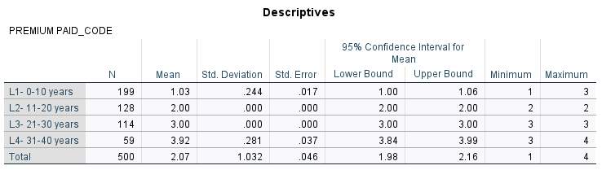
Appendix 1 One way ANOVA gtoup descriptives
Appendix 2

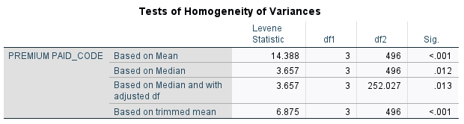
Appendix 3
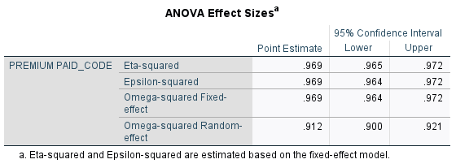

Appendix 4
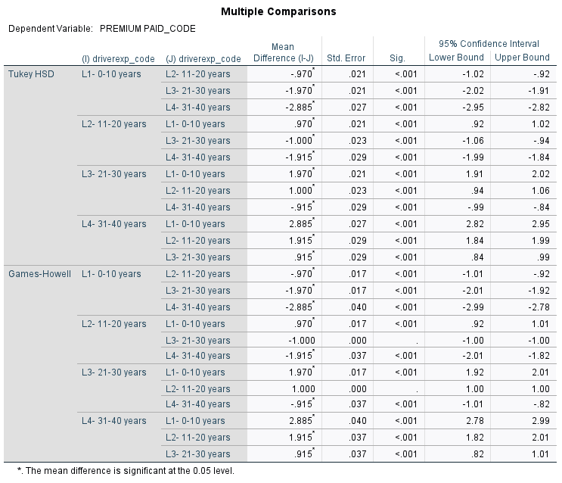

Appendix 5
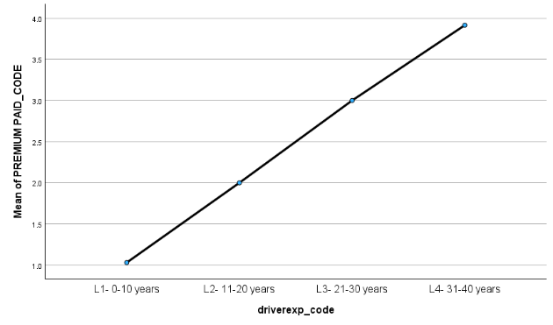

Appendix 6
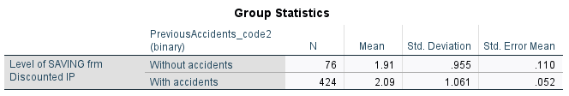

Appendix 7



