“Over the years there have been a number of high-profile product recalls. While product recalls are often only news for a short period of time the long-term impact of these recalls is much more difficult to measure. After all the cost of poor quality can often be measured in terms of tangible costs while intangibles factors are much more difficult to judge. Often product recalls are much more complex than just dealing with customers” (Thorne, 2022)

Darryl Jackson, Student No:2219398
University Wales Trinity Saint David
Key Words – Product Recall, Cost Of Poor Quality, Strategy
The impact of product recalls on businesses and projects.
Product Recalls. The Costs, impact’s and management strategy for a business.
Contents
- Introduction
- Product recall process
- Costs associated with product recalls and controls
- Restoring customer confidence
- Conclusion
- References

Introduction
Within the following literature, a critical review of the costs, impact and management strategy are considered for the process of product recall . The review considers multiple industrial examples with the aim of demonstrating best practices businesses should consider when confronted with a product recall, alongside the preparation required to manage the process effectivly . The product recall is in place to protect consumers and this should always be considered a businesses number one priority as per their ethical codes of practice, outside of this the two aims of the business should be to minimise cost and minimise reputation damage by implementing effective strategies in a timely manner .
Six Sigma techniques, practices and control methods are explored to demonstarte their impact on quality control alongside supply chain strategy, in an effort to reduce quality non conformance which directly leads to product recalls once at the consumer.
Product Recall Process Map
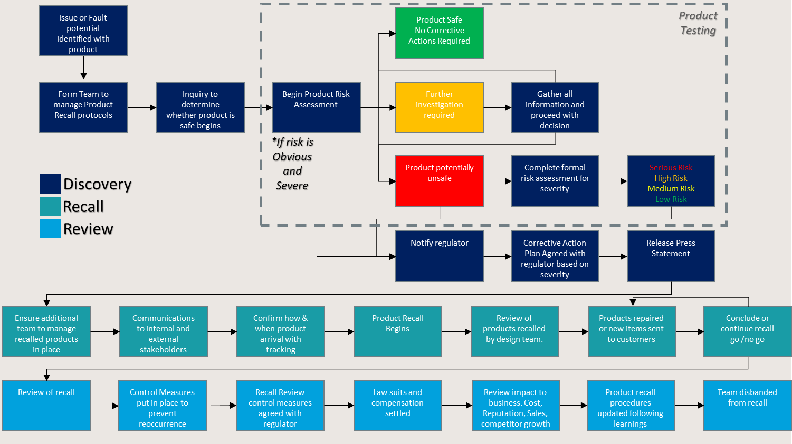
Costs associated with product recalls and controls
When product recalls are made we must consider the costs involved and how to manage these following the discovery of a fault or safety issue within the product. When considering the costs involved we can typically consider the costs to be Tangible and Intangible in nature.
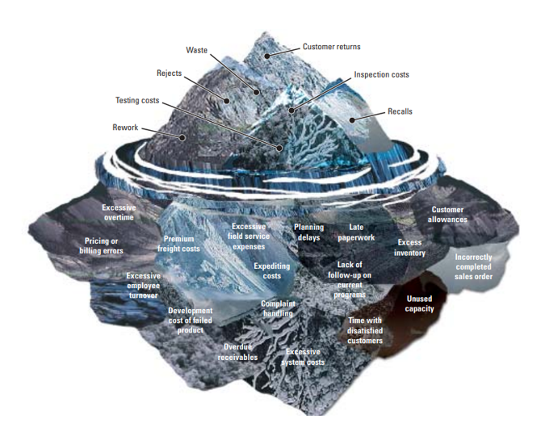
As demonstrated below from (DeFeo, 2001) the costs of poor quality (COPQ) are extensive yet many remain either unaccounted for or not considered by businesses as they are intangible. The impact of a product recall on a business cannot be generalised as each recall has influencing factors such as industry, market position, business size, recall strategy, consumer confidence, recall severity and the product itself.
Figure 1 - DeFeo COPQ Iceberg

(N.Craig Smith, 1996) reviewed Audi America’s 1986 recall which saw 132,000 units recalled as a result of faulty acceleration, their strategy and procedures for product recall were crucial in the final costs to Audi. Recalls were made throughout 1984-1986 however the product was adjusted, the recall process not followed and failures continued. Poor handling of the media saw a 3 month delay in announcing safety issues with the product alongside the lack of delivery on promises made to the consumer during the announcement lead to a severe decline in Audi America in the following years.
An estimated cost of $25million for the initial recall was calculated however, a study by (Sulivan, 1990) revealed as a result of reputation damage following the failures alongside media campaigns from competitors such as Jaguar, Audi saw resale values of Audi 5000 drop by 11.5%, models without failures such as Audi 4000 drop 9.5%, Audi Quatro drop 6.5% and a total unit drop of 72% by 1989(74000 units to 21225 units). A Review by National Highway Traffic Safety Administration (NHTSA) demonstrated the failures were in fact a result of driver error and not mechanical failure, by this time the damage had been inflicted and Audi Americas reputation with the consumer severely damaged.
Audi’s lack of control, planning and integrity to its consumers left their business in a difficult position to recover with short term intangible costs that only with extensive research and analysis over a longer period were possible to define as tangible.
The severity of the fault is typically the first piece of information a business will wait for before acting as this will set the tone for the strategy required to deal with the fault identified. (Angela Xia Liu, May 2016) identified during their study of product recall remedy that companies have conflicts between remedy cost and consumer harm. “A company will try to avoid full remedy when the total cost of recalled products is greater.” This demonstrates that the severity will directly impact both strategy and ultimately the final cost of the recall.
When a product fault is deemed severe a business is more likely to use full remedy to resolve the fault, the damage to the business by not ensuring the products have been recalled to the companies best efforts will result in damage to businesses reputation which increase the risk of long term business revenue and market share loss. Johnson and Johnson made the decision in 1982 to unconditionally recall all Tylenol products. (Benson, 1988) Even though the company suffered major revenue losses in the short term, it maintained consumer trust and regained the lost market share within 12 months. Managing the crisis proactively helped Johnson and Johnson establish itself as a responsible company. Johnson and Johnson’s example on how to manage a recall gives insight of the important in understanding fault severity versus the balance of impacts to short term and long term revenue loss and gain.
Millions of products are recalled each year, (Muhammad Saad Memon, 2015) state that the US Consumer Product Safety Commission (CPSC) indicates that the total recall cost in the US is more than $700 Billion each year just for consumer products. (CPSC, 2013). Direct costs for the recall of products are made up of repair and replacement products, destruction of products and current inventory, logistics of products from consumer and return items, testing of the faulty products , fines from authority boards, consumer compensation, communication both internal and external, media campaigns during and after the recall and maintaining business during an interruption.
(Schmitz, 2011) investigated the recall of Toyota November 2009 in which 8 million vehicles were recalled. Their findings of the costs incurred by Toyota are shown below in figure 2.
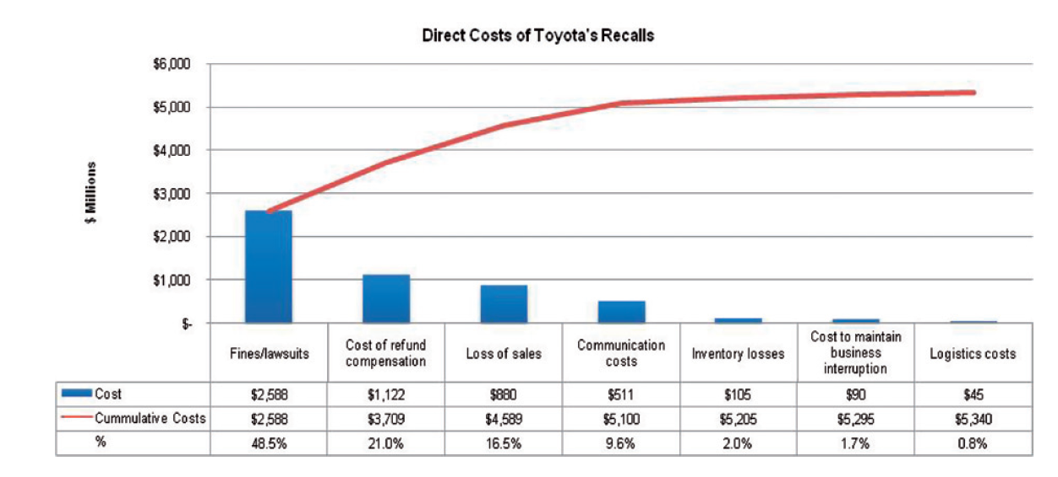
Figure 2 - Pareto Chart of Direct Costs of Toyota Recalls
This gives insight to the levels of each cost with fines and lawsuits accounting for 48.5% of the total costs alongside 21% for consumer refunds. Although the process of recalling the product is expensive the data shows that the costs involved for negligence in the eyes of the authorities and repairing consumer relationship in way of monetary compensation, can far outweigh the cost of the recall process itself. In Mattel’s case they recalled 1.5 million toys in 2007 due to excessive lead levels and saw its gross profit reduced by $71 million as a result. The costs included lost sales (53%), recall related expenses (29%) and inventory (18%) (Mattel Annual Report 2008). These two examples shed light on the costs involved when the recall risk is severe which could have been prevented had quality control and supply chain traceability been fully utilised during the manufacturing process.
Having a transparent and traceable supply chain is one tool utilised by businesses to ensure quality control and a reduction of the recall process time should one be required. The United states department of agriculture reported 82 recalls which contained 3,475,1115 pounds of meat for 2012. (USDA, 2012) “Manufacturers always faced problems in recalling defected products because of poor traceability systems. If the design of traceability system is appropriately effective and efficient then it significantly helps the production systems in managing the product safety issues and recall crisis” (Muhammad Saad Memon, 2015)
Value steam maps can be implemented throughout the supply chain to understand process lead and lag times, this exercise can help a business understand how their process works, its strengths, weaknesses, opportunities and threats (SWOT) in different scenarios including product recalls. Advances in track and trace technologies such as Radio Frequency Identification(RFID) is giving companies more visibility to the supply chain and can be beneficial in a product recall. (Phillips, Ocotber 2007) These advancements in technology allow supply chains to be more flexible, sustainable and the tools to react faster to deviations in the manufacturing process, these type of technologies should be implemented as a result of VSM and SWOT analysis which pinpoint the areas of the process whereby improvements are required. The speed at which a business can react to a product recall is of the upmost importance when looking at company value following the recall announcement. According to the US Food and Drug Authority (USFDA), company’s stock prices decline by 22% within two weeks after recall announcement. The average cost of recall in US companies is around $10 million. The revenue of the firm is immensely affected as a result of product recall (J. Gokhale, 2014)
One challenge the supply chain must consider within their recall strategy is the sourcing of materials or parts that make up their products. Proactive strategies include having multiple sources of supply to mitigate risk of supply disruption or failure of quality from one supplier therefore allowing the business to utilise the remaining suppliers. However, there is a key difference between supply uncertainty and recall risk. Under supply uncertainty, the shortage from one supplier can be compensated by other suppliers as those uncertainties are resolved before the firm sells products to the customers. Recalls, on the other hand, are often caused by quality and safety issues. They occur after the defected products have reached the customers. Thus, employing more suppliers does not necessarily reduce the recall risk of any product received by the consumers and may even result in more frequent recalls. (Long He, 2020) An example of this is the Lenovo recall of battery packs made by Sony and Sanyo in 2006 whereby the products were recalled regardless of the supplier of the battery.
One way of mitigating this risk is to distinguish suppliers by region therefore reducing the need for full recalls. As per the Samsung Galaxy Note 7 recall which recalled in the United States and Korea only as the fault was found with the supplier Samsung SDI. A month later a fault was found in the other Samsung Galaxy Note 7’s battery supplier Amperex Technology Limited which resulted in a recall in China only. (Jeong, 2016a) (Jeong, 2016b)
Another example of how suppliers can impact final product quality is Ford, they have reported that 76% of the companies quality problems are from 1st tier suppliers. (Sherefkin, 2002) This is supported by Ford’s May 2001 recall of 13 million Firestone Wilderness AT Tyres as a result of failures costing approximately $2.1 Billion, this case was particularly damaging as 88 Americans died between 1997-2000 before Ford’s Tyre supplier Firestone announced a recall. This raised serious ethical questions to both companies who had recalled the tyres in other countries due to similar failures, before recalling the products in the United States. (Verschoor, October 2000) The results of (Gary H. Chao, July 2009) indicated that knowing the suppliers failure rate can decrease a manufacturers costs by 10.14%, they also observed in some cases the value could be as high as 46.28%.
To ensure the supply chain alongside the manufacturing process is in control and quality standards are being met, businesses utilise Six Sigma techniques to visualise variability of short and long term trends. Statistic Process Control (SPC) is implemented with charts such as Cumulative Sum (CUSUM), Moving Average and Exponentially Weighted Moving Average (EWMA) to detect small non random shifts in the process. To visualise large shifts in the process, Shewarts charts such as Mean, Range and attribute charts in the form of p-chart, np-chart and u chart can be utilised. The importance of the charts in combination with Upper Control Limits (UCL) and Lower control limits (LCL) give a business the information required to maintain a stable process whilst keeping quality within the UCL and LCL indicating the product has passed quality control.
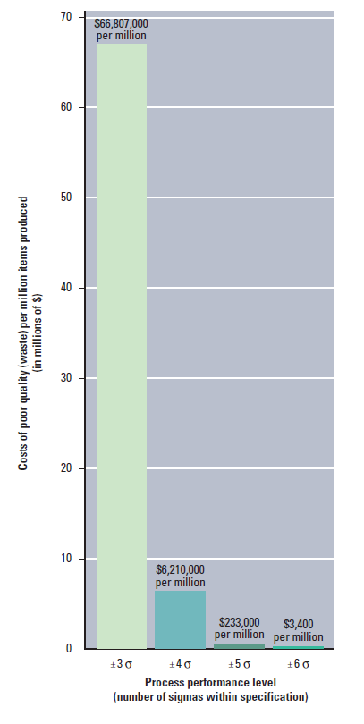
Six sigma has been implemented by large businesses globally for many years for example (DeFeo, 2001) states that Honeywell cost savings from six sigma have exceeded $2Billion between 1994-2001, General Electric again exceed $2Billion in benefits between 1996-1999 whilst Black and Decker recorded benefits exceeding $110 million between 1997-2001. To demonstrate the impact of six sigma manufacturing, figure 3 clearly shows the COPQ at different process performance levels 3 sigma, 4sigma, 5 sigma and 6sigma. When a process performance exceeds 3 sigma it is possible to reduce the costs of poor quality by 90%. This in itself reduces the risk of product recall further down the supply chain as higher levels of quality are achieved at the manufacturing stage.
Figure 3 - Cost of Poor Quality Vs Process Performance Level
(DeFeo, 2001) goes on to estimate the COPQ for a business explain “they can overlook the enormous costs associated with poor performance of products, services and processes. The costs associated with not meeting customer requirements, not providing products or services on time or reworking them to meet customer needs. These are the costs of poor quality. When added together, the costs of poor quality make up as much as 15 to 30% of all costs.”
One of the most effective strategies within the supply chain and manufacturing process to prevent a product recall is the design of the process. In Figure 4 (Schmitz, 2011) consider the concepts of prevention of product recall, by addressing these areas within the design phase of a process or product design the likelihood of quality issues and those leading to product recall is reduced (H. Li & L, 2000).
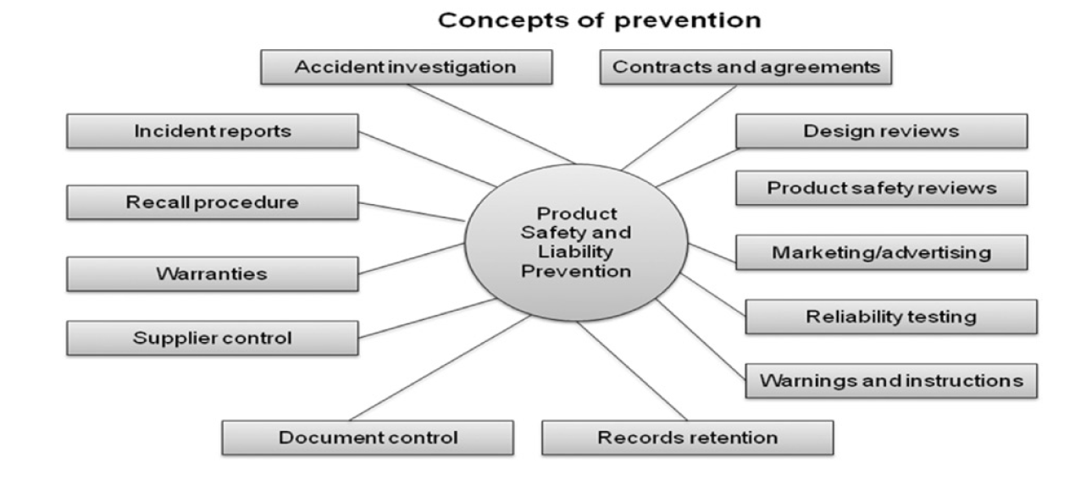
Figure 4 - Concepts of prevention for recalls
Within the design phase we should consider utilising a Failure Mode Effect Analysis (FMEA) study to establish the process risks, the identification of a failure and the likelihood of the failure occurring that could lead to a product recall. In the most basic of cases a business should consider a fault tree as per the example in figure 5 by (Schmitz, 2011) alongside their example of causes for failure in figure 6 whereby they utilise an Ichikawa diagram.
The additional costs of these quality assurance teams to identify failure root causes, quality testing, process design and supply chain control are negligible when compared to product recall costs. The importance of these teams and procedures has become a necessity for businesses with one example from (Anon., August 2007) showing Toys R Us increased its quality assurance budget by 25% .

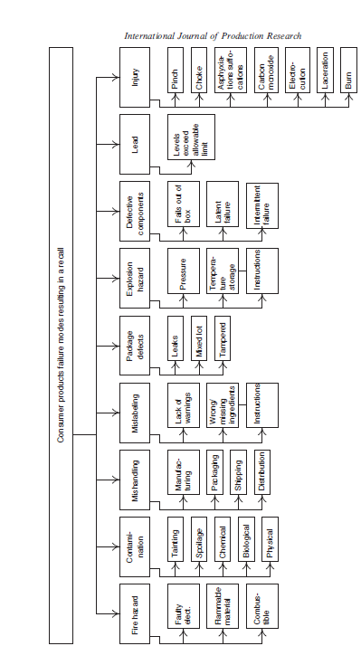
Figure 5 - Fault Tree illustrating potential modes of failure
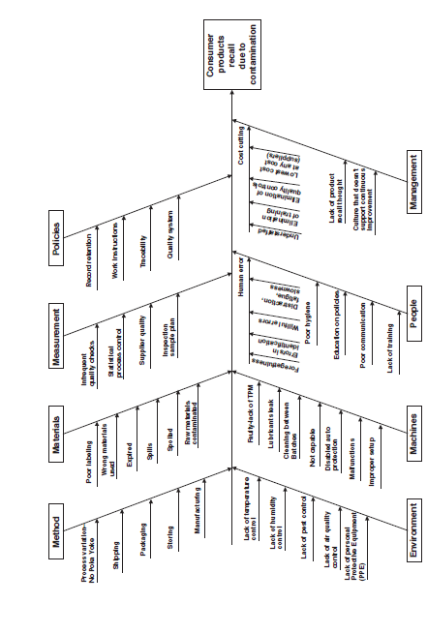
Figure 6- Ichikawa Diagram demonstrating Potential causes of failure

Restoring customer confidence
Black and Decker Space maker coffee maker 1988. 25000 units were recalled as it was determined unsafe due to risk of fire, testing was completed within 48 hours following identification of a potential fault. A clear protocol was followed by black and decker which resulted in a 92% return rate with integral factors such as an 800 number being setup for customers to claim their recall, utilisation of data to target large cities to increase return rate, a press release a memo to retailers, distributors, sales associates and all internal which allowed for a consistent message to the customer which gives the customer confidence that the business is in control and acting with the best interests of the customer. (N.Craig Smith, 1996).
The Black and Decker example illustrates the lengths a business must be willing to commit to satisfy consumers that their business is responsible and considerate when it comes to the consumers safety. When failures are minor, elicit low-level negative emotions like annoyance or disappointment and minimal if any, customer response behaviours (Surachartkumtonkun, 2015)However, when service failures are severe, customers tend to feel a range of negative emotions that escalate with each transgression (Surachartkumtonkun, 2015), (Grégoire, 2006), (McColl- Kennedy, 2009) These negative feelings usually result in harmful behaviours like exiting the firm, spreading negative word of mouth, and vindictive or third-party complaining (Thana A. Azizi *, 2022)
The communication between and business and the consumer is critical to the emotional response from the consumer. During the 1994 Intel recall of microprocessors the message from the business was to prove there is an issue and that it would not effect customer with a 1 in 9 billion chance of it affecting them.
CEO Andrew Grove later said, “We got caught between our mindset, which is a fact-based, analysis-based engineer’s mindset, and [the] customers’ mindset, which is not so much emotional but accustomed to making their own choice.”1 He also noted that “the kernel of the issue we missed…was that we presumed to tell somebody what they should or shouldn’t worry about, or should or shouldn’t do.” The cost of the recall was estimated at close to $500 million. (N.Craig Smith, 1996) . This is a clear demonstration of how not to install confidence into the consumer and to manage a recall announcement alongside the tangible costs but the intangible cost to the brand by losing confidence is clear.
During the recall a consumer is looking for direction and reassurance that they are not at risk from the product, business mitigate the risk in form of apologies and success stories of the brand. Toyota’s recall in 2009 saw Toyota launch a recall advertising campaign across radio, television, print and online seeking consumers’ forgiveness and patience as the company works through the safety issues (Schmitz, 2011).
An example whereby a recall was not required but the same crisis management communication had to be undertaken was the Pepsi Syringe Hoax of 1993 The example highlights the need to have give clarity to the consumer and use the authorities to your advantage to reassure the public. "This was a crisis without precedent," said Rebecca Madeira, Pepsi Cola's vice president of public affairs. "This was the only case I knew of where there was a crisis without a recall. You're not going to recall the product, you have to be able to reassure the public that this is absolutely the right move." In this type of situation, she added, "you have to cooperate with authorities because they're going to be valued as the neutral third-party, protecting consumer interest." The tone of the headlines began to change. "Initial reports are simply the allegations," Madeira said. "Over the next few days, the media pushes to understand why and how. That's the company's opportunity to show how we're working in the public's interest." (Elliot, August 1993)
During the BMW 2014 recall, US dealerships were told to prioritise recalled vehicles and ensure the consumer was not left with any costs or inconvenience. One example is the BMW dealership in Vista Florida where they handled the consumer recalls with a courtesy shuttle, loaner cars and cars from two rental car companies. The dealership manager was quoted as saying "With something like this, you gotta keep 'em happy." (Truett, 2014)
In the instance a product recall is required due to severe risk, the message needs to be bold, visible across multiple platforms and pushed by the business to ensure maximum recall. One instance where the recall message was not strong enough was Ikea 2017. During 2015, after a report of two child deaths in the USA, IKEA warned consumers that dressers and chests of the product line Malm may tip and fall if these products are not fastened to the wall. IKEA also offered a repair kit as a remedy. Then, in 2016, IKEA recalled more than 17 million Malm products following additional reports of injuries and deaths. Finally, in 2017, IKEA had to re-announce the recall after another child died. Between 1998 and 2017, eight children died from falling IKEA dressers. (CNN, 2017) Businesses will typically have insurance for such events to cover the huge costs involved with the recall process which will cover recall expense, third party expense, business interruption, lost profit within a set date, repair, replace or refund of products, product rehabilitation expense and adverse publicity. (Jing Chen, May 2021)
The CEO, Presidents and Vice presidents have large roles to play in product recalls as they are typically seen as the face to the recall due to their messaging to the consumers. It is considered that their decisions are sometimes led by their own personal interests and not in the consumers interest when choosing remedy strategy (Angela Xia Liu, May 2016). This in itself can lead to consumer mistrust as they begin to question the intentions of the management of the business involved in the product recall.

Conclusion
In conclusion there are different strategies to producal recalls dependent of the situation the business is faced with. From the research completed the sevrity of the risk to the consumer tends to be the key driver of the strategy taken by the business as consumers reaction to high risk products can be severly damaging for business brand and reputation. Businesses must consider both short term and long term gains when choosing a startegy but must not forget their ethical responsibily to the consumer when doing so, the decision must consider the consumer first then the profitability of the business second. Businesses are now more likely to have very strict qualty to control managed by separate team alongside transparent and traceable supply chains to reduce the risk of product recall, this stategy is seen as proactive in attemping to reduce poor quality at source rather than attempting to resolve the consequences once at the consumer.
The communication from the business to the consumer is shown to be more successful when done immediately after the intial finding of a hazard or risk to the consumer. This message can be seen as proactive and responsible by the consumer even in the face of a high profile, high risk recall scenario. Consumers welcome a business taking ownership of failures and taking suitable action to aleviate or remove risk from the consumer, even at the cost of the busienss. Examples have shown that this action in the short term can costs a business revenue, whilst in the long term the reputation and trust is regained from the consumer and therefore revenue and market share is typically returned to the same level if not higher.

References
Angela Xia Liu, Y. L. &. T. L., May 2016. What drives a firms choice of product recall remedy? The impact of remedy cost, product hazard and the ceo. The Journal of marketing, Volume 80, pp. 79-95.
Anon., August 2007. Global Supply Chain: Mattel incident shows companies can't go on the cheap when sourcing from Chine, Must take proactive control of entire supply chain.. [Online]
Available at: http://www.scdigest.com/assets/newsViews/07-08-08-2.php?cid=1165&ctype=content
Benson, J. A., 1988. Crisis Revisited : An analysis of strategies used by Tylenol in the second tampering episode. Communication Studies, 39(1), pp. 49-66.
CNN, 2017. Eighth child death from fallen IKEA dresser. [Online]
Available at: https://edition.cnn.com/2017/11/21/health/ikea-dresser-recall-eighth-child-death/index.html
[Accessed 20 November 2022].
CPSC, 2013. Product Recall Statistics. [Online]
Available at: http://www.statisiticbrain.com/product-recall-statisitics/.
DeFeo, J. A., 2001. The Tip Of the Iceberg. [Art].
Elliot, K., August 1993. Pepsi's Big Scare. The Public Relations Journal New York, 49(8).
Gary H. Chao, S. M. I. a. R. S., July 2009. Quality Improvement Incentives and Product Recall Cost Sharing Contracts. Management Science, 55(7), pp. 1122-1138.
Grégoire, Y. &. F. R. J., 2006. The Effects of relationship quality on customer retaliation. Marketing Letters, 17(1), pp. 31-46.
H. Li & L, X. L., 2000. Integrating systems concepts into manufacturing information systems. Systems Research and Behaviours, 17(2), pp. 135-147.
J. Gokhale, R. M. B. a. V. J. T., 2014. The effect on stockholder wealth of product recalls and government action : The case of toyotas accelertaor pedal recall. The Quarterly review of economics and finance, 54(4), pp. 521-528.
Jeong, E. -Y., 2016a. Samsungs Massive Galaxy Note Recall Over Reports of fires. [Online]
Available at: http://www.wsj.com/articles/samsung-to-recall-galaxy-note-7-smartphone-1472805076
Jeong, E. Y.-., 2016b. Samsung's Massive galaxy note 7 recall brings battery maker into focus. [Online]
Available at: http://www.wsj.com/articles/samsungs-massive-galaxy-note-7-recall-brings-battery-maker-into-focus-1473082175
Jing Chen, H. W. L. X., May 2021. Optimal Strategy in managing product quality risk for a risk averse manufacturer: prevention or mitigation?. Naval Research Journal, Volume 69, pp. 287-302.
Long He, Y. R. &. Z.-J. M. S., 2020. Product sourcing and disruption strategies under supply chain disruption and recall risks. Production and Operations Management, 29(1), pp. 9-23.
McColl- Kennedy, J. P. P. S. A. &. B. M., 2009. Customer rage episodes : Emotions, Expressions and Behaviours. Journal of Retailing, 85(2), pp. 222-237.
Muhammad Saad Memon, Y. H. L. a. S. I. M., 2015. Analysis of Traceability Optimization and Shareholder’s profit for efficient supply chain operation under product recall crisis. Mathematical problems in engineering, Volume 2015, pp. 1-8.
N.Craig Smith, R. J. T. &. J. Q., 1996. A Strategic Approach to Managing Product Recalls. Harvard Business Review.
Phillips, J., Ocotber 2007. Consumer product recalls prompt product visibility questions. Textile World, p. 157.
Schmitz, S. K. &. S., 2011. Managing recalls in a consumer product supply chain - root cause analysis and measures to mitigate risks. International Journal of Production Research, 49(1), pp. 235-253.
Sherefkin, 2002. Ford's Recall Challenge. Automotive News, Volume 62, pp. 8-9.
Sulivan, M., 1990. Measuring Image Spillovers in Umbrella-Branded Products, Chicago: The University of Chicago Press.
Surachartkumtonkun, J. M.-K. J. R. &. P. P. G., 2015. Unpacking Customer Rage. Jounral of Service Research, 18(2), pp. 177-192.
Thana A. Azizi *, M. T. S. *. M. H. R. *. G. M. A. *. L. T. K. *. M. M. E. M. *., 2022. Investigating the effectiveness of monetary vs. non-monetary compensation on customer repatronage intentions in double deviation. Central European Management Journal, 30(4), pp. 1094-1108.
Thorne, A., 2022. Swansea: University Wales Trinity Saint David.
Truett, R., 2014. BMW's big recall: 'It's all about the scheduling. Automotive News, 88(6619), p. 38.
USDA, 2012. Recall Summary for Calendar Year 2012. [Online]
Available at: http://www.fsis.usda.gov/wps/portal/fsis/topics/recalls-andpublic-health-alerts/recall-summaries
Verschoor, C. C., October 2000. Legal Compliance and Ethical blunders at Ford/Firestone. Strategic Finance, 82(4), pp. 22-24.

Figure 1 - DeFeo COPQ Iceberg 5
Figure 2 - Pareto Chart of Direct Costs of Toyota Recalls 7
Figure 3 - Cost of Poor Quality Vs Process Performance Level 9
Figure 4 - Concepts of prevention for recalls 10
Figure 5 - Fault Tree illustrating potential modes of failure 11
Figure 6- Ichikawa Diagram demonstrating Potential causes of failure 11

