Introduction

Inclusive education is an educational style in which all the students in a class can fully participate in the lesson, they are all treated with respect and as valued members of the educational institution, and should benefit from high-quality education and enjoy full participation (Moriña, 2016). It is a basic human right and the source of a rightful society (Forlin, 2013). Under the Equality Act 2010 a person is considered as disabled if they have a long-standing illness, condition or impairment which reduces their capability to carry out daily activities (Gov.uk, 2010). A disability or illness should not stand in the way of a person accessing and getting an education (Gov.uk, 2010). There are policies being put in place to support disabled students and make sure they have the same opportunities as everyone else (Gov.Wales, 2022). However, disabled students still face discrimination and barriers to learning compared to their non-disabled peers. Disabled also people hold lower and less qualifications (Gov.Wales, 2018) than those without disabilities. Specifically in Wales disabled youth are often Not in Education, Employment or Training (NEET; Equality and Human Rights Commission, 2017).

The aim of this research is to highlight the gaps in education and levels of qualifications held by those with disabilities compared to those without disabilities. And to explore possible reasons for the gaps (such as discrimination) and how they affect the learners, both in education and their lives. This research also aims to look at some possible solutions to bridge the gaps in education experienced by disabled students. Some of the solutions are organisational based while others are classroom based.

The research questions are:
- How effective are policies, and how well are they communicated?
- How do policies support in practice?
- Is there evidence of good practice improvement?
- What benefits do students who access support see in policy?

Literature review

Access to education in younger age groups is now more common for all people. Over the years the number of disabled people gaining qualifications has slowly increased (Fossey et al., 2015; Claiborne et al., 2010; Seale et al., 2015; Riddell and Weedon, 2014), as shown in Figure 1 (ONS, 2021a). Moreover, just under 7% of postgraduate students are disabled, this shows that some disabled students achieve a higher level of education than a degree (School of Advanced Study, 2016).
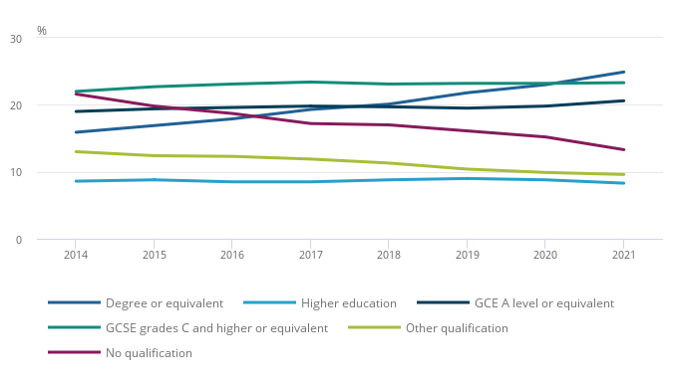
Figure 1 Proportion of disabled people by highest qualification, aged 21 to 64 years old, UK, year ending June 2014 to year ending June 2021
However, there are still significant gaps between disabled and non-disabled people accessing education and gaining qualifications. This problem often starts at a young age as many disabled children are never enrolled in school (Male & Wodon, 2017), as shown in Figure 2. The children that are enrolled are disadvantaged in school and accessing education, and often learn less compared to their non-disabled peers (Male & Wodon, 2017; Goodall, 2018). These gaps lead to lower literacy level for disabled people (Male & Wodon, 2017), as shown in Figure 3.

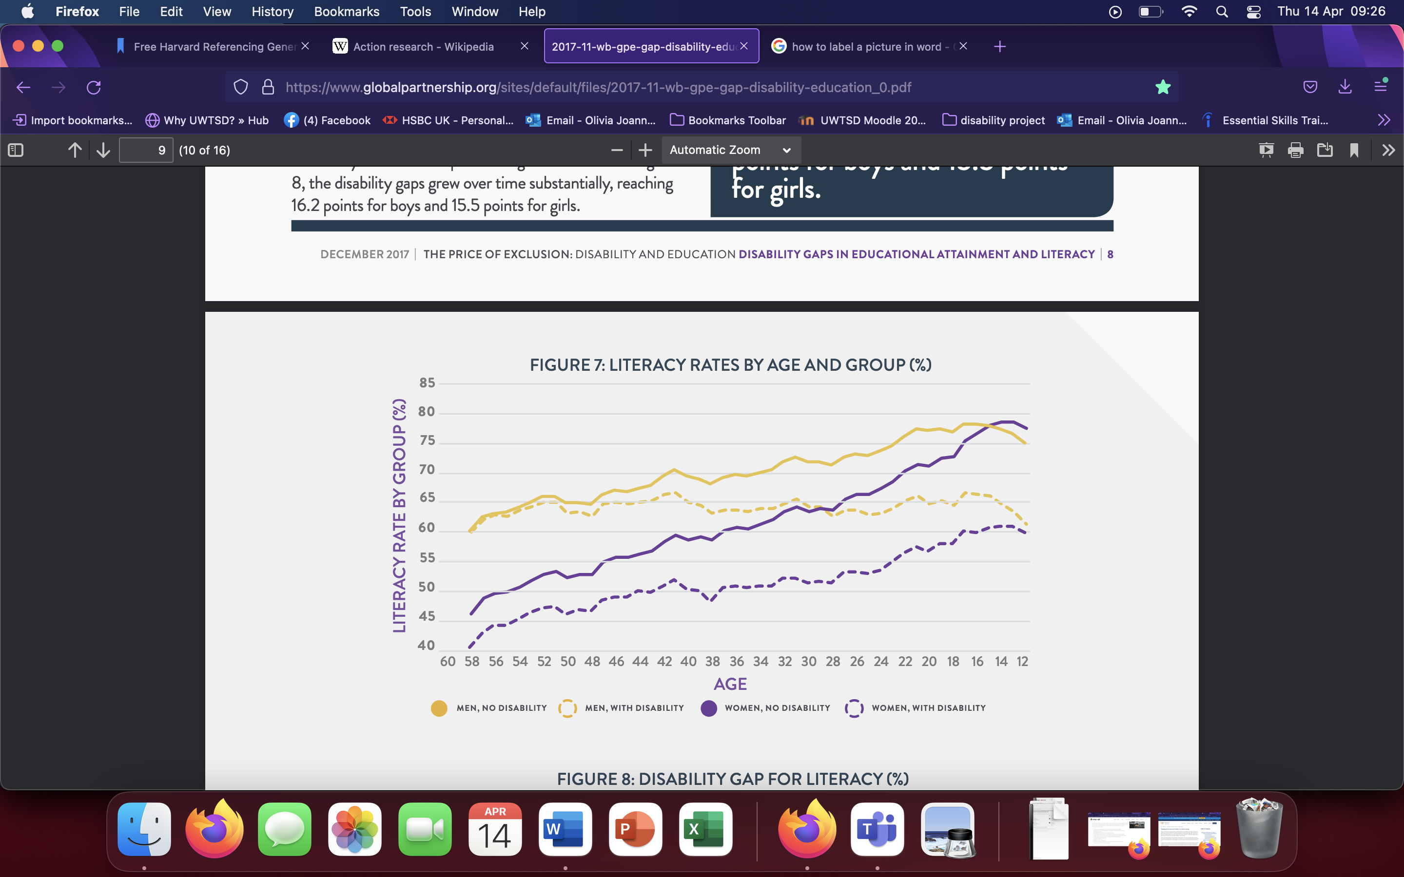
Figure 2 Shares of children ever enrolled by age and group (%)

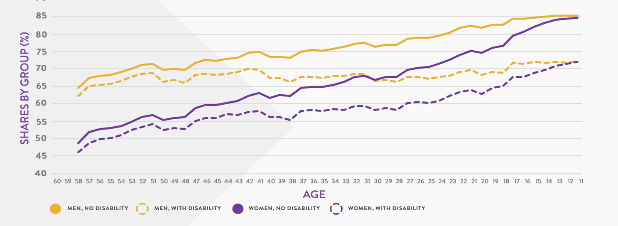
Figure 3 Literacy rates by age and group (%)

In Wales, disabled youth are more likely to be NEET (Equality and Human Rights Commission, 2017), and are more than twice (26%) as likely to have no qualifications compared to non-disabled adults (12%; Gov.Wales, 2018). Disabled people are almost four times more likely to be unemployed than those who are non-disabled before they are 30 years old (Gov.Wales, 2018). This is especially true with wheelchair users, who are less likely to find employment after their graduation (Gov.Wales, 2018). In 2021, the Annual Population Survey (APS) found that out of disabled people aged 21 to 64 only a quarter (24.9%) have a degree (or equivalent) as their highest qualification. This is significantly lower compared to 42.7% of non-disabled people (ONS, 2021a). However, 23.3% of disabled people have GCSE grades C and higher (or equivalent) as their highest form of qualification, in comparison to 17.4% of non-disabled people (ONS, 2021a). The biggest difference recorded is that of disabled people who have no qualifications (13.3%) compared to non-disabled people (4.6%; ONS, 2021a). This is further supported by reports which found that disabled students are more likely to drop out of universities in comparison to non-disabled students (Wessel et al., 2009; Quinn, 2016; Lombardi, Murray and Kowitt, 2016). Below Table 1 (ONS, 2021b) shows a difference in levels of qualification between disabled and non-disabled people; non-disabled people have more qualifications and at higher levels. The differences between qualification levels of disabled and non-disabled people in Wales compared to the rest of the UK is highlighted in Table 2; disabled people are less likely to have a degree compared to non-disabled people (ONS, 2021b). Lastly shown in Table 3 is the differences between levels of qualifications between those who are limited a lot or limited a little due to their disabilities (ONS, 2021b), the level of disability that affects the highest level of qualification held by the person with a disability.


Table 1 Highest level of qualification of people aged 21 to 64 by disability status

Table 2 Proportion of people aged 21 to 64 whose highest qualification is 'degree' or have 'no qualification' by disability status and country

Table 3 Highest level of qualification of disabled people aged 21 to 64 and their severity of impairment

The reason for those gaps could be due to the barriers and discrimination disabled students experience in comparison to those who do not have a disability (Girli et al. 2016; Shaw, Chan, and McMahon 2012; Matthews, 2009; Pennacchia, Jones and Aldridge, 2018). A report found that disabled students disclosed not feeling as confident about learning as non-disabled learners (Childcomwales, 2020). Barriers to learning are experienced a lot more by disabled students than non-disabled students (Equality and Human Rights Commission, 2017). This is evident by the Disability Rights in the UK, where it is stated that children with Special Educational Needs (SEN) continue to perform worse than children without SEN (Equality and Human Rights Commission, 2017). This could be because students with SEN are more likely to experience exclusion from school, and experience difficulties transitioning from school to Further Education (FE), and employment (Equality and Human Rights Commission, 2017). Disabled learners also face major struggles in accessing Higher Education (HE; Equality and Human Rights Commission, 2017). The challenges encountered by disabled students’ risk their marginalisation from education, employment opportunities and even enjoyment of a normal social life (Gov.Wales, 2018). Almost half (45%) of disabled students stated that the problems they experienced in school was because of their disability (Gov.Wales, 2018). Therefore, if disabled learners experience difficulties in school, they might be less likely to want to continue their education. This could explain the gaps between disabled and non-disabled people achieving a degree or higher level of qualification. Moreover, a different report found that young people, aged 12-18, with disabilities were more likely to prefer learning from home and enjoyed not attending school during the Coronavirus lockdown (Childcomwales, 2020). Some even expressed desires to be home schooled permanently (Childcomwales, 2020). Reasons given for this included not getting any help from the teachers, being bullied, having learning disrupted by others and finding school stressful (Childcomwales, 2020). Barriers that disabled students face are visual, physical and hearing related accessibility limitations. However, over half of populations presume that disabilities are only physical, and 34% disagree that hearing loss is a disability (Gov.Wales, 2018).

Other barriers to education faced by disabled learners are due to their illnesses/disabilities. Such learners may miss a lot of classes because of poor health, regular medical appointments, hospital visits or recovering at home (Vic.gov.au, 2012; University of Oxford, 2022; Toller & Farrimod, 2021; YDRF, 2021). This can then lead to decreased academic performance and struggles to complete assignments on time, or even be able to attend exams. Students who experience such struggles might feel less motivated which could be another reason why less disabled learners, than non-disabled, continue their education. Especially as their conditions might be easier to manage at home than in class (Howe, 2021).

The Welsh Government decided to change the experiences and outcomes for those with Additional Learning Needs (ALN). Therefore, a fully inclusive education policy for all children and young adults was put in place. This means that regardless of students’ needs and backgrounds they have the right to an education (ALN, 2018). Due to this FE and HE institutions have a lawful obligation to eliminate any difficulties a student might encounter in education due to their disability (Advanced HE, 2020; Scope, 2021). The ALN Act has been created by the Additional Learning Needs and Education Tribunal (Wales) Act 2018 to support young people with ALN who are in school or FE (Gov.Wales, 2022). The ALN Act aims to support children and young people (aged 0-25) with disabilities, in accessing education (Gov.Wales, 2022). Under the ALN Act students with ALN will receive Additional Learning Provision (ALP) support which should be agreed on in their Independent Development Plan (IDP; Gov.Wales, 2022). The Act aims that when planning support and an IDP for a learner with ALN, the student is kept in mind and listened to about their needs, views, wishes and feelings (ALN, 2018).

However, despite the ALN Act Childrens’ Commissioner for Wales report showed that disabled students were less likely to have been contacted by their school or college during the Coronavirus lockdown, compared to non-disabled learners (Childcomwales, 2020). This shows that the fully inclusive education policy fails as the disabled learners have not received the same level of care from the teachers as non-disabled students, and therefore are not getting the same access to education. The report also highlighted other ways in which disabled students are discriminated against. Some disabled learners admitted to feeling unable to ask their teachers for help when a subject feels difficult, and some admitted not getting any help from the teachers (Childcomwales, 2020). All these reasons could explain why disabled people continue to have lower levels of qualifications compared to their non-disabled peers. Receiving less support in education and experiencing regular barriers could explain why the levels of qualifications are lower for disabled learners. It could also clarify why fewer disabled people continue with their education. Lower levels of qualifications could stop disabled students from being accepted onto a course/program, stopping them from further pursing education. Besides negative school experiences could hinder disabled students’ desire to continue their education. YMCA (2022) research found a 30% difference in the wellbeing of those who had a positive experience in education, compared to those who did not. They further discovered that such experiences could have a lasting effect, which could lead to a lot of stress, confidence struggles and depression (YMCA, 2022, Goodall, 2018). Any learner who experiences such feelings is less likely to study well (causing them to have lower grades) or choose to continue their education (stopping them from achieving higher qualifications such as a degree. As established above, disabled students are likely to experience bullying in school (Goodall, 2018). Research found that experiencing bulling in school is likely to contribute to negative perceptions of learning (Pennacchia, Jones & Aldridge, 2018; Goodall, 2018). The reasons mentioned above could further explain the gaps in education between those with disabilities and those without.

Methodology

Action Research is a process of systematic analysis undertaken by practitioners to research their own practice (Bristol, 2021). In education Action Research uses a number of investigative, evaluative and analytical research methods to identify weaknesses or problems, which can be instructional, academic or organizational. This is done to help practitioners address the problems and find efficient and quick solutions (Great Schools Partnership, 2015). Thestart of the Action Research process is often looking at a situation or/and issue that a teacher/practitioner wants to change. So, the aim of Action Research is to create a change in a specific setting (Koshy, 2010), and empower practitioners through engagement with the research and suggestions (Meyer, 2000).

For my Action Research project, I chose to look at the barriers to education faced by disabled students. Despite ALN legislations put in place in Wales (Gov.Wales, 2018), there are still many challenges disabled students face. Firstly, I thought about what my research questions could be to help guide me in what areas of disability and education I wanted to research. I decided on four research questions. The research questions are outlined in the introduction and focus on looking at policies that are currently put in place to support disabled students. I collected secondary data about gaps in education and discrimination experienced by disabled students. The data was collected through websites, journal articles and government published information. I used reliable sources such as the Office for National Statistics to make sure my data was up to date and trustworthy. I then interpreted the data by looking at the statistics, tables and diagrams which showed me that there are big gaps in levels of education and qualifications between disabled and non-disabled people. After my research was finished where I had analysed the data, I made some suggestions of changes that should be put in place to better support disabled learners in accessing and continuing to at education.

Discussion/Recommendations

The above statistics show that, despite the ALN Act, disabled learners are still discriminated against and let down by the education system in Wales. Therefore, it is necessary to design policies and strategies that support disabled students in any educational setting, and, in the case of HE, the strategies should encourage students to remain in the university and complete their degree courses successfully (Moriña, 2016). One way in which disabled students struggle is in accessing the support available. Despite a lot of HE institutions setting up offices to support disabled students (Moriña, 2016), research found that only 25% of students registered as disabled take all the support available to them (Addis, 2020). Interestingly, the research also found that 64% of disabled students believe they use all the supported provided. Yet, the data shows that out of all the support given less than half (43.5%) of it was used. The main reason for this was because the learners (43%) felt that the support was not suitable for them. Another reason for this was that the students could not access the support, either because there was no one available to help them or no one replied to their correspondence. Some students found the whole process too complicated (Addis, 2020). For this reason, it is important that educational institutions really make sure that students with ALN are supported. This means educational institutions should have disability support offices (Riddell, Tinklin and Wilson, 2004) with a trained staff member whose focus is to support ALN students. As the above research pointed out that a lot of students do not know of all the support available (Addis, 2020), it would be beneficial to have an initial meeting with the students to inform them of all the support available. It would also help the students to have a discussion about what the learners themselves feel is necessary and create the IDP based on those needs. This is because the research found students felt the support available did not meet their needs (Addis, 2020). The trained staff member should be the main contact for the ALN learner to avoid miscommunication or missed correspondence. A main person of contact should take into consideration students’ own personal tactics to deal with their struggles (Prowse, 2009; Morina, 2015). The student should also be offered help at any point in arranging the support, as this process might be stressful and difficult (Addis, 2020). Lastly, it would be a good idea to have a follow up meeting with the students after the first term, this way the IDP could be adapted according to the students’ needs.

Another suggestion for supporting ALN students would be to have the main person of contact inform the teachers/lecturers of the students’ needs and share the IDP with them. Despite the stigma around declaring a disability decreasing in the last 30 years (Couzens et al., 2015), some students might still worry about admitting their disability (Kilpatrick et al., 2016). Disclosing and discussing the IDP with individual lecturers can be difficult and stressful for learners, and so they can shy away from it (Moriña, Cortes-Vega, Molina, 2015), especially as research found that some disabled students were met with negative attitudes from the practitioners (Moriña, 2016). Some students also never access any support available to them as the students are concerned they are not recognised as disabled enough (Couzens et al. 2015). Another reason could be because lecturers might question their ability to continue education (Moriña, 2016) and so this could also stop them from discussing their needs with individual lecturers. Yet, help from staff who believe in the students has been listed as a supportive factor students would appreciate (Seale et al., 2015).

After an IDP is shared with the teachers, they are then expected to apply the adjustments to their classrooms and examinations (Mullins and Preyde 2013). Yet they may struggle to fully understand how to apply the adjustments successfully (Fossey et al. 2017). It is rare for academic staff to have been trained in working with disabled learners (Fossey et al. 2017). This is noticed by the students who feel that the teachers are not well prepared to deal with their needs (Camacho, Lopez-Gavira & Diez, 2017; Morina, 2016). This can lead to learners not being supported enough in their learning (Osborne, 2018), and policies not being enforced (Morina, 2016). Therefore, it would be beneficial for the “main person of contact” to work with and support the teachers to help them adjust their teaching and classrooms accordingly to the needs of all students.

As 10% of the UK population have dyslexia (Gov.Uk, 2017), and as it is the most common type of declared disability (Nolan et al., 2014), it is important to consider dyslexia when planning for ALN students. There are simple ways in which teachers can support students with dyslexia, such as using coloured paper and screen backgrounds (use dark coloured text on light - but not white - backgrounds) and avoid using italics or underlining (BDA, 2018). If coloured paper is unavailable teachers could have coloured overlays which help some with dyslexia (Exceptional Individuals, 2021). However, as mentioned above some disabled students expressed getting bullied for their disabilities. So, it would be beneficial if practitioners always used coloured paper, this way ALN learners would not be singled out. Coloured paper and overlays should be provided by the institution.

It is important that the practitioners make disabled students feel welcome and supported. Students should not worry about not being seen as not disabled enough or too disabled to be part of the class. Practitioners should understand that disabled students’ paths in life and in education can be very difficult (Morina, 2015; Christani, Revetti, Young & Larwin, 2015), and they have to invest more time and effort into their studies (Skinner, 2004). Disabled learners often admit that they feel they work harder compared to their non-disabled peers, this is because they have to manage both their studies and disabilities (Seale et al., 2015). Familiarising themselves with the learners’ IDP is an important way in which practitioners can support ALN learners. Disabled learners could benefit from practitioners having a private chat with them as there could be other ways in which they can support the student which might not have been added to an IDP. One way teachers can support disabled students is by understanding they may not always able to attend classes in person, as Christani et al. (2015) found that learner’s physical health accounts for 36% of attendance struggles. As poor attendance greatly affects learners’ academic performance (Christani et al., 2015), teachers should find ways to help a disabled student participate as much as possible even if they are unable to come in. The Coronavirus pandemic has proven that online learning is possible (Thompson and Copeland, 2020). Therefore, giving a disabled students the option to join classes from home, or recording sessions and uploading them online for the students, could be very beneficial. However, it is important to keep in mind that all students are different, and some might not feel that joining a session online is the best approach for them. Research found that during the Coronavirus lockdown some disabled youth admitted that not being able to see a teacher/tutor (or join a class outside of school) affected their learning (Childcomwales, 2020). This is why it is important that the lecturers take the time to get to know their ALN students and their specific needs.

As academic staff are likely to be untrained at working with disabled learners (Fossey et al. 2017), training and/or online guidance should be provided for the practitioners (School of Advanced Study, 2016) through their educational institution. This would greatly benefit the staff and the students, as the staff would have better awareness of what their responsibilities towards students with disabilities are. This should aim to raise awareness and understanding of the staff’s responsibilities towards students with disabilities, provide practical examples of the support disabled students should receive from the staff to reach their full academic potential, and provide sources of supporting information (School of Advanced Study, 2016). Such guidance should inform the staff of what reasonable adjustments are and how they can be applied within the teaching space and make their teaching accessible for all. It would also be beneficial for the guidance to have a brief description of different disabilities and how best to support them (for example, avoiding bright artificial lights around autistic learners). This way the practitioners could easily refer back to the guidance. Ideally, the staff would attend mandatory training sessions which would give them a good understanding of disabilities and what struggles students face in everyday life. The training would also allow the lecturers to ask questions and seek direct support if they struggle with supporting their learners. By providing guidance and training the educational institutions could easily support disabled learners while they could work to put other support (such as online learning) in place. Moreover, such training can help normalise disability for the lecturers who might be unfamiliar with it and the barriers learners face (Dirth & Adams, 2019).

Conclusion

This research found that despite the Equality Act 2010 (Gov.Uk, 2010) and the ALN Act (ALN, 2018), disabled people still face barriers and discrimination when accessing education. These problems often start at young age (Male and Wodon, 2017 Goodall, 2018), and can have a long-lasting effects on individuals (YMCA, 2022, Goodall, 2018; Pennacchia, Jones & Aldridge, 2018), such as, stopping them from continuing their education. This shows that the current polices are not very effective and they are not communicated well. It also shows that the policies do not support disabled students well in practice, since many disabled students still struggle accessing suitable support. Based on the research, there does not seem to be evidence of good practice or improvement. Lastly, the research concludes that the students who access support do not see the benefits of the policy. However, those research questions cannot be fully answered as there is evidence of more disabled people now obtaining qualifications (Fossey et al., 2015; Claiborne, Cornforth, Gibson & Smith, 2010; Seale et al., 2015; School of Advanced Study, 2016). This could suggest that the policies have some effect and some effect in supporting disabled students. Yet, more people overall now continue their education and gain higher levels of qualifications (ONS, 2021b). Therefore, at the moment it cannot be known if the qualifications gained by disabled people are due to the policies or due to a general rise in people continuing education. Further research could investigate the reasons behind disabled people gaining higher qualifications and continuing their education. This would provide further answers to my research questions.

Finally, some suggestions have been made to further support disabled learners, both in the classroom and educational institutions. Despite the ALN Act, practitioners are often untrained in dealing with and supporting disabled students and following a student’s IDP. The main suggestion of this research is to provide more training for the academic staff, to understand the extent of learners’ disabilities and how best to support them.

References
Addis, K. (2020). Discrepancies between support provided and accessed in UK for disabled students. Asia Pacific Journal of Developmental Differences, 7(1), pp.99–111. doi:10.3850/s2345734120000062.
Adefila, A., Broughan, C., Phimister, D. and Opie, J. (2020). Developing an autonomous-support culture in Higher Education for disabled students. Disability and Health Journal, p.100890. doi:10.1016/j.dhjo.2020.100890.
ALN (2018). Additional Learning Needs and Education Tribunal (Wales) Act | GOV.WALES.GOV.WALES. Available at: https://gov.wales/additional-learning-needs-and-education-tribunal-wales-act.
BDA. (2018). Dyslexia friendly style guide. [online] British Dyslexia Association. Available at: https://www.bdadyslexia.org.uk/advice/employers/creating-a-dyslexia-friendly-workplace/dyslexia-friendly-style-guide.
Bristol. (2021). Action Research | School of Education | University of Bristol. [online] www.bris.ac.uk. Available at: http://www.bris.ac.uk/education/study/continuing-professional-development-cpd/actionresearch/.
Childcomwales (2020). Available at: https://www.childcomwales.org.uk/wp-content/uploads/2020/10/BriefingReport_disability_FINAL_ENG.pdf [Accessed 12 May 2022].
Christani, E., Revetti, L., Young, A.S. and Larwin, K.H. (2015). Effects of School Absences on GPAs for Disabled Students. International Journal of Evaluation and Research in Education (IJERE), 4(4), p.165. doi:10.11591/ijere.v4i4.4507.
Claiborne, L.B., Cornforth, S., Gibson, A. and Smith, A. (2011). Supporting students with impairments in higher education: social inclusion or cold comfort? International Journal of Inclusive Education, 15(5), pp.513–527. doi:10.1080/13603110903131747.
Couzens, D., Poed, S., Kataoka, M., Brandon, A., Hartley, J. and Keen, D. (2015). Support for Students with Hidden Disabilities in Universities: A Case Study. International Journal of Disability, Development and Education, 62(1), pp.24–41. doi:10.1080/1034912x.2014.984592.
Dirth, T.P. and Adams, G.A. (2019). Decolonial theory and disability studies: On the modernity/coloniality of ability. Journal of Social and Political Psychology, 7(1), pp.260–289. doi:10.5964/jspp.v7i1.762.
Equality and Human Rights Commission Supplementary submission to inform the CRPD List of Issues on the UK in Wales. (2017). Available at: https://www.equalityhumanrights.com/sites/default/files/ehrc_feb_2017_disability_rights_in_wales.pdf.
Exceptional Individuals. (2021). Dyslexia Glasses & Coloured Overlays: A Guide. [online] Available at: https://exceptionalindividuals.com/about-us/blog/dyslexia-glasses-coloured-overlays-how-do-they-work-exceptional-individuals/.
Forlin, C. (2013). Changing Paradigms and Future Directions for Implementing Inclusive Education in Developing Countries. Forlin Asian Journal of Inclusive Education, AJIE, p.19. Available at: https://ajiebd.net/wp-content/uploads/2016/08/chris_forlin_final.pdf.
Fossey, E., Bigby, C., Chaffey, L, J., Mealings, M., Williams, A., Serry, T., Venville, A., Oates, J., Ennals, P. (2017). Supporting students with mental health issues and acquired brain injury; University teaching staff perspectives. Journal of the Australian and New Zealand Student Services Association, 41(19), 15-25. Available at: https://www.researchgate.net/publication/315763221_Supporting_Students_with_Mental_Health_Issues_and_Acquired_Brain_Injury_University_Teaching_Staff_Perspectives
Fossey, E., Chaffey, L., Venville, A., Ennals, P., Douglas, J. and Bigby, C. (2015). Supporting Tertiary Students with Disabilities: Individualised and Institution-Level Approaches in Practice. Research Report. ERIC. National Centre for Vocational Education Research Ltd. Available at: https://eric.ed.gov/?id=ED561748.
Girli, A., Sarı, H.Y., Kırkım, G. and Narin, S. (2016). University students’ attitudes towards disability and their views on discrimination. International Journal of Developmental Disabilities, 62(2), pp.98–107. doi:10.1179/2047387715y.0000000008.
Goodall, C. (2018). ‘I felt closed in and like I couldn’t breathe’: A qualitative study exploring the mainstream educational experiences of autistic young people. Autism & Developmental Language Impairments, 3, p.239694151880440. doi:10.1177/2396941518804407
GOV.UK (2010). Equality Act 2010. [online] Legislation.gov.uk. Available at: https://www.legislation.gov.uk/ukpga/2010/15/contents.
Gov.Uk (2017). Simone: dyslexic user. GOV.UK. Available at: https://www.gov.uk/government/publications/understanding-disabilities-and-impairments-user-profiles/simone-dyslexic-user
Gov.Wales. (2018). Available at: https://gov.wales/sites/default/files/publications/2018-04/planning-to-increase-access-to-schools-for-disabled-pupils.pdf.
GOV.WALES. (2022). The additional learning needs transformation programme: frequently asked questions. Available at: https://gov.wales/additional-learning-needs-transformation-programme-frequently-asked-questions-html.
Great Schools Partnership (2015). Action Research Definition. [online] The Glossary of Education Reform. Available at: https://www.edglossary.org/action-research/
Howe, A. (2021). How to support pupils with chronic illnesses. Available at: https://www.tes.com/magazine/pastoral/general/how-support-pupils-chronic-illnesses [Accessed 16 May 2022].
Kilpatrick, S., Johns, S., Barnes, R., Fischer, S., McLennan, D. and Magnussen, K. (2016). Exploring the retention and success of students with disability in Australian higher education. International Journal of Inclusive Education, 21(7), pp.747–762. doi:10.1080/13603116.2016.1251980.
Koshy (2010). 36584 01 Koshy et al Ch 01. [online] Available at: https://www.sagepub.com/sites/default/files/upm-binaries/36584_01_Koshy_et_al_Ch_01.pdf.
Lombardi, A., Murray, C. and Kowitt, J. (2016). Social support and academic success for college students with disabilities: Do relationship types matter? Journal of Vocational Rehabilitation, 44(1), pp.1–13. doi:10.3233/jvr-150776.
Male, C. and Wodon, Q. (2017). DISABILITY GAPS IN EDUCATIONAL ATTAINMENT AND LITERACY. [online] Available at: https://www.globalpartnership.org/sites/default/files/2017-11-wb-gpe-gap-disability-education_0.pdf.
Matthews, N. (2009). Teaching the ‘invisible’ disabled students in the classroom: disclosure, inclusion and the social model of disability. Teaching in Higher Education, 14(3), pp.229–239. doi:10.1080/13562510902898809.
Meyer, J. (2000). Qualitative research in health care: Using qualitative methods in health related action research. BMJ, 320(7228), pp.178–181. doi:10.1136/bmj.320.7228.178.
Morgado Camacho, B., Lopez-Gavira, R. and Moriña Díez, A. (2017). The ideal university classroom: Stories by students with disabilities. International Journal of Educational Research, 85, pp.148–156. doi:10.1016/j.ijer.2017.07.013.
Moriña, A. (2015). ‘We aren’t heroes, we’re survivors’: higher education as an opportunity for students with disabilities to reinvent an identity. Journal of Further and Higher Education, 41(2), pp.215–226. doi:10.1080/0309877x.2015.1070402
Moriña, A. (2016). Inclusive education in higher education: challenges and opportunities. European Journal of Special Needs Education, 32(1), pp.3–17. doi:10.1080/08856257.2016.1254964.
Moriña, A., Dolores Cortés-Vega, M. and Molina, V.M. (2015). What if we could imagine the ideal faculty? Proposals for improvement by university students with disabilities. Teaching and Teacher Education, 52, pp.91–98. doi:10.1016/j.tate.2015.09.008.
Nolan, C., Gleeson, C., Treanor, D. and Madigan, S. (2014). Higher education students registered with disability services and practice educators: issues and concerns for professional placements. International Journal of Inclusive Education, 19(5), pp.487–502. doi:10.1080/13603116.2014.943306.
ONS. (2021a). Outcomes for disabled people in the UK - Office for National Statistics. Available at: https://www.ons.gov.uk/peoplepopulationandcommunity/healthandsocialcare/disability/articles/outcomesfordisabledpeopleintheuk/2021.
ONS. (2021b). Disability and education - Office for National Statistics. Available at: https://www.ons.gov.uk/peoplepopulationandcommunity/healthandsocialcare/disability/datasets/disabilityandeducation/current
Osborne, T. (2018). Not lazy, not faking: teaching and learning experiences of university students with disabilities. Disability & Society, 34(2), pp.228–252. doi:10.1080/09687599.2018.1515724
Pennacchia, J., Jones, E. and Aldridge, F. (2018). Barriers to learning for disadvantaged groups Report of qualitative findings August 2018Learning and Work Institute 2. Available at: https://assets.publishing.service.gov.uk/government/uploads/system/uploads/attachment_data/file/735453/Barriers_to_learning_-_Qualitative_report.pdf.
Prowse, S. (2009). Institutional construction of disabled students. Journal of Higher Education Policy and Management, 31(1), pp.89–96. doi:10.1080/13600800802559302.
Quinn, J. (2016). Drop out and retention of under-represented students in higher education in europe. doi:10.13140/RG.2.1.4274.1360
Riddell, S. and Weedon, E. (2014). Disabled students in higher education: Discourses of disability and the negotiation of identity. International Journal of Educational Research, 63, pp.38–46. doi:10.1016/j.ijer.2013.02.008
Riddell, S., Tinklin, T. and Wilson, A. (2004). Disabled students in higher education: a reflection on research strategies and findings. Disability Policy and Practice: Implementing the Social Model. Available at: https://www.research.ed.ac.uk/en/publications/disabled-students-in-higher-education-a-reflection-on-research-st
School of Advanced Study. (2016). Available at: https://www.sas.ac.uk/sites/default/files/files/Policies/SAS%20Guidance%20for%20Learning%20and%20Teaching.pdf
Seale, J., Georgeson, J., Mamas, C. and Swain, J. (2015). Not the right kind of ‘digital capital’? An examination of the complex relationship between disabled students, their technologies and higher education institutions. Computers & Education, 82, pp.118–128. doi:10.1016/j.compedu.2014.11.007.
Shaw, L.R., Chan, F. and McMahon, B.T. (2011). Intersectionality and Disability Harassment. Rehabilitation Counseling Bulletin, 55(2), pp.82–91. doi:10.1177/0034355211431167.
Skinner, M.E. (2004). College Students with Learning Disabilities Speak Out: What It Takes to Be Successful in Postsecondary Education. Journal of Postsecondary Education and Disability, 17(2), pp.91–104. Available at: https://eric.ed.gov/?id=ej876005
Thompson, K.M. and Copeland, C. (2020). Inclusive considerations for optimal online learning in times of disasters and crises. Information and Learning Sciences, 121(7/8), pp.481–486. doi:10.1108/ils-04-2020-0083.
Toller, L. and Farrimond, H. (2021). The unpredictable body, identity, and disclosure: Identifying the strategies of chronically ill students at university. Disability Studies Quarterly, 41(2). doi:10.18061/dsq.v41i2.7049.
University of Oxford. (2022). What it’s like to study at Oxford as a student with a chronic illness | University of Oxford. [online] Available at: https://www.ox.ac.uk/students/news/2020-12-07-what-its-study-oxford-student-chronic-illness [Accessed 16 May 2022]
Vic.gov.au. (2012). Chronic illness - coping at school. Available at: https://www.betterhealth.vic.gov.au/health/HealthyLiving/chronic-illness-coping-at-school.
Wessel, R.D., Jones, J.A., Markle, L. and Westfall, C. (2009). Retention and Graduation of Students with Disabilities: Facilitating Student Success. Journal of Postsecondary Education and Disability, [online] 21(3), pp.116–125. Available at: https://eric.ed.gov/?id=EJ831430 [Accessed 8 Mar. 2022].
YDRF (2021). Chronically ill? Starting college or uni soon? Read on! [online] York Disability Rights Forum. Available at: https://ydrf.org.uk/2021/08/10/chronically-ill-starting-college-or-uni-soon-read-on/.
YMCA. (2016). Negative educational experiences cause lasting damage to wellbeing. Available at: https://www.ymca.co.uk/health-and-wellbeing/feature/negative-educational-experiences-cause-lasting-damage-wellbeing.

