How can we improve our Product Stewardship?
2018-19 M5X01238 Design for Manufacture

Adam Higgins
BA Product Design

Product stewardship, what is it?
‘Product stewardship is an environmental strategy that means whoever designs, produces, sells or uses a product takes responsibility for minimizing the products environmental impact throughout all stages of a products life cycle, including its end of life.’ (Council, 2018)

In today's society product stewardship is a growing issue. With an increase of waste packaging, waste products and waste material there is an increasing responsibility to tackle these issues and minimize environmental impacts. The responsibility for a product is not just on the designers anymore, it's now down to the end users, manufacturers and distributors to share this responsibility. “The UK recycling rate for Waste from Households (including IBA metal) was 45.2% in 2016, There is an EU target for the UK to recycle at least 50% of household waste by 2020.” the recycling rate statistic for 2017 is only at 45.7%, (Department for Environment Food & Rural Affairs - Environment Agency, 2018). This statistic has only increased by 0.5% which in today's society needs to be improved, but who’s responsibility is this to improve the figure? Is it down to the homeowners recycling or government schemes. Also should designers and manufactures be influencing the users to make a better choices when they eventually throw products in the bin?
This report will cover how the individual, (end users) can improve their product stewardship. This meaning how can users take responsibility for minimizing products environmental impact on the world. There are many management strategies, therefore how can individuals use these and make the most out of them.
This report covers strategies such as take-back programs, recycling schemes and government strategies.

Are Take-Back Programs the Answer?
‘A “Take Back Program” is an initiative organized by a manufacturer or retailer, to collect used products or materials from consumers and reintroduce them to the original processing and manufacturing cycle. A company may implement this program in collaboration with end-of-life logistics and material processing firms.’ (WBCSD, 2018)

There are many companies and manufacturers which offer such programs but they're not heard of or talked in order for people to know they exist.

Panasonic
‘UK households dispose of over 1.2 million tonnes of electrical and electronic waste every year. This is the equivalent of 150,000 double decker buses and would be enough to fill the new Wembley stadium 6 times over’ (Panasonic , 2019)
Panasonic is one example of a major brand which does thi `s sort of program. They have set up a high-tech recycling centre called PETEC where they recycle old TV’s, washing machines and refrigerators. ‘Today PETEC recycles around 700,000 products a year’ (Panasonic , 2019)

Orange Box
Another great example of a company which run a similar program to take-back programs is Orange Box, they are a local business operating in Wales. They offer a re-upholstery service whereby they revitalise worn out or damaged furniture. Orange Box state they offer these services because ‘it helps us meet our customers’ long term service expectations and enables us to maintain the high levels of customer satisfaction”. (Orange Box , 2017)
This sort of business practice by Orange Box is a direction which should be duplicated by similar businesses as it can improve an individual’s product stewardship.

pwc
‘The UK reuses only 9% of the 39, 2 million items of corporate wear. An estimate 60% of all textiles in the UK currently go to landfill’. (WBCSD, 2018)
Pwc provides industry-focused services for public and private clients. They are an example of an internal take-back program within a business. They offer a staff uniform take-back program. When they issue a new uniform, the employees give back their old one in order to refurbish or reuse them. Addressing the issue of the number of textiles ending up in landfill. ‘Supplier employees were pleased to participate in the program as they felt they were contributing to an environmental solution’ (WBCSD, 2018).
The program is successful amongst employees, making them more aware of such programs like this. This will potentially encourage them to improve their own personal product stewardship.

These are a few examples of companies offering great services to individuals to help reduce the negative impacts surrounding waste, they are services which can improve product stewardship. Imagine how many other programs and services there are out there. The question that needs to be answered is, do people know about these services? A questionnaire conducted by myself can help answer that.

The questionnaire asked,
“Do you know what product take programs are?”

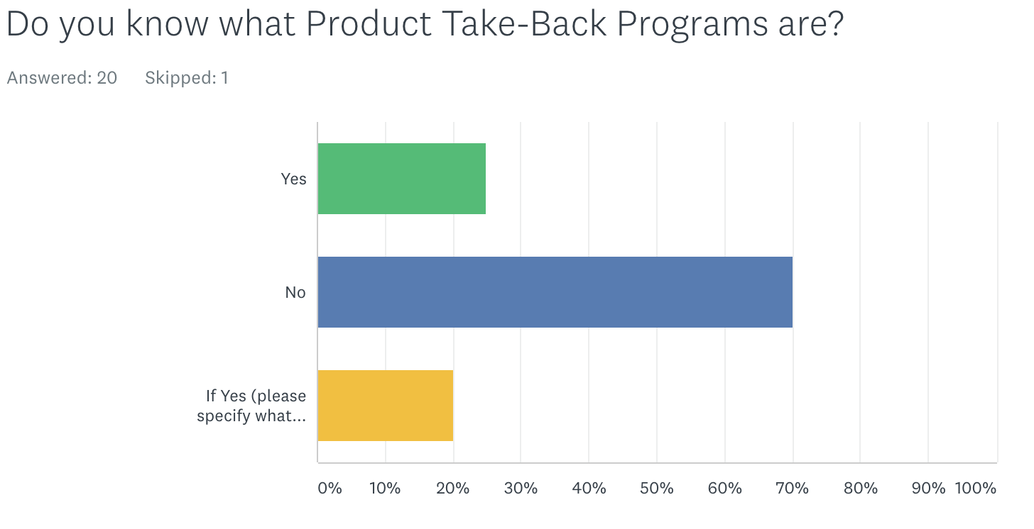
(Figure 1, Sustainability Topics of Interest, 2019)

Figure 1 shows that there were more people who didn’t know what product take-back programs were than those that did. Only 25% knew what product take-back programs were. This is a small sample size but we can use this to represent the larger population.

The people who answered yes were required to define what they thought product take-back programs are. From the few who said yes only 2 people were able to give a correct explanation of what the programs do.

The results are significant to this report. If the end users don’t know what these services are then how can they even participate? Or improve their product stewardship. There’s a need for more publicity for these services because results from the above case studies show that they do work and can help improve product stewardship.

Are Recycling Schemes the answer?
‘Recycling schemes are scheme enabling the public to recycle waste’. (Collins English Dictionary , 2019)

Linking back to the start of the report, ‘The UK recycling rate for Waste from Households (WfH; including IBA metal) was 45.7% in 2017’ (Department for Environment, Food and Rural Affairs, 2018). This statistic suggests that recycling needs to be improved around the UK.
One organisation which has taken on the issue is SUEZ who deliver innovative and environmentally responsible solutions to manage waste. ‘Over the course of the year, we handle over 10 million tonnes of waste in the UK’ (SUEZ, 2016)
They ‘Operate 13 household waste recycling centres in Cornwall, used by over one million people each year’ (SUEZ, 2016) these sort of recycling centres offers the public and individuals the ability to recycle. Having the development of these centres raises awareness of the topic. These centres in this particular case show they work, ‘Recycling rates have increased from around 25% to more than 60%’ (SUEZ, 2016) This statistic is a good increase, demonstrating that if the facilities are in place then people can improve their stewardship and recycle more.

Bottle Return Scheme
The Bottle return scheme is becoming increasingly popular. The idea behind the scheme is that you return all your single-use plastics or metal bottles to a deposit location and in return you get money. The catch being you pay more for the bottle on purchase, but you get that back when you return them.
‘UK consumers use around 13 billion plastic drinks bottles a year but more than three billion are not recycled’ (Harrabin, 2018) Bottle return systems will help improve individuals product stewardship as they are getting a reward when they return the bottles and cans.

Swansea Waste Management
‘It costs Swansea tax payers 3.5million a year to send black bags to landfill, but half of this waste can be recycled saving money’ (Swansea Council, 2019)
Swansea Waste Management is looking very positive currently, their current scheme makes the public separate card and paper, cans and glass and then household plastics. ‘The welsh government has set councils a target to recycle 64% of household waste by 2020’ (Swansea Council, 2019)
Recently Swansea council have implemented a new waste scheme whereby black bags are now being checked for items that can’t be recycled and if a non recyclable is found, you can be fined up to £100. The scheme is ‘designed to tackle the minority of people who still refuse to recycle’ (BBC News, 2019)

The current new campaign which has been implemented should in theory help to improve the public as the £100 fine is a deterrent and people won’t want to pay it. Without the public knowing, this is linking into improving end users product stewardship. This ‘Keep it Out’ campaign is making users recycle more.

The questionnaire asked,

‘Do you recycle?’

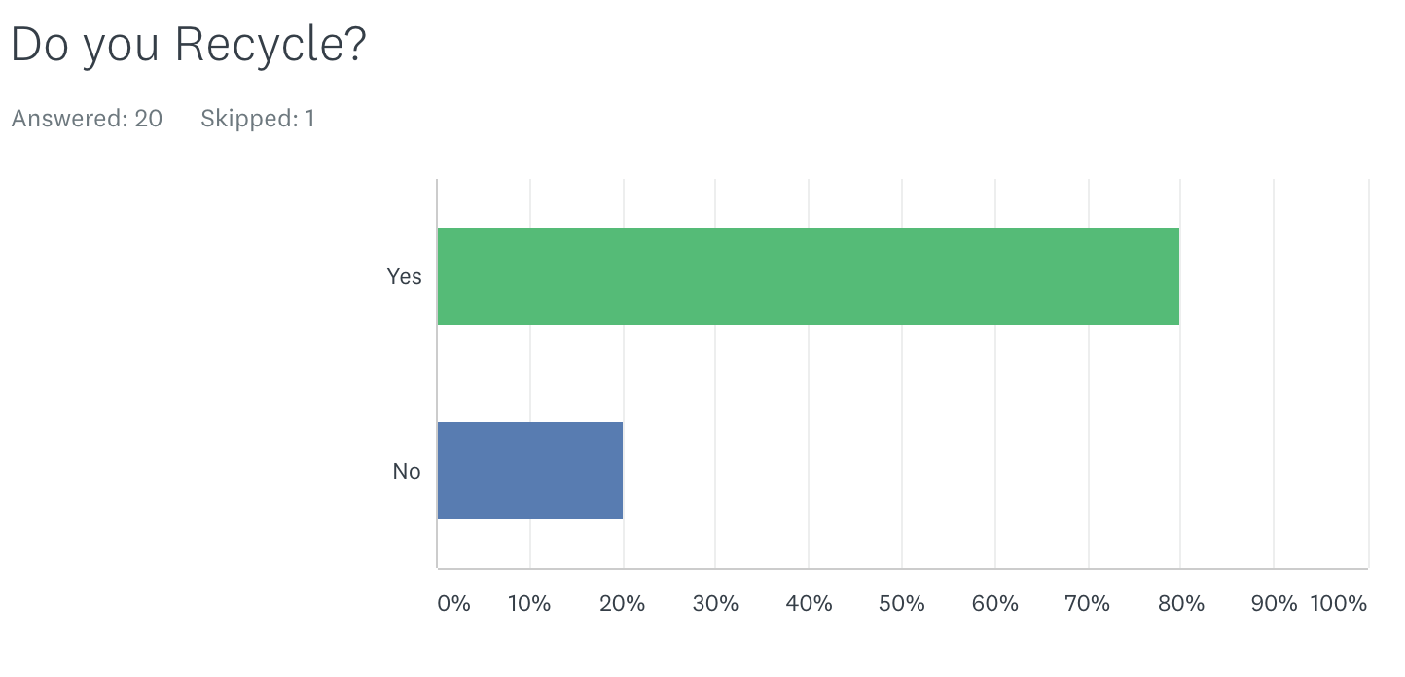
(Figure 3, Sustainability Topics of Interest, 2019)

Figure 3 shows that 80% of participants said they recycle. From the sample size of the questionnaire, this is a big percentage of people which is positive. The question demonstrates that people do know what recycling is and that they do recycle. Although, you have to ask the question how well do they recycle and do they know what things go in the correct bins.
Figure 3 shows that 80% are already taking the initiative to improve their stewardship, it doesn’t mean they consciously know that they’re improving personal product stewardship but its good a direction.

Another question asked regarding waste recycling centres was,
‘Do you know where your nearest waste recycling centre is?’
(Figure 2, Sustainability Topics of Interest, 2019)

Figure 2 shows there was nearly a 50/50 split, however there were more who did know where their nearest centre was. From the Cornwall case study above we can see that having recycling centres that are used by local communities can improve the recycling rates of an area and ultimately improve the end users product stewardship.

Is the Government the answer?

The ‘government pledged to leave the environment in a better condition for the next generation.’ (Department for Environment Food & Rural Affairs - Environment Agency, 2018)

The UK government have a 25 year plan which consists of many important issues and topics. Some of which can help improve end users product stewardship.

Sustainable production is one area they wish to tackle, they plan to ‘invoke the ‘polluter pays’ principle and extend producer responsibility for packaging, ensuring that producers pay the full costs of disposal for packaging they place on the market’ (Department for Environment Food & Rural Affairs - Environment Agency, 2018) This is not directly related to end users and improving their product stewardship but the principal is there. The government could apply such regulations to end users with similar topics of interest.
Another area they wish to focus on is helping consumers to take more considered actions. ‘Helping consumers choose and use more sustainable products, is both good for them and the environment.’ (Department for Environment Food & Rural Affairs - Environment Agency, 2018) These goals will help the users to improve their recycling, awareness and improve their carbon footprint.
The government have set 8 goals to help consumers,
‘
- incentivise consumers to purchase sustainably
- provide consumers with better information on the sustainability of their purchases
- ban plastic products where there is a clear case for it and alternatives exist
- address barriers to reuse
- support the market for remanufactured goods
- encourage appropriate disposal of used products’
(Department for Environment Food & Rural Affairs - Environment Agency, 2018)
With the backing of the government there is even more possibility for end users to reduce the negative impacts products produce. Users will be able to improve their responsibility as they can be supported with resources and the government body.

Each year landfill tax in the UK increases. In April 2018 the standard rate per tonne was £88.95 and is due to be increased to £91.35 per tonne. At the moment landfill tax does not directly impact individuals and household, it is more for ‘Businesses and local authorities bear the cost of Landfill Tax passed on to them by landfill site operators on the material they send to landfill.’ (Department for Environment Food & Rural Affairs - Environment Agency, 2018)
Is this something that can be brought into households for individuals? Should the public be paying for their waste to be taken to landfill?
From the questionnaire conducted, a question was asked ‘Do you agree with the government charging individuals landfill tax so that they can fund waste prevention services?’
(Figure 4, Sustainability Topics of Interest, 2019)
The results were positive with around 65% strongly agreeing or agreeing with the idea. This shows that the public are willing to take ownership and responsibility of their waste. They realise that putting waste into landfill has a negative impact. This ultimately shows that there is a positive push to improve product stewardship for products.

Conclusions
This report has covered the topic of how individuals (end users) can improve their product stewardship, meaning how users take responsibility for minimizing products environmental impact on the world. Product take-back programs are one strategy that users can use to minimise the impact a product has on the environment. The study has shown that the example case studies of take back programs all had positive results and responses in regards to the end users. It shows that there is a positive movement from businesses and individuals.

Waste recycling schemes was another area which has shown positive results and examples of businesses conducting and users taking part in recycling schemes. Recycling rates in certain areas of the UK have dramatically changed with the introduction of waste recycling centres. Areas in the UK have also backed government schemes such as ‘Keep it Out campaign’, an introduction to fines for people who refuse to recycle but also give rewards for people who return specific single use plastic bottles.

Finally, the government have seemed to get on board with related topics and the overall topic of sustainability. ‘The government pledged to leave the environment in a better condition for the next generation.’ (Department for Environment, Food and Rural Affairs, 2018) Government scheme are there to help the end users to participate and use them to their advantage.

Bibliography
BBC News, 2019. BBC News. [Online]
Available at: https://www.bbc.co.uk/news/uk-wales-47360778
[Accessed 06 03 2019].
Collins English Dictionary , 2019. Collins English Dictionary. s.l.:HarperCollins .
Council, N. P. S., 2018. Northwest Product Stewardship Council. [Online]
Available at: http://productstewardship.net/about/what-product-stewardship
[Accessed 18 01 2019].
Department for Environment Food & Rural Affairs - Environment Agency, 2018. GOV.UK. [Online]
Available at: https://www.gov.uk/government/publications/resources-and-waste-strategy-for-england/resources-and-waste-strategy-at-a-glance
[Accessed 04 03 2019].
Department for Environment, Food and Rural Affairs, 2018. Uk Statistics on Waste, York: Uk Goverment.
Harrabin, R., 2018. BBC News. [Online]
Available at: https://www.bbc.co.uk/news/science-environment-43563164
[Accessed 07 03 2019].
Orange Box , 2017. Orange Box. [Online]
Available at: https://www.orangebox.com/knowledge/on-site-services?o=overlay/knowledge/on-site-service
[Accessed 01 03 2019].
Panasonic , 2019. Panasonic. [Online]
Available at: https://www.panasonic.com/uk/corporate/sustainability/recycle.html
[Accessed 25 02 2019].
SUEZ, 2016. SUEZ. [Online]
Available at: https://www.suez.co.uk/en-gb/who-we-are/suez-in-the-uk/about-us
[Accessed 16 01 2019].
Swansea Council, 2019. In: Keep it Out . Swansea : Swansea Council .
WBCSD, 2018. Circular Economy Practitioner Guide. [Online]
Available at: https://www.ceguide.org/Strategies-and-examples/Dispose/Take-back-program
[Accessed 25 02 2019].
Figure - Higgins, A, 2019, Sustainablity topics of interest, Swansea, 15 Feburary. Avaliable at: https://www.surveymonkey.co.uk/r/9YLSSKW

