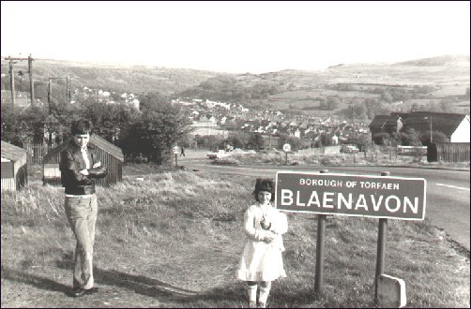
Picture 1, Blaenavon Street Sign with Community

The Distinctiveness of Blaenavon

  - Nicola Louise Bragg 1910223
BMSP:4005 Distictiveness and Regeneration
Course lecturers: Anthony Burns, Jessica Shore

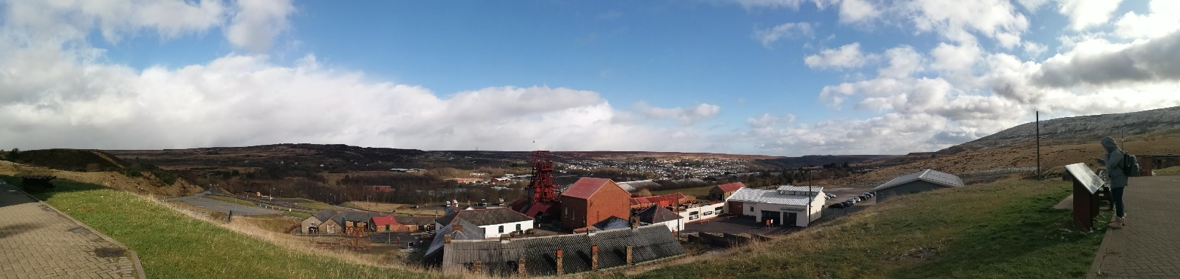

Contents
Picture 2; Pig pit and Blaenavon Panorama

1. Introduction
2. The start
2. The Ironworks
4. Coal formation
5. Coal and Blaenavon
6. Big Pit

 | 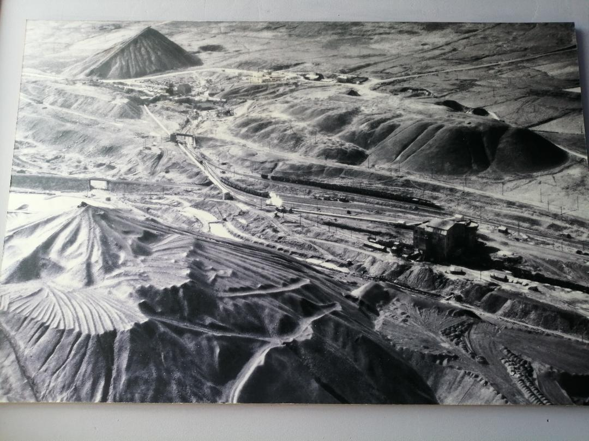 |  | 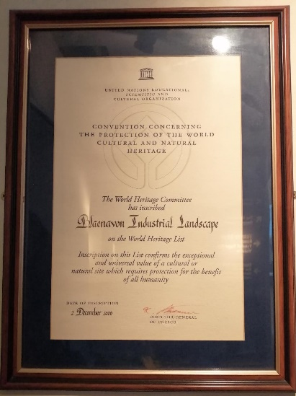
 | Introduction  This report will reflect upon my visit to Blaenavon 11/02/2020. The reason for investigating Blaenavon is to understand why this small welsh town became the heritage site it is now. Areas of interest include Blaenavon’s involvement in the industrial revolution, their coal formations and mines.  The Start  1325 ironstone and coal mines started to appear on the Blorenge this was the beginning of the industrial revolution it wasn’t till 1787 this event started to impact the town of Blaenavon, Thomas Hill, Thomas Hopkins, and Benjamin Pratt signed a lease from Lord Abergavenny which secured land, 1789 they developed 3 ironwork furnaces, the first multi-furnace in Wales (Knight, 2016, Burns, 2020).  The Ironworks  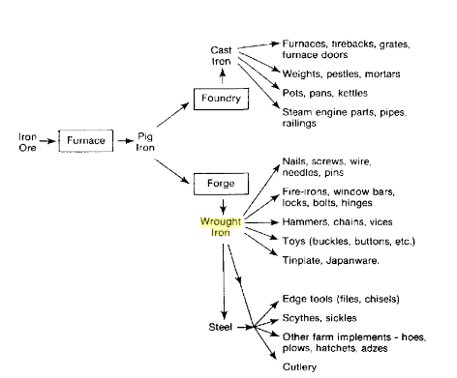  It was here where Sidney Gilchrist accomplished dephosphorisation, the process iron must go through to equip the production of steel “from within company’s own mineral properties were drawn iron ores, fireclay, coal and limestone”. Ironstone and/or clay ironstone was found within the coal seams, it began to form in the upper carboniferous period, made in nodules or lumps in long beds consisting of a few inches, mainly within the mid and low  measures of the coal measures (Burns, 2020).  Figure one and two depicts the technique of creating pig iron through a blast furnace, whilst figure three illustrates the uses. By 1796 5,400 tonnes of iron was produced per year. Blaenavon’s landscape started to change forever becoming industrialised “with coalmines, limestone quarries, iron forges, brickworks, tramroads” these were all controlled by the Blaenavon Iron Company and allowed for more homes for key workers to be built close by. 1805-6 two more furnaces were built and now the five furnaces had an annual production of 14,220 tonnes of pig iron. (28.01 Athony)  Figure 3  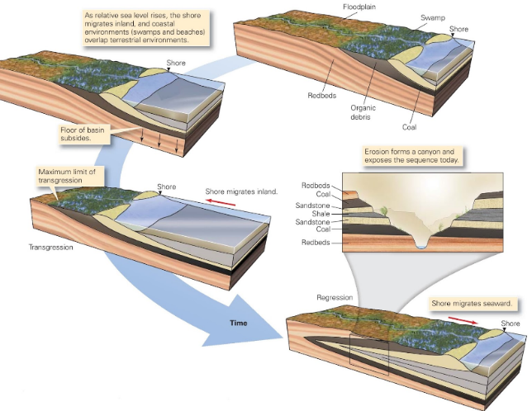  Figure 4  Coal Formation  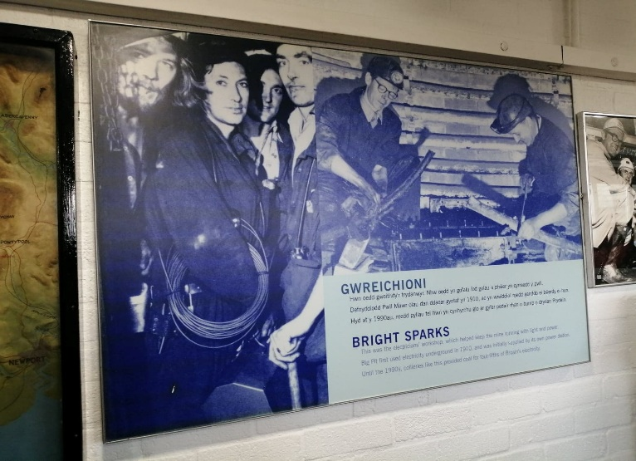  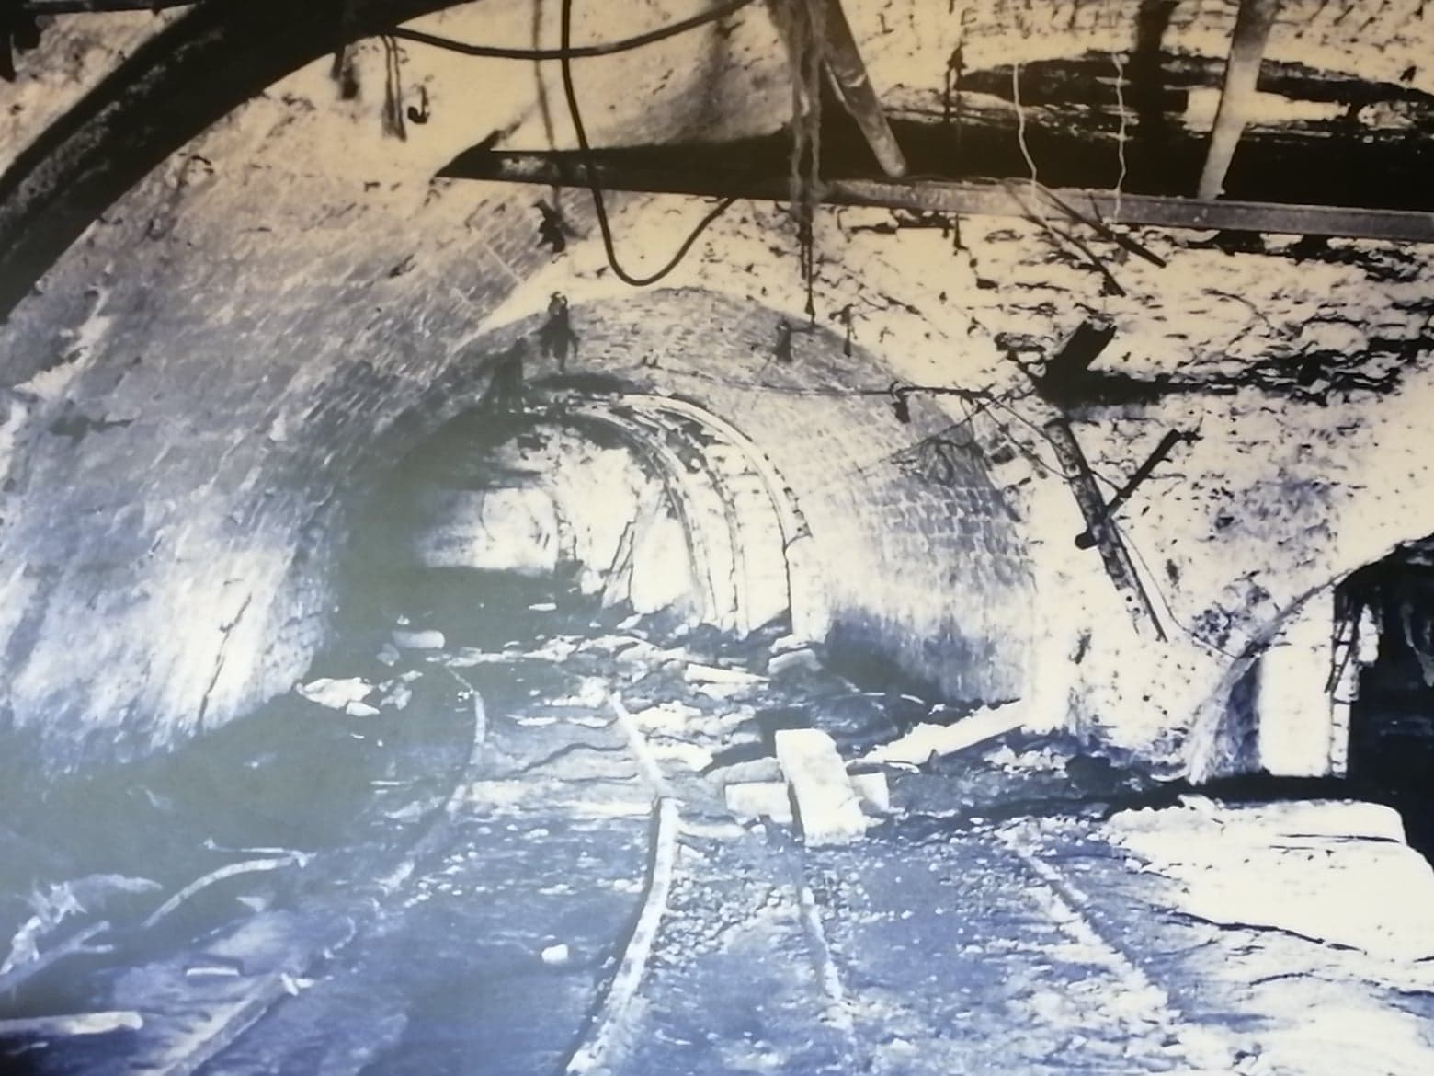  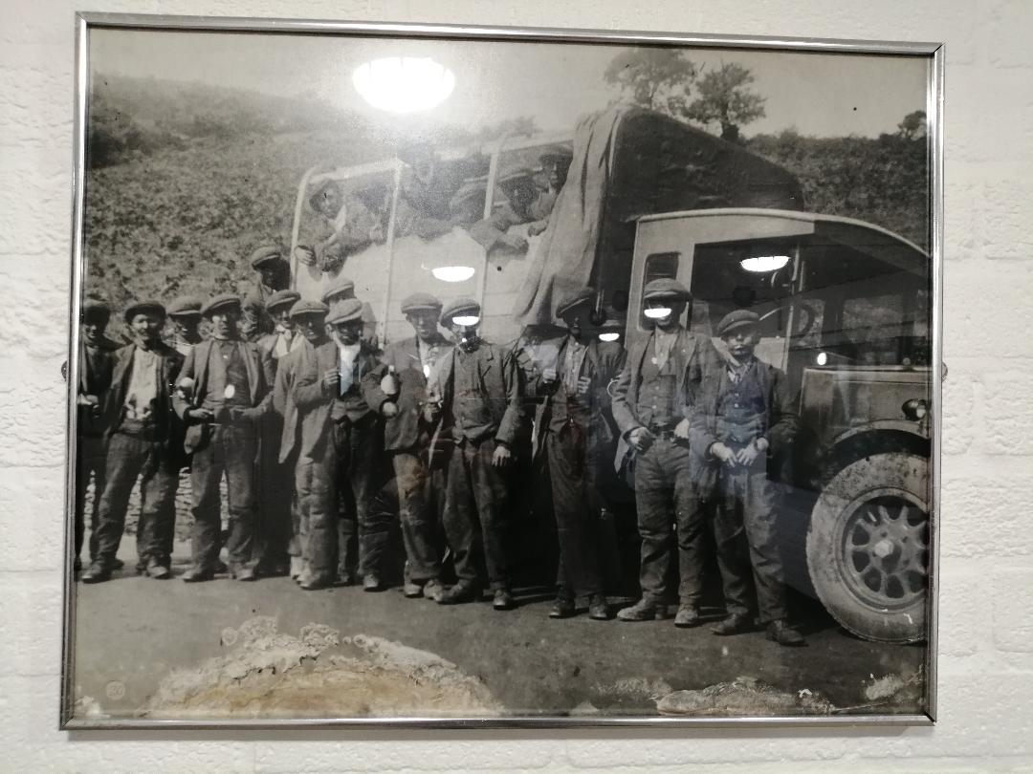  Coal started to form between 390 and 290 million years ago in carboniferous times when the UK was covered in swamps and deltas. Devonian times sparked the evolution of bony fish, lung fish and many others into the shallow waters along with vast amounts of plant life. Once creatures died, the remains lay upon the beds along with plants and algae. Land would flood with warm seas this moved locations of rivers and enabled coral reefs to flourish and push shell material into the rocks which would manifest into limestone found today in Welsh caves. The floods compacted these fossils and forest debris beneath newly made swamp mud. This process transpired repeatedly creating grave pressure upon the vegetation beneath making it nearly impossible to decompose with the lack of oxygen from the acidic water and muds above. The little carbonisation formulated peat; dark sponge type material, normally dehydrated, and used as a heat source. Eventually sea-beds began to dry and if left started to develop into lignite within coal seams, which is a soft brown coal containing 25-35% carbon, mainly used to generate electricity. Over time more layers were put down ensuring higher amounts of pressure and heat, whilst allowing time for the fossils to decompose more. Ensued was the next type sub-bituminous, around 100 million years old, containing 35-45% carbon and used the same as lignite. The next chapter was Bituminous; separated into smithing coal for forges, cannel coal for coal oil, and coking coal for the steel industry. Anthracite is the final formation with a carbon content of up to 97%, this type is more expensive, burns cleanly and leaves less soot it was used in home stoves and water filtration systems (Burns, 2020).  Figure 6  Figure 5  Figure 3  Coal and Blaenavon  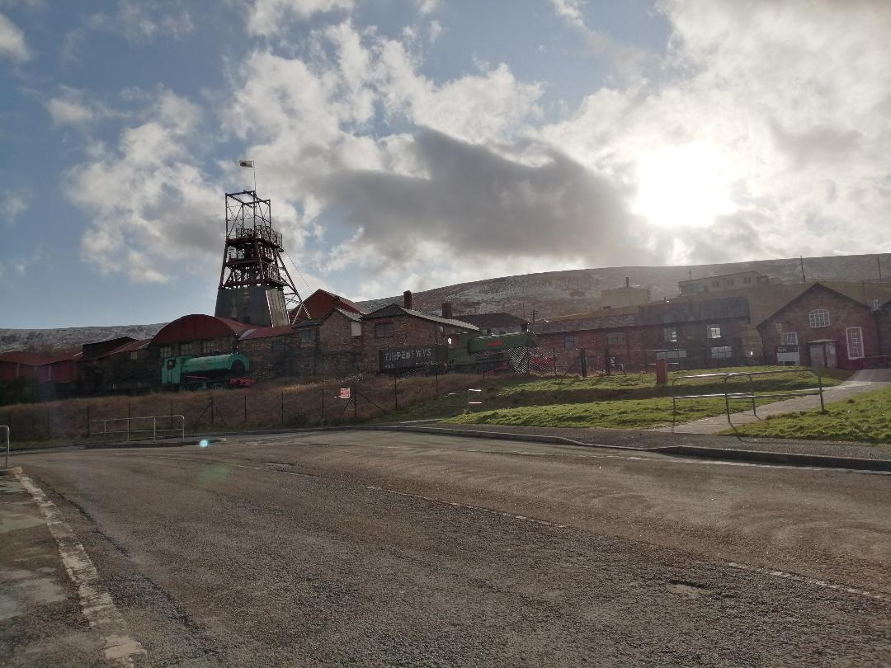  It was the process in the previous chapter that made Blaenavon a huge part of the industrial revolution as it manifested greatly in the area. The first extraction method was damning and/or rushing this separated iron ore from shales which wasn’t greatly used within Blaenavon. The Blaenavon Iron Company creating quarries generated a system called ‘Pillar and Stall’ which was used to mine the materials, before that ‘long wall working’ procedures were in place. (Burns, 2020).  Figure 7  Figure 7  Big Pit  Big pit before it was known today started as an iron mine consisting of 34 shafts and initially powered by a water balance winding wheel was turned into a coal colliery in 1880, its name comes from the size of its shaft which became deeper at this time and “was the first in the area to raise two drams side by side”. Over its time span it produced over 250,000 tonnes of coal per year. Employing 1,399 people at most, at one time. Location was key here for this mine to flourish, coal/iron seams were shall in the area which meant plenty of “supplies of limestone for flux and water for power”. Working and life in the mines was not great but it created a sense of community for everyone based at Blaenavon and further afield. Mines were a noisy, dirty place with young children being employed to open and close the doors between the cart tracks to safely ensure the delivery of the carts. Horses also worked and lived within the mines and “by the late nineteenth century there over a 100,000 in use.”  Figure 8  Before electricity was introduced in 1910 candles were used to light the tunnels poor children, if the flame extinguished would have to continue their duty in the blacker than black dark. In some cases, naked flames reaped deadly tragedies beneath the surface as the materials being mined in the confined space created dust and dirt, thick within the air mixed with carbon monoxide present and the ignition of any minute spark caused detrimental explosions. To prevent risk small birds like canaries were used to test the atmosphere by breathing it through their small chests, if the bird became ill or died, gas was present.  Before machinery was invented or affordable men and women used pickaxe to bring out the coal  The demise of Big Pit began when strikes initiated in 1984 to 1985 when the government owned National Coal Board decided to close 20 loss making pits, this was devastating for communities with relationships being broken by those who would refuse to work and those who chose to carry on their employment. When the strikes ended 29 Welsh collieries closed, 20,000 men lost their jobs ensuing a reduced to almost nonexistent need for the materials as they became cheaper to source elsewhere (Bragg, 2020). |  | 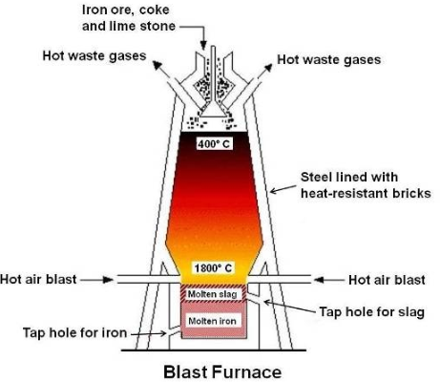  Figure 1  Figure 2  Figure 1  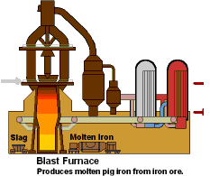  Figure 2

References

Knight, Jeremey (2016). Blaenavon from Iron Town to World Heritage Site. [Timeline]
Herefordshire: United Kingdom. Logaston press.

Burns, Anthony (2020).
Lecture – Industrial History of Blaenafon [powerpoint] Available at; Moodle UWTSD,
BMSP4005, Distinctiveness and Regeneration. (Accessed; Feb 02 2020)
Lecture – Ironstone [powerpoint] Available at; Moodle UWTSD, BMSP4005, Distinctiveness
and Regeneration. (Accessed; Feb 25 2020)
Lecture – How the Coals of Blaenafon Formed [powerpoint] Available at; Moodle UWTSD,
BMSP4005, Distinctiveness and Regeneration. (Accessed; Feb 25 2020)
Lecture – Limestone [powerpoint] Available at; Moodle UWTSD, BMSP4005, Distinctiveness
and Regeneration. (Accessed; Feb 25 2020)

Bragg, Nicola (2020).
Personal Experience – Big Pit Museum, Mine Tour, King Coal Visual Experience [University Trip] (Participated; Feb 11 2020)

Pictures

Picture 1; Available at; http://members.tripod.com/~Family_Thomas/blaenafon.htm

Figure 1 & 2; Burns, Anthony (2020).
Lecture – Industrial History of Blaenafon [powerpoint – slide 7, 11] Available at; Moodle UWTSD, BMSP4005, Distinctiveness and Regeneration. (Accessed; Feb 02 2020)

Figure 3; Lecture – Ironstone [powerpoint] Available at; Moodle UWTSD, BMSP4005, Distinctiveness
and Regeneration. (Accessed; Feb 25 2020)

Figure 4; Burns, Anthony (2020).
Lecture – How the Coals of Blaenafon Formed [powerpoint] Available at; Moodle UWTSD,
BMSP4005, Distinctiveness and Regeneration. (Accessed; Feb 25 2020)

Figure 5, 6, 7, 8, Picture ; Personal Experience – Big Pit Museum, Mine Tour, King Coal Visual Experience
[University Trip] (Participated; Feb 11 2020)

