March 12, 2026
Cheng Chen (2305261)

BSc Applied Computing
Data Mining
Data Warehousing & Data Mining
Contents
Purpose of Data Mining 2
Dataset Description 3
Pre-processing 4
Analysis Methods 5
Regression 5
Classification (J48 Decision Tree) 7
Clustering (K-means) 9
Business Recommendations 10
Reflection 11
References 12

Purpose of Data Mining
The purpose of this data mining task is to explore and analyze student performance data in order to identify patterns that influence academic outcomes. Data mining refers to the process of extracting meaningful patterns and knowledge from large datasets using techniques such as classification, regression, and clustering [1].

In this project, the aim is to understand which factors are most associated with whether a student passes or fails. This includes analyzing variables such as study habits, attendance, and family background. These factors are commonly examined in educational data mining (EDM), which focuses on improving learning outcomes through data-driven insights [2].

In addition, predictive models are developed to estimate student performance. Regression is used to predict continuous outcomes such as final grades, while classification is used to categorize students into groups such as Pass or Fail. These approaches are widely used in educational analytics to support early intervention strategies [3].

Clustering is also applied to group students with similar characteristics. This helps identify different types of learners, such as high-performing students and those at risk. Such grouping is useful because it allows institutions to design targeted support rather than applying a one-size-fits-all approach.

Overall, the purpose of this data mining exercise is not only to build models, but also to generate actionable insights that can support decision-making in an educational context.

Dataset Description
The dataset used in this project is the Student Performance dataset obtained from the UCI Machine Learning Repository [4]. It contains data collected from secondary school students and is widely used in educational data mining research.

The dataset includes 395 instances, where each instance represents a single student. There are 33 attributes, consisting of both numerical and categorical variables. These include demographic information (such as age and gender), academic-related variables (such as study time and failures), and behavioral variables (such as absences and social activities).

The attributes can be broadly divided into two categories. Numerical attributes include variables such as age, study time, and grades (G1, G2, G3). Categorical attributes include variables such as parental job, school type, and internet access. A full list of attributes is provided in the dataset documentation.

The most important variables in this dataset are the three grades: G1, G2, and G3, which represent performance at different stages. In this project, a new attribute called “Result” was created based on G3, where students scoring 10 or above are classified as Pass, and others as Fail.

This dataset is suitable for applying multiple data mining techniques because it contains mixed data types and a clear target variable. However, it should be noted that the dataset is relatively small and context-specific, which may limit the generalizability of the findings.

This report uses the student-mat.csv dataset, which contains 395 instances and 33 attributes related to students’ academic performance in mathematics. The dataset was selected for its completeness and relevance to predicting final grades.

Initial data exploration showed that the distribution of the final grade (G3) was slightly skewed, with a higher concentration of students achieving mid-range scores. A strong positive relationship between G1, G2, and G3 was observed, indicating that earlier academic performance is a reliable predictor of final outcomes. In addition, variables such as study time and absences showed noticeable variation across students, suggesting potential influence on academic performance.

Pre-processing
Before applying data mining techniques, several preprocessing steps were performed to ensure the dataset was suitable for analysis.

Firstly, formatting issues were addressed. The original dataset used semicolon separators, which are not compatible with Weka. Therefore, the data was converted into a comma-separated format to enable successful import.

Secondly, a new attribute called “Result” was created based on the final grade (G3). This transformation converted a numerical variable into a categorical variable, making it suitable for classification algorithms such as decision trees. This type of transformation is commonly used when converting regression problems into classification tasks.

In addition, certain attributes were removed to avoid data leakage. Specifically, G3 was excluded from the classification model because it directly determines the Result variable. Including it would result in artificially high accuracy without meaningful insight. Similarly, G2 was also removed to reduce the dominance of prior performance and allow other factors to contribute to the model.

No missing values were identified in the dataset, so no imputation was required. Furthermore, normalization was not applied because the selected algorithms (decision trees and K-means in Weka) are not highly sensitive to feature scaling.

These preprocessing steps ensured that the dataset was clean, consistent, and suitable for meaningful analysis. However, removing strong predictors such as G2 may reduce predictive accuracy, which highlights a trade-off between model interpretability and performance.

Analysis Methods
This section presents the application of regression, classification, and clustering techniques to analyse student performance. Linear Regression was selected because it is suitable for modelling relationships between continuous variables and provides interpretable coefficients for understanding feature impact on final grades. The J48 decision tree algorithm was chosen due to its ability to generate clear and interpretable classification rules, which are valuable in an educational context. K-means clustering was applied to identify underlying student groups, with k=3 selected to provide a balance between simplicity and meaningful segmentation for analysis.

Regression
A linear regression model was applied to predict the final grade (G3). Linear regression is a widely used statistical method for modelling relationships between variables [1].
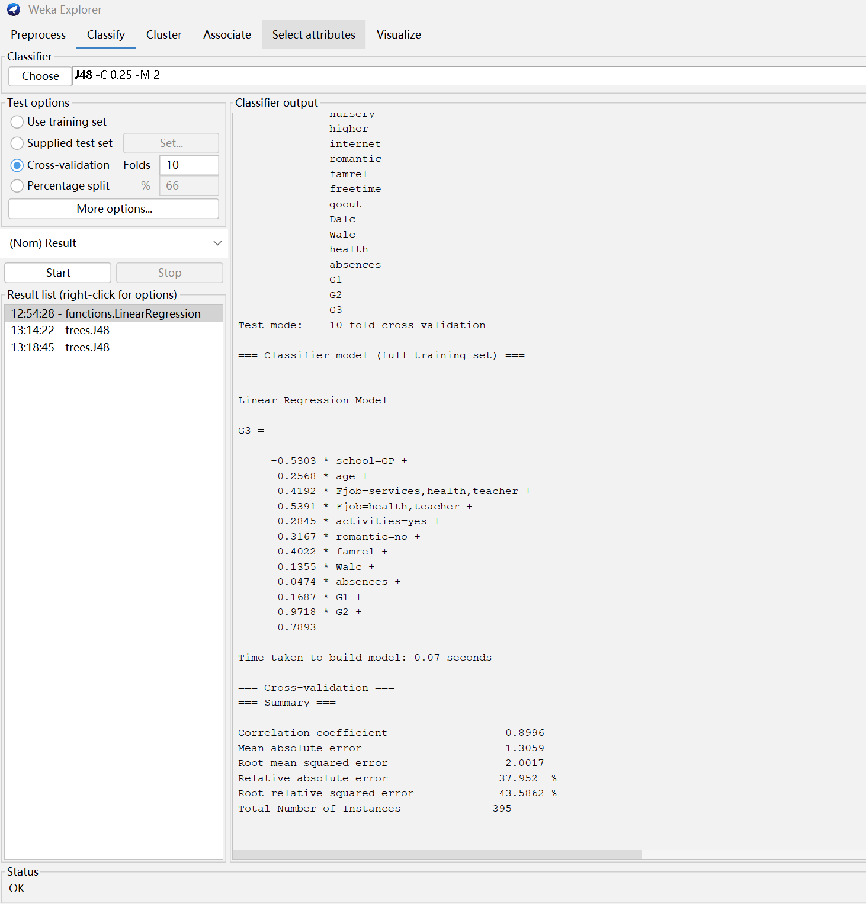
Figure 1 Linear Regression Model Output
Figure 1 shows the output of the linear regression model. The correlation coefficient is 0.8996, indicating a strong relationship between predicted and actual values. The model shows that G2 and G1 have the largest coefficients, confirming that previous academic performance is the strongest predictor of final grades. However, this may limit the ability of the model to identify new influencing factors beyond prior performance.

This also suggests that the model is heavily dependent on prior grades, which may reduce its usefulness in identifying behavioural factors. In practical applications, relying too heavily on past performance may reduce opportunities for early intervention. This indicates that while the model is effective for prediction, it may not be suitable for identifying underlying behavioural or environmental factors influencing student performance.

Classification (J48 Decision Tree)
A decision tree model (J48, based on the C4.5 algorithm) was used to classify students into Pass or Fail categories [5].

The model achieved an accuracy of 84.30%, which indicates good performance. Decision trees are particularly useful because they provide interpretable rules, making it easier to understand the factors influencing outcomes.
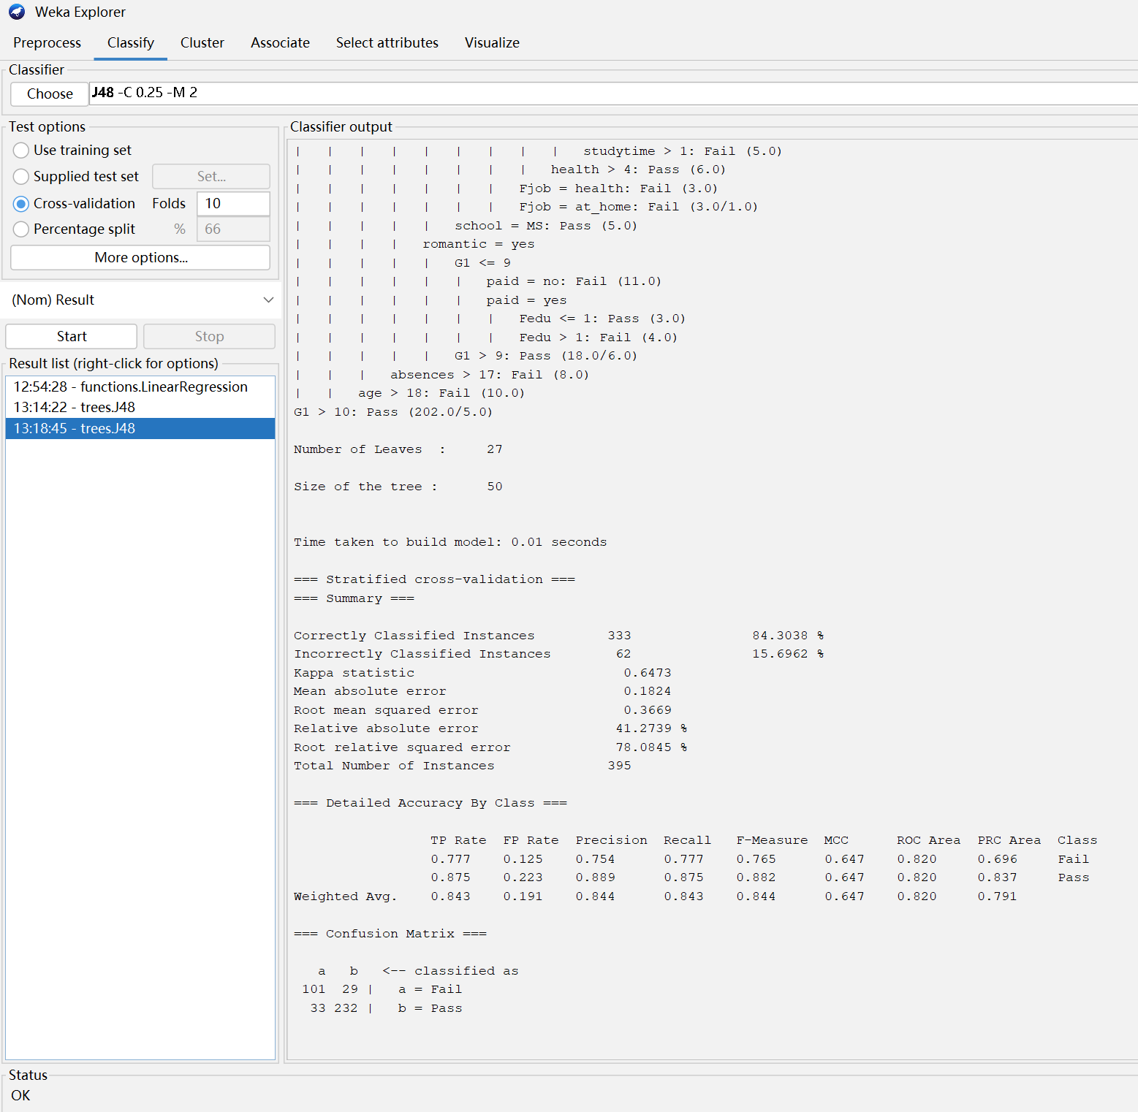
Figure 2: J48 Decision Tree for Student Performance
As shown in Figure 2, G1 appears at the top of the tree, indicating that early academic performance is the most important factor. In addition, variables such as absences and study time also influence the classification. Students with high absence levels are more likely to fail, which highlights the importance of attendance. This indicates good classification performance.

High absence levels are generally associated with failing, highlighting the importance of attendance.
It is important to note that an earlier model including G3 resulted in perfect accuracy. However, this was due to data leakage rather than true predictive power. After removing G3, the model produced more realistic and meaningful results. The confusion matrix shows that most students are correctly classified, although some misclassification occurs near the decision boundary. Although the model performs well overall, the confusion matrix suggests that misclassification mainly occurs in borderline cases. This indicates that incorporating additional features or using more advanced models such as ensemble methods could further improve classification performance.

Clustering (K-means)
Clustering was performed using the K-means algorithm, which groups data points into clusters based on similarity [6]. The choice of k=3 allows for a manageable interpretation of student groups while still capturing meaningful differences in academic performance and behaviour.
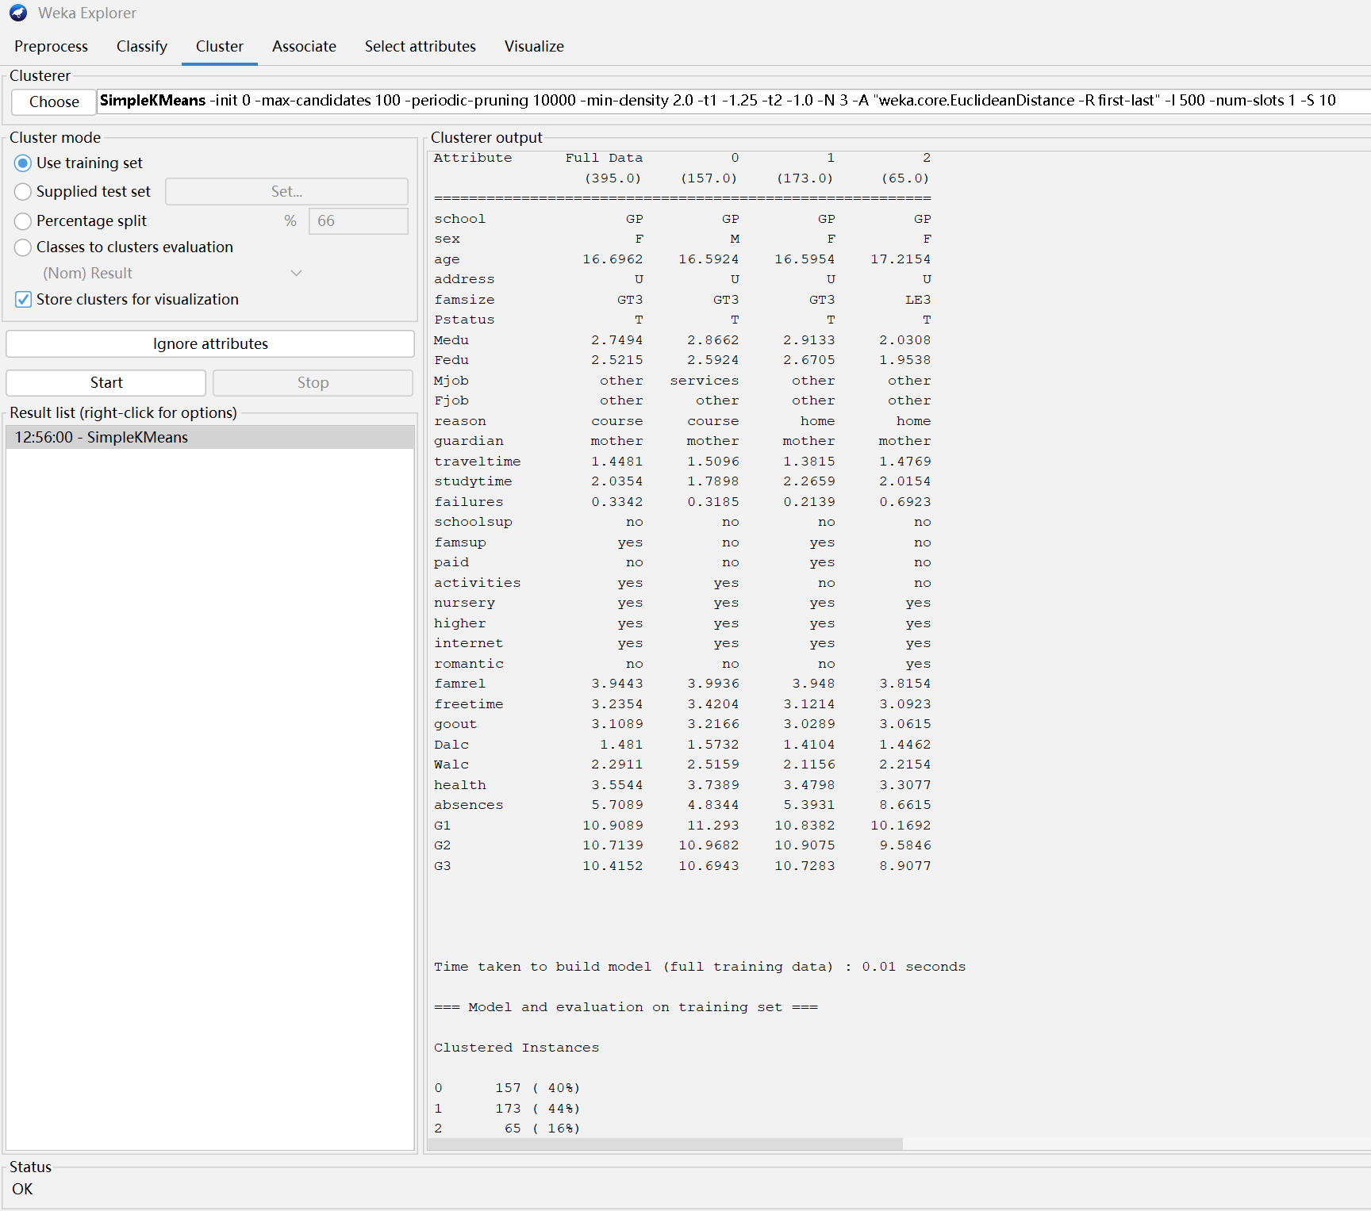
Figure 3: K-means Clustering Results
Figure 3 presents the clustering results. Three clusters were identified, with different group sizes (40%, 44%, and 16%). The clusters show variations in attributes such as grades, absences, and study time. One cluster represents higher-performing students, while another includes students with lower performance and higher absence levels, indicating a group that may require additional support. This demonstrates that student groups are not homogeneous and require different support strategies.

Clustering is useful because it identifies hidden patterns without predefined labels. However, the interpretation of clusters can be subjective, and results may vary depending on the number of clusters chosen. The selection of three clusters may influence the results, and different values of k could produce alternative groupings. Therefore, further experimentation is required to determine the most appropriate number of clusters.

Business Recommendations
Based on the analysis, several practical recommendations can be made.

One of the key findings from the analysis is that early academic performance (G1 and G2) strongly predicts final outcomes. Therefore, schools should monitor early assessment results to identify at-risk students. Early intervention strategies, such as tutoring or mentoring, could improve outcomes.

Secondly, attendance is an important factor. Students with higher absences tend to perform worse. This suggests that improving attendance could positively impact performance. Schools could implement attendance monitoring systems or provide support for frequently absent students.

Thirdly, clustering results indicate that students can be grouped into different categories. This suggests that personalized learning strategies may be more effective than general approaches. For example, additional support can be provided to low-performing students, while high-performing students can be offered advanced learning opportunities.

Finally, factors such as study time and family background also influence performance. Encouraging better study habits and providing support for disadvantaged students may help improve overall outcomes.

These recommendations demonstrate how data mining can support decision-making in education by identifying key factors and enabling targeted interventions.

Reflection
This project provided valuable experience in applying data mining techniques to real-world data. The use of regression, classification, and clustering allowed for a comprehensive analysis of student performance.

The models achieved reasonable accuracy, particularly the decision tree model. One advantage of decision trees is their interpretability, which makes them useful for explaining results to non-technical stakeholders.

However, there are several limitations. The dataset is relatively small and context-specific, which limits generalizability. In addition, strong predictors such as G1 and G2 dominate the models, reducing the influence of other variables.

Another limitation is that the analysis is based on historical data and does not account for factors such as motivation or teaching quality, which are difficult to measure.

If the project were to be extended, more advanced models such as random forests or neural networks could be explored. In addition, collecting more diverse data could improve model reliability.

In terms of efficiency, the models were computationally lightweight and executed quickly in Weka, making them suitable for small to medium-sized educational datasets.

Overall, this project demonstrates the usefulness of data mining in educational contexts, while also highlighting the importance of careful interpretation and awareness of limitations.

References
[1] J. Han, M. Kamber and J. Pei, Data Mining: Concepts and Techniques, 3rd ed. Morgan Kaufmann, 2012.
[2] C. Romero and S. Ventura, “Educational data mining: A review of the state of the art,” IEEE Transactions on Systems, Man, and Cybernetics, vol. 40, no. 6, pp. 601–618, 2010.
[3] G. Siemens and P. Long, “Penetrating the fog: Analytics in learning and education,” EDUCAUSE Review, vol. 46, no. 5, pp. 30–40, 2011.
[4] UCI Machine Learning Repository, “Student Performance Dataset.” Available: https://archive.ics.uci.edu/dataset/320/student+performance
[5] J. R. Quinlan, C4.5: Programs for Machine Learning. Morgan Kaufmann, 1993.
[6] J. MacQueen, “Some methods for classification and analysis of multivariate observations,” in Proc. 5th Berkeley Symposium on Mathematical Statistics and Probability, 1967, pp. 281–297.

