WORKSHEET 4 – QUESTION

Write a program to allow the user to have a dice duel against the computer.



- Write a program which generates three random numbers for the user, and then three for the computer. Add the numbers for each player - the player with the highest total wins the round.

Your output might look something like this:

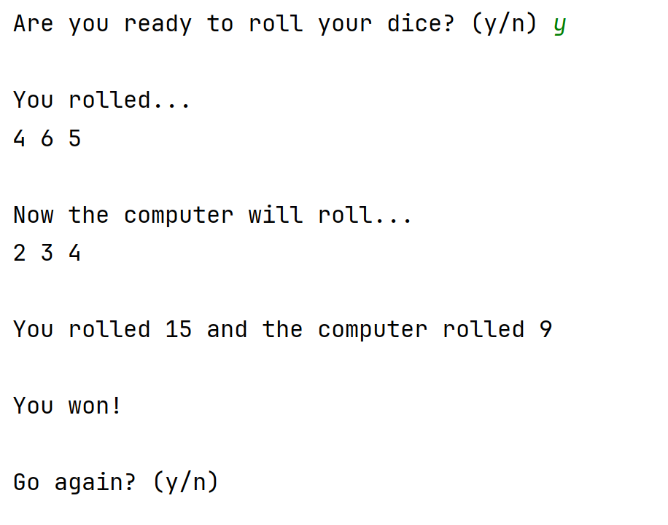

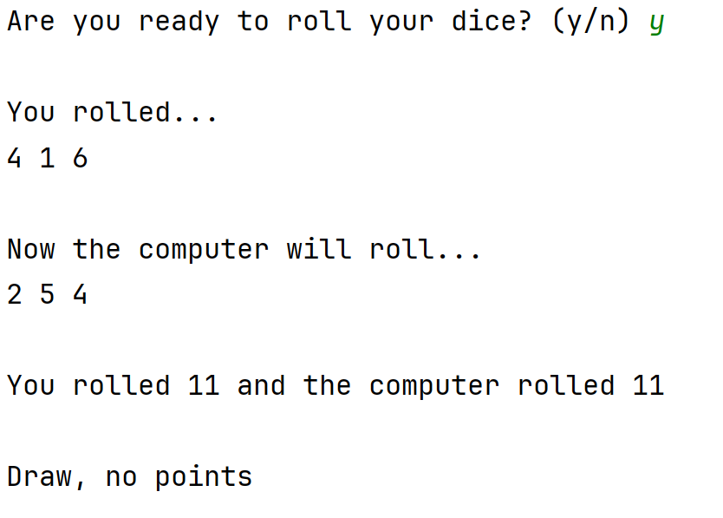

- Extend your program so that multiple rounds can be played. Keep track of the number of wins for each player. You might show the total wins for each player, you might also show in more detail who won each round.

Decide when the duel is won, eg first to five wins, best of 12 rounds etc (Note: no points are awarded for a draw) and tell the user when they (or the computer) have won.

Think carefully about your program and implement it as efficiently as you can, avoiding repetition of similar sections of code. This might be achieved by the use of loops, or possibly functions.

For example:

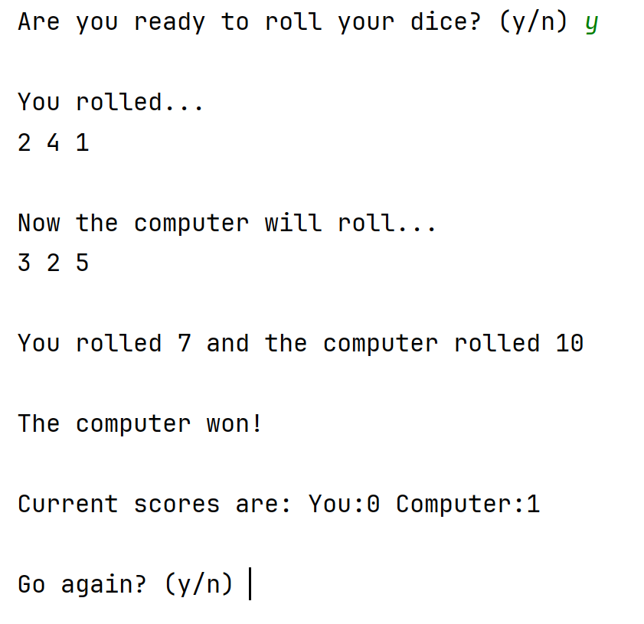

Or more complex with the round statistics shown:



