BMPS4009 & BMPL4007
2200212@student.uwtsd.ac.uk

Jack Banner (2200212)

Contents
Preparing for Higher Education 2
PowerPoint Link 3
Reflection 4
Reference List 5

Preparing for Higher Education
In modern policing in the UK, it is vital for aspiring officers to prepare for further education. Where getting a degree isn’t the only way of joining the police, at the very least you will achieve the same level 6 through the policing degree apprenticeship, keeping a standard through the 3 entry paths for modern police officers (UCAS, no date). According to joiningthepolice.co.uk (no date), the only entry that does not require you to work towards your level 6 qualification is the IPLDP traditional entry; however, this route is being phased out by April 2023. Where there is a necessity for an aspiring constable to develop practical skills that they will use when working, the professional body that recognizes degree entries have decided that the development of intellectual skills reigns just as important, with universities being one of the best options for individuals to acquire and then develop these skills while working towards a level 6 qualification (Bottomley, Pryjmachuk and Wright, 2019). Coming into the modern world of policing, there have been massive developments regarding the growing relationships between police forces and HE institutions throughout both England and Wales. Going forward where these forces are looking at, HE institutions to provide degrees for those aspiring to work in policing with the eventual phasing out of conventional means of entry (Hallenberg and Cockcroft, 2017). These close-knit relationships, along with career path means that unlike many civilian professions, the ability to move into the police force without prior work experience is accepted, along with universities such as my own providing opportunities with police forces to work in roles such as Special Constables due to the links that they have (University of Wales Trinity Saint David, 2022).

Mind Map
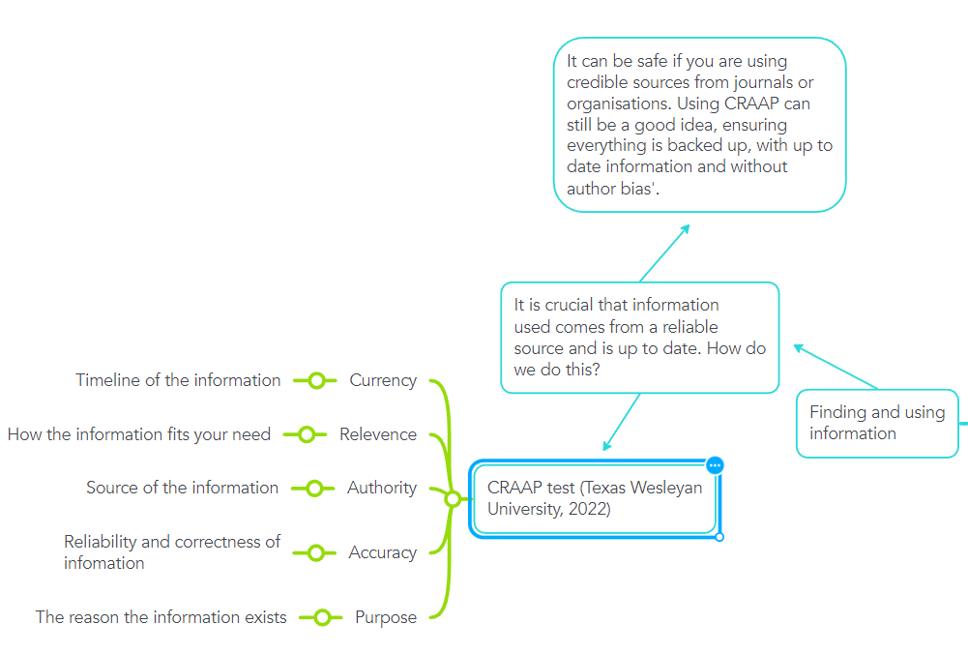
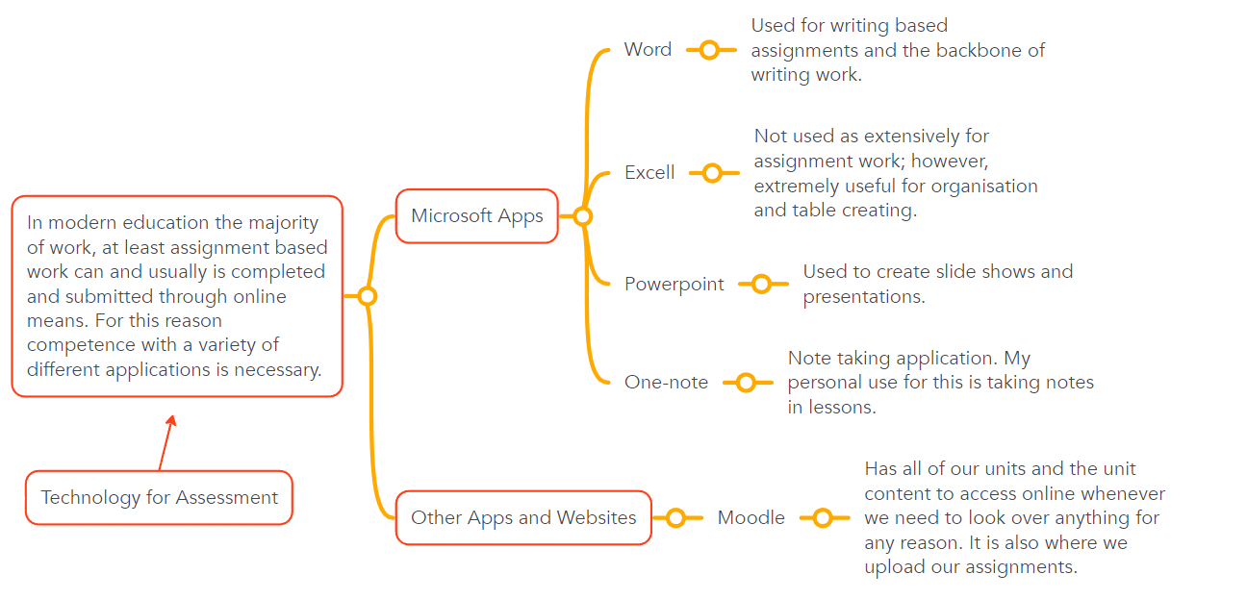
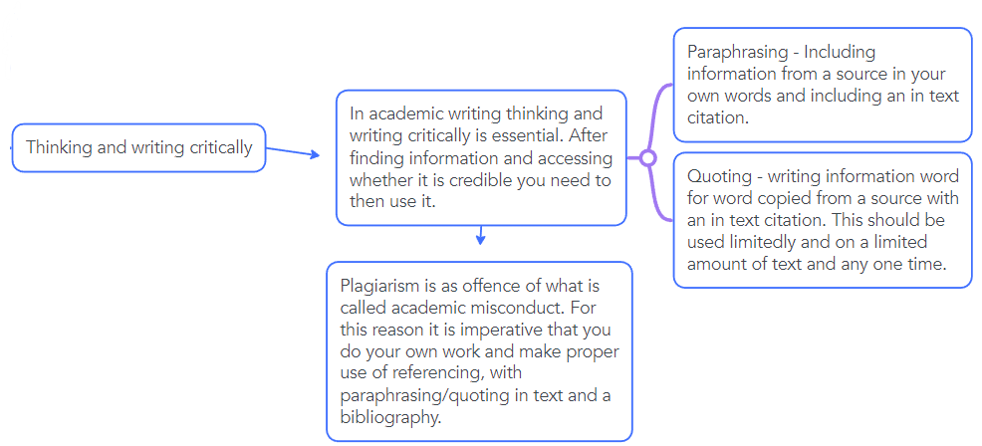
Becoming a Digital Learner.

PowerPoint Link
https://youtu.be/n0ZymACAqzI

Reflection
My start this year was a little different to many on the course due to me transferring a few weeks into the term from a different course and university. I started doing Engineering; however, I did not get along with that as my education has a background in Public Services. Because of this, coming into policing, despite being slightly behind, I have found the transition well as I have a history with the topic putting me in a better starting position compared to those who may have started from courses such as A Levels. So far, my biggest struggle has been getting to grips with Harvard referencing. Harvard referencing is a author/date style of referencing (The University of Sheffield, No Date). Where I can do the references, I find myself having to refer to online resources to help me due to the different ways that you reference each information source depending on its type. As for the main content of the course, I feel that my memory is being tested as I learn new legislation with my class while at the same time trying to catch up on what I’ve missed. One example of this is the use of the acronym GOWISELY which outlines what an officer should be telling a suspect prior to conducting a stop and search. According to the College of Policing (2022), knowledge of why an officer is deciding or performing an action will see a higher likelihood that it is accepted by the individual, making GOWISELY an important thing to learn. I also have an up-and-coming assessment at the time of writing this in which I must role-play a stop and search, proving that I know GOWISELY for going forward into the future. As for the writing element of the course, I am not struggling whatsoever. Throughout my public services BTEC I was assessed through coursework for the duration where I wrote to a high standard and was able to achieve a very good grade.

Reference List
Bottomley, J., Pryjmachuk, S. and Wright, M. (2019) Studying for your policing degree. 1st edn. St Albans: Critical Publishing.

Coursera (2022) What Is Effective Communication? Skills for Work, School, and Life. Available at: https://www.coursera.org/articles/communication-effectiveness (Accessed: 4 November 2022)

College of Policing (2022) Professional. Available at: https://www.college.police.uk/app/stop-and-search/professional (Accessed: 4 November 2022).

Home Office (No Date) APPRENTICESHIP AND TRADITIONAL ENTRY PROGRAMMES. Available at: https://www.joiningthepolice.co.uk/application-process/ways-in-to-policing/apprenticeship-and-traditional-entry-programmes (Accessed: 25 October 2022).

Hallenberg, K.M. and Cockcroft, T. (2017) ‘From Indifference to Hostility: Police Officers, Organizational Responses and the Symbolic Value of “in-Service” Higher Education in Policing’, Policing : a journal of policy and practice, 11(3), pp. 273–288. Available at: https://doi.org/10.1093/police/paw055.

Immigration Advisors Authority (no date) Personal beliefs, values, attitudes and behaviour. Available at: https://www.iaa.govt.nz/for-advisers/adviser-tools/ethics-toolkit/personal-beliefs-values-attitudes-and-behaviour/#:~:text=Values%20are%20stable%20long%2Dlasting,see%20it%20as%20being%20important.%E2%80%8B (Accessed: 4 November 2022).

Olsen, E. (2017) Personal Identity. Available at: https://www.oxfordbibliographies.com/view/document/obo-9780195396577/obo-9780195396577-0086.xml#:~:text=The%20term%20%E2%80%9Cpersonal%20identity%E2%80%9D%20means,how%20one%20differs%20from%20others.%E2%80%8B (Accessed: 4 November 2022).

Texas Wesleyan University (2022) The Research Process: A Step-by-Step Guide. Available at: https://txwes.libguides.com/ResearchProcess/websites (Accessed: 4 November 2022).

The University of Sheffield (No Date) Harvard Referencing. Available at: https://librarydevelopment.group.shef.ac.uk/referencing/harvard.html (Accessed: 4 November 2022).

University of Wales Trinity Saint David (2022) Professional Policing (BSc). Available at: https://www.uwtsd.ac.uk/bsc-professional-policing/ (Accessed: 4 November 2022).

UCAS (No Date) HOW TO BECOME A POLICE OFFICER. Available at: https://www.ucas.com/careers-advice/employment/how-to-become-a/police-officer (Accessed: 25 October 2022).

