

Air Quality Analysis Report And Task Summary

Student name : Vamsi Bejjam
Student ID number : 2527053
Programme : MSc Data and Artificial Intelligence
Module : Advanced Statistical Programming
Lecturer : Dr Aliyu Sambo

Contents
Task 1: Analysis Report 2
1. Data Import and Inspection 2
2. Exploratory Visualisation 2
3. Correlation Between Pollutants 4
4. Hypothesis Testing: NO2 under High vs Low Wind Speed 5
5. Group Comparison: Ozone Across Seasons 6
Task 2: Reflective Summary 7

Task 1: Analysis Report

1. Data Import and Inspection
The dataset includes 87,672 hourly observations of three weather variables (wind direction, wind speed, temperature) and six pollutants (Ozone, NO, NO2, NOx, SO2, CO, PM10, PM2.5) that were taken at a Port Talbot monitoring station during a period of about ten years. 24 original column headers were modified to brief, analysis-friendly labels upon import, and the string "No data"—which the station used to indicate a missing sensor reading—was mapped to NA. Since R had initially read the eleven measurement columns as character vectors due to the existence of "No data" strings, they were specifically forced to be numeric. Additionally, cleaning produced Year, Month, and Season variables for subsequent grouping and transformed the non-standard "24:00:00" timestamp—which represents midnight at the end of the day—into a valid date-time.
The summary() output displays strongly right-skewed distributions for each pollutant, with missingness ranging from about 2% (Ozone, Temperature) to nearly 7% (PM2.5). In each case, the mean is well above the median, and a number of variables have small negative values (an artifact of sensor calibration/drift near zero) rather than actual negative concentrations. The decision to employ non-parametric statistical techniques later in the report was directly influenced by this skew.

2. Exploratory Visualisation
The temporal variation of ozone (O₃) and nitrogen dioxide (NO₂) concentrations was analysed by calculating monthly mean values and presenting them using a line (time-series) plot. This approach is particularly appropriate when the independent variable on the x-axis represents time, as it clearly illustrates both long-term trends and recurring seasonal patterns in the data. By aggregating the data into monthly averages, short-term fluctuations are smoothed out, allowing for a clearer interpretation of underlying patterns. In contrast, plotting all individual data points would result in significant over-plotting due to the very large dataset, which consists of more than 87,000 hourly observations. Such dense visualisation would reduce clarity and make it difficult to identify meaningful trends, thereby justifying the use of aggregated monthly means in a time-series representation.
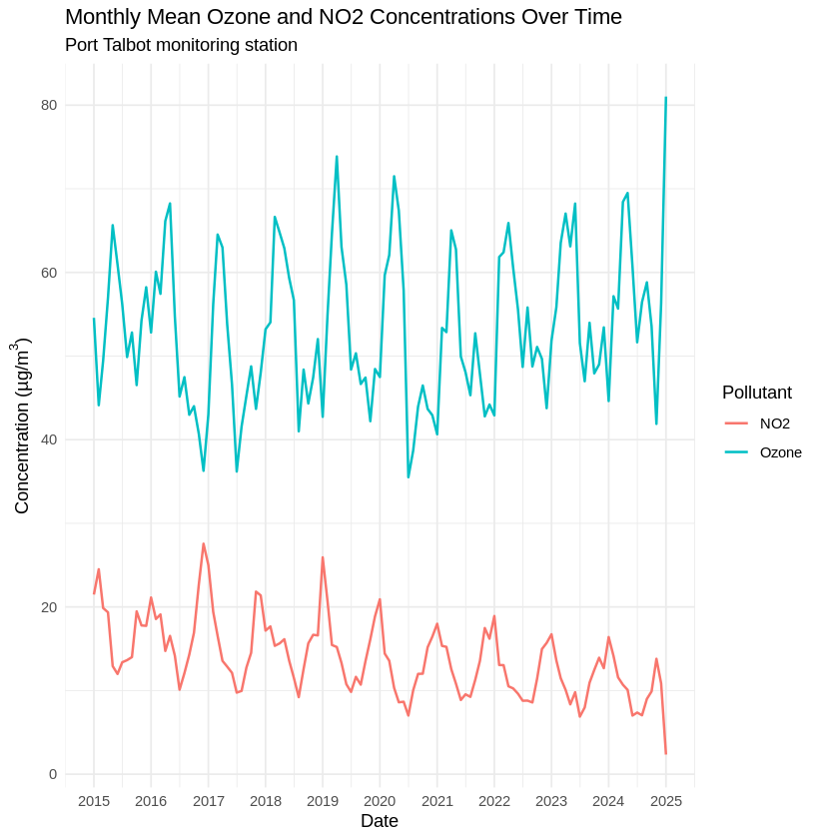
Figure 1. Monthly mean Ozone and NO2 concentrations, 2015–2025.
While NO2 has a long-term declining trend along with its own seasonal cycle, corresponding with decreases in traffic/combustion emissions during the time, Ozone exhibits a distinct repeating seasonal cycle with a little upward drift in peak values over the ten years. In line with the negative link mentioned in Section 3, the two pollutants move primarily in opposing phases each year.
b) Scatterplots of pollutants and weather. The link between two continuous variables was investigated using scatterplots, which have a linear trend line. To make the picture understandable, a random sample of 5,000 points was shown instead of the entire dataset; this does not alter the underlying relationship.
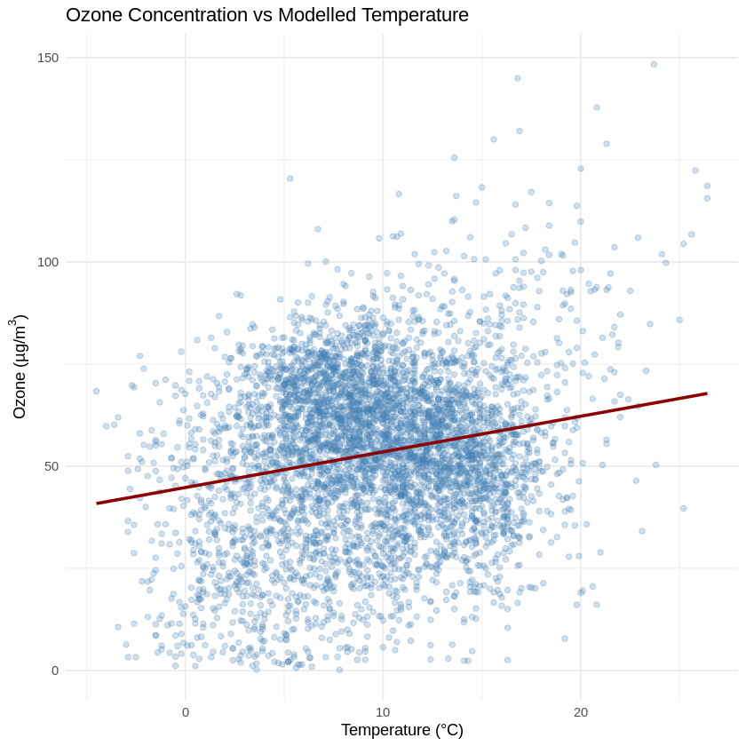
Figure 2. Ozone vs modelled temperature (5,000-point sample, with linear fit).
Ozone rises with temperature, consistent with greater photochemical ozone production in warmer, sunnier conditions.

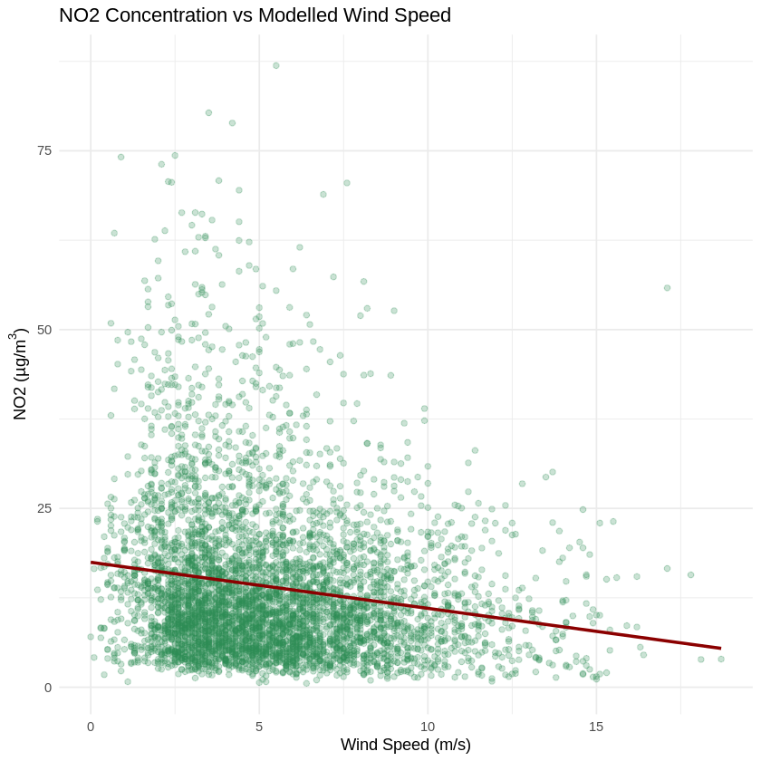
Figure 3. NO2 vs modelled wind speed (5,000-point sample, with linear fit).
NO2 falls as wind speed increases, consistent with stronger winds dispersing locally emitted pollution more effectively.
c) Distribution of PM2.5 by season. A boxplot was used because it is well suited to comparing the median, interquartile range, and outliers of a continuous variable across several discrete groups.
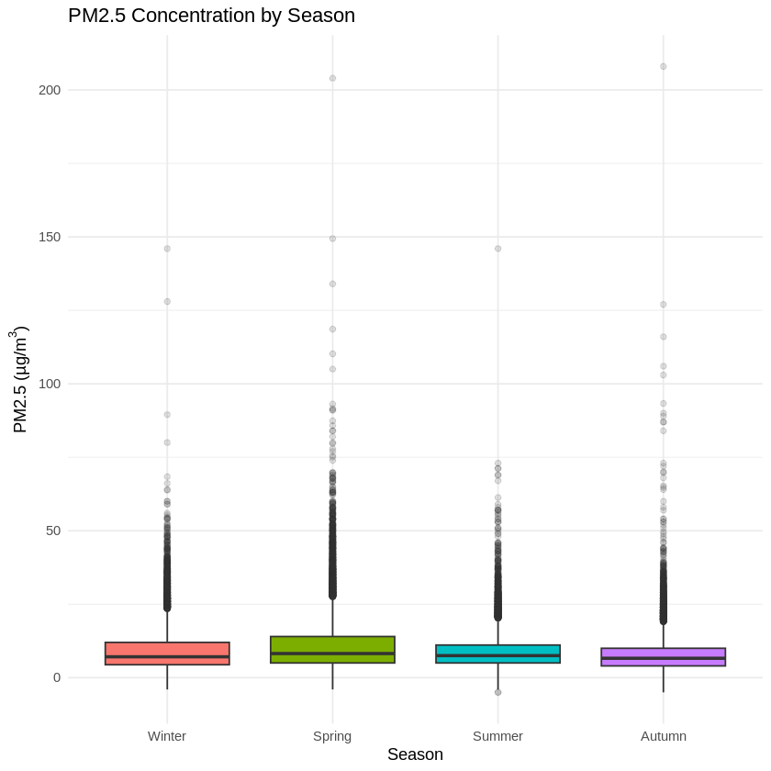
Figure 4. PM2.5 concentration by season.
Median PM2.5 is broadly similar across seasons, with Spring showing the highest median and most extreme high outliers, while Winter, Summer and Autumn are close to one another.

3. Correlation Between Pollutants
Spearman’s rank-based correlation coefficient was selected instead of Pearson’s correlation because the pollutant concentration data exhibit a clear right-skewed distribution, characterized by a large number of relatively low values and occasional extreme spikes or outliers. These features violate the key assumptions underlying Pearson’s method, particularly the requirements of linearity and normal (Gaussian) distribution of the variables. In contrast, Spearman’s correlation is a non-parametric approach that relies on the ranked order of the data rather than their raw values. This makes it more robust to outliers and skewed distributions. Additionally, Spearman’s method only assumes a monotonic relationship—where variables consistently increase or decrease together—rather than a strictly linear one, making it more appropriate for this type of environmental dataset.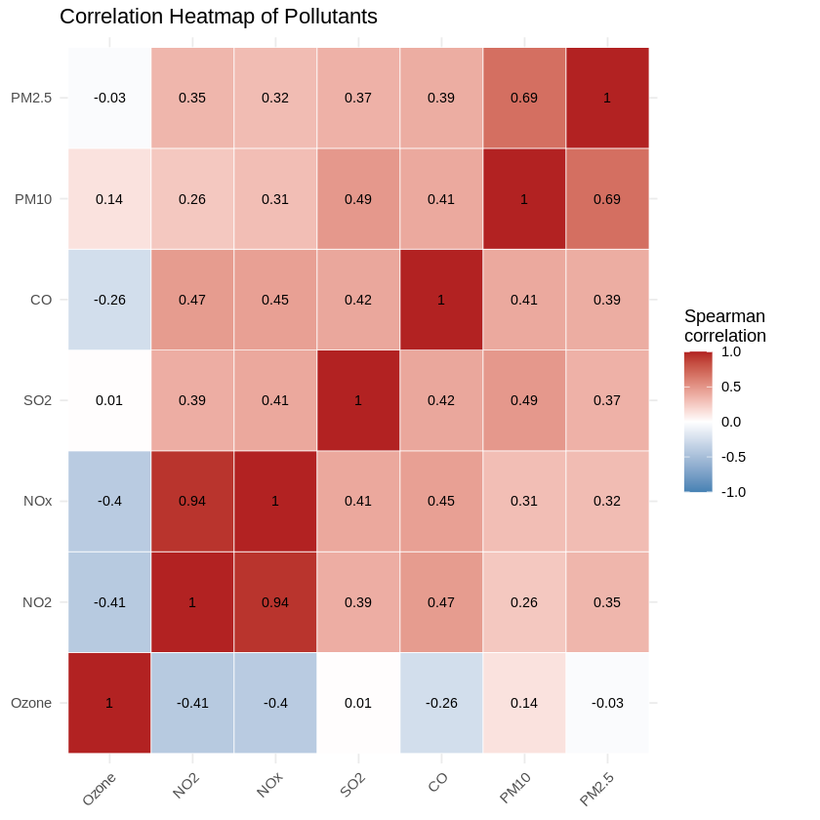
Figure 5. Spearman correlation heatmap of pollutants.
The matrix displays a moderately negative correlation between Ozone and NO2/NOx (ρ = −0.41 / −0.40), a strong positive correlation between PM10 and PM2.5 (ρ = 0.69), as PM2.5 is physically a subset of PM10, and a very strong positive correlation between NO2 and NOx (ρ = 0.94), as expected since NOx is defined as NO + NO2 and both share combustion/traffic sources. Two reasons account for this negative relationship: ozone generation and NOx emission follow largely opposing seasonal cycles, and fresh NO released by traffic reacts with and "titrates" ambient ozone close to the source.

4. Hypothesis Testing: NO2 under High vs Low Wind Speed
Ozone and NO₂ time trends were analyzed by first calculating monthly mean concentrations from the full dataset. These aggregated values were then visualized using a line (time-series) plot, which is the most appropriate method when time is represented along the x-axis and the goal is to clearly illustrate long-term trends as well as recurring seasonal patterns. Using monthly averages simplifies interpretation and highlights meaningful variations over time. In contrast, plotting all individual hourly observations—exceeding 87,000 data points—would result in significant over-plotting, making the graph cluttered, difficult to read, and less effective for identifying overall trends.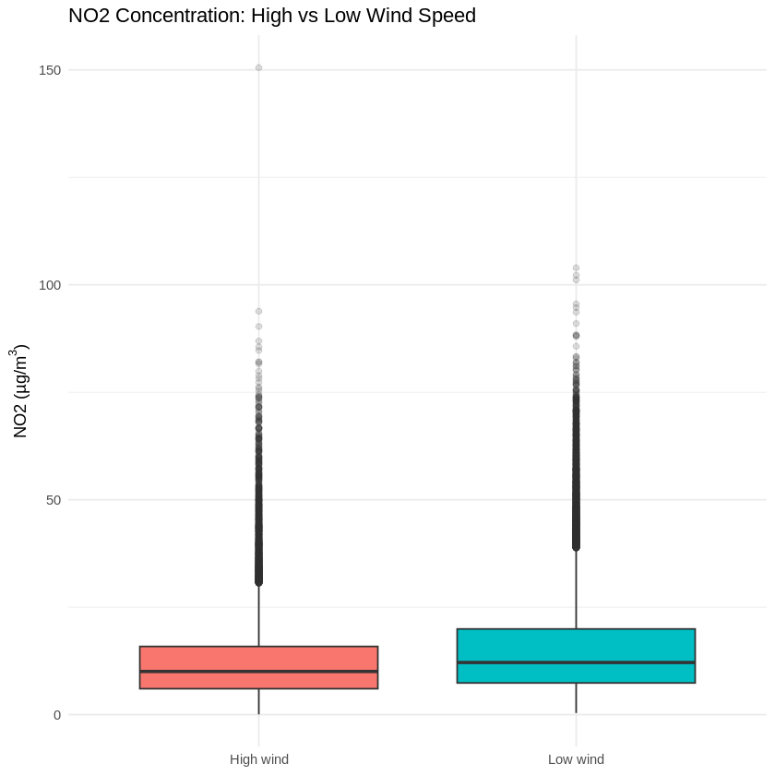
Figure 6. NO2 concentration under high vs low wind speed.
H0 is rejected since the test yielded W = 708,647,047, p < 2.2×10⁻¹◦, indicating that NO2 varies greatly depending on wind conditions. The direction is in line with expectations; median NO2 was lower under high wind (10.0 µg/m³, n = 39,978) than under low wind (12.1 µg/m³, n = 42,469), which is consistent with stronger winds more efficiently dispersing pollution. This statistically significant finding should be evaluated in conjunction with the small absolute difference in medians (about 2.1 µg/m³) rather than only the p-value because of the extremely high sample size.

5. Group Comparison: Ozone Across Seasons
Ozone is considered an important air pollutant, and its concentration levels were analysed across four seasonal groups: Winter, Spring, Summer, and Autumn. To statistically evaluate whether ozone levels vary by season, a hypothesis testing framework was established. The null hypothesis (H₀) states that all four seasons have the same median ozone concentration, implying no significant seasonal effect. In contrast, the alternative hypothesis (H₁) suggests that at least one pair of seasons exhibits a difference in median ozone concentration, indicating the presence of seasonal variability.
Before selecting an appropriate statistical test, the distribution of ozone concentration data was examined and found to deviate from normality. Since the assumption of normal distribution required for parametric tests such as one-way ANOVA was not satisfied, a non-parametric alternative was chosen. Specifically, the Kruskal–Wallis test was applied to compare the medians of the four independent seasonal groups. This test is well-suited for non-normally distributed data and does not assume homogeneity of variance, making it an appropriate method for determining whether statistically significant differences exist among the seasonal ozone concentrations.
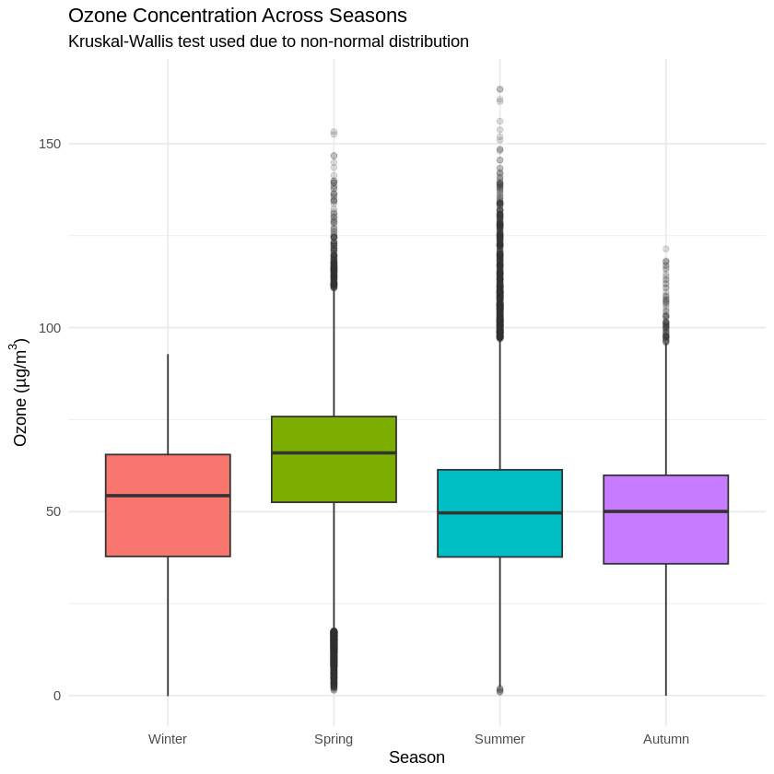
Figure 7. Ozone concentration across seasons.
The outcome (χ² = 8989.1, df = 3, p < 2.2×10⁻¹) leads to the rejection of H0: Seasonal variations in ozone are substantial. Surprisingly, Spring had the greatest median Ozone (66.0 µg/m³), followed by Winter (54.3 µg/m³), while Summer (49.6 µg/m³) and Autumn (50.0 µg/m³) had the lowest. Coastal UK sites are heavily impacted by a well-documented Northern Hemisphere "spring maximum" in background tropospheric ozone, which is linked to stratosphere–troposphere exchange and decreased NOx titration in cleaner spring air. This effect can outweigh summer photochemical production, even though sunlight-driven photochemistry would predict a summer peak. No single pair of seasons can be considered statistically equal because all seasons differ significantly from each other (all adjusted p-values < 8.1×10⁻¹¹), according to follow-up pairwise Wilcoxon tests with Bonferroni correction.

Task 2: Reflective Summary
This investigation served as a reminder of how much real-world environmental data needs to be cleaned up before it can be considered reliable. The raw file utilized a "24:00:00" convention for end-of-day timestamps that are invalid clock times and a text flag ("No data") for missing readings; neither problem is apparent unless you closely examine the data's structure. Without first addressing these situations, I would have silently converted entire rows to NA or dropped them, which would have subtly skewed subsequent results if I had converted directly to numeric or parsed dates. This served as a helpful reminder that judgments about data cleansing are analytical choices in and of themselves, not merely a mechanical initial step, and that they must be recorded in order for the analysis to be repeatable.
Learning to allow the nature of the data—rather than habit—determine the test selection was the most important statistical lesson. The descriptive statistics revealed distinctly right-skewed pollutant distributions with means significantly above medians, so I used the Wilcoxon rank-sum test and Kruskal-Wallis test instead, which compare distributions without assuming normality. Initially, my instinct was to use a t-test and ANOVA. This was further supported by the decision to use Spearman correlation rather than Pearson correlation for the same reason: aligning the approach to the characteristics of the data and being able to clearly defend that decision felt more significant than just generating a p-value.
In order to interpret the results, I also had to fight the need to fit them into the explanation I had anticipated. Because photochemical synthesis depends on sunshine, I thought ozone would rise in the summer, but the data indicated a March peak. Instead of writing this off as a mistake, I looked into the mechanism (the Northern Hemisphere tropospheric "spring maximum," which is associated with lower NOx titration and stratosphere–troposphere exchange) and discovered that it was a recognized atmospheric event at coastal locales. This was an excellent illustration of a conclusion that at first glance appeared incorrect but, upon closer examination, turned out to be both accurate and more intriguing than my first hypothesis; it served as a helpful check on my own confirmation bias.
Nearly all of the comparisons with sample sizes in the tens of thousands were "statistically significant" at p < 2.2×10⁻¹¹, which taught me that statistical significance by itself is not particularly informative at this scale. Instead of using the p-value as the primary finding, I found it more helpful to describe and interpret the impact size directly, such as the approximately 2 µg/m³ difference in median NO2 between high- and low-wind circumstances.
This analysis has obvious shortcomings. Because it relies on data from a single monitoring station, results cannot be extrapolated to other areas without caution. Additionally, no independent data on traffic volume, industrial emissions, or synoptic weather patterns was available to directly test the suggested mechanisms; the explanations put forth are reasonable given atmospheric chemistry but were not statistically tested. Pairwise exclusion was used to manage missing data (up to ~7% for PM2.5), assuming it is missing at random; this was not formally verified.
Instead of looking at these relationships one pair at a time, I would look into the missingness mechanism, test for autocorrelation in the hourly time series (observations are unlikely to be independent hour-to-hour), and fit a multiple regression or generalized additive model to determine how much of the variation in each pollutant is jointly explained by wind speed, temperature, and season.

