2110633
ECIE4004
Principles of Learning and Teaching

Element One
Demonstrate understanding of a theory of learning by
Friedrich Froebel

The Froebel Approach

Understanding the theory of learning of German educator, Friedrich Froebel (1782-1852)

Isn’t it remarkable to think that until 1840, children did not receive any schooling until the age of (at least) 7 years old? And when children started school around this age, they would be expected to study in a formal manner. They would be taught by dictation, they would read until facts were remembered or chant until they chanted lines or verses perfectly!
Friedrich Froebel was an educational pioneer and one of the first-known educators to consider the teaching and learning of the youngest of children.

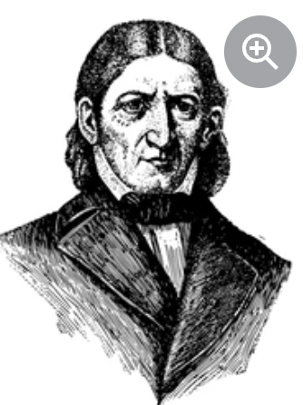
Who is Friedrich Froebel?
Friedrich Froebel was a German educator, who is best-known for being the founder of the kindergarten and early-years settings as we know them today.

Froebel had an unsettled childhood with his mother passing away when he was only nine months old. There are reports that Froebel felt lonely during his early childhood, before moving in with his Uncle around the age of 10 years old as his father was seemingly unable to look after him.
(Morphant Creation, 2019)
He developed a keen interest in nature, philosophy and he had an apparent thirst for knowledge. Despite being labelled as a ‘dreamer’, Froebel went on to study at the Universities of Jena, Göttingen and Berlin, and he later became a successful teacher and tutor.
(Weston, 2000).

Education at the time (18th-19th Century)
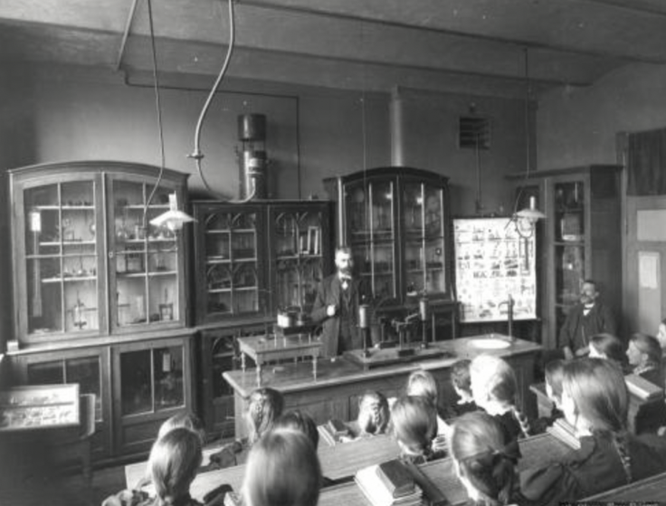
There were huge changes in the education system during the 18th and 19th Century across Western Europe. Gradually, it became necessary for schools to become the responsibility of the state. Schools would no longer be for the privileged or the wealthy, instead education had to be provided “for all of the children of all of the people” (Britannica, 2021).
(Olsen, circa 1900)

During this era, both public and private schools were “expected not only to promote literacy, mental discipline, and good oral character but also to help prepare children for citizenship, for jobs, and for individual development and success”. (Britannica, 2021). It should also be noted that before 1840, children did not attend formal schooling until at least 7 years old.

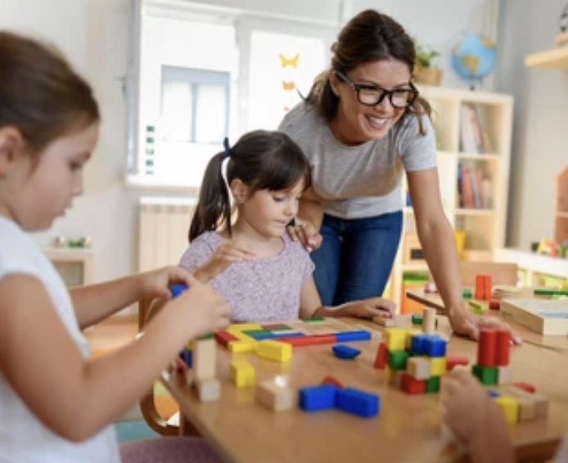
The first Kindergarten was born
In June 1839, 50 children registered at Froebel’s educational institution ‘Bad Blankenburg‘ in Germany and one year later, he renamed his ‘educational institution’ as a ‘kindergarten’. A quick Google translate will tell you that the German words ‘kinder’ and ‘garten’ translate into ‘children’ and ‘garden’ – aptly coined by Froebel who dreamt of creating a ‘garden for children’ where young people could “interact with nature, as well as play, plant, nurture, explore, observe and discover” (Zoromski, 2019). Interestingly, Froebel employed an all-female workforce at a time when women were not represented well in the teaching profession.
(Lordn, 2022)

Froebel’s Visions
Froebel rejected the idea of the teacher leading the education or the learning and believed that “children learnt best by doing things for themselves” (Froebel Trust, 2022). He did not think children should be expected to remain still or remain passive.

According to Britannica (2021), Froebel’s ‘curriculum’ consisted of three types of activities which you will see below:

- Playing with the ‘gifts’
(educational toys such as collapsible dice, balls, buttons)

- Playing games and singing songs.
He considered games one of the most important steps in the development of a child.

- Gardening and caring for animals, connecting with nature

Centrally to this, Froebel believed that play should be at the heart of child education.

Froebel was also very keen on promoting an inclusive environment with unity and respect instilled across the whole community.

Froebel’s Legacy
So what can we take away from this? Ultimately, Froebel was the first known educator to create an early-years programme which helped children to develop and thrive through play and activity. Interestingly, he is thought to be one of the first to discover that “brain development is quite rapid during the first three years of life” (Efe, Koleva and Atasoy, 2018, p.358). He envisioned an educational system for our youngest of learners which would maximise children’s development and learning at this crucial time of their lives.

Reference List
Britannica (2021) Western Education in the 19th Century. Available at: https://www.britannica.com/topic/education/Western-education-in-the-19th-century (Accessed: 16th December, 2022).

Curtis, Stanley James (2022) Friedrich Froebel German Educator. Available at: https://www.britannica.com/biography/Friedrich-Froebel (Accessed: 17th December, 2022).

Early Education (2020) Friedrich Froebel. Available at: https://early-education.org.uk/friedrich-froebel/ (Accessed: 16th December, 2022).

Efe, R., Koleva, I. and Atasoy, E. (2018) Recent Researches in Education. Cambridge Scholars Publishing: Lady Stephenson Library.
Froebel Trust (2022) Inspiring early learning. Available at: https://www.froebel.org.uk/ (Accessed: 29th December, 2022).

Lordn (2022) Preschool teacher with children playing with colorful wooden didactic toys at kindergarten. Available at: https://www.shutterstock.com/image-photo/preschool-teacher-children-playing-colorful-wooden-1187719606 (Accessed: 30th December, 2022).

Morphant Creation (2019) Friedrich Froebel, 1782-1852, he was a German educator and reformer [vintage line drawing or engraving illustration] Available at: https://www.shutterstock.com/image-vector/friedrich-froebel-17821852-he-german-educator-1382305307 (Accessed: 17th December, 2022).

Olsen, Erik (circa 1900) Picture Science courses at the Kalyskindet School (Norway). Available at: https://ehne.fr/en/encyclopedia/themes/education-teaching-and-professional-training/educating-europeans/educating-europeans (Accessed: 30th December, 2022).

Weston, Peter (2000) Friedrich Froebel His Life, Times and Significance. Second Impression. University of Surrey Roehampton: Peter Weston.

Zoromski, Kevin (2019) Why is Kindergarten called Kindergarten? Available at: https://www.canr.msu.edu/news/why-is-kindergarten-called-kindergarten#:~:text=The%20word%20kindergarten%20comes%20from,Garden%20of%20Children%2C%20in%201840 (Accessed: 17th December, 2022).

Element Two
Demonstrate understanding of a theory of learning by
Burrhus Frederick Skinner

B.F. Skinner’s Theory of Behaviourism

Do you know when you think of inventors in their white lab coats, with thick rimmed glasses, bedraggled hair, working in a busy laboratory on some whacky experiment? That’s what comes to my mind when I think B.F. Skinner - one of the most influential and fascinating psychologists of his time. This blog seeks to explain Skinner’s theory of ‘operant conditioning’ – learning through the consequences of one’s behaviour.

A radical thinker
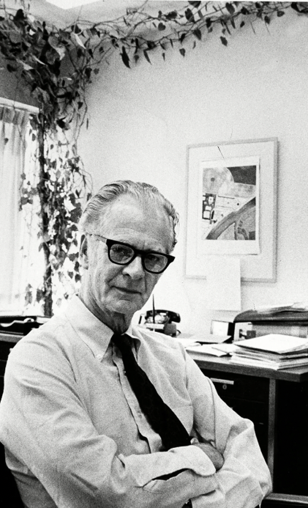
Burrhus Frederick Skinner (1904-1990) is known for being one of the most controversial names in the world of psychology – famous for arguing that humans are fundamentally no different to animals. Even as a young student studying Psychology, he went against the grain of believing that human action was the consequence of one’s thoughts, feelings and motivation. Instead he wanted to analyse humans similar to the way that animals would be observed and analysed interacting within their habitat.

The main work of Skinner was based around his view that classical conditioning was too basic to be an explanation of human behaviours. He believed that by looking more closely at the causes of a behaviour and its consequences, he would be able to better understand the behaviour of humans and animals alike. He coined the term ‘Operant Condition’ for this
Encyclopaedia Britannica (1971)
new approach.
(McLeod, 2018)

Operant Conditioning

In Skinner’s theory of ‘operant conditioning’, he argued that one’s actions would change based on the consequences of their behaviour. Essentially believing that humans (akin to animals) were simply creatures of their environment. To put it simply, the consequence of a response would determine how likely you were to repeat the response. Through operant conditioning, behaviour which is rewarded is likely to be repeated, where as behaviour which is punished is unlikely to be repeated. When a behaviour is repeatedly paired with a consequence, a new behaviour is created.

For example, is a dog trainer rewards a dog with a treat every time it lifts its left paw, the dog will learn that by raising its left paw, he will be rewarded. The dog will continue to raise its left paw again and again for more treats.

Another example is of operant conditioning on animals is getting a pigeon to turn in a circle to the right. A reward would be given after any small movement to the right, with larger rewards being given for larger movements to the right. Eventually the pigeon would turn in a complete circle to the right before receiving a reward.
(Public Broadcasting Service, 1998).
Hausmann (2017)

Operants that follow behaviour
McLeod (2018) explained that Skinner identified three types of Operants (or responses) that follow behaviour:

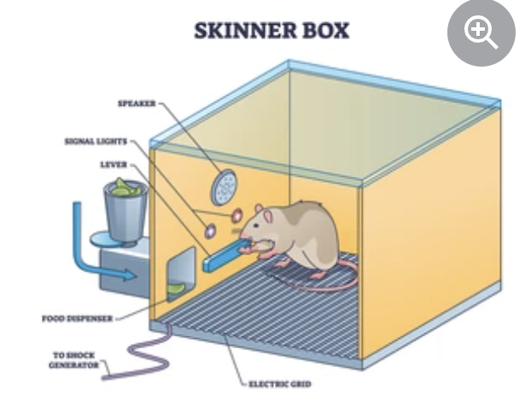
The Skinner Box
Now Skinner loved an experiment and he was a keen inventor. As explained by Harvard University, “among his gadgets were the ‘Skinner Box’ for shaping and counting lever-pressing in rats and key-pecking in pigeons” (2023).

In order to study operant conditioning, he would place an small animal inside the box and whenever the animal pressed the lever, it would receive food or water as a positive reinforcement/reward.

So what is the purpose of Operant Conditioning?
In summary, the main purpose of Operant Conditioning is to reward or encourage positive and pleasing behaviours through rewards and reduce negative or undesirable behaviours through punishments, or lack of rewards. Skinner “believed everything we do and are is shaped by our experience of punishment and reward” (Public Broadcasting Service, 1998) and showed a disregard for the ‘human mind’ or the ‘individual’.

To this day, B.F. Skinner remains one of the most influential psychologists of all time.

For more information on Skinner’s theory of behaviourism take a look at the following video:
https://youtu.be/2DrnhZ8G6EE
(PHIILO-notes, 2022).

Reference List

Butler-Bowden, T. (2017). 50 Psychology Classics. 1st edition. Nicholas Brealey Publishing.

Encyclopaedia Britannica (1971) B.F. Skinner. Available at: https://www.britannica.com/biography/B-F-Skinner (Accessed: 2nd January, 2023).

Harvard University (2023) B.F. Skinner. Available at: https://psychology.fas.harvard.edu/people/b-f-skinner (Accessed: 2nd January, 2023).

Hausmann, Klaus (2017) Dog terrier domestic animal pose. Available at: https://pixabay.com/photos/dog-terrier-domestic-animal-pose-2074921/ (Accessed: 3rd January, 2023).

McLeod, S.A. (2018) Skinner – operant conditioning. Available at: https://www.simplypsychology.org/operant-conditioning.html#:~:text=BF%20Skinner%3A%20Operant%20Conditioning&text=According%20to%20this%20principle%2C%20behavior,the%20Law%20of%20Effect%20%2D%20Reinforcement (Accessed: 30th December, 2022).

PHILO-notes (2022) Skinner’s Theory of Behaviourism: Key Concepts [video]. Available at: https://www.youtube.com/watch?v=2DrnhZ8G6EE (Accessed: 27th December, 2022)
Public Broadcasting Service (1998) B. F. Skinner. Available at: https://www.pbs.org/wgbh/aso/databank/entries/bhskin.html (Accessed: 2nd January, 2023).

Vectormine (2022) Skinner box or operant conditioning chamber experiment outline diagram [illustration]. Available at: https://www.shutterstock.com/image-vector/skinner-box-operant-conditioning-chamber-experiment-2177759265 (Accessed: 2nd January, 2023).

Element Three
Identify, discuss and evaluate the theoretical approaches to learning linked to Froebel’s and Skinner’s theories

Evaluating the theoretical approaches of Froebel and Skinner
Getting down to the nitty-gritty of Froebel’s Constructivist and Skinner’s Behaviourist Approaches

Froebel in a nutshell

(Britannica, 2021)
The above mind map seeks to demonstrate the approaches to learning that were important to Friedrich Froebel. He was one of the first educators to provide structured education for young children and his idea of ‘free play’ was poles apart from the formal teaching we all think of when we think of the ‘olden days’!

“The Principles of [Froebel’s] work have since become part of modern, mainstream early years educational practice” (Froebel Trust, 2022)
There is no doubt that the work of Friedrich Froebel has almost come full circle in the educational world and his “work and writing changed the way we think about and value early childhood” (Froebel Trust, 2022). Today, we see an emphasis in our schools on the importance of authentic learning opportunities and outdoor learning, with schools investing in forest school sessions or developing their outdoor areas. There is a case for this working for some children, but not for others, as some children feel more comfortable in a classroom environment.

Froebel wanted children to experience freedom inside and outside the classroom – “to think for themselves, make choices, solve problems and pursue their own interests and talents” (Tovey, 2020, p. 4). Welsh education and training inspectorate, Estyn, reinforced Froebel’s viewpoint when they wrote “focussing on developing independent learners of all ages and abilities has significantly impacted on standards, levels of wellbeing and provision” (2018). It must be noted that some learners will need more support in becoming a successful, independent learner.
SDI Productions (2017)
And finally, the idea of ‘learning through play’ may raise a few eyebrows by some in society who may deem it a waste of time, an easy option for the teacher or not a priority when the school curriculum is already overwhelming. Yet, as Zosh et al explain “children are born to learn through play (2017, p.12). Learning through play is more than having fun – it lays the foundation for learning and even past infancy, it is proved to be “an effective and worthwhile pedagogical technique for teaching in the 21st Century” (p. 32).

Skinner in a nutshell

(Blakemore and Frith, 2005)

There is no doubt that Skinner’s work had a huge impact on education and society and the way that educators consider recognising and rewarding desirable behaviour, as well as eliminating behaviours that are undesirable in the classroom. Rewards and sanctions are used across our educational settings and can be used to encourage pupils’ attitudes to learning and general school life. Group, class, year group or even whole school rewards such as special days, trips, house points, trophies or certificates can be helpful in encouraging a desirable behaviour or outcome. However, anyone who knows a young person will now that not all children will respond in the same way to positive reinforcements which can present a challenge in itself.

Repetition of a desired behaviour or action can be helpful in teaching pupils through ‘drilling’ such as language patterns, times tables or new vocabulary, although again for some pupils, a different method of teaching may be necessary. Similar to rewards in the classroom such as stickers, certificates and Golden Time, this will appeal to some pupils more than others and you will often find apathetic pupils who rewards and sanctions do not seem to have quite the same impact on.

Educators also need to be mindful that rewards and sanctions do not distract from the learning experience, they may not lead to a higher quality of learning and they may inadvertently isolate some pupils who have ruled themselves out of being in with a chance of receiving a reward.

(Santana, 2013)

Ultimately, I think it’s of great importance that educators get to know their pupils, their interests and motivations, in order to best decide what works best for the pupils in their classroom as be prepared for this to vary year on year!

Reference List

Blakemore S-J. and Frith U. (2005). The Learning Brain. Oxford: Blackwell

Britannica (2021) Western Education in the 19th Century. Available at: https://www.britannica.com/topic/education/Western-education-in-the-19th-century (Accessed: 16th December, 2022).

Estyn (2018) ‘Striving for independent learning for all pupils’. Available at: https://www.estyn.gov.wales/effective-practice/striving-independent-learning-all-pupils (Accessed: 4th January, 2023).
Froebel Trust (2022) Inspiring early learning. Available at: https://www.froebel.org.uk/ (Accessed: 29th December, 2022).
Public Broadcasting Service (1998) B. F. Skinner. Available at: https://www.pbs.org/wgbh/aso/databank/entries/bhskin.html (Accessed: 2nd January, 2023).
Santana, A. (2013) Trophy winner victory competition. Available at: https://pixabay.com/vectors/trophy-winner-victory-competition-5674028/ (Accessed: 5th January, 2023).
SDI Produtions (2017) Adorable boy giving thumbs up in preschool. Available at: https://www.istockphoto.com/en/photo/adorable-boy-gives-thumbs-up-in-preschool-gm886934266-246223304?phrase=independent%20child (Accessed: 5th January, 2023).
Tovey, H. (2020) Froebel’s principles and practice today. Available at: https://www.froebel.org.uk/uploads/documents/FT-Froebels-principles-and-practice-today.pdf (Accessed: 4th January, 2023).
Zosh, J.M. et al. (2017) Learning through play: a review of the evidence. Available at: https://cms.learningthroughplay.com/media/wmtlmbe0/learning-through-play_web.pdf (Accessed: 4th January, 2023).

Element Four
Draw on experiences from own setting to identify resources and strategies used to support effective teaching and learning, linking back to Froebel and Skinner’s theories

Supporting 21st Century learners using Froebel’s and Skinner’s Theories of Learning

Considering how the theories of Friedrich Froebel and B.F. Skinner are relevant in supporting the teaching and learning of secondary school pupils in the 21st Century

A breath of fresh air
Welsh Education has taken a huge leap forward with the launch of Curriculum for Wales in September 2022 which has six areas of learning and experiences and 4 purposes which should be the starting point for each school when designing their own curriculum.

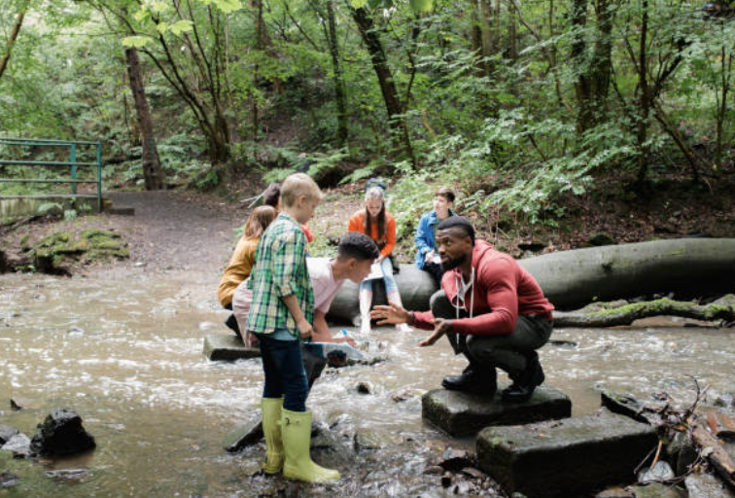
As Williams explains, “being outdoors is now recognised as equal to the indoor classroom” (2022) with the new curriculum having a particular emphasis on pupils’ connection to nature. The curriculum guidance states that schools must “allow learners of all ages to experience authentic learning opportunities both indoors and outdoors” (Hwb, 2022). Working away from the classroom is more important than ever, especially in a world where people generally seem to be spending more time indoors.
Solstock (2018)

Last year, I took 20 of our most challenging pupils to an outdoor learning space called Down to Earth, which is based in the Gower. The pupils selected were typically those who struggle in a classroom environment. As Down to Earth explain here, “even the most so-called ‘hard to reach’ people can thrive given a supportive and genuinely relationship centred approach which is based on meaningful and practical activities” (2022). We saw, over the three days, our young people’s attitudes shifting as they were experiencing success, teamwork, responsibility and mutual respect, all whilst working in the great outdoors. This is something Friedrich Froebel championed – the importance of the connection between children and nature, and spending time in the wider natural environment.

Every child has the right to play
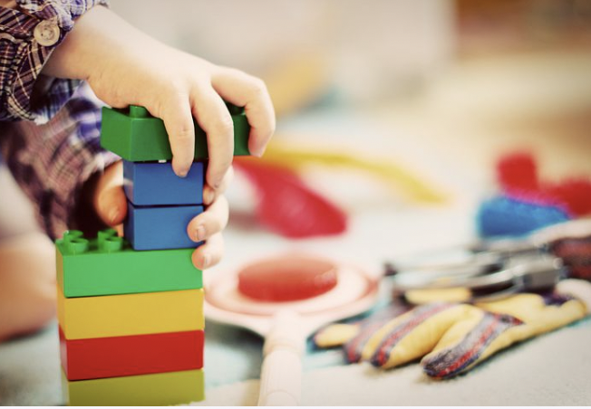
As stated in Article 31, every child has the right to “engage in play and recreational activities appropriate to the age of the child and to participate freely in cultural life and the arts” (Unicef, 1998). This is something that the Welsh Government championed through the launch of the Foundation Phase in September 2010. In agreement with Friedrich Froebel, Welsh Government stated that “educational provision for young people should be holistic with the child at the heart of any planned curriculum” (2015, p.4). The Foundation Phase Framework went on to state that there must be a balance of directed teaching and child-led activities.
Grünhagen (2016)

But it was Froebel who first introduced ‘frei arbeit’ (free work) back in the 19th Century – realising the importance and beauty of allowing the young person the chance to play freely. This has once again been highlighted by the Welsh Government with the launch of Curriculum for Wales with the 12 pedagogical principles including “pupils to take ownership of their learning” and “promote problem solving, creative and critical thinking” (Hwb, 2022).

In my experience, pupils both need and enjoy the opportunity to play up to and including secondary school age. Giving pupils the opportunity to play sport, games, develop their logic, critical thinking and problem solving skills are crucial. I believe this should be seen in both the classroom and outdoor learning environment, as well as through extra-curricular clubs.

Positive Reinforcements


Rewarding positive behaviour is something I have always championed in my setting but it can be tricky in a secondary school where sparkly stickers, certificates and colourful stamps are no longer deemed ‘cool’! Recently, we have started using Class Charts. If the young people are demonstrating positive behaviours, a text message can be sent home to praise the pupil for their attainment, attitude or response. If Skinner is correct, over time, pupils will understand that these are the desirable behaviours which are expected and rewarded.
Ab (2020)

On the contrary, clear sanctions must be embedded and understood to tackle the undesirable behaviour. The more children are ‘punished’ for their undesirable behaviour, the less frequently we hope to witness them. Our School Council play a huge role in our reward systems. The children understand this is a huge privilege and they play a crucial part in helping the school to make decisions and move forward.

Isn’t it remarkable that almost 100 years later, the works of these theorists are so evident in our education system – with the Welsh Government even advising practitioners “a child will repeat a behaviour if it is being rewarded”, “a child will be less likely to repeat a behaviour if sanctions are issued” and “if there is no consistency with rewards and sanctions then it is likely the child will continue to display the unwanted behaviour” (2015, p.7). Skinner in a nutshell!

Reference List
Ab, Kathryn (2020) Star Reward Bonus Trophy Success. Available at: https://pixabay.com/illustrations/star-reward-bonus-trophy-success-4803956/ (Accessed: 2nd January, 2023).

Down to Earth (2022) About Us. Available at: https://downtoearthproject.org.uk/about/ (Accessed: 29th December, 2022).

Grünhagen, E. (2016) Child Tower Building Blocks. Available at: https://pixabay.com/photos/child-tower-building-blocks-blocks-1864718/ (Accessed: 2nd January, 2023).

Hwb. (2022) Curriculum for Wales: designing your curriculum. Available at: https://hwb.gov.wales/curriculum-for-wales/designing-your-curriculum/ (Accessed: 30th December, 2022).

Koblin, J. (2021) Froebel’s Kindergarten: The Origins of Early Childhood Education. Available at: https://sproutsschools.com/froebels-kindergarten-the-origins-of-early-childhood-education/ (Accessed: 30th December, 2022).

Solstock (2018) Searching the River for Wildlife. Available at: https://www.istockphoto.com/photo/searching-the-river-for-wildlife-gm1055442684-282021261 (Accessed: 2nd January, 2023).

Unicef (1998) The United Nations Convention on the Rights of the Child. Available at: https://www.unicef.org.uk/wp-content/uploads/2010/05/UNCRC_PRESS200910web.pdf (Accessed: 30th December, 2022).

Welsh Government (2012) Practical approaches to behaviour management in the classroom. Available at: https://www.gov.wales/sites/default/files/publications/2018-12/practical-approaches-to-behaviour-management-in-the-classroom-a-handbook-for-classroom-teachers-in-primary-schools.pdf (Accessed: 29th December, 2022).

Welsh Government (2015) Foundation Phase Framework. Available at: https://hwb.gov.wales/storage/d5d8e39c-b534-40cb-a3f5-7e2e126d8077/foundation-phase-framework.pdf (Accessed: 30th December, 2022).

Williams, S. (2022) Increased role for outdoor learning and the natural environment in new school curriculum. Available at: https://naturalresources.wales/about-us/news/blog/increased-role-for-outdoor-learning-and-natural-environment-in-new-school-curriculum/?lang=en (Accessed: 2nd January, 2023).

