THE IMPORTANCE OF ACADEMIC SKILLS AND
HOW TO APPLY THEM
IN A
PERSONAL DEVELOPMENT PLAN

Prepared for

Dr. Tanja Nathan
University of Wales Trinity St David
Academic and Employability Skills

Prepared by

Michele Chiarello

January 2019
Table of contents

SECTION I:

Abstract…...……………………………………………..….. 4

About the author…………………………………………….. 4

Introduction…...…….………………………………....……. 4

Giving a presentation………………….…………………….. 5

- Opening…………………………………………….. 5

- Speaking……………………………………………. 6

- Behaviour…………………………………………… 7

- Conclusion and questions….……………………….. 8

SECTION II:

Skills evaluation…...……………….……….………………. 9

SECTION III:

Action Plans…...……………………………………………. 14

SECTION IV:

Application……………………….…………………………. 17

SECTION V:

Conclusions and evaluation…………………………………. 19

SECTION VI:

Appendix…...….……………………….…………………… 20

LIST OF FIGURES AND TABLES

Figure 1. Author presentation…………………………………….... 5

Figure 2. My Starter Pack………………………………………….. 6

Figure 3. Pros and cons…………………………………………….. 7

Figure 4. My Plan…………………………………………………... 8

Table 1. Action Plan………………………………………………... 16

Additional figures in the appendix………………………………….. 20

SECTION I

Abstract

This report describes the importance of the academic and professionals skills acquired during the course of Academic and Employability Skills, held during the first term of the academic year 2018/2019 at the University of Wales Trinity Saint David.
It discusses how to use them in the real life, during the development of a personal development plan and includes the author’s personal reflections and actions taken to achieve his aims.

About the author

Michele Chiarello is a student at the University of Wales Trinity Saint David. He is currently attending the first year of BSc(Hons) Cloud Computing. In this paper he is demonstrating the importance, from his point of view, of the Personal Development Plan and the possible practical application of it during a job search in the field in which he is studying.

Introduction

The following 4 images are the summary of the presentation made during the course. They aim to show the most important knowledges to be acquired during the study and the preparation of the personal development plan and they are focused on the main points needed to deliver a successful Power Point presentation.

Giving a presentation

One of the main professional skills learned during the course, it’s been the ability to show to a possible employer or team we are working with, the way we use the available technologies to communicate, explain and find solutions to possible thematics we could encounter during the course of an interview, meeting etc.
To do this, we learned how to develop presentations and how to make them interesting and successful.
This one, in particular, aims to talk about the preparation of my personal development plan.

- Opening

One of the first things we should keep in consideration during a presentation
is the opening. During this phase we should catch the interest of the audience, focusing directly on the point the presentation aims, making even use of pictures, to don’t let the audience distract itself.

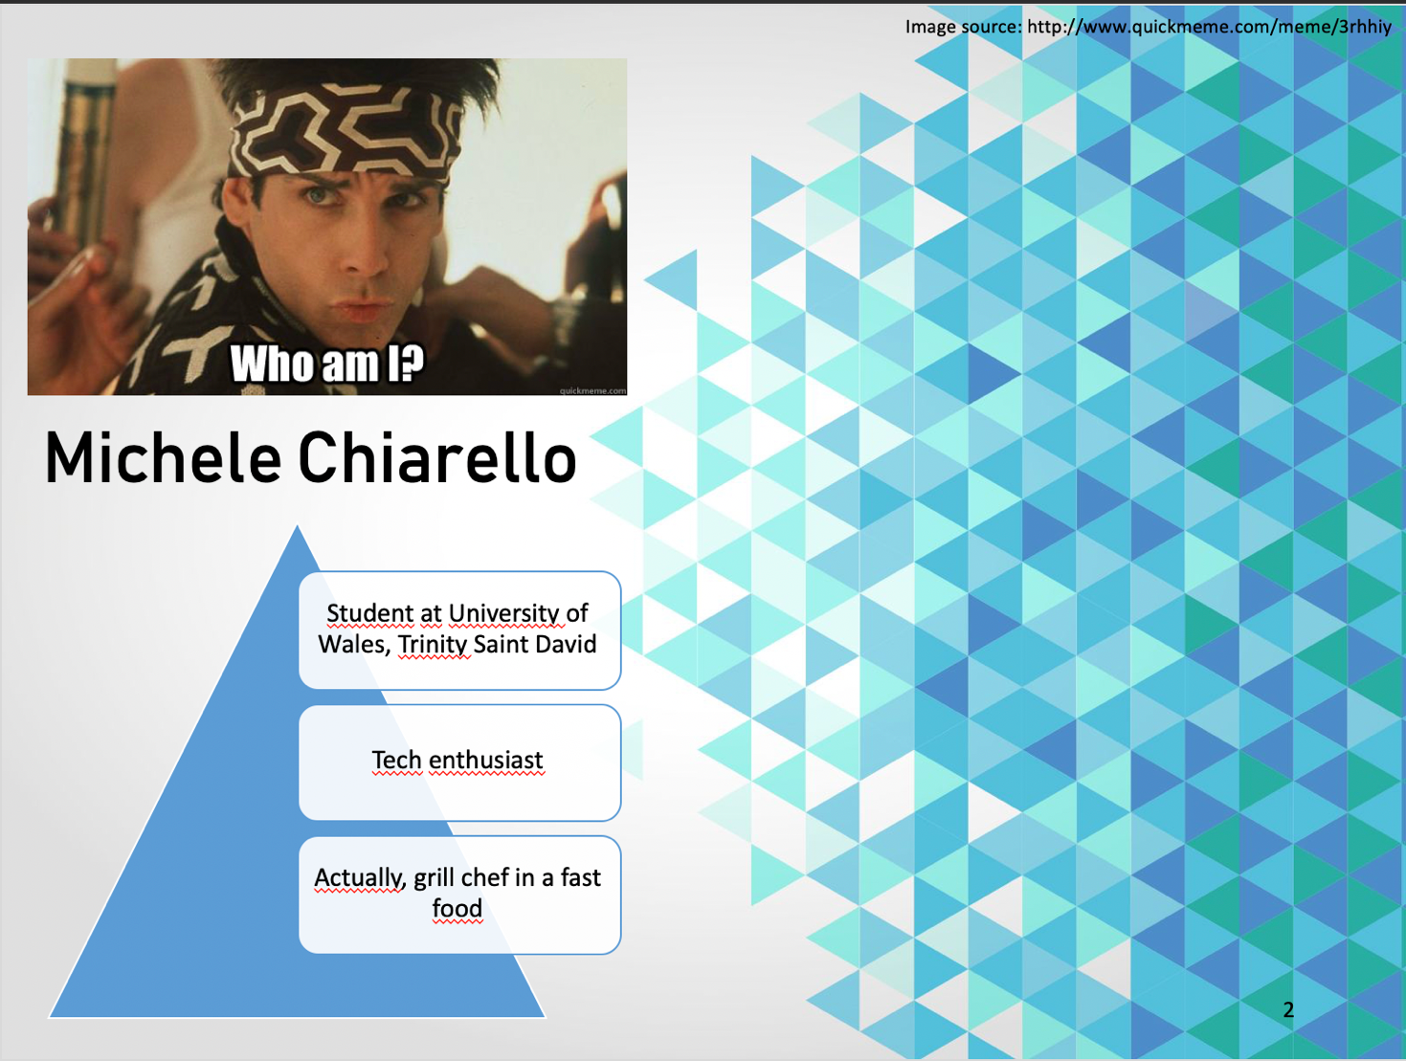
Giving a presentation

- Speaking

Another thing we learned it’s been the way we talk to the people.
In my opinion this is the most important point everyone needs to focus on, to be sure that what we are talking about is correctly understood.
The speaking skill it’s the one that lead us to achieve our aim. Without that we could even give a good presentation, but without deliver the content we want.

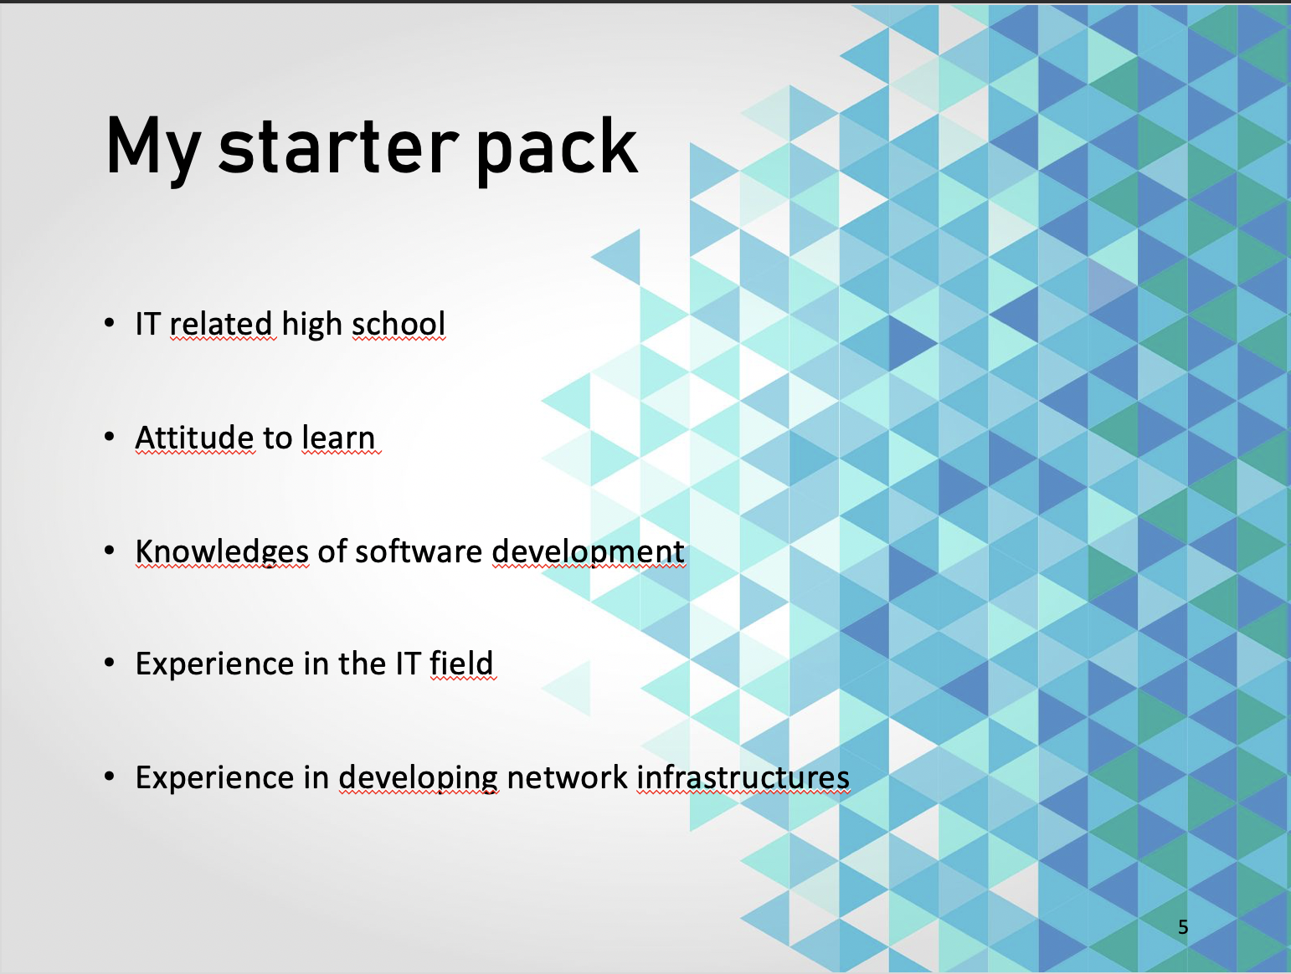

Giving a presentation

- Behaviour

To the ability to speak we have to add the behavior we should have with the audience.

This means that we should interact with the people we have in front of us, showing our enthusiasm while we speak, asking questions, using humor or finding alternative ways to involve them.

In the slide below we can see how we could involve the public simply asking for their opinion on what we have asked to ourselves during the planning of our PDP.

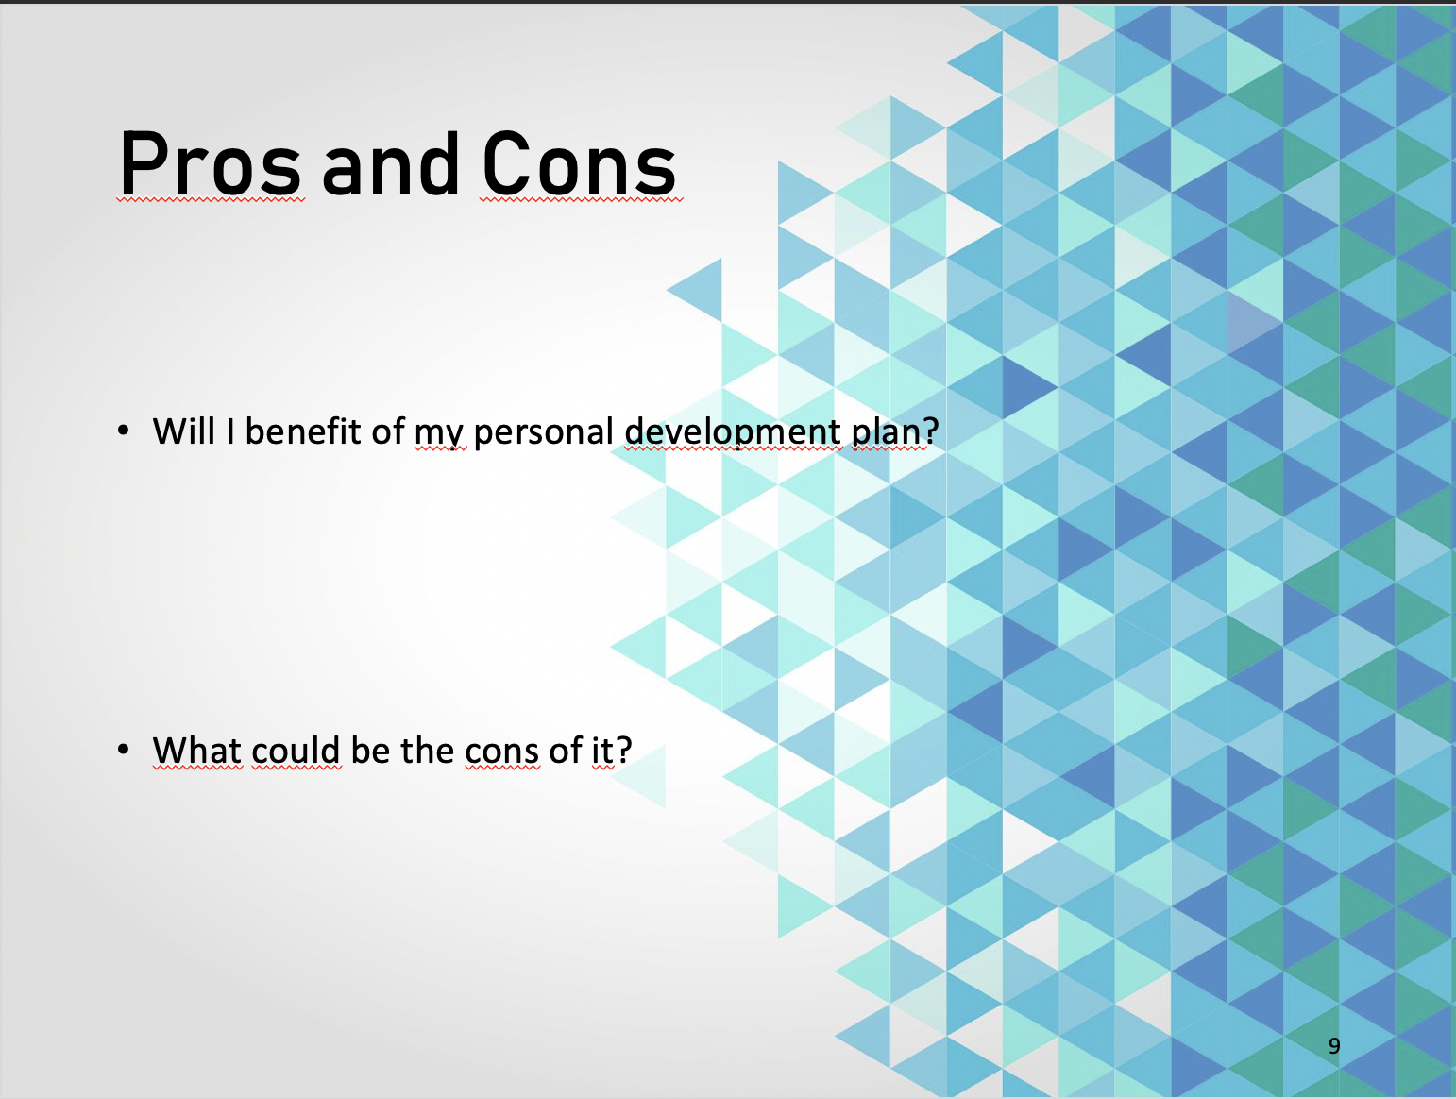

Giving a presentation

- Conclusion and questions

Finally, the last, but not less important, thing that we learned it’s been the way we end a presentation.
In the last slides we should summarize the content of the presentation we gave focusing on the key points we have explained during it and asking questions to the audience to check if there were misunderstandings and starting possible discussion on the treated subject.

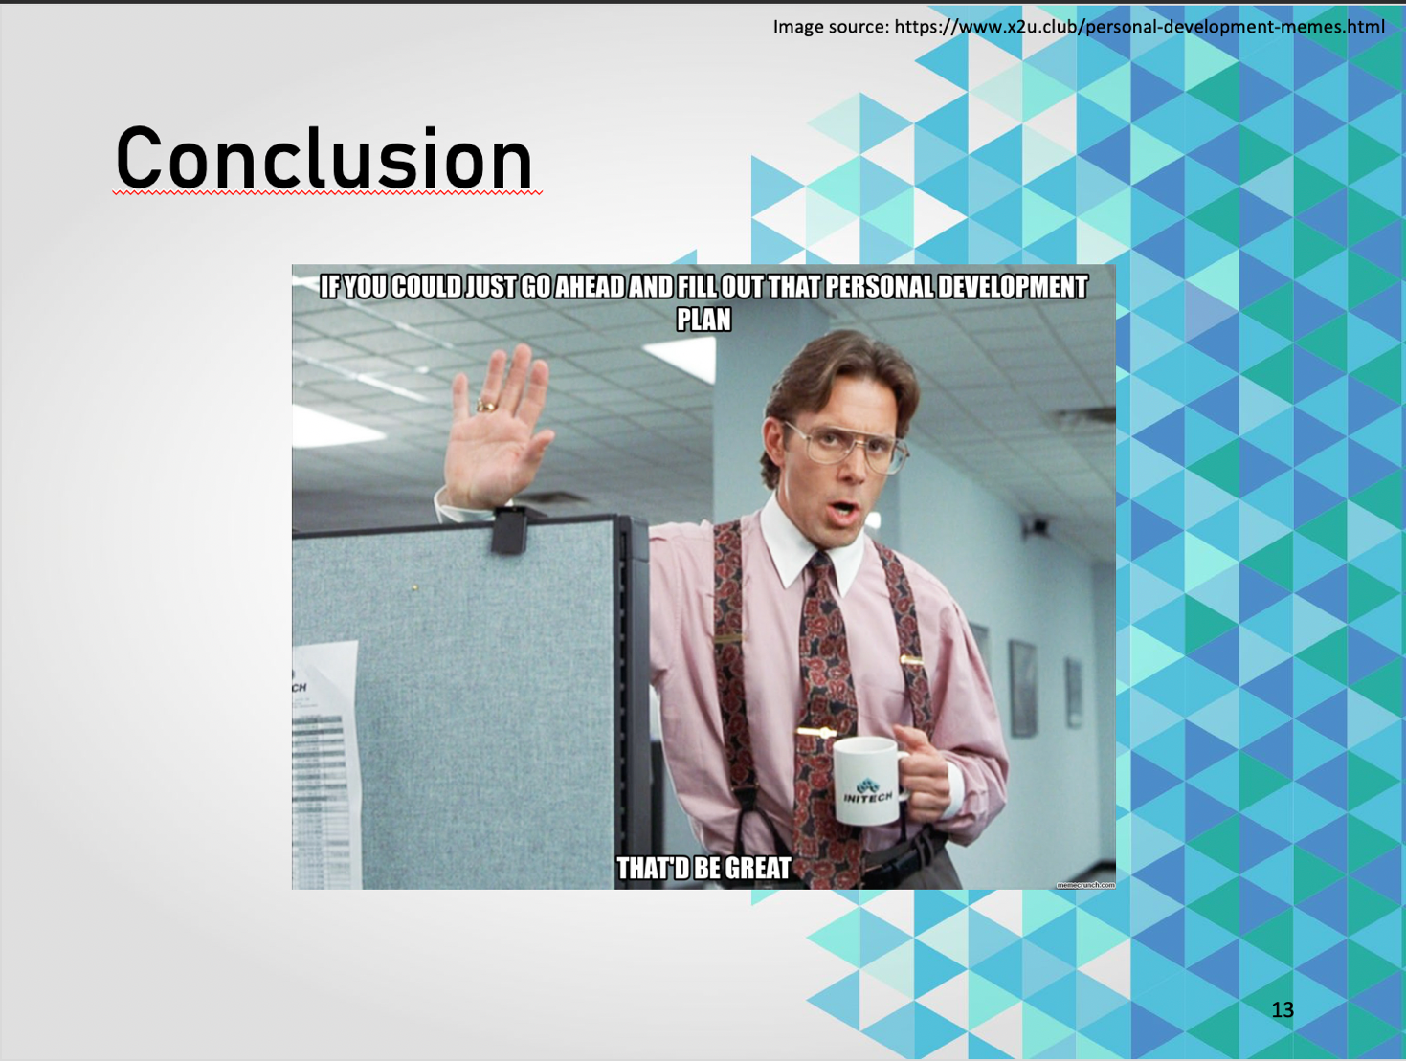

SECTION II

Skills Evaluation

This section introduce and explain the first step taken during the development of my PDP, the evaluation of the necessary skills needed to be successful in the High Education learning and Employability.

One of the first steps I did, trying to improve myself in the HE learning environment, it’s been to try to figure out which set of skills I already have, I need and I should acquire in the next future, to be able to complete my studies in the best possible way.

The same approach can be used to achieve the same results in the Employability field. All the steps to follow are the same, we have just to focus on new aims.

The following list covers the skills I identified during my research aimed to acquire and develop my abilities during the course of my studies and the list of the skills I will acquire after the graduation.

- Communications skills

- Critical thinking skills

- Inquiry skills

- Time management skills

- Analytical skills

Communications skills

This is the most essential skill that a student or an employee should have.

Communicating with the people around us, be they collegues, employers or lecturers it’s really important, because is the only way we have to understand what’s going on around us.

Jelf [1] states that “Communication, or the lack thereof, has been the reason for many tragedies and disasters that have taken place within the financial industry, health care, and the wider environment in recent years”

Critical thinking skills

Critical thinking is the ability to analyze and evaluate the information we receive, to reach a conclusion in a rational way.

Accordingly to Howard Gabennesch [2] that states “By critical thinking skills, I mean the various higher-order cognitive operations involved in processing information, rather than simply absorbing it: analyzing, synthesizing, interpreting, explaining, evaluating, generalizing, abstracting, illustrating, applying, comparing, recognizing logical fallacies.”, I think that this is one of the skills every student must develop, because is thanks to this that we are able to determine the importance and relevance of the ideas we come through in the everyday study and is thanks to this that we are able to appraise arguments.

Inquiry skills

Coming through the list we find the Inquiry skill.
This is the capability to learn asking questions and trying to reflect on what we are studyng and is directly connected to the Critical thinking skill, because it helps to develop it.
Asking questions and trying to find the answers is, in my opinion, one of the best way we have to develop ourselves.

Time management skills

During the course of the first term, I learned how to manage the available time I have during the everyday life.
Time management is the key to organize and plan the time we have, between the activities we have to accomplish during the day.
This is one of the skills I had to improve, and I have to continuing to work on.

An article redacted by the Mind Tools Content Team [3] argues that “Good time management requires an important shift in focus from activities to results: being busy isn’t the same as being effective.”

In fact, to be effective we have to find the correct path to follow according to the necessity we have.

Under my point of view, the best outlook to be productive is to find the way to split the day in a series of moments, in which we have the possibility to dedicate ourselves to different activities.
We don’t have to dedicate ourselves to only one or two activities per day, instead we can plan to give to every activity a variable length time between 1 or 2 hours.

This is the way I’m currently using and, even if in the beginning it’s not been simple, I can say it’s becoming my routine, starting to give me the first results.

Analytical skills

Finally, the last skill I identified as something I really need, is the Analytical Skill, or rather, the ability to gather and analyze the information we need and make decisions, using methodical approaches.

This skill is a collection of the others mentioned before but is really important and required even in the job field, while trying to solve problems or find solutions.

Self-evaluation

In order to discover my strengths, weaknesses and personality type, I conducted a self-evaluation exercise from MindTools on:

https://www.mindtools.com/pages/article/get-started.htm

In the Test, we can find 15 statements aimed to check Leadership and Management, Problem Solving and Decision Making, Communication Skills, Time Management and Personal Mastery skills, discover our strengths, weaknesses and personality type, to have some ideas of what areas we have to build up and improve to achieve to be a great leader, team member or contributor.
In the statements, we have to choose the best describes from:

- not at all

- rarely

- sometimes

- often

- very often

Then, it will calculate and generate the total score based on the options we choose.

Results

By conducting the test online, I’ve had a total score of 53/100.

Leadership and Management: 10/15

Problem solving and Decision Making: 9/15

Communication Skills: 10/15

Time Management: 16/20

Personal Mastery: 8/10

Leadership and Management is a skill apt to develop the way we lead and manage to motivate and build a great team. It can be compared to the Critical thinking skill mentioned before as a good leader is able to have a critical thinking skill to analyse the information to reach a conclusion in a rational way when he/she leads a team.
This is the point where I got 10/15 and I think I should improve my critical skills to effectively lead and manage a team.

Problem solving and Decision Making is a skill apt to identify and understand the root cause of the problem and hence to apply great tools and techniques to solve it. It can be compared to the Analytical Skill mentioned before as it is an ability to gather and analyse the information we need and make decisions by using methodical approaches.
I got 9/15 on this part of the test which is the lowest score I have among those five areas. I think I have to figure out the cause of the problem precisely and make a suitable decision by using effective methodical technology to become a better problem solver and decision maker.

Communication Skills, it’s a key skill to success whatever the role we are. Communication includes active listening, conflict resolution and negotiation.
In this part I got 10/15, so I can assume I have to focus on the people I am communicating with to make sure I completely understand what they are expressing and to give the reply properly and hence to be a good communicator.

Time Management covers the priority and schedule among the tasks and activities we have to complete.
The 16/20 I got in this part is the highest mark among the five areas. I should strengthen this area more to manage my time better by prioritizing and scheduling my time effectively.

Personal Mastery is a skill apt to recognise the personal strengths and weaknesses to make sure the understanding of the values we have. Also, we have to prepare ourselves to address negative thinking by building ourselves confidence and self-esteem. It can be compared to the Inquiry skill as it is a self-reflection by raising questions to have more understanding about ourselves and hence to develop it.
In this section I scored 8/10. I have to keep building up my strengths and improving my weaknesses by setting personal goals. I think that the thing I miss on this aspect is preparing to deal with negative situations. What I have to do is building my self-confidence and self-esteem.

SECTION III

Action Plans

Once identified and evaluated the needed skills, the next step I’ve done it’s been to create a Plan to let me develop them during the length of my studies.
To do this, I had to give to myself both short and long terms goals.

This part of the PDP leads to the achievement of the aims, so it must be studied accurately. During the creation of it, it’s necessary to:

- Define our needs and what we need to do

- Define how it should be done

- Define when it should be done

- Try to be peculiar about the goals

- Define some checkpoints to see if everything planned is going for the right way

To accomplish my needs, I started to choose these short-term goals:
- Learn computer programming

- Learn a programming language

- Improve my knowledges in the algorithms

And these long-term goals:

- Have in dept knowledges in computer networking and programming

- Have in dept knowledges in computer programming and apps development

In order to achieve short term and long term goals I defined before, I have to improve my personal and professional skills before.

The table below shows the Action Plan I’ve created to assist me to improve this skills.

Action Plan to improve my skills
Date | 20/11/2018
Goal of the plan | Improve my personal/academic skills for university and work
 | Action steps
Communication skill | - Start to read books and articles in English and, possibly, academic articles to improve even the academic English.  - Ask for feedbacks when communicating with other people.
Critical thinking | - Meditation  - Try to find other ways to solve problems already treaded
Inquiry skills | - Start to become more interactive during the lessons
Time management | - Create a Todo list  - Breakdown big tasks into small  - Find the most productive time during the day
Analytical skill | - Challenge myself with something difficult to do

SECTION IV

Application

One of the latest things discussed in class, it’s been related to the data protection strategy we should use to protect our data against possible threats.
This is an interesting topic, because we are subjects to threats every day.

To have a good and robust level of data protection, we should save our data in more than one place.
To give an example, the actual strategy I’m using is to save all the material related to the University (Assignments, Slides, Exercises, etc.) on portable drives, Personal computer and Cloud.
This not only to avoid accidental alterations of the files, but to grant me that all my data is backed up.
In my opinion this should be common sense, but I know that not everyone thinks in the same way.

As written in the studying material gave us in class the possible threats could be:

- Accidents

- Hacking

- Theft

- Malware

With the strategy adopted by me, it’s simple to recover all the possible data lost during one of these possible disasters. All we need to do, it’s simply to copy the data back from the storage media or cloud website, to the new/clean system.

This is one of the best ways to stay protected even against ransomwares, whose main purpose is to encrypt the data on the infected hosts and ask for a ransom in change of the decryption key.

Time management and organization:

To enhance my productivity and reduce the stress levels at work as during the university life, the most important points I focused on are:

- Prioritizing and scheduling the various tasks I have to accomplish.

- Creating a To-Do list and setting up deadlines for every task.

- Taking regulars breaks between every task.

SECTION V

Summary

Academics & Employability skills module provides me important knowledge and useful techniques that improved my learning process during my time at the University. It is a good approach for me to take responsibility for my own further learning. Though the skills I had identified above including Communication skills, Critical thinking skills, Inquiry skills, Time management and Analytical skills, gave me a great understanding of all topics I study. After conducting different skill tests, I have a better idea about my strengths and weakness. Therefore, I am able to keep building up my strengths and improving my weakness to achieve all the aims I projected in the future.
Besides, all the techniques used are useful and essential because they can be applied not only in the University field, but also in the employment context.

SECTION VI

Appendix

References:

[1] Jelphs, K. (2006). Communication: Soft skill, hard impact? Clinician in Management, 14, 33-37.

[2] Howard Gabennesch (2006) Critical Thinking: What Is It Good for? (In Fact, What Is It?) https://www.csicop.org/SI/show/critical_thinking_what_is_it_good_for_in_fact_what_is_it
[3] Mind Tools Content Team What Is Time Management? Working Smarter to Enhance Productivity
https://www.mindtools.com/pages/article/newHTE_00.htm

Additional figures

Personal development plan
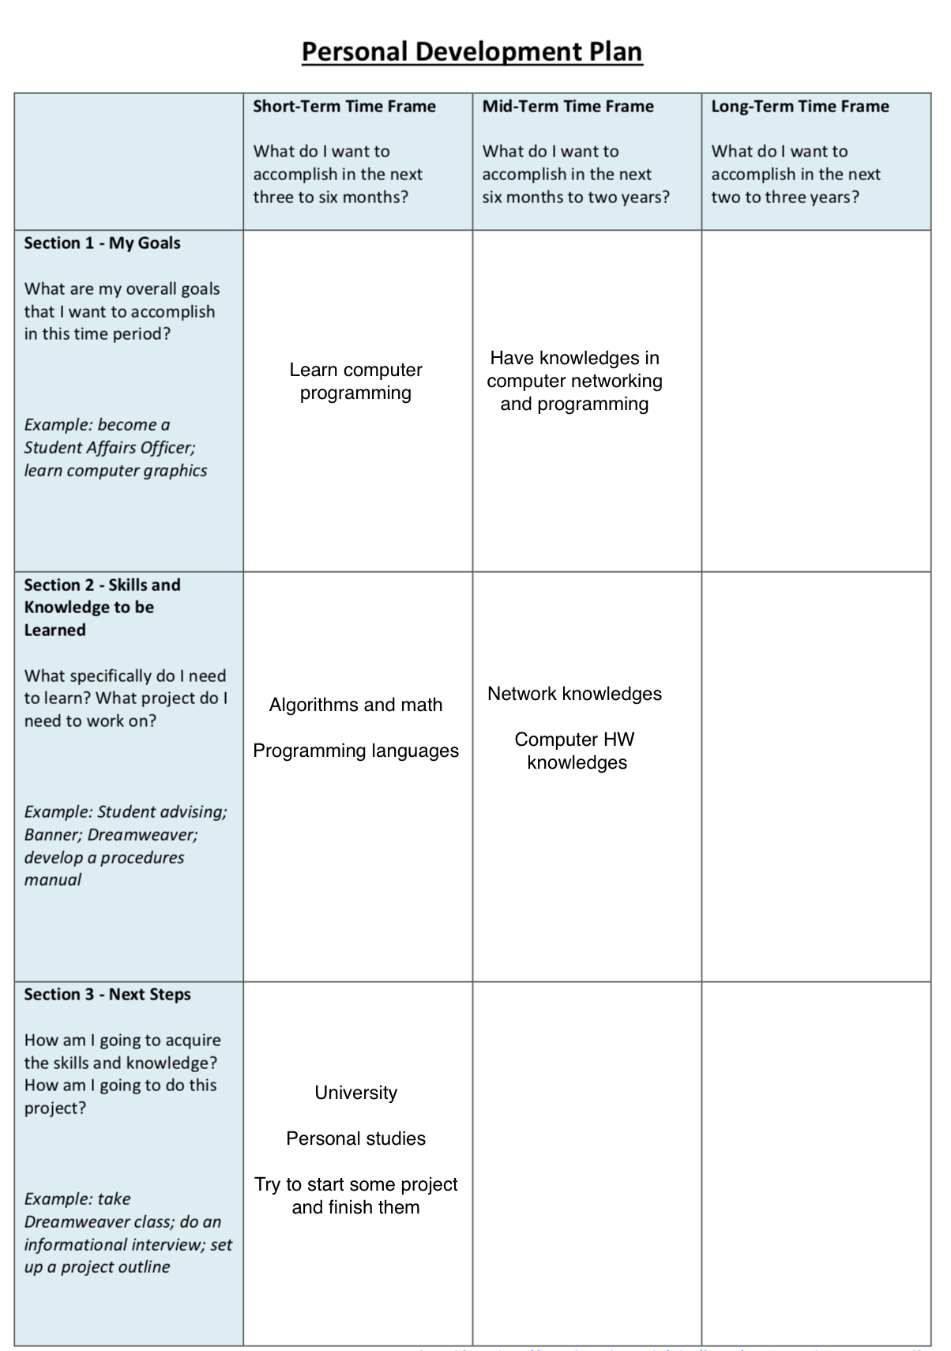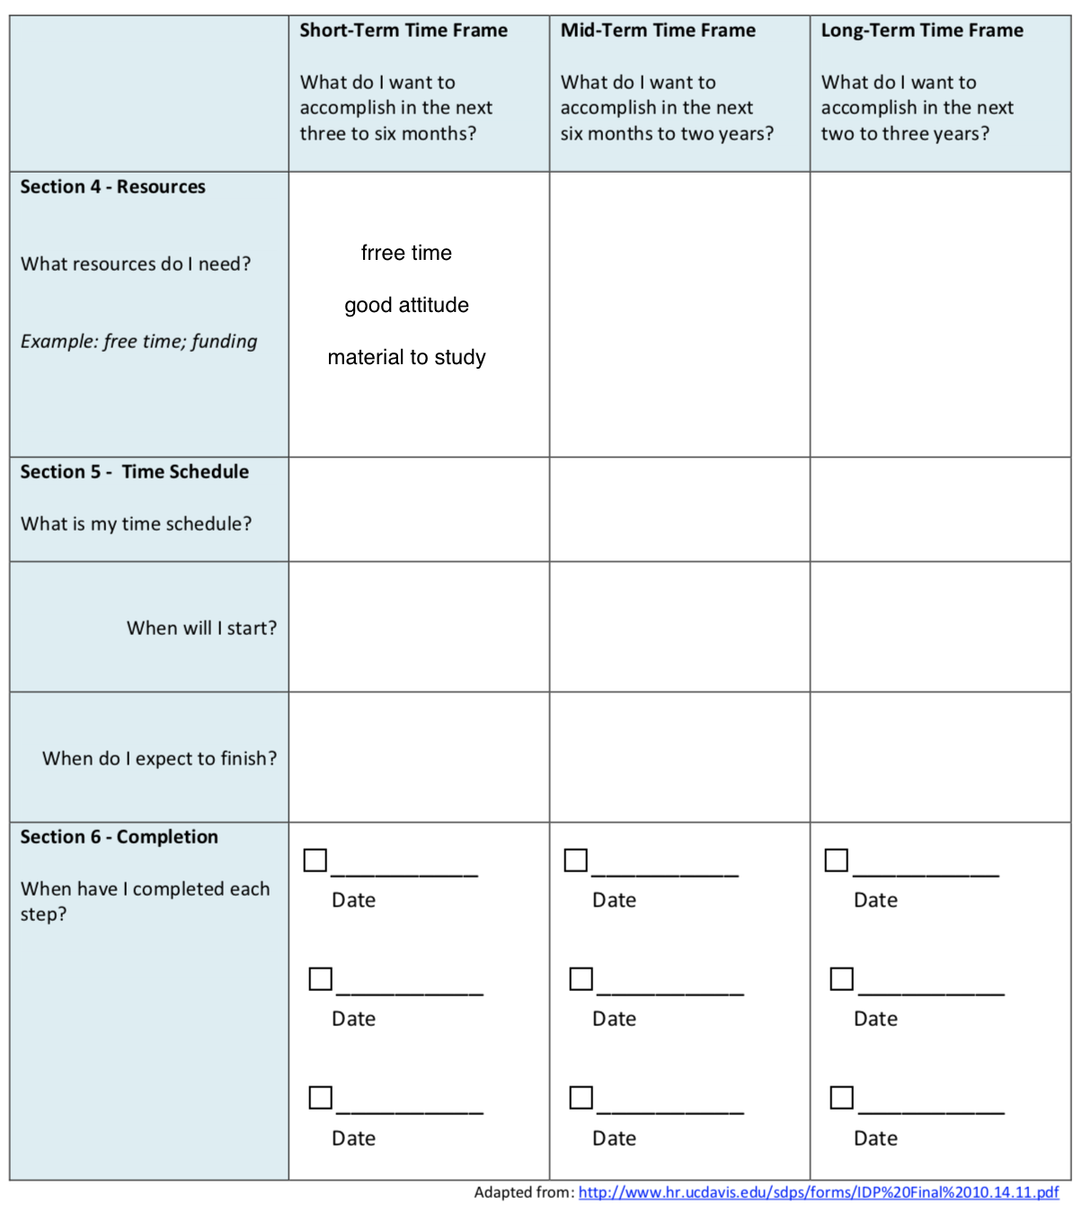

Skills test
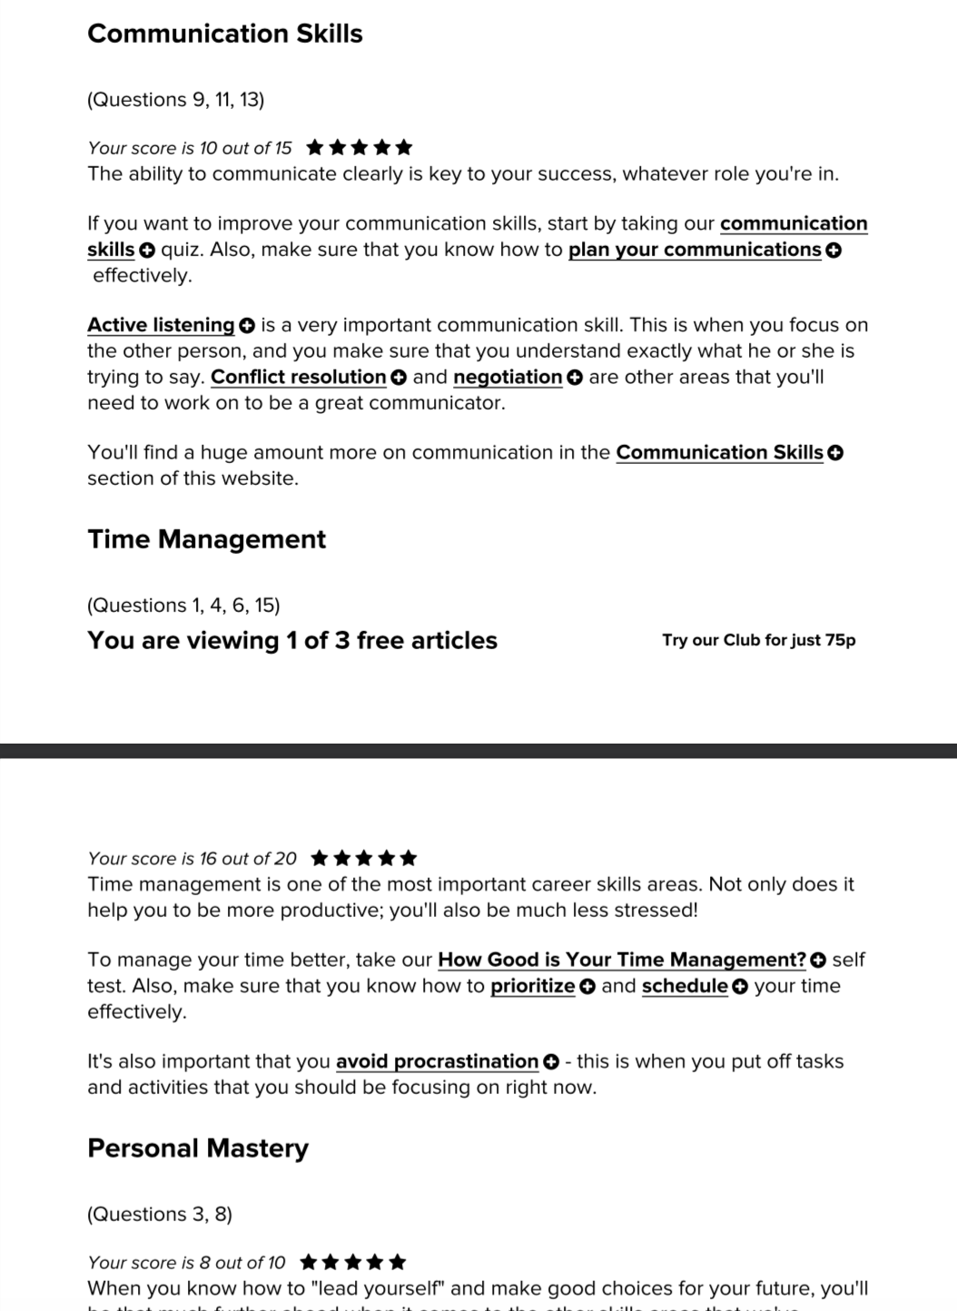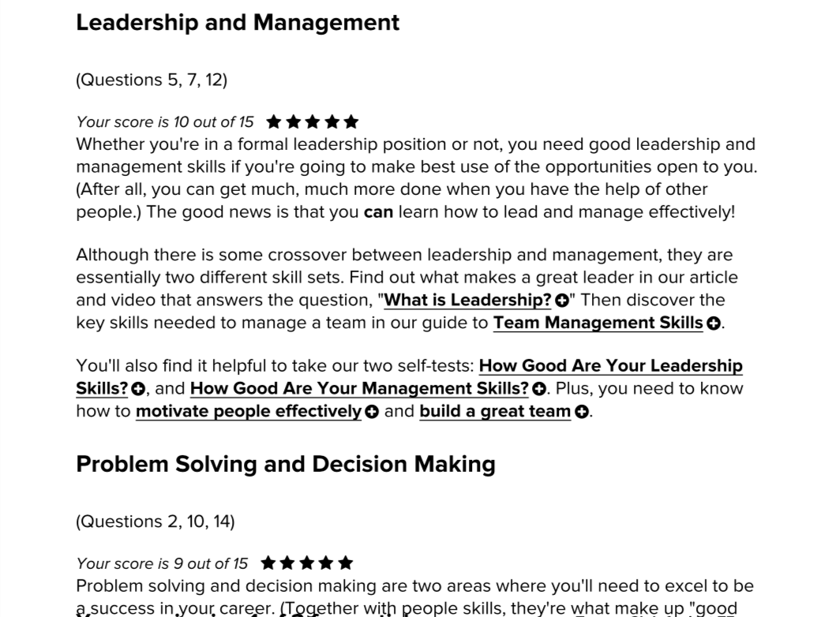

Online self assessment



