Gethin Purton (2406302)

Apprenticeship in Computing (Data and Information Systems
Databases and Application Development
Database Design and Implementation

Table of Contents
Introduction 2
Database Design 3
Implementation Documentation 4
Creation 4
Inserting 6
Triggers and Stored Procedures 9
Add Student stored procedure 9
End Club membership 11
Deactivating a club 13
Trigger to go with procedure 14
Stored Procedure and Transactional Scenario 16
Performance Tuning Enhancement 17
Conclusion and Reflection 18
References 19

Introduction
Key members from Student Clubs have approached me to design and implement a relational database system that meets their requirements to be able to see all club activities, current and former members and a way to track and trace audits. The solution I have proposed to them will support data integrity, minimise redundancy, and provide efficient storage, retrieval, and management of club-related information. My implementation will demonstrate the system’s functionality using suitable test data and be accompanied by clear documentation as a prototype.

Database Design
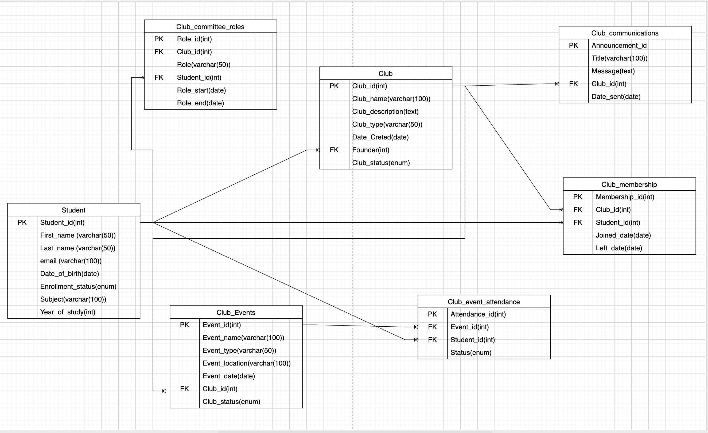
The above ERD (Entity Relationship Diagram) was created using draw.io to visually model the structure of the Campus Club Management System and to identify entities, attributes and relationships. The ERD was designed following Third Normal Form (3NF) to minimise redundancy and improve consistency across related tables. According to an article written by Solmaz Kolahi and Leonid Libkin, “3NF has the least amount of redundancy among all dependency-preserving normal forms.“ [1]
PK is short for Primary Key. Primary Keys are used to identify unique values to identify a record in a table, for example a student number. “Primary keys play an important role in relational databases by reinforcing data integrity and enabling successful data retrieval.” [2]
FK is short for Foreign Key. Foreign Keys are like Primary Keys, however “A Foreign Key is a field (or collection of fields) in one table, that refers to the Primary Key in another table.” [3]

Implementation Documentation

Creation

Student table
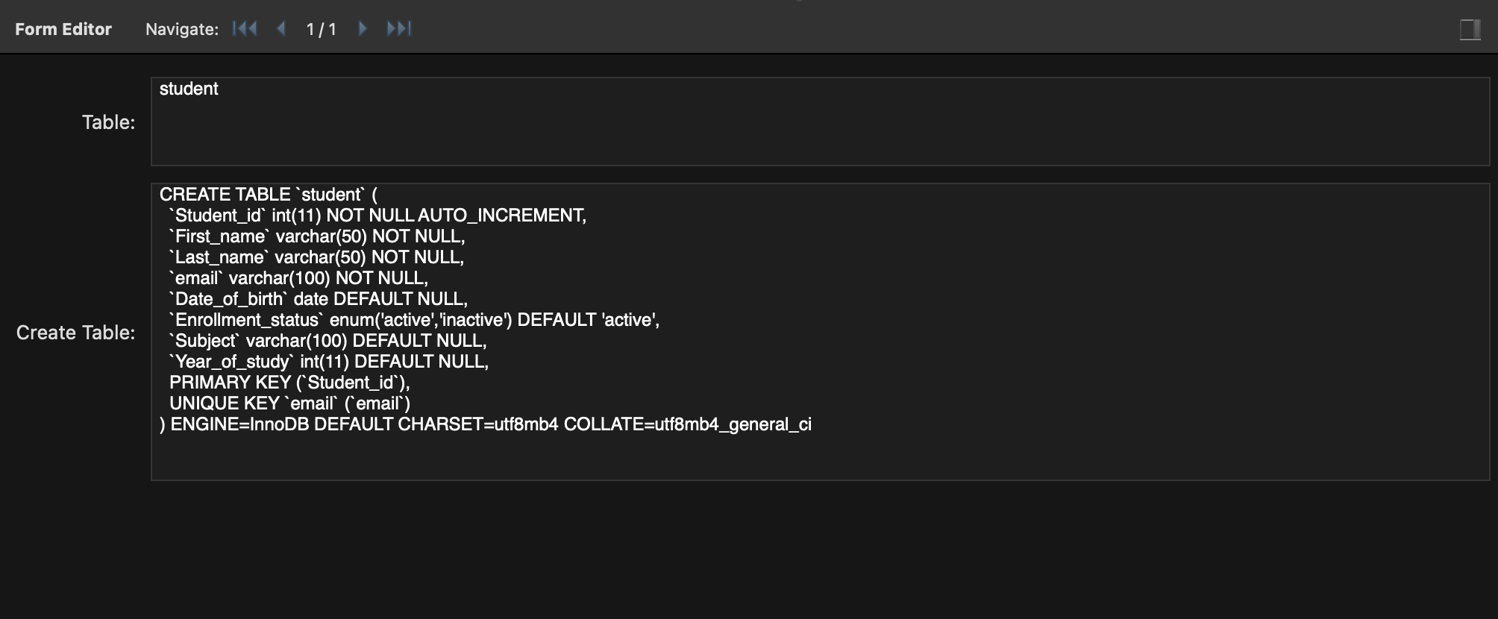

Club table
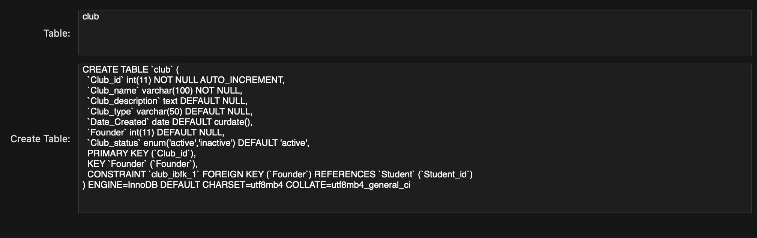

Club Events table
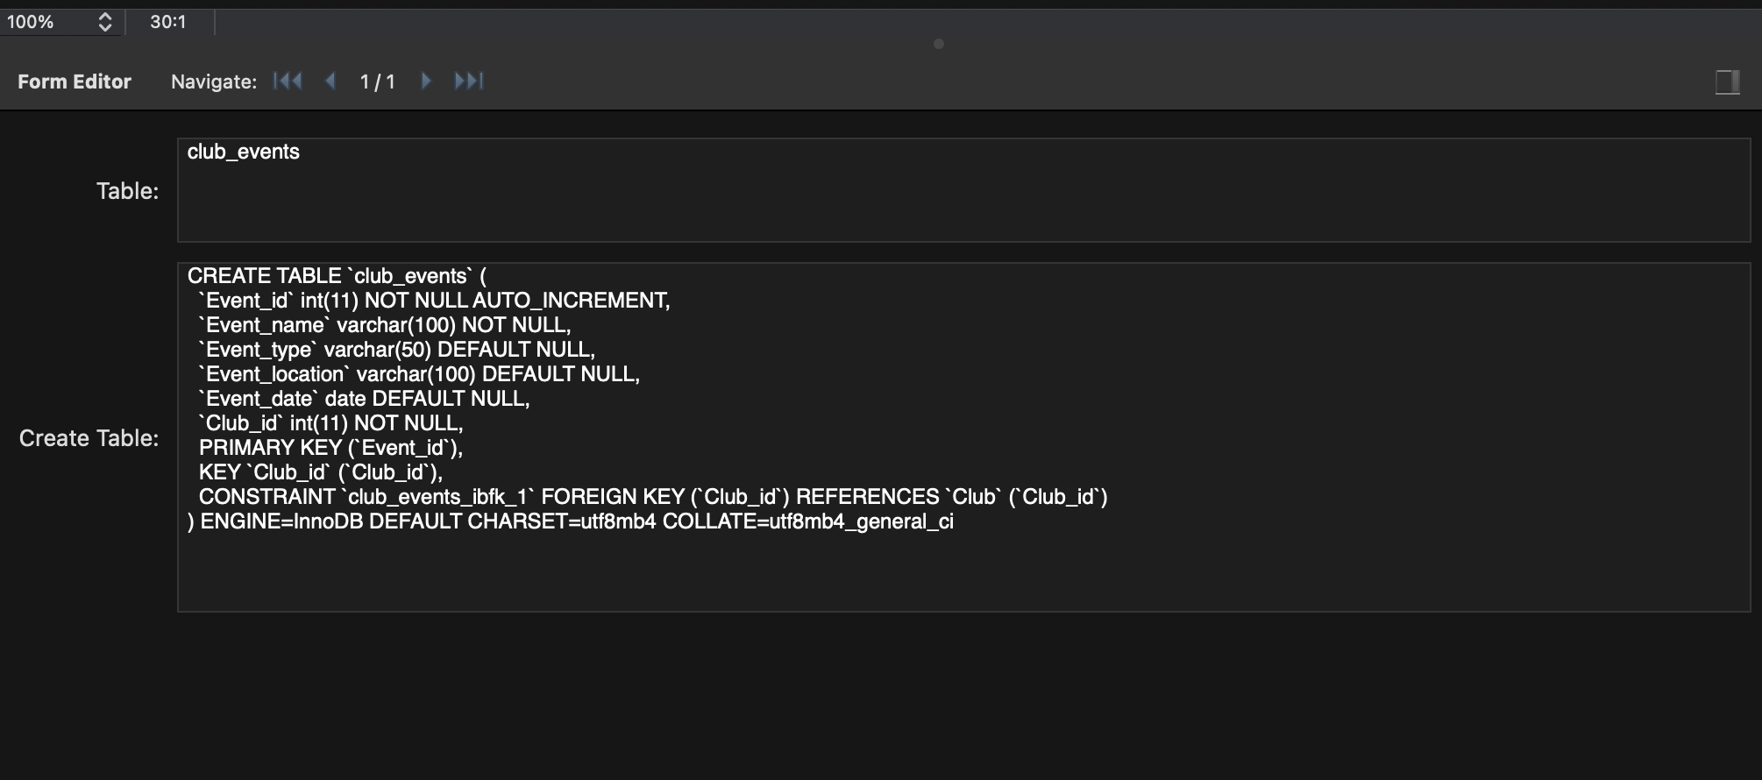

Club Membership table
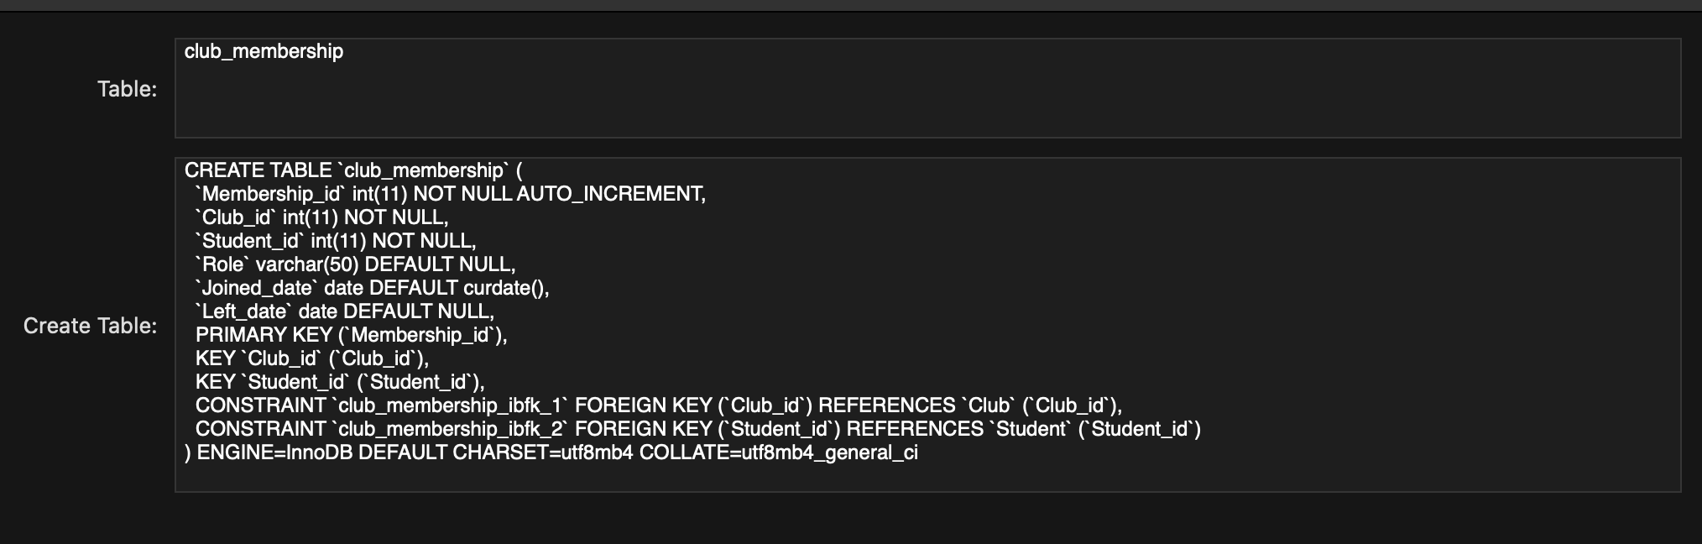

Club Event Attendance Table
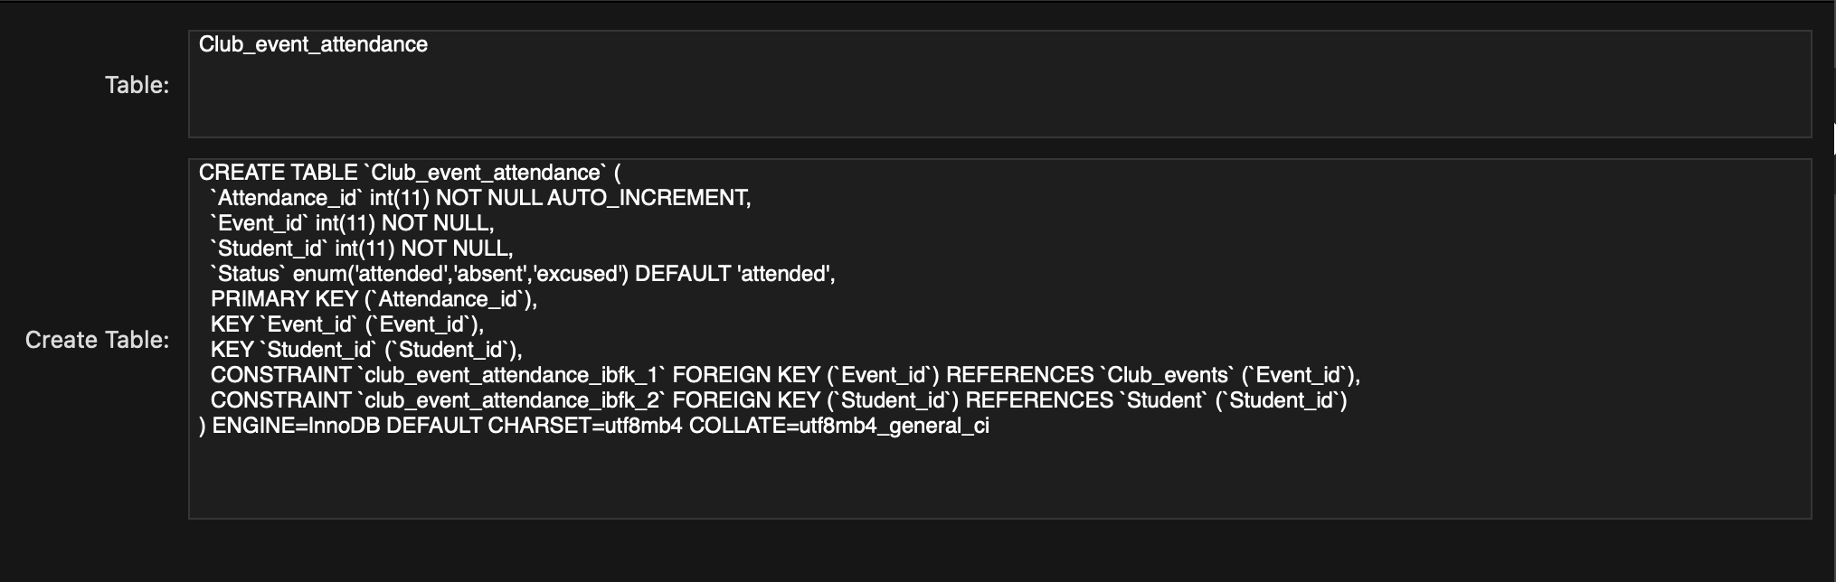

Club Communications table
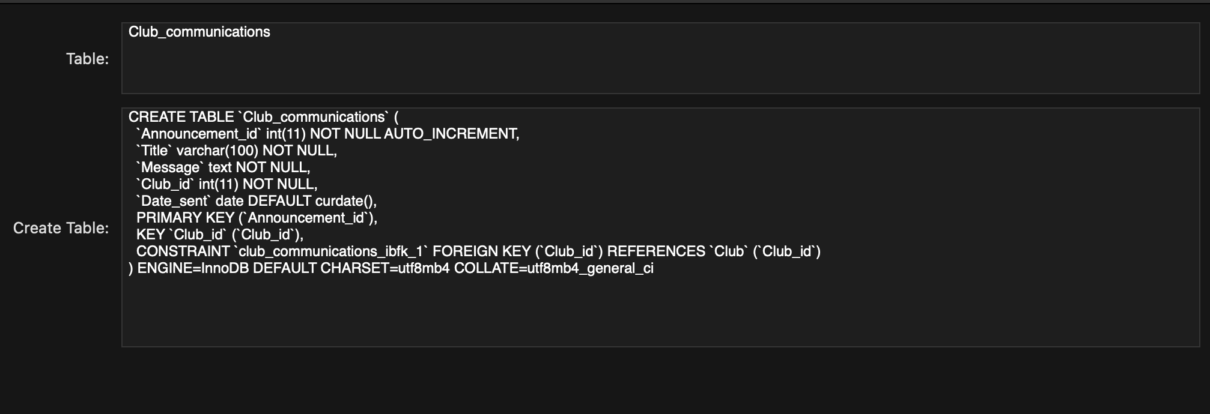

Club Committees Roles table
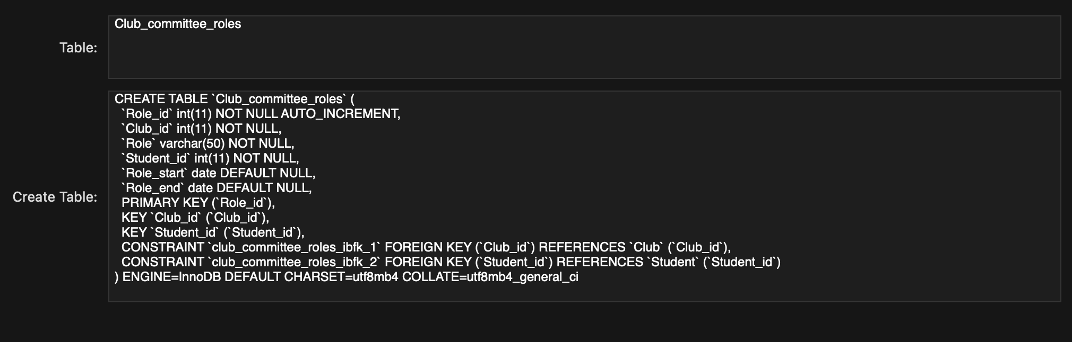

Inserting

Club

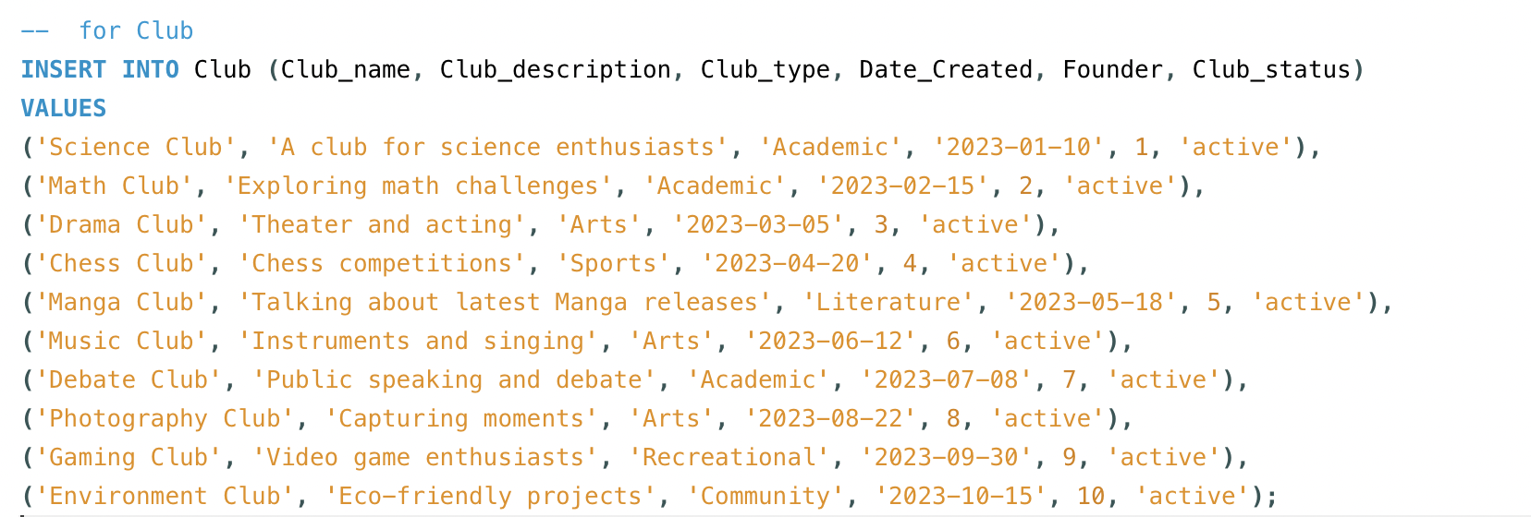

Student

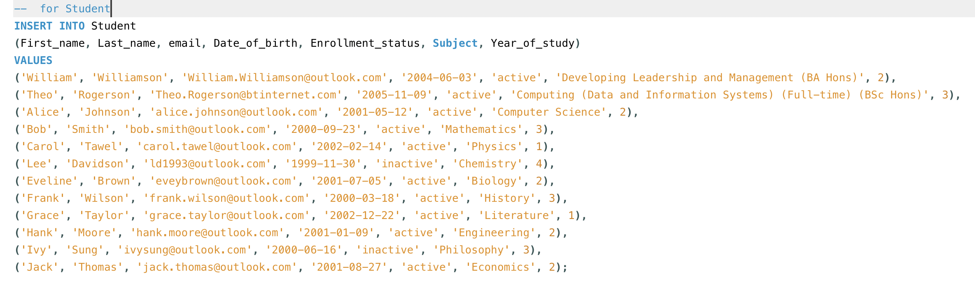

Club Committee Roles

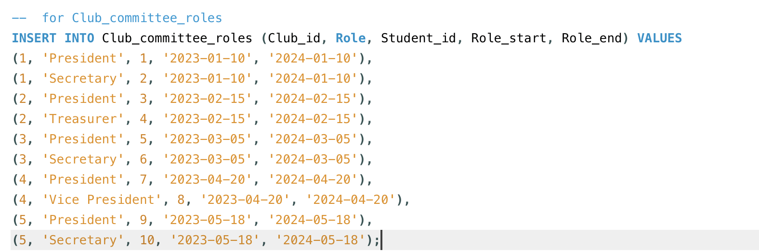

Club Communications

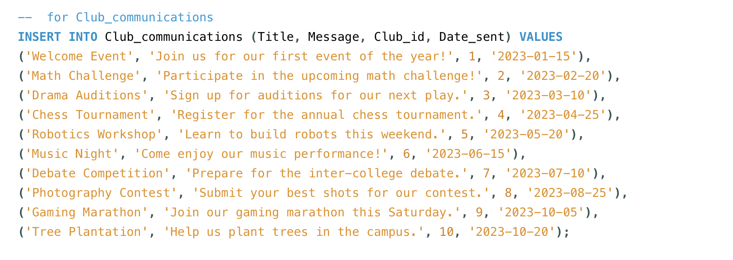
Club Events
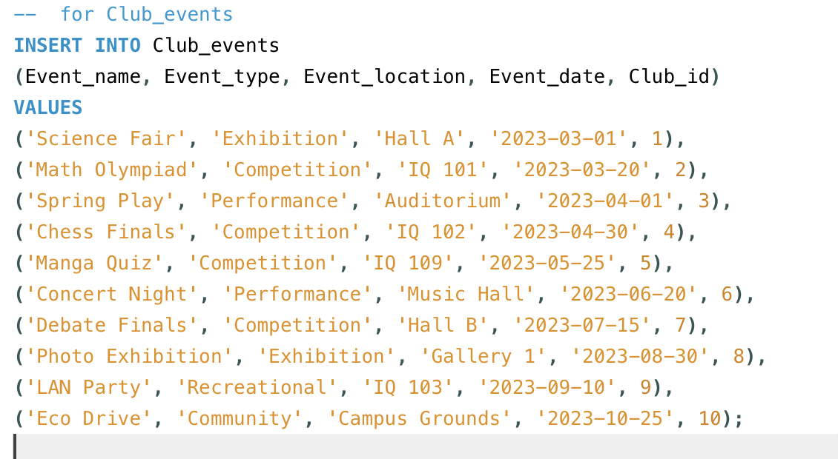

Club Event Attendance

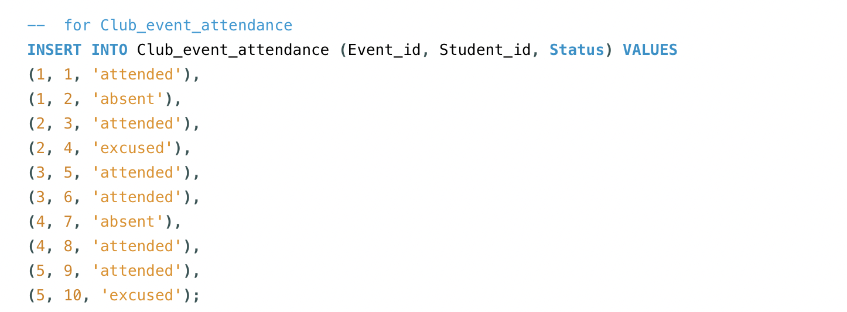

Club Membership

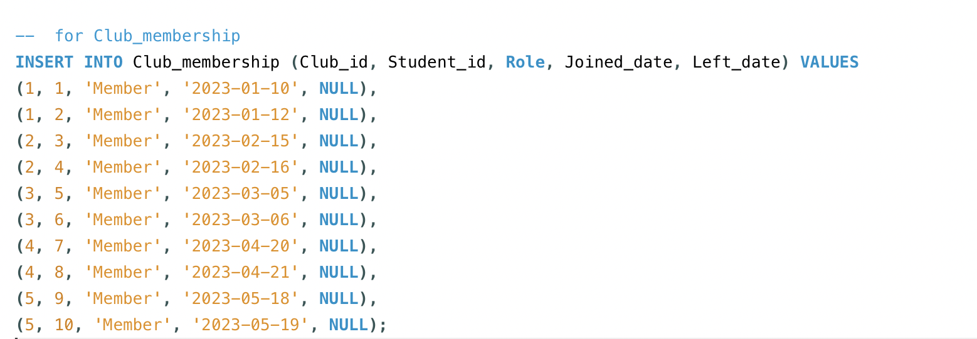

Triggers and Stored Procedures

Add Student stored procedure
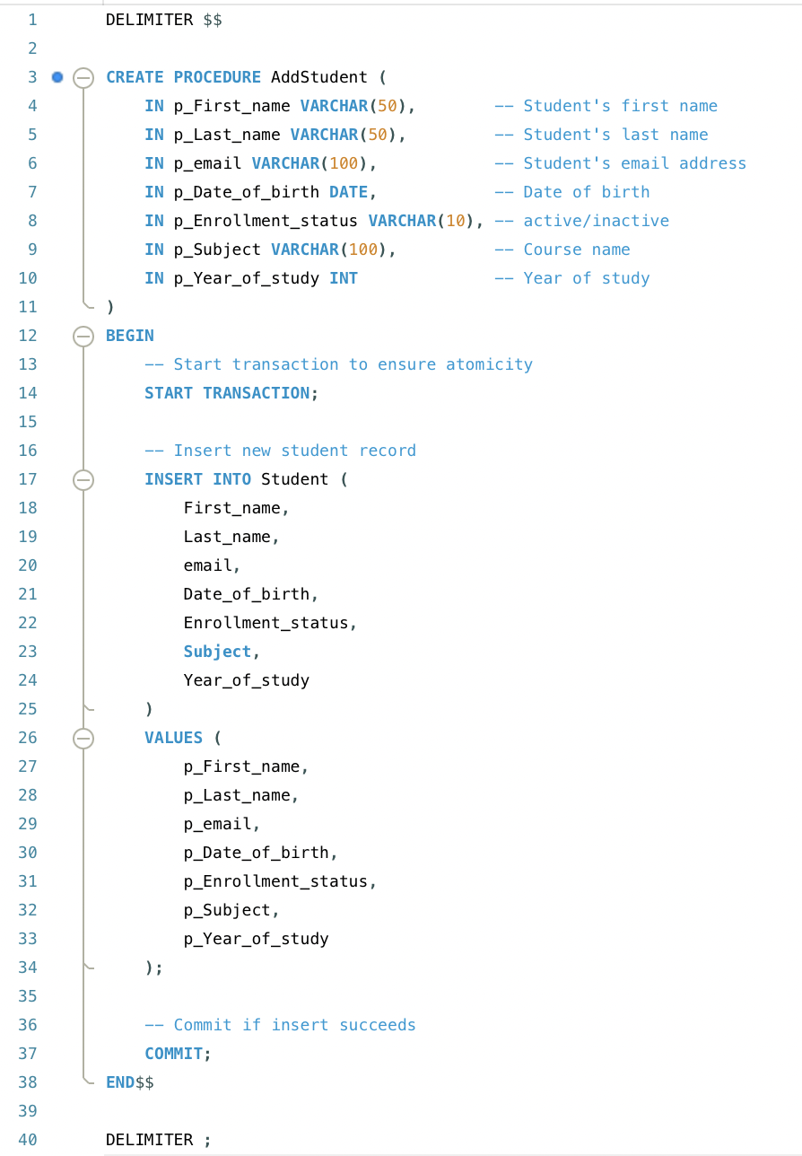

Testing AddStudent procedure
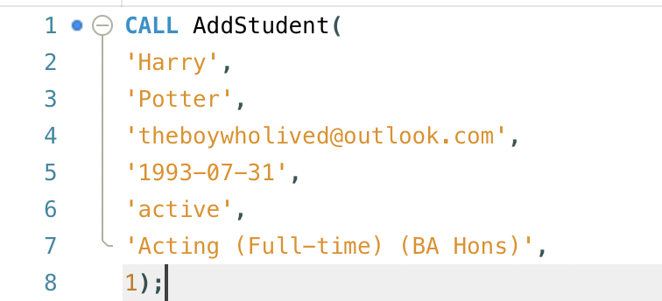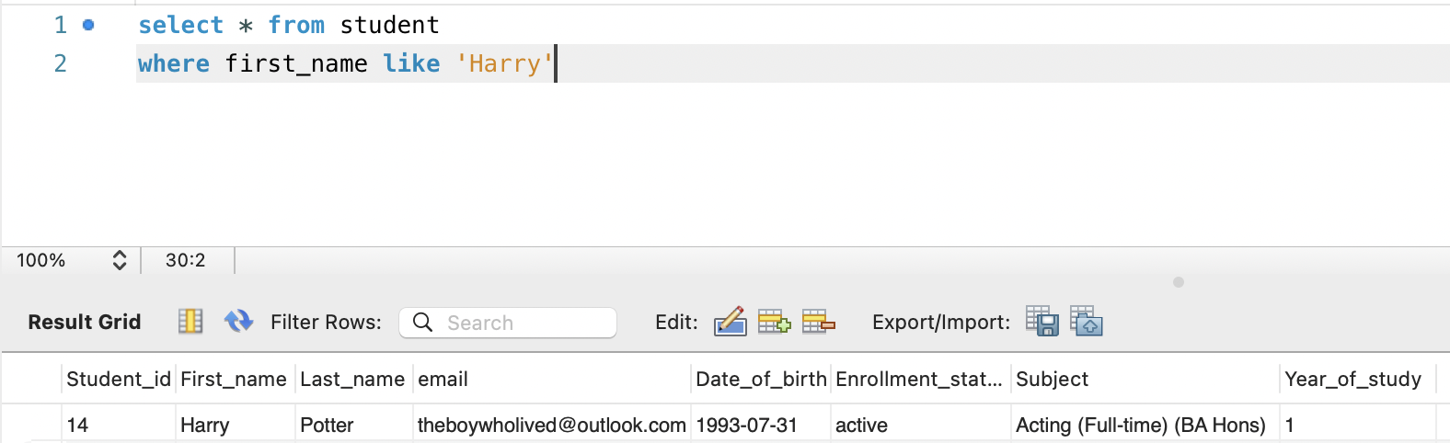

End Club membership
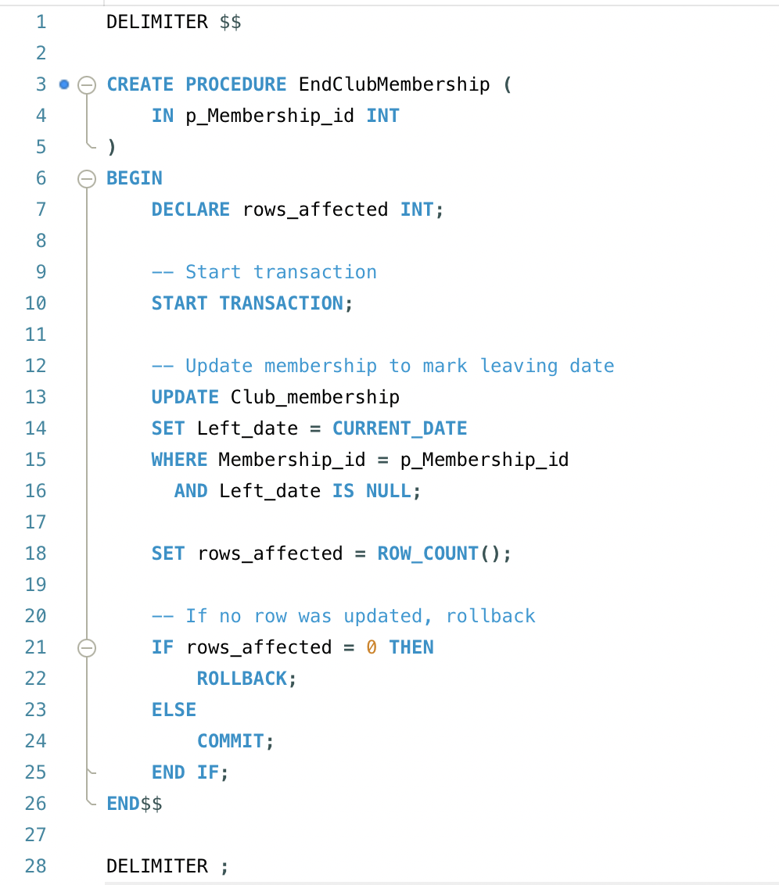

Testing End Club Membership
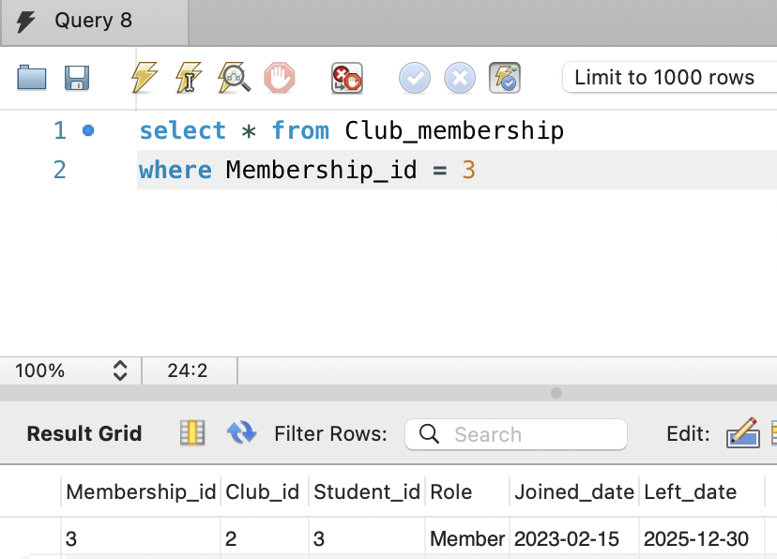

Deactivating a club
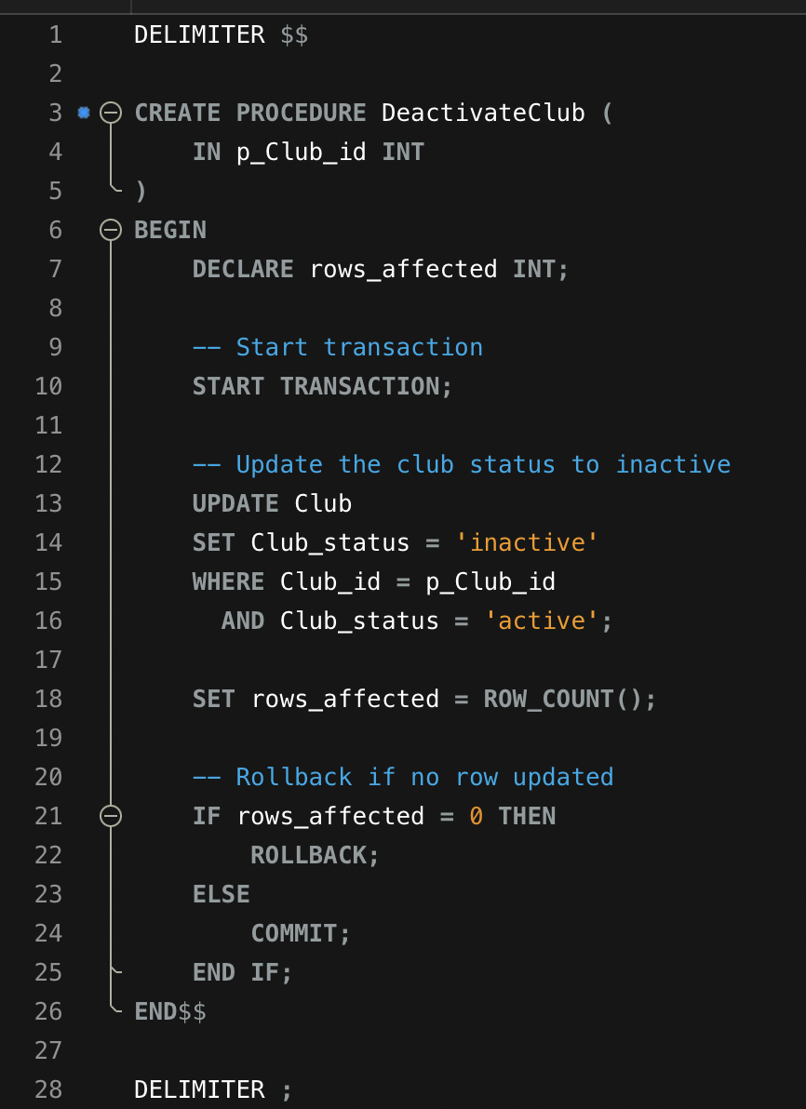

Trigger to go with procedure
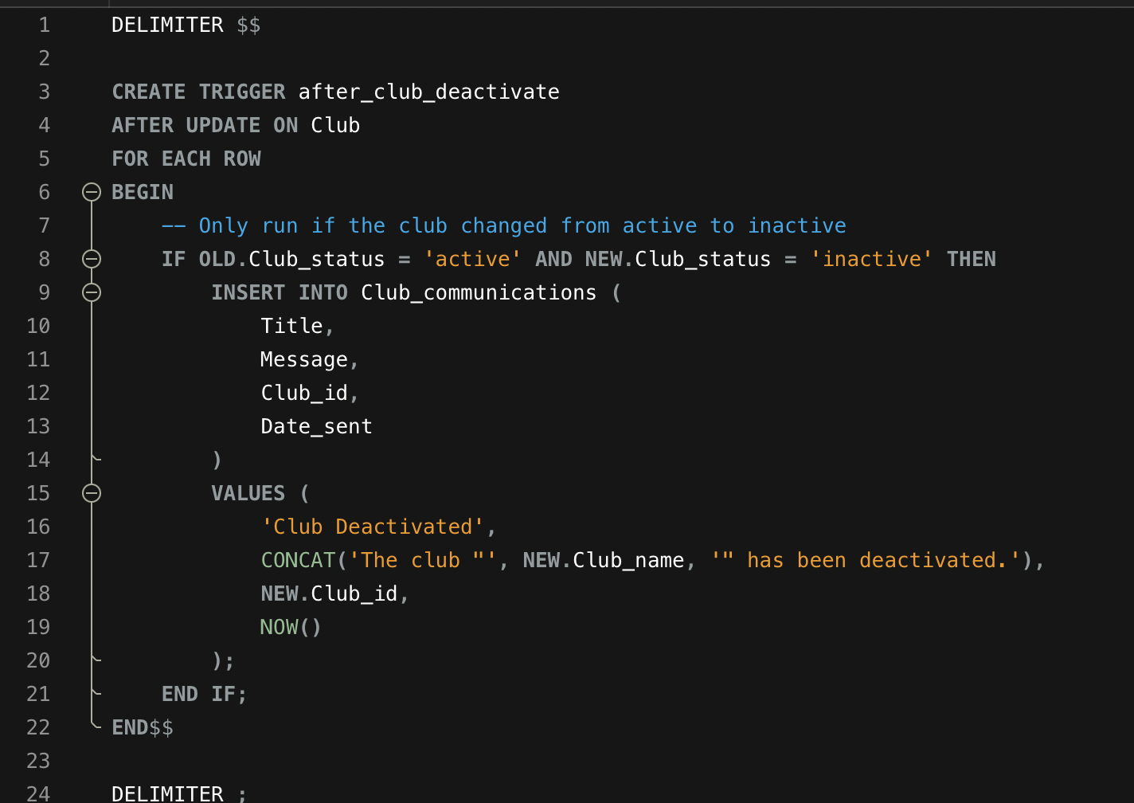

Testing deactivation
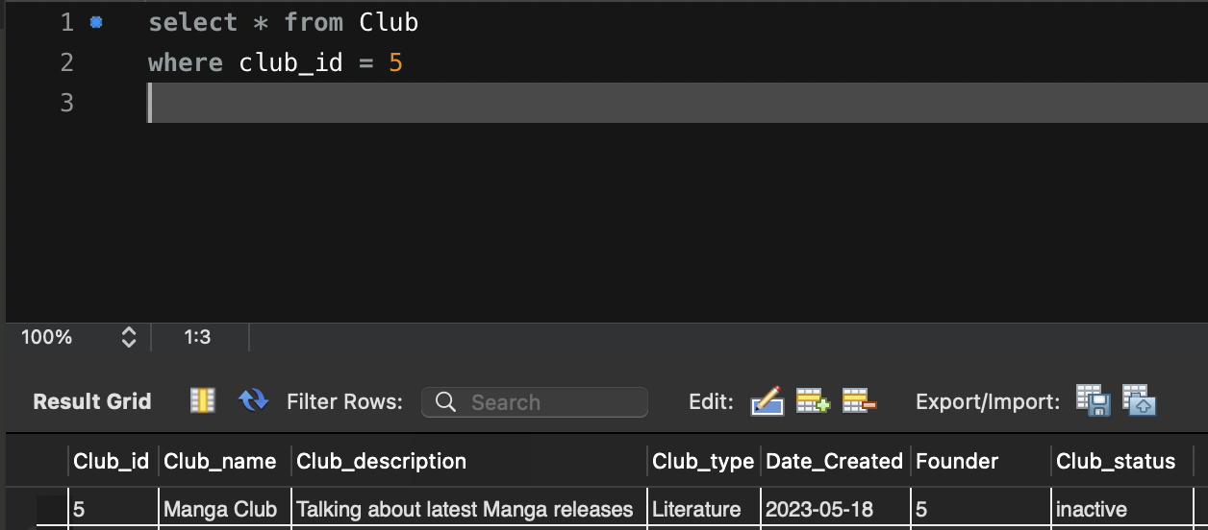
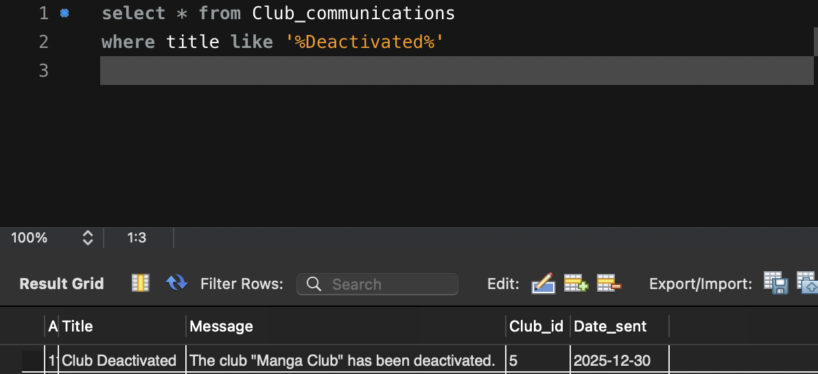

Stored Procedure and Transactional Scenario

Scenario: Student joins but the club is deactivated.
Transactions have been implemented to ensure atomicity and consistency, two of the key properties of ACID-compliant database systems (Atomicity Consistency Isolation and Durability). Guaranteeing that the database operations complete fully or are safely rolled back if an error has occurred. According to the MySQL documentation “With START TRANSACTION, autocommit remains disabled until you end the transaction with COMMIT or ROLLBACK. The autocommit mode then reverts to its previous state.” [4]

Add Student
A new student is enrolling into the University, so their details are added to the database.
The procedure starts the transaction and inserts the student’s details into the table called “Student”.
If the insertion is successful, the procedure commits the changes. If there is an issue such as a duplicate email or other issues, the transaction rolls back. This ensures atomicity that either the student is fully added or no changes occur to the table.

Ending Club Membership
After joining a club, the student may decide to leave. Perhaps to focus on their studies or they did not enjoy the club as much as they hoped.
The EndClubMembership procedure marks the student’s membership as ‘left’ by setting the Left_date to the current date in the table.
Transaction handling ensures data integrity by checking if the membership_id does not exist or if the student has already left, the procedure rolls back, leaving no changes to be made.
If the membership_id exists and the update is successful, the procedure commits the change to the table.

Club being deactivated
In some cases, clubs may need to be closed either by choice or through no fault of the club. For example, founding members have left the university and the management responsibilities are left unfilled.
The DeactivateClub procedure updates the club’s status from active to inactive.
The transaction checks if the club is already inactive, the procedure rolls back making no changes to the table.
If status is changed from active to inactive, the procedure will apply the changes and make sure they are committed.
Once the status is updated in the table, the automatic trigger inserts a message into the Club_communications table. Notifying the members that the club has been deactivated.

Failure examples
Below are some examples that can happen with the stored procedures failing.
If the AddStudent procedure fails, no new student is added to the Student table.
If the EndClubMembership fails by a membership_id not being found, no membership changes happen to the Membership table.
Although not strictly a failure, if DeactivateClub runs and a club already flagged as being inactive. The club status remains unchanged, and no announcement is generated in the Announcement table.
These failure scenarios demonstrate that the procedures combined with the transactions make sure that data integrity is accurate and consistent

Performance Tuning Enhancement
To help with performance, secondary indexes have been created to speed up searches, joins and WHERE clause filtering. This can help load times when creating reports or dashboards with tools like PowerBI and Tableau.

Indexes significantly improve query performance by reducing the number of rows scanned during a search or a join between tables. This is commonly used in large datasets. According to MySQL documentation “Without an index, MySQL must begin with the first row and then read through the entire table to find the relevant rows. The larger the table, the more this costs.” [5]
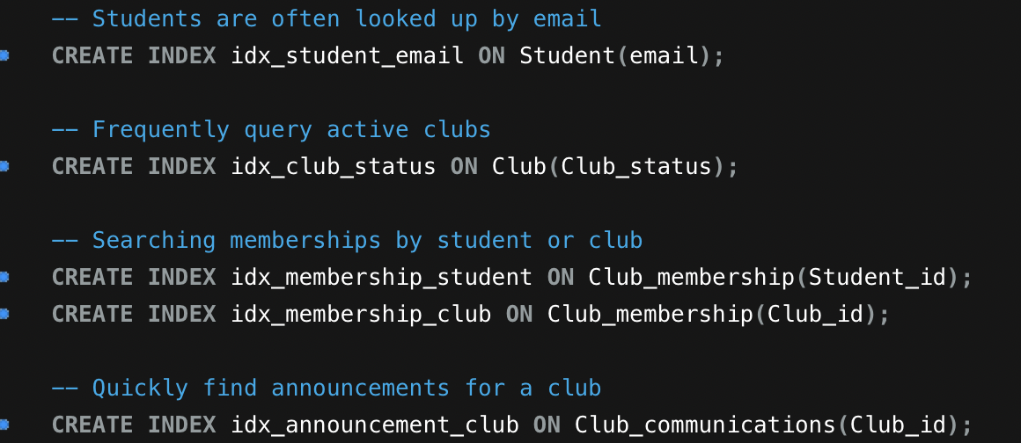
- Student email: This has been indexed as each email is unique to every student. Making it faster to search for a student, as there are common first and last names for example John Smith.
- Club Status: Has been indexed to filter faster as a club can only be active or inactive.
- Membership: Has been indexed to optimize joins between students and clubs. By doing this, it can make event and membership reports more efficient to run.
- Announcements: Has been indexed to retrieve club messages quicker for a club dashboard, improving dashboard load times.
The indexes will reduce load times by not needing to do a full table scan. This allows for SQL statements to locate relevant rows directly. Improving SQL Query speeds and will ensure that both transactional operations (like the stored procedures created) and reporting tasks will run efficiently, even as the dataset grows as more students enrol into university and join clubs.

Conclusion and Reflection
To conclude on creating a database management system for the Student Union, I believe that the core requirements have been met to help them move over from their paper-based system to an electronic one.

Challenges faced
One of the biggest challenges faced was the scope of creating a database from scratch was not being able to see their paper copies to help them migrate to the new system. Due to this the deciding on what the foreign keys in each table was a priority and making sure each table created would fit the flow of what the Union needed.

Improvements
To improve upon this management system in its current form, merging the Club_membership and Club_committee_roles into one table as you can be in a club as just a member or be in the club and have a role.
Creating an Audit table that records club changes, membership change and event updates to make tracking history of the club easier.
Adding more indexes such as a composite index for more multi-column queries such as finding what clubs a student belongs to.
Adding more stored procedures to help with the ease of use instead of the three that are there. The main ones that would be beneficial to have would be to add a new club, update a student’s details, update club membership and club committee roles.

Reflection
Overall, the database provides a strong foundation for the Student Union to move over to a digital database instead of using paper with optimisation and scalability in the future.
Developing the database has highlighted the importance of careful planning and understanding requirements before implementation. Designing foreign keys, relationships and constraints prevented data integrity issues later down the line.
Transactional stored procedures reinforced the need for balancing functionality and performance along with indexing other columns.
Overall thinking about scalability and thinking outside of just a database with tables and instead of thinking of audits and creating reports have helped design a database that is structured and will help with decision making.

References
[1] S. Kolahi and Libkin Leonid, "On redundancy vs dependency preservation in normalization | Proceedings of the twenty-fifth ACM SIGMOD-SIGACT-SIGART symposium on Principles of database systems," 26 June 2006, Accessed: Dec 30, 2025. Available at: https://dl.acm.org/doi/abs/10.1145/1142351.1142369.
[2] Gomstyn Alice and Jonker Alexandra, "What Is a Primary Key? | IBM." IBM.com. Accessed: Dec 30 2025. [Online]. Available: https://www.ibm.com/think/topics/primary-key
[3] "SQL FOREIGN KEY Constraint." Accessed: Dec 30 2025. [Online]. Available: https://www.w3schools.com/sql/sql_foreignkey.asp
[4] "MySQL :: MySQL 8.0 Reference Manual :: 15.3.1 START TRANSACTION, COMMIT, and ROLLBACK Statements," Accessed: Dec 30, 2025. Available at: https://dev.mysql.com/doc/refman/8.0/en/commit.html.
[5] "MySQL :: MySQL 8.0 Reference Manual :: 10.3.1 How MySQL Uses Indexes," Accessed: Dec 30, 2025. Available at: https://dev.mysql.com/doc/refman/8.0/en/mysql-indexes.html.

