Museum Report: Oriel Myrddin
Al Williams-Spooner

1. Using the establishment visited how easy is it to gain a sense of what constitutes Welsh culture?
WHAT IS WELSH CULTURE?
When one thinks of what constitutes Welsh culture, it’s easy to think of the traditional chimney black hats, our cawl dish, the rolling green hills, Welsh cakes, the Eisteddfod, the abundance of sheep that are in the fields, and, of course, the Ddraig Goch on the country’s flag. But as accurate as those things may be, that is not all that represents the Welsh and the culture we have, in fact, culture as a broad term doesn’t just need to be food or clothing or the landscape, it can also be the music, the myths, the legends, the history, the traditions, and so on. On Wales.com, it lists a number of Welsh legends, such as King Arthur, Merlin, the Ddraig Goch and the Mari Lwyd, as well as history and traditions, such as St David and Owain Glyndŵr (Wales, 2024). Comparatively, the Visit Wales website focuses more on the physical history and heritage of the country, such as the castles, pubs, prehistoric treasures and wool (Visitwales.com, 2019).
However, these two sources, although specific to Wales, primarily represents a large body of the population, when Welsh culture is something that can also be felt incredibly differently to every individual living in the country. What constitutes Welsh culture to someone down the road working a 9 to 5, could be extraordinarily different than someone still in school or being paid to promote the tourist attractions on a government website. With all of this in mind, the current exhibition being held at the Oriel Myrddin Gallery in Carmarthenshire, can be a good look into what they consider to be an integral aspect of Welsh culture.

ORIEL MYRDDIN GALLERY AND ITS EXHIBITIONS
The Oriel Myrddin Gallery located in the heart of Carmarthen town in a listed Victorian building, is a largely publicly funded ‘art and craft’ gallery, which also has support from the Carmarthenshire County Council, Carmarthenshire Town Council and The Arts Council of Wales (Oriel, 2019). It is also a Charitable Trust that is supported by a board of trustees.
At the time of writing this report, the gallery have an exhibition running, titled GWRACH | WITCH Clive Hicks-Jenkins A Fairytale Retold. This exhibition displays the artistic interpretation of the classical fairytale of the Brothers Grimm, Hansel and Gretel, done by Hicks-Jenkins, with interwoven elements of Welsh folklore and collaborations with fellow artists and creatives such as Benjamin Pollock and Simon Armitage (Tale, 2025). Other professionals working on the exhibition are Simon Costin, the curatorial consultant and director of the Museum of Witchcraft and Magic, and Meriel Hunt the exhibition designer. There is also a separate installation contributed by the Welsh-Egyptian photographer, Mohamed Hassan, titled Threads of Belonging.
With the focus of the exhibition being the childhood fairytale, Hansel and Gretel, you would assume that the artwork would take on a very German folklore theme, since that is the place of origin for the story with the Brothers Grimm (Wikipedia, 2025). However, with the artist Clive Hicks-Jenkins being a renowned painter and stage director of Wales, working with multiple Welsh galleries and museums such as the Martin Tinney Gallery in Cardiff, the Museum of Modern Art Machynlleth, and Aberystwyth Art Centre (Clive Hicks-Jenkins, n.d.), his time growing and working in Wales really shines through in his work, with the artist himself declaring his inspiration for delving into the story of Hansel and Gretel came from “…a Toby Twirl annual. There was a story of a witch who captured Toby and imprisoned him. The pictures of her terrified and enthralled me… an idle moment some years ago I felt the need to be drawing a witch, I chose Hansel and Gretel as the vehicle simply because a witch was central to the plot.” (Clive Hicks-Jenins’ Artlog, 2024).
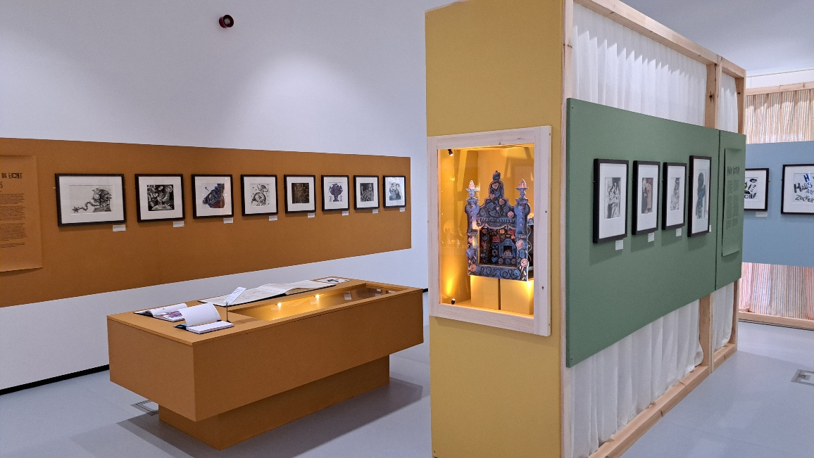
(Williams-Spooner, 2025, Oriel Myrddin Gallery)
Regarding the other separate installation at the Oriel Myrddin Gallery, it is a large collection of black and white portrait photographs, accompanied by a description by Paul Cabuts, and a quote from the historian Gwyn Alf Williams; “Wales has always been now… have lived by making and remaking themselves in generation after generation… Wales is an artefact that the Welsh produce.”
The photographs are meant to represent a challenged sense of identity and belonging in a contemporary Wales, showcasing the many different backgrounds of the people living here in single snapshots of moments. However, this installation cannot be found on either the Oriel Myrddin Gallery website, nor Mohamed Hassan’s website (Hassan, 2014) at the time of writing this report
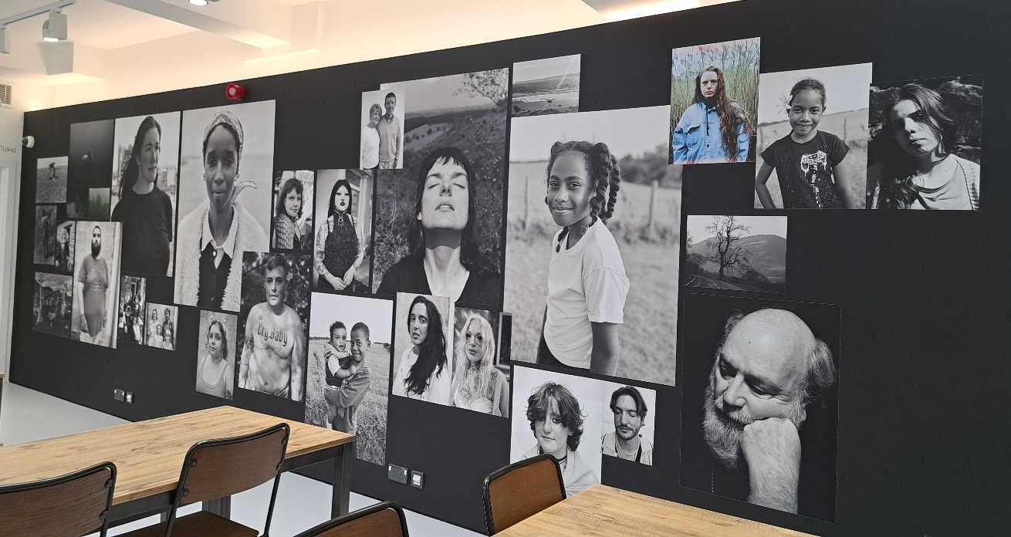
(Williams-Spooner, 2026, Oriel Myrddin Gallery)
Both the exhibition and the portrait installation contribute their own unique perspectives and representations of Welsh culture, whether it be through identity through photography or paintings and drawings incorporating Welsh iconography and feel.

ONLINE EXPERIENCE
When you open the webpage for the Oriel Myrddin Gallery, you are immediately met with the logo of the gallery’s initials, and a choice whether to continue to the rest of the site in either English or Cymraeg. Once you continue to the main site, you are then presented with an animated announcement video for the exhibition, GWRACH | WITCH, which shows you some of the artwork from the exhibition itself in a moving format with dramatic music overlaying the picture. Directly beneath is the dates in which the exhibition is taking place and a very small introduction/invite to see the artwork. Finally, there is an advertisement for a job and details on how to apply.
Along the top of the screen are the different sections of the website, listed from left to right as Home, Shop, What’s On, OM X CRAFT Festival, Education, Podcasts, Journal, About, Visit, Contact Us, and then the gallery’s social media accounts.
In the What’s On section is where all the current and upcoming events for the year are listed and displayed, although there are no pictures of the current exhibition on the page. On the dedicated page for GWRACH | WITCH there is a lengthy description describing the displayed artwork, Clive Hicks-Jenkins himself, as well as Meriel Hunt and Simon Costin. The only virtual display of the exhibition itself by Oriel Myrddin Gallery can be found on their Instagram account (Instagram.com, 2017). Comparatively, the Clive Hicks-Jenkins website has multiple pictures of the exhibition from multiple angles (Clive Hicks-Jenkins’ Artlog, 2024), and even some close-up images of certain artworks displayed, like the ceramics and picture-book.
Although the Oriel Myrddin website does describe its connections to its Welsh roots and their consistent collaboration with Welsh artists, the lack of digital display of their gallery space and exhibition leaves much to the imagination of the audience. This could be intentional with the hope that it ignites curiosity to visit the gallery in person, but without any hint of what the space looks like, it can make people feel unprepared to venture into an unfamiliar place with no idea what to expect behind the door.
What the gallery could do, instead of relying on visitors to have social media, is present one or two images onto the website page, which would give visitors and idea of the exhibition while still not revealing all of it.

IN PERSON EXPERIENCE
The in-person experience of the GWRACH | WITCH exhibition, if needed to be summed up in only a handful of words, could be described as short, tight-spaced but interesting. At first I had trouble finding the entrance, as it has been moved to the side of the building through the shop instead at the front through the white door. Once inside and passed the small shop, there is a small cafeteria where the Mohamed Hassan installation is and then a small flight of stairs to the exhibition room (I saw no elevator for wheelchair access).
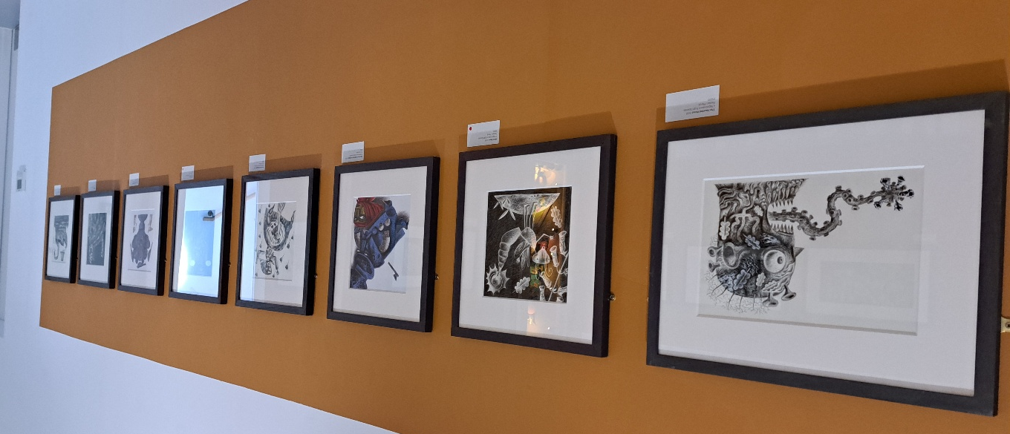
(Williams-Spooner, 2025, Oriel Myrddin Gallery)
Immediately upon entry you are surrounded by high-standing installations that hold picture frames of some of the artworks and an information board, all of which makes you feel quite boxed in. You are presented with two potential paths to take, either left or right, either of which takes you further into the room to see a number of the artworks displayed in lines along the walls in black picture frames.
Throughout the exhibition there are information boards, written in both Welsh and English, that describe Hicks-Jenkins’ work and collaboration with the theatre. The boards are in obvious display and easy to read, positioned directly next to the piece of work they are describing. In the centre of the first room is a table with Hicks-Jenkins picture book and a small, interactive notebook asking visitors to describe their visit. Opposite this is a looped animated video, depicting a scene from Hicks-Jenkins’ A Nightmare in Eight Scenes, which then also shows a small ending clip from the related theatre production.
Behind this video is a much more entertaining interactive section, which is a shadow puppet area. This allows visitors, mainly children, to play with character shaped wooden figures sellotaped to sticks and watch as their shadows reflect on the background propped up in the corner. This is a good use of the space and a brilliant way to get children involved in making their own fun and stories influenced by the colourful artwork displayed around them. It is also an excellent way to introduce children to classic folklore in an entertaining way.
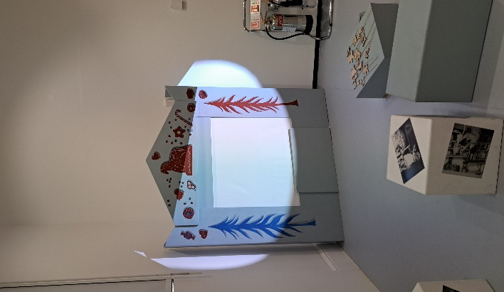 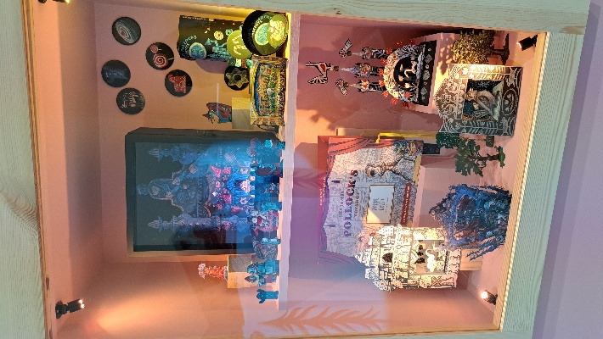
(Williams-Spooner, 2025, Oriel Myrddin Gallery)
The second exhibition room is a lot smaller and darker than the main one, presenting you first and foremost with the dolls of Hansel and Gretel used in the stage production mentioned previously. On the walls of this room are two concept drawings of the dolls, a large, black dollhouse, a small, animated video of a crow and spindly fingers, a cabinet of witch posters and advertisements and hand-held puppets, and more black and white portraits taken by Leia Morrison.
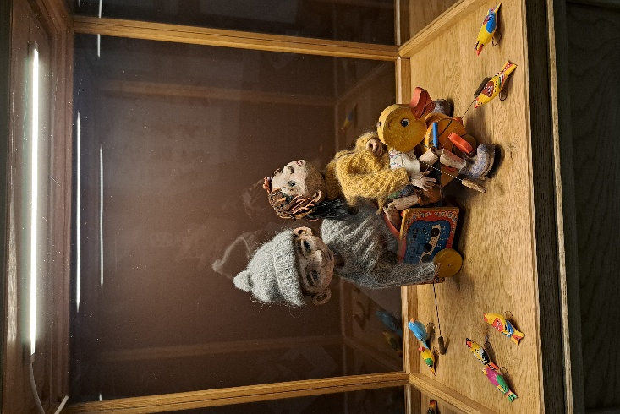 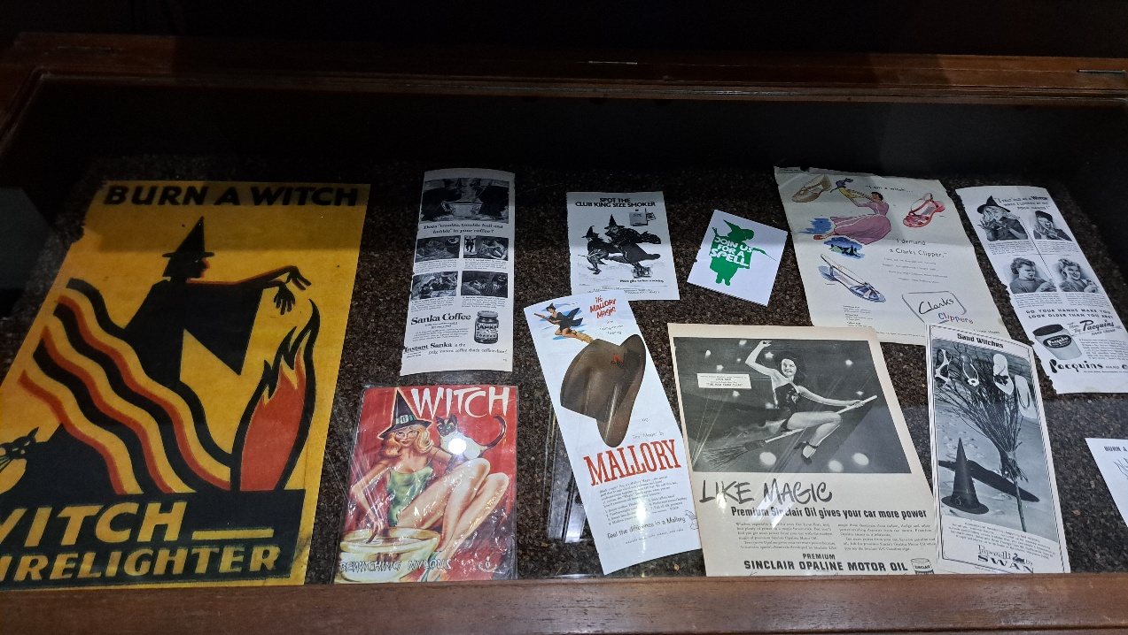
(Williams-Spooner, 2025, Oriel Myrddin Gallery)
This room is filled with interesting artwork and is displayed in an organised way, and despite the darkness of the room everything is perfectly visible. Once you have viewed everything in the gallery, you leave the same way you entered.

CONCLUSION
Going back to the question at the start, “how easy is it to gain a sense of what constitutes Welsh culture”, the honest feedback is that the strongest sense of Welsh culture came from the photograph installation at the very start by Mohamed Hassan, which depicted real-life people living in Wales and how they all represented their own identities as Welsh people. It displayed the vastness of the Welsh population and how unique but also connected everything is, while the GWRACH | WITCH exhibition felt more of a general atmosphere of witchy folklore.
The Oriel Myrddin Gallery displays multiple facets of Welsh culture in multiple ways, both through their website and their physical exhibitions. The choice to not display the GWRACH | WITCH exhibition on their website could boil down to the fact that they change exhibitions every few months, so filming a virtual tour of the layout could be seen as a waste of time since it is only going to change, although some pictures could help entice more visitors. As for the accessibility, a ramp or stair lift would be recommended.

BIBLIOGRAPHY
- Clive Hicks-Jenkins. (n.d.). ABOUT. [online] Available at: https://www.hicks-jenkins.com/about-forte. [Accessed: 16 January 2026]
- Clive Hicks-Jenkins’ Artlog: (2024). Clive Hicks-Jenkins’ Artlog: [online] Available at: https://clivehicksjenkins.wordpress.com/. [Accessed: 16 January 2026]
- Hassan, M. (2014). Mohamed Hassan photography. [online] Mohamed Hassan photography. Available at: https://www.mohamedhassanphotography.com/about. [Accessed: 16 January 2026]
- Instagram.com. (2017). Oriel Myrddin Gallery (@oriel_myrddin) • Instagram photos and videos. [online] Available at: https://www.instagram.com/oriel_myrddin/ [Accessed 16 January 2026].
- Oriel (2019). Oriel Myrddin Gallery. [online] Oriel Myrddin Gallery. Available at: https://www.orielmyrddingallery.co.uk/about [Accessed 15 January 2026].
- Tale, F. (2025). Oriel Myrddin Gallery. [online] Oriel Myrddin Gallery. Available at: https://www.orielmyrddingallery.co.uk/whats-on/witch-lgrs5 [Accessed 15 January 2026].
- Visitwales.com. (2019). History, Heritage & Traditions | Travel Information | Visit Wales. [online] Available at: https://www.visitwales.com/info/history-heritage-and-traditions. [Accessed: 16 January 2026]
- Wales. (2024). Welsh traditions, myths, and legends. [online] Available at: https://www.wales.com/about/history-and-heritage/welsh-traditions-myths-and-legends. [Accessed: 16 January 2026]
- Wikipedia (2025), Hansel and Gretel, Available at https://en.wikipedia.org/wiki/Hansel_and_Gretel#CITEREFHarries2015 [Accessed: 16 January 2026]

