EMOTIONAL INTELLIGENCE
Thilaka Kirubaharan 2422401
LCLM5006 Developing Emotional Intelligence Skills
“Emotional intelligence involves monitoring one’s emotions and using them to guide thinking and decision-making.”
— Salovey (1997)

1 EMOTIONAL AWARENESS  To what extent do my emotions influence my thinking and decision-making?  My emotions can significantly influence my thinking and decisions.  When stressed, anxious or tired, I may overthink, lose focus and make more impulsive choices. When calm and positive, I can think more clearly, approach problems logically and make better decisions. | 2 EMOTIONAL INTELLIGENCE IN ACADEMIC SUCCESS  What emotional factors contribute to academic success?  • Stress management — maintains focus, reduces anxiety and helps prevent burnout.  • Motivation — builds consistency, effort and progress towards long-term goals.  • Resilience — supports recovery from setbacks and encourages persistence.  • Emotional regulation — can improve concentration, behavior and relationships (Faria, Costa, Taksic, 2025). | 3 PERSONAL REFLECTION  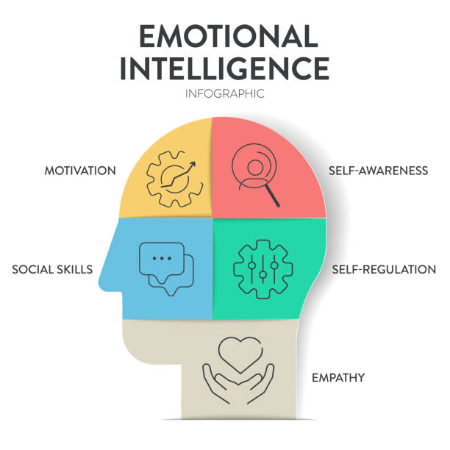  To what extent can mindfulness and emotional regulation strategies improve my learning experience?  Mindfulness and emotional regulation can positively influence learning by helping me stay present, manage stress and prevent emotions from taking over when challenges arise.  Examples from my experience:  • Before exams, I use deep breathing and mindfulness to calm my mind and improve focus.  • When overwhelmed, I take a short break, step away and reset my thoughts.  • Gratitude and positive self-talk help maintain motivation and confidence.  • Regulating my responses can improve relationships with peers and reduce unnecessary stress.
  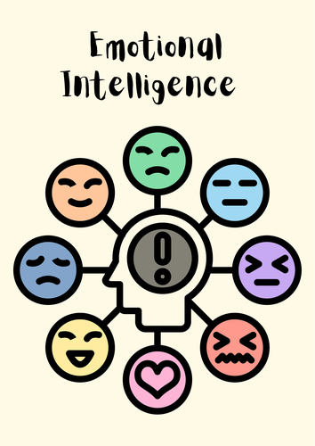
  Key ways to develop emotional awareness
  • Mindfulness — notice and name emotions without judgement.
  • Self-reflection — check in with yourself regularly, e.g. through journaling.
  • Seek feedback — understand how emotions affect others and your actions.
  • Recognise triggers — identify situations or people that influence your emotions.
  Applying emotional intelligence to common challenges
  • Procrastination → build self-discipline, set small goals and reward progress.
  • Anxiety → use breathing techniques, positive self-talk and reframe negative thoughts.
  • Low motivation → reconnect with your purpose, track progress and celebrate small wins.
  Overall…
  These strategies can help me think more clearly, make better decisions, manage challenges and get more from my learning experience.

METHOD  My approach to this poster  1 Reviewed key theories and models of emotional intelligence and mindfulness.  2 Linked the concepts to personal experiences and academic challenges.  3 Analysed how emotional awareness, regulation and mindfulness can support academic success.  4 Organised the findings into a clear poster focused on practical strategies. | KEY TAKEAWAYS  ✓ Emotions influence thinking and decisions — awareness can lead to better choices.  ✓ Emotional intelligence supports academic success through stress management, motivation and resilience.  ✓ Mindfulness and emotional regulation can improve focus, confidence and overall wellbeing.  ✓ Small, consistent strategies can make a meaningful difference to the learning journey. | BE AWARE  BE IN CONTROL  BE YOUR BEST  References:  Faria, L., Costa, A. and Taksic, V. (2025) ‘The role of emotional understanding in academic achievement: exploring developmental paths in secondary school’, Journal of Intelligence, 13(8), p. 96. Available at: https://pmc.ncbi.nlm.nih.gov/articles/PMC12387470/ (Accessed: 6 October 2026).  Lane, R.D. and Smith, R. (2021) ‘Levels of Emotional Awareness: Theory and Measurement of a Socio-Emotional Skill’, Journal of Intelligence, 9(3), p. 42. Available at: https://pmc.ncbi.nlm.nih.gov/articles/PMC8395748/ (Accessed: 6 October 2026).

