Module Code: EMPL4008- Problem Solving
MD Bablu Kamali
Student Number: 1605371
Tutor Name: Syed Muhammad Hammad
Assignment title: “Looking into the purpose and requirements in managing problems effectively in terms of resourcing an organisation with talent and skills appropriate to fulfil Business objectives”

Table of Contents
Introduction: 3
Part 1: 4
AC1.1 Definition of problem with stages of it and the psychological impact of problem on human health along with examples: 4
AC 2.2 Critical thinking along with the involved steps and its importance in an organisation: 7
Part 2: 8
2.1 Key influencing factors of Tesco plc. based on PEST analysis: 8
Political factors: 8
AC 2.2 Letter to the line manager: 9
Part 3: 10
AC 3.1 Types of Employee behaviour and the key influencing techniques of the management: 10
Part 4: 11
AC 4.1 Implications of Technology ion Tesco along with advantages and disadvantages: 11
Conclusion: 11
References: 12

Figure 1: Psychological problem in workplace (Stavroula and Aditya, 2017) 6
Figure 2: grocery market share of UK 2017 (Grocery Market Share - Kantar Worldpanel, 2017) 9

Introduction:
Finding solutions to different problems occurring in an organisational context leads to improving the overall efficiency of an organisation. For this very reason, it is very important to opt for generic as well as specified methods for solving different problems within an organisation. Different aspects of problem-solving have been covered in this assignment form the viewpoint of Tesco Plc.

Part 1:

AC1.1 Definition of problem with stages of it and the psychological impact of the problem on human health along with examples:
A problem can be referred to a situation where the current outcome varies from an expected outcome. That means the gap between the desired result and an actual result can be defined as a problem and this gap is required to be fulfilled in order to solve that problem. The concept of problem-solving became popular in the 1980’s by the total quality management movement by W. Edwards Deming (Robertson, 2016). The solution to a problem characterises its type. If the probable solution to a problem is known then it is referred as a simple problem. However, if the problem is new and the solution is needed to be found out by working separately on it without the routine tasks, then it is considered as a complex problem.
Usually, the process of solving a problem comprises of certain stages which are given below (Problem Solving - organization, system, manager, definition, company, business, system, 2017):
- Identification:
While identifying a problem, three things are to be kept in mind. The first one is to not be blindsided while identifying a problem. The second one is to understand the significance of the particular problem and the third one is to prevent overreaction to the problems. Whenever a problem arises, the first job is to analyse whether such problem has occurred previously or not.
- Verification:
The resources which will be needed for verification of the identified problem depend mainly on the nature of the problem. If the problem is simple and the solution is probably known, then resources will be needed at a superficial level. However, if the problem is ill-defined and unstructured and if the manager has to intervene to solve a problem recognised by someone else, then the proper verification is needed.
- Definition:
This step is basically a proper acknowledgement of the problem between two parties who are to solve the problem originally and the party who are to supervise them. The parties have to decide the probable or benchmark solution at this stage.
- Origin analysis:
In this stage, the root cause of the problem is identified and analysed. If the actual reason for the problem is uncovered and eliminated or minimized, then it might help in preventing the occurrence of such problem again.
- Determining Alternatives:
Once the actual reasons behind the problem are identified, the relevant parties look for alternatives to eliminate or reduce the problem. Measures are taken to control and eliminate the problems. The solutions can come from both conventional and non-conventional ways depending on the problem.
- Evaluation:
After the determination of the alternatives, they are evaluated to see which of the alternatives works best in minimizing the problem. The best alternative is the one that eliminates the problem completely. However, it might be impossible to eliminate some problems and in those scenarios, the best measure is the one that minimizes and controls it.
- Implementation:
The best alternative chosen is then implemented at this stage of problem-solving. A proper course of action is needed for implementing the solution.
- Reviewing:
Once the plan is implemented to solve the problem, it has to be reviewed in order to check for pitfalls.
- Feedback and control:
Timely feedbacks are necessary to ensure the smooth flow of operation. Controlling the entire system is necessary to prevent the problem from occurring once again.
Psychological hazards at the workplace can lead to excessive stress, anger or overreaction to problems as well as depression. The psychological hazards at the workplace can arise from job content, workload, control, the voicing of opinion, organisation culture, workplace relationships and home-work interface etc. Stress might lead to incompletion of deadlines and tasks and cause nervous breakdowns as well. Not being able to keep up with the pressure in the workplace might lead to problems like chronic depression and overreaction. These psychological disorders have a bizarre impact on human health and as a result, reduce workplace productivity. A detailed description of these problems can be seen in the following diagram:
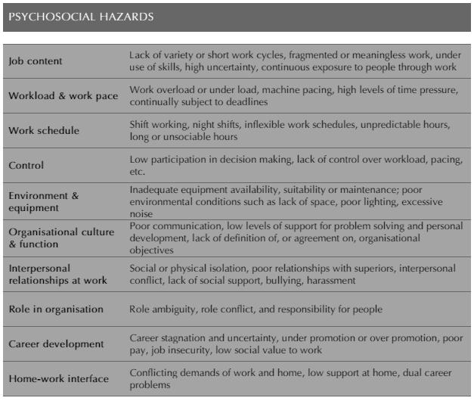
Figure 1: Psychological problem in workplace (Stavroula and Aditya, 2017)
Tesco Plc. being a multinational grocery faces a lot of simple and complex organisational problems. As a grocery store, the problems in inventory, billing, information technology, error in internet server or any other internal function can be concluded as a simple problem as the probable solution and the process of solving the problem is known. But the complex problems are those that arise suddenly and require a careful and strategic approach to be solved. The cases filed by customers, allegations about food alteration and other forms of customer complaints can be considered as examples of complex problems.

AC 2.2 Critical thinking along with the involved steps and its importance in an organisation:
The term critical thinking was first invented in the mid-late-20th century (Butler, 2017). Critical thinking is a systematic process that involves the active and skilful application of intelligence for conceptualisation, analysis, synthesis and evaluation of information. The concept of critical thinking involves purposes, processes, assumptions, empirical grounding, questions at issue etc.
There are certain steps which are involved in the process of critical thinking which are as follows:
- The first step of critical thinking is knowledge. This step identifies the problem and asks questions that lead to the solutions to the problem if solved using proper knowledge.
- The second step is comprehension. This involves alignment of the necessary facts for solving the identified problem in step 1.
- The third step is an application. This step involves the proper understanding of the methods, resources and information required to solve the problem.
- The fourth step is to analyse. Upon the collection of necessary information, the relationship of that information with respect to the problem is analysed. Priorities are set upon identification of strong points, weak points and challenges.
- The fifth step is synthesis. After the previous procedure, an initial decision is formed along with an initial route to solve the problem. In case of more than one solution, the solutions are prioritised and evaluated on the basis of being the most advantageous one.
- The last step is taking action. The actual results of the whole thinking process are transferred into this step.
The importance of critical thinking in terms of Tesco Plc. can be understood by evaluating an example. In the recent times Tesco plc. has experienced an increase in sales and decrease in market share. Although the sales went up by 2.9 %but the market share decreased from 28.2% to 27.9%.
For analysing the reason behind this, the critical thinking approach can be used. Using the available knowledge, Tesco saw that all the big four competitors including Morrison’s and Sainsbury had also lost market shares. By comprehending, analysing and synthesising it could be seen that the reason was the market growth of Aldi and Lidi. So, the probable to be taken in this regard will be to rebuild the brand image to claim the highest market share along with the highest growth in sales.

Part 2:

2.1 Key influencing factors of Tesco Plc. based on PEST analysis:

Political factors:
The existing qualms in political affairs of the United Kingdom owing to Brexit are distressing the grocery industry and its activities. According to the GFK consumer confidence index, deepening pessimism can be noticed as the points have decreased by 18 compared to the previous year. All these effects cannot be defined correctly till the entire negotiations end and Brexit takes place. The stringent health and safety regulations imposed by the government are also part of this environment.
Economic Factors:
The GDP, interest rates, unemployment rate, inflation rate, market shares etc. can be considered as the elements of the economic environment. The administrative uncertainties owing to Brexit have had an inordinate influence on the monetary circumstances as well. The sales of Tesco Plc. went up by 2.9 % this year but the market share has decreased from 28.2% to 27.9% (Neilan, 2017). The customers have preferred low price rather than better quality in the present economic context.
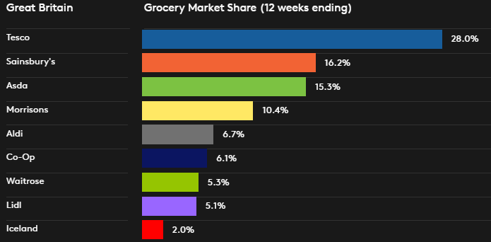
Figure 2: grocery market share of UK 2017 (Grocery Market Share - Kantar Worldpanel, 2017)
Social factors:
The culture of a society, customer preferences, religious beliefs etc. affect the business operating within a particular society. For fulfilling social accountabilities Tesco Plc. has distinct “corporate social responsibility” (CSR) strategies. They use the “reduce, reuse and recycle” approach for decreasing the influence on the atmosphere. They have native trader programmes and platforms for assisting Irish suppliers (Suppliers & Ethical Trading | Tesco Corporate Responsibility, 2017).
Technological factors:
As the grocery industry is related to the day to day lifestyle, an adaptation of this industry with customer-friendly technology is a must. The present customer base prefers online shopping to a great extent for convenience. Tesco has kept up with this technology. Customers can pay using cash, cards and mobile which shows another implication of technology in this regard.

AC 2.2 Letter to the line manager:
On the basis of the PEST analysis, it can be seen that the political, economic, social and technological factors do influence the activities. As this industry is highly competitive, the strategies should be taken after analysing the impacts of all these elements.
The changes in EU legislation after Brexit might create barriers to free movements of goods and hence some alternative solutions have to be found out beforehand. The health and safety regulations have to be followed properly for avoiding lawsuits. For continuing to lead the market, Tesco Plc. has to come up with a stronger strategy to beat the growth progress of Aldi and Lidi. Recently, the competitor Sainsbury has initiated a virtual stores facility and this might make Tesco backwards in terms of technology. For being in the competition, Tesco also should bring up a new technology that will be widely appreciated by the customers.

Part 3:

AC 3.1 Types of Employee behaviour and the key influencing techniques of the management:
Employee behaviour can be defined as the manner in which employees react to a particular situation at the workplace. The methods of interactions among the employees are also a part fo employee behaviour.
Employee behaviour can be classified into eight major types such as commander, drifter, performer, attacker, pleaser, performer, analytical and achiever behaviour (Types of Employee Behaviour, 2017). Among these eight two will be discussed here.
The analytical behaviour in a workplace symbolises being meticulous in ones work and double checking the things. These types of employees perform better when they work alone compared to working in teams as their nature makes them find faults with the new ideas proposed and they often irritate the team with information overloads.
The achievers in the workplace are considered to be the best as they are capable of adjusting to all the other types in the organisation. They perform well in teams as well as individually. They focus on the organisational goal attainment rather than thinking about their personal gains.
The key techniques to influence employee behaviour are as follows:
- Ensuring a great communication network is a well-recognized tool for managing employee behaviours.
- Shaping the organisation culture for the best possible attainment of the goal is another technique used by the management (Robertson, 2016).
- Being assertive rather than being aggressive is a new way of managing employee behaviour.
- Recognising the efforts given by employees and rewarding them for better performances is another widely applicable tool for managing employee performance (Ways to Influence Employee Behaviour, 2017).

Part 4:

AC 4.1 Implications of Technology ion Tesco along with advantages and disadvantages:
The uses of technology in Tesco have enabled it to cope up with the changing customer preferences. The online shopping system has helped the customers to shop from their home or shop on the go. The mobile app of Tesco also helps the customers to pay as they go and to pay on a monthly basis (Tesco Mobile app | Tesco Mobile, 2017). The stores also have free Wi-Fi which can be used by the club card members.
The automated billing and payment system supports the operations of Tesco pretty well. The supply chain management and inventory management of Tesco are also done using the Big data. The internal communication network is established based on information technology. In this manner, it can be said that technology is used in every aspect of Tesco.
The key advantages of using technology in business can be seen in the following manners:
- Information can be processed effectively and efficiently.
- Data processing errors get reduced due to automation
- Faster communication within and outside the organisation is possible
The disadvantages are:
- Costs can become higher for training employees and keep pace with new technologies
- Valuable information can get leaked due to hacking and other internet malware

Conclusion:
This report has been prepared on different important sections of problem-solving from the perspective of Tesco Plc. as an organisation. The analysis in this report has been made more and more factual to ensure the credibility of the report and necessary real-life examples have also been added for proper understanding.

References:
Butler, S. (2017) Tesco - six challenges in store for Matt Davies, the Guardian. Available at: https://www.theguardian.com/business/2015/may/11/tesco-six-challenges-in-store-for-matt-davies (Accessed: 6 December 2017).
Grocery Market Share - Kantar Worldpanel (2017). Available at: https://www.kantarworldpanel.com/en/grocery-market-share/great-britain (Accessed: 6 December 2017).
Neilan, C. (2017) Sales rise but market share falls for Big Four grocers, Cityam.com. Available at: http://www.cityam.com/274004/sales-rise-but-market-share-falls-big-four-grocers-aldi-and (Accessed: 6 December 2017).
Problem solving (2009). New York: Ferguson.
Problem Solving - organization, system, manager, definition, company, business, system (2017). Available at: http://www.referenceforbusiness.com/management/Or-Pr/Problem-Solving.html (Accessed: 6 December 2017).
Robertson, I. (2016) Problem solving. [Place of publication not identified]: Psychology Press.
Stavroula, L. and Aditya, J. (2017) Cite a Website - Cite This For Me, Apps.who.int. Available at: http://apps.who.int/iris/bitstream/10665/44428/1/9789241500272_eng.pdf (Accessed: 6 December 2017).
Suppliers & Ethical Trading | Tesco Corporate Responsibility (2017). Available at: http://www.tesco.ie/corporate-responsibility/suppliers-and-ethical-trading/ (Accessed: 6 December 2017).
Tesco Mobile app | Tesco Mobile (2017). Available at: https://www.tescomobile.com/tescomobile-app (Accessed: 6 December 2017).
The Eight Classic Types of Workplace Behavior (2017). Available at: http://work.chron.com/eight-classic-types-workplace-behavior-9648.html (Accessed: 6 December 2017).
Types of Employee Behaviour (2017). Available at: http://www.managementstudyguide.com/types-of-employee-behaviour.htm (Accessed: 6 December 2017).
Ways to Influence Employee Behaviour (2017). Available at: http://www.managementstudyguide.com/ways-to-influence-employee-behaviour.htm (Accessed: 6 December 2017).

