

Student Name:MD Natikul Islam

Student ID: 2437633

Module Name: Marketing Management

Module Code: LCMB7024

Lecturer’s Name: Dr.Laila Maazouz

Portfolio – Marketing Strategy Pitch

Term 1

Table of content

Element-1:Company Introduction and New Brand Concept........................3

Element 2: Marketing Mix – 4Ps ................................................5

Poster............................................................................................................................. 7

Element 3: Marketing Strategy...................................................8

Element 4: Reflection........................................................... 9
Conclusion..............................................................................................9

Reference.......................................................................................................................10

Element-1:Company Introduction and New Brand Concept

The LEGO Group is a well-known toy company with a strong brand equity built over decades, a system of interlocking plastic bricks, and creative play. LEGO has made a public commitment to sustainability activities, such as the creation of substitute materials, in response to growing environmental concerns, changing consumer values, and governmental pressure on plastic usage. (LEGO Group, 2023).

A new brand called LEGO PlaySetTM is suggested to broaden LEGO's product line to include paper-based, environmentally friendly modular building kits. LEGO PlaySetTM comprises three product lines, as shown in the poster: Adult Collector Series – Paper Stadiums, PlaySet Studio Trucks, and Eco-Mini Booths for kids. The brand's tagline, "Build Big. Leave a Small Footprint," upholds LEGO's fundamental commitment to creativity and education while reflecting the company's sustainability-led value proposition.

This new brand immediately addresses growing ethical consumer trends, as parents and adults are looking for eco-friendly products without compromising on quality or fun. (Carrington et al., 2014) LEGO PlaySetTM enables the LEGO Group to develop beyond plastic while preserving brand authenticity by delivering lightweight, recyclable paper construction kits.

Market Appeal and Consumer Behaviour Trends

The popularity of LEGO PlaySetTM is supported by a number of market trends. First, there is a noticeable increase in environmentally conscientious parenting, with parents consciously selecting toys that are sustainable, safe, and non-toxic(Euromonitor, 2023). Second, markets for collecting toys and adult fandom are still growing, especially among millennials and Generation Z, who place a high value on significant, eye-catching goods (Kotler et al., 2021). Third, the desire for construction-based toys is being reinforced by the growing emphasis on experiential learning and creative play in childhood development(Solomon et al., 2019). By providing eco-friendly materials, educational value, and aesthetically pleasing designs appropriate for both play and display, LEGO PlaySetTM capitalises on these changes.

To achieve a thorough grasp of customer demands, the market for LEGO PlaySetTM can be classified using a combination of demographic, psychographic, and behavioural characteristics. The brand's target demographics include middle-class to upper-class individuals between the ages of 18 and 45 who are collectors, hobbyists, and design aficionados, as well as children between the ages of 5 and 12, whose purchases are mostly made by parents. Psychologically, the brand appeals to consumers that value innovation, ethical consumption, and brands with a purpose that are consistent with their own beliefs. In terms of behaviour, LEGO PlaySetTM caters to parents who are actively looking for sustainable and educational toys for their kids as well as adult consumers who buy construction sets for fun, relaxation, or collecting, including those who show a strong brand loyalty while remaining receptive to new product formats.

In order to maximise market reach, LEGO PlaySetTM uses a multi-segment targeting strategy. The main target market comprises of environmentally concerned parents with kids between the ages of five and twelve who give learning, creativity, and sustainability top priority when making purchases. Adult collectors and enthusiasts interested in luxury paper-engineered products, stadium models, and architectural constructions make up the secondary target audience. LEGO PlaySetTM is able to effectively customise its product offers and marketing messages to specific consumer needs without compromising the brand's essential values thanks to this dual targeting strategy. By combining material innovation, sustainability leadership, and brand credibility, LEGO PlaySetTM sets itself apart in the cutthroat toy industry. The brand's dedication to environmental responsibility is further demonstrated by the use of sturdy, recyclable paper bricks, which mark a substantial change from conventional plastic construction toys.

Alignment with LEGO's more general corporate responsibility goals reinforces this sustainability-led positioning. Furthermore, LEGO PlaySetTM broadens its customer base by providing items for both kids and adults, which distinguishes it from many of its current paper-based toy rivals. By including modular construction and narrative aspects that improve the overall play experience, LEGO leverages its well-established reputation for quality, inventiveness, and precision engineering to increase perceived value and consumer confidence(Keller, 2013).

Element 2: Marketing Mix – 4Ps

Product
Product Three main product categories are available from LEGO PlaySetTM:Eco-Mini Booths: For younger kids, these lightweight paper blocks emphasise safety and imaginative play. PlaySet Studio Trucks: Modular car sets with sustainability and recycling themes.Paper Stadiums from the mature Collector Series are intricate, show-oriented structures intended for mature buyers. Every product uses soy-based inks, is manufactured from recycled paper that has received FSC certification, and is completely recyclable. Brand values are reinforced via sustainability education components in instruction manuals.
To ensure complete recyclability and minimal environmental effect, all LEGO PlaySetTM items are produced using recycled paper that has received FSC certification and printed using soy-based inks. Instruction manuals incorporate sustainability education, which enhances the learning process and discreetly reinforces pro-environmental ideals. According to Peattie and Crane (2005), this strategy is a reflection of the broader trend towards purposeful consumption, where customers are expecting businesses to show real environmental responsibility instead of just making symbolic claims. LEGO PlaySetTM enhances brand credibility and differentiation by delivering functional, aesthetic, and ethical value by fusing sustainable materials with LEGO's well-established design accuracy (Keller, 2013).

Price

The price model used by LEGO PlaySetTM is value-based. As a reflection of quality and brand equity, prices are positioned above generic cardboard toys but slightly below classic LEGO plastic sets. • Children's sets: mid-range, reasonably priced • Adult collector sets are more expensive because of their intricate design. With this pricing strategy, perceived value and accessibility are balanced. (Kotler & Armstrong, 2020).
In order to stimulate parental purchases, children's product lines are priced in the intermediate range, especially for middle-class to upper-class homes looking for toys that are both environmentally friendly and educational. The Adult Collector Series, on the other hand, is more expensive because of its elaborate designs, more difficult construction, and appeal as a display or collecting object. This pricing strategy supports Kotler and Armstrong's (2020) claim that value-based pricing works best when customers comprehend and value the advantages provided. In order to avoid being perceived as "greenwashing," LEGO PlaySetTM justifies its price point by highlighting sustainability, durability, and brand trust. Additionally, by presenting LEGO PlaySetTM as an investment in both creativity and environmental responsibility rather than a cheap substitute, this tactic promotes long-term brand ownership.

Place

Major toy retailers (such Smyths and Toys "R" Us); online marketplaces like Amazon; museum stores and eco-lifestyle stores for adult collector goods; and LEGO's official website and physical LEGO stores are examples of distribution methods. Convenience and wide market penetration are guaranteed by this omnichannel strategy.
Because products are delivered via LEGO's official website and real LEGO stores, the company is able to maintain control over the consumer experience and narrative. While online marketplaces like Amazon offer convenience and worldwide accessibility, well-known toy businesses like Smyths and Toys "R" Us appeal to family buyers and have a wide market reach. Distribution for the Adult Collector Series is expanded to include eco-lifestyle and museum gift shops, further solidifying the product's premium and design-focused status. According to Kotler et al. (2021), modern customer shopping behaviour is reflected in this diverse distribution approach, where smooth transitions between online and offline channels are increasingly anticipated. By guaranteeing accessibility at many touch-points, Convenience is increased while brand awareness is preserved with LEGO PlaySetTM. Additionally, the brand is associated with creativity, education, and sustainability when adult collector goods are strategically positioned in cultural and leisure settings.

Promotion

In order to communicate LEGO PlaySetTM's sustainability-led value proposition and set it apart in a crowded toy industry, promotion is essential. To guarantee message coherence across all platforms, integrated marketing communications (IMC) are used (Belch & Belch, 2021). With sustainability-focused initiatives on social media sites like Instagram, YouTube, and TikTok, digital marketing serves as the foundation of promotional activities. These advertisements appeal to both parents and adult consumers by showcasing eco-friendly materials, innovative potential, and educational advantages.
Influencer collaborations with eco-parenting and design communities; sustainability-focused digital campaigns on social media; educational content emphasising recycling and creative learning; in-store displays utilising recycled materials; and poster-based advertising, like the given image, emphasising eco-play are some examples of promotional strategies. Message consistency is ensured via integrated marketing communications(Belch & Belch, 2021).
By using recycled-material displays to reinforce sustainability messaging at the point of sale, in-store promotion supports digital initiatives. The given image is an example of poster-based advertising, which is crucial for swiftly and successfully conveying the brand's identity. LEGO PlaySetTM's inclusive appeal to both children and adults is reflected in its vibrant colours, kid-friendly graphics, and unambiguous sustainability messaging. Long-term loyalty is supported and brand recall is strengthened by this blend of informative content and emotive narrative.

Combining with the Overarching Brand Strategy All consumer touchpoints constantly promote LEGO PlaySetTM's sustainability positioning thanks to the marketing mix's coherence. Product innovation shows a real commitment to the environment, pricing conveys quality and value, distribution guarantees accessibility and legitimacy, and promotion raises awareness and fosters trust. This alignment enables the brand to react proactively to changing consumer expectations while supporting LEGO Group's larger environmental goals (LEGO Group, 2023). LEGO PlaySetTM is well-positioned to achieve both commercial success and beneficial social effect as ethical and ecologically conscious consumption continues to influence consumer behaviour (Montiel & Delgado-Ceballos, 2014; Euromonitor International, 2023).
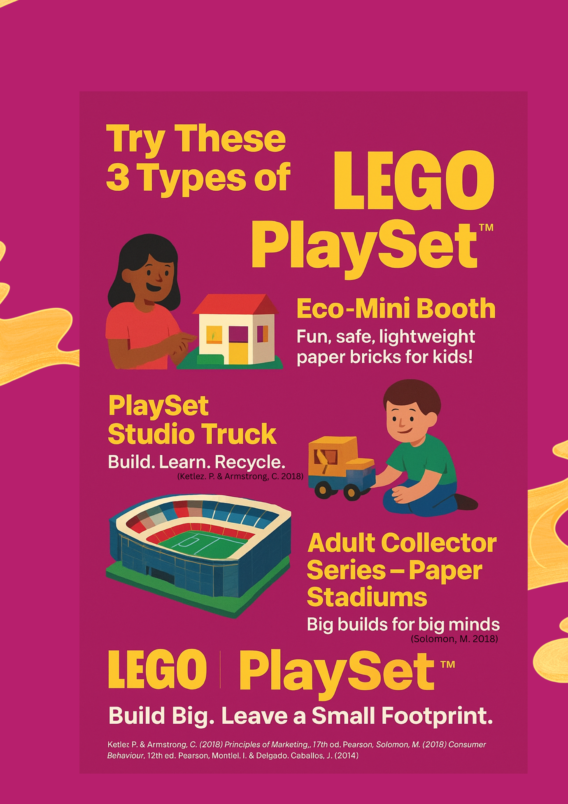

Element 3: Marketing Strategy

The future of imaginative play, where creativity and responsibility collide, is embodied by LEGO PlaySetTM. This new brand offers cutting-edge paper-based construction sets for kids and people who care about the environment, building on LEGO's well-known legacy. Our approach is aimed at adult collectors wanting meaningful, design-led constructions and environmentally concerned parents seeking safe, instructive toys. With items like elaborate Paper Stadiums and Eco-Mini Booths, LEGO PlaySetTM broadens the brand's appeal without sacrificing its essential principles. LEGO PlaySetTM presents itself as a high-end yet affordable substitute for plastic toys by utilising recyclable materials and sustainability-focused marketing. The brand guarantees maximum visibility and convenience through distribution through LEGO shops, online platforms, and lifestyle merchants. In the end, LEGO PlaySetTM encourages users to construct large structures with minimal environmental impact, demonstrating that sustainable innovation can still be enjoyable, imaginative, and lucrative.

Element 4: Reflection

The creation of the LEGO PlaySetTM brand concept gave important insight into the strategic challenges of introducing a viable product within a well-known international brand. The ability to incorporate theoretical marketing frameworks, such STDP and the marketing mix, into a coherent and practical brand proposal was one of the most important abilities acquired during this process. My understanding of consumer behaviour has improved as a result of this study, especially with regard to the growing significance of sustainability and ethical consumption in brand decision-making. I was forced to consider brand equity and innovation balance thoroughly as I examined how LEGO could expand its brand without weakening its core identity.

The development of the LEGO PlaySetTM brand concept provided crucial insight into the strategic difficulties of launching a successful product under a well-known global brand. One of the most crucial skills developed during this process was the capacity to integrate theoretical marketing frameworks, such as STDP and the marketing mix, into a logical and useful brand proposal. This study has helped me better understand customer behaviour, particularly in relation to the increasing importance of sustainability and ethical consumption in brand decision-making. As I investigated how LEGO could grow its brand without undermining its fundamental identity, I was compelled to carefully analyse brand equity and innovation balance.

All things considered, this project has greatly enhanced my professional marketing abilities, inventiveness, and strategic thinking. These skills will be very applicable to both real-world marketing positions and future academic work.
Conclusion
In conclusion, the examination of LEGO playsets highlights the intricate relationship between consumer behaviour, brand management, marketing tactics, and business sustainability. As a well-known brand throughout the world, LEGO has effectively used integrated marketing communications (IMC) to sustain its market position while negotiating changing consumer demands and technology advancements. According to Belch and Belch (2021), developing brand equity and making sure that promotional efforts complement one another require a unified IMC approach. This strategy is demonstrated by LEGO's multi-channel marketing efforts, which integrate digital media, experiential marketing, and traditional advertising to ensure consistent messaging across all touchpoints.
From the standpoint of strategic branding, LEGO's success can be ascribed to its capacity to cultivate deep emotional bonds with customers. According to Keller (2013), associations, experiences, and perceived value are just as important in building brand equity as functional benefits. With their emphasis on imagination, creativity, and education, LEGO playsets produce meaningful experiences that appeal to both kids and adults. According to Euromonitor International (2023), LEGO's strong brand identification helps it stand out from rivals in the fiercely competitive toy and game market.

Reference
Belch, G. & Belch, M. (2021) Advertising and Promotion: An Integrated Marketing Communications Perspective. 12th edn. New York: McGraw-Hill.
Carrington, M.J., Neville, B.A. & Whitwell, G.J. (2014) ‘Why ethical consumers don’t walk their talk’, Journal of Business Ethics, 122(2), pp. 275–288.
Euromonitor International (2023) Toys and Games: Global Industry Overview. London: Euromonitor.
Keller, K.L. (2013) Strategic Brand Management. 4th edn. Harlow: Pearson.
Kotler, P. & Armstrong, G. (2020) Principles of Marketing. 17th edn. Harlow: Pearson.
Kotler, P., Kartajaya, H. & Setiawan, I. (2021) Marketing 5.0: Technology for Humanity. Hoboken: Wiley.
LEGO Group (2023) Sustainability Progress Report. Billund: LEGO Group.
Solomon, M.R., Marshall, G.W. & Stuart, E.W. (2019) Marketing: Real People, Real Choices. 9th edn. Harlow: Pearson.
Peattie, K. & Crane, A. (2005) ‘Green marketing: Legend, myth, farce or prophesy?’, Qualitative Market Research, 8(4), pp. 357–370.
Montiel, I. & Delgado-Ceballos, J. (2014) ‘Defining and measuring corporate sustainability’, Organization & Environment, 27(2), pp. 113–139.

