INNOVATION

PERSUASION

BRANDING
“What is the role of innovation and persuasion and branding in shaping the behaviour of the customer and their loyalty?”

Student: Alexandra Emanuela Craciun
Student number:1816129
Program of study: BA Creative Advertising
Module: Research in Practice ADAD5004
Tutor: Donna Williams
Words count: 2730.

Table of Contents
Contents
Introduction 3
Keyword 1: Innovation 4
Keyword 2: Persuasion 7
Keyword 3: Branding 11
Conclusion 15
References 16

Introduction
The essay has analysed three keywords which are Innovation, Persuasion and Branding. The essay first provided a comprehensive understanding of the term innovation and provided the application of innovation in different sectors.
The theories of Joseph Schumpeter and Friedrich Hayek have been highlighted and using suitable examples a clear understanding of their theories has been provided. Similarly, to explain persuasion the concept has been defined and deconstructed and theories of Aristotle on persuasion have been elaborately explained. Examples of visual persuasion have been provided to support the arguments.
Lastly, the concept of branding has been explained using definitions and models of David Aaker and Keller which helps to analyse the concept and importance of branding.
The essay also has attached images of artists such as Pablo Picasso and designers such as Steve Jobs who contributed to some major innovations that have influenced shaping the world, we live in.

Keyword 1: Innovation
The word innovation and the name of Thomas Edison are spoken together. Hailed as the father of innovation, Thomas Edison believed that necessity was the key element that led to innovation. There are many definitions of what innovation means but their definitions are not suitable for all organisations or individuals. Peter Drucker is of a similar opinion and defines innovation as the creation of value through new ideas. However, a comprehensive definition of innovation has been provided by the Oslo Manual. It defines innovations as the creation of a new or a more refined idea or product which have been made available to the public and helps in solving problems (Arundel et al., 2019). Innovation is the crucial element which promotes socioeconomic growth and evolution (Surya et al., 2021).
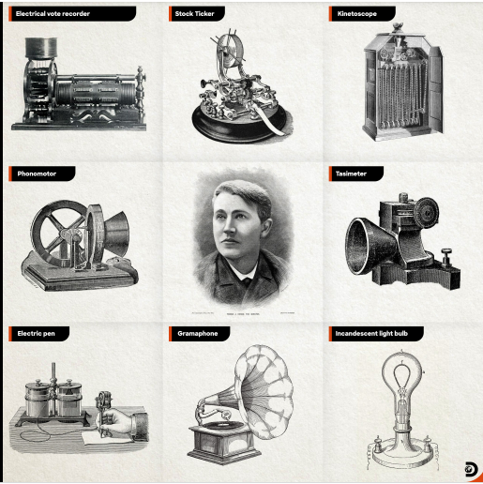
Figure 1Thomas Edison’s inventions (source Discovery Channel India 2021)
The application of innovation can be seen across various areas of our lives in medical advancement, technological advancements and in art (Damar, 2021). Smartphone devices are a result of innovation which has further led to the development of social media and other modern technologies like AI (Torous et al., 2021). These innovations have transformed the way we interact with one another. It is through innovation that development of vaccinations and cures for life-threatening diseases have been developed (Sarkis et al., 2021). The innovations in technology have facilitated e-learning for students and have given them the opportunity to gain vast knowledge. In the field of business, innovation has led to the invention of new products and has helped to make organisations effective and efficient (Marion and Fixon, 2021).
In the opinion of Joseph Schumpeter, innovation helped to create a free market and led to economic growth (Blok, 2021). The concept of “creative destruction” was coined by him and argued that replacing outdated technologies with modern and advanced technologies was indispensable for progress (Sobel and Clemens, 2020). According to his theory, people who lost their job due to the adoption of technologies would allow them to seek new jobs which would promote their productivity (Blok, 2021). The theory of Schumpeter identifies three parts to technological change which are invention or having a vision, innovation to make the vision a reality and diffusion where people tried to imitate the invention. The application of his theory can be illustrated by the invention of the Xerox machine. Chester Carlson developed the concept of the photocopy machine out of necessity, to make it a reality Chester had to seek investors and present them with his ideas and finally after the success of the technology other firms adapted the technology to develop further inventions like the fax machines (Vinokurova and Kapoor, 2020). The philosophy of Thomas Edison that innovation is the result of necessity has been reflected in Chester’s Xerox machine.
However, the theory of Schumpeter has only taken into consideration the economic element in his theory (Blok, 2021). Friedrich Hayek criticises that the application of the theory is not limited to economic progress but has a significant impact on social and political values as well. The political theory that was developed by Friedrich Hayek and his companion Karl Popper focuses on the impact of innovation on the social values of the people. They believed innovation created discomfort as people were sceptical about the consequences of innovation (Brandão, 2021). The introduction of unapplied ideas possessed the risk of causing unwanted issues and disasters. Taking the example of the innovation of video recorders, major film studios were against the invention as according to them possessed a risk to their profits. Innovations in medicines and drugs led to side effects and as such created a bad reputation for innovation (Brandão, 2021). Plato in his book The Republic states that governing management is in the pursuit of the preservation of social order and hence is not supportive of innovations that challenge the order (Hughes et al., 2021).
Designers such as Steve Jobs and artists like Pablo Picasso have contributed to some major innovations that have influenced shaping the world, we live in. The creative innovations of Steve Jobs in the development of the Macintosh and later portable devices such as the Macbook, and iPod revolutionised the music industry, and the iPhone has transformed the way we interact with technology (Hunter, 2019).

Figure 2 Steve Jobs (Source: Schwantes, 2019)
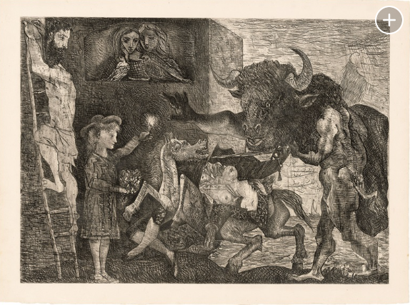

While Pablo Picasso’s innovations gave birth to new forms of art, poetry, and other multiple art forms.
Pablo Picasso (1881-1973), La Minotauromachie, 1935.
Figure 3 Pablo Picasso
(Source: Stewart, 2019)

Keyword 2: Persuasion
Persuasion has been a subject of study since the time of ancient Greece (Fleming, 2019). Persuasion was perceived as an art form and emphasised elocution and the expression of words to be a hallmark of a prominent leader (Akinola, 2019). Perloff defines persuasion as a process where the speaker tries to convince the listeners and influences them in their behaviours and attitudes (Lebedeva, 2020). Persuasion has been used as a tool that helps in influencing the perspective and beliefs. Aristotle’s views and philosophies in rhetoric have made significant contributions to the concept of persuasion. Rhetoric refers to the art of using words in a way that effectively persuades someone and rhetor are referred to the speaker.
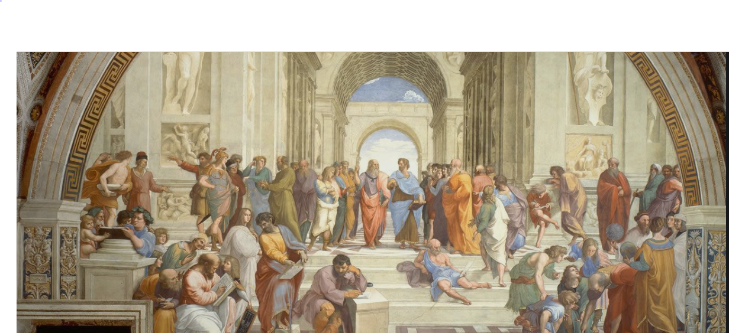
Figure 4 Raffaello Sanzio de Urbino (Raphael), "The School of Athens" (1509-1511)
There are three techniques of persuasion as stated by Aristotle. These communication techniques achieve the primary goal of influencing the attitudes and beliefs of the listener. The listeners can be influenced using reasoning, providing evidence, or making the language emotionally appealing (Amos et al., 2022). The use and application of persuasion can be seen in various institutions such as politics, television commercials, educational institutions, and various other forms of interpersonal communication. In this context, persuasion is used to educate the listeners and inform or influence people to support a political agenda (Amos et al., 2022).
The success of political parties lies in their strength of members, and it is essential for these parties to gather as many members as possible (Widmann, 2021). This is where the political leaders of the parties come forward and through effective speech persuade the mass to support their party. Political theme songs, flyers and promises of development are all forms of persuasion. In TV commercials partnering with popular celebrities to promote a product helps to appeal to the audience and hence persuades them to buy the product or services of the company.
Among the numerous philosophers and scholars, Aristotle has provided a comprehensive explanation of persuasion and categorises persuasion into three groups that are Ethos which appeals to ethics and morals, Pathos helps in emotional appeal and Logos is concerned with a reason (Alkaraan et al., 2023). Ethos addresses the identity of the people and pursues them by using their area of specialisation (Heidari et al., 2021). For example, TV commercials on dental health are acted by people dressed up as dental professionals. This helps to gain the trust of the viewers and provides credibility. The viewers are more influenced as they see a specialist and take their word seriously. Trust is the first element of the trust equation, and then reliability and creating intimacy complete the equation. On the other hand, Pathos compliments Logos in persuasion. The factual evidence element of Logos and the use of facts when combined with the emotional delivery described by Pathos create an effective persuasion (Jovic et al., 2023).
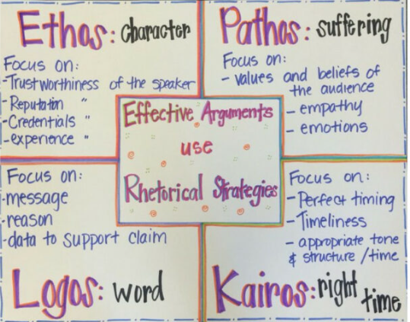
However, there are many challenges to persuasion and the barriers to persuasion such as the resistance level of the audience, suspicion and disinterest of the audience can greatly hinder effective persuasion (Adam-Troian, 2022). As persuasion can influence people to have changes in behaviour and beliefs, unethical practices such as manipulation and fraud can be promoted. The act of persuasion can also create bitterness towards the persuader.
There has been various propaganda in the past that serves as an example of persuasion. During WW1 Britain came up with various posters that persuaded people to join the army and fight alongside Britain. One such propaganda was the use of posters, where the illustration and a statement created a deep impact on the viewers of the poster. “Daddy, what did you do in the Great War” is one such poster that was designed by Savile Lumley which portrays a daughter asking her father what he contributed to the war. The father is filled with guilt as he had not participated in the war (Imperial War Museums, 2019).
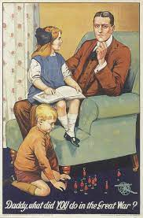
Figure 5 British persuasive poster (Source: Awm.gov.au, 2023)
This was an effective form of persuasion and was directed at men to enrol themselves in the army. Similarly, the “Uncle Sam” poster was used by the US Army to recruit soldiers during WWI (Nationalgeographic.org, 2022).

Figure 6 Uncle Sam(Source: U.S. Department of Defense, 2019)
Persuasive advertisements are heavily applied by many companies by adding elements of trust and highlighting the benefits of their products (Helmold, 2022). They also make use of large fonts to inform the viewers about special discounts and offers.
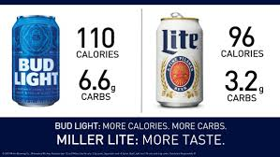
Figure 7 Example of persuasive advertisement (Source: Chi, 2021)

Keyword 3: Branding
The term branding can be defined as the creation of a positive image of a company that accurately sums up its services and products by incorporating the use of logos and a statement (American Marketing Association, 2023). The colour schemes and the overall theme of the branding help companies to create a memorable image with which the customers associate and differentiate. Branding helps companies build a relationship with their customers which promotes other factors such as loyalty and revenue for the company (Khan et al., 2022).
David Aaker has been hailed as the father of modern branding (Brandtuned.com, 2023). The model of Aaker identifies five elements that are crucial for building an effective brand. These elements include generating awareness of the brand, providing quality products and services, associating of people with the brand, listing patents and creating loyalty towards the brand. The model suggests that creating awareness of the brand will positively affect the perception of the people towards the brand (Steenkamp, 2020). This makes them more probable to purchase the products and services of the brand and build continuity in repeat purchases. The increase in loyalty of the people towards the brand reduces the costs of marketing a company making it cost-effective. The increased loyalty also helps to gain new customers as existing customers will advertise the brand through word of mouth. Having strong loyalty enables a company to have enough time to adapt to threats from competitors and generate constant revenue (Steenkamp, 2020). Even though the quality of the product has no relation to the loyalty of the customers. People being habituated to the brand will continue buying the product. People’s association with a brand makes a company unique and makes it stand out from the rest of the competitors in the market. In addition to this, the patents and trademarks of a company also influence the purchasing behaviour of the people.
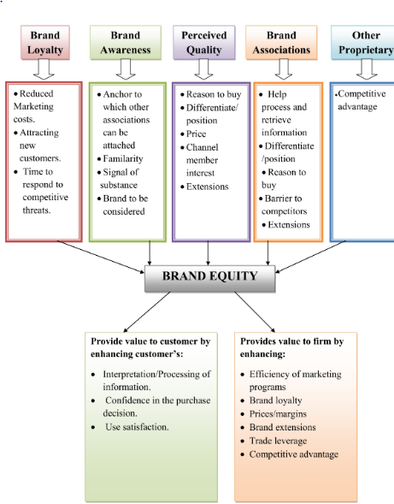
Figure 8 David Aaker Brand Equity Model
Kevin Lane Keller also provides a model on branding which belies that the perception of the customer is what adds value to a brand. The Brand Equity Model of Keller identifies four levels of hierarchy that are associated with branding. These four elements are Brand Loyalty, the response of the customers, the meaning of the brand and the identity of the brand. The company needs to state its mission and vision in order to sustain its brand and create an identity for the brand (Steenkamp, 2020). The purpose of the company needs to be stated which will help to create meaningful products that meet the needs of the customers. The model then states the need to build connections with customers and adapt the brand to generate positive feelings among the customers. On the top of the hierarchy is brand resonance where the customers begin to associate themselves with a brand. Fulfilling the prior stages, according to Keller's model helps to achieve this stage (Keller and Brexendorf, 2019).
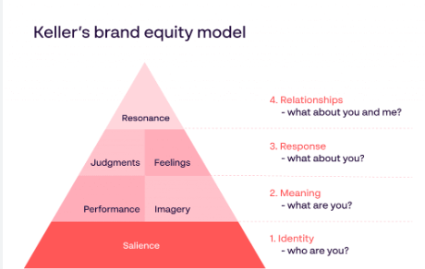
Figure 9 Keller’s Brand Equity Model
The element of storytelling in branding is critical for the success of a brand. Compelling storytelling helps the brand to attain greater loyalty from the customers (Kim and Sullivan, 2019). An example of a brand that has been successful in storytelling is Nike. The brand built a brand that focuses on providing athletes with the best equipment. The mission statement of Nike “Just Do It” has a significant impact on the customer of Nike and resonates with their customers (Savitha and Roopa, 2023). The simple and short tagline has long-lasting impressions on the customers and the phrase when said makes people perceive the brand, Nike.

Figure 10 Colin Kaepernick Nike's Just Do It campaign.

The use of creative elements such as texts, logos and unique colour themes gives a visual appeal to the branding of a company. A thoughtful logo makes it unique and differentiates the brand from other similar companies. The Apple logo has a strong use of imagery and design which has made its logo recognisable and linked to the financial status of a person (Razak et al., 2020).

Figure 11 Apple Logo (Source: Apple, 2023)
Another brand that has considered to have the most recognisable brand logo is Coca-Cola (Tien et al., 2019). The consistency in colours and fonts has helped the company to become a leading brand globally.
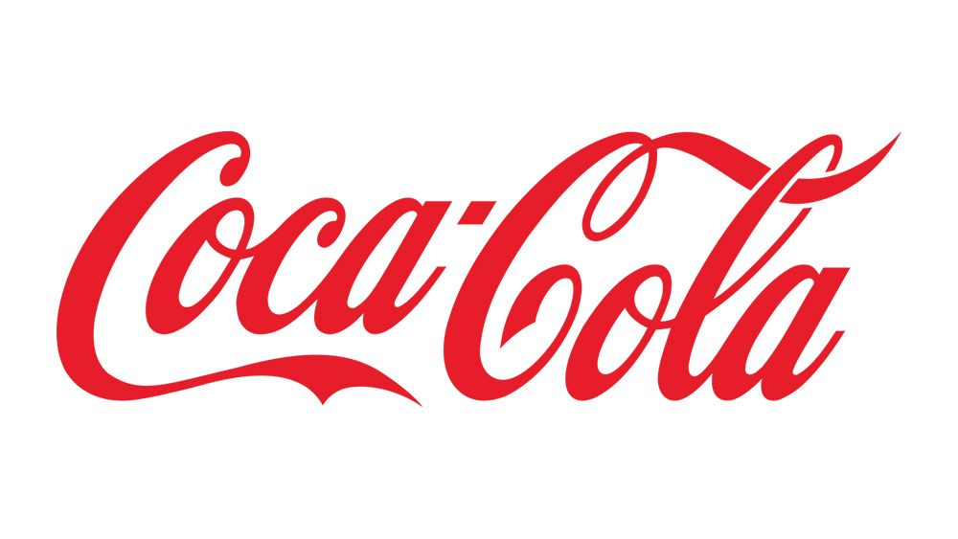
Figure 12 Coca-Cola Logo(Source: Coca-cola.co.uk, 2023)

Conclusion
The keywords that have been explored in the essay are Innovation, Persuasion and Branding. Innovation is concerned with the generation of new ideas and identifying areas of improvement and coming up with effective solutions. It focuses on the development of technologies that not only help in the growth of the economy but have an influence on social and political areas as well. Persuasion on the other hand deals with convincing individuals or groups of individuals to do something or influence their beliefs and values. Persuasion deals with influencing the behaviour of people and is also used by companies and brands to promote the sales of their products. Whereas branding is concerned with creating unique designs for a company that highlights the missions of the company and differentiates it from its competitors. In these ways, these keywords are different in definition and purpose.
Even though the concepts are different in nature there are closely linked to one another. Taking innovation and branding as an example. Innovation of new products and services that are unique can be made popular using strong branding. The innovations help to improve the image of a brand as an innovator. Persuasion can be used to promote the products of the brand which improves sales of the brand. Using persuasion, the brands can effectively communicate the values of the brand with which the audience resonates. Using innovative methods of persuasion helps brands to effectively communicate with customers and change the buying behaviour of the customers.
Research on innovations can help a company to identify new opportunities and act on them to create new products that can be marketed under a brand name. Similarly, effective research on effective methods of persuasion can help a business to form effective posters and advertisements that influence its customers. Incorporating all three keywords and applying them strategically will not only help businesses but enhance the life of an individual as well.
The question that I will be working on in my independent inquiry is “What is the role of innovation and persuasion and branding in shaping the behaviour of the customer and their loyalty?”

References
Adam-Troian, J., 2022. The Fitness-Validation Model of Propagandist Persuasion and the 5Ds of Propaganda.
Akinola, A.J., 2019. Pragmatics of musical rhetoric in the post-2015 elections in Nigeria. Journal of Language and Education, 5(3), pp.11-23.
Alkaraan, F., Albahloul, M. and Hussainey, K., 2023. Carillion's strategic choices and the boardroom's strategies of persuasive appeals: ethos, logos and pathos. Journal of Applied Accounting Research, (ahead-of-print).
American Marketing Association., 2023. Branding Archives. [online] Available at: https://www.ama.org/topics/branding/ [Accessed 15 Apr. 2023].
Amos, C., Zhang, L., King, S. and Allred, A., 2022. Aristotle’s modes of persuasion and valence effects on online review trustworthiness and usefulness. Journal of Marketing Communications, 28(4), pp.360-391.
‌Apple (United Kingdom)., 2023. Apple. [online] Available at: https://www.apple.com/uk/ [Accessed 15 Apr. 2023].
‌Arundel, A., Bloch, C. and Ferguson, B., 2019. Advancing innovation in the public sector: Aligning innovation measurement with policy goals. Research policy, 48(3), pp.789-798.
Blok, V., 2021. What Is Innovation?: Laying the Ground for a Philosophy of Innovation. Techne: research in philosophy and technology, 25(1), pp.72-96.
Brandão, T., 2021. Open innovation: the open society and its entrepreneurial bias. In Handbook on Alternative Theories of Innovation (pp. 162-181). Edward Elgar Publishing.
Chi, C., 2021. Persuasive Advertising: What It Is & How to Do It [+Examples]. [online] Hubspot.com. Available at: https://blog.hubspot.com/marketing/persuasive-advertising [Accessed 15 Apr. 2023].
Coca-cola.co.uk., 2023. Coca-Cola Great Britain. [online] Available at: https://www.coca-cola.co.uk/ [Accessed 15 Apr. 2023].
Damar, M., 2021. Metaverse shape of your life for future: A bibliometric snapshot. Journal of Metaverse, 1(1), pp.1-8.
Fleming, D., 2019. Fear of persuasion in the English language arts. College English, 81(6), pp.508-541.
Heidari, K., Heydarinejad, S., Saffari, M. and Khatibi, A., 2021. Investigating the leisure behavior of Iranians: the structural model of serious leisure, recreation specialization and place attachment. Journal of Policy Research in Tourism, Leisure and Events, 13(1), pp.77-93.
‌Helmold, M., 2022. Promotion and Advertising Strategies. In Performance Excellence in Marketing, Sales and Pricing: Leveraging Change, Lean and Innovation Management (pp. 199-208). Cham: Springer International Publishing.
Hughes, I., Byrne, E., Glatz-Schmallegger, M., Harris, C., Hynes, W., Keohane, K. and Gallachóir, B.Ó., 2021. Deep institutional innovation for sustainability and human development. World futures, 77(5), pp.371-394.
Hunter, N., 2019. Steve Jobs. Capstone.
Imperial War Museums., 2019. Daddy, what did You do in the Great War? [online] Available at: https://www.iwm.org.uk/collections/item/object/17053 [Accessed 15 Apr. 2023].
Jovic, M., Kurtishi, I. and AlAfnan, M.A., 2023. The Persuasive Power of Hedges: Insights from TED Talks. World, 13(5).
Keller, K.L. and Brexendorf, T.O., 2019. Measuring brand equity. Handbuch Markenführung, pp.1409-1439.
Khan, R.U., Salamzadeh, Y., Iqbal, Q. and Yang, S., 2022. The impact of customer relationship management and company reputation on customer loyalty: The mediating role of customer satisfaction. Journal of Relationship Marketing, 21(1), pp.1-26.
Kim, Y.K. and Sullivan, P., 2019. Emotional branding speaks to consumers’ heart: the case of fashion brands. Fashion and Textiles, 6(1), pp.1-16.
Marion, T.J. and Fixson, S.K., 2021. The transformation of the innovation process: How digital tools are changing work, collaboration, and organizations in new product development. Journal of Product Innovation Management, 38(1), pp.192-215.
‌Nationalgeographic.org., 2022. Uncle Sam. [online] Available at: https://education.nationalgeographic.org/resource/uncle-sam/ [Accessed 15 Apr. 2023].
Razak, M., Hidayat, M., Launtu, A., Kusuma Putra, A.H.P.A. and Bahasoan, S., 2020. Antecedents and consequence of brand management: empirical study of Apple’s brand product. Journal of Asia Business Studies, 14(3), pp.307-322.
Sarkis, M., Bernardi, A., Shah, N. and Papathanasiou, M.M., 2021. Decision support tools for next-generation vaccines and advanced therapy medicinal products: present and future. Current Opinion in Chemical Engineering, 32, p.100689.
Savitha, R. and Roopa, J., 2023. A Study on Effect of Content Marketing on Customer Engagement with Respect To NIKE. Journal of Survey in Fisheries Sciences, 10(4S), pp.1806-1816.
Schwantes, M., 2019. Steve Jobs: ‘Technology is nothing’—here’s what he said it really takes to achieve great success. [online] CNBC. Available at: https://www.cnbc.com/2019/10/05/apple-ceo-steve-jobs-technology-is-nothing-heres-what-it-takes-to-achieve-great-success.html [Accessed 15 Apr. 2023].
Sobel, R.S. and Clemens, J., 2020. The Essential Joseph Schumpeter.
Steenkamp, P., 2020. Aaker versus Keller's models: much ado about branding. Ciudad del Cabo, Western Cape, República Sudafricana: Cape Penynsula University of Technology.
Stewart, J., 2019. 10 Surprising Facts About Pablo Picasso. [online] My Modern Met. Available at: https://mymodernmet.com/surprising-pablo-picasso-facts/ [Accessed 15 Apr. 2023].
Surya, B., Menne, F., Sabhan, H., Suriani, S., Abubakar, H. and Idris, M., 2021. Economic growth, increasing productivity of SMEs, and open innovation. Journal of Open Innovation: Technology, Market, and Complexity, 7(1), p.20.
The White House., 2023. Strategy for American Innovation: Introduction. [online] Available at: https://obamawhitehouse.archives.gov/innovation/strategy/introduction [Accessed 15 Apr. 2023].
Tien, N.H., Vu, N.T. and Tien, N.V., 2019. The role of brand and brand management in creating business value case of Coca-Cola Vietnam. International Journal of Research in Marketing Management and Sales, 1(2), pp.57-62.
Torous, J., Bucci, S., Bell, I.H., Kessing, L.V., Faurholt‐Jepsen, M., Whelan, P., Carvalho, A.F., Keshavan, M., Linardon, J. and Firth, J., 2021. The growing field of digital psychiatry: current evidence and the future of apps, social media, chatbots, and virtual reality. World Psychiatry, 20(3), pp.318-335.
U.S. Department of Defense., 2019. WWII Posters Aimed to Inspire, Encourage Service. [online] Available at: https://www.defense.gov/News/Feature-Stories/story/Article/1990131/wwii-posters-aimed-to-inspire-encourage-service/ [Accessed 15 Apr. 2023].
Vinokurova, N. and Kapoor, R., 2020. Converting inventions into innovations in large firms: How inventors at Xerox navigated the innovation process to commercialize their ideas. Strategic Management Journal, 41(13), pp.2372-2399.
Widmann, T., 2021. How emotional are populists really? Factors explaining emotional appeals in the communication of political parties. Political Psychology, 42(1), pp.163-181.
‌

‌

