An assignment focussing on:

Practice Management within Construction Organisations in the UK

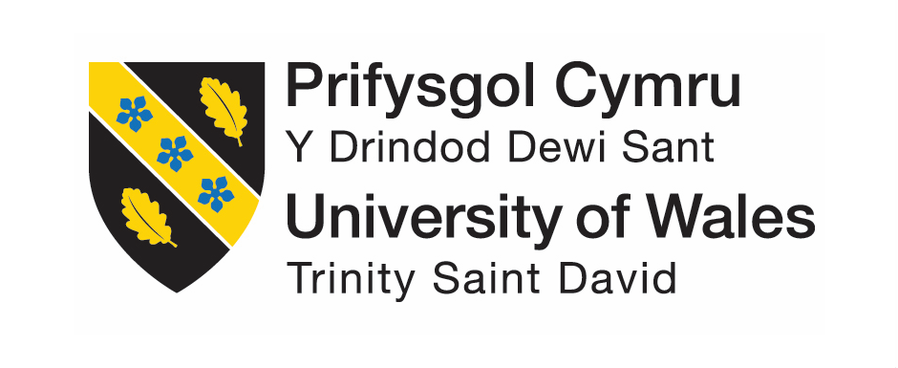
Module: Self-Development, Professional Practice and the Management of Construction Personnel
(ACBA5008)

Prepared for:
R. Cook

Created by:
Natalie Jopling
1911296

Date completed:
10th April 2022

Table of Contents
Page Numbers

- Professionalism and Ethics 3 - 6
- Professional Development – Personal CV 7 - 10
2.1 Personal Development Plan 11
2.2 Importance of understanding Organisational behaviour 11 - 13

- Leadership 13 - 16

- Teamwork 17

- Personal Learning Points 18

- References 18 - 20

- Professionalism and Ethics
Within the Construction Industry, professionalism and ethics is important as it provides feedback of a company’s reputation as well as a personal reputation. It helps win the trust of others, such as customers or contractors and can also be a learning device to teach contactors how to also respect their staff members. Having a professional attitude is needed to show other people how they want to be seen by others. This will all implicate how they want to approach others on certain issues and how they want to discipline others.

Professionalism
Professionalism is to demonstrate certain traits within a workplace. These can be such things as:-
- Competence – This is having good knowledge within your job role as well as being able to solve issues that may arise
- Communication – It is important to be able to communicate clearly with colleagues and make sure everyone is aware of certain situation or changes that occur.
- Boundaries – Having an understanding of professional boundaries are required when information needs to be private and confidential as well as communicating in the appropriate language within the working environment. This prevents not being involved within the gossip which may occur.
As found in historic records, within the Second World War, the ‘US Naval Mobile Construction Battalion Five’, earned a good reputation for their professionalism. They assisted in almost every part of the world building airstrips, roads and hospitals. Since then, certain characteristics are influenced within the workplace (Professionalism in the Construction Industry, 2022). They can be as follows:-
- Appearance – A persons appearance in the workplace can help with your colleagues see you as well as feeling good in yourself, which can lead to being more productive. First impressions are very important as a professional and it will all help towards impressing others (Faro, 2022).
- Behaviour – Behaviour is seen as a form of etiquette within the workplace. A good and positive mindset on behavior can boost morale and allow a nicer working environment (12 professional behaviour tips, 2022).
- Language – The impact of the language and the way of communicating in your workplace will lead people to form an opinion about you. By avoiding foul language and office gossip, it will help with your profession (Professionalism: Language - The Conover Company, 2022).
In order to create a successful professional environment with the construction industry, a variety of managers, skilled and unskilled people must create a budget and complete the project successfully. The teams usually consist of Architects, Civil Engineers and Quantity Surveyors. Each profession has its own responsibility, as explained below:-

Architect
An architect is responsible for the design of the project. They will work within a design team where they will produce technical drawings which will include the site plan and elevations. The architect will take responsibility on responding to any queries that may arise about the drawings and designs. A more senior architect would face challenging tasks such as leadership, consulting and business strategies.
Civil Engineer
A Civil Engineer is similar to an architect in the way that they handle designs as well as improving the surrounding infrastructure areas. The Civil Engineer also handles any queries relating to the drawings, specifications and feedback relating to any technical issues.
Quantity Surveyor
A Quantity Surveyor helps manage the cost of a construction project which can also involve the extension, demolition and maintenance of the build. They can work in a variety of sectors such as commercial, residential and agricultural. Quantity Surveyors should have the ability to manage the cost efficiency of the project as well as obtaining the needs for the client. The design team would initially provide the Quantity Surveyor with a tender pack, which would be inclusive of the project drawings and specifications. The Quantity Surveyor will have the responsibility in gathering quotes from various contractors. As part of their profession, the quotes received would need to be kept confidentially and not articulated to other contractors or members of the project team (RICS, 2022).

Regarding professionalism, there is one incident in work I can recall regarding the invoicing procedure. Once a contractor has finished a job, they will submit an invoice as well as an installation form, which provides a list of the works they have completed. The site manager is required to sign this form, as well as the invoice, to confirm they are happy with the work completed. The accounts department has a list of site manager’s signatures to check that they match what we receive from site. We received an invoice from a carpentry company where we queried the signature on the documents, as it wasn’t one that was not recognized. It turns out that the site foreman, who was working from an agency, had signed the documents. The construction department were aware that it is an unacceptable practice and not in the company’s policy. The invoice was returned to site and asked to be signed by the site manager. As this caused a delay, it not only made the commercial department look unprofessional, but also Persimmon PLC as the invoice had missed the deadline date to the accounts department and was unable to be paid on time. The contracts manager of the site was made aware and asked to remind the site manager about the companies rules and requirements, in order for this to not happen again, The commercial department also reminded the carpentry contractor, that as per their Terms and Conditions, they need the site managers signature on all invoice documents and an agency workers signature would not suffice.

Ethics
Ethics within the workplace begins from the way the staff members are treated, developing equality and providing good morals. Providing good ethical practices can implement a good reputation for the company, which is highly beneficial (CHAS, 2022). The ways of knowing if a workplace has good ethics is:-
- High staff retention
- Staff feedback
- Word of mouth recruitment
- Ethical perks such as an extra day off a year for your birthday

The company I work for, ‘Persimmon PLC’, provide seven sub-heading ethical codes. They are listed below as well as an explanation on how they expect employees to comply.

Integrity
Persimmon PLC expects their employees to act with integrity when it comes to having a business relationship. They expect employees to be professional and fair when dealing with contractors/customers and not to engage in any unethical practices such as bribery (Code of Ethics, 2022).

Objectivity
Persimmon PLC advice that an employee should observe the terms of the employment, however, if they do not want to engage in an activity which they see as unlawful or are unethical, they have the right to decline and report to their line manager.

Financial and other involvement
Persimmon PLC requires their employees to report any problems which may be created by personal or financial involvement. This is permitted within the employee’s contract of employment and any doubts should be reported to their line manager in writing.

Standards
Persimmon PLC allows an employee to not perform or accept a task where the employee is not competent to undertake unless they have been advised to complete the work competently.

Confidentiality
Persimmon PLC expects employees to not release any information which isn’t public domain, which would be a person who isn’t a member of staff. This is both during employment as well as when employment is finished.

Courtesy
Persimmon PLC expects all employees to engage with other co-workers with consideration and courtesy throughout their employment. No disrespect, harassment or bullying is not tolerated. If an employee feels they have witnessed this, or feel they could be a victim, they need to approach their line manager.

Membership of Professional Bodies
Persimmon PLC requires their employees who are members of professional bodies to comply with the ethical standards that are provides by those bodies.

Ethics within the construction industry can also comply with the ‘Corporate Social Responsibility’, or known as the acronym CSR. The CSR is lowering the possible negative effects on the businesses operation and concentrating on the positive effects. These could be reducing the risks of modern slavery, contributing to local economies as well as climate change. It is important to focus on this whilst in the construction industry as projects can have a big impact on a community and competitive prices can affect small local businesses.

- Professional development – Personal CV

NATALIE ANNE JOPLING
8 Ger Y Coed, Pontyates, Llanelli, Carmarthen, SA15 5UN
Email: jopling1@hotmail.co.uk
Mobile: 07817 571 289

Profile:
Conscientious hard working individual; I am confident working on my own initiative as well as a capable team player. I have good interpersonal skills to support a pro-active work ethic and possess a great eye for detail in order to complete tasks to a high standard, as well as an efficient employee possessing many transferable skills. I always strive to achieve the highest standard possible, at any given task in any given situation. I am accustomed to working in a fast pasted and challenging environment, particularly when dealing with a variety of live projects and priories at the same time.

Key Skills
- Team Player – engaging as a team member
- Time Management – efficient scheduling of priorities and used to diary management
- Customer service – used to dealing with clients/customers and providing service
- IT literacy –Microsoft packages and current payment system ‘COINS’
- Confidentiality – trusted staff member
- Office practice – ranging from general administration duties to problem solving
- Data Entry – accurately and timely entry of details in order to ensure adequate record keeping

Career History

March 14th 2017 – Current Persimmon Homes LTD - Trainee Quantity Surveyor
Within my current role I organise the initial health and safety information/meetings prior to any work starting on the sites. I do the administration work for the department as well as working directly with a senior Quantity Surveyor. I am also currently studying Quantity Surveyor at HND level and have completed a level 5 NVQ for Construction Management. My daily jobs include site visits, data entry, invoices for a variety of contractors and direct labour, procurement, tendering, final account queries, retention queries as well as general administration duties such as photocopying, scanning and daily emails.

May 2015 – Jan 2017 Alexandra Chambers Solicitors - Conveyancing Assistant
Reporting to the New Build team; responsibilities included dealing with all aspects of administration within the Conveyancing Department, for example client enquiries, scanning, filing, answering the phone, data entry, dealing with monies and confidential information. I have gained a vast amount of

knowledge/experience in Help to Buy Procedures, Registering Transfers/Leases of Part together with relevant Management Company Restrictions, dealing with Local Authority Affordable Housing and the documentation involved.

March 2013 – May 2015 DW sports fitness - Supervisor & Duty Manager
Supervisor/Manager role in a large retail business, duties included general retail duties, data entry, stock control, banking along with man-management and ensuring targets and priorities within the business were achieved

Oct 2012 – Mar 2013 The Village Hotel /Starbucks - Receptionist/Barista
Receptionist within a hotel environment whilst working within a food service entity, both of which required customer service skills and a pro-active approach to multi-task duties accordingly

Aug 2012 – Oct 2012 Admiral Car insurance (CCR) - Advisor
Call centre environment dealing with client/customer requirements and arranging car insurance accordingly

May 2010 –August 25th 2012 DW sports fitness - Supervisor
Store Supervisor ensuring the smooth running of the store and that sales targets were achieved

Jan 2007 – May 2010 – varies retail roles and training in customer service skills

Education
Penyrheol Comprehensive Gorseinon College
Educated to GCSE level Educated to A Level
English Media Studies
Geography Photography
French
Music
Physical Education

University of Wales Trinity St David
Higher National diploma
Quantity Surveying – Complete in June 2022
Level 5 NVQ Construction management – Completed September 2021

Other Qualifications
Edexcel BTEC level 2 in hospitality and catering principles
Edexcel level 2 NVQ diploma in food and beverage service
Edexcel level 1 essential skills in communication
Edexcel level 1 essential skills in application of number
Edexcel level 1 essential skills in Maths
Edexcel level 2 essential skills in English
Edexcel level 2 essential skills in information technology

Interests and Activities
I enjoy spending time with my partner, friends and family. I thrive being in the outdoors walking our family member’s dogs, as well as working out in our garage gym. I have a fondness of listening to podcasts and documentaries as I enjoy learning about a variety of topics, mostly psychology and life skills. I have a grade 6 in piano and am also graded in Tap and Modern dance.

Personal Information
Nationality: British
DOB: 03.02.1988
Full Clean Driving Licence

References
Matthew Mellor Joel Phillips
Persimmon Homes West Wales DW Sports Fitness
Penllergaer Trostre Retail Park
Swansea Llanelli
SA4 9HJ SA14 9UY
Tel: 01792 229800 Tel: 01554 740810

2.1 Personal Development Plan

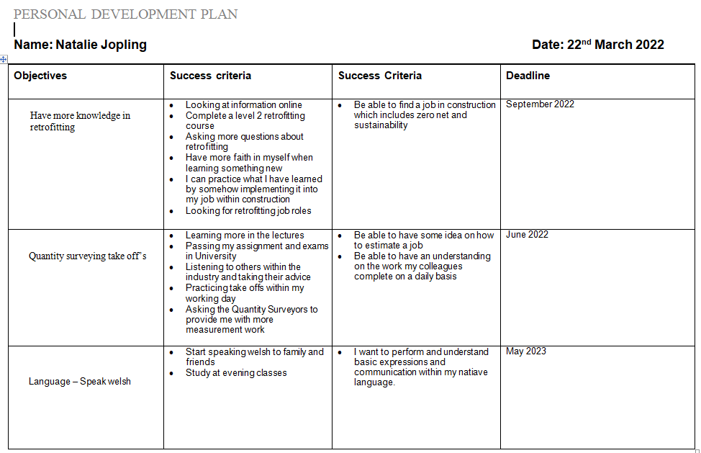
(www.dexform.com, n.d.)

2.2 Importance of understanding Organisational behaviour

Organisational behaviour is the study of human behaviour in organisational settings. Well-known philosophers Plato and Aristotle analysed components such as clear communication and leadership. They are a basic practice in today’s society and helped produce the foundation for organisational behaviour in the past (Organizational Behavior: Definition, Importance, Nature, Model, 2022). Organisational behaviour can be divided into three separate parts as shown and explained below:-

- Human behaviour in an organisational setting
- The individual-organizational initiative
- The organisation

Human behaviour
Each individual brings to an organisation a unique set of personal characteristics and a diverse personal background, with a set of experienced from other organisations. When considering the people who work in the organisation, one of the most important keys to become a good manager is to look at the unique perspective each individual brings to the work setting. This requires a good knowledge of understanding behaviour and attitudes and how they are possibly influenced by an organisation or by manager’s actions. It is good practice to have an understanding of different personalities within a team setting (Organizational Behavior: Definition, Importance, Nature, Model, 2022).

The individual organisational initiative
Following from the human behaviour, individuals come in contact with other people within their workplace in a variety of ways. These ways could be co-workers, managers and procedures and policies of the organisation. Over some time, individuals change through their learning from personal experiences, work experiences and organisational development. Recently, people would have seen a change within the global economy and would have been working remotely using technical systems like Microsoft Teams and Zoom. A manager would need to understand the difference between the work-life and home-life with their team and possibly offer more interaction on phone calls as well as offering little and often breaks to help focus (Cross and Carbery, 2021).

The Organisation
An organisation exists before a person joins it and will continue once a person leaves. The organisation represents a third person perspective from which to view organisational behaviour. Organisations benefit from organisational behaviour as it offers a company to have engaged happy employees with clear goals and a good business strategy as well as lack of conflict and a good direction path. By listening to employees, building their work and gaining trust, results have shown that managers have boosted performance (Cross and Carbery, 2021).

Organizational behaviour can be considered as an applied science to build the mind and body of knowledge in order to improve the working world. Research in organizational behaviour can be collection by testing certain theories such as the below:-
- Case studies – This would require a study with either an individual or group which would include observations over time and an analysis of interviews
- Survey research – This would involve the surveys of population. Once the survey is complete, the information is gathered and is analysed using statistics in behaviour across the individuals and groups
- Interviews and focus groups – This would include interviewing both individuals and groups which can be highly structured and all answers would be analysed as data.

With the change in globalisation, it has created a context where people can complete work and organised their careers. This change has created a variety of experiences for managers such as managing virtual teams due to the differences in time zones. Larger organizations are multi-national and are spread across a variety of countries. As a manager, the importance of collaborations and communication will be a new task to consider. When different countries are involved, a cultural difference will be an important aspect to consider. As an example, a manager could introduce a new scheme which works incredibly well in Spain and the UK, but the scheme could not work as well in China due to the cultural difference (Cross and Carbery, 2021).

3. Leadership
Leadership is an important role in a team environment as it is usually the person who makes sure the team and working well together, as well as achieving the goals needed to perform well (Constructingexcellence.org.uk. 2022). The leader tends to be the role model and is good with communication and provides an honest and understanding attitude. The leader provides opportunities for all members of the team, to contribute their ideas when it comes to solving problems and achieving solutions (Lee, 2022). There are seven known primary leadership styles when taking into consideration peoples personality types.

Autocratic
An autocratic leadership is when one person takes lead and makes all the decisions, whilst allowing very little input from other members of the team. They reply on their own decisions and do not allow suggestions and advice from others. The characteristics of an autocratic leader are dictating all tasks with no recognition being provided once it is complete, which causes a lack or morale within the workplace. This type of leadership is commonly seen in smaller companies with fewer employees. It is used in best practice when a quick decision needs to be made, which provides the outcome of all responsibility landing on the autocratic leader (What is Autocratic Leadership? Definition of Autocratic Leadership, Autocratic Leadership Meaning - The Economic Times, 2022).
Authoritative leadership
Authoritative leadership is an effective type of leadership but can also be controversial. The leaders will do whatever it takes to get a task completed, which when completed well, provides quick decision making. It is a similar leadership type as an autocratic; however an authoritative leader helps coach and progress employees. They will show the employee how to complete a task and will let them continue it on their own. An authoritative leader will set boundaries and organise goals with what standards the company are expecting. If any issues occur, the authoritative leader usually keeps calm and will address the problem in a transparent way, which will help the employees learn how to handle a certain situations for the future (What Is Authoritative Leadership? | Indeed.com, 2022).

Pacesetting leadership
A Pacesetting leader thrives on tasks to be completed faster, better and to a high standard. If they notice a poorer performance from certain people within the team, they will expect better from them going forward. A pacesetting type of leadership is used at its best when trying to grow a new business. They expect team members to be motivated and capable as well as providing good results. With this style of leadership, employees can feel pushed by the leader if it is applied poorly. The leaders could come across with lack of empathy and could become blind to their own negativities (Pacesetting Leadership Style - Coach You: Executive, Leadership and Team coaching, 2022).
Democratic leadership
A democratic leader consists of being in-charge of a team, but includes everyone involved when problem solving and making a decision. They welcome all input but they do make the final decision. A democratic leader usually makes team members feel like they are an important part of the team when welcoming their ideas. They show employees respect and most importantly trust, which is usually reciprocated by their team members. This leadership style is one of the most powerful types as it helps identify potential within a team by letting them feel a part of the team, and promoting creative ideas. The employees feel like they are a part of a team which helped build high staff morale and commitment (Rolstone, 2022).
Coaching leadership
A coaching leader has attributes of fulfilment and collaboration, which is important within the construction industry. They create a high level of a performing type of leadership by unlocking potential in employees. They are active listeners and have skills of learning and developing (What is a coaching leadership style?, 2022). They believe in behaving as coaches by enabling communication and creativity with employees, which allows them to make their own decisions and succeed. This type of leadership is best used when an employee needs encouraging and motivation which will help to reach their goals (What Is the Coaching Leadership Style?, 2022).
Affiliative leadership
Affiliative leadership is more of an emotional leadership where it uses positivity, team building and a happy workplace. It focuses on resolving any conflict that may arise as well as creating a connection between employees to help gain trust. This type of leadership creates good morale between the employees, by introducing unity within the workplace, as well as reducing the turnaround of staff within a company. It also creates powerful teams in a way where they work well collaboratively, by forming a close bond which provides job satisfaction. With possible stress levels rising in work places, this type of leadership also helps lower the levels, as it promotes caring aspects and positive interaction. It helps reduce a negative working environment (Affiliative Leadership: Definition and Tips | Indeed.com, 2022).

Laissez-faire leadership
Laissez-faire, which means ‘let it be’, is a type of leadership that is useful for people who prefer to work on their own. They tend to have a leadership style where they leave the decisions up to the employee, by taking into account the strengths and weaknesses of each person. As long as the employers work actions do not conflict companies rules, they will let them continue to do what they think is best, to complete the companies goals. This type of leadership is suitable for employees who are confident in their work and what tasks they are set, as they enjoy taking responsibilities and showing off their abilities. Laissez-faire leadership usually provides constructive criticism which can benefit employers for their future. This type of leadership could cause employers to feel overwhelmed by feeling they are left to deal with certain tasks that they cannot manage (Laissez-Faire Leadership: Definition, Tips and Examples, 2022).
With the different leadership types mentioned above, within my workplace, I can think of a particular situation where a director has used the autocratic leadership style. This person in particular has all the traits of an autocratic leader, where they expect quick results and provide no recognition of work, which has resulted in a negative mind set towards this individual. I have witnessed on many occasion this director approaching a particular employee, in front other members of the team, with an intimidating persona when asking a question about a particular topic. This situation happens to a certain staff member quite often as I feel like they are more of a team player who avoids conflict. This employee has admitted to me that even if they have been told to put on hold a certain task by another director, if they are approached by the autocratic leader as to why it is incomplete, they will not mention that they were told to not perform the task. The reasoning behind this is because they do not want to get another team member in trouble.
The director with the autocratic leadership approached this employee with a question as to why a carpentry tender had not been issued for a new site that was starting in two months’ time. The employee had received the amended drawings three days prior to the director querying this, and with this particular employee being a member of the commercial department and not the technical department, this was still deemed as his error and he received the backlash for the delay. The director raised his voice at this employee and embarrassed him in front of his team members. He wanted to task to be completed quicker than expected and deemed decision of the employee as the wrong way to work. He demanded the work to be completed by the end of the day, which caused much stress on the employee as he had other deadlines to reach on the same day. This is a common occurrence with this particular director, which causes low morale and low respect from employees in the company. Staff members do not know what to expect on certain days as his personality changes so often. This creates issues within work where he is not an approachable leader.
I feel like this director could have approached this situation in many different ways. Firstly, the director could have asked the employee to go into their office, to have access to privacy from other employees. This would have lowered the lack of embarrassment and awkwardness from others. If the director had listened to the employee when he initially explained the situation, he would have realised that the drawings had only just been received from the Technical Department. The director should have been more understanding with the situation, rather than to aim blame at this particular person. The director needs to think about the way he approaches situations by lowering the tone of his voice. I feel he think the louder he is, the more authority he has, but in reality, he looks like he is bullying employees within the company.
My own ways of leadership would be very similar to an affiliative leadership style. When I worked in DW Sports gym, as a supervisor and duty manager, I would always try to create a positive working environment. I would try to start the shift with a positive mind-set and felt like I had a close bond with other employees. If I was on a morning shift, the busiest time of the day would be on the café area at lunch time. There would be an influx of women coming from their aqua aerobics class, expecting to have lunch with friends. There would only be one member of staff working on the café who was expected to serve drinks as well as cook the food. As the manager, I would organise my tasks around that particular hour of the day, in order to help my colleague with the rush. I feel like this approach provided good team work as well as respect for one another.
If I was working the evening shift where the busiest time would be between 6pm and 8pm, I would prioritise my time in both the gym area and changing rooms. There would be no-one working on the gym area and only one member of staff working as a general assistant in the changing rooms/pool side. I would be an extra pair of hands to complete the 20 minute pool checks, as well as go to the weights area to tidy up. I find having a leadership style where you provide a high level of being a team player reciprocates respect amongst employees.
If a team member would for any reason be upset during their shift, I would show them that I am an approachable person, whom would be willing to listen to their problem, as well as keep it fully confidential. I would allow employees to have as many toilet breaks as they wanted and to have unlimited teas or coffees during their shifts. These little benefits help boost morale for all.
I completed a personality test during a lecture which resulted in my personality being like a ‘Golden Retriever’. The benefits of this personality type showed I am loyal, a great listener, empathetic, team player, patient, easy going and supportive. The negatives of this personality type showed that I am indecisive, as well as struggle when it comes to authority, which are both true statements. I feel like I could be taken advantage of on times with these traits, as I could come across as being soft and too easy going. I am also an advocate, where this also has its strengths and weaknesses. The strengths include insightfulness and passion and weaknesses such as being sensitive to criticism and being prone to being exhausted due to the lack of self-care.

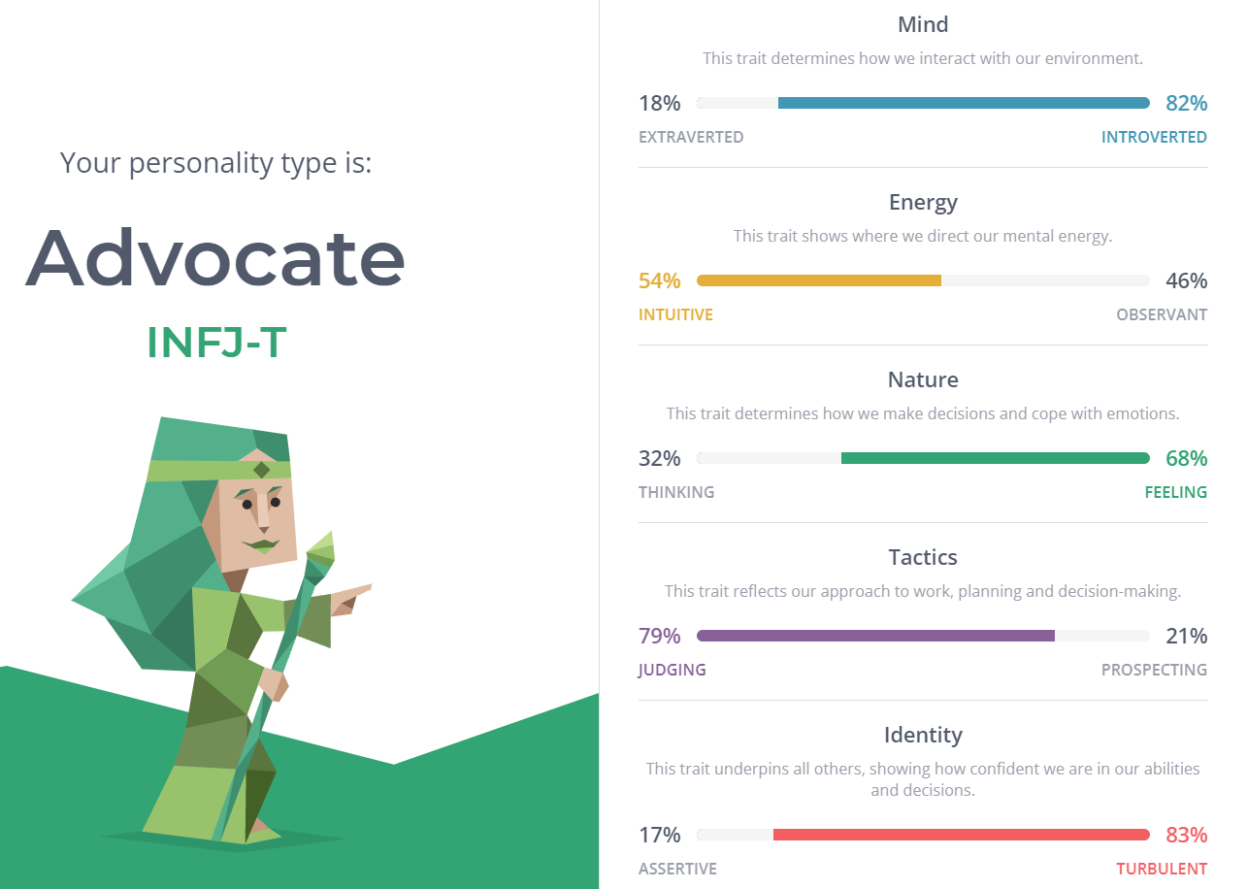

- Teamwork
Teamwork, especially within the construction industry, is a collabroative activity. It provides various groups of people with certain skills, to work together and co-ordinate a task efficiently. A successful teams consists of trust, helpfulness and team spirit. Found within a time, there is usually somone who is the leader and someone who is the co-ordinator. Within my current role and previous job roles, I have always thrived on being a team player. As mentioned above, when I previously worked in a gym as a supervisor / duty manager, I received positive feedback from members of staff. I would not hesitate to help every department when it was needed. This could have varied from cleaning, to reception as well as putting the weights away in the gym area. I feel this way of managing a team is very important as it shows a large amount of respect and no matter what department you work, we are one team. The saying ‘you scratch my back and I will scratch yours’ is a good example of helping others, but also hoping the appreciation is reciprocated. Within my current job role, as I am the Commercial Secretary, I try my best to help the Quantity Surveyors as best as possible. If I am aware of certain deadlines that are approaching, I will ask the team if there is anything I could do which would help lower their work load. I feel this is extremely important, especially in recent months, as budgets are being changed often due to rises in costs which causes more work for the Quantity Surveyors.
Working together as a team makes daily tasks much easier. Since working remotely, it is also important to be aware of team members mental health and possibe personality changes. As working as a team is a daily occurance, changes in a persons ways could be an obvious sign of stress and anxiety and I feel that by anyway of lowering that feeling for someone would be a positive outcome for both parties.
Communication is key when working as part of a team. Organising weekly team meetings and updates are valuable for both business and social reasons. Business reasons could vary from informing the team of any future actions to future allocations of new sites. By having this information, the allocated person has been given the opportunity to prepare ahead of schedule. Social meetings give colleagues their chance to voice any ideas or worries they may currently have. I also think it is important to have social time outside of work to get to know the team in a non-work environment (Constructingexcellence.org.uk. 2022).
When looking at the mental health aspect within teamwork, we studied information about wellbeing within construction. A study showed that 1/5 of a workforce can be off at any one time due to stress, depression and anxiety (Youtube.com. 2022). The study showed that 87% of the construction industry is male dominated and projects could be based away from their home. This could cause stress and loneliness but as a macho dominated industry, it is not shown. The other factor is that 53% of the industry is made up of self-employed workers which can lead to money worries. As being a part of a team, providing this knowledge to colleagues could help them without you even knowing.

5. Personal learning points

- Covid 19 impact on the construction industry – Changes with supply chains, new health and safety measures such as social distancing & delays with timetables
- Code of practice – Looking at what it means and how it can help with working practice
- Professionalism
- Time management
- Communication
- Appearance
- Knowledge
- Legislative changes and guidance
- Health and Safety – Importance of RAMS
- Project planning – Information from Kier about the start, middle and end of planning a project
- Professional Indemnity Insurance – Covers firms and people when errors are made
- Mental Health and Wellbeing – Understanding what factors can affect people mental health within the workplace, how to manage symptoms and how to address them
- Professional Development
- Conflict Management – Understanding how to manage a positive outcome when people disagree over a topic
- Retrofitting – Understanding how to fit new systems that are designed for high energy efficiency and low energy consumption. Into buildings that have previously been built.
- Understanding personalities – Having a good understanding on how personalities differ

6. References

2022. [online] Available at: <https://www.chas.co.uk/blog/promoting-good-ethics-in-construction/>

Constructingexcellence.org.uk. 2022. [online] Available at: <https://constructingexcellence.org.uk/wp-content/uploads/2015/03/Teamwork_Guide.pdf>

Coach You: Executive, Leadership and Team coaching. 2022. Pacesetting Leadership Style - Coach You: Executive, Leadership and Team coaching. [online] Available at: <http://www.coach-you.co.uk/pacesetting-leadership-style/>

Cross, C. and Carbery, R., 2021. Organisational behaviour. 2nd ed. Ursula Gavin, p.12

Faro, T., 2022. How Important is Appearance in the Workplace?. [online] Skills Portal. Available at: <https://www.skillsportal.co.za/content/how-important-appearance-workplace>

iEduNote. 2022. Organizational Behavior: Definition, Importance, Nature, Model. [online] Available at: <https://www.iedunote.com/organizational-behavior>

Indeed Career Guide. 2022. Affiliative Leadership: Definition and Tips | Indeed.com. [online] Available at: <https://www.indeed.com/career-advice/career-development/affiliative-leadership>

Indeed Career Guide. 2022. Laissez-Faire Leadership: Definition, Tips and Examples. [online] Available at: <https://uk.indeed.com/career-advice/career-development/laissez-faire-leadership>

Indeed Career Guide. 2022. What Is Autocratic Leadership?. [online] Available at: <https://uk.indeed.com/career-advice/career-development/autocratic-leadership>

Indeed Career Guide. 2022. What Is Authoritative Leadership? | Indeed.com. [online] Available at: https://www.indeed.com/career-advice/career-development/authoritative-leadership

Katie Roberts Career Consulting. 2022. 12 professional behaviour tips. [online] Available at: <https://www.katieroberts.com.au/career-advice-blog/12-professional-behaviour-tips/>

Lee, E., 2022. Leadership Styles. [online] CPD Online College. Available at: <https://cpdonline.co.uk/knowledge-base/business/different-leadership-styles/>

Persimmonhomes.com. 2022. Code of Ethics |. [online] Available at: <https://www.persimmonhomes.com/corporate/about-us/code-of-ethics/#:~:text=All%20employees%20should%20conduct%20themselves,tolerate%2C%20harassment%20of%20any%20kind.>

Performance Consultants. 2022. What is a coaching leadership style?. [online] Available at: <https://www.performanceconsultants.com/what-is-a-coaching-leadership-style>

PositivePsychology.com. 2022. What Is the Coaching Leadership Style?. [online] Available at: <https://positivepsychology.com/coaching-leadership-style/>

Rics.org. 2022. [online] Available at: <https://www.rics.org/globalassets/rics-website/media/qualify/pathway-guides/quantity-surveying-construction-pathway-guide-chartered-rics.pdf>

Rolstone, G., 2022. Democratic Leadership | Delphinium. [online] Delphiniumcc.co.uk. Available at: <https://delphiniumcc.co.uk/democratic-leadership/>

The Conover Company. 2022. Professionalism: Language - The Conover Company. [online] Available at: <https://www.conovercompany.com/professionalism-language/>

The Economic Times. 2022. What is Autocratic Leadership? Definition of Autocratic Leadership, Autocratic Leadership Meaning - The Economic Times. [online] Available at: <https://economictimes.indiatimes.com/definition/autocratic-leadership>

Ukessays.com. 2022. Professionalism in the Construction Industry. [online] Available at: <https://www.ukessays.com/essays/construction/the-professionals-of-construction-industry-construction-essay.php>

Youtube.com. 2022. [online] Available at: <https://www.youtube.com/watch?v=9vo2QodLDAk>

