



Ash Edwards,
65 Llandeilo Road
Crosshands,
Llanelli.
1704521@student.uwtsd.ac.uk
0790013207
Mr Dwayne Pipe,
Procrastination Nation,
123 Letsbe Avenue,
Bristol,
SMPH 123.
17th March 2019

Dear Mr Pipe,

I would like to apply for the role of staff script writer with your production company. As requested, I am enclosing my CV.
2:1
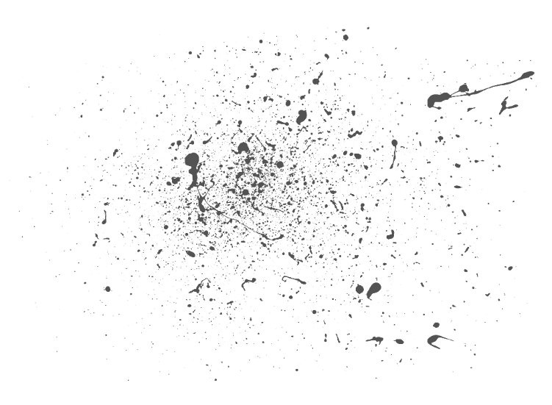


I am in my 2nd year of a Film degree at UWTSD and am expecting to graduate with a First. I am an experienced scriptwriter specializing in comedy and sitcoms. Writing is a passion of mine and having spent a great deal of time on this so far during my degree, writing was a hobby and creative outlet before joining and I now hope to make it a profession with your assistance
I am creative, punctual, versatile, confident, an actual human
I have many great ideas.
I can write to a deadline
I have Microsoft word
During my time at university I have done consistently well in the written modules and have yet to have a mark below 70 in my second year. I have written several comedic scripts all of which have received positive feedback, one of which I adapted into a short movie ‘The Dog is Dead’. I am almost very well organized and I am competent at the preproduction aspects of film. My major influences and inspirations are Kevin Smith, Ricky Gervais and Graham Linehan.
You should hire me because I am an actual person and will work myself to the point of an anxiety attack. I am happy doing vast amounts of preproduction work and am quite confident* in my ability to string together a sentence. I am also good at organizing a Gantt Chart for a production. I can work well with others, and I am excited to work as part of an inspirational company such as yours.


Cheer very much
looking forward to your reply,
ASH EDWARDS



*one of the few things I am confident in
Disclaimer: most of this is not true

