Rhodri Jones Student Number: 2118434
Advanced Manufacturing Operations/ Engineering Management
L4 –Quality & Business Improvements
ACMA4004
Quality Tools & Root Cause Analysis

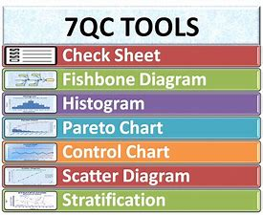

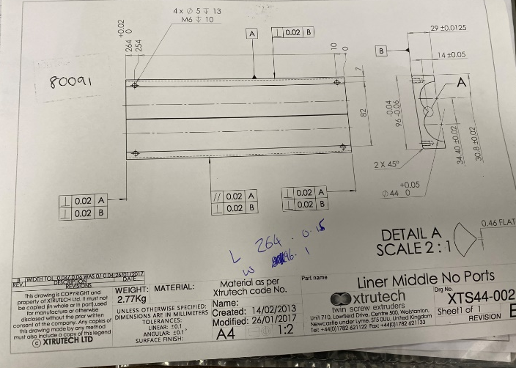


Contents Page

Page 1: Cover Page

Page 2: Contents Page

Page 3-4: Introduction & problem identification

Page 4-5: Data collection and analysis of original process

Page 5-6: Root cause analysis

Page 6-7: Data analysis of Improved process

Page 7-8: Action plan

Page 9: action plan & References Page.

Page 10: references

Introduction
This Report will be identifying and discussing a manufacturing method carried out in the company I work for called FSG tool and Die and identifying improvements which could be made to the process and then implementing the improvements which could be made to the process which in turn could benefit the company and make the process much more efficient in machining the component in question. In this report there will be use of numerical data as evidence to show the process improvement throughout my analysis, and also use Root cause analysis to identify the main issues with the process and produce an action plan for the future using the improvements discovered.

Process Identified with areas needed for improvement.
While working in the factory I have been machining components on a CNC milling machine for one of our customers and I while working on this job I have realized that the process can be improved to increase the factory efficiency and increase the products final overall quality.
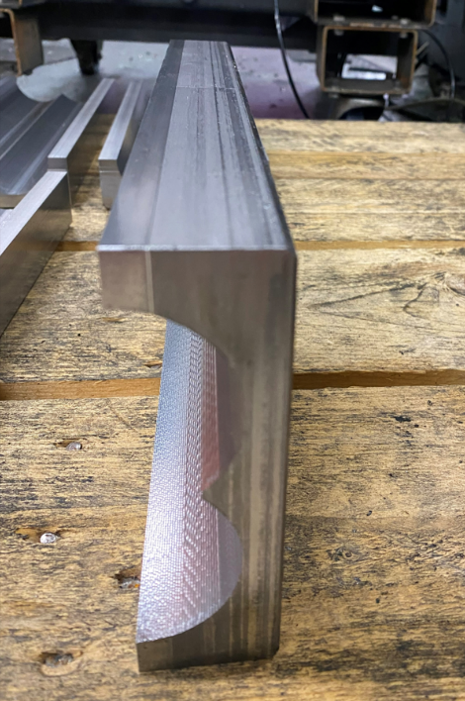
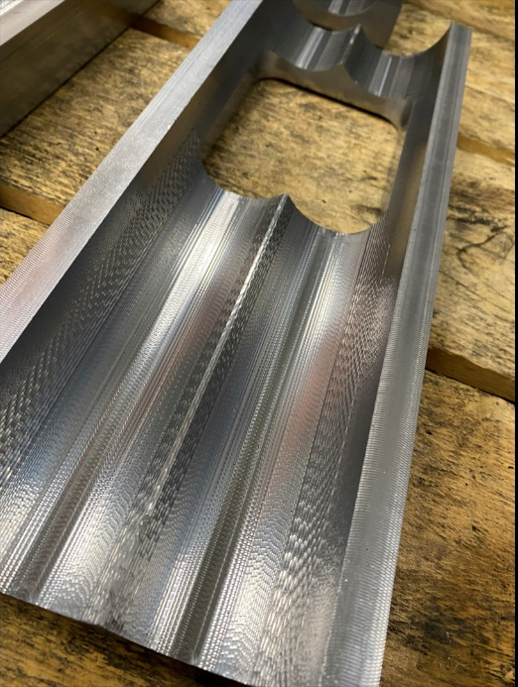
Here you can see Two Profile images of the product in question after it has been completed using the original production method which I will be improving in this report.
While working on this machine manufacturing these parts, some key issues with the process were discovered which were harming the products quality and in turn also the efficiency of the machining process. The Main issues that were detected included the overall cycle time to machine a single part on the machine which had a total 8 hour cycle time which I knew could be improved and also the Final product finish on the two Radii channels, as it was very rough and jagged where it should really be a smooth shining surface finish. After discovering the main areas for improvement on the process, investigations began to identify what were the main causes of these defects in the product, such as the poor finish and the extremely long cycle time. After assessing one of the components being machined and taking notes a few key factors were discovered which were causing the poor part quality. These factors Included Incorrect speeds and feeds inputted into the products program, also the machine cutters being used were not the best suitable cutters for the machining work of the hard material the part is made from causing the cutters to damage and wear quicker than usual creating a poor surface finish to the job, the types of tool holders being used were also not very suitable for the job in question also causing defects in the products overall quality as the cutter being held in the holder was throwing causing vibrations and creating poor surface finishes.
Once satisfied with the areas of improvement which had been identified, evidence would then need to be collected to support my findings and use them as a reason to begin the plans for process improvement which would then be used to show the section leader.
To collect and display the data the 7 quality tools will be used to choose the best method which displays the information gathered in the best format for user consumption and ease of reading of the findings.

Above you can see a line graph which displays the data which has been collected showing how many parts we can manufacture using the existing process over a 24 hour period and as you can see the results in terms of efficiency are not good. By using this chart as a guide, we can calculate that to complete a batch of 15 of this part would take 5 days this is clear as the findings gathered show that it takes the machine 8 hours to complete 1 part. This must be improved as this is way too long and is losing the company profit.
It is also needed to inspect the quality of the parts machined using the original process and record the quality findings to use them later when comparing it to the new and improved process.
Defect Data for component
Process Used to Create Parts | Colleague/co-worker | Part which was machined over the previous 24 hours | Any defects and issues found with the part.
1 | Shane | 1 | ⚫ X O
1 | Will | 2 | ⚫ X O
1 | Jeff | 3 | ⚫ X O
Legend:
X = Poor Surface Finish O= Burring ⚫= Improper Geometry/Shape
Above you can see a small table on defect data which is able to collect data on the products final overall quality and to gather the most accurate findings on the products quality. 3 of my colleagues were asked to assess 1 of the 3 pieces machined using the original method this provides a more fair and wider range of assessment when looking at the final product as they would have different opinions and would not be bias as they are not working on the same job. And as you can see the results of the findings are not good for a completed part all 3 colleagues found burrs, defects to the overall shape and poor surface finishes on all 3 of the parts machined in the previous 24 hours. With defects including chattering marks which are most expectedly caused by the incorrect tooling being used and also the wrong tool holder causing the tool to throw out of trueness.
By using the findings gathered using the line chart and now the information gathered from the defect table, plans can be put in place to start applying the improvements needed to make this process more efficient and suitable to make the product outcome a much higher standard.
Root Cause Analysis
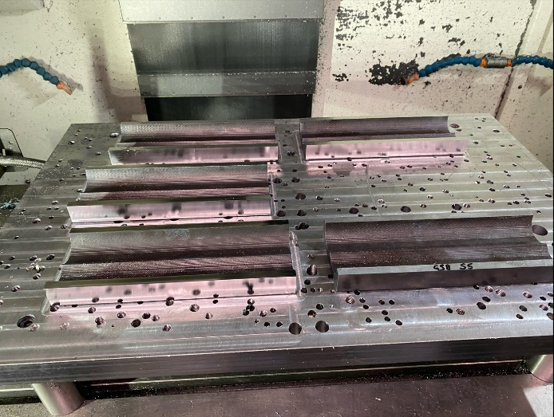
Root cause analysis is a systematic process used to identify the ‘’root’’ causes of a problem with a manufacturing process and is used to identify and apply suitable processes which could be applied to help improve the processes efficiency.
With all the relevant research collected the report is now able to implement my ideas for process improvement using Root cause analysis to explain my improvements in this report. The biggest issue the original process has which is affecting its efficiency is it massive cycle completion time of 8 hours which when it comes to large batch productions like the ticket I was machining of a 15 off batch. This wastes company resources such as machines and also money as the wage bill would also increase with the amount of man hours being used. To improve this, I have created a solution which allows the company to clamp 5 or 6 jobs if wanted to the machine bed at one time using a fixing plate and machine all 6 of the components in one machine operation without needing to stop the machine. This would save time as it would avoid taking out and setting up individual parts multiple times which would be taking up machining time. In the image to the left you can see the fixing method of the parts where I have used screws from the bottom side of the to securely hold the jobs in place.
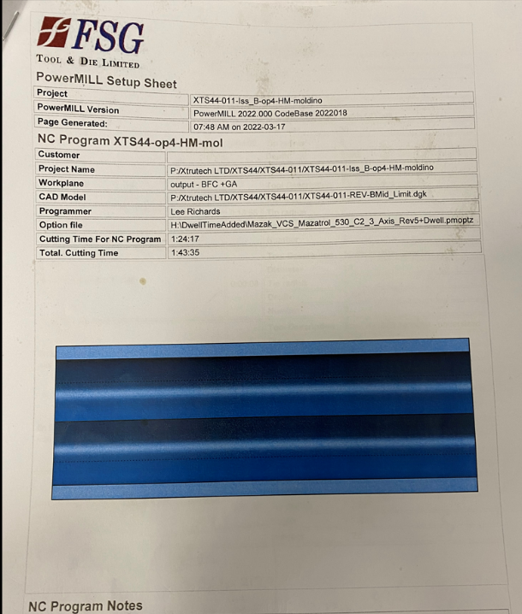
I also adjusted the machining program which drastically improved the overall machining time of the product down from 8 hours to 1 hour and 45 minutes. I managed this by adjusting the speeds and feeds of the cutters being used to machine the parts and made them more suitable to the hard material they are machining. By adjusting the cutting speeds and feeds this also helped preserving the cutters life span also, as the cutters began to last longer without needing to change them while the machine was running which also saved a lot of time. The image to the left is the new and updated set up sheet for the job which I created and on it states the new cycle time for the job and also a link to the program so anyone who is running the machine can easily go and check the program if unsure.
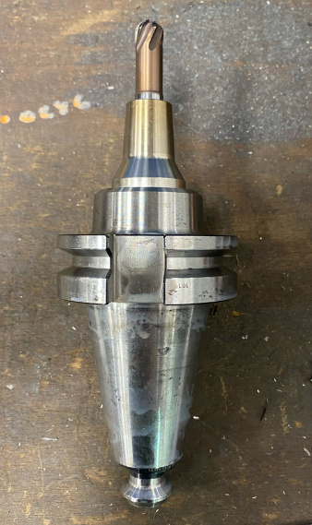
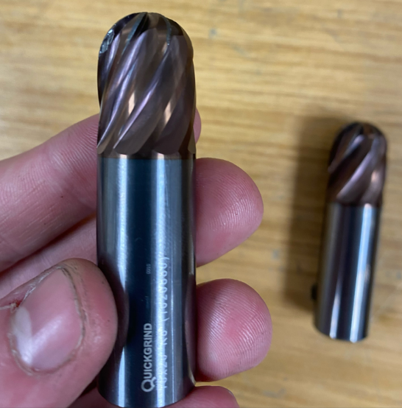
Once happy with the improvements made to the process with regards to time improvement, we must then focus on ensuring the overall quality of the part was also improved. To do this I considered my findings from my products defects data and decided to change some of the tooling being used to more suitable hard machining cutters which would machine the material easier and give a better surface finish. I also changed the tooling holder to a shrink fit holder when finishing the inside channel of the part as this removed all chattering from the tool when machining which provided a much smoother to the product with no burrs or added defects once completed.
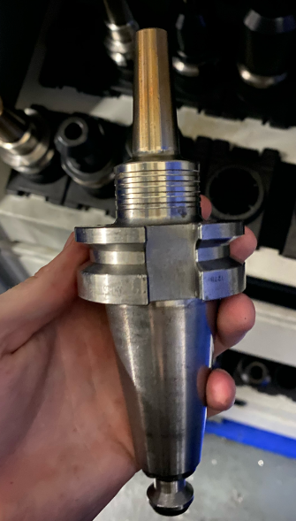
In these 3 images you can see the tooling that will be changed to improve the surface finish and also you can see the new shrink fit holder that will be used to remove all cutter chatter and movement while machining.

After Using Root cause analysis to identify the problems with original process I have now created a more efficient set up and machining plan for manufacturing the parts and also part of root cause analysis I have implemented all improvement plans I have come up with using all the relevant data I had for the process improvement into the new and improved manufacturing process, which I will now have to run and assess how smoothly the new operation runs with all the amendments and record the findings to confirm all changes made have benefitted the company for the future.

Data Collection and Assessment of new and Improved process.

Above you can see that after incorporating the changes I had decided to make to the old process after running the process machining cycle through there is a clear and drastic improvement with the overall completion time of number of complete parts manufactured in a 24 hour period. With there being 13 completed parts being made of the 15 total number in just 24 hours this has cut the original batch machining time from 5 days to just over 1 day which is a huge improvement. As this saves the company money as they would not have to pay additional wages to complete the job but would also increase profits as the job is being done in less time meaning they can get other jobs up and running quicker meaning there is a better flow in production. Although I am very happy with the improvements made to the cycle time, I want to ensure that this has not sacrificed product quality as I want to see product improvement with regards to the surface finish and defects which we had problems within the original process.

Process Defect Data for Improved Process
Process Used to Create Parts | Colleague/co-worker | Part which was machined over the previous 24 hours | Any defects and issues found with the parts.
Improved Second Process | Shane | 1-4 | None
Improved Second Process | Will | 4-9 | None
Improved Second Process | Jeff | 9-13 | O

Legend:
X = Poor Surface Finish O= Burring ⚫= Improper Geometry/Shape

In Order to assess the quality of the new process I conducted the same Defect Data analysis using the same colleagues to make the findings as fair as possible and due to the process manufacturing more parts compared to the original process, I spread the parts fairly between my colleagues to assess the work done by the second process.
And as you can see the overall quality improvement is a great success with there being no issues with the final product apart from some burring on the parts 9-13 which I expected as this could just be due to the cutters beginning to wear which when machining such a hard material it is expected especially when the cutter has machined 9 perfect parts before those.
Overall I can say I am extremely pleased with outcome to the improved process as I achieved everything I wanted to when I started the project, I have successfully cut the machining time down drastically to just over 1 day when the original process was over 5 days and I have also improved the quality in finish to the part which provides the company a better reputation with the customers and hopefully brings them back for our services in the future.
Action Plan for the Future.
After showing the results of the improved process to the section leader and explaining what I did to improve the process he has decided to show the management team and they have decided to continue to manufacture the components using my improved method from now on as it is a great improvement from the previous process which is what the company wants. They do also want to find a way which stops all burring of parts in the future, but they are more than satisfied with the quality of parts being produced using the new and improved manufacturing process. The company has also suggested purchasing new and better cutting tools for this process as they believe it would improve it even more so with regards to cutting total machining time down and overall finish quality. They are more than happy purchasing the new cutters due to amount of many which was saved improving the original process.

References
Root analysis Image: https://st3.depositphotos.com/1004370/14070/i/950/depositphotos_140706822-stock-photo-diagram-of-root-cause-analysis.jpg
Root cause analysis:
Author:
Root Cause Analysis | Department of Enterprise Services (wa.gov)

Quality Tools Image: https://techqualitypedia.com/wp-content/uploads/2021/01/7-QC-TOOLS-1-3.jpg

Fsg Logo: https://www.bing.com/rp/sjRKqL7qEBB3rUAoLZkYF0PHd6Y.svg

Process and part images:
Author of images: Rhodri Jones
Date of images: 02-03-22 to the 25-03-22
All other images were supplied through my own personal camera roll as a means of data collection and evidence for the project.

