Art analysis of ‘The lady with the shawl’ 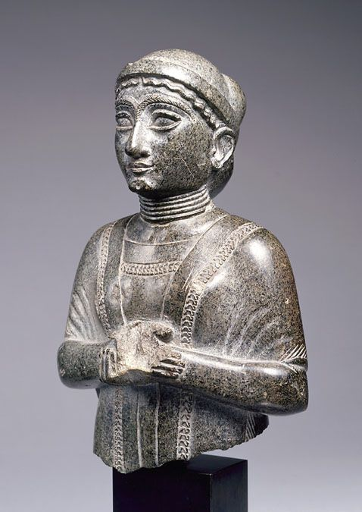

I want to preface my interpretations by stating that there seems to be very little in terms of sources and interpretations of this statue beyond basic descriptions, which I have found puzzling as I later explain my thoughts on this object I believe it to be apparent why it warrants further analysis. The reason I have chosen to analyse this statue for my object analysis I because I believe that it exudes agency, and not agency that has been embedded into stone by a craftsman (although I do not doubt there is also a strong case for that argument.) Rather, I have found myself beguiled by the intricacies of this females representation. First the material of the statue itself is rather striking, classified by the Louvre as diorite, this presents a speckled and yet lustrous appearance, that has been utilised by the artist in creating contours and highlights upon her face. The exquisite specialism that must have been required to create such smooth edges cannot be understated, as that plays with our desires to engage with the statue in a tactile manner. (Neumann and Thomason,2021) I could happily just engage with this figure visually, yet I am still tantalised by the thought of running my fingers across the waves of her hair, and the shallow carving that represents the bunching of her shawl. (Bailey, 2013) It is unfortunate that this statue is damaged as I imagine her having a rather plump and rounded chin. Similarly with the pronounced overlapping hands, that being another vulnerable point on the surface, susceptible to damage. I also find the scratch upon the figures left cheek, creates a sense of ‘human-ness’ for me as though she obtained a scar through living, and to become scarred one most put themselves in a position to get hurt, which my mind has used to conceptualise a woman who lived fiercely. Measuring in height: 17.8cm, length: 11cm and width: 6.7cm; again as I mentioned it is unfortunate we do not know the measurements in their entirety as the artefact is in a fragmentary condition. (Louvre, 2022) The piece is dated between 2120-2110 BCE and provenanced to the Sumerian city of Girsu, modern day Iraq. The statue has been manufactured through the use of relief techniques, and through this we can see differences in the direction of the carving indicating variability in texture, especially between the movement of her hair which is gentle and fluid, juxtaposed to the sharp arrow-like grain used for her emotive, highly arched eyebrows. We can see this has been made with great care, in that her hair is tucked behind her ears – which alongside the eyes and nose are rather large in proportion to the rest of her figure. Does this dictate an emphasis on certain senses, or were these features important culturally, contemporary to her creation – as possible indicators of beauty. Or was it just recognised that these senses took precedence in the community or context in which the statue belonged. (Moser and Gamble, 1997) The hands are positioned in a gesture that appears passive, however is a distinct act of reverence.
She is also part of a larger collective of art objects from her initial origins, as there are several similarities to the popularised Gudea statues of ancient Sumer. Whilst there is extensive literature on Gudea, she largely remains unwritten about and is decidedly consumed as an art object. Whereas the features of the Gudea have been analysed as depictions of the characteristics necessary to rule. The shared similar features could be part of an artistic standard, or could also pertain to a more complex iconography. I have included an image (below) of a Gudea statue for comparison, and have chosen this particular one as the hands are complete. I also unintentionally picked a comparative image that also depicts the subject with a side profile, whereas seated Gudea statues tend to be frontward facing online. What I like about these two is the difference in material and yet we have the same exaggerated facial features, smooth shoulders and the draped fabric culminating in this elevated depiction of an individual. (British Museum, 2022)
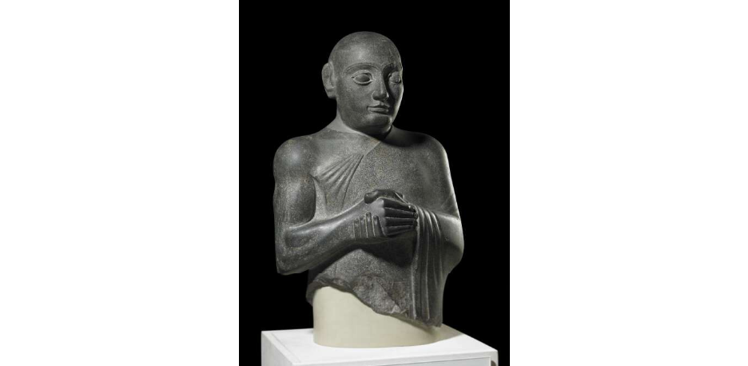

Perhaps part of the attraction of this object is the fact it is recognisable as female, without any gender specific exaggerated anatomical features. She remains quite demure, and I imagine this appealed to a modest western audience, as we have a predisposition to view nakedness as inherently sexual or vulgar. (Bailey,2013) Arguably the largest, or better yet clearest indicators of gender remain to be the hair/headdress and garment. I cannot hesitate to discuss gender, yet Meskell warns of the temptation that archaeologists have to gender representations of people, from civilisations where we cannot comprehend their concepts and constructions. (Meskell,1998) Bahrani however, brings forth into the discussion of that statue what we know about the powers of women in Girsu stating that they had : independence, legal rights, they could own and inherit land and the had the ability to commission art for themselves and on behalf of their family. (Bahrani, 2017)
For this analysis, I was conflicted on whether or not to refer to this as an object or not? As since I have begun reading about art from ancient civilisations the correct terminology seems to be a large point of contention among scholars. As this statue, is clearly of a woman it goes against my nature to objectify her; as a representation that is so beautiful and expressive. Having read Insoll’s article on why we miniaturise or choose to represent people through figurative material, he makes a case that size (within archaeology) has often been the biggest indicator for how an object should be categorised, which I would posit normally confines objects of artistic excellence and intertwines them with modern terminology and understandings. (Insoll, 2017) Which is where I found it useful to read works by the likes of Bahrani and Sonik, who argue that applications of modern artistic principles and interpretations can greatly detract from ancient ‘art’, and whilst we normally only have the physical material to work from, we should be hesitant to even define such pieces as works of art – as the ancient civilisation that created it, might not have had a singular concept for art. (Neumann and Thomason,2021) Whereas, art for us as a contemporary audience is extremely subjective, even more-so what constitutes ‘good’ art? It is my opinion that classical western ideals have persisted and placed realism as the pinnacle of human artistic achievement, possibly stemming from a very vain and human pursuit of wanting to be everlasting, by transcending our own lifetime. The attraction in ancient art for me lies within the unfamiliarity, we can recognise humans but in shapes, sizes and representations that do not conform to these standards of realism, meanwhile we can still extrapolate individuals from the material in certain instances. Ancient art comes under criticism for the usage of empty space, asymmetry and foreign compositional designs, whilst statues such as this ‘Lady in the shawl’ are fascinating for her ‘likeness’ (Winters, 2009) to the human form, which is where I think the application of Alfred Gells’ theories are effective; as this object is encompassed by both the idea of object agency, as well as the concept of technologies of enchantment. When looked at through the lens of enchantment however I would argue that both points, that I will summarise in the briefest of terms – beautifully made, or made to be beautiful, are both apt but I would argue that with this particular object the two are not equal. (Gell,1998) As I would argue that the object, depending on the viewer fluctuates it’s position between the two. If you have a greater appreciation for ancient technology and crafting capabilities you would favour it as beautifully made, whereas looking at the object purely for its aesthetic you would prefer made beautiful. (Gell, 1998) That is not to say both cannot be acknowledged with her. What I find intriguing about the images of ‘The lady in the Shawl’ is that most photographs are taken from an angle that creates a ‘side profile’. Which is a compositional technique used in modern portraiture and photography that abstracts a royal or high status appearance from the subject; at least I would believe that this is how a contemporary audience would perceive her. Contrary to this, I would argue that this statue has been sculpted, in a way that shows intricate details from all angles and should thusly be viewed in three dimensions – and is not limited to the usual static qualities of 2 dimensional viewing. (Bahrani,2014)(Winters,2009) Following on from this, her pose and gesture seem quite rigid stylistically, however I would argue that her soft facial features and smooth shoulders indicate an innate peacefulness in her character; from which her agency outwardly affects recipients instilling them with the same sense of calmness that she carries. (Gell,1998) Which moves me onto the extent of her agency, from my experience of watching others react to mere images of the material, it instantaneously ignited a discussion on her appearance but also her character. Amongst my fellow peers, we were intrigued by the figure and all of us by different aspects of her ‘being’ (Taylor,1975)
We have the luxury of a vast expanse of different subsets of art, in order to create culturally and socially recognisable genres in which pieces ‘belong’. As modern people we find comfort in being able to label and place things within pre-existing groups and if they do not exist we create the terminology to suit that purpose. From here, a term I see as rather fitting I will borrow from Hegelian philosophy, Vorstellung, (that translates to representation) is defined more-so as “art used as a mode of thought, which relies on images instead of being purely conceptual”. The term itself originally used by Hegel in relation to the conceptualisation and manifestations of religion. Hence my use of it with this ancient statue that has been referred to as ‘votive’. We lack the literature to concretely place the statue as religious, yet with the gesture that is widely recognised in ancient Near Eastern art, there seems to be this sense of Vorstellung exhibited through her. (Taylor, 1975) What the thought was behind the object, we will likely never know but perhaps it is satisfactory consuming this image without this answer as I do not believe it needs to be limited to a singular idea. (Insoll ,2017)
I am uncertain as to how this object would have been originally displayed, as mentioned above, the way she is displayed and consumed now seems to be from a distance, and largely as a portrait but with this subtle hint of realism that to her discredit dissuades people from looking beyond the surface value that has been placed upon her. I like to imagine this lady originally being draped with fabrics and shawls over her supple shoulders, to act in place of the engraved material or alongside it, if she had been a prominent or influential individual to the community. The best reference to the statues role as a representation I could find was that which called her the ‘Wife of Gudea’ but delving further into that interpretation I found myself unconvinced due to the lack of academic sources or contextual evidence (Bahrani, 2017). I want to further question the importance of how she was viewed originally as we assume it was as important to ancient viewers as it is to contemporary audiences; but for differing reasons, with most value placed on this statue coming from a modern reception, which has been relatively dissonant. As clearly she is magnificent enough to be on display at the Louvre, and whose image I see being utilised as a commodity, rather than one of archaeological interpretation. She was carved from all sides, which leads me to believe the image was displayed with accessibility to all angles, or because of the elaborate facial features we can assume the ideal way to view this was face on, as that’s how one addresses another person. As far as we are aware the Sumerians understood representing people in material but perhaps not with the intention of them being art objects to act as true portraitures of individuals, so my final thought is should we interpret this an a piece of art or rather as an artefact, because it seems to have been decided already and in doing so have we destined this statue to little more than life on a plinth.

References
Bahrani, Z. (2014) The Infinite Image: Art, Time and the Aesthetic Dimension in Antiquity. Reaktion Books, London. Pp. 14-48
Bahrani, Z. (2017) Mesopotamia: Ancient Art and Architecture. Thames and Hudson Ltd, London. Pp 137-149
Bailey, D. W. 2013. ‘Figurines, corporeality, and the origins of the gendered body’, in D. Bolger (ed.), A Companion to Gender Prehistory (Chichester: John Wiley), pp. 244–64.
Childe, G. (1952) New Light On The Most Ancient East – The Urban Revolution In Mesopotamia. Routledge & Kegan Paul LTD, London. Pp 123-147
Gell, A. (1998) Art and Agency: an Anthropological Approach. Oxford University Press, New York. Pp 5-26
Hodder, I (2012) Entangled: An Archaeology of the Relationships between Humans and Things. Wiley-Blackwell. Pp. 1-38
Insoll, T. (2017) Miniature Possibilities?: An introduction to the varied dimensions of figurine research. Oxford Handbooks [online] Available at: academia.edu/33034882/Insoll_T._2017._Miniature_Possibilities_An_Introduction_to_the_Varied_Dimensions_of_Figurine_Research._In_Insoll_T._ed._Oxford_Handbook_of_Prehistoric_Figurines._Oxford_Oxford_University_Press_pp._3-15
Meskell, L. (1998) Changing Bodies, Changing Meanings: Studies on the Human Body in Antiquity – The irresistible body and the seduction of archaeology. Routledge, London pp.139-160
Moser, S. and Gamble, C. (1997) The Cultural Life Of Images: Visual Representation in Archaeology – Revolutionary images: the iconic vocabulary for representing human antiquity. Routledge, London. Pp 184-211
Musée du Louvre. 2022. statue. [online] Available at: <https://collections.louvre.fr/en/ark:/53355/cl010119564>
Neumann, K. and Thomason, A. (2021) The Routledge Handbook of the Senses in the Ancient near East. Milton: Taylor & Francis Group. Pp. 530-545
Taylor, C. (1975) Hegel. Cambridge University Press, London. Pp 465-479
The British Museum. 2022. statue | British Museum. [online] Available at: <https://www.britishmuseum.org/collection/object/W_1931-0711-1>
Winters, I. (2009)What/When Is a Portrait? Royal Images of the Ancient near East: Proceedings of the American Philosophical Society, Vol. 153, No. 3, Published by: American Philosophical Society, Pp. 254-270 [Online]: http://www.jstor.org/stable/40541670

