Building a Strong Foundation for Data Protection and Security
Zoe Selina Clark
Student University of Wales Trinity St David, Swansea, Wales
97011450@student.uwtsd.ac.uk

Contents

Introduction 3
1. Digital Forensic Tool Selection 4
2. Detailed Tool Analysis 5
2.1 Autopsy (Open source) 5
2.2 FTK Forensic Toolkit (Commercial) 6
2.3 Volatility (Memory Analysis) 7
2.4 Cloud Tools – The Impact of a Dynamic Environment 8
3. Categorisation Table 10
4. Conclusion 11
5. Introduction 12
6. Case Scenario and Forensic Context 12
7. Forensic Preparation and Acquisition Approach 13
8. Analysis of Findings 16
8.1. Detection of Concealment and Anti-Forensics Techniques 19
8.2. Timeline Correlation and Attribution 24
8.3. Documentation and Reporting 24
10. Conclusion 25
References 25
List of Figures and Tables 29

Abstract
This paper presents an analysis of selected forensic tools, identifying strengths, limitations, and applicability to investigative contexts. A forensic case study is then introduced to demonstrate practical application of disk-based tools and methodologies in a static, post-incident investigation. The report also considers legal and procedural requirements relevant to tool use and evidential handling.
Keywords: Digital forensics, forensic methodology, forensic tool analysis, evidential integrity, forensic investigation.

Introduction
Digital forensic investigations depend on structured methodologies and validated tools to support evidential integrity. Investigators build a forensic toolkit suited to the type of incident, system environment, budget and evidence available. While dedicated forensic suites such as Forensic Toolkit (FTK) or Autopsy handle disk-based acquisition and analysis, memory-focused tools like Volatility are used to extract volatile artefacts from RAM. Supporting tools such as VirusTotal can be used alongside core forensic platforms to verify malware signatures or cross-reference suspicious activity
The purpose of this paper is to examine selected forensic tools, identifying where each is best applied, what constraints may limit their use, and how they support the forensic process. And meet the need for investigative workflows that align with legal and evidential standards.

Digital Forensic Tool Selection
Some forensic tools specialise in examining specific types of evidence, while others offer a broader suite of functions. These range from open-source solutions to licensed commercial platforms. The choice of tool depends on evidence type, investigation context, resource availability, and legal admissibility.
Reliability is essential when selecting forensic tools. Tools that do not produce consistent and traceable results risk undermining evidential integrity. The UK Forensic Science Regulator Code of Practice, issued under section 2 of the Forensic Science Regulator Act 2021, requires validation or verification of tools that impact outcomes [1]. This applies equally to commercial and open-source software and includes managing risks from updates or configuration changes.
Independent testing by recognised organisations helps build trust in tool performance. Important for the professional investigator carrying out detailed analysis or those that will rely on the reports resulting from analysis based on its outputs. The NIST Computer Forensics Tool Testing Program (CFTT) publishes performance data forensic tools under realistic conditions including FTK and Autopsy, allowing investigators to understand their strengths and constraints before deploying them [2][3].
Other considerations include:
- Legal and regulatory compliance
- Integration with systems and file types
- Handling of large datasets
- Resistance to anti-forensic techniques (e.g. steganography, timestamp manipulation)
- Vendor support, update cycles, and cost implications.

The open source and commercial tools selected for review, FTK, Autopsy, and Volatility, were chosen for their range of functionality and relevance. Commonly used in the profession, selected to explore the range of challenges faced by digital forensic practitioners across a range of evidence types and investigative contexts.

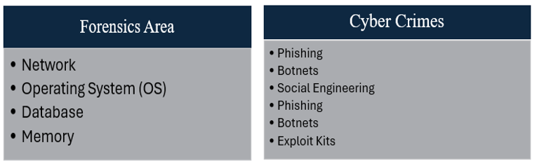
Figure 1: Considerations for Digital Forensic approaches [4]

2. Detailed Tool Analysis

2.1 Autopsy (Open source)
Autopsy is an open-source forensic tool used across education, business, law enforcement, and government environments [5]. It uses The Sleuth Kit (TSK) for structured file recovery and supports additional analysis through optional modules. These include video processing, malware detection, and ingest modules for artefacts such as Bitcoin wallets [6][7]. Some modules are jurisdictionally restricted and only available to authorised agencies [8].
It can be used to examine evidence from sources such as mobile devices and digital media [9]. In addition, it has optional modules that can be added to expand it capabilities such as:
- Video analysis
- Malware detection to confirm or rule out evidence planting claims (scanning for backdoors).
- Third Party modules for example and Ingest module (immediate auto processing) for Bitcoin detection [5][6].
Autopsy supports deleted file recovery, timeline creation, keyword searching, and automatic detection of artefacts such as registry values, browser activity, USB history, and installed programs [10][11]. It runs on Windows, Linux, and macOS. Case management features include user tracking and structured access control [11].
Autopsy does not include a built-in file carver. File carving is performed using the bundled PhotoRec tool, listed as the “File Carver (PhotoRec)” module. This must be manually enabled and configured. The carving is done by PhotoRec, not Autopsy or TSK [12]. In testing by NIST, PhotoRec performed well on simple file recovery but was less effective with deleted, fragmented, or non-aligned data. Embedded images were not recovered.
Autopsy does not alert users to manipulated metadata or hidden content. Artefacts are grouped broadly, possibly reducing efficiency when reviewing output detail. It lacks built-in audit logs and formal vendor support, which may limit use in contested investigations. [3].
Autopsy can perform well against commercial tools such as Forensic Explorer. Tests included anti-forensic and evasion techniques such as steganography (hiding files within other files), metadata manipulation, and timestamp alteration. Autopsy showed ability to recover artefacts, including deleted files, browser history, and USB activity. Basic obfuscation identification was demonstrated but it could possibly miss encrypted or embedded content created using tools like OpenStego or Steghide. This also highlights the need to understand anti-forensic methods and employ extra tools or checks to counter any tool limitations. However, using the base version of Autopsy only was a testing limitation in this instance. With key features being the flexibility and range of modules, this should be weighed against the built-in support offered by comparative commercial tools for a better understanding of range. For users confident in configuration, the flexibility of open-source tools may be a suitable budget friendly alternative [13].

2.2 FTK Forensic Toolkit (Commercial)
FTK is a commercial forensic platform known for its case management, hashing, logging, and chain of custody features. It supports full-disk indexing, keyword searching, email parsing, and structured export. FTK has a native file carver and supports custom definitions, allowing recovery of standard and less common formats. [14]
NIST testing showed FTK performed strongly in recovering non-aligned and fragmented files and in extracting embedded content. It maintained consistency across formats and allowed structured reporting [2]. These features align with evidential requirements under the Forensic Science Regulators Code [1].
Additional functions include email analysis, file decryption, keyword filtering, OCR, and support for Cerberus. Internal viewers for common file types and the ability to reduce and categorise large datasets assist with triage and prioritisation [15].
FTK is suited to large-scale investigations that require traceability, speed, and structured workflows. It supports file system analysis and can be used across a wide range of disk-based cases. As a commercial tool, it may not be a practical option for those with lower resource needs or capabilities.
For cloud environments Exterro have produced a separate product FTK Central. Adding further licencing cost to the toolkits but with the benefit of user-friendly user interfaces (reduced training resource needed), automation and security/ privacy considerations with controls via Role Based Access. For professionals using the traditional this requires serious consideration and could be considered a worthwhile investment as on-premise activity moves into the more scalable cloud [16].
Additional Solutions are available include law enforcement-specific builds or additional functions such as AI analysis, e-discovery for complex data management, and remote collection to reflect modern usage and access requirements. These additions may offer practical advantages, keeping professionals more up to date and able to deal with wider demands of usage scenarios, but at an increasing cost [17].
Diversification of tools is another option, such as using a targeted tool like Volatility for volatile memory analysis where in-memory artefacts are critical.

2.3 Volatility (Memory Analysis)
The Volatility Framework is an open-source collection of tools, first released in 2007, developed for the forensic analysis of volatile memory images. Initially written in Python, it continues to be expanded through community-led development. Subsequent releases have introduced improved performance and compatibility, with support for memory from Linux, macOS, and Windows 64-bit/Server environments. [18].
It can extract information on active and terminated processes, command-line activity, network connections, loaded DLLs, registry values, and in-memory files. The tool uses a plugin system for targeted extraction of specific evidence types[18].
Volatility can be valuable as a tool where in-memory malware or fileless threats are suspected, especially files intended to escape detection through hidden executables. Since all executable activity passes through RAM, it can detect behaviours that static disk tools may not. It requires configuration but offers automated analysis once plugins are set up. This highlights that core capabilities rely on plugin selection and user expertise.
Using a captured RAM image, Volatility can be used to analyse processes and activity associated with malware. Comparing results against VirusTotal demonstrates how external tools can assist in validating memory artefacts [19].
Volatility is suited to live or near-live forensic response situations, where memory has been captured. It is not applicable to static investigations where memory was not preserved and therefore dependant on initial incident response ensuring RAM data is preserved by preventing shutdown. This may make it redundant for post-incident cases like the insider sabotage investigation in Task 2.
Further research explores memory forensics in contexts such as dark web browser use, highlighting the importance of Volatility in being able to detect non-disk-based artefacts [20].

2.4 Cloud Tools – The Impact of a Dynamic Environment

Cloud environments introduce technical and procedural conditions that traditional forensic tools and frameworks were not originally designed for. These include distributed control, limited data access, and remote volatile evidence sources. As a result, many existing approaches are acknowledged as unsuitable for cloud-based investigations [21].

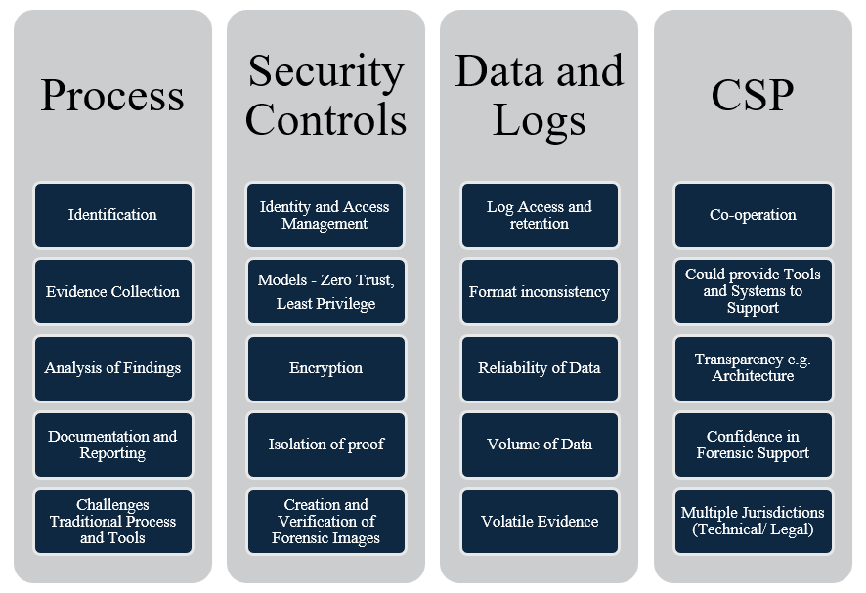
Figure 2: Practical considerations and challenges for Cloud Forensic investigation [22]

An assessment published by NIST identifies and groups the challenges of cloud computing forensics into nine categories.
Table 1: NIST summary, nine groups of cloud forensic challenges [23].
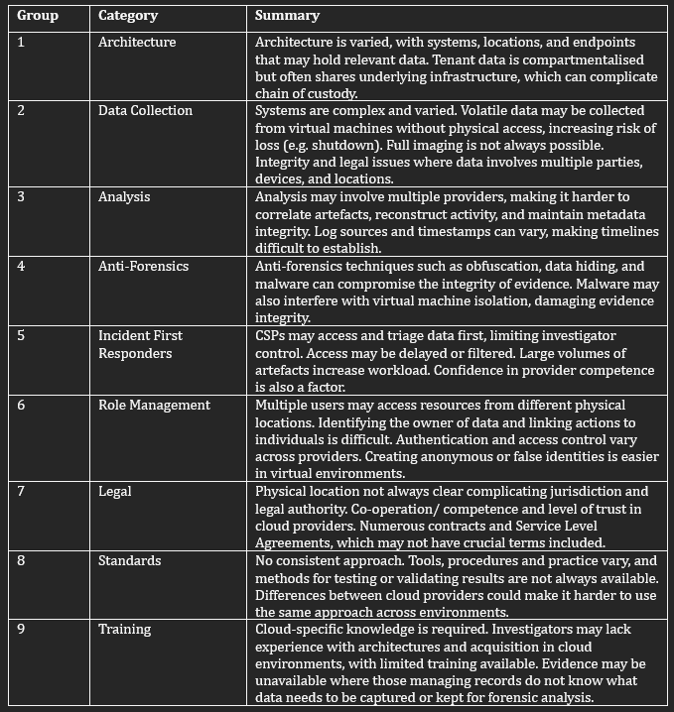

Some of the issues listed in Table 1 are already present in traditional forensic contexts but become more significant in cloud environments. Architectural complexity (1) affects access to low-level system components, including memory. Volatility, which requires pre-captured RAM, is not applicable once virtual instances have shut down or been reset. In many cloud environments, this data is no longer available to the investigator.
Traceability and user identification (6) depend on audit trails. As noted in Section 2.1, Autopsy does not log user actions internally, which limits its use where multi-user access or contested findings are involved. FTK (Section 2.2) supports hashed acquisition and structured logging, aligning with the requirements for data integrity and process reconstruction under (2) and (3). Other challenges such as cross-jurisdictional access (7), Cloud Service Provider (CSP) cooperation (5), and legal authority remain external to the tools functionality but need to be considered alongside technical aspects to ensure readiness for using them e.g. to respond to incidents and ensuring relevance and accuracy of outcomes.
Tool features that support traditional investigations may not transfer directly to cloud settings. Infrastructure control, data access, and logs can be managed externally, which limits what traditional forensic tools can do without additional support.
The increasing use of AI within cloud environments adds further complexity. AI offering advantages e.g. processing large data volumes (record keeping (Table 1). However, it also offers like risks, lower expertise needed and automated malicious activity. This means forensic professionals must continually review developments, assess toolkit suitability and flexibility.
Further engagement with the forensics profession and any relevant CSP and organisations may also be of benefit when working at the early point of design and development with cloud environments. Encouraging adoption of approaches like the principles of Secure by Design [24]. building in requirements to meet forensic needs at the design stage alongside using validated tools and techniques as discussed previously could better support evidential integrity and the chain of custody strengthening the reliability of outcomes in forensic and legal settings [25].

Categorisation Table
Table 2: Comparison of Digital Forensics Tools
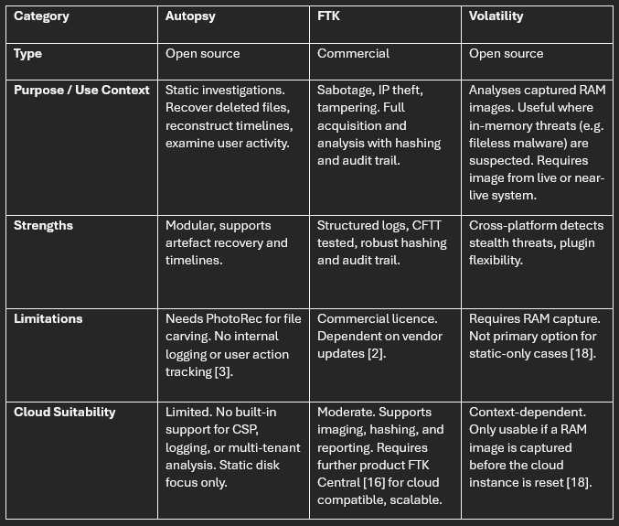

Conclusion
Tool selection is a key part of digital forensics, requiring an understanding of strengths, limits, and appropriate context. Autopsy, FTK, and Volatility each offer useful capabilities for different investigation types. Autopsy is flexible and accessible but needs careful validation. FTK supports structured workflows and evidential integrity in complex cases. Volatility offers critical insight into system behaviour at the point of compromise but is limited to situations where memory has been captured.
A toolkit approach that combines core forensic tools with supporting methods allows investigators to match tool capability to case needs. This supports accuracy, traceability, and evidential compliance. Forensic practice must remain responsive to new threats, which means continually reviewing tool functionality, validation requirements, and practical applicability.

5. Task 2: Introduction
This report examines the approach and methodology of a forensic investigator working within EC-Council Computer Hacking Forensic Investigator (CHFI) [26] and Certified Ethical Hacker (CEH) certified professional standard [27]. This is described through application to a sabotage case study scenario. The structure considers the case study against the forensic investigation steps identification, acquisition, analysis, and reporting.
Example illustrations of relevant forensic techniques and outputs are tested by the author using Autopsy unless otherwise stated and is intended to be for illustrative purposes, rather than a recommendation or suggestion that this would be the preferred tool of the case study investigator.

6. Case Scenario and Forensic Context
Every forensics investigation brings different demands, influenced by geography, system and network architecture, recovered artifacts, damage (attempted or realised) and technologies used by both subjects and investigators. There are technical techniques alongside an understanding of methodologies, forensic purpose and legal significance requiring consideration of potential impacts at each stage. Investigations also place demands on those carrying them out.
The investigator, Troy Simpson, is not legally required to hold certification, but trusted qualifications such as CEH and CHFI provide benchmarks, recognised accreditation of expertise and knowledge. Demonstrating proficiency in the theoretical and technical skills expected in this type of forensic work assists the investigator in investigation preparation and completion. It provides some professional and technical assurance for the client CEO Ker Walters. Figure 3 illustrates suggested attributes, knowledge for and expectations of forensics professionals. [26] [27] [28].

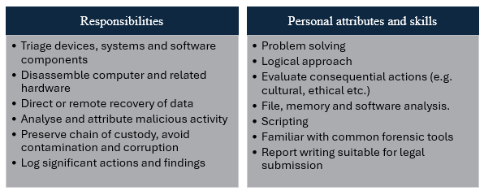
Figure 3: Summary of key responsibilities and attributes needed for a professional Forensic Investigator [28].

The case study indicates a company has concerns that a former employee, as an insider, maliciously deleted or concealed confidential mobile phone design files relating to a high-value product under development and potentially passed designs to competitors. A breakdown of the case study details is provided in Appendix A. The forensic objective provided is to locate and recover evidence of sabotage and missing files. This investigation is a commercial rather than criminal, initiated by an employer, not law enforcement.
As discussed in Sections 1 and 2, the choice of forensic tools is influenced by technical capability, and investigators experience or specialist expertise. As certified professional with no specialism noted, it is expected that the investigator will have a range of well recognised commercial tools possibly supplemented with open source for increased capabilities. The tools need to be suitable for the commercial environment e.g. common equipment, software, architecture and activity. This may include Network, Operating software such as Windows, databases, E-mail etc [4].
While specific approaches taken varies depending on case, reliable forensic outcomes depend on applying consistent non-negotiable principles. These include avoiding contamination maintaining evidential integrity and presenting findings objectively. A structured process ensures decisions taken at one stage do not compromise the outcome of others and that any conclusions drawn can be defended based on evidence not pre-conceived narratives or assumptions. [33]. Presenting well-documented actions in a balanced way will help maintain and demonstrate integrity of purpose, process and findings.
A law enforcement-led investigation must focus heavily on admissibility of evidence for prosecution. The focus here is investigating internal misuse, identifying possible data concealment, transfer and destruction. As the intent of the employer to pursue civil or legal cases further on is not established it is suggested the investigator to clarify this as part of the initial stages and ensure from investigation to reporting that findings remain defensible.
Frameworks and legal issues are still key as they start the investigation as they set out an approach and prepare for each specific investigation.

7. Forensic Preparation and Acquisition Approach

Preparation and awareness of correct processes are essential to ensure evidence is acquired and handled appropriately. This includes practical and legal considerations, depending on the case setting. In this scenario, the initial investigator should begin by reviewing the known devices and storage media used by the subject to determine the best method of acquisition.
Volatile memory, such as RAM, can be lost when a system is powered down. If the investigator arrives while the machine is still on, immediate steps must be taken to capture volatile data before proceeding further.
Practical preparation includes preserving integrity of evidence by preventing any unauthorised access or activity on the device and confirming isolation. Legal checks include reviewing seizure documentation, establishing jurisdiction, and assessing if any evidence may be located on cloud services in other geographical locations (Section 2.4)
Actions taken by the investigator must also consider ethical aspects. If the image includes data belonging to others, such as shared folders or internal emails, care must be taken to avoid breaching employee privacy. Similarly, methods such as brute-force password cracking must only be used lawfully. These decisions require more than technical knowledge. Each step must be assessed considering the specific circumstances of the case, with consideration given to necessity, proportionality, and potential impact, including legal or reputational consequences [34]. Being prepared helps reduce the risk of mishandling the investigation and strengthens the reliability of any findings.
In addition to relevant laws that the investigator would be required to adhere to such as the Data Protection Act 2018 and United Kingdom General Data Protection Regulation (UK GDPR) there are other laws and standards (Table 1) that will ensure legal compliance and ensure robust ethical processes. Clearly documented adherence to recognised standards could also support findings and aid admissibility through best practice.
Jurisdiction can be crucial such as handling e-mail data sent by an EU citizen which is also covered under European Union (EU). Laws including the Computer Misue Act may apply to the subject of the investigation.
Table 1 items may be regularly reviewed, the investigator keeping up to date with any amendments that may impact approach or methodology.

Table 3: Useful guidance and standards digital forensic professionals should be aware of (non-exhaustive).
Law/ Guidelines | Type | Description
ISO/IEC 27043 | International Standard | Incident investigation principles and processes involving digital evidence [28].
ISO/IEC 27037 | International Standard | Specific activities in handling digital evidence, which are identification, collection, acquisition and preservation of digital evidence that may be of evidential value [29].
ACPO | UK Guidance | Association of Chief Police Officers Good practice guide for dealing with digital based evidence [30].
Code of Practice for the Investigation of Protected Electronic Information | UK Guidance | Issued under Part III of the Regulation of Investigatory Powers Act 2000 (RIPA).  Investigation of protected electronic information and disclosure of protected information i.e. information that requires a key to the data to access or be read intelligibly [31].
Forensic Science Regulator: Code of Practice for the Investigation of Protected Electronic Information | Code of Practice | Standards of conduct and practice for carrying out Forensic Science Activities e.g. working with data from digital storage devices, network and video multimedia [32].

Evidence must be handled in a way that maintains its integrity and supports later use if needed. Standards set out in ISO/IEC 27037 are reinforced by the UK guidance.
Before analysis, the investigator must establish the physical sources of the data. Identifying relevant systems and peripherals, as these can affect the presence and condition of digital evidence.
The investigator works from a verified forensic duplicate (image) of machine used by the subject. Acquired in a secure environment, keeping clear records of actions taken. [33], using a write blocking tool ensuring “a bit-by-bit copy of the original media, the storage device, including unused portions, deleted files, and anything else that may have been on the device” [34].
Confirming integrity, a cryptographic hash, such as MD5 or SHA-256, should be generated on acquisition, then compared against the hash of the duplicate. Allowing the investigator to validate through matching values (example Figure 4).

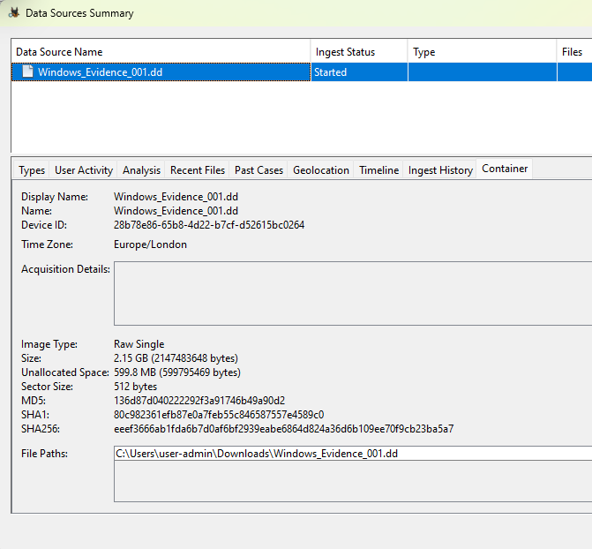
Figure 4: Data source with cryptographic hash values to check integrity of evidence.

Following these steps allows the investigator to demonstrate any findings relating to the missing design files were handled properly and could be relied on if challenged with actions supported by validation methods and auditable records.
To further ensure the integrity of evidence from initial acquisition through to final reporting the Chain of Custody must be maintained documenting transparently any activity and how evidence is handled. [35] Ambiguity or gaps could compromise an investigation.

8. Analysis of Findings

As the investigator is preparing to start the main analysis, they will need to ensure steps, methods, findings and limitations are clearly documented as they proceed. Setting up the case then loading the image into the analysis tool.
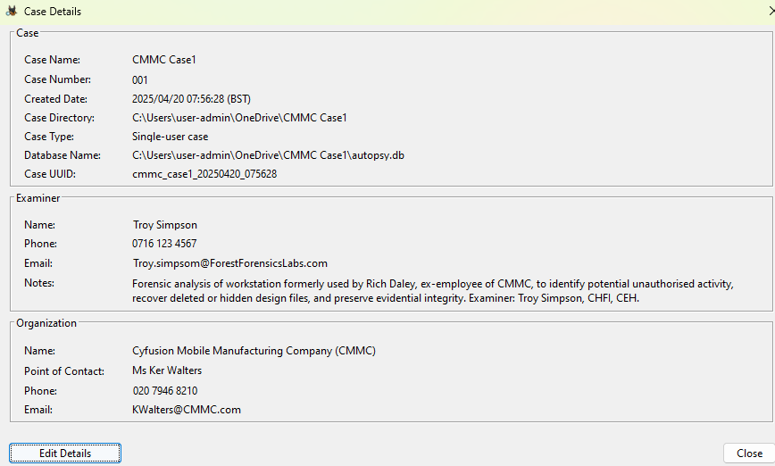
Figure 5: The investigator sets up the case details to support formal documentation of the investigation, capturing key information.

An image can mean vast amounts of user, system and network information, for the investigator sift. Using a technical toolkit (Sections 2 and 3) provides access to the full image but also assists with workflow and focus via automation.

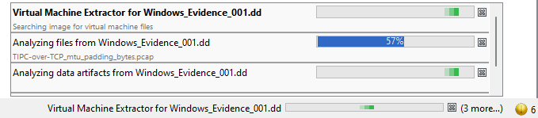
Figure 6: Automated analysis of image contents, reducing the need for manual file-by-file review by the investigator.

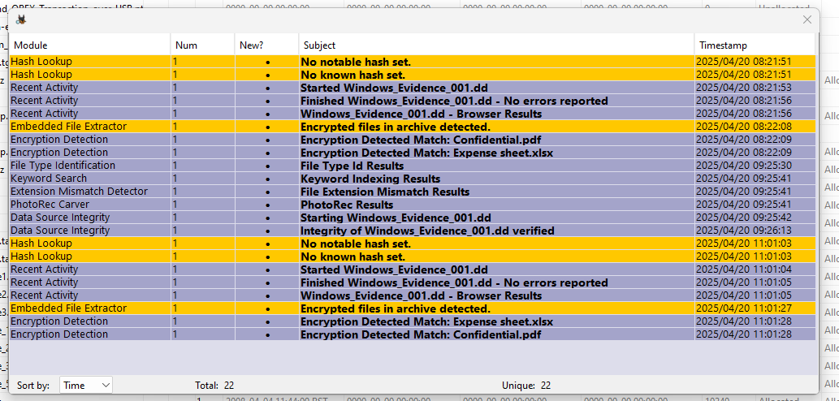
Figure 7: Automatic processing results highlighting items of possible significance.

Analysing if files were deleted, concealed, or transferred by the subject prior to resignation, the investigator examines file system artefacts. Reviewing outputs suggests an initial focus on highlighted items (as seen in Fig 6, Fig 7), extending the review using file type filters and keyword searches to identify content linked to the project. As it is established that the missing designs were created using Autodesk Maya relevant file types such as .ma, .mb, and .obj could be prioritised [36].
The full image is available, th data of interest (Fig. 6, Fig 7) assisting the investigator in build a timeline, reconstruct patterns of activity and sequences of events surrounding the suspected sabotage through highlighting timestamps, filtering and managing workflows.
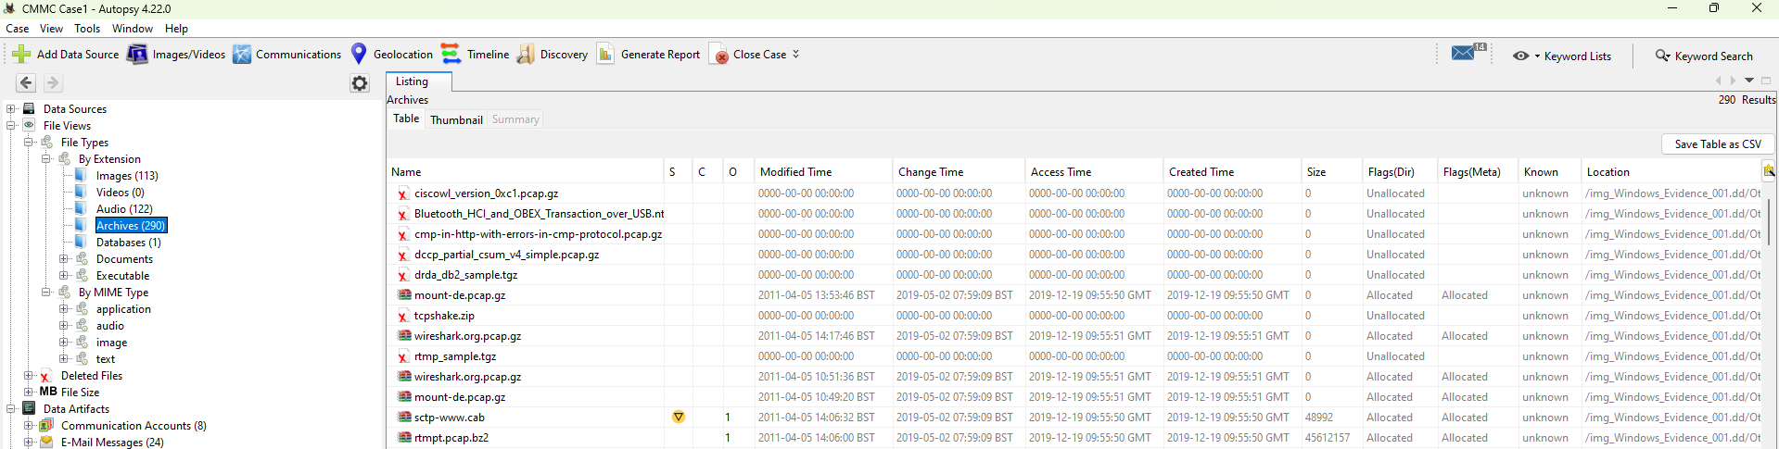
Figure 8: Full details on the image are available via the tool with indicators such as the yellow Icon indicator for items of further interest.

While much analysis so far is technical, the investigator will continue to drive it forward by investigative questions shaped by the case: What designs existed? Where were they stored? What actions could have been taken to remove or hide them? Findings at this stage are collated but not yet interpreted.

8.1. Detection of Concealment and Anti-Forensics Techniques
Being aware of a range of concealment methods and using the technical tools as a starting point to identify, the investigator moves further into review and analysis. As the subject was involved in negotiation (Appendix A) with competitors it is possible they have used obfuscation to attempt to cover their activity e.g. e-mail or research on the dark web to aid moving files.
Checking the recycle bin for deleted artefacts, as metadata often remains intact, allowing easier recovery. Due to deliberate deletion, it is likely the investigator establishes that key files are no longer in the recycle bin or the subject bypassed it.

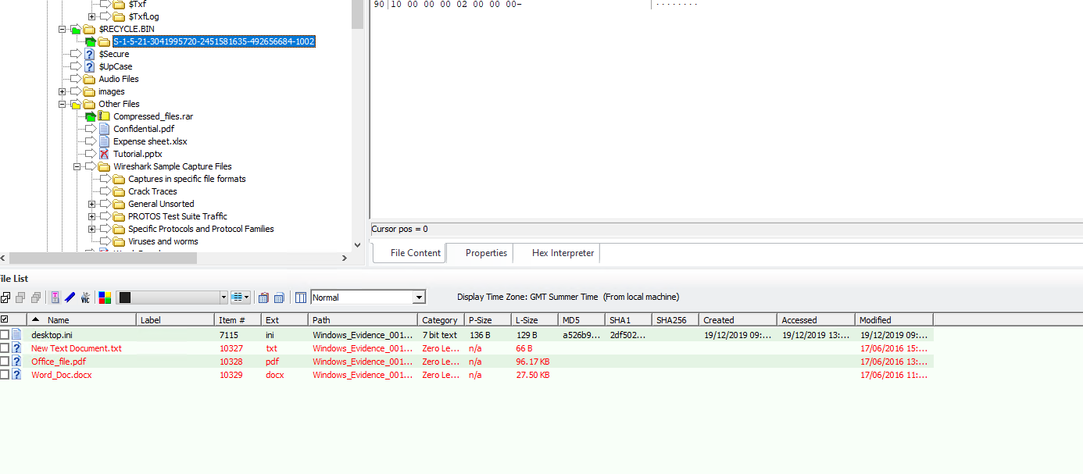
Figure 9: Deleted files recovery of files from recycle bin

Checking unallocated space, file carving is applied to try to recover files by looking for known header and footer patterns [37]. When files are deleted, the space is marked as available, but the data remains in unallocated memory until it is overwritten. If metadata is still present, files may be recovered. Where files are fragmented or partially overwritten, the investigator may only be able to recover fragments. This may still yield data of possible significance with forensic or commercial value. Even if limited it could support confirmation of deliberate actions by the subject [38].

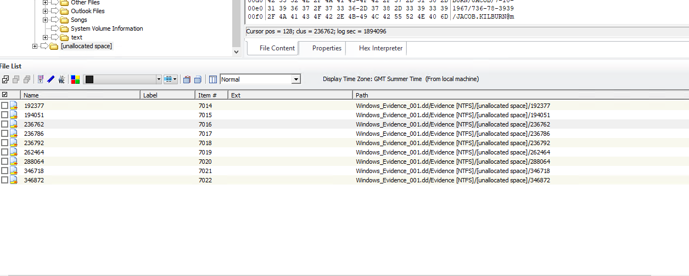
Figure 10: Items identified by Autopsy in unallocated space

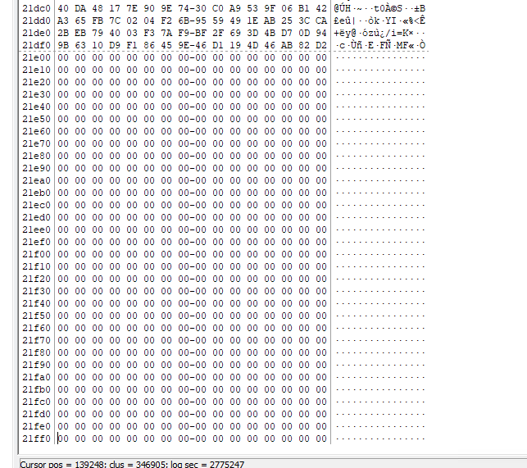
Figure 11: Artifact header identified for file carving.

Analysis of header data may also revel further obfuscation such as file extension changes. Figure 10 shows a file recovered with a pdf file extension, however header analysis indicates a word document [37]. Additional tools and checks used by the investigator such as VirusTotal (Figure 11) can confirm and strengthen findings.

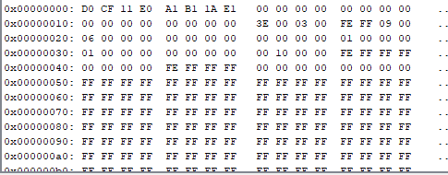
Figure 11: Hex header analysis of a file labelled as .pdf reveals a Microsoft Word document format. The altered extension may indicate intentional to mislead through obfuscation, leading the investigator to investigate further.

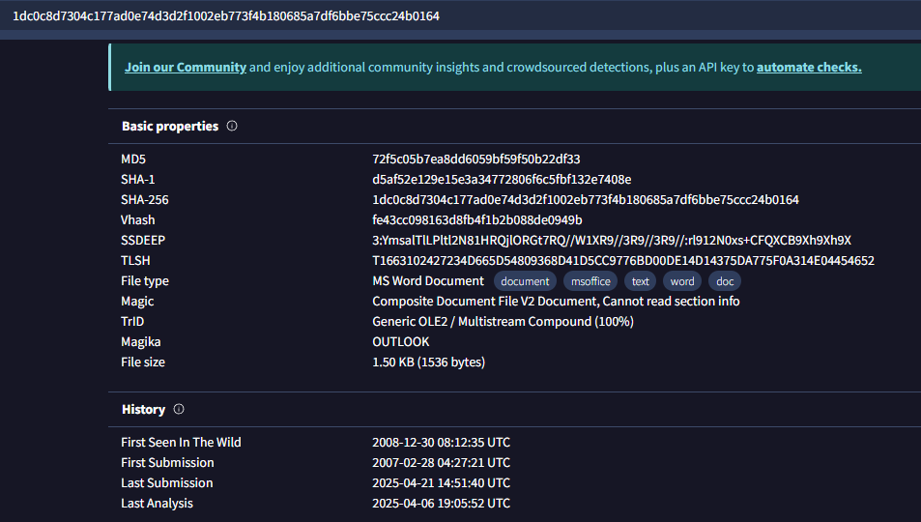
Figure 12: Further analysis of example file shown in Fig 10 with additional tool VirusTotal confirms and reinforces finding that file type as most likely Word document.

The presence of anonymising tools (e.g., TOR browser) or activity linked to onion domains could indicate files were intended for transfer via Dark Web services. The investigator may not confirm the presence of dark web related artefacts, however the type of case calls for a judgement call to include checks for such methods as part of due diligence. This ensures that potential exfiltration is not overlooked during the investigation [20].
If unusual activity is observed investigating possible traces of known anti-forensics software and malware.

Further searches for hidden files are carried out by analysis of image files. The investigator using Another place information could be hidden is image files (.png, .bmp). Analysing these further with Steganography identification tools may reveal the missing files.
Patterns of activity matter in this process, reviewing e-mails could lead the investigator to analyse the sudden increase in images being sent between the subject and an external individual. Tools such as DeepSound will assist in identifying if anything is hidden in audio files such as a .txt file.

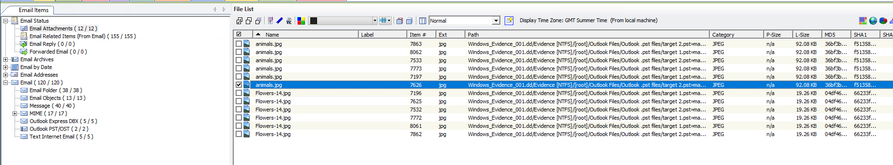
Figure 13: Image files for further investigation

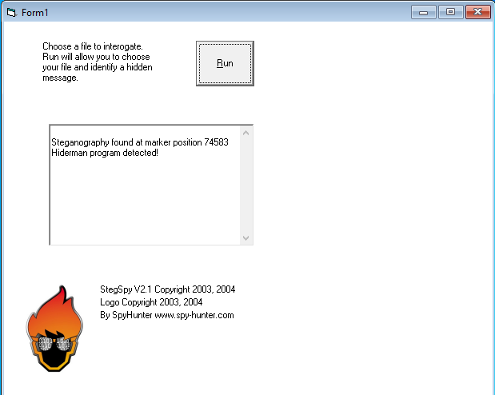
Figure 14: StegSpy tool detecting hidden data within an image file.

Tools such as DeepSound will assist in identifying if anything is hidden in audio files such as a .txt file.
The same search on different cases may have different results. To maintain integrity, the investigator needs to remain methodical, building narratives from evidence not vice-versa.
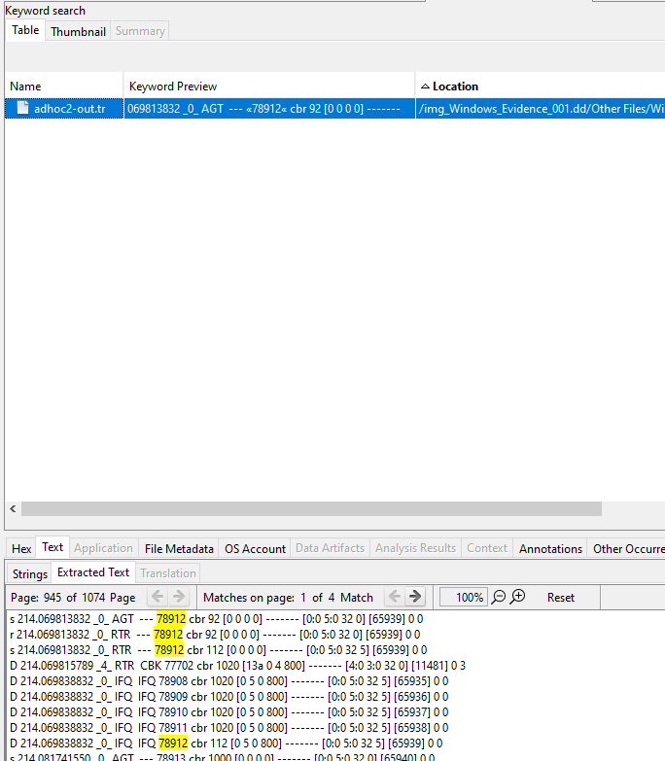
Figure 15: Results of a keyword search. Not all investigation leads to significant artifacts.

Encrypted or password-protected artifacts identified including .zip files could be key. The investigator may need to deploy tools and techniques to brute force. Legal aspects must be resolved before proceeding at this point.

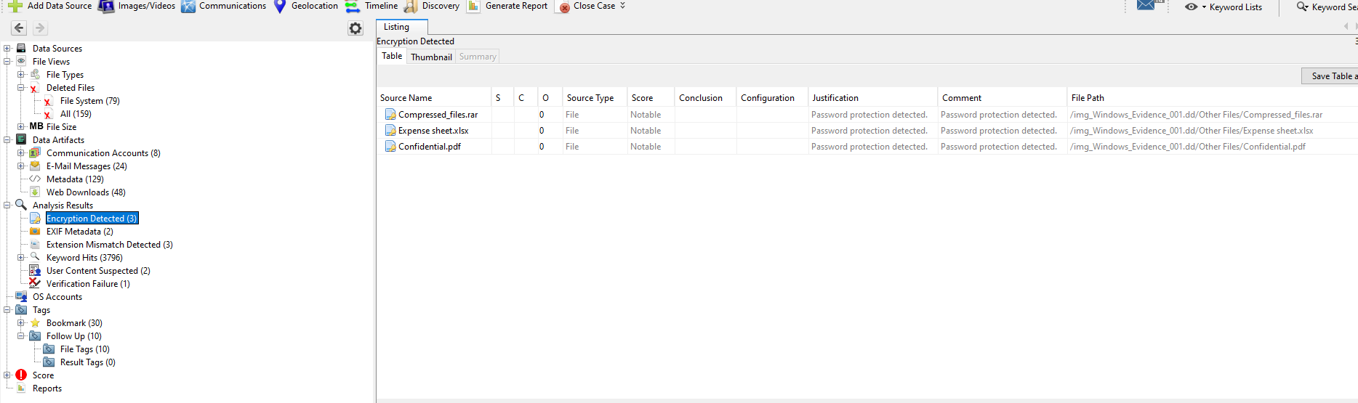
Figure 16: Automation may identify encrypted files for review by the investigator.

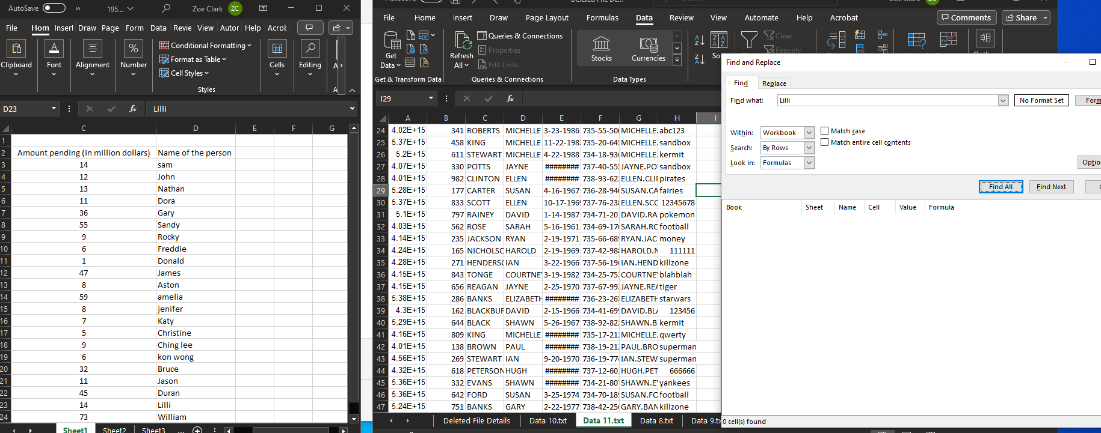
Figure 16: Encryption files opened and unencrypted copies saved for review using Advanced Archive Password Recovery and using Advanced PDF Password Recovery.

As artifacts are reviewed activity may be a false positive or reveal further insights for analysis. The investigator continues to methodically document.

8.2. Timeline Correlation and Attribution

Artefacts alone are not enough; the investigator must correlate findings to build a credible case timeline. Some tools like FTK assist with date filtering and sorting of timestamps however the investigator needs to build the timeline to establish the patterns of behaviour. Considering Appendix A windows of interest include the period immediately before the subjects resignation and if any timestamps. As there is possible contact with competitors and transfer of the designs any files that have a Autodesk Maya extension or unusual network activity or renaming/ deleting of files identified would add key data.
This timeline helps link artefacts to user behaviour and supports the investigator interpretation of intent or sequence. However, caution is required when relying solely on metadata. Time-stamps may be incomplete, manipulated, or absent due to prior system behaviour or anti-forensics. While timelines do not prove motive, they assist in contextualising findings for stakeholders.

8.3. Documentation and Reporting

The investigator now brings together their notes and documentation into a report for the client. There is no single format. Discussion being held with the client in the preparation stage the client has indicated they need something that establishes the events, clearly explains any technical aspects and assists in decision making for next steps.
Some data recovery may have been possible, however if a competitor has access to the designs civil or legal action may be required to contain the data. The report therefore also needs to set out information, supported by the evidence and validation. This may include context, tools used and how, methods and processes alongside the final findings tempered with limitations and constraints. A professional neutral tone avoiding speculation will be the aim of the investigator [39].
Ethical conduct, supported by the Forensic Science Regulators Code and ISO/IEC 27037, requires clarity and transparency throughout the reporting process.
Sample FTK report provided in Appendix B

9. Conclusion

This investigation has followed the steps of the investigator against the case study at each step has been guided by legal, ethical, and procedural standards needed more and more as digital boundaries expand and move into the cloud.

The investigators cases may vary, the tools, techniques and anti-forensic methods develop but core principles continue to sit at the heart of digital forensics. These will guide the investigator in skilled investigation and producing transparent. ethical and defensible reporting.

References

[1] Forensic Science Regulator, Code of practice and conduct for forensic science providers and practitioners in the criminal justice system, Version 1, Mar. 2023. [Online]. Available: https://assets.publishing.service.gov.uk/media/64da431cc8dee4000d7f1c1e/FINAL_2023.1.18_Code_of_Practice.pdf. [Accessed: Mar. 11, 2025].
[2] U.S. Department of Homeland Security, “Test results for graphic file carving tool: FTK v8.0,” Sept. 27, 2024. [Online]. Available: https://www.dhs.gov/sites/default/files/2024-09/24_0919_st_test_results_for_graphic_file_carving_tool_ftk_v8.0_0.pdf. [Accessed: Mar. 11, 2025].
[3] U.S. Department of Homeland Security, “Test results for graphic file carving tool: Autopsy 4.21.0,” Sept. 27, 2024. [Online]. Available: https://www.dhs.gov/sites/default/files/2024-09/24_0919_st_test_results_for_graphic_file_carving_tool_autopsy_4.21.0_0.pdf. [Accessed: Mar. 11, 2025].
[4] D. Raj, A. K. Gupta, and K. R. Krishna, “Comparative analysis of different approaches for cyber forensics,” in Proc. 2024 4th Int. Conf. on Technological Advancements in Computational Sciences (ICTACS), IEEE, Nov. 2024.
[5] Basis Technology, “Use cases,” Autopsy, [Online]. Available: https://www.autopsy.com/about/use-cases/. [Accessed: Mar. 25, 2025].
[6] Basis Technology, “Add-on modules,” Autopsy, [Online]. Available: https://www.autopsy.com/add-on-modules/. [Accessed: Mar. 25, 2025].
[7] The Sleuth Kit, “autopsy_addon_modules,” GitHub, [Online]. Available: https://github.com/sleuthkit/autopsy_addon_modules. [Accessed: Mar. 25, 2025].
[8] Basis Technology, “Law enforcement bundle,” Autopsy, [Online]. Available: https://www.autopsy.com/add-on-modules/law-enforcement-bundle/. [Accessed: Mar. 25, 2025].
[9] Basis Technology, “About Autopsy,” Autopsy, [Online]. Available: https://www.autopsy.com/about/. [Accessed: Mar. 25, 2025].
[10] D. Delija, G. Sirovatka, and M. Žagar, “Forensic analysis of the NIST hacking case: Integrating Autopsy tools and artificial intelligence in teaching digital forensics,” in 47th MIPRO ICT and Electronics Convention, Opatija, Croatia, May 2024. [Online]. Available via IEEE Xplore. [Accessed: Mar. 11, 2025].

[10] M. Farnan, J. Pratt, A. David, and M. Shakiba, “Digital forensic tools: Comparison of Autopsy TSK and Forensic Explorer,” in Proc. 2024 IEEE Int. Conf. on Information Technology, Electronics and Intelligent Communication Systems (ICITEICS), Karnataka, India, Jun. 2024. [Online]. Available via IEEE Xplore. [Accessed: Mar. 11, 2025].
[12] Basis Technology, “PhotoRec carver page,” Autopsy User Documentation v4.19.2, Feb. 22, 2022. [Online]. Available: https://sleuthkit.org/autopsy/docs/user-docs/4.19.2/photorec_carver_page.html. [Accessed: Mar. 11, 2025].
[13] A. S. Ahmed and S. I. Alawadi, “Digital forensic tools: Comparison of Autopsy TSK and Forensic Explorer,” in Proc. 2022 4th Int. Conf. on Computer and Information Sciences (ICCIS), Sakaka, Saudi Arabia, Mar. 2022, pp. 1–6.
[14] Exterro, The Basics of Digital Forensics, [Online]. Available: https://www.exterro.com/basics-of-digital-forensics/chapter-1-what-is-digital-forensics. [Accessed: 30-Apr-2025].
[15] T. P. Tong, K. Asokan, and I. S. Munjal, “The impact of forensic accounting tools in investigating white-collar crime,” E3S Web of Conferences, vol. 389, art. no. 09034, 2023.
[16] Exterro, “FTK Central – Digital forensics software,” Exterro, [Online]. Available: https://www.exterro.com/digital-forensics-software/ftk-central. [Accessed: Apr. 30, 2025].
[17] Exterro, “Digital forensics software,” Exterro, [Online]. Available: https://www.exterro.com/. [Accessed: Apr. 30, 2025].
[18] The Volatility Foundation, “About Volatility,” The Volatility Foundation, [Online]. Available: https://volatilityfoundation.org/about-volatility/. [Accessed: Mar. 29, 2025].
[19] S. J. Nair and S. R. Syam, “Automated malware detection using memory forensics,” in Proc. 15th Int. Conf. on Computing Communication and Networking Technologies (ICCCNT), IEEE, Jun. 2024. [Online]. Available: https://ieeexplore.ieee.org/document/10509708. [Accessed: Mar. 25, 2025].
[20] R. Pizzolante et al., “A machine learning-based memory forensics methodology for TOR browser artifacts,” Concurrency and Computation: Practice and Experience, vol. 33, no. 23, e5935, 2021.
[21] S. T. Pirjade and P. Dhotre, “A systematic study on cloud forensic framework, challenges and technologies used for evidence preservation,” in Proc. 2024 IEEE Int. Conf. on Blockchain and Distributed Systems Security (ICBDS), Pune, India, Oct. 2024, p. 5.
[22] A. R. Khan et al., “A systematic study on cloud forensic framework, challenges and technologies used for evidence preservation,” IEEE Access, vol. 9, pp. 87226–87248, 2021.
[23] M. Herman et al., NIST Cloud Computing Forensic Science Challenges, NIST Interagency/Internal Report (NISTIR) 8006, Gaithersburg, MD, USA, 2020. [Online]. Available: https://doi.org/10.6028/NIST.IR.8006. [Accessed: Mar. 25, 2025].

[24] Government Digital Service, “Secure by design – About,” UK Government, Apr. 11, 2025. [Online]. Available: https://www.security.gov.uk/policy-and-guidance/secure-by-design/about/. [Accessed: Apr. 30, 2025].
[25] M. Stoyanova et al., “A survey on the Internet of Things (IoT) forensics: Challenges, approaches, and open issues,” IEEE Commun. Surv. Tutor., vol. 22, no. 2, pp. 1191–1213, 2020.
[26] EC-Council, “Computer Hacking Forensic Investigator (CHFI),” EC-Council, [Online]. Available: https://www.eccouncil.org/train-certify/computer-hacking-forensic-investigator-chfi/. [Accessed: Mar. 25, 2025].
[27] EC-Council, “Certified Ethical Hacker (CEH),” EC-Council, [Online]. Available: https://www.eccouncil.org/train-certify/certified-ethical-hacker-ceh/. [Accessed: Mar 25, 2025].
[28] International Organization for Standardization, “ISO/IEC 27043:2015 Information technology, - Security techniques - Incident investigation principles and processes,” ISO, [Online]. Available: https://www.iso.org/obp/ui/en/#iso:std:iso-iec:27043:ed-1:v1:en. [Accessed: Mar 25, 2025].
[29] International Organization for Standardization, “ISO/IEC 27037:2012 Information technology – Security techniques – Guidelines for identification, collection, acquisition and preservation of digital evidence,” ISO, [Online]. Available: https://www.iso.org/obp/ui/#iso:std:iso-iec:27037:ed-1:v1:en. [Accessed: Mar 25, 2025].
[30] Digital Detective, “ACPO Good Practice Guide for Digital Evidence,” Digital Detective, [Online]. Available: https://www.digital-detective.net/acpo-good-practice-guide-for-digital-evidence/. [Accessed: Mar 25, 2025].
[31] Home Office, Code of practice for the investigation of protected electronic information, 2021. [Online]. Available: https://www.gov.uk/government/publications/code-of-practice-for-investigation-of-protected-electronic-information. [Accessed: April 19, 2025].
[32] UK Government, “Forensic Science Regulator: Code of Practice (Accessible),” GOV.UK, [Online]. Available: https://www.gov.uk/government/publications/statutory-code-of-practice-for-forensic-science-activities/forensic-science-regulator-code-of-practice-accessible. [Accessed: Mar 25, 2025].
[33] J. Sachowski, Digital Forensics and Investigations: People, Process, and Technologies to Defend the Enterprise, Boca Raton: CRC Press, 2018
[34] ScienceDirect, “Forensic image,” Computer Science Topics, [Online]. Available: https://www.sciencedirect.com/topics/computer-science/forensic-image. [Accessed: April 19, 2025].
[35] S. Nath, K. Summers, J. Baek, and G.-J. Ahn, “Digital evidence chain of custody: Navigating new realities of digital forensics,” in Proc. 2024 IEEE 6th Int. Conf. on Trust, Privacy and Security in Intelligent Systems and Applications (TPS-ISA), pp. 11–20.
[36] Autodesk, “Working with Maya files,” Autodesk Maya 2022 Documentation, [Online]. Available: https://help.autodesk.com/view/MAYAUL/2022/ENU/?guid=GUID-864BD203-C437-4481-8BFC-3A6C1D2C824C. [Accessed: April 19, 2025].
[37] Library of Congress, “File Format Description for Microsoft Word,” Digital Preservation, [Online]. Available: https://www.loc.gov/preservation/digital/formats/fdd/fdd000509.shtml. [Accessed: April 19, 2025].
[38] M. Boiko, V. Moskalenko, and O. Shovkoplias, “Advanced file carving: Ontology, models and methods,” Radioelectronic and Computer Systems, no. 3, pp. 204, 207, 212, 2023.
[39] G. Horsman, “Technical reporting in digital forensics,” Journal of Forensic Sciences, vol. 67, no. 6, pp. 2458–2468, 2022.

General reading
Y. Prajapati, K. Gosai, and S. K. Singh, “A comprehensive review on Windows forensic based ransomware detection and analysis,” in Proc. 2024 Parul Int. Conf. on Engineering and Technology (PICET), 2024, pp. 1–2.
S. Ahmad and B. Verma, “A review of deep learning techniques for image forgery detection,” in Proc. 2024 1st Int. Conf. on Advances in Computing, Communication and Networking (ICAC2N), 2024, pp. 926–931.
D. C., Technical Director for Platforms Research, NCSC, “Products on your perimeter,” NCSC Publications, Feb. 29, 2024. [Online]. Available: https://www.ncsc.gov.uk/blog-post/products-on-your-perimeter. [Accessed: Apr. 14, 2025].
C. W. Adams, “Legal issues pertaining to the development of digital forensic tools,” in Proc. 3rd Int. Workshop on Systematic Approaches to Digital Forensic Engineering (SADFE), IEEE, 2008. [Accessed: Mar. 11, 2025].
S. T. Pirjade and P. Dhotre, “A systematic study on cloud forensic framework, challenges and technologies used for evidence preservation,” in Proc. 2024 IEEE Int. Conf. on Blockchain and Distributed Systems Security (ICBDS), Pune, India, Oct. 2024, p. 5.
Exterro, “Digital forensics software,” Exterro, [Online]. Available: https://www.exterro.com/. [Accessed: Apr. 30, 2025].
[BC] The Chartered Society of Forensic Sciences (CSFS), “Membership and professional standards,” CSFS, [Online]. Available: https://www.csofs.org/membership/. [Accessed: May 5, 2025].
[BG] G. Gogolin, Digital Forensics Explained, 2nd ed., Boca Raton: CRC Press, 2021

Appendices submitted separately.

List of Figures and Tables
Figure 1: Considerations for Digital Forensic approaches [4] 4
Figure 2: Practical considerations and challenges for Cloud Forensic investigation [22] 8
Figure 3. Summary of key responsibilities and attributes needed for a professional Forensic Investigator [28]…………………………………………………………………………………………………………..

Table 1: NIST summary, nine groups of cloud forensic challenges [23]. 9
Table 2: Comparison of Digital Forensics Tools 11

