Student Name: Blagovest Miroslavov Vasilev
ID: 1918701
Lecturer’s Name:Rula Alousi

Module Code: LCBB4004
Blogging to Communicate
Project: Launching of Samsung alarm facility-based ear pods

A marketing project is always bound with a range of phases, marketing mix strategies, environmental opportunities and campaigns. The launching of Samsung water-proof ear pod intends to create a better competitive advantage in the market and these blogs will help the company to communicate the project to its target market.

Blog post: 01

Different stages of the Samsung alarm facility-based ear pod launching project
Samsung is planning to launch alarm facility-based ear pods which will provide its customers with durable Bluetooth connectivity and better sound quality. The marketing department of the company is planning to go through a few stages so that this product and its features can be communicated properly to the target group. The marketing process of the company has to go through a few stages.
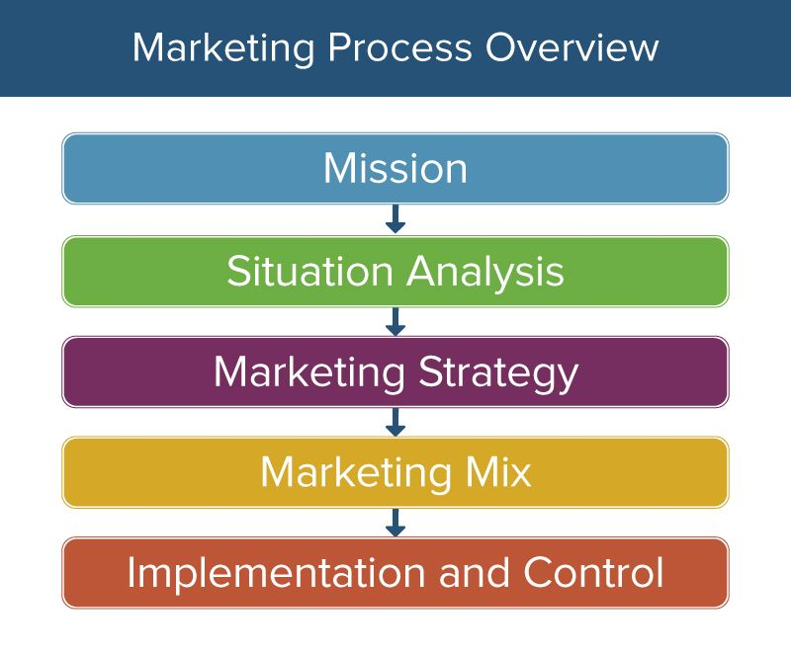
Figure 1: Marketing Stages of Samsung
Source: (Sandhusen, 2017)
The company has to first set up its particular mission of launching this product. Here the aim of launching the product is to create a competitive advantage for the brand. Then it has to analyse the overall scenario of launching the product in the market so that it becomes easier for it to set a target group. After that, the marketing strategies need to get set by it which will include pricing, advertising, distribution channels, etc. As a leading company, Samsung tries to capture the highest possible shares in the market and so its strategies are always made to enhance its organisational value in the eyes of the target audience. It monitors its marketing impact on the market demand for its products by using customer feedback and bring changes to its procedures according to the reviews.

Blog post: 02

Determining the mission and market situation of the project
Mission enables to acknowledge the organisational intention of introducing a product. Samsung brought out its ear pods to create a sustained competitive advantage of the company and to keep pace with the current changing market trends.
The ear pods is a device that is used not only for the necessity but also for having an easy lifestyle. In the young generation, the use of ear pods is a part of leading a fashionable lifestyle. At present, Apple is reigning in the ear pods market and sold approximately 60 million units in 2019. Besides, Jabra, Sony, FiiO, Bose are also having a good position in the market. Samsung is in this market having the 3rd position which it is trying to prove through its innovative approaches (Diaconescu, 2020).

Figure 2: Market Shares of Different Ear Pod Brands in 2019
Source: (Diaconescu, 2020)

However, the new Samsung ear pods will possess a feature that will have an alarm-setting facility. Through that, the customers can set an alarm and on the set time, a ringtone will be played at a moderate value. Besides, customers can also make set time for the songs played through the ear pods to stop automatically.
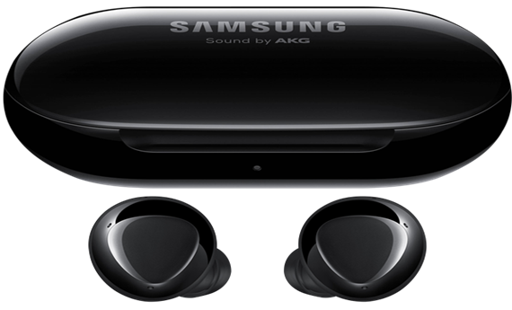
Figure 3: Picture of Samsung Wireless Ear Pods
Source: (Samsung Galaxy Buds - Bluetooth Wireless Earbuds | Samsung US, 2020)
These features might help the company to increase its market share and create a sustainable competitive advantage in the company. The new feature of this ear pod does is going to help the company create a better and creative place in the market and make it enough convincing to the customers.

Blog post: 03

Identifying the target group and setting the positioning statement
To determine the perfect customer-base of the product, the marketing team of Samsung has to go through a detailed STP analysis. Through this new product idea, the company has made a simple strategy of gaining enhanced customer-base and so the marketing team of the company is emphasising on selecting the most preferred audience.

Figure 4: STP Analysis
Source: (McDonald, 2016)
The market for this new series of ear pods has been segmented by the company very wisely. It did not go for mass distribution, rather it found it much easier to do the segmentation based on demography (the young, middle and upper-income group) and psychography (lifestyle and fashion). However, it is aiming to target the young generation and the middle and upper-income people.

Figure 5: The Young People Using Earpods
Source: (Samsung Earbuds Galaxy Buds, 2020)
The company has a distinctive value that encourages customers to buy its products. The company positioned its new product based on its user-friendly nature and long-term durability. It is promoting its products regularly to ensure it creates a longer-lasting impression in the minds of the customers (Samsung Earbuds Galaxy Buds, 2020). Its main focus is to attract its target group by communicating its positioning by using various strategies.

Blog post: 04

Fixing the product category and pricing of the new project
Samsung is always marked for its amazing product quality. So it always tries to make its product durable and user-friendly. The new ear pods of the company are also created keeping the customer demand and their comfort in mind. The new ear pods will be introduced in 5 colours including black, white, silver, blue and golden. These ear pods will have the water-resistance feature along with Bluetooth quality. The ear pods will help the customers to talk via phone as well. These ear pods will have the alarm feature. Through this feature, customers can set an alarm which will ring a buzz at a very moderate sound and customers can set time for their music to stop automatically after a certain time.

Figure 6: Ear Pods of Samsung
Source: (Ron, 2020)
Samsung launches both mid-range and premium products for its customers. Its ear pods are always available at a reasonable price in the market which increases its demand among the middle-income group more. When the company launches a new product, the authority fixes the price based on the target group and product features (Mobile | TV | Home Electronics | Home Appliances | Samsung US, 2020). The new ear pods of Samsung is trying its best to increase popularity among the young people along with ensuring the participation of middle and higher income group. However, this new product is going to be launched having a middle-range price where the company will try to follow the psychological pricing strategy to attain more customer attention.

Figure 7: Picture of Psychological Pricing
Source: (Prasad, 2015)
As a newly introduced product, Samsung Company will try to gain customer attention and accelerate sales growth through psychological pricing strategy.

Blog post: 05

Identifying the place and promotional strategies of the project
Samsung Company is always well-reputed for its strategic and strong distribution channel (Brooke, 2020). The company will send its products to various super shops, physical stores and so on. The company will also provide its products through various distributors and agents. Besides, various online shops or e-commerce platforms will be used to distribute the ear pods.

Figure 8: Samsung Store
Source: (Brooke, 2020)
The company will go for massive promotional activities as it always thrives through getting the attention of people. The company always tries to integrate social media through postings. Besides, the review by social media influencers and YouTubers are also its big strategies.
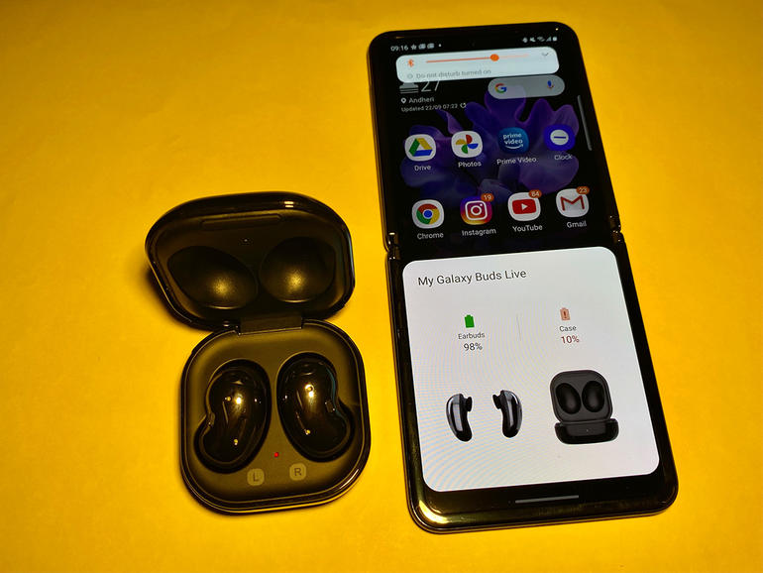
Figure 8: Social Media Postings of Samsung Ear Pods
Source: (Steve, 2020)

The company can also promote its new products through TVCs so that it becomes eye-catching to the customers. The company can hire a celebrity as its brand ambassador who will promote the product and make people attracted towards buying it. Eye-catching billboards can also be another scope of gaining customer attention. Besides, the company can introduce campaigns which will be including the young generation involvement. The company can initiate steps for search engine optimisation as well. As a well-established company, the company has to invest much in its promotional contents due to ensure its well-to-do reputation. Moreover, it can sponsor various web-series and popular programmes to catch the attention of its customers. Promotional strategies will enable the company to establish its brand identity more and add value to its growth.

Blog post: 06

Implementing the ideas properly in the project
Samsung Company is highly sensitive to its project execution and implementation of planning. The marketing department of the company takes step-by-step initiatives to ensure organisational value and proper promotion of the new product of the company (Samsung Earbuds Galaxy Buds, 2020).
The marketing team at first understands the market situation and then it takes initiative to evaluate the customer needs. After its research, it puts its most efficient staffs to accomplish the manufacturing process along with completing the marketing activities. The company allocates resources and proper budget for completing its project. It tries the best to ensure proper benchmark of the product so that the customer never suspects the brand value. The company aims to keep its product quality better to make sure its customers turn into regular customers. The Ear pod that is going to be launched by the company is surely one of the latest technologies to be offered by Samsung and so the company is trying its best to employ the best staffs and deliver the utmost quality range to the customers at a cheaper rate. The marketers working in the company has divided all its activities based on the authority and is going to execute its marketing strategies the way the utmost advantage of the company will be ensured.

Blog post: 07

Controlling the project carefully
Fulfilling the customer demands properly is one of the most desirable aspects of any company which intends to be the market leader (Bonomo, 2017). Samsung is undoubtedly one of the biggest companies in the market and so the customer expectations are supposedly much from it. This company is in the third position in the earbuds market and needs to get on the top position. So the company went for big market research to evaluate the demand for customers. The company found out that in this era of technology and rush, people love the devices that can be used for multiple purposes and so it brought out the new alarm facility-based earbuds. This innovation has been possible due to the gaining of proper customer feedback. The company uses various tactics including reviews, surveys, ratings, etc. to get a statistical result which will help the company to evaluate the customer taste and interest. After launching the product, the company again goes through feedback policies to ensure its standard of the product is the same as the demand. If it does not meet the benchmark, the company will try to figure out the flaws and ensure better performance all over again (Bonomo, 2017). As a leading company, quality is very important for Samsung and it tries to ensure its through all its controlling approaches.
These series of blog postings enable the Samsung Company to meet its objective of communicating with the target group of this project.

References
Bonomo, J., 2017. Monitoring And Controlling The International Transfer Of Technology. Santa Monica, CA: Rand.
Brooke, J., 2020. New Samsung Phones, Tablets & Devices From AT&T. [online] AT&T. Available at <https://www.att.com/brand/samsung/> [Accessed 30 December 2020].
Diaconescu, A., 2020. Apple And... Apple Are The World's Top Two True Wireless Earbuds Vendors In Terms Of Revenue. [online] Phone Arena. Available at: <https://www.phonearena.com/news/q3-2019-true-wireless-earbuds-global-sales-apple-beats-xiaomi-samsung_id120537> [Accessed 30 December 2020].
McDonald, M., 2016. Market Segmentation. Wiley.
Prasad, B., 2015. Analysis of pricing strategies for new product introduction. Pricing Strategy and Practice, 5(4), pp.132-141.
Ron, T., 2020. [online] Amazon.com. Available at: <https://www.amazon.com/Samsung-Wireless-improved-Charging-included/dp/B083KVM9VW> [Accessed 30 December 2020].
Samsung earbuds. store. 2020. Samsung Earbuds Galaxy Buds. [online] Available at: <https://www.samsungearbuds.store/> [Accessed 30 December 2020].
Samsung Electronics America. 2020. Samsung Galaxy Buds - Bluetooth Wireless Earbuds | Samsung US. [online] Available at: <https://www.samsung.com/us/mobile/audio/galaxy-buds/> [Accessed 30 December 2020].
Samsung us. 2020. Mobile | TV | Home Electronics | Home Appliances | Samsung US. [online] Available at: <https://www.samsung.com/us/> [Accessed 30 December 2020].
Sandhusen, R., 2017. Marketing. Hauppauge, N.Y.: Barron's Educational Series.
Steve, M., 2020. Samsung's Social Media Strategy. [online] Adobe Spark. Available at: <https://spark.adobe.com/page/PZ5ymGN75qn3z/> [Accessed 30 December 2020].

