Callum Sullivan
1903417@student.uwtsd.ac.uk
Abstract
This document will discuss security configurations and recommendations for a BYOD policy as well as looking at Secure network configurations.
Coffee Capulus security report

Introduction
The aim of this report is to grant a better understanding of mobile devices in the workplace and presents ways to allow safe use of these mobile devices through specialised software and security policies. By the end of the document, the reader should have enough knowledge to be able to make a decision on whether a Bring Your Own Technology (BYOT for short) policy would benefit the company or whether it’s a security risk. Included in this report is an example network topology and a flow diagram that discusses how a BYOT policy would be used in practice.

What is BYOT?
BYOT, otherwise known as Bring Your Own Device (BYOD) is the name given to a method of allowing users to access the network using their personal mobile devices as apposed to the company having to supply them. [1] “BYOD encourages company employees to work on the device they choose - accessing corporate email, viewing text documents and much more.”
With a scheme like BYOT there are a positives in that, the company will be saving money in the long run since users will be supplying the phones, that also means that a lot of the time, it is likely that the users will upgrade to the latest mobile devices every so often; this would mean that the users are using better technology without impacting the company finance, this has been mentioned in [2]. On the other hand, it could also be the case where some users may not have a mobile that is powerful enough to access emails or do work efficiently, in that case it may be a case of providing a device.
[2] also reports that “Higher employee productivity, according to a study that shows a 16 percent boost in productivity over a 40-hour workweek” this is down to the users feeling comfortable with the device they are using so know how to use it as apposed to being provided a phone with a different operating system for example. It might also be that the users do some work on their commute.
There are some negatives introduced when allowing users access to their own phones, mainly being the security side of things. It is a lot harder to monitor users personal devices since they may not want you to access their personal data which is completely understandable. [3] talks about addressing security concerns to minimise the risk to the network. Some ways in particular they mention are: “Prevent use in public WiFi networks” and “Implement password protection, antivirus and back-up software”. These ways are preventative measures that stop the virus before it has a chance to manifest itself on the network.

BYOT Software
To make managing devices easier, there is software dedicated to keep a log of devices that access the network and can grant different security levels to users depending on their needs. This makes this task easier for the IT department and introduces another level of risk prevention.
The software that is recommended by this report is Cisco Meraki, Cisco is a big name in the cyber security with [4] “an industry share of about 53.4 percent [ethernet switches] in the first quarter of 2018” and have $51.9bn revenue in 2019 so far. Meraki has been recommended due to its features that it has more use than just for BYOT.

Cisco Meraki
The application itself is useful in the registering and managing of devices and users on the network. After the user has been granted permission to access the network with their device, the device is able to connect use view documents that they would normally be able to access from their computer. When the device connects to the network for the first time it is registered on the Meraki app and it stores information about the device in a database.
The application works for Android and Apple devices and requires the location service to be turned on as it tracks the location of device so IT can see where the devices are connecting from. Here is an example of how it looks [6]: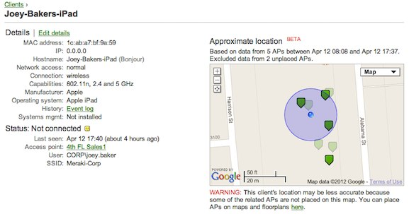
From a Cyber security standpoint, knowing where a device connects from is useful to make sure that the only people connecting are from within the building. The device details also shows what user is logged on to each device and the type of device they are logged on with.
Another feature of the software is the ability to apply group policy and allows you to set access levels per device or per user so that the devices are only able to access certain areas of the network. This means even if someone tries to connect to the network and is successful, there is another level of security to stop unwanted access to sensitive information.
Cisco Meraki also has an antivirus which the mobiles accessing the network require to install [5]: “Clients that fail to meet antivirus requirements are placed in a quarantine, where antivirus software can be downloaded.” This reduces the risk of viruses compromising the network and you are able to run a virus scan at scheduled times.
This is what the interface looks like [7]:
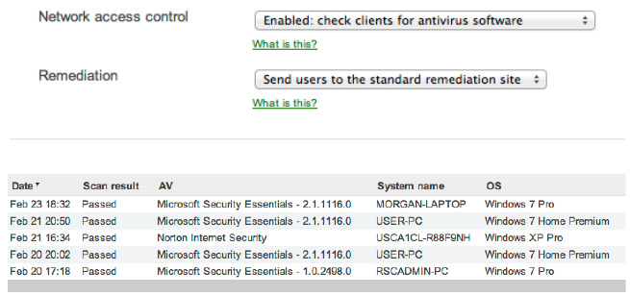
The Meraki software is more than just BYOD, the software itself is an all round network monitoring software and provides analytics over the LAN and WIFI and usage per device so you can see where the bandwidth is being used most, it always allows for limiting bandwidth use.
The negatives to this software is that since it has got several different uses in the app, this will raise the cost of use. Since the app requires you to allow location services and you are required to install the antivirus, some users may not want to agree to these terms as it could be seen as intrusive to collect information about the devices.
This is how the BYOT Policy would be implemented:
User requests use of their own device on the network from the Mobile device management team
The mobile device team provides user with the BYOD form for them to fill out
When the form has been filled out, user provides form to manager to approve and sign
Filed out form is submitted to the team to grant access to the network via mobile device
Does user have approval?
User is not allowed to use their device on the network.
No
Yes

Physical security
Cyber security is only part of protecting data, there needs to be a level of physical security in place to prevent any unwanted access to the servers or theft. It is advised to keep any sensitive information in a room with no windows and require a pass to access the room; this way even if someone is able to get to the room, they will not be able to enter without a key card.
There should be one way into the building that is also secured with a card key pass with a security guard at the front desk so that entry into the building is monitored, it would be advisable to hire only a handful of security guard, this way, the guards will get to know the staff and can tell if there is anyone entering that doesn’t work there (or is new), that being said, there should be a guest list that requires guests to sign in prior to entering the building. The colleague that the guest is there to see must escort the guest around the building.
Cameras will need to be set up to see everyone who goes in and out of the building, it is important that the cameras cover every area of every floor, this is to monitor access to restricted areas by either guest or actual authorised employees. In the case of a breach, the cameras can narrow down the perpetrator. The cameras [8] “can even be set up to send e-mail or cell phone notification if motion is detected when it shouldn't be (such as after hours).”
To prevent theft, it is advisable to know where the important data lies, the server cases will need to be locked to prevent access to the hard drives [8] “A hacker can plug a laptop into a hub and use sniffer software to capture data traveling across the network.” Other potential targets for thieves are laptops and other portable devices, physical devices are replaceable but the intellectual property on the hard drives would cost the company a lot more if lost.
It is recommended to set up a CMDB (config management database) to log the company’s CIs (config items), this way you have a dynamic database of every resource the company owns, the Meraki software is able to assist with this as each CI that connects to the network is stored, if a device goes missing, since the application requires you to turn on location settings, you are able to ping the missing device for its location and submit a police report to retrieve the missing item.
On the subject of theft, a policy that advises what to do in a situation where hardware has been stolen is advised. I propose the following;
- When the device is reported missing, file a police report so that the process to recover the device has been started, log the crime reference number to against the CI in the CMDB so that there is a way of looking up the status of the device.
- Ping the device using the location finder on Meraki if possible. The device should hopefully let you know its location, failing that there needs to be a way to remotely wipe the device when it is next on a network.
- Wiping the device is advisable since it prevents data leaks.
With that in mind, no documents should be stored on these personal devices, the documents should only be accessible, not downloadable. This way, stealing the device would only give you the hardware and not any important company information.

Network setup
This is how the report advises to setup the network:
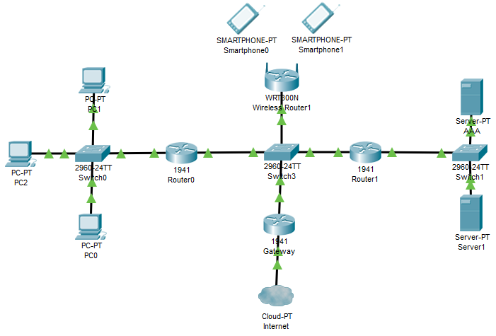
The wireless access point is away from the servers and the computers, this is to ensure that there are walls that will be needed to break through in order to reach the data on these devices.
Each switch and router have been password protected and the IP domain-lookup has been turned off to prevent DNS lookups.
The access point has been set up with WPA2 Enterprise security, with the Mobile device management software, you may be able to connect to the router, but the network will still be unusable until access is provided by IT.
The internet access is also blocked by the default gateway router, any traffic trying to enter the network will be met by the default gateway which is also password protected.
There has been an AAA server setup which is to allow policy updates to be sent out to devices [9] “Changing the Group Policy or VLAN for an existing client session using a WPA2-Enterprise network is possible using CoA to force the client to re-authenticate and assign the new policy.” This is to make sure the policy on any device is up to date, any updates in the MDM Software can be sent out to any device connected to the access point.

Conclusion and considerations
This report contains many policies that, if followed correctly, could save the company from data loss and financial loss. According to [10] the most common method for spreading malware is Emails with [11] “75% of all attacked business reported fraudulent emails.” There are also reports that show that [11] “Unauthorized use of systems, computers or servers from outside entities rose by 5% in 2018.” Cyber crime is on the rise.
With that in mind, training users in managing their data would be the most effective way of keeping the hackers out, teaching them what a fraudulent email looks like and to advise them not to click on emails would make it a lot harder for people to access the network through malware sent through email attachments. There could also be training exercises where test “fraud” emails are sent out and you can monitor who clicks on the links in the emails to target the training to these users in particular.
Having posters around the office to advise of the threats of hackers could also work to lessen the risk to the network. Having a robust security policy is paramount to protect the company’s sensitive data from hackers that want to access it.
It may be worth considering a robust backup strategy for the data on the network to minimise the effect of a ransomware attack, these attacks are where data is locked down unless a certain ransom is paid (usually in bitcoin), most of the time, even if the ransom is paid, the data is not 100% likely to be returned. The best way to secure data is to make sure it is in at least 3 different places, for instance, locally on the machine, on a server and on the cloud. If one of the locations is compromised then it is possible to retrieve the data from one of the backups.

Future work
In the future, to improve the quality of report produced it would be advised to research what different security policies look like, the structure of this report could have been better. The key points have been explored but more examples were available and possibly could have been provided also.
In reflection of the work produced, a more variety of sources could have been found since there have been times the same source have been used more than once. It would have been more effective to provide a more variety of sources also since the web has been the only source of information in the report.
The network section of the report could have included firewalls to solidify the security on the network, there was an attempt to add firewalls to the network, but the writer was unsure how to set up the firewall and the firewall rules.

References
[1] https://www.techradar.com/uk/news/computing/what-is-byod-and-why-is-it-important-1175088 accessed 06/12/2019 written by Dean Evans 06/11/2019
[2] https://www.forcepoint.com/cyber-edu/bring-your-own-device-byod accessed 06/12/2019
[3] https://www.msidata.com/pros-and-cons-of-byod-in-mobile-field-workforce/ accessed 06/12/2019 written by Gina Matteucci 28/08/2019
[4] https://www.statista.com/topics/2286/cisco/ accessed 07/12/2019
[5]https://meraki.cisco.com/ accessed 07/12/2019
[6] https://meraki.cisco.com/img/solutions/ipad-client.jpg accessed 07/12/2019 (image)
[7] https://meraki.cisco.com/img/solutions/virus-protection.jpg accessed 07/12/2019 (image)
[8] https://www.techrepublic.com/blog/10-things/10-physical-security-measures-every-organization-should-take/ accessed 08/12/2019
[9]https://documentation.meraki.com/MR/Encryption_and_Authentication/Change_of_Authorization_with_RADIUS_(CoA)_on_MR_Access_Points accessed 08/12/2019
[10] http://techgenix.com/10-hacking-stats/ accessed 09/12/2019
[11] https://hostingtribunal.com/blog/hacking-statistics/#gref accessed 09/12/2019

marking criteria and Student FEEDBACK

This section details the assessment criteria. The extent to which these are demonstrated by you determines your mark. The marks available for each criterion are shown. Lecturers will use the space provided to comment on the achievement of the task(s), including those areas in which you have performed well and areas that would benefit from development/improvement.

Common Assessment Criteria Applied (Assignment 1) | Marks available | Marks  awarded
1. Research-informed Literature
Extent of research and/or own reading, selection of credible sources, application of appropriate referencing conventions.
Very good report but lack credible peer reviewed articles sources. Only websites used. Reference convention applied. (Grade mark: 50.00%) | 15 | 7.5
2. Knowledge and Understanding of Subject
Extent of knowledge and understanding of concepts and underlying principles associated with the discipline.
As mentioned above good knowledge of the basic concepts and understanding apply but lack credible sources. (Grade mark: 50.00%) | 15 | 7.5
3. Analysis
Analysis, evaluation and synthesis; logic, argument and judgement; analytical reflection; organisation of ideas and evidence
You have discusses the relevant areas for this assignment; policies, MDM and security. It would be good to inter-relate your discussion with the case study. Very good; a written conclusion and future work done. (Grade mark: 70.00%) | 40 | 28
4. Practical Application and Deployment
Deployment of methods, materials, tools and techniques; application of concepts; formulation of innovative and creative solutions to solve problems.
Relevant security measures applied would do with some annotation and how it applies to the case study. (Grade mark: 75.00%) | 20 | 15
5. Skills for Professional Practice
Attributes in professional practice: individual and collaborative working; deployment of appropriate media; presentation and organisation.
Flow well, could do with justified alignment. Some grammatical errors; avoid contraction grammar for academic work. (Grade mark: 60.00%) | 10 | 6

Assignment Mark (Assessment marks are subject to ratification at the Exam Board. These comments and marks are to give feedback on module work and are for guidance only until they are confirmed. ) | Late Submission Penalties (tick if appropriate) |  | 64%
 | Up to four weeks late |  | 64%
 | First Attempt? |  | 64%

