A Guidance Handbook for Early Years Practitioners during Childhood Transitions



(Source: Psychology Today, 2019).

Contents

Introduction 3

How to use this Handbook 5

Needs of the Child 6

Role and Responsibility of the Adult 11

Importance of Partnerships 15

Interventions 18

Proposed Outcomes 19

Reference List 23

Introduction
Transition is the process in which something changes from one state to another. To transition from one state or activity to another means to move gradually from one to the other (Collins English Dictionary, 2020).

It is recognised by Allingham (2012) that children encounter many transitional periods in their early and most informative years. Allingham (2012) defines transitions as a variety of changes that will affect typical routine. Transitions can be relatively small or can be far more complex. Changes affecting the team of staff, moving from home to an early years setting, moving from room to room within a setting, moving from pre-school to Nursery and Nursery into full time education are all examples of transitions in a child’s life from birth to five years.

It is essential that early years practitioners are aware of and fully support children through transitions. Nutbrown and Page (2008) suggest, whilst it is inevitable children will experience many changes in their early years, practitioners have a duty to be completely in touch with the needs of the child and sensitively manage transitions alongside the child taking the lead from them. This is also reflected in Article 12 of United Nations Convention on the Rights of the Child (UNCRC) that states,
“Every child has the right to express their views, feelings and wishes in all matters affecting them, and to have their views considered and taken seriously. This right applies at all times, for example during immigration proceedings, housing decisions or the child’s day-to-day home life (Unicef, 2019)”.
Bronfenbrennar’s (1979) Egological Model of Human Development offers that the way in which children develop and adjust to school is influenced by social, cultural, developmental and biological characteristics and factors. (Dunlop, A-W. and Fabian, H. 2007).
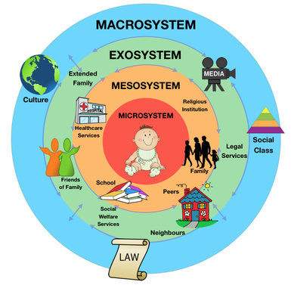

(Source: Study of the Mind, 2015).

Margetts (2002) suggests a combination of personal characteristics, experiences and interrelationships between home and settings will lay the foundation to how a child adapts to school life. (Dunlop, A-W and Fabian, H. 2007).

How to use this Handbook
For this purpose, the guidance handbook is designed to be used by keyworkers in a Flying Start setting caring for children aged two to three years. It will promote the keyworker’s understanding of how effective communication during transitional periods is essential to support a young child’s learning and development.

Welsh Government (2017) suggests effective transitions must be planned for, managed carefully ensuring children’s individual needs are thoroughly considered, and parents/carers are truly valued as partners in their child’s learning and periods of transition. Keyworkers will establish strong, professional relationships with families to enable an open, two-way communication system to develop. This ensures parents/carers feel comfortable, confident and build trust with the keyworker as well as the practitioner themselves gaining vital knowledge about the child’s individual needs, enabling practice and strategies to be adapted to provide the best possible support for improved future outcomes and full potential to be achieved. This is underpinned by UNCRC Article 3 which suggests that the best interests of a child must be at the forefront in all decisions made that will affect them. (Unicef, 2019).

Practitioners should draw upon observations of the child and other sources of information that have been gathered to enable informed judgements to be made whilst still supporting the child’s emotional development and wellbeing during the time of change. (Dunlop, A-W and Fabian, H. 2007).

This guide will enable keyworkers to meet children’s needs holistically and demonstrate a commitment to consistency in care, learning and development that in turn will be embedded in practice. High quality transitions will occur when they are prioritised and carefully managed under an ethos of gradual and fully supported integration. (Welsh Government, 2017).

Needs of the Child
Nutbrown (2011) suggests that positive, secure attachments are essential for all children regardless of religion, ethnicity, cultural beliefs, family background, disability or gender. This includes when children are cared for away from their home, for example in an early years setting. The role of the key worker is to form a secure attachment with the child through high-quality interactions, warmth and being responsive to individual needs. Nutbrown (2011) also offers that the keyworker will develop close, personal interactions with both child and parent/carer. By observing the child closely, the keyworker is able to ensure activities and the environment cater for their likes, dislikes, interests and what is familiar and important to them. This creates an environment and relationship whereby the child’s voice is heard and their views are respected, thus supporting children and their parent/carers to aid smooth transitions and enhance development.

Maslow (1943) developed a Hierarchy of Needs that theorised that there are a set of specific needs that humans strive for and are motivated to achieve. (Simply Psychology, 2018).
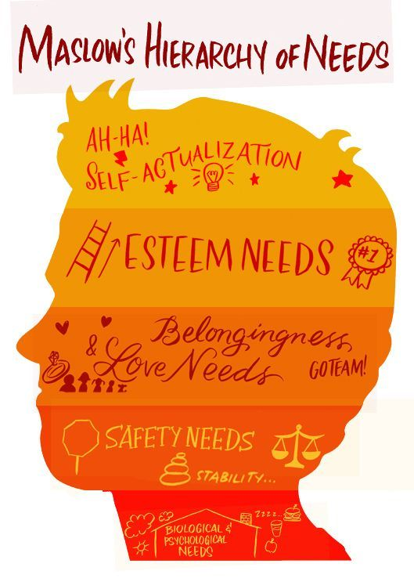

(Source: Curriculum Management Solutions, 2020).

Maslow (1943) suggests whilst the basic human instinct is for survival, once that need is met people will be motivated to achieve the next need within the ‘hierarchy’ and this pattern will continue until they reach the fifth tier of Self-Actualisation. (Simply Psychology, 2018). Practitioners have a responsibility to meet the individual needs of children to ensure they have a fair opportunity to develop to their full potential against Maslow’s Hierarchy of Needs.

Play is an essential part of child development and heavily contributes to children understanding the world around them, which in turn supports transitions. Children often immerse themselves in the fun activity of ‘play’ and learn a range of skills whilst doing so such as working with others, sharing and problem solving. (Family Lives, no date). The Foundation Phase Framework (2015), which focusses on children aged three to seven years old, acknowledges that children in receipt of first-hand, quality play experiences are able to consolidate learning, acquire problem-solving skills and are active decision makers. Through play, children develop an understanding of the world around them as well as a sense of themselves promoting self-esteem and self-worth. (Welsh Government, 2015). There are seven areas of learning within the Foundation Phase Framework (2015) that allow children to develop holistically and for practitioners to provide a range of activities and learning experiences within. These include:
- Personal and Social Development and Well-Being and Cultural Diversity
- Language, Literacy and Communication Skills
- Mathematical Development
- Welsh Language Development
- Knowledge and Understanding of the World
- Physical Development
- Creative Development

Professor Colin Blakemore agrees with play forming the basis of learning as he outlined that formal teaching prior to the age of seven years old does not benefit children longer term. (Nursery World, 2019). Blakemore argued that children who were taught more formally at a young age forego vital skills such as social skills.

Havard University (2020) suggest the foundations for resilience and robust brain development are built through responsive adult relationships, healthy environments and growth-promoting experiences. Brain development is most active in the early years when neural connectors are formed, providing the foundations for later life. Experiences during the early years affect brain development and impact on future behaviour, health and learning. The responsiveness of a carer in the formative years strengthen neural connectors and support the development of communication and social skills. (Havard University, 2020).



(Source: Jump Associates, 2017).

A key worker approach within settings enables practitioners to observe and identify children’s individual needs and develop responsive, nurturing relationships with them. This approach ensures the child’s best interests and voice are at the heart of any decisions made and transitions can be supported and planned for well. (Nutbrown, 2011).

Role and Responsibility of the Adult
When children feel safe in a secure attachment they are more prone to being independent, resilient and motivated to participate in new experiences. (Early Years Matters, 2020). Bowlby (1953) suggested that the need to form secure attachments is innate for children. Whilst Bowlby recognised that secondary attachments can be developed and are valuable, he argued that the attachment with a primary carer or ‘mother figure’ was typically more important and impactful on a child. Bowlby (1953) also suggests that the relationship a child has with their primary care giver is the foundation for which future social relationships are based upon and that continuous disruption in the attachment or inconsistent responsiveness from the ‘mother figure’ can result in emotional, cognitive and social difficulties for the child into adulthood. (Simply Psychology, 2017).

Secure attachment and deep emotional bonds are formed with the caregiver who responds sensitively and accurately to a child’s needs rather than the person who spends the most time with the child. (Simply Psychology, 2017). By adopting a keyworker system and being attentive to the needs of individual children, practitioners are able to support development holistically. Children thrive when people who they have formed special attachments with care for them. (Professional Association for Childcare and Early Years, (PACEY) 2020).

“A key person is someone identified in group day care who has specific responsibility for a number of named children. She or he liaises with parents and attends to all aspects of the young child’s needs and development while in the setting. (Nutbrown, 2011. Page 85).”

It is the responsibility of the Early Years practitioner or allocated keyworker to ensure children are fully supported during periods on transition. This should be carefully planned for, identifying and taking into consideration the individual needs of the child so these can be accommodated. This in turn promotes independence and provides the child with a sense of confidence enabling them to settle into their new routine or environment with ease. Transitional periods such as moving away from the home to attend a Flying Start setting can induce anxieties and stress for parents/carers as well as the individual child. Practitioners must support the whole family and manage transitions sensitively to ensure best possible outcomes. (Croneri, 2019). The aim of attachment is a secure base and when attachment needs are fulfilled then play and exploration can begin. (Holmes, 2013).

To begin the transitional period, the setting facilitates Open Days. Children and parents/carers are invited to attend these sessions prior to the child turning two years old. They are able to access and familiarise themselves with typical activities offered within the setting environment, the routine and meet the staff team. The next step to aid smooth transition from home into the Flying setting is that the keyworker, along with the manager, will conduct a visit to the family home prior to the child accessing the childcare setting. This not only provides an opportunity to complete relevant paperwork to gather further information about the child such as likes, abilities, dislikes, current skills being learnt and family needs, but also an opportunity for the child to meet their keyworker in a familiar environment with the person with whom they have formed their secure attachment. Staff have further insight to the child’s home environment and background with regards to vulnerabilities and cultural beliefs. Parents/carers have the opportunity to ask questions and share information about their child. This forms the beginning of the relationship between family and staff as well as home and setting. This approach ensures an individualised transition support plan can be implemented as it is heavily influenced by the information shared within the home visit. This is in line with Welsh Government (2017) who suggest that inclusion, support and positive relationships are key and the child, along with their family, should be at the centre of the transition process. Furthermore, the responsibilities of you as keyworker continue throughout the phased transition and settling in process. These are outlined by Welsh Government (2017) as:
Where children and their families access other services offered within the Flying Start programme, information will be effectively communicated to the wider Flying Start team to ensure continuity of care, learning and development.

Children and their families are safeguarded from harm. Practitioners will be knowledgeable in identifying needs, knowing when, how and to whom they will refer on for more targeted support.

Supporting documentation such as one page profiles are completed in conjunction with families to ensure further information with regards to how best to support the child and what is important for them is obtained taking into account the keyworkers observations within the childcare environment.

Parent/carers are involved and valued. They are included in events such as outings, story and craft sessions and celebrations. Time is also set aside to discuss progress and concerns through a parent/carers preferred method of communication such as face-to-face meetings, written reports or telephone calls.

A defined pathway of support is outlined for children and their families and is communicated and shared clearly with them.

By adopting this approach, transitions are managed effectively with children and their families having positive experiences of change with emotional and practical support, thus enhancing well-being, relationships, learning and development. (Welsh Government, 2017).

Importance of Partnerships
Working in partnership with parents/carers best supports children and brings their best interests to the forefront. Care Inspectorate Wales (CIW) (2016) outline in standard six of the National Minimum Standards (NMS) the requirement that staff should work in partnership with parents to meet the individual needs of a child and fully recognises and respects the parent’s primary responsibility for their child. It ensures parents are kept informed about their child’s development, achievements and has access to records held about their child. Involving parents/carers at the start of their child’s learning journey enables strong, positive relationships to be formed and for crucial information about the child or young person to be shared that will inform practice, planning and approaches based on their individual needs. The Foundation Phase Framework (2015) also reflects this as it requires practitioners to foster strong and positive relationships with parents/carers as they are recognised as the child’s first educators.
As keyworker you will be responsible for including parents/carers during transitional periods. You will:
Conduct Toddler Talk meetings with parents/carers to share progress and provide opportunities for families to share any worries or concerns that can then be addressed appropriately.
Feedback to parents/carers daily on how the child has settled and what they have enjoyed doing.
Involve parents/carers in their children’s experience of the setting by facilitating family sessions such as Story and Craft, Sing-A-Longs, Community outings and parties.
Ensure parents/carers have equal access to information about their child and how they can best support their child by sharing resources, ideas and activities.

This approach lays the foundation for a trusting, supportive and positive two-way communication system to develop with parents/carers that ensures the child’s needs are at the forefront at all times.

Multiagency working is another important aspect of a family receiving individualised support. Professionals such as Health Visitors, Social Workers, Speech and Language therapists, Educational Phycologists and Nursery teachers are people who you, as keyworker, will be required to liaise with in the best interests of the child and their family. Prior to any onward referrals to external agencies being submitted, parental consent must always be sought. (NHS Wales, no date.) As keyworker you will discuss the possible need for onward referrals and obtain consent as well as explaining and completing the ‘Sharing and Storing Information’ document with the parent/carer as part of the admissions pack which discusses with whom, how and why information will be shared.

According to Welsh Government (2012), multiagency working allows for early identification of needs to take place and correct assessment and referral to happen in order for children and families to access the right support. Assessments such as WellComm screens and the Foundation Phase Profile will be undertaken by the keyworker in the setting and give an insight to overall development and any areas where specialised support may be required. These assessments can also form part of a decision making process for further assessment or referrals to be made by other professionals such as the Health Visitor conducting a targeted Schedule of Growing Skills assessment or onward referral to a Paediatrician for a Ruth Griffiths assessment. The keyworker will continue to liaise with and support parent/carers ensuring they are fully included within the process and aware of all other agencies involved. Communicating sensitively with parents/carers, ensuring they are fully informed about their child’s time and progress within the setting, enables keyworkers to build strong relationships with them as well as form meaningful attachments with the children. (Professional Association for Childcare and Early Years (PACEY), 2020).

Interventions
Reggio Emilia is a small Italian city that has an outstanding model of early childhood education. This model was initially developed by parent/carers who wished for their children’s educational experiences to look different to their own and provides learning communities that embed freedom and democracy into practice. (Mcnally and Slutsky, 2017). The model consists of fundamental principles that are interconnected and dependent on one another. There is a sense of community commitment and duty to children within this approach which is at the heart of its success. (Mcnally and Slutsky, 2017). Welsh Government (2017) also suggest that a child’s ability to participate can be heavily influenced by the quality of adult support they are in receipt of and the weight given to their views being valued and respected.

Within the setting the keyworker, along with the wider staff team, will be committed to providing high-quality childcare ensuring children feel supported, valued and respected. This allows children to feel securely attached and to form positive links with their keyworker, building on their confidence and free exploration within play. By adopting this approach, children’s best interests, short and long-term needs are accommodated, enhancing future outcomes. Nutbrown, Clough and Selbie (2008) suggest that in an appropriate environment play can be considered as both an intrinsic and extrinsic motivator for children. Having a shared vision of what a positive, stimulating and holistic environment is, practitioners are able to motivate learning providing children with quality play experiences enhancing their development and building sustainable life skills.

Proposed Outcomes
Welsh Government (2017) suggest that all children develop at varying rates and have a range of differences such as skills, abilities, personal characteristics and experiences. Children will respond differently to change and transitions, some taking longer or needing more support to adjust. O’Connor (2006) suggests that children who are supported well through early experiences of transition learn to manage change more positively in the short term and later in adult life.

The main outcome is that children and their families receive practical and emotional support during transitional periods as suggested by Welsh Government (2017). Transitions should be carefully managed and planned for ensuring the needs of the child are met and parents/carers are considered as true partners. Effective communication with families and professionals is the basis that successful transitions rely upon. O’Connor (2006) reflects this by suggesting that transitions should be looked at as part of practice and not in isolation. By embedding transitions into everyday practice, then children are more likely to become emotionally intelligent and able to make strong attachments. Furthermore, children will be resilient and resourceful when they encounter change and will be able to embrace new experiences and take risks confidently.

Vygotsky (1896-1934) believed that children develop higher functions such as problem solving skills, language acquisition, counting and voluntary attention through social interactions with peers or adults who are more ‘advanced’ then themselves. (Doolittle, 1995). They learn new skills and develop cognitively through these interactions within the zone of their proximal development requiring less support with activities and tasks as they progress. Blatchford-Siraj (2009) suggests children learn through play and shared, playful activities. Early Years practitioners need to engage in quality, shared interactions with children to further develop knowledge, skills and cognition. Engaging in and planning for opportunities for sustained shared thinking improves outcomes for children and young people. (Blatchford-Siraj, 2009).
Professor Graham Donaldson conducted a review of the curriculum in Wales in 2014. Some of his findings suggested that the curriculum was outdated, heavily centred around assessments and lacked focus on well-being, basic life-skills and personal confidence. (Welsh Government, 2015). The report aims to provide a more creative way of teaching, a more interesting and challenging experience of education for children and young people and enables parents/carers to engage in a more direct way with their child’s learning and development. (Welsh Government, 2015).
Donaldson identified four purposes for the curriculum in Wales. He recommended that the curriculum be designed in such a way that children are supported in becoming:
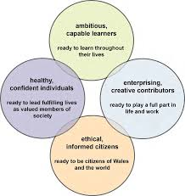

(Source: Trinity Fields School and Resource Centre, no date).

Lewis (2015) acknowledged that the independent review by Donaldson provided a new opportunity for the curriculum in Wales to be current and relevant for the twenty first century. It is clear that with sustained and active participation by early years practitioners, improved outcomes for children and young people can be obtained. The way in which transitions are managed and planned for by practitioners will play a pivotal role in achieving proposed outcomes.

