HND Computing
Year 2

Database Management

By
James Glanville
Table of Contents
Page 3:……………………..Introduction
Page 4:……………..Performance tuning
Page 4-6:…………………………..SQL’s
Page 6:………………………….Rollback
Page 7:………………………….Indexing
Page7-8:………………Required indexes
Page 8:...Triggers/implemented Triggers
Page 9-10:……….Database Distribution
Page 11:………………………….Testing

Introduction
Once the database had been created and all of the necessary fields had been filled with data, we were given the task of finding any performance issues and identifying/creating any relevant/required performance enhancements (e.g indexing) to the database as well as putting forth a solution for the ‘Cycles to Share’ company on a way to fragment and distribute the database to all stations of ‘Cycles to Share’.

Performance Tuning
SQL’s: (I) = Indexed (C) = Create (R) = Read (U) = Update (D) = Delete
Transaction 1: (R)(I)
SELECT StationName, StationAddress, PostCode, PhoneNumber
FROM Station
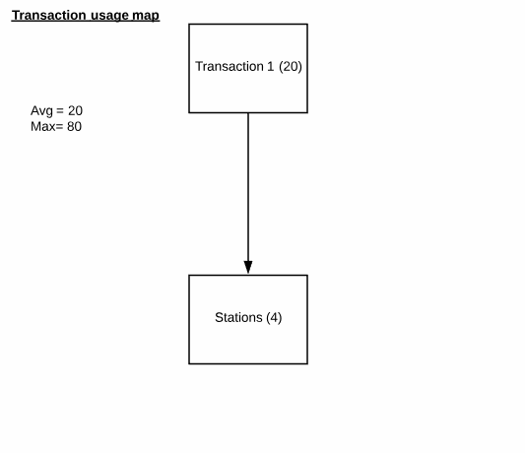
WHERE PostCode LIKE 'SA%'
Transaction Volume:
Average: 5 per Day
Peak: 20 per Day (between Friday to sunday)

Predicate: PostCode = ‘SA%’
Join Attributes: None
Ordering Attributes: None
Grouping Attributes: None
Built-in Functions: None
Attributes updated: None

This transaction is used for finding station contact and address details with in a specific Postcode/Region. This would be utilised when a customer is needing to know local stations that they could possibly drop off the bike when finished and its location, or ways for the customer to contact another station in order to make any necessary enquires/transactions.
Access | Entity | Type of access | Number of references
Access | Entity | Type of access | Per transaction | Avg per day | Peak per day
 | Station | (R) | 1 | 20 | 80
Total References |  |  | 4 | 80 | 320
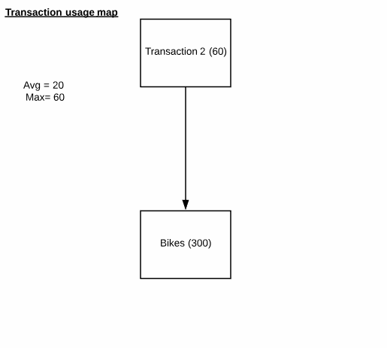

Transaction 2: (R)(I)
SELECT BikeCode, StationCode, BikeStatus
FROM Bike
Transaction Volume:
Average: 20 per Day
Peak: 60 per Day (between Friday to sunday)

Predicate: None
Join Attributes: None
Ordering Attributes: None
Grouping Attributes: None
Built-in Functions: None
Attributes updated: None
Access | Entity | Type of access | Number of references
Access | Entity | Type of access | Per transaction | Avg per day | Peak per day
 | Bike | (R) | 1 | 20 | 60
Total References |  |  | 300 | 6,000 | 18,000
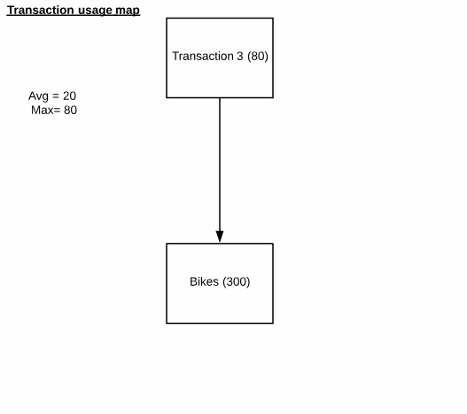
This is a transaction that would mainly be used for checking whether a specific bike is ‘AVAILABLE’ or is already ‘RENTED’. This reasoning behind this is that regular customers may enjoy renting a specific type of bike or a bike that had previously been rented by them. By using this transaction, it would enable quick access to whether or not it is available for them.

Transaction 3: (U)
UPDATE Bike
SET BikeStatus = 'AVAILABLE'
WHERE BikeCode = 'B0001'
Transaction Volume:
Average: 20 per Day
Peak: 80 per Day (between Friday to sunday)

Predicate: BikeCode = ‘B0001’
Join Attributes: None
Ordering Attributes: None
Grouping Attributes: None
Built-in Functions: None
Attributes updated: BikeStatus
Access | Entity | Type of access | Number of references
Access | Entity | Type of access | Per transaction | Avg per day | Peak per day
 | Bike | (U) | 1 | 20 | 80
Total References |  |  | 300 | 6,000 | 24,000

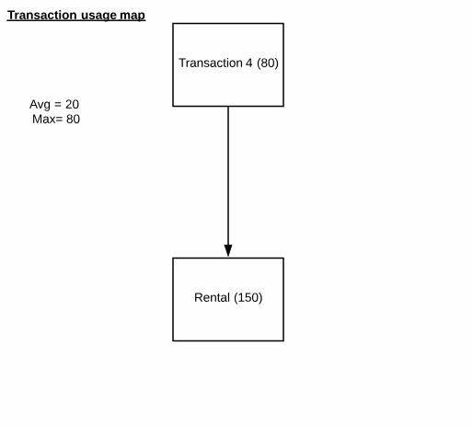
Here we have an update Query which is able to update the bikes status. This transaction is used when a customer has recently returned a bike after finished and the employee needs to update the bike status from ‘RENTED’ to ‘AVAILABLE’.

Transaction 4: (U)
UPDATE Rental
SET RentalStatus = 'RETURNED'
WHERE RentalNo = 'R0101'
Transaction Volume:
Average: 20 per Day
Peak: 80 per Day (between Friday to sunday)

Predicate: RentalNo = ‘R0101’
Join Attributes: None
Ordering Attributes: None
Grouping Attributes: None
Built-in Functions: None
Attributes updated: RentalStatus
Access | Entity | Type of access | Number of references
Access | Entity | Type of access | Per transaction | Avg per day | Peak per day
 | Rental | (U) | 1 | 20 | 80
Total References |  |  | 150 | 3,000 | 12,000
I had to create an extra column of data in the effort to solve the no more than 6 bikes at one time issue that the company wanted implemented as it is a company policy. By having an extra column determining the status of whether the bike has been returned or not I am able to implement a rollback feature that would prevent over renting which is determined by the account and its rental status.
This query will update the field from rented to returned which will allow the customer to rent more bikes if they had reached the limit before return.

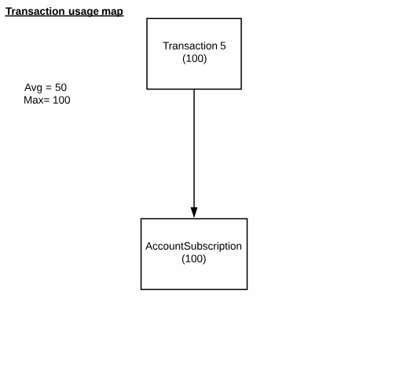
Transaction 5: (R)(I)
SELECT SubscriptionId, AccountNo, SubscriptionType, SubStatus
FROM AccountSubscription
WHERE AccountNo = 'AC003';

Transaction Volume:
Average: 50 per Day
Peak: 100 per Day (between Friday to sunday)

Predicate: AccountNo = ‘AC003’
Join Attributes: None
Ordering Attributes: None
Grouping Attributes: None
Built-in Functions: None
Attributes updated: None
Access | Entity | Type of access | Number of references
Access | Entity | Type of access | Per transaction | Avg per day | Peak per day
 | AccountSubscription | (R) | 1 | 50 | 100
Total References |  |  | 100 | 5,000 | 10,000

This SQL query is used to check the subscription status as well as the type of subscription that particular account has. It would be used mainly to check whether or not an account has paid for the subscription or if payment is needed, otherwise the subscription will be terminated.

Rollback:
The rollback function will rollback the database if predetermined conditions are met. It is primarily used for database security/integrity so if a user where to input the incorrect data or in the case of ‘cycles to share’ over-renting a bike to a customer then it would rollback the database to its last known state before any errors have been made and an error message would then be given to the user. Another example would be if a server where to fail during a transaction the database would trigger a rollback to its last known state to prevent incorrect or partial data being entered into the database.

As said previously in the SQL section I had to add an extra field to the Rental table for a rollback feature to be implemented and work accordingly. The code is provided below

BEGIN TRANSACTION AddBike

INSERT INTO Rental (RentalNO, AccountNo, BookingDateTime, PickupStation, LockCode, RentalStatus)
VALUES ('R0109', 'AC001', '2019-01-12 08:00', 'ST001', '9753', 'RENTED')

IF (SELECT COUNT (*) FROM Rental WHERE AccountNo = 'AC001' AND RentalStatus = 'RENTED') > 6

BEGIN
ROLLBACK TRANSACTION AddBike
RAISERROR('Error! Account has reached limit of bikes rented at one time.',16,1);
END
ELSE
COMMIT TRANSACTION AddBike;
Indexing:
We use indexes to help search through large amounts of tables and data stored in a database, we do this as large amounts of data can have a large impact on the execution time and efficiency of SQL Query’s. This is because with non-indexed tables being utilised in an SQL Database, when a query is executed by the user it would have to search throughout the entire database from start to finish. When working with tables of a small nature the impact that this would have would be minimal but for larger tables it could potentially have a drastic effect on the efficiency and execution time.
The downside of using indexes is that they can slow down the overall process of UPDATE, DELETE and INSERT Queries unless a WHERE clause has been utilised. The INSERT, UPDATE and DELETE Queries become slower because with each execution of the Query the indexes must also be updated.
To Aid in deciding on what tables to index I performed a Transaction/relation cross-reference matrix. The basis being to layout the tables queried and each transaction and tick on the table effected by each transaction on whether it’s a (C) = Create, (R) = Read, (U) = Update or (D) = Delete. Based of the results it will help show what needs indexing most and which don’t.
Table | Transaction1 | Transaction2 | Transaction3 | Transaction4 | Transaction5
 | C R U D | C R U D | C R U D | C R U D | C R U D
Station
Bike
Account
Subscription
Rental

Required Index’s:
After I had gone through the SQL queries that I thought were needed for the ‘cycles to share’ business, I then had to think on what queries would be used a lot as well as the action that they are doing by performing a Transaction/relation cross-reference-matrix to show the crud and tables most used. After taking all points into consideration I chose 3 indexes that would be beneficial to the performance of the database.
The three indexes are listed below and why not the others.

Index 1(Transaction 1):
Transaction one is intended to search up contact and address details for stations within a postcode area, as customers will most likely need to know what stations are available and ways of contacting/finding them in the foreseeable future. I chose to index the station table as it will be used often when searching for details, and as it doesn’t update, delete or insert data within the table, which as said previously slows down the performance because it will need to update the table and index each time.

Index 2(Transaction 2):
Index 2 is on the Bike table as the query most used from what I have made would be when customers check a status of a bike (rented/available) as well as the station that is being held at. This is one of the queries that would benefit most from indexing as it is a read only query.

Index 3(Transaction 5):
Index 3 has been placed on the ‘AccountSubscription’ table as the query for checking subscriptions could be used from many different reasons and would most likely be used very often

Transaction 3 and 4:
I chose not to index any of the other tables that are involved in sqls as they would more than likely make the performance worse or add extra strain on the system as they both update fields in tables which if indexed would also need to get updated every time that the query is executed

Triggers:
Triggers can be used for many different reasons. They are used to perform a predefined action that would execute automatically whenever a user tries to modify any data on the specific table that the trigger is on. They can be very useful with maintaining integrity but also very strenuous on the system if it is not used properly, as it would proc every time a query is executed on the specific table which can slow processing speed down a lot if it is a query that is used frequently as well as the complexity of the trigger can also affect the performance.

Implemented Triggers:
After looking at the database and all tables, I felt there was only 1 trigger that would be of use. Mainly it will be used for added integrity of constraints within a table.

CREATE TRIGGER overRentingBikes ON Rental

AFTER INSERT, UPDATE
AS

DECLARE @Msg VARCHAR(100)

IF (SELECT COUNT(*) FROM Rental where AccountNo ='AC001' AND RentalStatus = 'RENTED') > 6
BEGIN

SELECT @Msg = 'Account ' + AccountNo + ' already renting 6 Bikes' FROM inserted

RAISERROR(@Msg, 16, 1);
ROLLBACK TRANSACTION; -- Reverses the INSERT Statement
END;

This trigger is to ensure the company policy of no more than 6 bikes rented at one time. The trigger was created on the Rental table and would trigger after every insert into it. Although as said previously this can affect performance on the execution of the query, as this trigger isn’t that complex I believe it would have minimal affect and considering this was the only requirement they asked for I wanted to make sure that there would be no chance in the trigger and transaction not catching it and performing a Rollback.

Database Distribution solution
After completing the various SQL queries, indexes, rollback’s and triggers I was tasked with coming up with a distributed database design in which can be used to distribute information according to the proposed requirements (e.g. who and where is using the database).

To do this I had to look at the locations (station) the transactions (query’s) and the user (HR/Finance).
After taking all points into consideration a logically distributed database would be most beneficial. I would make the Cardiff station the main site, in which copies of data from all stations would be delivered to and stored. By doing this I am able to ensure all of the data from all of the sites are backed up, this is a necessary feature as it prevents loss of data in the event of server failure(s) at other sites. By backing up all data from each of the stations, if one or more stations is undergoing maintenance or experiencing server failure(s) they would still be operational by utilising the main site as a way of accessing their data. However, each location will store their own data , therefore if the main site experiences server failure etc, the data from each location will be unaffected, and can be later stored at the main site once operational additionally data from other stations would be received via the main site.
The main site would be in control of what data can accessed (Fragmenting). This is to ensure integrity of the database as well as ensuring the user is only able to see relevant data for their store. Each sub-location would be in charge of fragmenting data depending on the user which all sub-locations would contain a copy of the fragmentation.

This is What the data would look like normally. For security and performance reasons it would consist of horizontal and vertical fragmentation which would remove the AccountPassword and PaymentCardCVC coloumns and would only show accounts with that particular location e.g. CityCide.

AccountNo | RegistrationDate | FirstName | Surname | DateOfBirth | Email | AccountPassword | PhoneNumber
AC001 | 2018-08-06 | James | Glanville | 1991-07-06 | jamesG@gmail.com | James12* | 01348875545
AC003 | 2018-07-11 | Joseph | Griffiths | 1982-07-20 | josephG@gmail.com | Griff93 | 01633875545
AC010 | 2018-02-24 | Tye | Pierce | 1979-07-06 | TyeP@gmail.com | Pa55w0rd | 01792875545
AC021 | 2018-03-22 | yana | Woodward | 1989-07-06 | YanaW@gmail.com | Bike23 | 02911293812

AccountAddress | CityCode | PostCode | PaymentDate | PaymentCard | PaymentCarCVC
37, Dan-y-bryn | C0001 | SA65 9LQ | 2018-08-06 | 4554699956340 | 636
2 Oxford Close | C0064 | NP18 3PB | 2018-07-11 | 1229309021444 | 182
29 Ffordd Cwm | C0104 | SA5 7HJ | 2018-02-24 | 4920185743829 | 921
37 Mountain R | C0026 | CF15 8LF | 2018-03-22 | 5612647739220 | 817

After fragmentation the table of data would show something like this

AccountNo | RegistrationDate | FirstName | Surname | DateOfBirth | Email | PhoneNumber
AC001 | 2018-08-06 | James | Glanville | 1991-07-06 | jamesG@gmail.com | 01348875545

AccountAddress | CityCode | PostCode | PaymentDate | PaymentCard
37, Dan-y-bryn | C0001 | SA65 9LQ | 2018-08-06 | 4554699956340

This now shows only the data for an account in ‘CityCode’ C0001 as well as hiding any private information like the PaymentCardCVC and AccountPassword. This will ensure that the data is relevant when querying as well as added security by restricting personal information from being mis-used by employees etc.

These are the list of fragmentation and the predicate/ columns involved with the fragmentation:
(H) = Horizontal
(V) = Vertical
(M) =Mixed
(D) = Derived
(N) = None
Fragmentation 1: Account table (M)
Predicates - (WHERE CityCode = ‘C0001’)
Columns - (AccountNo, RegistrationDate, FirstName, Surname, DateOfBirth, Email, PhoneNumber, AccountAddress, CityCode, PostCode, PaymentDate, PaymentCard )

Fragmentation 2: City table (H)
Predicates – (WHERE CityCode = ‘C0026’)
The City table would not need to be seen other than by the main site in Cardiff. Is it wouldn’t be relevant in any situation for all sub stations to have this data.

Fragmentation 3: Bike table(N)
No fragmentation would be needed for the bike table as you would want it to be available from all stores in case a customer is looking for a specific bike

Fragmentation 4: Rental, RentalBike tables (H)
Predicates - (WHERE StationCode = ‘ST001’)
These two tables would be fragmented so that they will only be able to see their own relevant information. This would help query performance.

Fragmentation 6: Station table (N)
The station table would not need any fragmentation as all stations will need to be able to see station details in case a customer is needing to find or contact one.

Fragmentation 7: Tariff, TariffRate (H)
Predicates – (WHERE StationCode = ‘ST001’)
Tariff and TariffRate would be fragmented so that only the main site Cardiff station would be able to see and interact with this data, although other stations would have access to them when performing bookings

The fragmentation would be selective Replication which is a combination of replication, fragmentation and centralisation which has good reliability decent performance in comparison, it storage cost are affordable for the benefits with very low costs for communication between databases .the main site will have complete records for all tables with only certain fragmentation being utilised to other sites to ensure reconstruction of the tables after fragmentation.

Testing
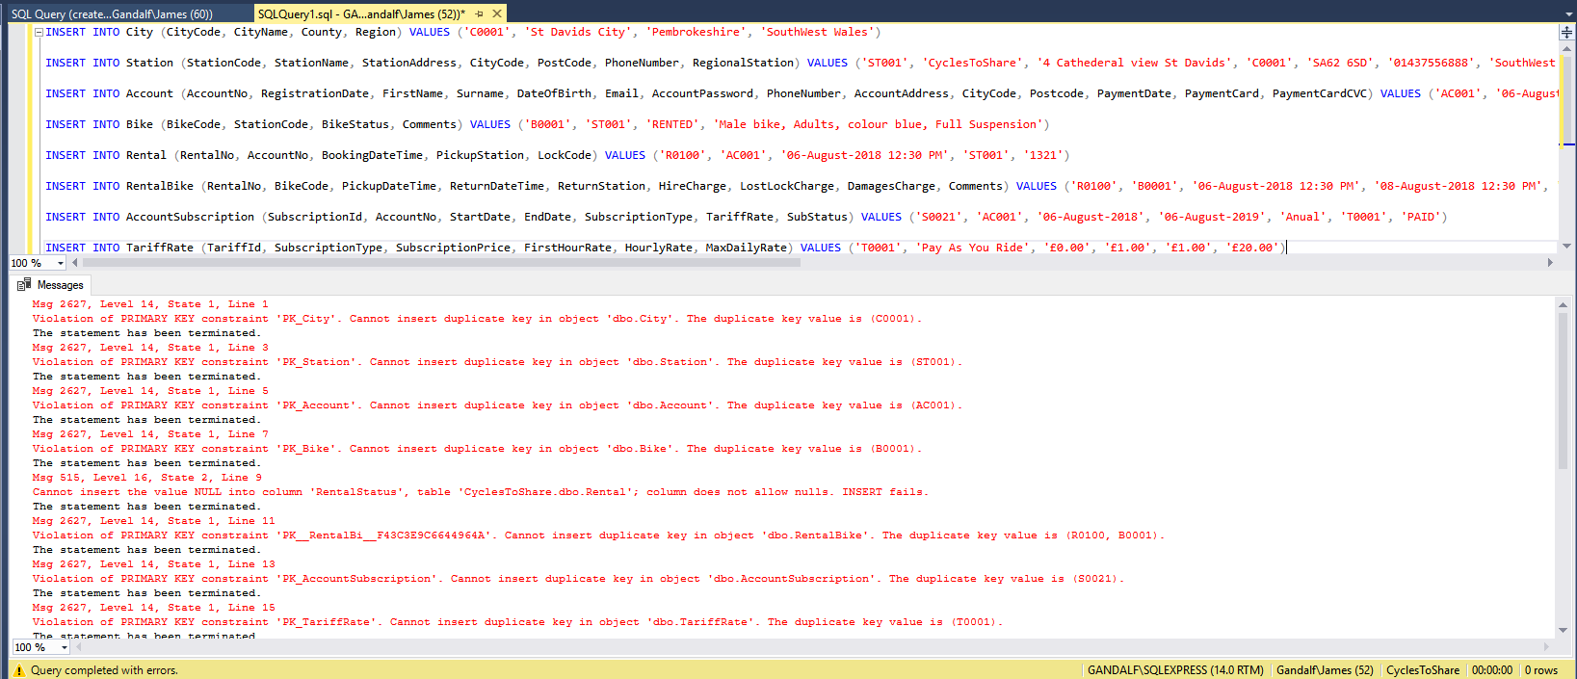
Primary constraints:
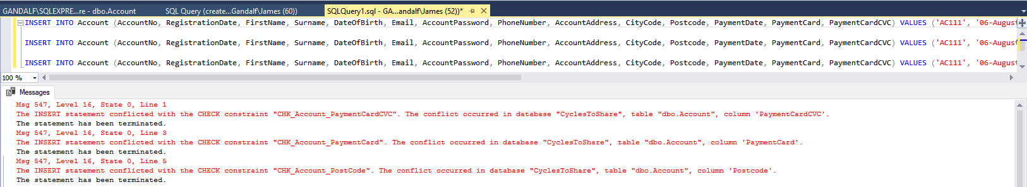
Check length constraints:

Rollback constraint:


