Sophie Morgan (1908091)
Fundamentals of Construction Technology
Construction Detailing
Word Count: 1,714

Contents
Content | Page
Introduction | 3
The Ground Floor | 3
The First Floor | 4
Openings | 4
Eaves Detailing and Roof Covering | 5
The Main Roof Structure | 6
Appendix | 7
References | 15

Introduction
Within this report I will be producing annotated sketches of a single, two storey detached domestic building with a loft room. In terms of construction detailing I will be evaluating the ground floor, the first floor, openings within the building, the eaves detailing and lastly the main roof structure. I will be including a step by step method of how each element is built and will identify the methods and materials used to prevent humidity and protect the building from the natural elements. Furthermore, I will be specifying within my report how my designs meet the current building regulations for a new build.
The Ground Floor
The proposed building is to be built on a greenfield site that has 450mm of topsoil above a form subsoil with a low clay content. There is to be a suspended timber ground floor with tongue and groove softwood flooring. This type of ground floor is cheap and easier to construct as it reduces the amount of ground preparation needed. It is the best method for sloping sites, low-lying areas or sites with bad climatic conditions and the use of timber allows it to have a minimal impact on the environment (Home Advice Guide, 2020). My proposed design for the foundations and ground floor can be seen in Appendix 1.
To construct the ground floor, we would first need to remove the 450mm of topsoil and then excavate a trench for the foundations. Building Regulations, Document A should be referred to in relation to the depth of the trench needed to support the building (Government, 2013). The internal floor will then need to be reduced for the hardcore and concrete slabs and the concrete foundation will need to be poured. The cavity wall should be built to Damp Proof Course (DPC) level including the brick plinths. The cavity wall will provide weather protection, thermal insulation and noise attenuation for the building. The DPC will prevent the groundwater from being absorbed by capillarity action in walls. Next, the cavity will need to be filled with concrete and the hardcore concrete will need to be installed to the internal floor area. Then the concrete base can be poured. The sleeper walls that are built on top of the subfloor and support the joists can then be constructed. DPC should then be fitted on top of the sleeper walls, to prevent decay from rising moisture, before placing the wall plates on top (Flynn, 2013). The external cavity wall should then be continued above DPC level, including installation of airbricks and cavity insulation. The use of airbricks will allow air to flow beneath the timbers, keeping them dry and preventing decay. Next, the internal floor joists and noggings should be installed above the wall plates. Reference should be made to Eurocode 5 Span Tables (Ranasignhe, 2014) to calculate the size of timber members needed to support the building’s weight. BS 8103-3:2009 Structural Design for Low-rise Buildings (British Standards, 2009) can also help recommend the size of timbers for detached houses. Refer to Building Regulations, Document A (Government, 2013) for information on how to correctly assemble the joists into the external wall to provide stability for the building against wind and ground movement. Insulation can then be installed between joists before laying the tongue and groove softwood flooring above. After this an external and internal render would need to be carried out. The external render would protect the external wall from weathering.
The First Floor
To construct the solid timber first floor, the joist hangers will first need to be installed level around the room and the centres corrected. Traditionally the joists would have been built into the blockwork however this takes considerably longer as the blockwork must be built around the joist ends (Northumbria University, 2020). Furthermore, the noggings will then need to be positioned to maintain the correct gap and strength in the joists. The noggings should extend at least half the depth of the joists and be at least 38mm thick. Next, the restraining straps will need to be inserted to restrain the joists into place and to tie them into the cavity wall. The tension straps are to turn down at least 100mm within the cavity and to be tight against the face of the walling inner leaf. Also, the strap should be rebated into the top of the joists to allow the floorboards to lay flat. Finally, the tongue and groove flooring is to be laid flat on top. My proposed design for the first floor can be viewed in Appendix 2.
Openings
To construct the openings around the buildings, the first step is to build the cavity blockwork up to form the door/window openings to the height and length required. Afterwards, the steel lintel is to be placed over the top of the openings. Metal lintels are a much cheaper and faster solution but need to be carefully installed and insulated to prevent thermal bridging. In reference to the Building Regulations, Part M (HM Government, 2010), the lintels should be installed with a minimum end bearing of 150mm, bedded on mortar, and levelled along its length and across its width. The masonry above the lintel should be built in accordance with BS EN 1996-2:2006. The mortar should be allowed to cure before applying any floor or roof loads (IG STeel Lintels, 2020). Next, the cavity tray needs to be inserted into the blockwork. This can be seen in Appendix 3. The Building Regulations, Document M (HM Government, 2010), also states that a DPC or a cavity tray should be installed over all openings in external cavity walls. A cavity tray allows water to be transferred from the cavity to external walls through the weep holes, avoiding any moisture in the building. Then the brickwork soldier course will need to be placed around the newly fitted lintel, including weep holes no more than 450mm apart. This can be identified in Appendix 4. Furthermore, the brickwork should be continued up above the opening. Then the decorative sill should be installed, as can be shown in Appendix 5. Next, the cavity fire sock and cavity closure should be fitted around the newly fitted opening. Lastly, the external skin is to be rendered and the light oak wood effect uPVC windows with double glazing are to be fitted and sealed to be made water tight.
Eaves Detailing and Roof Covering
Eaves are a part of the roof that hang out over the edge of the walls to provide shade to the outside of the building. An eave is formed when the ends of the rafter extend out past the outside of the walls and hang over the side of the house. They also encourage water to run off the side of the house rather than directly down its walls, preventing any leak problems (BUILD, 2020).
To construct a closed eave, the cavity blockwork will first need to be built up to wall-plate height. These plates are bedded into cement mortar on top of load-bearing walls. They provide the bearing and fixing medium for various roof members and distribute loads evenly over the wall. Next, the cavity closures need to be fitted and completed with DPC. Then, the trussed rafters can be installed at a 40º pitch inclusive of the restraining strap tying back into the external wall. The use of timber trusses reduces waste, allows faster construction and they can be prefabricated off site to save time. The rafters and restraining strap can be seen in Appendix 6. Furthermore, the fascia strip ventilation and felt support tray can be installed, this allows air flow to the roof and prevents any condensation. The felt underlay will then need to be installed complete with overhang into the gutter, this prevents any moisture getting into the building and protects the rafters from decay. Next, the timber battens should be placed on the roof in preparation for the slates. According to the BS 5534:2014+A2:2018 timber battens should be either larch, British pine or British spruce if they are British-grown or redwood, whitewood, spruce-pine-fir or southern pine if they are imported. Once the battens are placed the natural slate tiles can be fitted to cover the roof along with the ridge tiles and roof vents. The tiles should be staggered at the joints and the BS 5534:2014 should be used to calculate the correct head lap required for the correct sized slate tile. This will ensure that the roof is watertight and that no water can enter. Additionally, the barge boards and soffit plate can then be fitted. Then, the soffit board and fascia can be installed to protect the rafters from weathering. The guttering will then need to be fitted including the guttering clips and downpipes which allow the safe disposal of surface run-off. BS 5534:2014+A2:2018 should be relied upon to calculate the minimum gutter valley width, depending on the location and rainfall rate. Lastly, the insulation is to be installed between the rafters internally to regulate the temperature. My eaves detailing design can be viewed in Appendix 7.
The Main Roof Structure
Most of the roof construction was spoke about during the eaves detailing design, however there are some additional details to be included to complete the main roof structure fully. The design shows three double glazed roof windows which are to be installed, two at the front of the house and one at the rear. These Velux windows will need to be fitted and complete with lead flashing after the fascia strip ventilation and felt support tray have been installed. Furthermore, plywood valley boards will be needed in the main structure to carry rainwater from the roof (rci, 2020). The felt underlay can then be laid on top along with the timber battens. Then, a lead strip will need to be fitted in the valley boards, on top of the timber battens, before the natural slate can be laid. For the main roof, eave, ice and snow guards will also be required to protect the structure from weathering. Lastly, gable end vents will need to be installed to ensure extra air flow to the roof. The main roof structure can be identified in Appendix 8.

Appendix 1
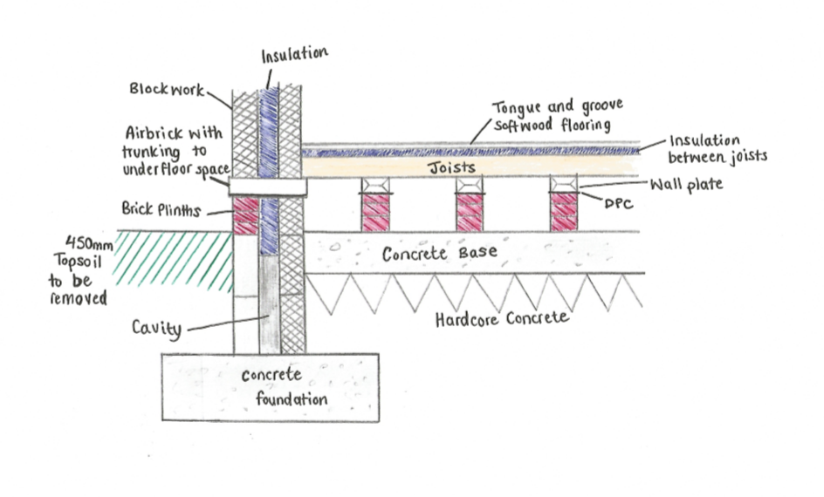
Appendix 2
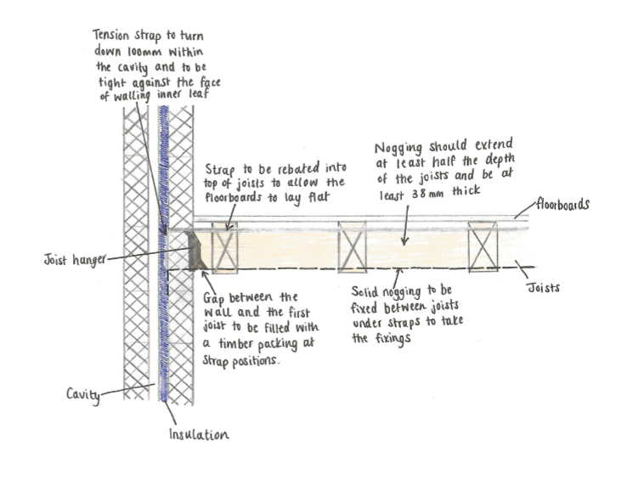
Appendix 3
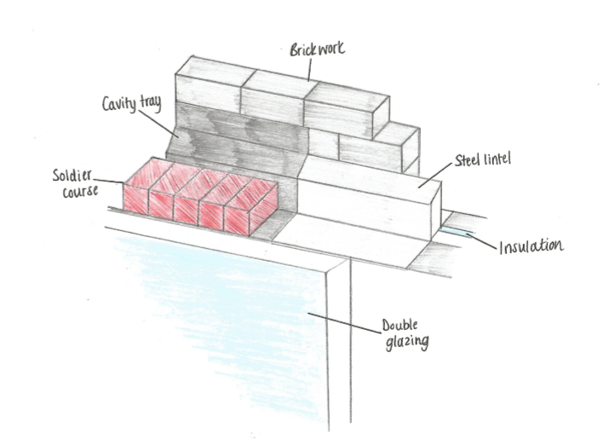
Appendix 4
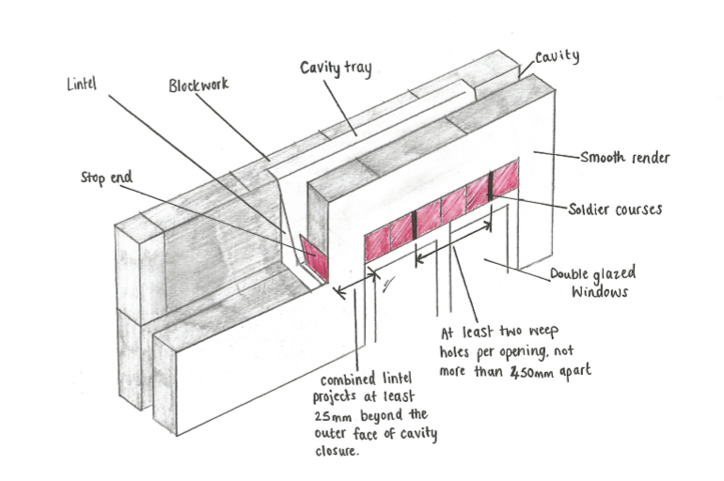
Appendix 5
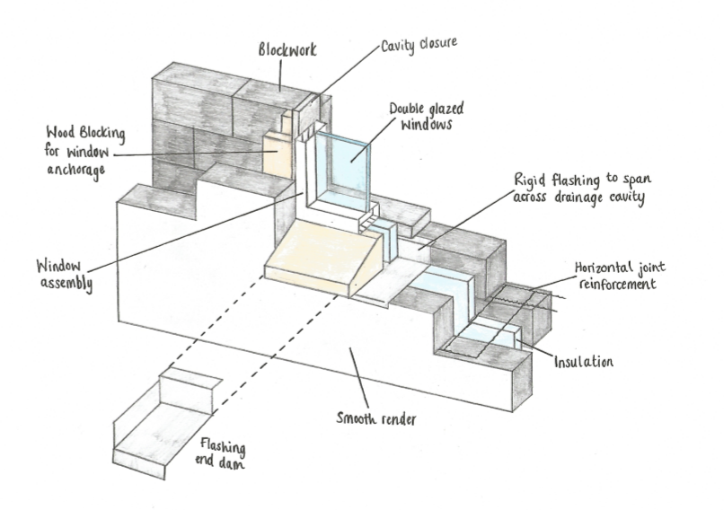
Appendix 6
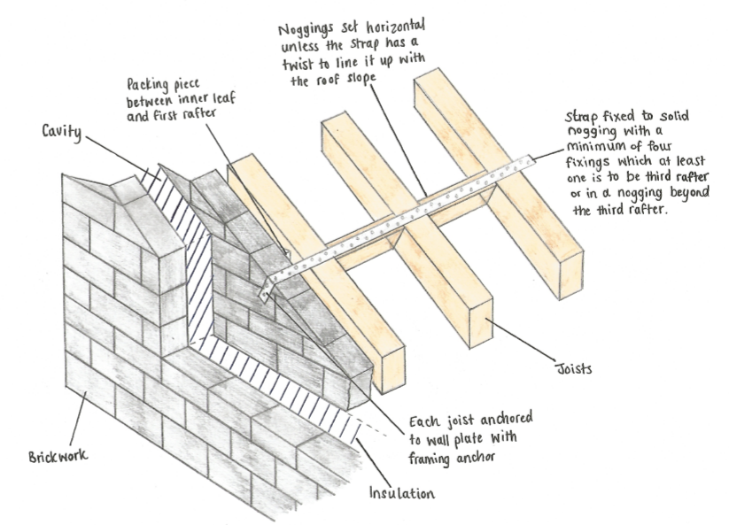
Appendix 7
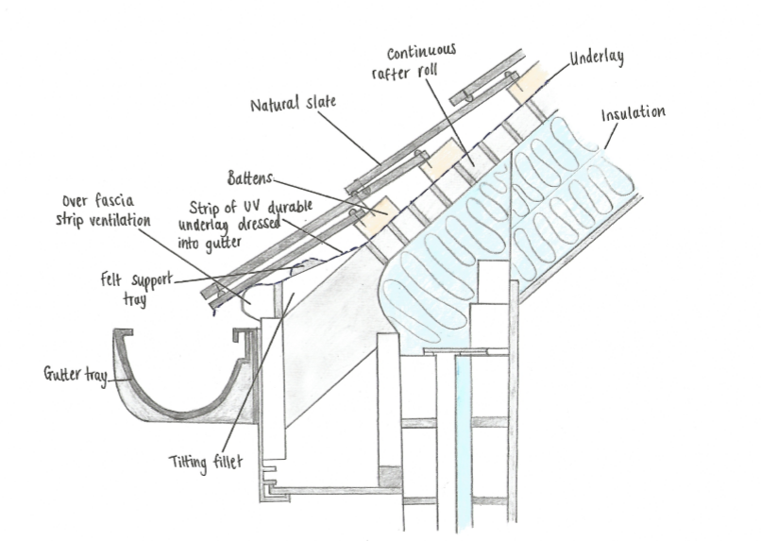
Appendix 8
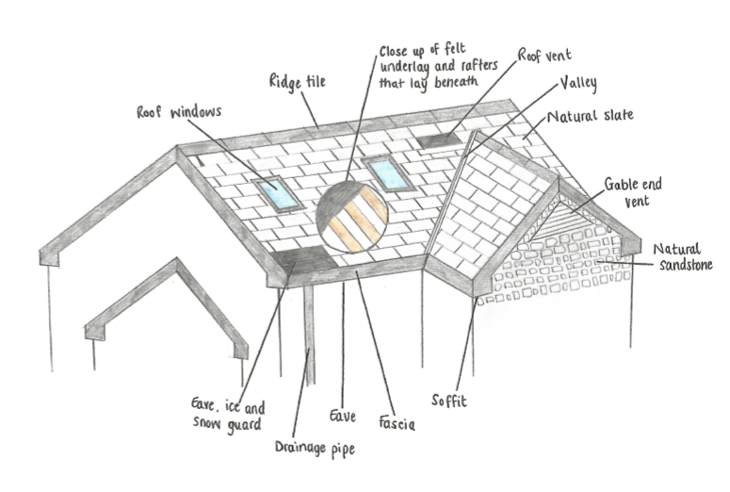

References
(2020, April 15). Retrieved from Home Advice Guide: https://www.homeadviceguide.com/underwood-insulation-suspended-timber-floor/
(2020, April 18). Retrieved from IG STeel Lintels: https://iglintels.com/technical-support/steel-lintels-installation-guide/
(2020, April 20). Retrieved from BUILD: https://build.com.au/eaves
(2020, April 20). Retrieved from rci: https://rcimag.co.uk/sandtoft-blog/how-to-ensure-the-correct-detailing-of-pitched-roof-valleys
British Standards. (2009). Structural Design fro Low-Rise Buildings. BSI.
Flynn, C. (2013). Retrieved from Construction Studies Q1: http://constructionstudiesq1.weebly.com/suspended-timber-floor.html
Government, H. (2013). The Building Regulations 2010. NBS.
HM Government. (2010). The Building Regulations 2010, Document M. NBS.
Northumbria University. (2020, April 13). Retrieved from School of the Built Environment: http://nuweb.northumbria.ac.uk/bedemo/domestic_floors/page_16.htm
Ranasignhe, K. (2014). Eurocode 5 Span Tables for Solid Timber Members in Floors, Ceilings and Roofs for Dwellings. TRADA Technology.
Standards, B. (2009). Structural Design of Low-Rise Buildings. BSI.
University, N. (2020, April 13). Retrieved from School of the Built Environment: http://nuweb.northumbria.ac.uk/bedemo/domestic_floors/page_16.htm

