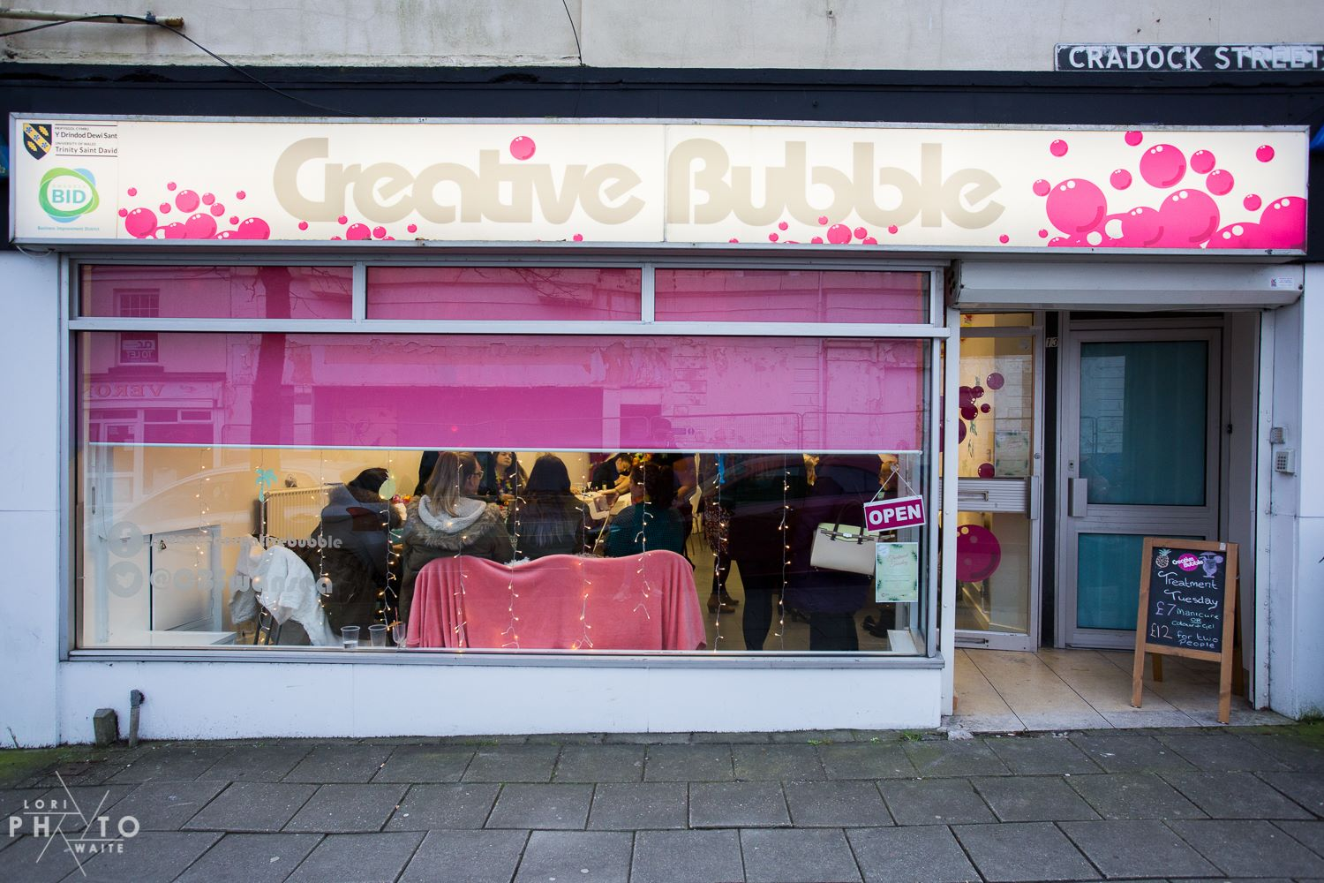

Raising awareness and improving the marketing of Creative Bubble.

Consultancy Project

  - Sharon Maclaren – P144835





Contents
1. Background of Creative Bubble 3
1.1 Stakeholders 3
2. Project Justification 3
2.1 Project aim 3
2.2 Project objectives 3
2.3 Rationale 4
2.4 Scope for project 4
3. Methodology 4
3.1 Primary research 4
3.2 Secondary Research 5
4. Potential Outcomes 5
4.1 Potential benefits 5
4.2 Potential limitations 5
5. Staffing 6
5.1 Roles 6
5.2 Communication 6
6. Timetable / Project plan 7
7. Bibliography 8

Background of Creative Bubble
Creative Bubble is a joint initiative between Swansea BID and University of Wales Trinity Saint David (UWTSD). It was set up in June 2013 to explore ways in which the two organisations could work together to make a positive impact on Swansea City Centre - socially, economically and culturally. (UWTSD, 2018)
Creative Bubble encourages students from UWTSD to work together using the empty shop space as a base. The bubble provides students with a safe environment to hold and run a range of events including pop-up shops, exhibitions, performances, workshops and film premieres. The aim is to encourage enterprise and entrepreneurial thinking. A team of Student Enterprise Interns help to support the activities while gaining invaluable experience generating new ideas and looking after the unit.
The project ultimately seeks to improve the economic future of Swansea by increasing footfall and supporting students who want to set up their own businesses. It also adds to the rich culture and vibrancy of Swansea. Since 2013 over 11,000 people have set foot in the shop to visit hundreds of pop-up student projects. (UWTSD, 2018)

1.1 Stakeholders
The definition of a stakeholder is “those groups who are vital to the survival and success of the corporation” (Freeman, 2004 cited by Friedman and Miles, 2006). Following this definition, the Creative Bubble have a list of stakeholders that include:
- UWTSD management.
- Swansea BID team.
- University staff who run the Creative Bubble.
- Student enterprise interns who work with the Creative bubble staff to help organise events.
- Lecturers of courses that use Creative Bubble for projects.
- Students who regularly run events there.
- Students of UWTSD
- Local businesses in the area
- Swansea council

Project Justification

2.1 Project aim
Having a clear aim for a research project is important to ensure there is focus to the research.
The aim of the project is to make more students aware of the Creative Bubble and improve the general marketing strategies currently in place.

2.2 Project objectives
- Analyse current marketing strategies.
- Find out why people do not know about the Creative Bubble through questionnaires.
- Make more students aware of the opportunities available to them with Creative Bubble.
- Provide recommendations and develop strategies on how to improve the marketing.
- Increase footfall.

2.3 Rationale
The Creative Bubble is currently unable to reach all students via email due to university restrictions. As this is the main form of communication between staff and students this has led to many students not knowing anything about the Creative Bubble or even that it exists. Currently the students that tend to take advantage of the space are those in art and design courses who use the Creative bubble for exhibitions and pop up shops for their work. However, outside of these courses there do not appear to be very many students holding or even attending events here.
The main form of marketing carried out is on social media via Creative Bubble pages on Facebook and twitter. Emails also get sent to some lecturers in the university and they have been featured in student newsletters however, this is not as effective as desired. There is still little knowledge about them and awareness must be improved.

2.4 Scope for project
The intention of this project is to improve the marketing strategies and raise awareness of the Creative Bubble with students in UWTSD. By doing this there is likely to be increased footfall into the shop and an increase in events held there. The project will look into the reasons why a wider range of courses are not holding events and develop strategies to change this so there is more interest. The project will also suggest ways in which the Creative Bubble can evolve for the future. Whether the suggestions are acted upon or not is completely up to the manager of the venue.

Methodology
Methodology is important to any research project. The way in which the research is carried out, collected and then analysed can indicate how reliable the data is. Redman and Mory define research as “a systemised effort to gain new knowledge.”(Redman and Mory cited by Kothari, 2005)

3.1 Primary research
Primary research will be carried out so that the consultant has data that is unique and specific to the project. This way, questions asked will be exactly what is needed in order to analyse and provide accurate research for Creative Bubble to use when deciding the future of the venue.
The main form of primary data collection will be through the use of questionnaires. This will provide both quantitative and qualitative data by asking a range of questions to get people’s opinions on the marketing of Creative Bubble. The type of questions asked will be:
- Whether they know about the Creative Bubble and its purpose.
- What form of marketing do they take most notice of?
The consultant will then make recommendations based on what is found to be the best method of marketing by looking at responses.
The way these questionnaires will be filled in will be both online and in person. The consultant will visit different university buildings/campuses in Swansea to ask students first hand. Alternatively, the questionnaire will also be available online. This way it can be shared via social media such as Facebook so a wider range of students can answer the questions too. In order to get a reliable sample size for the data, between 100-200 students and staff members will be asked the questionnaire.
In order to get stronger qualitative data interviews will be held with at least one or two members of staff of Creative Bubble. This may include UWTSD staff or student interns of the venue who are aware of how exactly the venue runs. This will be done to gain an insight into what exactly the staff believe could be the issue. Often staff/volunteers have ideas of their own which may be useful as they know the type of clients that use the Creative Bubble however, they may not voice these ideas. By interviewing them and finding their opinions and possibly hearing their own recommendations on what can be done, the feedback collected can be used to tailor strategies to make them relevant to what will be most effective for the space and the clientele of the Creative Bubble.

3.2 Secondary Research
Secondary research will be used to gather a more general background and insight into the topic. The internet is a useful tool to research the different forms of marketing and strategies that can be used. By researching online, ideas may be found that could work well when implemented into Creative Bubble.

Potential Outcomes

4.1 Potential benefits
The completion of the project aims to provide benefits to the Creative Bubble if the recommendations are implemented.
Potential benefits include:
- Increase in events held in Creative Bubble.
- Raised awareness of Creative Bubble among students.
- Increased footfall.
- Improved marketing strategy.
- New ideas suggested to help evolve the brand.

4.2 Potential limitations
As with most projects, it is likely that this research will have limitations and restraints in the process. However if these are planned for, the effects can be minimised.
The potential issues this project is likely to face is:
- Not having enough participants willing to fill out the questionnaires. This may result in a smaller sample size and could affect the reliability or results.
- Communication: As the designated member of UWTSD staff who runs Creative bubble works part time, she is often busy with meetings and other work. This could affect the amount of communication there is between her and the consultant. For this reason it is likely that much of the communication will be through email.
- Time: As the consultant is a full time, final year student, other university work must be done at the same time as research should be carried out. Time management will be key to ensuring this project is completed on time and to a high standard.
- Easter holiday: The majority of time designated to carrying out primary research for this project is over the university Easter holidays. This means many students may not be in Swansea at this time so there would not be as many students available to ask as usual. This is another reason why questionnaires will be available online so that students and staff can fill them in from where ever they may be over the holiday.

Staffing

5.1 Roles
The Consultant: This role is carried out by student, Sharon Maclaren. She will carry out and analyse all research. She will then produce a report from her findings which will highlight the key aspects of the research and provide recommendations in order to achieve the aim of the project.
The Client: This is manager of Creative Bubble, Lucy Beddall. She is the main contact for the consultant on this project. Lucy will provide Sharon with the appropriate information about the Creative Bubble that is needed in order to carry out accurate research.
University lecturer: Mike Davis will be the lecturer whom Sharon will discuss the project with. He will ensure the work is kept on track and will provide the consultant with any advice if needed.

5.2 Communication
Communication is important to ensure that the research being carried out is what the client requires. In order to ensure there is regular communication the main methods of communication will be:
- Emails on a weekly basis.
- Meetings when possible and when required to discuss the progress of the research.

Timetable / Project plan
Gantt Chart
Creative Bubble Marketing |  |  |  |  |  | Complete |  |  |  | Plan to do
 | WEEK
ACTIVITY | 1 | 2 | 3 | 4 | 5 | 6 | 7 | 8 | 9 | 10 | 11 | 12 | 13
Identify project
Aims & Objectives
Write PID
Secondary Research
Make surveys
Pilot Surveys
Primary Research
Ask Surveys
Interviews
Analysis
Conclusions
Recommendations
Hand in Project

Bibliography
UWTSD (2018). Bubble Facts - University of Wales Trinity Saint David. [online] Uwtsd.ac.uk. Available at: http://www.uwtsd.ac.uk/creative-bubble/bubble-facts/ [Accessed 14 Mar. 2018].
Kothari, C. (2005). Research Methodology : methods & techniques. 2nd ed. New Delhi: New Age International (P) Ltd, p.1.
Friedman, A. and Miles, S. (2006). Stakeholders: Theory and Practice. 1st ed. New York: Oxford university press, p.2.

