Discuss the Contribution of Classical Greek to
Astrology in the Twentieth and Twenty-First Centuries
Word Count 1,573
This essay will attempt to discuss the role that ancient Greek astrology from the Classical period had on influencing modern astrologers in the twentieth and twenty-first centuries. The intersection of astronomical reflections with the examination of spiritual and erudite ideas from antiquity, will be defined with examples that will show how Classical Greek astrology continued to hold sway in the shaping of Western astrological tradition. To look at the impact that Greek society has made to modern practitioners, key figures of antiquity will be examined as well as an overview of their contributions, before scrutinising astrologers of the twentieth and twenty-first century to see whether their philosophies were aligned. Of note, the works of Ptolemy (c. 100-c. 170 CE) and the books of Firmicus Maternus (lived in the fourth century) will be referred to and dissected in their overall respective influence on the inspiration of esoteric astrologers such as Alice Bailey (1880-1949) and Franz Boll (1867-1924).
To explain the legacy of Greek astrology, the time-period will be identified and, further, Zodiacal signs, planetary associations and astrological aspects will be explored as well. Additionally, core principles of astrology will be explored, such as the geocentric model of Greek astrology, planetary symbolism, Platonic philosophy and cosmology, and the informing of contemporary astrological practises.
When discussing Greece in antiquity, ‘the [Classical time] period [lasts] from about 500[BCE] to the death of Alexander the Great’ (356-323 BCE). In the zeitgeist of common perception, this time is the pinnacle of Greek civilisation, that laid a foundational framework in art, literature and philosophical thought. Although there were some astronomical observations in the context of other writing prior to this time, for example in Hesiod’s (c.700 BCE) Works and Days, Theogony, and historically attributed to Hesiod Astronomia (or Astrologia), most of the astrology as it is understood now, only arrived in the Grecian diaspora through Berosus (c. 3rd century BCE) a Babylonian priest, writer and astrologer, and the dedication of his work Babyloniaca (The History of Babylon). Babylonian astrology informed the conception as the more important influence than date of birth and were more in common with political horoscopes.
Similarly, it can be argued that Plato (428/427 BCE or 424/423 BCE- 348 BCE) referenced Babylonian astrology within his astronomical concepts and writings. However, Babylonian astrology tended to focus upon the administrative governmental doctrines or weather-related portents while Plato’s philosophical views were three-fold between the cosmic harmony of the universe, the deification of celestial bodies as divine beings that impacted with human life and thirdly, that astrology helped to guide a soul towards ascension therefore bringing spiritual enlightenment. In Plato’s Timaeus, Plato communicates the creation of the universe and the way that planetary bodies move through the sky and the astrological influences that they can inflict on mortals. Whereas in the Republic, Plato looks at the role the astrology has within governance and education. Whilst finally in Phaedo Plato, explored the connection between spirituality, reincarnation and spiritual evolution with astrology.
Although Greek astrology was primarily based on natal charting, there is evidence that situational and observational astrology was also practised. One of the first of these and one of the earliest Greek depictions is of a representation of the star sign Leo in the form of the Lion Horoscope Relief from Nemrut Dag Hierothesion (holy seat), in southeast Turkey. ‘The sixteen of the stars carved on the body of the lion resembles the Leo, the constellation of […the…] lion. Three more are carved on the […body of…] lion […representing the…] planets Mars, Mercury and Jupiter. The Regulus (Leo α), the best visible star in Leo is shifted […] to form a collar with again intentionally upturned crescent.’
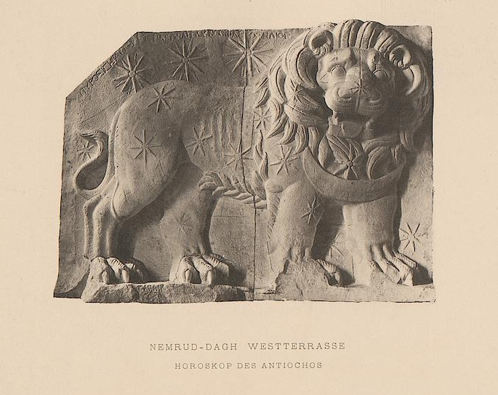
Rekindled interest in ancient cultures was a key factor in the revival of classical Greek astrology through the lens of Western astrology. With the discovery of ancient Greek and Roman texts this sparked a fascination with classical civilizations, albeit through an idealisation perception of what astrology in antiquity looked like. Publications such as the Astrological Journal, the literary arm of the Astrological Society of Great Britain, restored astrology's origins and related contemporaneous practise to antiquated customs. Pioneers of the Theosophical Movement, like Helena Blavatsky (1831-1891) and Alice Bailey (1880-1949) promoted Eastern spirituality, guiding and encouraging interest in astrology and the supernatural. Regarding how Theosophists defined themselves, Santucci wrote that instead of a religious order, they viewed themselves ‘as a system that embraces what they [Theosophists,] see as the "essential truth" underlying religion, philosophy, and science.
Another key theosophist, that further progressed the interest in Classical Greek astrology was Alan Leo (1860-1970), who promoted “Esoteric Astrology” that combined spirituality with mysticism, expanding on the Eastern philosophies of Blavatsky and brought astrology into the commonplace by publishing horoscopes, “Sun Sign Astrology”, in newspapers. As well as these, Leo also founded the Astrologer’s Magazine and established schools that focussed upon the teaching of the occult and astrology. Alan Leo, was introduced to theosophy by Sepharial (1864-1929), Walter Gornold, who was an early establishing member of theosophy in England and companion to Helena Blavatsky.
One of the turning features of Classical Greek astrology’s heavy bearing on more contemporary Western astrology is apparent through the renewed interest in Zodiacal divisions. Both Leo, Sepharial and Grant Lewi (1902-1951) worked in Greek standards, while the latter, Lewi, also combined Greek mythos into his astrology. Within traditional Greek astrology there are twelve primary divisions which are now known as under the names of the horoscopes: Capricorn, Aquarius, Pisces Aries, Taurus, Gemini, Cancer, Leo, Virgo, Libra, Scorpio, Sagittarius. These are developed as a traditional twelve sign zodiac and is based on the writings of Ptolemy (c. 100-c. 170 CE) in his 4 books on astrology, known as the Tetrabiblos. Ptolemy himself followed on from and was influenced by the work of astronomer and mathematician, Hipparchus (c. 190-c. 120 BCE). Hipparchus defined the sky and zodiac into an imaginary orb, the Celestial Sphere, that was further divided into twelve equidistant positions of thirty degrees each, for each Zodiac, with each single degree being the distance of twice the diameter of the sun or moon from the position of the earth. Astrology to the Greeks, therefore, was of equal import to other branches of science.
The secondary division of Greek astrology was of “Decans” dekanoi (Ancient Greek: δεκανοί; pl. of δεκανός dekanos, English: tenths) a further partitioning of three in each Zodiac sign, equalling ten degrees each. The signs of the Zodiac were segmented again into equal portions of twelve at two and a half degrees called dodekatemoria (or dodecatemoria). As identified by Bouché- Leclercq, the name "dodecatemoria" is a Latinization of the Greek δωδεκατημόρια (singular Gr. δωδεκατημόριον, L. "dodecatemorium" or dodecatemorion). According to Ptolemy’s Tetrabiblos, each house of the horoscope was able to be subdivided amongst four repeating “elements”, fire, air, earth, and water that each have fundamental traits that correspond with that sign. Capricorn, earth; Aquarius, air; Pisces, water; Aries, fire; are followed by the next group of four in the same pattern Taurus, earth; Gemini, air; Cancer, water; Leo, fire; and the pattern continues into the third group of four Virgo, earth; Libra, air; Scorpio, water; and finally, Sagittarius, fire.
A critique that has been addressed about the validity of astrology as a science is that the zodiac “drifts”, in a method known as Precessional Movement, or the movement of the stars from west to east, at the rate of approximately one degree per seventy-two years. Hipparchus determined that because of Precessional Movement, each age of the Zodiac would last just over twenty-one hundred years. According to some astronomers we will not reach the age of Aquarius until the year 2600, although to some astrological calculations we are already in the age of Aquarius. As ‘the Sun crosses the equator at the vernal equinox moving backward against the fixed stars from one year to the next […] the whole twelve signs […would complete their cycle…] in about twenty-five thousand, seven hundred and seventy-two years, known as the Platonic, or Great, Year.
Although the Lion Horoscope Relief is evidence of Grecian understanding of the mapping of astrological placements, there are younger, reed fragments that endured long enough to be transcribed by astrologers in the Renaissance and the twentieth and twenty-first centuries, but they are generally a record of celestial positionings. An exception to this is the Hellenic astrologer Vettius Valens (120 CE – c. 175 CE), who lived at roughly the same time as Ptolemy. As a well-travelled, working astrologer, his treatise Anthology, or Anthologiae, summarised various customs of different astrological groups, that is Babylonian, Egyptian and other Greeks. Pingree ‘emphasized the use and importance of the Anthologiae to later astrologers’.

Thomas R. Martin, Ancient Greece, Yale University Press, 1996, p. 94.
Blah blah
Blah blah
Blah blah
Blah blah
Blah blah
Blah blah
blah
blah
blah
blah
blah
A. Öncü Güney, An Iconological Study on the Lion Horoscope Relief of Nemrut Dag Hierothesion 2008 p.2
The Lion with the Stars, unknown photographer, c. 1890, Karl Humann excavation.
The Astrological Journal (1890): Published by the Astrological Society of Great Britain.
James A. Santucci, Theosophy in The Cambridge Companion to New Religious Movements, 2012, p.234
Alan Leo, Astrologer's Magazine (1890).
Kim Farnell, Astral Tramp, 1988.
Grant Lewi, Astrology for the Millions, 1940, Digital Library of India, online. https://archive.org/details/in.ernet.dli.2015.128045
Blah blah
Auguste Bouche-Leclercq, L’Astrologie Greque, 1899, p.299
Blah Blah
Wolfram Demonstrations Project, Precession of the Earth’s Axis, online.
David Pingree, Antiochus and Rhetorius p. 203 in Mark Riley A Survey of Vettius Valens p. 21

