CIPD Diploma in Applied Human Resources

Module Name: Contributing to Resourcing and Talent Planning

Word Count: 2,707 words

Student Name: Laura Walters
Student Number: 2005785
CIPD Membership Number: 57493192

By signing below, I confirm that the work/evidence presented is my own, unaided work. I understand the regulations pertaining to candidate malpractice and the action that may be taken as a result.

Signed: L. Walters
Date: 21/05/2022

Contents
Evidence Matrix 3
LO1 - Statement 6
1.1 Assess how and to what extent the organisation undertakes workforce and talent planning. 6
1.2 Analyse internal and external information relating to the organisation’s future people and skills needs and the availability of talent. 6
1.3 Assess the extent to which current organisational planning activities are addressing potential needs. 7
LO1 – Evidence 8
LO2 – Personal Statement 9
2.1 Make reasoned recommendations for how the organisation can maintain an appropriate number of people with the skills required by the organisation. 9
LO2 – Evidence 9
LO3 – Personal Statement 10
3.1 Identify and explain the rationale for a specific resourcing activity within the organisation. 10
3.2 Agree roles and responsibilities with other contributors to the activity. 10
3.3 Identify organisational procedures and legislative requirements which underpin the activity. 11
3.4 Plan and prepare for agreed role, ensuring the availability of any materials or resources required. 11
3.5 Undertake agreed role in a timely and accurate manner, in line with organisational procedures and legislative requirements. 12
3.6 Reflect on the effectiveness of the resourcing activity in meeting required objectives and report back to stakeholders. 12
LO3 – EVIDENCE 13
Reference List 16
Bibliography 17

Evidence Matrix
Candidate name: Laura Walters |  |  |  |  | CIPD Membership/registration No.:  57493192
Qualification title: CIPD Diploma in Applied Human Resources Level 5 |  |  |  |  | Unique Learner No. (ULN):  2005785
Unit code | Unit title |  | Assessment criteria no. | Evidence description | Evidence reference number |  | Assessor  initials | I/V initials if sampled
5ARTP | Contributing to Resourcing and Talent Planning |  | LO1.1 | HOME OFFICE RETURN CATCH UP IN CALENDAR | EV1.1
5ARTP | Contributing to Resourcing and Talent Planning |  | LO1.1, LO1.2 | HOME OFFICE RETURNS | EV1.2
5ARTP | Contributing to Resourcing and Talent Planning |  | LO1.1, LO1.2 | PROBATION DATA – STUDENT OFFICERS | EV1.3
5ARTP | Contributing to Resourcing and Talent Planning |  | LO1.2 | DAILY RECRUITMENT MEETING | EV1.4
5ARTP | Contributing to Resourcing and Talent Planning |  | LO1.2 | INTAKE STATUS | EV1.5
5ARTP | Contributing to Resourcing and Talent Planning |  | LO1.2 | RECRUITMENT POLICY | EV1.6
5ARTP | Contributing to Resourcing and Talent Planning |  | LO1.2 | COMPETANCY AND VALUES FRAMEWORK PACK | EV1.7
5ARTP | Contributing to Resourcing and Talent Planning |  | LO1.3 | E2E TRACKER | EV1.8
5ARTP | Contributing to Resourcing and Talent Planning |  | LO2.1 | ON THE JOB ASSIGNMENT – EMPLOYEE ENGAGEMENT | EV1.9
5ARTP | Contributing to Resourcing and Talent Planning |  | LO2.1 | DIAL IN WITH THE CHIEF | EV2.0
5ARTP | Contributing to Resourcing and Talent Planning |  | LO3.1, LO3.3, LO3.6 | VRF TEMPLATE | EV2.1
5ARTP | Contributing to Resourcing and Talent Planning |  | LO3.2 | HR SYSTEM – TRENT | EV2.2
5ARTP | Contributing to Resourcing and Talent Planning |  | LO3.4 | SENDING NEW VRF TEMPLATE | EV2.3
5ARTP | Contributing to Resourcing and Talent Planning |  | LO3.5 | SENDING VRFS TO SERG/SRG | EV2.4
5ARTP | Contributing to Resourcing and Talent Planning |  | LO3.5 | INFORMING OF VRF OUTCOME | EV2.5
5ARTP | Contributing to Resourcing and Talent Planning |  | LO3.6 | RECRUITMENT WORKSHOP | EV2.6
5ARTP | Contributing to Resourcing and Talent Planning |  | LO3.6 | AMENDING VRF FORM | EV2.7
5ARTP | Contributing to Resourcing and Talent Planning |  | LO3.6 | OUTCOME SPREADSHEET FROM PANEL | EV2.8
Candidate declaration:
- I confirm that the work/evidence presented for assessment is my own unaided work.
- I have read the assessment regulations and understand that if I am found to have ‘copied’ from published work without acknowledgement, or from other candidate’s work, this may be regarded as plagiarism which is an offence against the assessment regulations and leads to failure in the relevant unit and formal disciplinary action.
- I agree to this work being subjected to scrutiny by textual analysis software if required.
- I understand that my work may be used for future academic/quality assurance purposes in accordance with the provisions of the Data Protection Act 1998.
- I understand that the work/evidence submitted for assessment may not be returned to me and that I have retained a copy for my records.
- I understand that until such time as the assessment grade has been ratified through internal and external quality assurance processes it is not final.
Signature: |  | L.Walters |  |  |  | Date: | 21/05/2022

LO1 - Statement

1.1 Assess how and to what extent the organisation undertakes workforce and talent planning.

Dyfed Powys Police (DPP) consists of both staff and officers. Officers are technically not classed as employees but as servants of the crown, therefore slightly different approaches apply. For the purpose of the portfolio, police officers only, will be assessed here. It is generally agreed that workforce planning is comprised in 4 stages (Wilkinson and Taylor, 2016, p.58):
- Forecasting demand
- Forecasting supply
- Identifying gaps
- Addressing gaps

DPP does adopt this approach as will become clear in this portfolio.
The Home Office dictates a specific number of police officers DPP should have at the very least by the end of the financial year to receive their funding. Failure to reach this figure results in a fine (EV1.1). Every month I analyse the workforce data, and breakdown our officer headcount, our PC intakes, transferees in and attrition rates (EV1.2). This enables the workforce planning specialist to predict our numbers by the end of the financial year. He has a part to play here, as he must keep a record of those officers who are due to retire. This occurs when they’re either, turn 55, turn 60 (depending on their pension scheme) or after 30 years’ service. This allows the team to accurately predict our flow out of the organisation. He also factors in any unexpected leavers into these figures based off previous data (Faragher, 2017).
There are also standard periods of student officer and transferee intakes. With regards to the student officers, these enter the organisation at various entry levels – some with degrees, some without, which impacts on their probationary period (EV1.3). These students must enter via assessment centres, medical checks, vetting and subject to satisfactory references. Therefore, there are a number of steps in the process where they could fail and subsequently officers are lost from the flow into the organisation, which cannot always be predicted. The same can be said for transferees. These also occur at pre-planned points during the year which enables the team to predict the flow in vs flow out of police officers for the year and potentially beyond. This is how DPP addresses the gaps they have forecasted (Taylor and Wilkinson, 2016, p.59).

1.2 Analyse internal and external information relating to the organisation’s future people and skills needs and the availability of talent.

Our daily recruitment meetings (EV1.4) analyse the organisations’ future people and skills needs, as required in the 4 stages in developing a workforce plan (Taylor and Wilkinson, 2016, p.58-59). As the deadline to meet student intake figures approaches, I provide the Head of People Services and OD with daily forecasted figures – indicating whether we are on target or not (EV1.5). When tight, we discuss solutions to mitigate the risk. This includes discussing retirement dates with those intending to leave and engaging with student applicants to ensure they were providing everything required to on board them into the organisation as quickly as possible.
The recruitment policy (EV1.6) sets out the expectations in order to conduct a fair recruitment process with the hopes of on-boarding the right people to add value to the organisation. Each interviewer is required to undergo Competency and Value Framework training (CVF) (EV1.7) to ensure they recruit based on an individuals’ values (Taylor and Wilkinson, 2016, pp.65-7). Examples of the Police’s values are transparency and honesty.
Lots of macroeconomic factors have an impact on how easy it is to recruit and the availability of talent, such as Brexit, the pandemic and Ukrainian crisis (Taylor and Wilkinson, 2016, p.54). At present, the market appears to favour candidates, with organisations’ demand outstripping the supply of candidates (Jacobs, 2022, p.30). DPP needs to be mindful of the tight market (Taylor and Wilkinson, 2016, p.53) of this when predicting the flow in of individuals (EV1.3). The pandemic has also shifted individuals’ perspectives on life and has generated “the great resignation” whereby individuals re-evaluate their lives and their careers (CIPD, 2022). This is likely to amplify the flow in and out of officers. This is evident already, in the average length of service figures. The number of student officers, those with a shorter length of service, is increasing (EV1.2). This poses a risk to the organisation due to a lack of experience in the workforce (CIPDa, 2021).

1.3 Assess the extent to which current organisational planning activities are addressing potential needs.

As mentioned, every month the workforce planning team report the police officer figures to the Home Office (EV1.2). One could argue that this is effective way of workforce planning as DPP continues to hit its target figures. However, feedback from the various divisions indicated that their police officer figures in their respective areas were not a true picture of the reality of resources on divisions. Historically, officers were recruited based on their location. I.e. if the successful candidate was from Carmarthen they would be based in this area regardless of whether they are required in that division. Now, the force has changed the way we look at resourcing. We recruit to utilization rates on divisions, meaning we only recruit the numbers required for each area. The utilization rate considers: maternity/ adoptive leave, long term restrictions, and long term absence and student officers. These all have an impact on the service provided to the public. As part of a new structural change within the force, it was identified that more accurate resourcing was required. This took the form of the “End to End” tracker which shows the utilization rates (EV1.8).
There is still room for improvement, however. Police officer numbers are still tight which indicates that perhaps the recruitment process is not working effectively (EV1.2). The easy recommendation to make would be to recruit more police officers by selling the role and the benefits the public sector brings e.g. excellent pension schemes and an attractive organisational brand which fits into the post-Covid world (Campalini) (Taylor and Wilkinson, 2016, p.61). The reality of this is that there are strict parameters set in the public sector by the funding provided. There is X amount of funding made available for police officers, therefore to improve the resourcing issue DPP may need to think past recruitment and look towards L&D and retaining experienced officers so that the quality of officers are so good, that extra resource is less likely to be required.

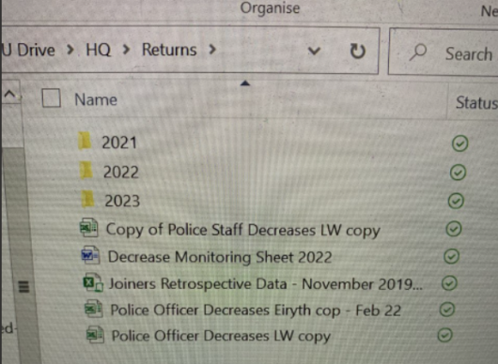

LO1 – Evidence

EV1.1
EV1.2



EV1.3
EV1.4


EV1.5




EV1.8
EV1.7
EV1.6

LO2 – Personal Statement

2.1 Make reasoned recommendations for how the organisation can maintain an appropriate number of people with the skills required by the organisation.

To retain officers, the organisation must ensure they remain engaged. Following a discussion with my line manager (EV1.9), she explained that due to the nature of policing, there is a high rate of discretionary effort. This leads to commitment to the role and organisation (Korsh and Gilmartin). Nonetheless, Covid has been extremely challenging for officers and therefore it is vital that this level of engagement is maintained. Promoting excellent welfare strategies and making these readily available for teams has become ever more important and readily sought after by jobseekers (Urquhart, 2022, p.10).
Open communications and a leadership team who are prepared to listen and take onboard ideas go a long way in building trust. This results in an inclusive culture (ACAS, p.4). Those who feel included are less likely to exit the organisation which stabilises the flow out of the workforce. Higher retention rates are good for the organisation as nurtured talent is retained and passed on leading to a better skilled workforce (Wilkinson and Taylor, 2016, p.59). DPP has gained a new Chief Constable, who has facilitated these talks via Microsoft Teams, in the “Dial in with the Chief” forum (EV2.0), as part of his 100-day discussion with the force. I would recommend that he continues this discussion past the 100 days.
DPP should also listen to those who do exit the organisation by means of exit questionnaire’s and interviews. Taylor and Wilkinson predict that 90% of employee turnover is voluntary, therefore it is likely that they are willing to share their reasoning why (2016, p.70). This can help prevent future employee turnover.

LO2 – Evidence
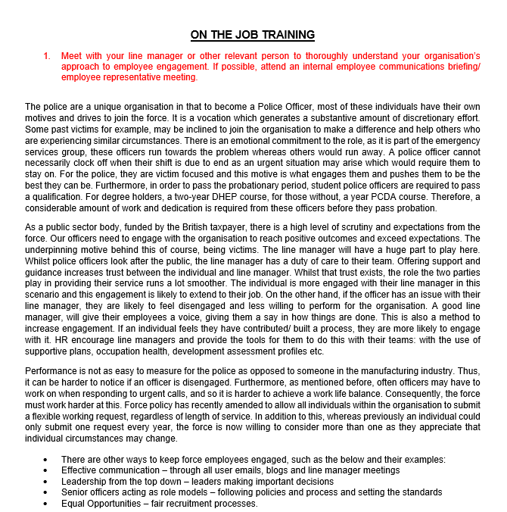
EV1.9


EV2.0

LO3 – Personal Statement

3.1 Identify and explain the rationale for a specific resourcing activity within the organisation.

The Vacancy Request Form (VRF) ensures there is an audit trail and fair process in deciding which vacancies to advertise and which to decline within the police force. The form (EV2.1) captures all of the necessary information required to make a decision as to whether the vacancy should be prioritised over another. This includes:
- Who the vacancy is replacing
- The seat name and reference
- Who the successful candidate would be reporting to
- The number of hours required
- Rationale
- How the seat is funded

It also enables the vacancy’s “seat” to be created on the HR systems and passes all the information onto the support unit who then arrange for the role to be advertised and for the recruitment process to be carried out smoothly. Therefore, the purpose of the form is to keep the process fair but to also provide the relevant information to those at the end of the process in order to complete the recruitment cycle.

3.2 Agree roles and responsibilities with other contributors to the activity.

Line managers have a responsibility to identify vacancies/ need for establishment changes within their respective areas. Heads of Department should ensure they agree with this and give their authorisation to submit the VRF. The line manager has the responsibility to ensure their VRF is accurate and contains all the information required for the forum to make the best decision.
Workforce planning have the responsibility in checking the forms and that they match actual and established resourcing figures (EV2.2). They must also ensure; role profiles are provided and are accurate as well as sending the forums to the correct forum in a timely manner. This maintains the effective service delivery. The workforce planning representative (usually myself) liaises with the form point of contacts and ensures they are made aware of the outcome of the forum and the next steps in the process.
The recruitment team forward the approved VRFs to the HR BSU and they will progress in the appropriate manner. They will also monitor and track that recruitment process via their Oleeo system.
The HR BSU’s responsibilities kick in towards the end of the process. They will do a final check of the VRF, liaise with the advert lead, and advertise the role accordingly. They also complete all necessary paperwork associated with the form.

3.3 Identify organisational procedures and legislative requirements which underpin the activity.

The vacancy request procedure is as follows:
- The line manager identifies a vacancy within their team
- This is confirmed by their Head of Department
- Either one of them fill out a Vacancy Request Form (EV2.1)
- The VRF is sent to the Workforce Planning Inbox
- I/ a member of the Workforce Planning team reviews the form to ensure it is accurate, pushing back and requesting more information where applicable
- The form is forwarded to the appropriate forum where they consider if the role is necessary (Wilkinson and Taylor, 2016, p.63)
- The outcome as to whether the vacancy can go out to advert is communicated to myself
- I then tell the VRF lead the decision outcome
- If approved, a member of the Recruitment team forwards the relevant forms and accompanying information to the HR Business Support Unit
- They liaise with the form lead to progress the advert and subsequent recruitment process which follows.

The law requires that all recruitment processes are fair and do not discriminate against any protected characteristics such as sex, disability and age (Wilkinson and Taylor, 2016, p.67). DPP have a positive action officer (name cannot be disclosed for confidentiality reasons), who ensures that we try and attract candidates who are currently underrepresented. The recruitment process is also based off a point based system, scored against a consistent and open competency and values framework.

3.4 Plan and prepare for agreed role, ensuring the availability of any materials or resources required.

There are not many resources required in completing the VRF. The template itself must be made readily available to those who require it. This template has recently changed, outlining new timescales for example, so it was important that I circulated this to all relevant people and ensured that only those VRFs completed on the correct template were sent to the relevant forum for a decision (EV2.3).
In order to complete my part in the VRF process, I also need to ensure I have access to the ‘Trent’ HR system. This enables me to ensure that the vacancy/ funding is actually there and therefore I am not pulling the budget from one department to another. This would therefore make the process unfair. If the vacancy is a straight-forward backfill, I can extract the seat reference and include that information on the form for the business support unit. This helps speed up the recruitment process because once the successful candidate is appointed, the support unit can place the candidate into the new seat immediately. It is important not to delay the process in any way. The on-boarding process into the police is a lengthy one due to the extensive vetting which is required, there is a risk here that a candidate may be lost due to a better offer. Especially with the labour market favouring the candidate at the time of writing this (Jacobs, 2022, p.30).

3.5 Undertake agreed role in a timely and accurate manner, in line with organisational procedures and legislative requirements.

It is vital that my part in the process is done in a timely manner and is accurate. I must ensure that I have all the relevant information on the form in order to feed back a decision to the departments in a timely manner. I must be accurate here. If I were to mark a vacancy as full time when there was only funding available for a part time post, I would be costing the organisation money. This could have a detrimental impact on a different department who could lose some of their establishment. There are two forums to send the VRFs therefore I must send the forms to the right one. I also must ensure that they get to the decision makers on time, i.e. a Monday afternoon (EV2.4). I am mindful that the decision makers in the forum are extremely busy, and so to assist the process, I also include a brief summary as to what the VRF is requesting and why it is required. This saves time. Regardless of the outcome, the departments must be informed so that they can plan effectively (EV2.5).
I also include documents such as the job description with the VRF form, so that if approved, the business support unit have the relevant information in order to advertise. The job description is an excellent tool to ensure the right candidate is attracted to the role. Taylor and Wilkinson explain that over 82% of employers use them in job adverts (2016, p.64).
The Equality Act 2010 ensures that no candidate with a protected characteristic is discriminated against (Wilkinson and Taylor, 2016, p.67). This form kick starts a fair recruitment process, it ensures that “favourites” are not promoted or moved to an alternative role without advertising it to all; promoting equal opportunities.

3.6 Reflect on the effectiveness of the resourcing activity in meeting required objectives and report back to stakeholders.

The VRF process requires improvement. The recruitment objectives are to resource fairly, quickly and ensuring the talent entering the organisation holds the same values. I reported this back to the stakeholders via the two day recruitment workshop (EV2.6). The main issues identified were as follows:
- The responsibility of form completion and submission to the forums was based solely on one individual (me). If that individual were to be absent, the process would fall apart. I recommended that individuals be cross trained to cover each other.
- Individuals were not clear on the timelines in submitting the forms. This meant we as a team, were not able to manage expectations effectively. I amended the VRF form to clearly outline the timings (EV2.7).
- From this two day discussion, it became clear that DPP required a cultural shift. There were too many “corridor conversations” taking place, and too many individuals attempting to by-pass the process and go straight to the top of the hierarchy with their requests. In order to mitigate this, I explained that I needed the support of my superiors to push back any requests which did not come through via the correct channels.
- Once I communicated the outcomes to those who submitted the forms, they often ask for the rationale. I suggested that this is provided straight away so I can answer the question before it is asked. This resulted in the creation of the outcome spreadsheet, which the decision makers would send me. There was also a clear trail of the decision making process (EV2.8).


LO3 – EVIDENCE

EV2.1



EV2.2

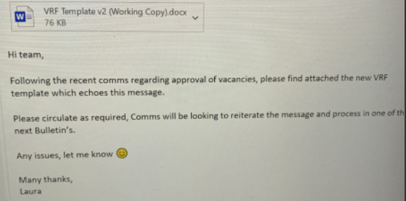
EV2.3


EV2.4
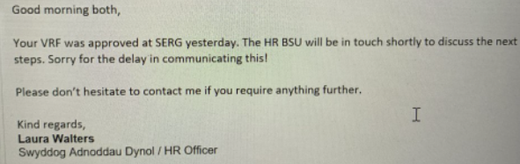

EV2.5


EV2.6

EV2.7


EV2.8

Reference List
ACAS. ‘The People Factor – engage your employees for business success’. [Internet]. Available at: https://moodle.uwtsd.ac.uk/pluginfile.php/255715/mod_resource/content/1/Advisory-booklet-The-People-Factor.pdf [Accessed: 19/01/2022].

Campalani, F. ‘Managing your employer brand during a crisis’, Ranstad. Available at: https://moodle.uwtsd.ac.uk/pluginfile.php/363928/mod_resource/content/0/Ranstad%20-%20Managing%20your%20employer%20brand%20through%20a%20crisis%20-%20Mandatory.pdf [Accessed: 22/05/2022].

CIPDa. (2021). ‘Employee turnover and retention’, CIPD. [Internet]. Available at: https://www.cipd.co.uk/knowledge/strategy/resourcing/turnover-retention-factsheet [Accessed: 07/03/2022].

CIPD. (2022). ‘The great resignation – fact or fiction?’. CIPD. (Article). Available at: https://www.cipd.co.uk/news-views/cipd-voice/Issue-33/great-resignation-fact-fiction [Accessed: 17/05/2022].

Faragher, J. (2017). ‘How to solve workforce planning – before you become the next
Ryanair’, People Management. [Article]. (23 Oct). Available at: https://moodle.uwtsd.ac.uk/pluginfile.php/351628/mod_resource/content/0/How%20to%20solve%20workforce%20planning%20-%20before%20you%20become%20the%20next%20Ryanair%20-%20recommended.pdf [Accessed: 07/03/2022].

Jacobs, K. (2022). ‘There are better ways to recruit good HR people’, People Management. [Article]. (March, pp.30-33).

Korsh, J. and Gilmartin, M. ‘Navigating to employee relationship transformation’, Deloitte. [Internet]. Available at: https://www2.deloitte.com/us/en/pages/human-capital/articles/navigating-the-employee-relationship-transformation.html?id=us:2em:3na:consedge:awa:cons:053019:hc&ctr=cta&sfid=0031O00002zz1SAQAY&elqcst=272&elqcsid=14975#top [Accessed: 09/01/2022].

Urquhart, J. (2022). ‘Now you see them: how employers can prevent jobseeker ghosting’, People Management. (March). [Article]. [Accessed: 21/05/2022].
Wilkinson, K. and Taylor, S. (2016). ‘Resourcing and Talent Planning’, Human Resource Management: People and Organisations. (2nd edn). London: CIPD.

Bibliography
ACAS. ‘The People Factor – engage your employees for business success’. [Internet]. Available at: https://moodle.uwtsd.ac.uk/pluginfile.php/255715/mod_resource/content/1/Advisory-booklet-The-People-Factor.pdf [Accessed: 19/01/2022].
Campalani, F. ‘Managing your employer brand during a crisis’, Ranstad. Available at: https://moodle.uwtsd.ac.uk/pluginfile.php/363928/mod_resource/content/0/Ranstad%20-%20Managing%20your%20employer%20brand%20through%20a%20crisis%20-%20Mandatory.pdf [Accessed: 22/05/2022].
CIPD. (2019). ‘Employer brand’, CIPD. [Internet]. Available at: https://moodle.uwtsd.ac.uk/pluginfile.php/351616/mod_resource/content/0/CIPD%20Employer%20brand%20factsheet%20-%20mandatory%20reading.pdf [Accessed: 07/03/2022].
CIPDa. (2019). ‘Mega Trends. Ageing gracefully: The opportunities of an older workforce’. CIPD. [Report]. Available at: https://moodle.uwtsd.ac.uk/pluginfile.php/351423/mod_resource/content/0/Megatrends-ageing%20gracefully%20the%20opportunities%20of%20an%20older%20workforce%20-%20recommended.pdf [Accessed: 09/03/2022].
CIPDb. (2019). ‘The many merits of workforce planning’. CIPD. [Podcast]. Available at: https://www.cipd.co.uk/podcasts/workforce-planning [Accessed: 09/03/2022].

CIPD. (2020). ‘Succession Planning’, CIPD. [Internet]. Available at: https://www.cipd.co.uk/knowledge/strategy/resourcing/succession-planning-factsheet [Accessed: 07/03/2022].

CIPD. (2021). ‘Talent Management’, CIPD. [Internet]. Available at: https://www.cipd.co.uk/knowledge/strategy/resourcing/talent-factsheet [Accessed: 07/03/2022].

CIPDa. (2021). ‘Employee turnover and retention’, CIPD. [Internet]. Available at: https://www.cipd.co.uk/knowledge/strategy/resourcing/turnover-retention-factsheet [Accessed: 07/03/2022].

CIPDb. (2021). ‘Recruitment: an introduction’. CIPD. [Internet]. Available at: https://www.cipd.co.uk/knowledge/fundamentals/people/recruitment/factsheet# [Accessed: 09/03/2022].

CIPD. (2022). ‘The great resignation – fact or fiction?’. CIPD. (Article). Available at: https://www.cipd.co.uk/news-views/cipd-voice/Issue-33/great-resignation-fact-fiction [Accessed: 17/05/2022].

Faragher, J. (2017). ‘How to solve workforce planning – before you become the next Ryanair’, People Management. [Article]. (23 Oct). Available at: https://moodle.uwtsd.ac.uk/pluginfile.php/351628/mod_resource/content/0/How%20to%20solve%20workforce%20planning%20-%20before%20you%20become%20the%20next%20Ryanair%20-%20recommended.pdf [Accessed: 07/03/2022].

Jacobs, K. (2022). ‘There are better ways to recruit good HR people’, People Management. [Article]. (March, pp.30-33).

Korsh, J. and Gilmartin, M. ‘Navigating to employee relationship transformation’, Deloitte. [Internet]. Available at: https://www2.deloitte.com/us/en/pages/human-capital/articles/navigating-the-employee-relationship-transformation.html?id=us:2em:3na:consedge:awa:cons:053019:hc&ctr=cta&sfid=0031O00002zz1SAQAY&elqcst=272&elqcsid=14975#top [Accessed: 09/01/2022].

ONS. (2022). ‘Unemployment’, Officer for National Statistics. [Internet]. Available at: https://www.ons.gov.uk/employmentandlabourmarket/peoplenotinwork/unemployment [Accessed: 24/02/2022].
Taylor, S. (2019). Resourcing and Talent Planning. 7th edn. Kogan Page: CIPD.
Thomas, J. and Hatcher, C. (2018). ‘The key to retaining talent: The leader’s role in creating a supporting and caring culture’, Roffey park. [Article]. Available at: https://moodle.uwtsd.ac.uk/pluginfile.php/240123/mod_resource/content/1/The%20Key%20to%20Retaining%20Talent.pdf [Accessed: 07/03/2022].
Trading Economics. ‘France Employment Rate’. [Internet]. Available at: https://tradingeconomics.com/france/employment-rate [Accessed: 24/02/2022].
https://www2.deloitte.com/us/en/pages/human-capital/articles/navigating-the-employee-relationship-transformation.html?id=us:2em:3na:consedge:awa:cons:053019:hc&ctr=cta&sfid=0031O00002zz1SAQAY&elqcst=272&elqcsid=14975#top [Accessed: 09/01/2022].
Urquhart, J. (2022). ‘Now you see them: how employers can prevent jobseeker ghosting’, People Management. (March). [Article]. [Accessed: 21/05/2022].
Wilkinson, K. and Taylor, S. (2016). ‘Resourcing and Talent Planning’, Human Resource Management: People and Organisations. (2nd edn). London: CIPD.
XpertHR. (2022). ‘Recruitment pitfalls’. (Jan). [Podcast]. [Accessed: 02/04/2022].

