Kinetic Energy Recovery

University of Wales Trinity Saint David
Engineering Academic Discipline



Jason Taberner
2404389
BEng, Motorsport Engineering
30/11/2025
Alternative Propulsion Systems, ACHA5010
Word Count: 1626 words

Contents
1 Introduction 3
2 Vehicle Selection and Characteristics 3
2.1 Test Mass 3
2.2 Frontal Area 3
2.3 Rolling Resistance Coefficient 3
2.4 Coefficient of Aerodynamic Drag 3
3 Spreadsheet Details 4
3.1 Data Snapshot 4
3.2 Resistances 5
3.3 Cumulative Energy 6
3.4 Tractive Power 7
3.5 WLTP Cycle 8
4 KER System Requirements 9
4.1 Peak Braking Power and Energy 9
4.2 Energy Storage Target 10
5 KER System Selection 11
5.1 KERS Type 11
5.1.1 Electric 11
5.1.2 Flywheel 11
5.1.3 Hydraulic 11
6 Selected System Parts 11
6.1 Motor Generator 11
6.2 Energy Storage 12
6.3 Efficiency 12
7 Energy Recovery 13
8 System Explanation 14
8.1 KERS Operation 14
8.2 Limitations 14

Introduction
This report will cover the potential for Kinetic energy recovery of a selected vehicle, investigating the energy losses of the vehicle over the WLTP cycle. The main types of kinetic energy recovery systems (KERS) will be examined and the most suitable one selected for use. Once a system is selected the components will be sized, efficiencies evaluated, and the improvements to the vehicles fuel economy will be investigated.

Vehicle Selection and Characteristics
The vehicle that will be investigated in this report is one of the Royal Mail Vans, the Peugeot EXPERT. This vehicle has been selected as it doesn’t currently use any KER systems and would benefit from having energy recovery due to the long routes it drives. This vehicle is in class 3 for the WLTP cycle as its power to weight ratio is 53.3 which is greater than the required 34 (ECOpoint Inc, 2019) and it has a top speed of 160km/h (ultimate SPECS, 2025).

Test Mass
Gross vehicle weight =3100kg
Kurb weight =1716kg
Test mass = $\left(\frac{2830-1657}{2}\right)+1657=2243.5kg$ at 50% load capacity
(Peugeot, 2025a)

Frontal Area
Width = 1924mm (excluding mirrors)
Height = 1904mm
(Peugeot, 2025a)
Frontal area(m) = $1.92*1.904 =3.66m^{2}$ (Peugeot, 2025b)

Rolling Resistance Coefficient
As the exact rolling resistance coefficient isn’t published for the selected vehicle 0.015 (Ehsani et al., 2018, p.20) will be used as it is slightly higher than that of a car on asphalt since a postal van is heavier than the average car and would therefore have a higher rolling resistance coefficient.

Coefficient of Aerodynamic Drag
As there is no published coefficient of aerodynamic drag for the selected vehicle an average of 0.5 for a van body shape will be used (Ehsani et al., 2018).

Spreadsheet Details

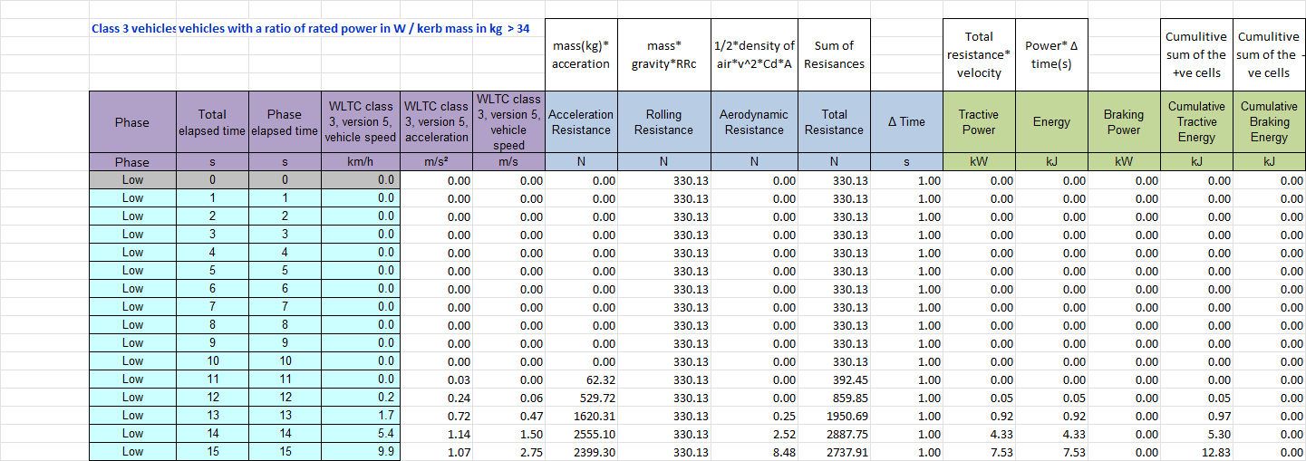
Data Snapshot
Table 1 Data Snapshot
Table 1 shows a snapshot of the data that was used to produce some of the graphs shown in this report. All the data in the blue and green columns was calculated using the supplied WLTP data and the researched vehicle characteristics displayed in section 2. When calculating the cumulative energy data IF statements were used to separate tractive from braking energy (Yes Excel, 2023).

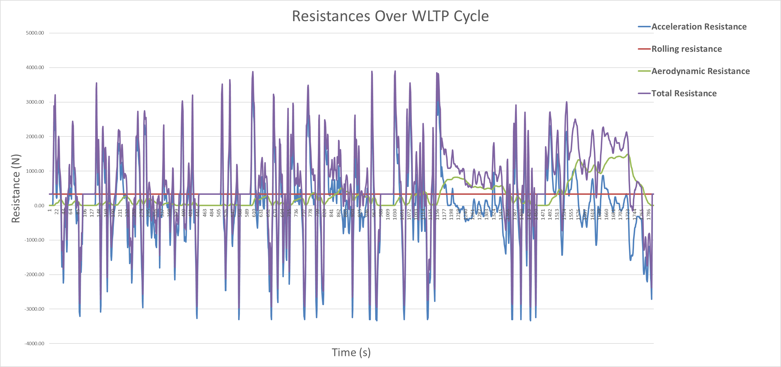
Resistances
Figure 1 Resistances During the WLTP Cycle
Figure 1 shows the 3 resistances that the vehicle will experience over the flat road WLTP cycle as well as the total resistance which all 3 added together. Looking at the graph, the acceleration resistance is the most significant resistance the vehicle will experience.

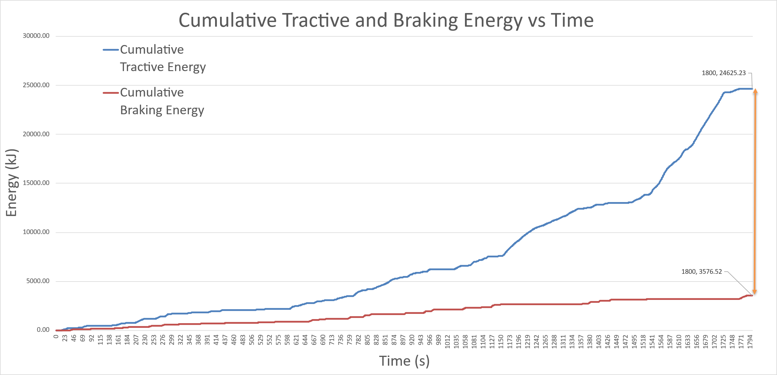
Cumulative Energy
Losses =21048.71 kJ
Figure 2 shows the cumulative tractive and braking energy over the WLTP cycle. The braking energy has been inverted to find the losses over the WLTP cycle as the values would ordinarily negative.
Figure 2 Cumulative Tractive and Braking Energy

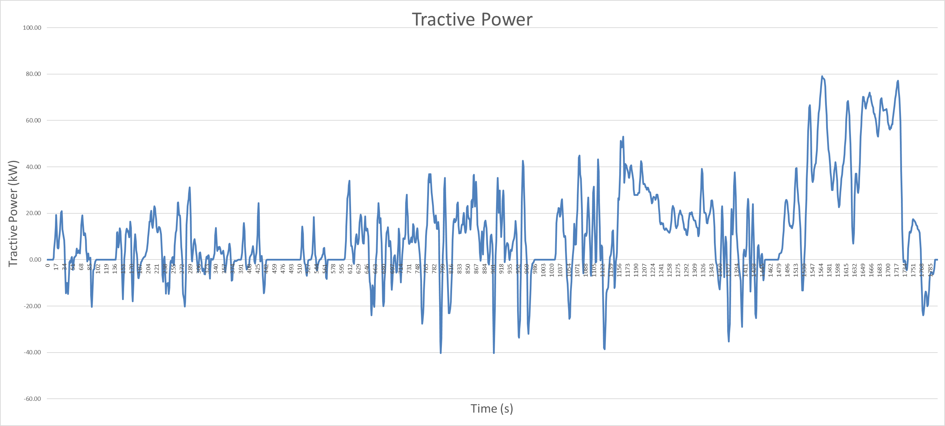
Tractive Power
Figure 3 Tractive Power Over the WLTP Cycle

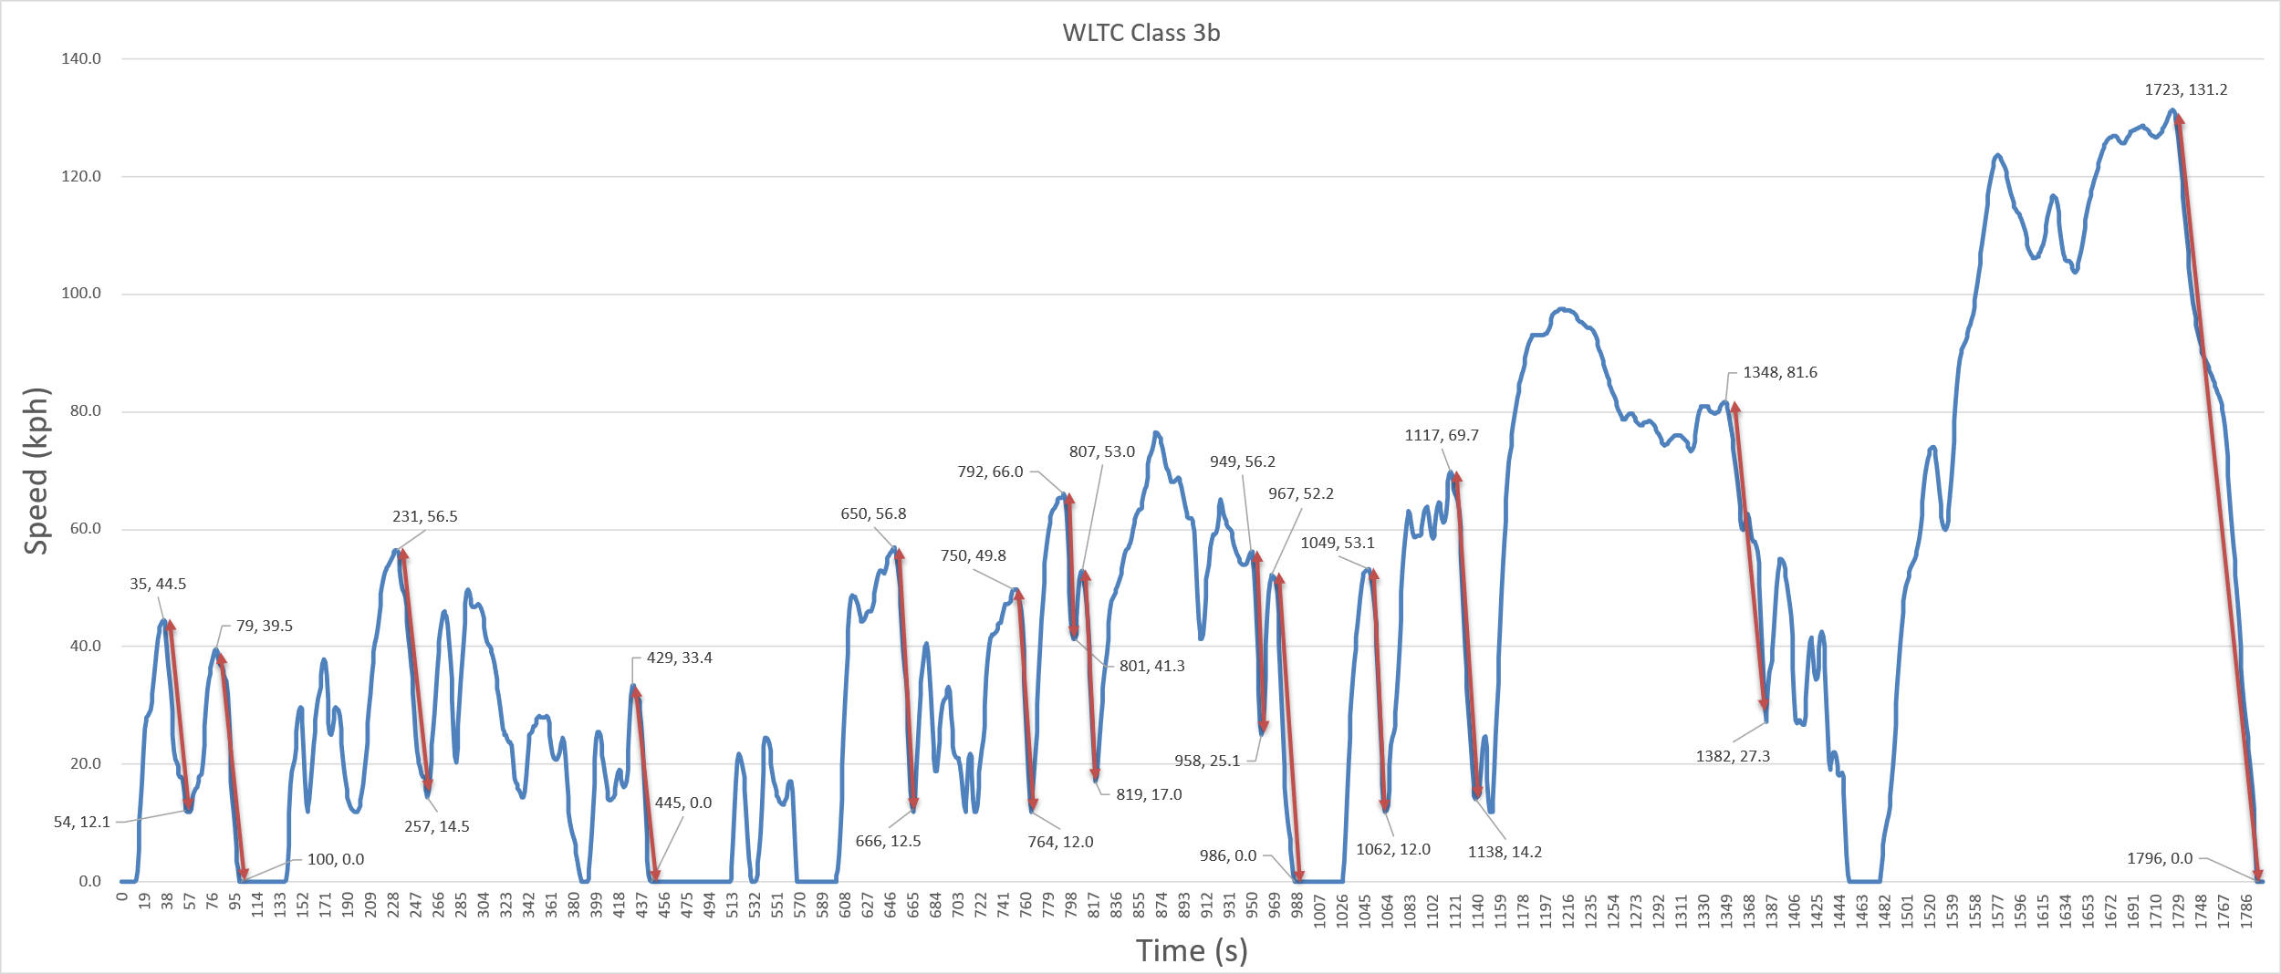
WLTP Cycle
Figure 4 WLTP Cycle with Highlighted Braking Areas

KER System Requirements

Peak Braking Power and Energy
Table 2 Kinetic Energy Available for Recovery Calculation and Max Braking
Table 2 shows the method used to find the recoverable kinetic energy for the selected braking events highlighted in figure 4.

Energy Storage Target
Table 3 Usable Kinetic Energy Available for Recovery
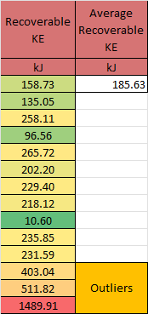
When selecting the target for the energy storage device, the environment the vehicle will be operating in should be considered. Since the selected vehicle is a post van, the environment will be mostly suburban areas where the speed limits are lower. For the KERS energy storage device, a target of 185kJ will be used because it is better matched with the mid-range values highlighted in table 3 as it is the average excluding the outliers. This provides a more practical limit than if the maximum recoverable energy of 1489.91kJ were used. The limitations of this design choice will be examined in section 8.2.

KER System Selection

KERS Type
There are three main types of KERS, electric, flywheel, and hydraulic (Śliwiński, 2016). These three systems will be briefly described below.

Electric
For an electric system the kinetic energy is collected using a motor generator and stored in a battery or supercapacitor (Pipitone and Vitale, no date). This energy can then be used to help accelerate the vehicle when needed. A benefit of this system is that it can have low losses depending on the parts used. It also can store the energy for an extended period with relatively low losses.

Flywheel
For a flywheel KERS the kinetic energy gets stored in a flywheel as rotational energy. As the car is barking the energy gets transferred into the flywheel which stores it until the car needs to accelerate, the energy is then transferred back into the wheels. A flywheel KERs has efficiency of around 70% (Pipitone and Vitale, no date)

Hydraulic
Hydraulic KERS works by stored in pressure tanks of air or some incompressible fluid. The pressure is increased when the vehicle is braking and released when the vehicle is accelerating. When the pressure is released, the power is transferred back to the wheels to help with acceleration. (Pipitone and Vitale, no date)

Selected System
For the postal van application, an electric KERS will be used with super capacitors as the storage device because they can charge and discharge over short periods of time (Senamaw, 2019).

Motor Generator
When selecting a motor generator, the size and power requirements must be considered. The peak instantaneous braking power experienced over the WLTP cycle is 40.23kW as shown in table 2. This means that the selected motor generator must be able to accommodate this power requirement. However, a smaller motor can be used since the 40.23kW is a very short spike and not a continuous power. The controller will need to be able to handle the 40.23kW spike, when looking at a controller that can handle this it can be seen that it has a limit of 120V (MGM COMPRO, 2025a).

Energy Storage
For the energy storage a bank of supercapacitors will be used. With the standard supercapacitor being rated for 2.7V (Lui Gough, 2023) a bank of them will be needed.
To find the number of cells needed for the bank if they are connected in series, you divide the max voltage of 120V (MGM COMPRO, 2025a) by the voltage of each cell. $n=\frac{120}{2.7}=44.4$ this means that 45 supercapacitors will be needed to reach the desired voltage.
$E=\frac{1}{2}×CV^{2}$ $C=\frac{2E}{V^{2}}$ we know that E=185kJ and V=120V we can then calculate the capacitance $C=\frac{2×185×{10}^{3}}{{120}^{2}}=26F$
So, if we have a 35kW motor generator (MGM COMPRO, 2025b), that can generate 120V. To store185kJ of energy we need a bank of supercapacitors rated for 26F. to see how many banks of 45 supercapacitors are needed the energy must be calculated using the actual voltage range that is available. In the case of this system the limits are with the controller which has a voltage range of 32-120V (MGM COMPRO, 2025a) so using the formula from earlier with the voltage range we find the energy available.
$E=\frac{1}{2}×C{(Vmax}^{2 }-Vmin^{2})=\frac{1}{2}×26({120}^{2}-{32}^{2})=173.9kJ$
This is lower than the average energy shown in table 3 and so there will be a 2nd bank connected in parallel in order to double the energy that can be stored and the capacitance by using the second bank in parallel. (Revision World, 2025). This leaves the system with a total of 52F and 348kJ of useable energy storage.

Efficiency
To find the total system efficiency the regen efficiency and the boost efficiency must both be calculated and then multiplied together. For this report the system is theoretically in almost ideal circumstances, if there is a range/inexact efficiency, 3% will be removed from the highest value as long as it doesnt then go below the minimum. The efficiency assumed for the motor is 92% (TYTO Robotics, 2023), for the controller 96% (MGM COMPRO, 2025a), and 95% round trip for the supercapacitor bank (Eaton, 2025).
0.92*0.96*0.95*0.92*0.96=74% system efficiency.

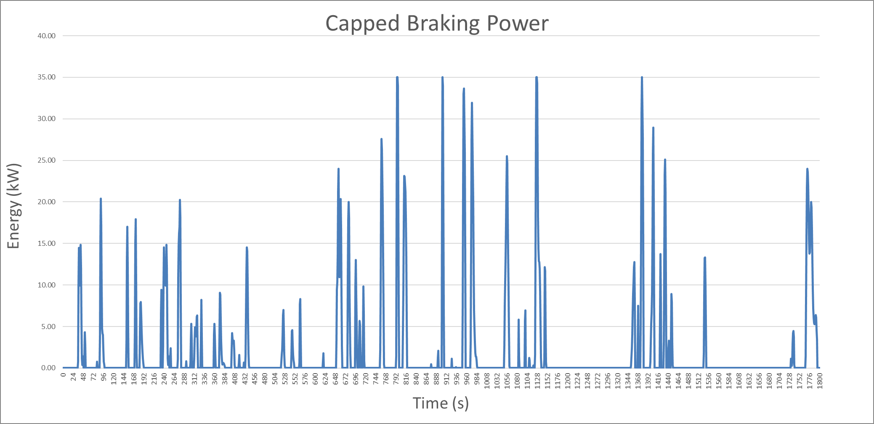
Energy Recovery
Figure 5 Braking Power Capped at 35kW

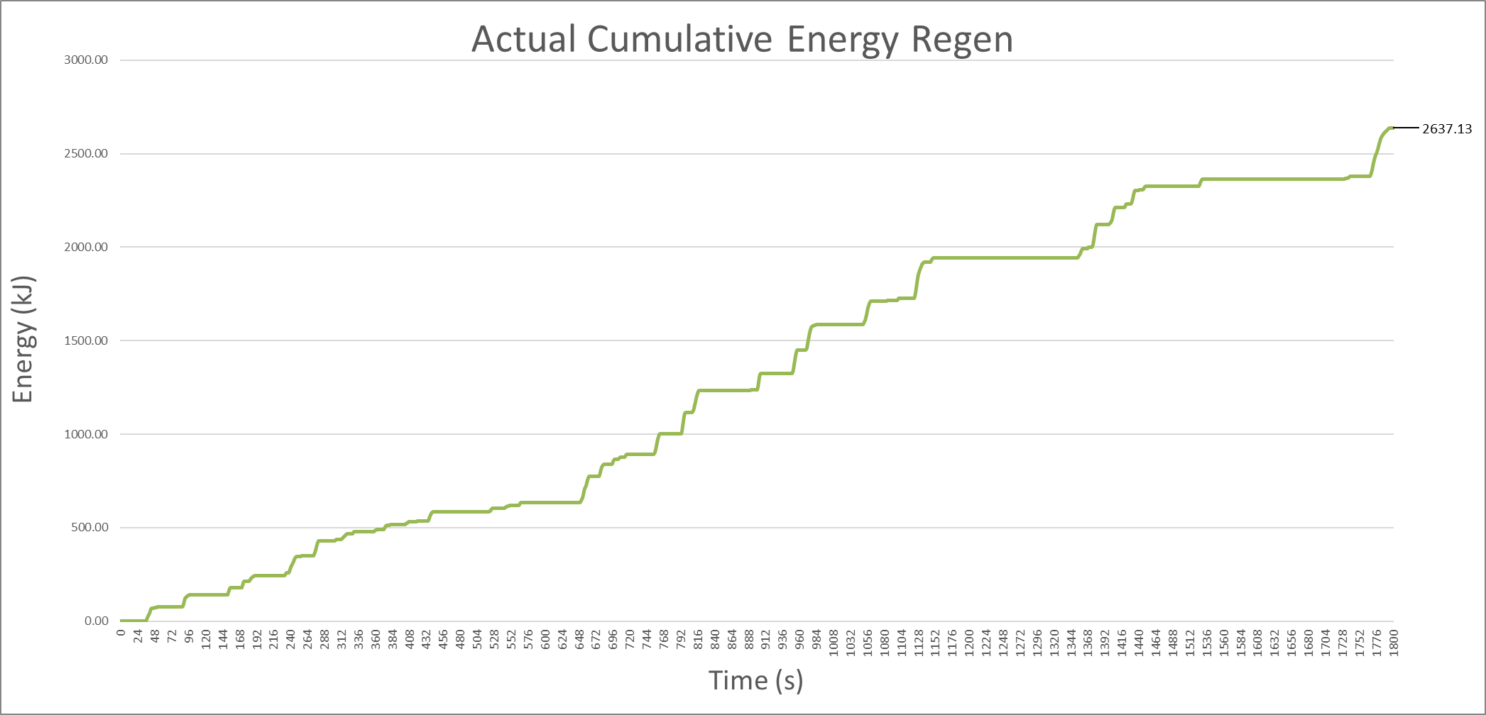
Using the capped power the actual cumulative energy is calculated considering the overall KERS efficiency.
Figure 6 Energy Regen after Efficiency Deduction

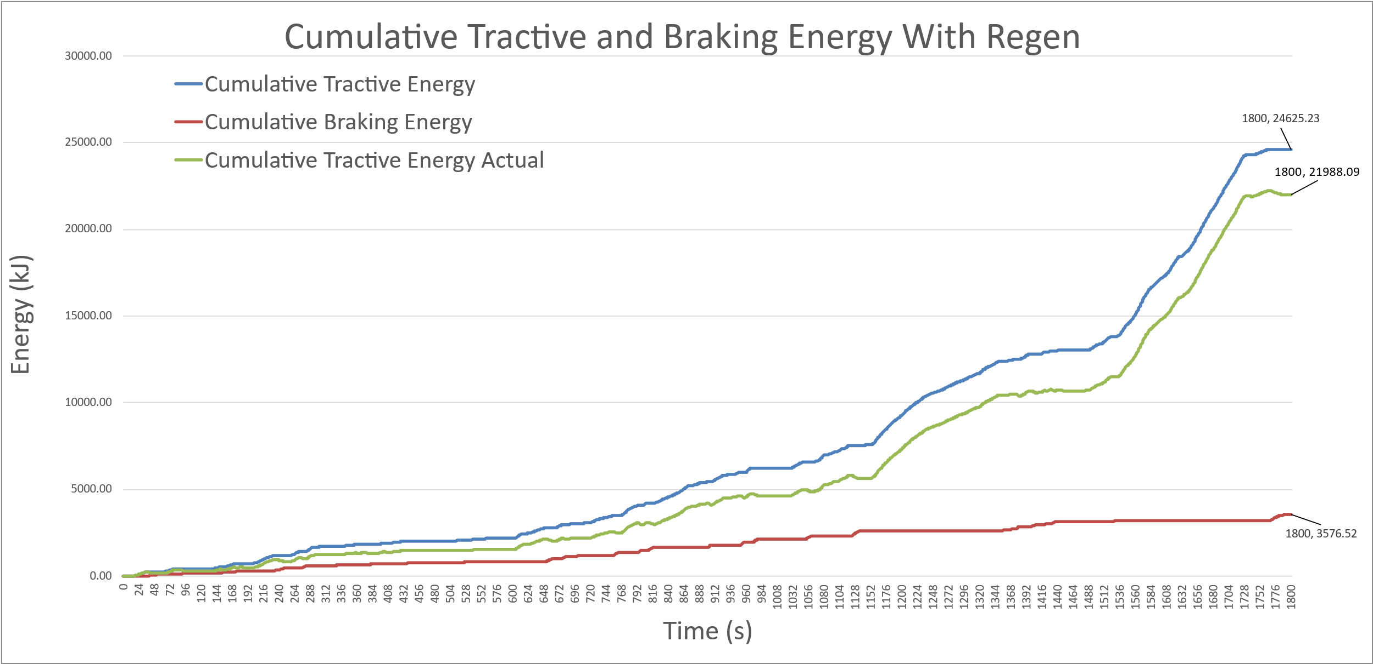
Using the cumulative regen energy the difference the KERS is making can be plotted on the same cumulative energy graph shown in section 3.3. The actual cumulative tractive energy is calculated by subtracting the cumulative regen energy from the cumulative tractive energy.
Losses=18411.57 kJ
Figure 7 Cumulative Tractive, Braking, and Actual Tractive Energy

System Energy Savings
The losses between tractive and braking energy without the use of a KERS was 21048.71 kJ as shown in figure 2. The losses after the implementation of a KERS is 18411.57 kJ as shown in figure 7. $21048.71-18411.57=2637.14kJ$ saved over the WLTP cycle. Finding the percentage improvement in tractive energy,
$$\frac{Energy Saved}{Tractive Energy}*100= \frac{2637.14}{24625.23}*100=10.71\%$$
The MPG if the Peugeot Expert is 44.8. Fuel economy is inverse to fuel consumption (National Research Council, 2011) so, with a 10.71% decrease in fuel consumption
$Old consumption(Oc)*\left(1-0.1071\right)=New consumption(Nc)$. Due to the KERS the improvement in fuel economy is
$MPGnew=\frac{1}{Nc}=\frac{1}{Oc*(1-0.1071)}=\frac{MPGold}{1-0.1071}=\frac{44.8}{1-0.1071}=50.17MPG$

System Explanation

KERS Operation
The selected KERS works by connecting a BLDC motor to the drivetrain so that when the vehicle is slowing down, it works as a generator, and the kinetic braking energy is collected and stored in a super capacitor. The controller in the system can then provide this energy back to the motor when the vehicle needs to accelerate which gives it a boost, reducing the overall energy requirements from the internal combustion engine. A system like this will improve the fuel economy of the vehicle as shown in section 7.1 which is ideal for a vehicle used by the royal mail to reduce to fuel costs of each post van. The driver will feel an improvement in the acceleration because of the added torque provided by the BLDC motor which could make the vehicle more enjoyable to drive. They will also feel an addition braking force due to the motor charging the supercapacitors.

Limitations
Because of the motor selection the system does have limitations with how much energy it can store. The bank of capacitors can store a maximum of 348kJ, this is far below the 1489.91kJ that were available over the last braking event in the WLTP cycle. Because of this limitation if the vehicle experiences any long braking events it will not be able to make use of all of the energy generated and will have more losses than if a capacitor bank was sized for the maximum energy. However, because the vehicle will be used primarily in suburban areas it will very rarely experience braking events like that and so the limitation is within the bounds of practicality.

Conclusion
In conclusion, this report has analysed the losses of the Peugeot Expert as standard from the factory, investigated different KERS and displayed the improvements with the use of a super capacitor KERS. The difference to the fuel economy of the post van with the KERS is significant as it improves the miles per gallon by 5.37 miles; this is a 12% improvement compared to the MPG without the KERS.

References
Eaton (2025) Supercapacitor modules frequently asked questions. Available at: https://www.eaton.com/us/en-us/products/electronic-components/faq/supercapacitor-modules-frequently-asked-questions.html (Accessed: November 30, 2025).
ECOpoint Inc (2019) Emission Test Cycles: WLTC. Available at: https://dieselnet.com/standards/cycles/wltp.php (Accessed: November 26, 2025).
Ehsani, M. et al. (2018) Modern Electric, Hybrid Electric, and Fuel Cell Vehicles Third Edition. 3rd ed.
Lui Gough (2023) What’s Super about Supercapacitors? – Part 7: Quite a lot, actually! (Final) - element14 Community. Available at: https://community.element14.com/challenges-projects/design-challenges/experimenting-with-supercapacitors/b/blog/posts/what-s-super-about-supercapacitors-part-7-quite-a-lot-actually-final (Accessed: November 29, 2025).
MGM COMPRO (2025a) HBCi 320120 | MGM COMPRO | Controllers | Inverters | ESCs. Available at: https://mgm-compro.com/controllers-inverters-escs/hbci-320120/ (Accessed: November 27, 2025).
MGM COMPRO (2025b) REX 50 | MGM COMPRO. Available at: https://mgm-compro.com/electric-motor/rex-50-35-kw/ (Accessed: November 30, 2025).
National Research Council (2011) “Assessment of fuel economy technologies for light-duty vehicles.”
Peugeot (2025a) Configurator Peugeot Expert Panel Van standard. Available at: https://www.peugeot.co.uk/models/new-peugeot-e-expert/configure-expert/configure-expert-panel-van-standard.html/summary (Accessed: November 26, 2025).
Peugeot (2025b) Peugeot Expert. Available at: https://pricelist.varioweb.co.uk/peugeot-expert/ (Accessed: November 26, 2025).
Pipitone, E. and Vitale, G. (no date) “A regenerative braking system for internal combustion engine vehicles based on supercapacitors-Part 1: System analysis and modelling.”
Revision World (2025) Capacitors - A-Level Physics Revision. Available at: https://revisionworld.com/a2-level-level-revision/physics/fields-0/capacitors?utm_source=chatgpt.com (Accessed: November 29, 2025).
Senamaw, Z. (2019) “A Review Paper on the Study of Charging and Discharging the Capacitor,” American Journal of Quantum Chemistry and Molecular Spectroscopy, 3(2). Available at: https://www.researchgate.net/profile/Senamaw-Zegeye/publication/391716885_A_review_paper_on_the_study_of_charging_and_discharging_the_capacitor/links/6824514c6b5a287c304186f3/A-review-paper-on-the-study-of-charging-and-discharging-the-capacitor.pdf (Accessed: November 30, 2025).
Śliwiński, C. (2016) “Kinetic energy recovery systems in motor vehicles.” Available at: https://doi.org/10.1088/1757-899X/148/1/012056.
TYTO Robotics (2023) AC vs DC vs BLDC Motor Efficiency Comparison - Tyto Robotics. Available at: https://www.tytorobotics.com/blogs/articles/ac-vs-dc-motor-efficiency (Accessed: November 30, 2025).
ultimate SPECS (2025) Peugeot Expert Van 1.5 BlueHDi 120 226C Specs, Performance, Comparisons. Available at: https://www.ultimatespecs.com/car-specs/Peugeot/116802/Peugeot-Expert-Van-15-BlueHDi-120-226C.html (Accessed: November 26, 2025).
Yes Excel (2023) (107) Separate Positive and Negative Numbers in Excel - YouTube. Available at: https://www.youtube.com/watch?v=Iqh3IbuUgVk&t=68s (Accessed: November 26, 2025).

