DESIGN AND IMPLEMENTATION OF A RELATIONAL DATABASE SYSTEM FOR THE ECORIDE ELECTRIC BIKE RENTAL SERVICE

Introduction
The database system of EcoRide was created in order to facilitate the work of the electric bike rental program introduced by the local authority. The rental scheme of providing electric bikes on hire will make travelling sustainable as it can be borrowed in various places and dropped at any station in the system [1]. With the increased popularity of the service, using paper-based registers and spreadsheets posed challenges like making two bookings, wrong availability tracking and inability to monitor the maintenance activities [2]. This project was aimed at designing and implementing a relational database system that would be consistent with the functionality demands of EcoRide such that the registration of users, availability of bikes, rental recording and maintenance tracking of the bikes could be easily handled. The report provides conceptual and logical design, implementation in Microsoft access and validation of functionality of the system by testing it.

Scenario Overview
The idea of EcoRide came as a public transportation program to enhance the idea of commuting in the eco-friendly way by making electric bikes available in parks, university campuses and train stations to be rented. The riders will be supposed to complete their information at the rental point after which they use a bike and later drop the bike in any of the stations where the bikes are available. Employees oversee maintenance procedures and see that bikes are in good working conditions. The shortcoming of manual recording in the scenario provided put in place the challenge of identifying which bikes were on stock, which bicycles were in operation and which ones were under repairs [3]. These problems are mitigated in the new database that organises the operational data in an organised manner that is accurate, fast to retrieve and trace.
The scenario conditions implied the necessity to keep the systematised records of rider data, bike stock, rental data and a list of services performed by employees. These data sets were connected in a natural way to a relational database schema [4]. To a great extent therefore, the database helps to ensure that redundancy is rolled out and that it allows consistency and helps to create analytical information like the frequency of the rentals, monitoring the status of the bike as well as performance of the maintenance team.

Entity Relationship Diagram
The first step in developing the database design was to carefully analyse the situation and figure out the major elements that are present within the EcoRide environment. The key tables were the Rider, Bike, Staff, Rental and Maintenance tables [5]. User data of the rental service is stored in the Rider entity which has details of every user including the identification and contact details of the user. Bike entities manage vital information on each electric bike such as the type of model and its status and physical location. The Staff entity is a section that has a group of personnel who are involved in inspection and repair work. The Rental entity records all the rental transactions that have been made by the riders and associates each rental with the rider and bike [6]. The Maintenance entity records the service operations on bikes and links each job to a staff and a bike. Existence of the various inter-entity dependence indicated that an organised relational glue was required in place to maintain data precision and enhance operational candour.
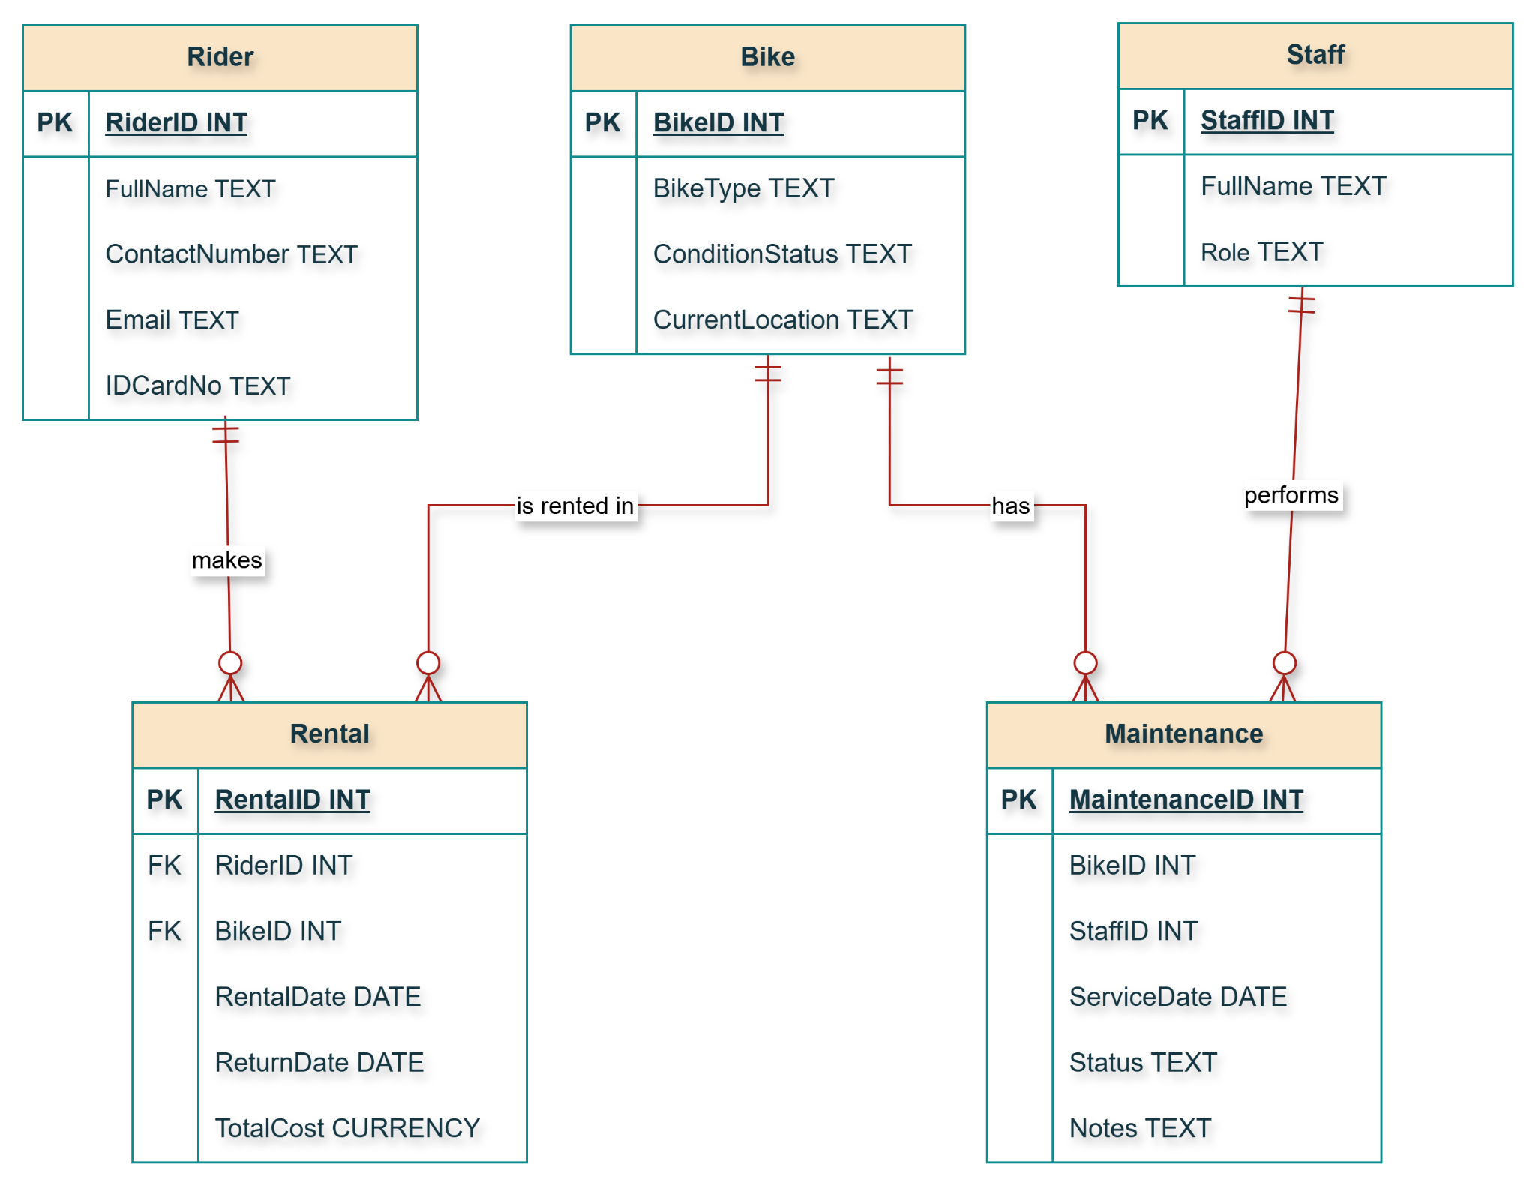

Figure 1: Entity Relationship Diagram
(Source: Self-created using draw.io)
The ERD was a graphical representation of the tables and associated relations according to the primary and foreign key relationships.

Data Structure Development
The database application was used based on Microsoft Access starting with the development of a table with SQL commands. All tables were created and had AutoNumber primary keys and relevant data types according to length of each attribute [7]. The database development involved developing every table that was in the Microsoft Access database via table design editor, all the fields should have the appropriate data type and the primary key must be well established.
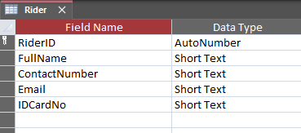

Figure 2: Rider Table Creation
(Source: Self-created in Access)
The details of Rider table creation displayed in the above figure will be used to support unique identification and storage of rider information.
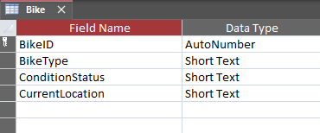

Figure 3: Bike Table Creation
(Source: Self-created in Access)
The above figure indicates the creation details of the Bike table so that the type, condition status and where the bikes are could be recorded.
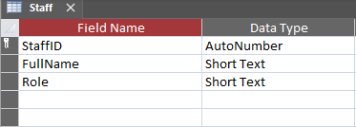

Figure 4: Staff Table Creation
(Source: Self-created in Access)
The figure above represents the Staff table generation to store personnel data utilised in maintenance operations.
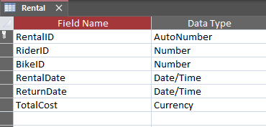

Figure 5: Rental Table Creation
(Source: Self-created in Access)
The creation details of the Rental table are depicted in the above figure to facilitate the association of every single item of the rental events with a rider and a bike along with capturing pertinent transaction details.
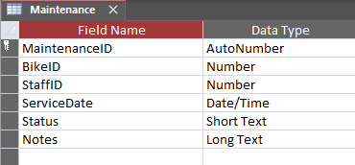

Figure 6: Maintenance Table Creation
(Source: Self-created in Access)
The above figure indicates the creation of the Maintenance table to contain the services activity details as well as connect them with bikes and staff members concerned.
The Relationships tool was then applied to draw connections between the tables after creating the tables and impose referential integrity [8]. Foreign-key constraints ensured that different records and maintenance or rental records were not inserted as orphans and the data consistency across the system were ensured.
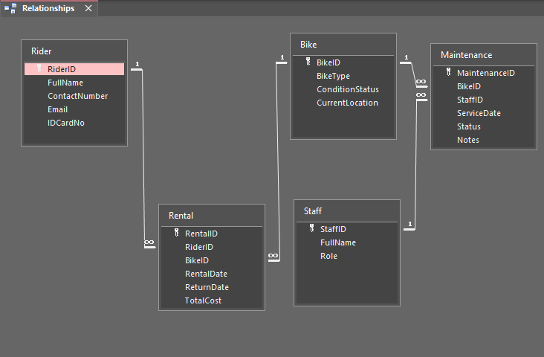

Figure 7: Relationships between the tables
(Source: Self-created in Access)
The relationship configuration confirmed the fact that the system architecture supported the desired referential model.

Normalization
The stage of developing data structure involved normalisation to make sure that the database design embraced the concept of accuracy, consistency and non-redundancy in storage. The identified raw attributes that were found during the scenario analysis were tested on the basis of the principles of First, Second and Third Normal Form. Recurring groups have been dropped to meet the requirement of 1NF and partial dependencies were dropped to meet the requirement of 2NF. Lastly, all the non key attributes were rendered to be entirely dependent on the primary key which made them comply with 3NF. This guaranteed that tables contain the information about one concept only and all relationship between entities was via the foreign keys. Normalisation thus minimised the amount of data duplication as well as enhancing efficiency in the queries and updates.

Sample Data Insertion
After creating tables and establishing relationships the custom forms were created to enable easy entry of data. The functionality of Form Wizard was followed to create a form per table and therefore sample data can be shown as form data easily without any need to change datasheet tables directly. The Rental and Maintenance forms have been improved with lookup dropdowns, which lets them choose the names of the Rider, Bikes and Staffs rather than typing down the ID number. The system was fed with sample data to the system using a custom-built form in Microsoft Access which enabled real addition of records as opposed to typing direct data into the tables.
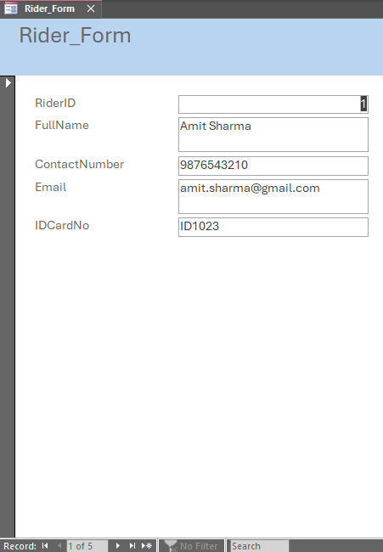

Figure 8: Sample data insertion through Rider Table form
(Source: Self-created in Access)
The registration of new riders into the database was smooth using this form.
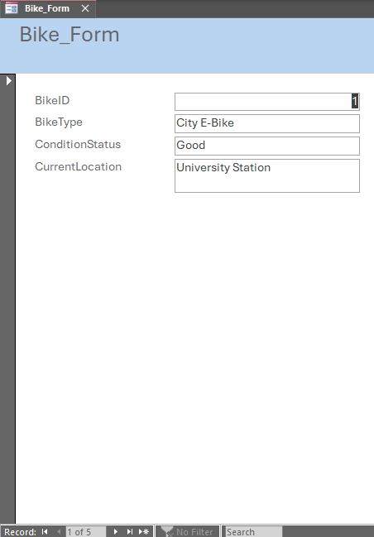

Figure 9: Sample data insertion through Bike Table form
(Source: Self-created in Access)
This form enabled storage of accurate bike details that can be tracked during availability.
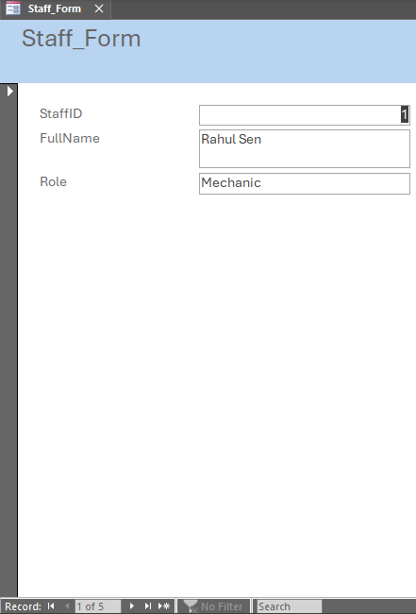

Figure 10: Sample data insertion through Staff Table form
(Source: Self-created in Access)
This form helped in introducing maintenance personnel into the system.
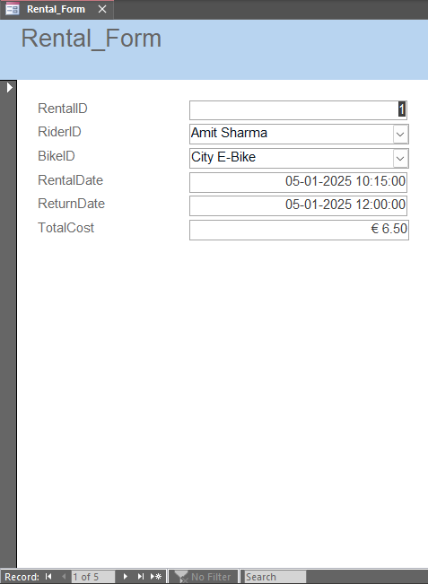

Figure 11: Sample data insertion through Rental Table form
(Source: Self-created in Access)
This form logged rental activities by connecting a rider and a bike to dates.
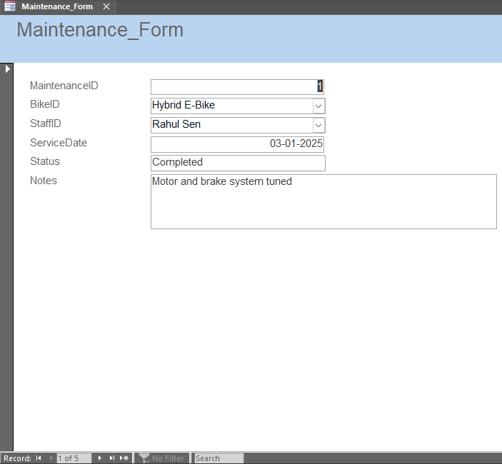

Figure 12: Sample data insertion through Maintenance Table form
(Source: Self-created in Access)
This form contained the service activity details that were related to a bike and a staff member.

Query Development
Once the sample data were inserted, SQL queries were run to show that the database is useful in real-world making decisions related to the service of EcoRide. The initial query was designed to find out bikes that were currently out on rent by locating transactions where the return date is not known [9;10].
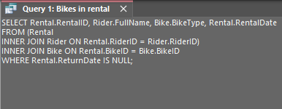

Figure 13: Query 1 for retrieving bikes in rental
(Source: Self-created in Access)
This screenshot displays the search query of retrieving bikes in rental.
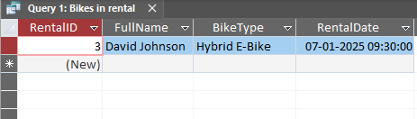

Figure 14: Output of Query 1
(Source: Self-created in Access)
Only bikes that are in use are shown into the results, which confirms proper monitoring of rentals in use.
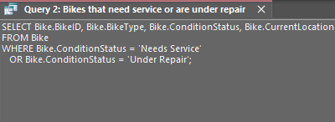

Figure 15: Query 2 for retrieving bikes that need service or under repair
(Source: Self-created in Access)
The second query brought in the bikes requiring services or those under services hence making maintenance prioritisation simpler.
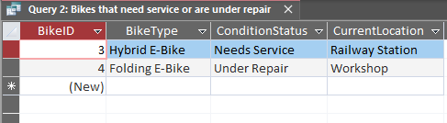

Figure 16: Output of Query 2
(Source: Self-created in Access)
The output shows that the system has been properly configured to list bikes that need maintenance.
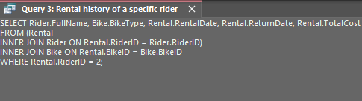

Figure 17: Query 3 for retrieving rental history
(Source: Self-created in Access)
The third query obtained the rental data of a chosen rider, which made it possible to analyse the user history of rentals.
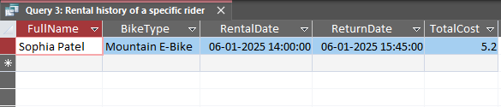

Figure 18: Output for Query 3
(Source: Self-created in Access)
The outcomes assure that the database provides advanced user history retrieval.
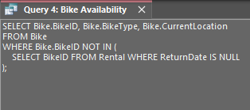

Figure 19: Query 4 for checking bike availability
(Source: Self-created in Access)
The fourth query identified those bikes that were available after filtering out those that were in open rentals.
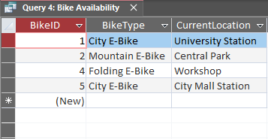

Figure 20: Output for Query 4
(Source: Self-created in Access)
The output consists of a list of bikes that are available to be rented.
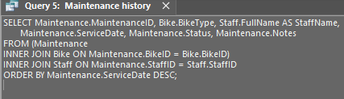

Figure 21: Query 5 for checking maintenance history
(Source: Self-created in Access)
The fifth query contributed to the creation of a maintenance history report through connecting bike and staff data.
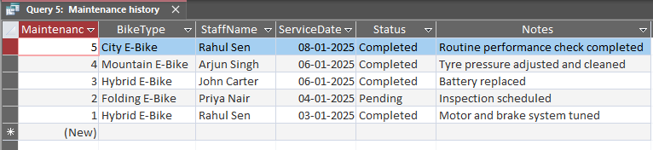

Figure 22: Output for Query 5
(Source: Self-created in Access)
The output ensured that maintenance work as well as the personnel involved can be efficiently traced.

Testing and Validation
To ensure that the database was running to its fullest potential, testing was done to ensure that it was both functional and structurally sound. Testing of data input involved testing of data input in all forms such that any new data would be saved in the relevant tables [11]. The Lookup fields behaviour in Rental and Maintenance forms also enhanced accuracy of the data since less human typing and human error errors are minimised.
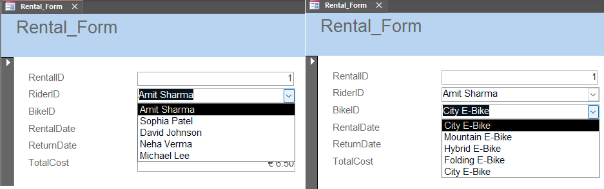

Figure 23: Lookup dropdowns in Rental form
(Source: Self-created in Access)
The dropdowns of lookups in the Rental and Maintenance forms were tested to ensure that they gave users the chance to choose riders, bikes and staff, instead of entering them manually through typing of identifiers.
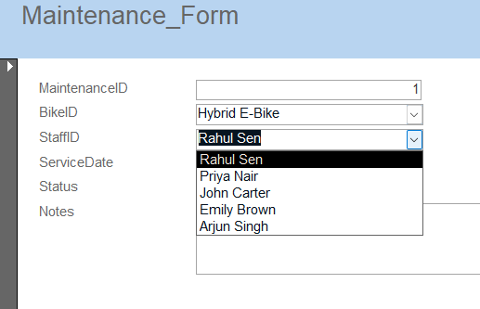

Figure 24: Lookup dropdowns in Maintenance form
(Source: Self-created in Access)
This screenshot demonstrates that dropdown menus are used to select staff and bikes reliably. In the testing stage, queries were also tested using a closer comparison with the anticipated and real outputs. Continuing rentals query could only give records of null return dates which verified the correct filtering logic [12]. The database acted in a very logical manner and corresponded to all the suggested outputs, which provided the confirmation that the database can be used under the circumstances of the scenario.

Conclusion
The EcoRide relational database system effectively deals with operational problems that are experienced with manual recording in the electric bikes rental program. The database helps in proper rate keeping of the riders, bike stock, rental and maintenance records. Strategic design, which has been attained with the help of the ERD and enhanced by the Third Normal Form normalisation, is characteristic of the consistency of data and avoidance of redundancy. The system is usable in the real world and implemented through a Microsoft Access, utilising forms and dropdown-based input mechanisms. The development of queries established that the database was able to respond effectively to the operational queries relating to the availability of bikes, rental and maintenance activities. It was tested that integrity constraints, form input and query executed as intended. In general, the final system offers an efficient and customer-friendly approach to the management of the EcoRide service and can be further expanded in future to achieve the new operational needs.

Reference List
- Zhu, L., Ali, M., Macioszek, E., Aghaabbasi, M., and Jan, A., 2022. Approaching Sustainable Bike-Sharing Development: A Systematic Review of the Influence of Built Environment Features on Bike-Sharing Ridership. Sustainability, 14(10), 5795.
- Mahajan, S. and Argota Sánchez-Vaquerizo, J., 2024. Global comparison of urban bike-sharing accessibility across 40 cities. Scientific Reports, 14(1), p.20493.
- Wen, Z., Tian, D., and Wu, N., 2025. Modeling and Analyzing the Spatiotemporal Travel Patterns of Bike Sharing: A Case Study of Citi Bike in New York. Sustainability, 17(1), 14.
- Qin, Y. and Karimi, H.A., 2023. Evolvement patterns of usage in a medium-sized bike-sharing system during the COVID-19 pandemic. Sustainable Cities and Society, 96, p.104669.
- Sharma, P., Chetti, P., Dash, B. and Ansari, M., 2023. Data Modeling Best Practices Key to Data Mining and Data Standardization. Available at SSRN 4337595.
- Saint, R. and Duncan, P., 2024. Data Modelling Good Practice Guide.
- Microsoft, 2024. Add an AutoNumber field as a primary key. Available at: https://support.microsoft.com/en-us/office/add-an-autonumber-field-as-a-primary-key-96ba683b-7f86-4354-aa25-3849f5e5b641 [Accessed on: 21.11.2025]
- Alderden, J.G., Sharkey, P.D., Kennerly, S.M., Ghosh, S., Barrett, R.S., Horn, S.D., Ghosh, S. and Yap, T.L., 2023. Developing a Relational Database for Best Practice Data Management: The Turn Everyone and Move for Ulcer Prevention Database. CIN: Computers, Informatics, Nursing, 41(2), pp.59-65.
- Kim, K., 2024. Discovering spatiotemporal usage patterns of a bike-sharing system by type of pass: a case study from Seoul. Transportation, 51(4), pp.1373-1407.
- Liang, Y., Huang, G. and Zhao, Z., 2023. Cross-mode knowledge adaptation for bike sharing demand prediction using domain-adversarial graph neural networks. IEEE Transactions on Intelligent Transportation Systems, 25(5), pp.3642-3653.
- Gobert, M., Nagy, C., Rocha, H., Demeyer, S. and Cleve, A., 2023. Best practices of testing database manipulation code. Information systems, 111, p.102105.
- Shaikh, R.H., 2025. Referential Integrity: Why It’s Vital for Databases. Acceldata. Available at: https://www.acceldata.io/blog/referential-integrity-why-its-vital-for-databases [Accessed on: 21.11.2025]

