Master of Business Administration
International Business pathway


Contemporary employability skills
Assessment 1: Individual report. Weight: 100%

Module name: International Marketing: Principles and Practices
Module code: LCMB7026

Lecturer name: Dr Jamiu Odugbesan
Student name: Md Abdulla Al Mamun
Student ID: 2503784

Word count: 5287

Submission date: 13-08-2026

Basic Acknowledgement format of AI tool use
1. I acknowledge the use of Gemini (https://gemini.google.com/app) in July to generate Table data for my assessment. I used the prompt(s):
- Create a Hofstede Dimension table for Japan and UK.

2. I acknowledge the use of Gemini (https://gemini.google.com/app) in August to generate a Picture of Gibbs' (1988) Reflective Cycle. The prompt(s):
- create a picture of Gibbs' (1988) Reflective Cycle.

3. I acknowledge the use of Gemini (https://gemini.google.com/app) in July for PROOFREADING to analyze the draft file for finding any incomplete sentence for my Assessment. The prompt(s):
- Analyze this file and see if there are any incomplete sentences and grammar errors.
4. I acknowledge the use of Gemini (https://gemini.google.com/app), Qwen AI (https://qwen.ai/home) Claude AI (https://claude.ai/new) in June and July to research for my Assessment.

I confirm that I have not presented any AI generated text as my own work. I confirm I have copies of my drafts, notes, and other resources I used before, and after the use of AI tools which I may be asked to provide in evidence.

Table of Contents
Executive Summary 3
Section 1: International Market Entry Strategy and Marketing Mix 4
1. Introduction 4
2. Brand and Country Overview 5
3. Comparative Macro-Environmental Analysis (PESTEL) 6
Political 7
Economic 7
Social 7
Technological 8
Environmental 8
Legal 8
4. Comparative Cultural Analysis (Hofstede) 9
5. Comparative STP Strategy 11
Segmentation 12
Targeting 12
Positioning 12
6. Comparative Marketing Mix (7Ps) 13
Product 13
Price 14
Place 14
Promotion 14
People 15
Process 15
Physical evidence 15
7. Evaluation of Market Entry Strategy (United Kingdom) 16
8. Evaluation of Ethical Issues 18
9. Recommendations 21
10. Conclusion 22
Section 2: Reflective Account 23
Reference List 26

Executive Summary
This report evaluates the international market entry strategy and marketing mix of Toyota Motor Corporation ("Toyota") in its home market, Japan, against its host market, the United Kingdom (UK), applying PESTEL, Hofstede's cultural dimensions, Segmentation-Targeting-Positioning (STP), the extended marketing mix (7Ps), the Uppsala internationalization model and ethical analysis. Rather than treating each framework as a checklist, the report applies each one analytically, explaining what it measures before testing it against contrasting evidence or an alternative theory. The PESTEL analysis shows Japan's ageing population and tariff exposure set against the UK's regulatory-driven electrification pressure, while Hofstede's dimensions, applied alongside their well-documented methodological limitations, help explain differences in Toyota's dealer structure and appetite for risk. STP and 7Ps analysis shows a company that standardizes platform engineering and brand promise while adapting dealer format, pricing logic and sponsorship locally. The Uppsala model, tested alongside internalization theory and Dunning's eclectic paradigm, explains Toyota's incremental 1989 shift to UK manufacturing while also exposing the limits of relying on any single theory. Informed by both shareholder- and stakeholder-based ethics, I adjudicate home-market governance failures quite seriously alongside the UK-facing strategy around electrification. In conclusion, overcoming the risks of governance and electrification will depend on Toyota's ability to strike the right balance between global standardization and local adaptation in the future.

Section 1: International Market Entry Strategy and Marketing Mix

1. Introduction
Toyota Motor Corporation is one of the world's two largest automobile manufacturers by volume and offers a rich case for international marketing analysis, because its vehicles are engineered on shared global platforms while its management philosophy, the "Toyota Way", remains inseparable from Japanese manufacturing culture (Baack, 2018).
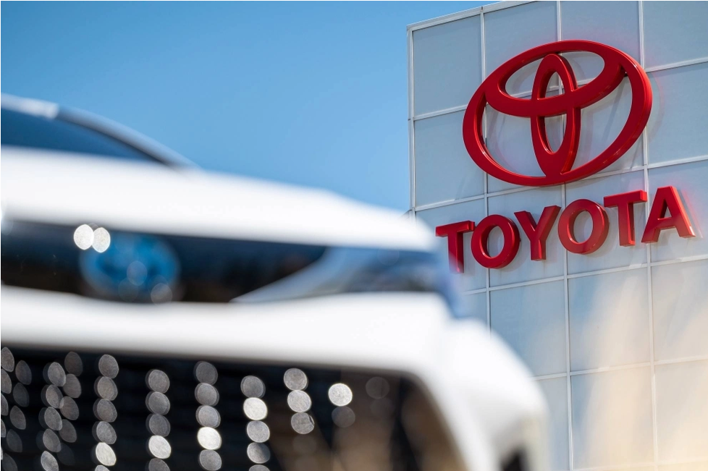
Figure 1 Toyota Motor Corporation
This report, prepared for the LCMB 7026 International Marketing module, compares Toyota's strategy in Japan, its home market, and the UK, a host market where Toyota has manufactured cars for more than three decades. Rather than simply describing each market in turn, the report applies established frameworks analytically: each concept is briefly explained before it is applied, and each application is tested against an alternative view or contrasting piece of evidence, in keeping with the critical, evaluative standard expected at this level. The report profiles the brand and both countries, compares their macro- and cultural environments, evaluates STP and the 7Ps, assesses Toyota's UK entry mode, and examines ethical issues, before concluding with recommendations.

2. Brand and Country Overview
Toyota traces its origins to 1937, when it was spun out of Toyoda Automatic Loom Works by Kiichiro Toyoda, and remains headquartered in Toyota City, Aichi Prefecture (Statista, 2026). Toyota did not internationalize rapidly; it first built its production philosophy, the Toyota Production System (TPS), a manufacturing approach centered on eliminating waste and continuously improving processes, before expanding through exporting and later overseas manufacturing, a staged approach that foreshadows the incremental entry-mode pattern examined in Section 7. Today the wider Toyota Group includes the Toyota and Lexus brands alongside Daihatsu, Hino Motors and Toyota Industries, and reported consolidated net revenue of approximately 48 trillion yen for its 2025 financial year, with Japan remaining its largest single revenue market (Toyota USA Newsroom, 2026; Statista, 2026). Much of Toyota's home-market resilience rests on keiretsu, long-term, cross-shareholding supplier relationships that bind component manufacturers closely to Toyota and underpin the just-in-time production discussed in Section 6; this same tight integration, however, has also been identified as a contributing factor in the governance failures discussed in Section 8, since close, trust-based supplier relationships can weaken the incentive for independent external scrutiny. The UK is a host market Toyota has served since the 1960s, initially through direct exporting via Toyota (GB) Limited, before establishing Toyota Motor Manufacturing (UK) Limited (TMUK) in December 1989, with plants at Burnaston, Derbyshire and Deeside, North Wales, that began production in 1992 (Toyota Motor Corporation, 1989; Toyota Media Site, 2024). Unlike some Asian competitors that later withdrew manufacturing from Britain, Toyota's continued UK investment illustrates a depth of host-market commitment returned to when the entry-mode theories are evaluated in Section 7.

3. Comparative Macro-Environmental Analysis (PESTEL)
PESTEL analysis decomposes a country's macro-environment into six categories, Political, Economic, Social, Technological, Environmental and Legal, so that broad, easily overlooked external forces can be compared systematically across markets rather than assessed impressionistically (Baack, 2018). Applied uncritically, however, PESTEL can produce a static checklist that under-represents how these factors interact; the analysis below therefore treats each factor as connected to the others rather than isolated.
Factor | Japan (Home) | United Kingdom (Host)
Political | Close government-industry coordination; elevated US tariffs on Japanese-made cars despite 2025 trade agreement | Arm’s-length regulation; looming 2027 EU-UK rules-of-origin dispute over EV battery content
Economic | Modest growth (c.0.8-1.2%); weak yen aids exports but erodes domestic spending power | ‘Stagflation-lite’; GDP growth c.1%, inflation c.2.8-3%, high industrial energy costs
Social | Severe demographic contraction; domestic car sales down from 7.78m (1990) to c.5.23m | Stable, diverse population; individualistic, cost- and emissions-conscious buyers
Technological | Home of Toyota’s hybrid/hydrogen R&D and Toyota Production System innovation | Strong automotive engineering base; reliant on imported EV battery technology
Environmental | Parallel hybrid/hydrogen strategy actively supported by policy | Binding Zero Emission Vehicle (ZEV) mandate forcing faster BEV investment
Legal | Vehicle safety certification regime exposed by 2023-24 Group testing scandals | Strict, independently enforced consumer, type-approval and advertising law
Table 1 PESTEL analysis of Japan and UK

Political
Political risk for Toyota takes a different form in each market. In Japan, the July 2025 Japan-US trade agreement reduced tariffs on Japanese-made cars entering the United States, but the effective rate remains elevated, leaving Toyota's largest export market exposed to a cost imposed by a foreign government rather than by domestic policy (Goldman Sachs, 2026). In the UK, political risk instead stems from a trade agreement the UK itself negotiated: from 2027, tightened EU-UK "rules of origin" will require a higher proportion of a vehicle's value, including electric-vehicle battery content, to originate in the UK or EU or face a 10% tariff (Fleet World, 2026; Electrive, 2026). This distinction matters: Japan's exposure is exogenous, imposed by a trading partner, whereas the UK's arises from a self-negotiated agreement, giving Toyota more indirect influence, through bodies such as the SMMT, over how it is eventually resolved.

Economic
Economically, Japan is expected to grow between 0.8-1.2%, constrained by a declining, ageing labor force, although a weak yen boosts export competitiveness at the same time as eroding domestic consumers' spending power (Statistics of the World 2026; OECD 2026). The UK, by contrast, faces what commentators term "stagflation-lite": approximately 1% GDP growth, inflation near 2.8-3%, and some of the highest industrial energy costs in Europe (RSM UK, 2026; House of Commons Library, 2026). Although both economies are sluggish, the mechanism differs: Japan's weakness is structural and demographic, whereas the UK's is driven more by energy costs and confidence, meaning the appropriate response, long-term diversification in Japan versus cost discipline in the UK, differs too.

Social
Socially, Japan faces one of the most severe demographic contractions among advanced economies: domestic new car sales have fallen from roughly 7.78 million units in 1990 to about 5.23 million recently, a decline that directly forced Toyota to consolidate its once-elaborate multi-channel dealer network in 2020 (Japanese Nostalgic Car, 2020). The UK population is comparatively stable, and UK consumers, as the Hofstede analysis below will show, tend to make more individually driven purchasing decisions focused on running costs and environmental credentials. This contrast suggests Toyota's Japanese social challenge is structural and demand-side, simply fewer buyers, whereas its UK challenge is behavioral, different buyers wanting different things, requiring distinct strategic responses rather than one global fix.

Technological
Technologically, Japan hosts Toyota's own hybrid, hydrogen fuel-cell and TPS manufacturing research, giving Toyota a genuine "home advantage" in piloting new technology domestically before wider rollout. The UK possesses strong automotive engineering expertise, particularly in the Midlands, but depends heavily on imported battery-cell technology, since UK battery "Gigafactory" capacity remains limited relative to continental Europe and Asia. This means Toyota's UK operation is technologically dependent in a way its Japanese operation is not, a vulnerability that grows more consequential alongside the environmental and legal factors below.

Environmental
The UK's binding Zero Emission Vehicle (ZEV) mandate has increasing annual zero-emission sales targets that manufacturers must meet, allowing Toyota to commit faster to the battery-electric pack notwithstanding its proclaimed "multi-pathway" strategy remaining hybrid-led (Fleet World, 2026), where Japanese policy is more tolerant of a parallel hybrid and hydrogen approach rather than enforcing a single zero-emission pathway. This asymmetry in regulatory attention means whereas the same corporate strategy is well aligned with home-market policy, it becomes increasingly misaligned with host-market regulation, a tension revisited in Section 8.

Legal
UK consumer, vehicle type-approval, and advertising regulations are politically strict (UK-DCMS, 2022) and applied independently in practice, while Japanese vehicle-safety certification, long considered rigorous, was exposed as considerably weaker by the discovery of systematic irregularities in safety-testing process across Toyota Group subsidiaries for 2023-24 (Section 8; Associated Press, 2024). This indicates that strong regulations look good on paper but do not, even literally, translate into compliance, especially in a regulatory setting where there is close cooperation between the government and industry (such as Japan), which tends to diffuse the intensity of external independent audit.
Taken together, the PESTEL comparison shows a home market defined by demographic contraction, technological leadership and comparatively soft regulatory oversight, against a host market defined by regulation-driven electrification pressure, rising costs and stricter independent enforcement, a contrast that recurs throughout the STP, marketing-mix and ethical analysis that follows.

4. Comparative Cultural Analysis (Hofstede)
Hofstede's model measures national culture along six dimensions, power distance, individualism, masculinity, uncertainty avoidance, long-term orientation and indulgence, derived from a large-scale survey of employees across many countries (Hofstede, 2001).
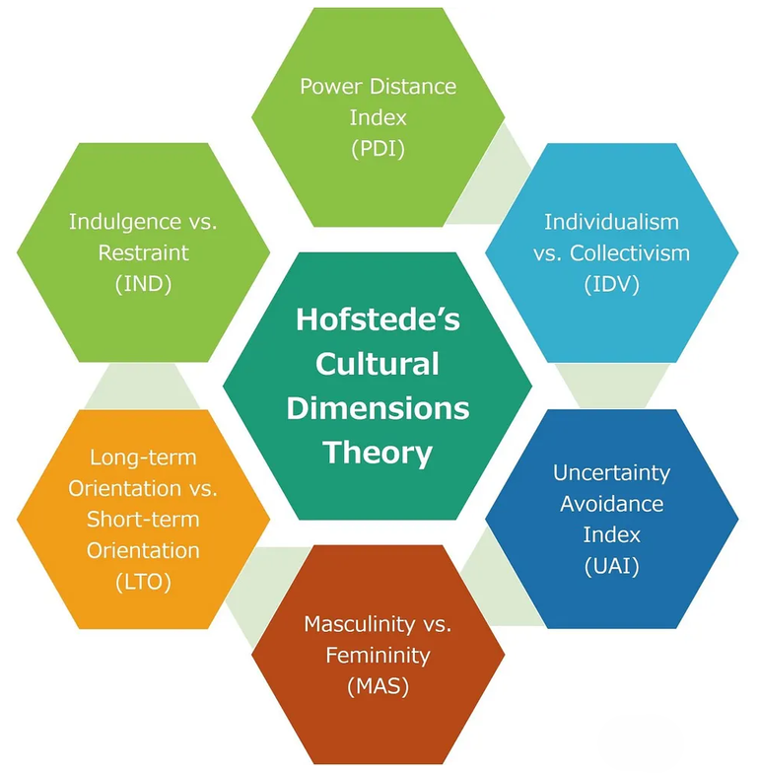
Figure 2 Hofstede’s framework
The framework usefully converts an abstract concept, "culture", into comparable numerical scores, but it has been challenged on methodological grounds: McSweeney (2002) argues that treating an entire nation as culturally uniform risks an "ecological fallacy", since Hofstede's scores describe an average tendency rather than every individual within a country. This limitation is acknowledged rather than ignored here, since a critical application of Hofstede should treat its scores as a starting hypothesis rather than a deterministic explanation.
Hofstede Dimension | Japan | United Kingdom
Power Distance | 54 (moderate) | 35 (low)
Individualism | 46 (balanced) | 89 (individualist)
Masculinity | 95 (very masculine) | 66 (masculine)
Uncertainty Avoidance | 92 (very high) | 35 (low)
Long-Term Orientation | 88 (very high) | 51 (moderate)
Indulgence | 42 (restrained) | 69 (indulgent)
Table 2 Hofstede Dimension table of Japan and UK
With this caveat in mind, Japan scores moderately on power distance (54), suggesting a hierarchical but consensus-driven culture in which seniority and group harmony still shape authority, a pattern visible in Toyota's keiretsu supplier relationships. It sits closer to the midpoint on individualism (46), balancing group loyalty against individual achievement, and scores very high on masculinity (95), one of the highest scores recorded for any country, reflecting a strongly competitive, status- and achievement-driven culture that plausibly helps explain Toyota's sustained domestic investment in Gazoo Racing motorsport. Japan also records a very high uncertainty-avoidance score (92) and long-term orientation (88), consistent with a culture that favors meticulous planning and multi-decade patience, visible in Toyota's development of hybrid technology from the first-generation Prius in 1997, long before regulation made hybrids commercially necessary (Hofstede, 2001). Critically, this same extreme uncertainty avoidance may also help explain, rather than merely coincide with, the 2023-24 discovery of systematic test-cheating at Daihatsu, Hino Motors and Toyota Industries: employees appear to have resorted to shortcuts specifically to appear to meet the exceptionally exacting internal standards that a high-uncertainty-avoidance culture demands, showing that a single cultural trait can plausibly explain both a strength and a failure.
The UK differs sharply on several of these scales. Its low power distance score (35) implies that brands are expected to communicate with consumers relatively informally, while its very high individualism score (89) means UK consumers respond well to messaging emphasizing personal choice and running costs rather than group belonging. Most significantly for strategy, the UK's uncertainty-avoidance score (35) is far lower than Japan's, suggesting UK consumers and regulators are comparatively more comfortable with disruptive change, such as a rapid, mandate-driven shift to battery-electric vehicles, whereas Japan's high uncertainty avoidance favors a cautious, multi-pathway transition. This is not simply a cultural curiosity: it offers a plausible cultural explanation, alongside the regulatory explanation given in Section 3, for why the UK's ZEV mandate is politically feasible in a way an equivalent Japanese mandate might not yet be. These cultural distances directly inform the STP and promotional choices examined next: drawing on Ko et al.'s (2007) cross-national segmentation research, Toyota generally standardizes its reliability-and-efficiency promise globally while adapting sponsorship, dealer format and messaging tone to each culture's distinct risk appetite.

5. Comparative STP Strategy
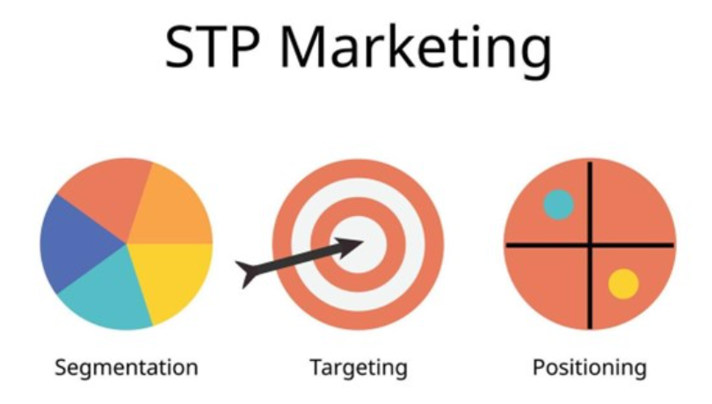
Figure 3 (STP) strategy

Segmentation
Segmentation is the process of dividing a heterogeneous market into groups of customers with broadly similar needs, so a single offer does not have to serve every buyer equally well (Baack, 2018). In Japan, Toyota historically segmented through separate dealer channels, Toyota, Toyopet, Corolla and Netz, but a shrinking domestic market forced their unification into a single "Toyota Mobility Store" format between 2018 and 2020, meaning segmentation now operates mainly at the model and technology level rather than the dealer-channel level (Japanese Nostalgic Car, 2020). In the UK, Toyota segments more explicitly by body style and powertrain, from city cars (Aygo X) through crossovers (Yaris Cross, C-HR) to premium buyers directed to the separate Lexus marque, showing that a shrinking market can force a company to collapse one segmentation basis in favor of another even under the same global brand.

Targeting
Targeting follows segmentation by selecting which groups a company will actively pursue (Baack, 2018). Toyota's Japanese targeting is now close to undifferentiated, since every unified dealer can sell the full range to essentially the whole adult population, with Lexus alone targeted as a premium segment. In the UK, targeting is more differentiated: cost-conscious family and fleet buyers are targeted strongly, since hybrid and plug-in hybrid models attract favorable Benefit-in-Kind company-car tax treatment, a UK-specific incentive reducing the taxable value of low-emission company cars, while a smaller enthusiast segment is targeted through the GR (Gazoo Racing) performance sub-brand. An alternative reading is that Toyota's near-undifferentiated Japanese targeting, while efficient, risks diluting the brand's premium associations, a trade-off less visible in the UK's more segmented approach.

Positioning
Positioning refers to how a brand is deliberately placed in consumers' minds relative to competitors on attributes that matter to them (Baack, 2018). Toyota's global positioning, reliability and efficiency through hybrid leadership, remains consistent, but its emphasis differs: in Japan, Toyota is positioned around monozukuri (the craft and pride of making things well) and everyday "mobility for all", reinforced by its high-masculinity-linked motorsport investment, whereas in the UK it is positioned as the practical, low-running-cost hybrid leader, a message strengthened by high energy costs and Benefit-in-Kind tax advantages, while the GR sub-brand simultaneously builds performance credibility through Gazoo Racing's WRC and endurance-racing success. Mapped on axes of price and electrification confidence, Toyota sits closer to the "hybrid-pioneer" pole in the UK, where roughly three-quarters of Toyota Motor Europe's (2026) reported sales are now electrified, than in Japan, where hybrid, petrol and forthcoming hydrogen options are marketed more evenly, a gap that reflects the regulatory and cultural contrasts identified above rather than a simple difference in product availability.

6. Comparative Marketing Mix (7Ps)

Figure 4 7Ps Framework

Product
Product decisions not only involve with the physical vehicle but also the bundles of features, technology, and brand meaning that a customer purchases (Baack, 2018). Toyota New Global Architecture (TNGA), the brand's common platform strategy standardizing engineering, safety systems and hybrid powertrains while generating economies of scale, underpins the Toyota core range of vehicles (2013–2026). Adaptation, however, does live on: the UK range is heavily slanted toward crossovers and hybrids (Yaris Cross, C-HR, RAV4), as it must per European demand and ZEV mandate pressure; the Japanese domestic range includes smaller utilitarian models—and via Toyota's ownership of Daihatsu the ultra-compact "kei-car" segment with no UK equivalent—indicating platform standardization and model-level adaptation can be inherently contradictory.

Price
Price reflects not only production cost but also local taxation and finance norms (Baack, 2018). In the UK, pricing incorporates VAT and is shaped by Benefit-in-Kind tax bands that make hybrid and plug-in hybrid models disproportionately attractive to business buyers, alongside widely used PCP finance deals. In Japan, pricing is instead shaped by engine-displacement-based vehicle tax bands favoring smaller engines and by intense domestic competition among Japanese manufacturers. This shows that "price" in international marketing is rarely a single, comparable figure; the same vehicle can carry a different effective cost once local tax architecture is factored in, which complicates any simple cross-market price comparison.

Place
In Japan, since 2020 Toyota sells its entire range through the unified "Toyota Mobility Store" network of thousands of independently owned, franchised outlets, ending decades of channel-based segmentation (Japanese Nostalgic Car, 2020; Toyota-Global, no date). In the UK, Toyota (GB) plc oversees a smaller franchised dealer network supplemented by online configurators and direct fleet sales, while roughly 85% of vehicles built at Burnaston and Deeside are exported to continental Europe rather than sold domestically, meaning the UK functions simultaneously as a retail market and a European production hub, a dual role Japan does not share.

Promotion
Toyota standardizes major global campaigns, notably its "Start Your Impossible" Olympic and Paralympic partnership and its Gazoo Racing motorsport programs across the World Rally Championship, World Endurance Championship and Dakar Rally, but adapts sponsorship locally to each market's sporting culture (Toyota Media Site, 2024). In the UK, Toyota (GB) sponsors England cricket, including "The Hundred" competition, and has extended its ParalympicsGB "Every Body Moves" partnership to 2028 (SportBusiness Sponsorship, no date; Toyota Media Site, 2025), whereas in Japan promotion instead draws on Toyota's own corporate rugby team, Toyota Verblitz, and domestic motorsport heritage. This split illustrates a hybrid promotional strategy rather than a purely standardized or purely localized one.

People
In Japan, unified Mobility Store dealer staff now sell the full model range, while factory employees follow "Toyota Way" principles of kaizen (continuous, incremental improvement) and genchi genbutsu (going to see a problem first-hand rather than relying on reports). In the UK, roughly 3,000 employees at Burnaston and Deeside are trained in the same global Toyota Production System, while independently employed franchised dealer staff handle retail and after-sales separately, meaning Toyota's "people" consistency is strongest on the factory floor and weakest at the point of sale.

Process
Just-in-time production, a system that manufactures components only as they are needed rather than holding large inventories, and kaizen-based continuous improvement underpin manufacturing at both Toyota City-area plants and Burnaston/Deeside, giving globally consistent build quality. Retail processes differ more: Japan's twice-yearly shaken (vehicle inspection) system drives frequent dealer visits that Toyota's dense domestic network is well placed to serve, while UK after-sales relies on a smaller dealer footprint supplemented by roadside assistance and online booking, a more fragmented process than Japan's inspection-driven cycle.

Physical evidence
In Japan, unified Mobility Store showrooms use one design language nationwide, and Toyota's Mega Web facility in Tokyo showcases brand heritage directly to domestic consumers. In the UK, franchised showrooms follow standard corporate guidelines, while physical evidence also comes from motorsport visibility, such as Gazoo Racing displays at the Goodwood Festival of Speed, and factory tours at Burnaston. Both build tangible brand credibility, but Japan's centers on heritage in one flagship location, whereas the UK's rests more on distributed, event-based visibility, consistent with Japan's larger, more concentrated domestic market.

7. Evaluation of Market Entry Strategy (United Kingdom)
International-business theory offers three complementary explanations for entry-mode choice: internationalization theory (the Uppsala model), internalization theory, and Dunning's eclectic (OLI) paradigm. Toyota's UK entry is best understood by applying all three together rather than relying on any single lens (Johanson and Vahlne, 1977; Dunning, 1979). The Uppsala model explains internationalization as an incremental, experience-based process in which firms reduce "psychic distance" (the felt difference between markets) by moving through four stages: no regular export activity, export via independent representatives, an overseas sales subsidiary, and finally local production.
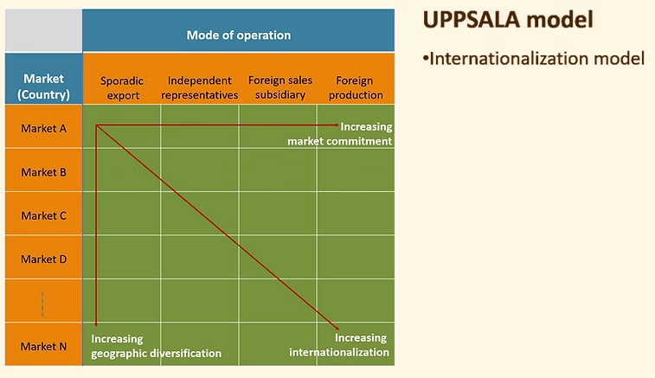
Figure 5 the Uppsala model
Toyota exemplifies this sequence closely: it exported into the UK from the 1960s through Toyota (GB) Limited, before announcing in December 1989 its first European manufacturing subsidiary, Toyota Motor Manufacturing (UK) Limited (Toyota Motor Corporation, 1989), with plants at Burnaston and Deeside that began production in 1992 and the first UK-built car rolling off the Burnaston line that December (Toyota Media Site, 2012), precisely the "local production" stage the model predicts as the deepest form of commitment.
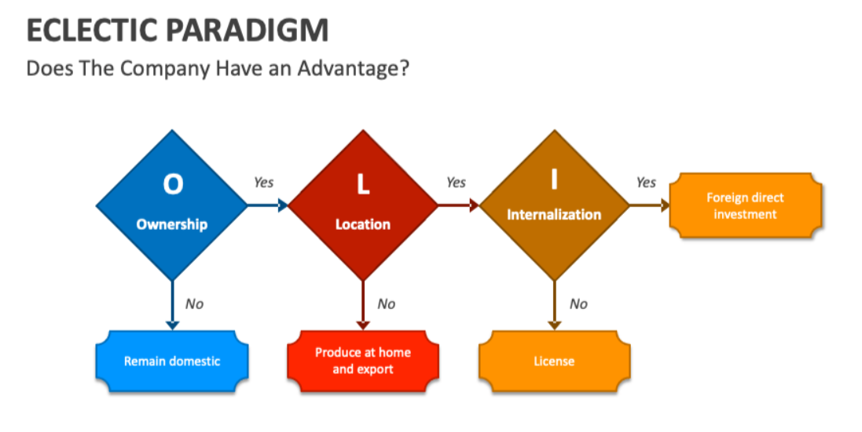
Figure 6 Figure 3 Dunning's (1988) eclectic (OLI) paradigm
Internalization theory adds an explanatory bridge Uppsala alone does not provide: exporting is treated as the default, most efficient entry choice, but firms shift to more controlled, "internalized" modes, such as a wholly owned subsidiary, once risk and uncertainty make arm's-length exporting too costly to sustain. A wholly owned subsidiary gives a company complete managerial and marketing control and lets it trade under its own brand and standards, but at the cost of bearing the full investment risk alone and forgoing a local partner's market knowledge, a trade-off distinct from lower-control, lower-commitment modes such as licensing or franchising, where control is exchanged for shared risk and faster, cheaper entry. An alternative mode existed for Toyota, a joint venture with a UK manufacturer, which would have shared risk and provided local market connections; joint ventures, however, also risk lost or leaked proprietary knowledge if a partner later uses shared expertise independently, a risk Toyota was especially likely to weigh heavily given that its core competitive advantage is the Toyota Production System itself, precisely the kind of asset a joint-venture partner could appropriate. Wholly owned entry therefore protected Toyota's most valuable asset even though it forwent risk-sharing.
Dunning's (1979) eclectic paradigm offers a third, complementary lens, explaining the same decision through ownership, location and internalization advantages rather than gradual learning alone: Toyota's UK investment reflected an ownership advantage (proprietary TPS know-how competitors could not easily replicate), a location advantage (tariff-free EU access and a skilled Midlands labor pool), and an internalization advantage in keeping production in-house rather than licensing it out (Keegan and Green, 2013). Applying all three theories together gives a fuller account than any one alone: Uppsala explains the gradual timing, internalization theory explains why exporting became insufficient, and OLI explains why full ownership, not a shared or licensed structure, was chosen. Unlike some Asian manufacturers that later withdrew UK production once cost conditions changed, Toyota's commitment has continued to deepen, with cumulative investment now exceeding £2.75 billion and Burnaston becoming Toyota's first plant outside Japan to build full hybrid vehicles (Toyota Media Site, 2024). This sustained depth of commitment also exposes a shared limitation of these theories: none fully anticipates a reversal in location advantage after entry, yet the 2027 tightening of EU-UK battery rules of origin, reported by Electrive (2026), threatens the very location advantage that originally justified UK production in the first place.

8. Evaluation of Ethical Issues
Toyota's conduct raises serious ethical questions in both markets, though the most consequential are rooted in Japan. The 2009-10 "unintended acceleration" crisis saw Toyota issue recalls covering more than ten million vehicles worldwide relating to floor-mat entrapment and slow-to-return accelerator pedals (CBC News, 2014). A four-year US Department of Justice investigation found Toyota had misled regulators by describing its 2009 recall as having addressed the "root cause" of the fault when internal tests had already shown other unrecalled vehicles were similarly vulnerable, leading to a 2014 Deferred Prosecution Agreement and a $1.2 billion penalty, at the time the largest ever imposed on an automotive company (IEEE Spectrum, 2014; CBC News, 2014).
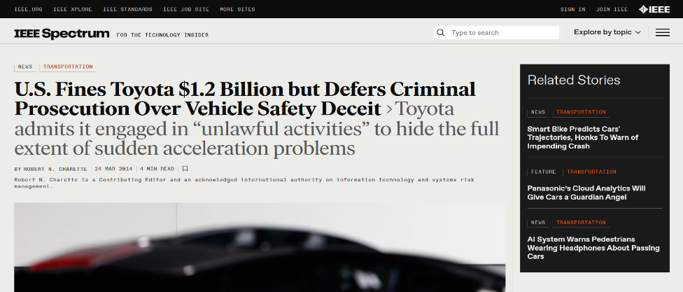
Figure 7 IEEE Spectrum, 2014 report on Toyota
From a shareholder-primacy perspective, in which management's core duty is to protect shareholder value (Friedman, 1970), Toyota's early, defensive public statements might be read as a rational, if short-sighted, attempt to limit reputational and financial damage; a stakeholder-theory perspective, however, which holds that a firm owes duties to all parties affected by its decisions, not only shareholders (Freeman, 1984), casts the same conduct as a clear breach of duty of care, a reading the DOJ's findings ultimately supported. A second, more recent set of episodes compounds this concern. In December 2023, Daihatsu was discovered to have improperly conducted safety tests on 64 vehicle models over decades, which led the company to suspend shipments of more than 88,000 vehicles (Associated Press, 2023).
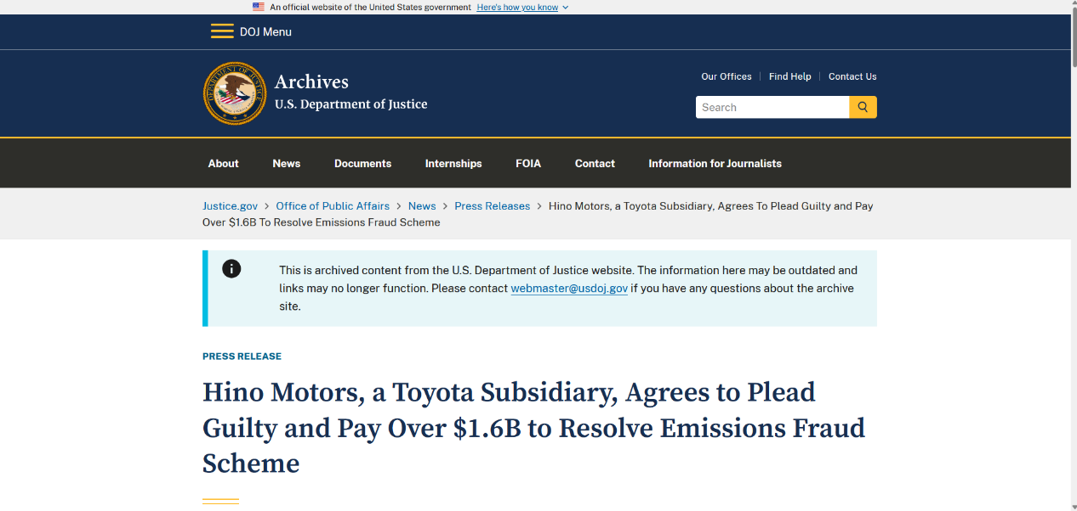
Figure 8 US Department of Justice, 2025 report
Hino Motors separately admitted falsifying emissions and fuel-economy data on some engines since as early as 2003, misconduct serious enough that in January 2025 Hino agreed to plead guilty in the United States and pay over $1.6 billion, a second major Department of Justice penalty that closely parallels the 2014 case discussed above (US Department of Justice, 2025); a further certification-testing scandal at Toyota Industries in mid-2024 then led Chairman Akio Toyoda to apologize publicly for what he called repeated "irregularities" across the group (Associated Press, 2024). As the Hofstede analysis suggested, Japan's high uncertainty-avoidance culture, which prizes rigorous, standardized testing, may paradoxically have created pressure for engineers to falsify results rather than risk missing exacting internal certification deadlines, a critical explanation that goes beyond simply labelling the episode "corporate misconduct". A third, more UK-relevant concern is the criticism from environmental campaigners that Toyota's hybrid-led "multi-pathway" strategy has slowed the industry's shift to full battery-electrification, a tension increasingly tested by the UK's binding ZEV mandate (Fleet World, 2026); Toyota might reasonably counter that a multi-pathway strategy better serves consumers in markets, such as Japan, where charging infrastructure remains uneven, showing this is a genuine strategic dilemma rather than a straightforward ethical failing. Taken together, Toyota's gravest ethical failures, concealment in 2009-10 and certification fraud in 2023-24, are concentrated in home-market engineering and subsidiary governance, while UK-facing exposure concerns the pace, not the existence, of its environmental commitment.
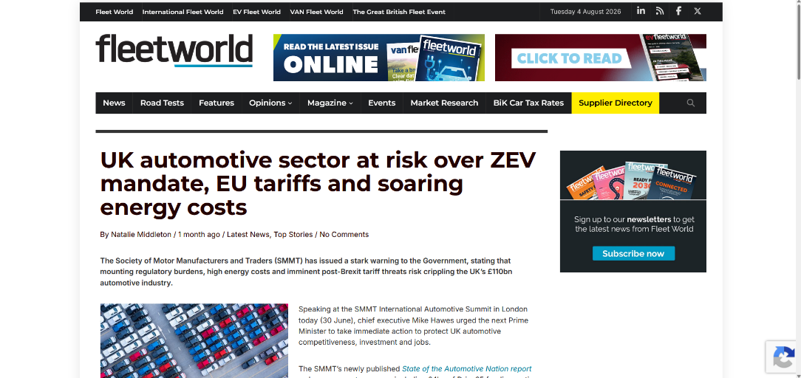
Figure 9 Fleet World, 2026 report

9. Recommendations
First, Toyota should commission independent, externally verified certification audits across all Group companies, including Daihatsu, Hino Motors and Toyota Industries, publishing results rather than relying on internal assurance, which evidently failed to prevent the 2023-24 scandals.
Second, in the UK, Toyota should set out clearer, dated battery-electric milestones to ease growing tension with the binding ZEV mandate, while resisting a wholesale reversal of its multi-pathway strategy, since hydrogen and hybrid options remain genuinely useful in markets with uneven charging infrastructure.
Third, Toyota should work with UK and EU policymakers toward a pragmatic resolution of the 2027 rules-of-origin threshold, given the scale of trade at risk and its own three-decade manufacturing commitment.
Fourth, Toyota should preserve global standardization of platform technology and brand promise while continuing to adapt sponsorship and retail structure locally, retaining cricket and Paralympic partnerships suited to the UK alongside motorsport- and corporate-sport-led promotion suited to Japan's high-masculinity culture.
Finally, given Japan's demographic decline, Toyota should treat UK and European operations as a genuine long-term production hub rather than a peripheral market, since a shrinking domestic market cannot alone sustain global volumes.

10. Conclusion
This report has compared Toyota's marketing strategy in Japan and the UK using PESTEL, Hofstede, STP, the 7Ps, entry-mode theory and ethical analysis, applying each framework analytically and testing each conclusion against an alternative explanation or contrasting theory. Toyota standardizes platform technology and brand promise while adapting dealer structure, pricing logic, promotion and after-sales process to local conditions. Its UK entry, best explained by combining Uppsala's incremental learning, internalization theory and Dunning's ownership-location-internalization logic, has deepened for over three decades even as new trade friction now tests it. Ethically, Toyota's gravest failures are concentrated at home, while its UK-facing concerns are more strategic than criminal. Toyota's continued success in both markets will depend on maintaining this balance between standardization and adaptation while addressing the governance and electrification-pace concerns identified throughout this report.

Section 2: Reflective Account
For this section I have used Gibbs' (1988) Reflective Cycle, structured around description, feelings, evaluation, analysis, conclusion and action plan, to review how I researched and prepared the Toyota report; I note critically, however, that Gibbs' cycle assumes a tidy, linear progression through stages that my actual research process did not always follow.
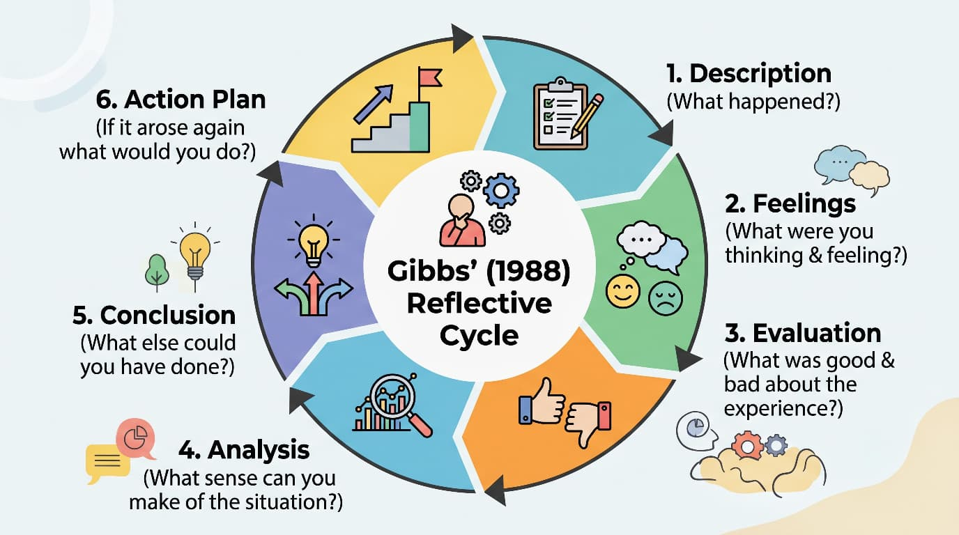
Figure 10 Gibbs' (1988) Reflective Cycle
Description
The assessment required comparing a brand's macro-environment, culture, STP, marketing mix, entry mode and ethics across two countries. I chose Toyota because its management philosophy is inseparable from Japanese culture, offering a clear contrast with the UK. I revisited the module's session slides, including the Week 8 material on organizational structures and market entry, to confirm which frameworks (PESTEL, Hofstede, Uppsala, internalization theory, Dunning's OLI paradigm, 7Ps) the brief expected me to apply, then researched Toyota's history, financial position, UK manufacturing record and controversies using Toyota's own archives, reputable news and academic sources. I organized research for two countries at a time under each heading rather than researching Japan fully and then the UK, which made both contrasts and critical comparisons easier to write directly into the text.

Feelings
I felt confident applying the theory itself, since the module covered PESTEL, STP and the 7Ps in depth, but less confident about how much evidence each claim needed, and cautious about the ethics section, since discussing two serious controversies for one real company required careful, evidence-based handling. Revising the report to add explicit critical contrasts, for example weighing Friedman's shareholder view against Freeman's stakeholder view of the 2009-10 recall, initially felt like extra work; once written, however, it sharpened my understanding of why the concealment mattered, rather than simply asserting that it did.
Evaluation
The frameworks mapped cleanly onto real information: PESTEL organized very different data, Japan's demographic contraction versus the UK's ZEV mandate, into one comparable structure, and Hofstede's dimensions explained why Japan's uncertainty avoidance sat awkwardly alongside its testing scandals. Harder was resisting the temptation simply to describe facts about Toyota rather than use them to support an argument; an explicit Point-Evidence-Explanation-Link structure helped, since it forced an explanation and a link, often a contrasting theory, after every piece of evidence rather than letting a paragraph end on a citation alone.
Analysis
Reflecting on why this was difficult, comparative reports naturally generate many individually interesting facts, and analytical value only comes from connecting each fact back to a named theory, for example linking Toyota's UK sponsorships not to "local adaptation" in general but specifically to Hofstede's masculinity and individualism gap. Some frameworks also compare more symmetrically than others: PESTEL and Hofstede are explicitly comparative by design, whereas Toyota's ethical record is not evenly split between countries, so forcing artificial balance there would have misrepresented the evidence rather than demonstrated genuine critical thinking.

Conclusion
Overall, the report met its brief: it applied every specified framework analytically, tested conclusions against alternative theories or counter-arguments, and used dated, verifiable sources throughout. Revising the draft specifically for critical depth showed me that critical writing is not simply adding "however" sentences, but genuinely holding two explanations side by side, here Uppsala against Dunning's OLI paradigm, and Friedman against Freeman, and judging which fits the evidence better.
Action plan
In future assessments, I intend to draft with a Point-Evidence-Explanation-Link structure from the first draft rather than retrofitting it at revision stage, since building in a contrasting theory or counter-argument earlier would likely deepen the first draft's analysis rather than requiring a separate critical pass. I will also keep a running reference log noting exact publication dates and source types from the first research session, and deliberately identify, for each major section, one plausible counter-argument or alternative framework before writing the paragraph, rather than searching for one only after a descriptive draft is already complete.

Reference List
Associated Press (2023) Toyota's small car unit Daihatsu will suspend all vehicle shipments over widespread safety cheating. Available at: https://www.aol.com/toyotas-small-car-unit-daihatsu-114507649.html (Accessed: 30 July 2026).
Associated Press (2024) Toyota apologizes for cheating on vehicle testing and halts production of three models. Available at: https://www.aol.com/toyota-apologizes-cheating-vehicle-testing-102117195.html (Accessed: 30 July 2026).
Baack, D.G. (2018) International marketing. 2nd edn. London: SAGE Publications.
CBC News (2014) Toyota, U.S. reach $1.2B settlement over safety problems. Available at: https://amp.cbc.ca/lite/story/1.2578343 (Accessed: 23 July 2026).
Dunning, J.H. (1979) 'Toward an eclectic theory of international production: some empirical tests', Journal of International Business Studies, 11(1), pp. 9-31.
Electrive (2026) Automakers call for delay to UK-EU EV tariffs. Available at: https://www.electrive.com/2026/06/08/automakers-call-for-delay-to-uk-eu-ev-tariffs/ (Accessed: 23 July 2026).
Fleet World (2026) UK automotive sector at risk over ZEV mandate, EU tariffs and soaring energy costs. Available at: https://fleetworld.co.uk/uk-automotive-sector-at-risk-over-zev-mandate-eu-tariffs-and-soaring-energy-costs/ (Accessed: 23 July 2026).
Freeman, R.E. (1984) Strategic management: a stakeholder approach. Boston: Pitman.
Friedman, M. (1970) 'The social responsibility of business is to increase its profits', The New York Times Magazine, 13 September.
Gibbs, G. (1988) Learning by doing: a guide to teaching and learning methods. Oxford: Further Education Unit, Oxford Polytechnic.
Goldman Sachs (2026) 2026 Japan economic outlook: steady fundamentals, policy risks ahead. Available at: https://www.gspublishing.com/content/research/en/reports/2026/01/06/eefdf592-d197-40da-a74b-dd316dbea9ee.html (Accessed: 23 July 2026).
Hofstede, G. (2001) Culture's consequences: comparing values, behaviors, institutions and organizations across nations. 2nd edn. Thousand Oaks, Calif.: SAGE Publications.
House of Commons Library (2026) Economic indicators: key statistics for the UK economy. Available at: https://commonslibrary.parliament.uk/research-briefings/cbp-9040/ (Accessed: 23 July 2026).
IEEE Spectrum (2014) US fines Toyota $1.2 billion and defers criminal prosecution for misleading public and regulator on safety issues. Available at: https://spectrum.ieee.org/us-fines-toyota-12-billion-and-defers-criminal-prosecution-for-misleading-public-and-regulator-on-safety-issues- (Accessed: 23 July 2026).
Japanese Nostalgic Car (2020) The history of Toyota's insane dealer networks, explained. Available at: https://japanesenostalgiccar.com/toyota-consolidates-all-dealerships-into-one/ (Accessed: 23 July 2026).
Johanson, J. and Vahlne, J-E. (1977) 'The internationalization process of the firm: a model of knowledge development and increasing foreign market commitments', Journal of International Business Studies, 8(1), pp. 23-32.
Keegan, W.J. and Green, M.C. (2013) Global marketing. 7th edn. Boston, Mass.; London: Pearson.
Ko, E., Kim, E., Taylor, C.R., Kim, K.H. and Kang, I.J. (2007) 'Cross-national market segmentation in the fashion industry: a study of European, Korean, and US consumers', International Marketing Review, 24(5), pp. 629-651.
McSweeney, B. (2002) 'Hofstede's model of national cultures: a triumph of faith - a failure of analysis', Human Relations, 55(1), pp. 89-118.
OECD (2026) Key policy insights: OECD economic surveys: Japan 2026. Available at: https://www.oecd.org/en/publications/oecd-economic-surveys-japan-2026_54cc833d-en/full-report/key-policy-insights_e3384128.html (Accessed: 23 July 2026).
The Open University (no date) Figure 7 Hofstede's cultural difference scores, UK compared with Japan. Available at: https://www.open.edu/openlearn/mod/oucontent/view.php?id=68113&section=3 (Accessed: 23 July 2026).
RSM UK (2026) UK economic outlook 2026. Available at: https://www.rsmuk.com/insights/real-economy/uk-economic-outlook (Accessed: 23 July 2026).
SportBusiness Sponsorship (no date) Organisation: Toyota. Available at: https://sponsorship.sportbusiness.com/organisation/toyota/ (Accessed: 23 July 2026).
Statista (2026) Toyota Motor Corporation revenue 2026. Available at: https://www.statista.com/statistics/262752/total-net-revenues-of-toyota/ (Accessed: 23 July 2026).
Statistics of the World (2026) Japan economy 2026 — deflation era ends, BOJ rates & GDP outlook. Available at: https://statisticsoftheworld.com/japan-economy (Accessed: 23 July 2026).
Toyota Media Site (2012) Toyota Motor Manufacturing UK: 20 years of quality and progress. Available at: https://media.toyota.co.uk/toyota-motor-manufacturing-uk-20-years-of-quality-and-progress/ (Accessed: 23 July 2026).
Toyota Media Site (2024) Corolla makes history as Toyota's five millionth UK-built car. Available at: https://media.toyota.co.uk/corolla-makes-history-as-toyotas-five-millionth-uk-built-car/ (Accessed: 23 July 2026).
Toyota Media Site (2025) Toyota (GB) extends its commitment to ParalympicsGB's Every Body Moves campaign. Available at: https://media.toyota.co.uk/toyota-gb-extends-its-commitment-to-paralympicsgbs-every-body-moves-campaign/ (Accessed: 23 July 2026).
Toyota Motor Corporation (1989) Toyota's U.K. manufacturing company established. Available at: https://global.toyota/en/detail/7848812 (Accessed: 23 July 2026).
Toyota Motor Europe (2026) Toyota Motor Europe posts all-time record sales of 1,229,000 vehicles in 2025. Available at: https://newsroom.toyota.eu/toyota-motor-europe-posts-all-time-record-sales-of-1229000-vehicles-in-2025/ (Accessed: 23 July 2026).
Toyota USA Newsroom (2026) TMC announces April through December 2025 financial results. Available at: https://pressroom.toyota.com/tmc-announces-april-through-december-2025-financial-results/ (Accessed: 23 July 2026).
Toyota-Global (no date) 75 years of Toyota: sales and after-sales service networks. Available at: https://www.toyota-global.com/company/history_of_toyota/75years/text/leaping_forward_as_a_global_corporation/chapter4/section6/item4_g.html (Accessed: 23 July 2026).
US Department of Justice (2025) Hino Motors, a Toyota subsidiary, agrees to plead guilty and pay over $1.6B to resolve emissions fraud scheme. Available at: https://www.justice.gov/archives/opa/pr/hino-motors-toyota-subsidiary-agrees-plead-guilty-and-pay-over-16b-resolve-emissions-fraud (Accessed: 30 July 2026).

