Effective Team Work and Communication Assessment 1

Table of Contents
Introduction: 3
Strategies for effective team working: 4
The 'Seven C’s': 4
Group dynamics management: 5
Range of communication skills integral to success within the workplace: 6
Models of communication: 6
The communication skills essential for workers: 11
Conclusion: 12
References: 13

Introduction:
Effective collaboration with others requires more than clear and succinct communication. Facilitates the training of all team members on any subject pertinent to their tasks. If members of a team can successfully communicate with one another, they will be able to work together more efficiently and achieve a shared objective more quickly. When team members can have open and honest dialogues about their perspectives and concerns, it is much easier for them to function as a unit. Through this report, the researcher will analyses the importance of team work and the importance of communication though the work process. Moreover, the researcher will evaluate the Group dynamics, team working and communication to the workplace.

Strategies for effective team working:
Group members face similar challenges. Synergies have made collaboration more appealing and important. A team that collaborates well will always outperform one that doesn't (Saavedra, 2013). The Seven C's of effective team performance show how companies manage teamwork.

The 'Seven C’s':
- Clear: The communication must be clear and to the point, and the recipient should have no trouble understanding what is being said. The only person who can be certain of the meaning of a communication, in the event that the sender is uncertain of its aim, is the recipient (Madhani, 2018). The message shouldn't try to address a broad variety of topics in a single phrase; rather, it should zero in on a single objective and emphasize achieving that goal.
- Correct: The truth of the statement should not be in question. The sender is responsible for ensuring that the message they have sent has no grammatical or spelling errors, and it is their responsibility to check the message for any errors. Aside from that, the message has to be delivered in a clear and concise manner at the appropriate moment (Pollak, 2019). Clear communication not only has a more profound effect on the person receiving it, but it also helps the person doing the communicating feel more confident in themselves.
- Complete: It is anticipated that the message will include all of the necessary information. It is essential that every relevant piece of information that the audience in question is looking for be presented, as they have requested it (Madhani, 2018). The whole information offers explanations for each and every one of the inquiries that the receivers have, and it teaches them how to improve the quality of their decision-making by using the acquired knowledge.
- Concrete: The communication has to be concrete, which means that the message has to be unambiguous, particularly to the point where there is no room for misinterpretation left at all (Rongala, 2015). In the event that someone sends a message, the leader should make it a point to respond with all of the pertinent facts and data in order to offer credibility to what they are saying.
- Concise: The message has to be straightforward and succinct in order to get to the point as fast as possible. It is best to avoid using sentences that are overly lengthy, and the sender should make every attempt to express the topic using as few words as is humanly possible (Rongala, 2015). The sentence that is both brief and to the point is able to convey more information while simultaneously making it simpler to hold the attention of the listener.
- Considered: The sender is necessary to take into consideration the receiver's thoughts, knowledge, attitude, and background, among other things, in order to have an effective communication. This is one of the requirements for an effective communication. The sender has to establish a connection with and be engaged with the recipient of the message in order for there to be successful communication.
- Courteous: It has been proposed that the sender should take into account the sentiments and points of view of the recipient in order to guarantee that the message is successful and targeted toward the audience (Bhatti and Ahsan, 2017). The message, which should not be biased in any way, should include terminology that expresses respect for the recipient. Additionally, the message itself should not be biased in any way.

Group dynamics management:
Each team member has strengths, weaknesses, and specialties. Transformational leaders inspire their staff to do more for the organization. Transformational leaders focus on team members' growth and development. Transformational leaders help their teams communicate effectively, adopt new methods of working, and enjoy their jobs more. Team members should freely share ideas and information without fear of repercussions or embarrassment. Confidence encourages open communication, which leads to more creative ideas. Everyone on the team must trust that others will meet deadlines, pull their weight, and complete their task. Collaboration generates innovative solutions. Diverse viewpoints can benefit decision-making. Consensus decision-making is important but must be done correctly. Few important speakers will likely dominate the conversation. Peer pressure can hinder decision-making. Members must compromise and combine ideas without feeling pressured.

Range of communication skills integral to success within the workplace:

Models of communication:

Transmission Model of Communication: Shannon and Weaver

Figure 01: Transmission Model of Communication: Shannon and Weaver (Al-Fedaghi, 2012)
- Sender: One who composes and transmitting a communication is known as the sender of the message.
- Encoder: Encoders are used to convert messages into signals or binary data, and the sender is known as the encoder. An explicit reference to the machine may also be made (Al-Fedaghi, 2012).
- Channel: Sending a message may be done in a number of ways.
- Decoder: The word decoder may be used to refer to either the piece of equipment that is used to turn signals or binary data into messages or the receiver that is responsible for translating signals into messages.
- Receiver: When a communication is delivered to a recipient, it is known as being delivered to a receiver. It is the responsibility of the recipient to provide feedback that is in line with the content of the communication.
- Noise: Noise refers to any physical interruption, such as an environment, people or other objects, that stops the message from being received in the exact form in which it was provided to the receiver.

Explanation of Shannon Weaver Model:
Recipients receive encrypted messages via telephone or telegraph. The message is encoded for computer reading. Sending messages uses codes. Messages must be decoded before being understood. In some cases, receptor devices can also decode (Al-Fedaghi, 2012). Channel noise and the receiver's inability to understand it will slow communication. The brain sends the message, the mouth encodes it, the air is the channel, and the ear receives it. The air carries the noise that bothers him, while his reaction serves as feedback. The model had five parts. We added noise (Drew, 2022). Shannon developed this concept to simplify technical phone conversations. It's designed to be quiet while offering the most phone capacity. Shannon Weaver named the paradigm after using it to build successful communication. Shannon's model, called information theory, is used to calculate device transmission.

Schramm's Communication Model:
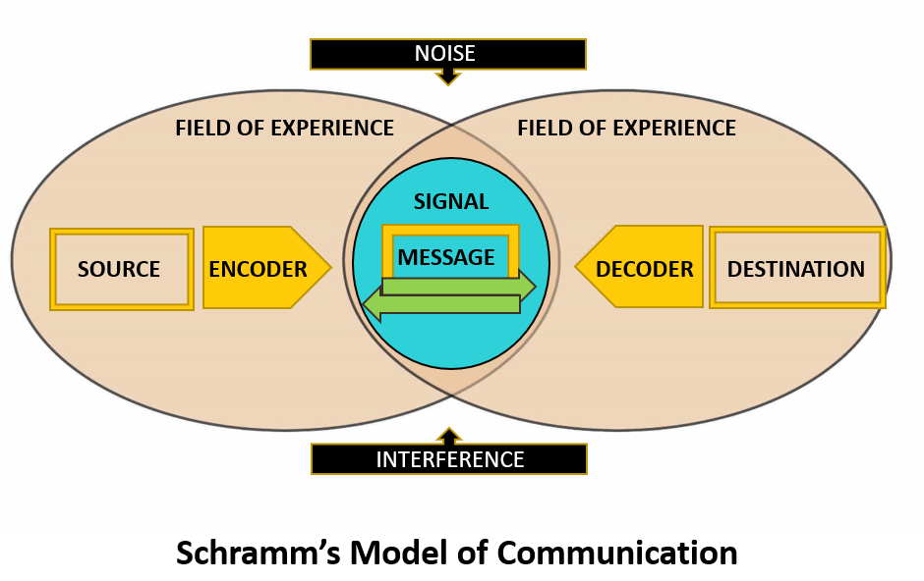
Figure 02: Schramm's Communication Model (Juneja, 2015)
Schramm's Communication model communicated in a manner that was more applicable to real-world situations as opposed to depending on the sender-receiver paradigm. This model is uncommon in comparison to others of its kind (Bhasin, 2020). The primary obligation of the receiver is to grasp the meaning of what the sender is attempting to communicate.
- Source (encoder): The person who sent the communication is referred to as the sender. The creator of a message must be able to communicate why the receiver should read it in a clear and brief manner. As a result, anybody intending to send a message must ensure that the information supplied is trustworthy, useful, and timely. Encryption is essential to guarantee that the communication can be decoded by the receiver (Bhasin, 2020). As a result, the sender and the receiver must be acquainted. The capacity to provide information in a simple yet understandable manner will determine whether or not this communication endeavor is effective. Cultural factors, viewpoints, knowledge, attitudes, experiences, and abilities all contribute to message encoding.
- Decoder (destination): A message's receiver is the individual or group to whom it was directed. A communication's decipherability is contingent on a variety of things (Bhasin, 2020). Some examples include if they are receptive to receiving messages and whether they have a positive rapport with the sender. Cultural factors, views, knowledge, attitudes, experiences, and abilities all impact how a message is perceived and interpreted by the recipient. Decoding a message requires psychological abilities. Once the signal is received, the stimulus is sent to the brain for interpretation. If applicable, message significance may be set here. This processing step is also known as decoding. An effective form of communication depends on the capacity of the receiver to accurately perceive the transmitted message.
- Message: Experts in communication and rhetoric agree that a message is only a string of information. This information may be conveyed by words, letters, or a variety of other symbols. Schramm's concept of communication recognizes the significance of all forms of communication, including verbal and nonverbal encounters. Messages delivered through email or WhatsApp, as well as phone calls and in-person conversations, all qualify as voice-containing means of communication (Bhasin, 2020). Messages may also include nonverbal components such as movements, gestures, body language, eye contact, physical touch, and time in addition to the real objects being transmitted.
- Noise: Both the message and the communication mechanism fail as a result of noise interference. When a recipient's interpretation of a message differs from the sender's original intent, a misunderstanding results (Juneja, 2015). The presence of noise may or may not allow the receiver to decipher the signals sent by the transmitter. If the message's original intent is being muddied by surrounding noise, it is quite probable that it is being misinterpreted.

Berlo’s SMCR Model of Communication
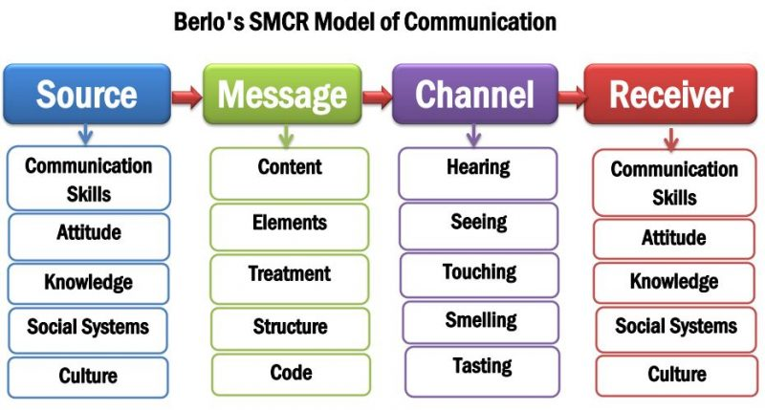
Figure 03: Berlo’s SMCR Model of Communication (Saud et al., 2014)
According to Berlo's Model, the communication process consists of four essential components. A communication is sent from one individual to another through a channel. Multiple factors affect the performance of each component.
- Source: The sender is the one who transmits the message. The message delivered by the sender is received by the receiver. Communication skills, attitude, knowledge, social structure, and culture all play a role in this.
A good communicator can speak, read, write, and listen. The significance of the communication is decided by the attitudes of the sender and the receiver. The receiver must already be acquainted with the topic matter for a message to be successful (Saud et al., 2014). A skilled communicator has a thorough understanding of the subject. Values, beliefs, rules, practices, and religion are among societal factors that impact how a message is transmitted. Individuals' communication styles are influenced by cultural differences. Something that is accepted in one culture may be offensive to someone from another.
- Message: The message sent by the source or sender of the communication to the receiver is the core content. Encoding is another word for this procedure. David Berlo adds five additional characteristics: content, components, treatment, structure, and code.
The message's substance, on the other hand, refers to the text's real contents. The whole conversation is part of its essence from beginning to conclusion. Elements are nonverbal items that accompany content, such as gestures, signs, language, and so on (Muyanga and Phiri, 2021). In the context of communication, treatment refers to how a message is received. The recipient's reaction is influenced by the treatment. The message's organizational structure or presentation has a direct impact on its effectiveness. The message is transmitted as code. It might take the shape of language, literature, cinema, or any other media.
- Channel: A channel is the medium that transports sender-receiver communication. Berlo emphasized hearing, seeing, touching, smelling, and tasting as communication tools. Listening conveys messages (Communication Theory, 2014). It's the main communication method. Humans understand visual cues. It's a key nonverbal channel. People form snap judgments based on others' looks. Touch is used for nonverbal communication. Olfactory communication is also intrapersonal. A pleasant scent boosts self-esteem. Tasting involves nonverbal communication through tasting. Tasters evaluate food's flavor.
- Receiver: The individual who is the recipient of a message is referred to as the receiver of that communication. According to this paradigm, for communication to be successful, the way of thinking as well as the other components mentioned above need to be in harmony (Muyanga and Phiri, 2021). If the communication is to have the desired impact, both the sender and the receiver should share the same understanding of its contents. A person who is a good listener is equally vital for the receiver.

The communication skills essential for workers:
- Effective email writing skill: Using a commonly accepted email style when composing a business email is a fantastic method to guarantee that the receiver receives the message (Malkinson, 2001). To keep the recipient's attention on the email and ensure that he or she understands the purpose of the communication, it is essential to keep messages brief. As part of a partnership or lead generation initiative, it is vital to compose email messages effectively.
- Case study analysis skill: The case studies require workers to demonstrate talents in problem solving, decision making, communication, the ability to work in groups, inter-personal relationships, and self-management (Preston, 2011). The capacity to work on one's own is also a need for workers. Many educators believe that case studies may help students learn how to utilize and develop these skills more effectively and more fully.
- Technological skill: It is possible for employees to have a positive impact on the leader's performance, self-confidence, and workplace culture. Job seekers with technical skills tend to be more confident than those without in some industries.

Advantages and disadvantages of technology in communication.
Advantages:
- Technology a method of communication that is not only more efficient but also more prompt in times of emergency
- Technology help to communicate from any area in the world makes it easier to have conversations across great distances and makes communication in general simpler (Wickham, 2011).
Disadvantages:
- People of a certain age have a harder time navigating it, and it makes it easier for cyberbullying and cyber skyping to take place. It is also not always reliable, reducing the intimacy of online contact and making it impossible to know with whom one is conversing.

Conclusion:
The ability to communicate effectively in the workplace is critical to a company's success. An employee's ability to communicate well in the workplace may help reduce unnecessary obstacles and push them to work more. To be more productive and build a strong team, it's probable that having excellent communication skills is a plus in the workplace.

References:
Al-Fedaghi, S. (2012). A Conceptual Foundation for the Shannon-Weaver Model of Communication. International Journal of Soft Computing, [online] 7(1), pp.12–19. doi:10.3923/ijscomp.2012.12.19.
Bhasin, H. (2020). Schramm model of communication | Elements, Advantages & Limitations. [online] Marketing91. Available at: https://www.marketing91.com/schramms-model-of-communication/ [Accessed 5 Aug. 2022].
Bhatti, M.W. and Ahsan, A. (2017). Effective Communication among Globally Distributed Software Development Teams. Journal of Global Information Management, 25(3), pp.40–62. doi:10.4018/jgim.2017070103.
Carmeli, A. and Shteigman, A. (2010). Top management team behavioral integration in small-sized firms: A social identity perspective. Group Dynamics: Theory, Research, and Practice, 14(4), pp.318–331. doi:10.1037/a0018254.
Communication Theory. (2014). BERLO’S SMCR MODEL OF COMMUNICATION. [online] Available at: https://www.communicationtheory.org/berlos-smcr-model-of-communication/ [Accessed 5 Aug. 2022].
Drew, C. (2022). Shannon Weaver Model of Communication | 7 Key Concepts (2020). [online] Helpful Professor. Available at: https://helpfulprofessor.com/shannon-weaver-model/#:~:text=The%20Shannon%20and%20Weaver%20Model [Accessed 5 Aug. 2022].
Hamad, H. (2015). Transformational Leadership Theory: Why Military Leaders are More Charismatic and Transformational? International Journal on Leadership, 3(1), p.10. doi:10.21863/ijl/2015.3.1.001.
Juneja, P. (2015). Schramm’s Model of Communication. [online] Managementstudyguide.com. Available at: https://www.managementstudyguide.com/schramm-model-of-communication.htm [Accessed 5 Aug. 2022].
Madhani, P.M. (2018). Building a customer-focused culture in organisations: developing 7Cs model. International Journal of Business Excellence, 16(2), p.199. doi:10.1504/ijbex.2018.10015931.
Malkinson, T.J. (2001). Get to the point! writing effective email, letters, reports and proposals [Book Review]. IEEE Transactions on Professional Communication, 44(3), pp.214–215. doi:10.1109/tpc.2001.946469.
Muyanga, C.C. and Phiri, J. (2021). Assessment of Effective Communication in International Schools in Developing Countries Based on the Berlo’s SMCR Model. Open Journal of Business and Management, 09(01), pp.448–459. doi:10.4236/ojbm.2021.91024.
Pollak, K.I. (2019). Teaching effective communication by modeling effective communication: Experiences of a communication coach for clinicians. Patient Education and Counseling, 103(2), pp.10–15. doi:10.1016/j.pec.2019.08.024.
Preston, D.S. (2011). Exploring The Use Of Case Study Analysis In Consultant Skill Training. Journal of Business Case Studies (JBCS), 2(1), p.29. doi:10.19030/jbcs.v2i1.4877.
Rongala, A. (2015). 7 Rules of Effective Communication with Examples - Invensis Learning Blog. [online] Invensis Learning Blog. Available at: https://www.invensislearning.com/blog/7-rules-of-effective-communication-with-examples/ [Accessed 5 Aug. 2022].
Saavedra, L.K. (2013). Effective Team Building: The Role of Coaches. Strategies, 26(4), pp.3–6. doi:10.1080/08924562.2013.799925.
Saud, S., Jufri, A., Rahman, M.A. and Salam, S. (2014). Learning Devices Development on Descriptive Writing for Foreign Language Based on Berlo’s SMCR Communication Model of Secondary School Student. Journal of Language Teaching and Research, 5(5), pp.5–10. doi:10.4304/jltr.5.5.1033-1041.
Wickham, J. (2011). Low Skill Manufacturing Work: from skill biased change to technological Regression / Niedrig qualifizierte Industriearbeit: vom qualifikationsbeeinflussten Strukturwandel zur technologischen Regression. Arbeit, 20(3), pp.15–20. doi:10.1515/arbeit-2011-0307.

