

Programme: Master of Business Administration
Module: International Business Concepts
Module code: LCMB7034
Title : Report on BMW in UK
Word count: 5169
Lecturer : Dr Ejike Udeogu
Student Name : Darvin Sabhaya
Student ID: 2505280
Submission Date- 20/032026

Table of Contents
SECTION 1: INTERNATIONAL INDUSTRY REPORT
1.0 Introduction .................................................................................................... 3
2.0 Industry and Country Overview ..................................................................... 3-6
3.0 Porter's Diamond Model Analysis .................................................................. 7-9
4.0 BMW Group in the United Kingdom: Critical Evaluation .................. …………9-14
5.0 Conclusion ..................................................................................................... 14

SECTION 2: REFLECTIVE ACCOUNT
Application of Gibbs' Reflective Cycle ................................................................... 15-18

References ............................................................................................................. 19-20


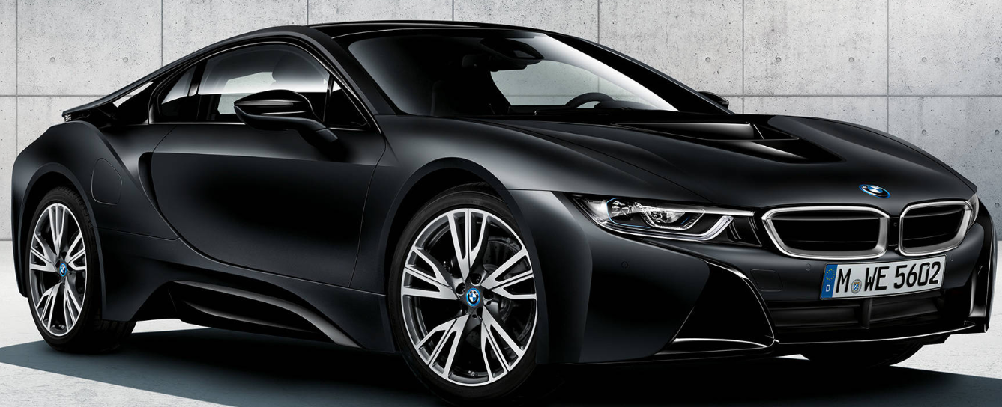

SECTION 1: International Industry Report

1.0 Introduction
This report looks at the UK automotive industry and specifically at the BMW Group as a multinational company operating in this market. I chose this topic because the UK car industry has gone through a lot of changes lately, especially because of Brexit and the push towards electric vehicles, which makes it an interesting case to study. The BMW Group was selected because it has a strong and long-standing presence in the UK through both its MINI factory in Oxford and the Rolls-Royce plant in Goodwood.
The report begins by giving an overview of the UK automotive sector, looking at how big it is, who the main players are, and what challenges it faces. After that, Porter's Diamond Model is used to think about why the UK has, or sometimes does not have, a competitive advantage in this industry. The third main section looks more closely at BMW itself, using the PESTEL framework and the CAGE Distance Model to explore the political, economic, legal and cultural factors that affect how the company operates in the UK. The report ends with a conclusion pulling together the main findings.

2.0 Industry and Country Overview

2.1 Introduction to the UK Automotive Industry
The UK has had a car industry since the very early days of motoring, and for a long time it was one of the biggest in the world. Things have changed considerably since then. The industry is no longer dominated by British-owned companies; instead, most of the major manufacturers operating in the UK are foreign multinationals. Despite this shift, the sector remains very important to the economy and employs hundreds of thousands of people directly and through supply chains. Some well-known brands still manufacture vehicles here, including MINI and Rolls-Royce (both owned by BMW Group), Jaguar Land Rover, and Nissan in Sunderland. However, in recent years a number of companies have scaled back their UK operations, partly due to uncertainty around Brexit (SMMT, 2023).
Geographically, car manufacturing is concentrated in certain regions. The West Midlands has historically been the centre of the industry and is still home to Jaguar Land Rover and many suppliers. Oxford is where MINI vehicles are produced, and Goodwood in West Sussex is where Rolls-Royce cars are made. These areas have built up clusters of expertise over time, which Porter (1998) argues helps companies become more competitive because they benefit from shared knowledge, skilled workers, and nearby suppliers.

2.2 Size, Scope, and Economic Importance
The UK automotive sector makes a substantial contribution to the national economy. According to the SMMT (2023), annual turnover in the sector is around £67 billion, adding approximately £14.9 billion in value to the UK economy. Production figures have declined sharply compared to the pre-Brexit and pre-pandemic years, with around 775,000 units produced in 2022, well below the 2016 peak of over 1.7 million. The industry employs around 182,000 people directly, with considerably more working in the wider supply chain and retail network (SMMT, 2023).
One of the most striking features of the UK industry is its export orientation. Around 80% of vehicles produced here are sold abroad, with the EU, the US, and China being the main destinations (SMMT, 2023). This makes the sector highly sensitive to trade policy changes — a concern that has grown considerably since the Brexit referendum in 2016 and the Trade and Cooperation Agreement that followed (Department for Business and Trade, 2023).
The government has also been pushing hard on electric vehicles, introducing a Zero Emission Vehicle mandate in 2023 that requires manufacturers to sell increasing proportions of zero-emission cars each year, with a 100% target by 2035 (HM Government, 2023).
Category | Details
Annual Turnover | Approximately £67 billion
Contribution to Economy | Around £14.9 billion Gross Value Added (GVA)
Production Volume (2022) | Around 775,000 vehicles produced
Production Peak (2016) | Over 1.7 million vehicles
Employment | Approximately 182,000 direct jobs; additional employment in supply chain
Export Share | Around 80% of vehicles exported
Main Export Markets | European Union, United States, China
Key Challenge | Sensitivity to trade policy changes following Brexit
Government Policy | Zero Emission Vehicle (ZEV) mandate introduced in 2023
Future Target | 100% zero-emission vehicle sales by 2035

2.3 Major Domestic and Multinational Firms
Most of the significant car manufacturers in the UK are actually subsidiaries of foreign companies. Jaguar Land Rover, which is the largest UK-based manufacturer in terms of both revenue and employment, is owned by Tata Motors from India since 2008. JLR makes premium vehicles under the Jaguar and Land Rover names at factories in Solihull, Castle Bromwich and Halewood. In the 2022/23 financial year, the company reported its highest-ever revenues of £23 billion, driven mainly by strong sales of the Range Rover and Defender (Jaguar Land Rover, 2023).
BMW Group runs two production sites in the UK. The Oxford plant, which made around 215,000 MINI vehicles in 2022, and the Rolls-Royce factory in Goodwood, which produces the brand's ultra-luxury cars. Both sites are important to BMW Group's global strategy, and Oxford is being prepared to manufacture the new electric MINI from 2024 (BMW Group, 2023). Other notable manufacturers include Nissan in Sunderland, which has one of Europe's most productive car plants and is expanding its EV output, Stellantis at Ellesmere Port which has been retooled for electric Vauxhall production, and Toyota in Derbyshire. Smaller specialists like McLaren and Bentley (owned by Volkswagen Group) also operate in the UK, focusing on high-value niche segments where the country has developed genuine expertise.

2.4 Comparative Strategic Positioning
The strategies of the main players reflect quite different positions within the market. JLR is pursuing a premium differentiation strategy grounded in British heritage while investing heavily in electrification through its 'Reimagine' programme (JLR, 2023). BMW Group's two-brand approach in the UK — MINI targeting premium compact buyers and Rolls-Royce the ultra-luxury segment — allows it to serve distinct audiences without the two brands competing against one another. Nissan combines high-volume production efficiency with a growing EV focus, positioning itself as a leader in affordable electric motoring. Stellantis arguably faces the most difficult transition, attempting to reposition Vauxhall away from conventional ICE vehicles towards electric alternatives while remaining cost-competitive.

- Comparative Digital Constraints: BMW vs. Domestic Competitors

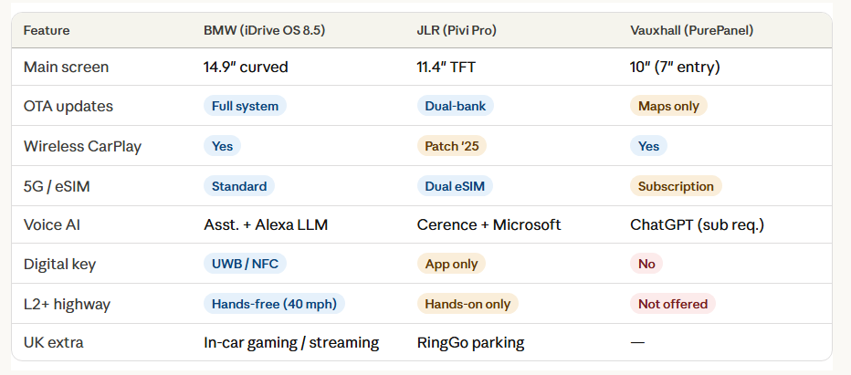

3.0 Porter's Diamond Model of National Advantage Applied to the UK Automotive Industry
Porter's Diamond Model of National Advantage (Porter, 1998) provides a useful framework for understanding why certain countries develop competitive advantage in specific industries. The model centres on four interrelated determinants: factor conditions, demand conditions, related and supporting industries, and firm strategy, structure, and rivalry. Government policy and chance events also play a moderating role. Applying this to the UK automotive sector reveals both genuine strengths and some significant structural concerns.

3.1 Factor Conditions
Factor conditions refer to a country's endowment of the inputs needed to compete — labour, capital, infrastructure, and knowledge. The UK has some genuine strengths here. Institutions such as the Manufacturing Technology Centre in Coventry and the Faraday Institution provide research capability that feeds directly into industry innovation (Faraday Institution, 2023). The UK's engineering talent base is highly skilled, particularly in advanced manufacturing and software systems — capabilities that are increasingly central to modern automotive competition.
There are, however, real disadvantages. Labour costs are considerably higher than in Eastern European countries such as Poland and the Czech Republic, which have attracted substantial automotive investment. Energy costs — electricity in particular — are among the highest in Europe, which is a significant issue as EV battery production is highly energy-intensive (Make UK, 2023). Brexit has also restricted the free movement of labour, creating skills shortages in some areas and adding upward pressure on wages.

3.2 Demand Conditions
The UK is the second-largest new car market in Europe, with approximately 1.62 million new cars registered in 2022 (SMMT, 2023). British consumers are relatively affluent and show a strong preference for premium brands, which directly benefits companies like BMW and JLR. The UK was also among the earlier adopters of electric vehicles in Europe, with EVs accounting for around 22% of new registrations in 2023 (SMMT, 2023). This engaged and sophisticated consumer base encourages manufacturers to innovate and deploy their latest products in the UK market, which Porter would identify as a positive demand condition.
The ZEV mandate adds a layer of regulatory demand pressure, requiring manufacturers to sell increasing proportions of zero-emission vehicles from 2024. In Porter's terms, this should push the UK towards stronger competitiveness in the EV era. That said, the slowdown in EV sales growth observed in 2023 — linked to high prices and concerns about range and charging infrastructure — suggests the transition will not be as straightforward as policymakers anticipated (Cox, 2023).

3.3 Related and Supporting Industries
A strong supply chain is essential for any car manufacturing cluster to thrive. The UK has historically had a reasonably well-developed supply chain, particularly in the West Midlands where there are over 4,000 automotive suppliers (West Midlands Combined Authority, 2023). Companies like GKN, Delphi Technologies and Ricardo provide important components and engineering services to vehicle manufacturers.
The supply chain faces serious structural pressures, however. The Rules of Origin provisions in the post-Brexit Trade and Cooperation Agreement require that EV batteries must contain at least 65% UK/EU-sourced content by 2027 to qualify for zero-tariff exports to the EU (UK-EU TCA, 2020). Since most battery cells are currently sourced from Asia, this creates an urgent need to develop domestic battery manufacturing capacity that the UK has so far been relatively slow to address compared to Germany, France, and Sweden. The Envision AESC gigafactory in Sunderland and Tata's planned Somerset facility represent genuine progress, but a significant gap with Continental Europe remains.

3.4 Firm Strategy, Structure, and Rivalry
The UK automotive market is home to some of the world’s best-known car companies, which generates real competitive pressure. BMW, JLR, Mercedes-Benz and Audi compete intensely in the premium segment, which tends to drive product quality and innovation. One issue, though, is that most of the major manufacturers in the UK are foreign-owned. This means that profits and key decisions often flow back to parent companies abroad, limiting how much the UK economy benefits from having these prestigious brands operating here.
Government industrial strategy has been useful but inconsistent. Programmes such as the Automotive Transformation Fund, the Advanced Propulsion Centre, and the Faraday Challenge have committed substantial public funding to supporting the sector's transition to zero-emission vehicles. However, abrupt policy shifts — most notably the 2023 decision to delay the ban on new petrol and diesel cars from 2030 to 2035 (Department for Transport, 2023) — create precisely the kind of uncertainty that discourages the long-term investment decisions automotive manufacturers need to make.

3.5 Role of Government and Chance
Government has been a mixed factor for the UK automotive industry. On the positive side, post-Brexit industrial policy has allowed for more targeted interventions to support specific manufacturers and technologies. On the negative side, Brexit itself created significant new costs and frictions in supply chains that weren’t there before. New customs requirements and the Rules of Origin provisions have added administrative burden that companies must manage on an ongoing basis (KPMG, 2022).
The COVID-19 pandemic and the subsequent global semiconductor shortage also hit the UK automotive sector hard. Production fell sharply in 2020 and 2021, and chip shortages alone are estimated to have cost UK manufacturers around £6.5 billion in lost output in 2021 (SMMT, 2022). These disruptions have encouraged greater interest in building more resilient, less globally stretched supply chains.

4.0 BMW Group in the United Kingdom: Critical Evaluation of Operational Success Factors
BMW Group is one of the world's leading premium automotive manufacturers, with a brand portfolio spanning BMW, MINI, and Rolls-Royce. Headquartered in Munich, the group generated revenues of €142.6 billion in 2022 and sold approximately 2.4 million vehicles globally (BMW Group, 2023). Its UK operations — centred on the MINI plant in Oxford and the Rolls-Royce facility at Goodwood — are among the most strategically significant it has outside Germany. This section evaluates the key factors shaping BMW Group's performance in the UK, drawing on the PESTEL framework and the CAGE Distance Model.

4.1 Political Factors
Brexit is without question the most significant political development affecting BMW's UK operations in recent years. The Trade and Cooperation Agreement (TCA) that came into force in January 2021 fundamentally altered the trading relationship between the UK and the EU — BMW's largest export market for UK-produced vehicles. BMW's supply chains involve components crossing the UK-EU border multiple times before final assembly, so the introduction of new customs requirements and Rules of Origin compliance has added meaningful cost and administrative complexity to its operations (Oliver Wyman, 2021).
The Rules of Origin provisions in the TCA are particularly significant for BMW's electrification strategy. From 2024, manufacturers must demonstrate that 45% of an electric vehicle's value originates in the UK or EU to export it tariff-free, rising to 65% from 2027 (UK-EU TCA, 2020). Since battery cells — the highest-value component in any EV — are currently sourced predominantly from Asia, meeting these thresholds is a major supply chain challenge. BMW has been lobbying both governments for a temporary relaxation of these requirements during the transition period (SMMT, 2023).
UK industrial policy has been helpful in some ways, for example through the Automotive Transformation Fund which has provided support for tooling at the Oxford plant for EV production (HM Government, 2023). But the government's decision to push back the ICE ban to 2035 introduced uncertainty, particularly as BMW had publicly welcomed the original 2030 deadline as useful for planning long-term investments (BBC News, 2023).
The broader political instability in the UK between 2019 and 2023 — during which there were four prime ministers — has also complicated long-term investment planning. That said, the UK's generally open approach to foreign investment and its business-friendly regulatory environment have helped sustain BMW's commitment to its UK manufacturing base.

4.2 Economic Factors
The UK is one of BMW's most important single markets. In 2022, BMW registered around 162,000 new vehicles here, making it one of the company's largest markets outside Germany (BMW Group, 2023). British consumers' affinity for premium German engineering and strong brand loyalty create a favourable demand environment that directly benefits BMW.
However, the UK economic environment in 2022-23 was difficult. Inflation hit over 11% in late 2022, the highest in four decades, driven by energy costs and supply chain disruptions (ONS, 2023). Interest rates were raised sharply by the Bank of England, reaching 5.25% by August 2023 (Bank of England, 2023), which made car finance more expensive and dampened demand for big purchases like cars. BMW noted softer demand in some UK segments during this period.
Currency volatility adds further complexity. MINI vehicles are exported globally, with substantial proportions priced in US dollars or euros. Sterling depreciation — persistent since the Brexit referendum and dramatic following the September 2022 mini-budget — creates a positive translation effect on export revenues when reported in euros, but simultaneously increases the cost of imported components priced in foreign currencies, squeezing production margins (BMW Group Annual Report, 2023).
Wage pressures have been another issue, with manufacturing wages in the automotive sector growing by roughly 8% in 2023 according to SMMT (2023), adding to production costs at the Oxford plant.

4.3 Legal Factors
BMW operates in a complex and evolving legal environment in the UK. As a German-headquartered company manufacturing vehicles that are largely exported to EU markets, it must navigate both UK domestic law and, where relevant, EU regulatory requirements. This dual exposure has grown considerably more complicated since Brexit.
Vehicle type approval is a significant area. Following Brexit, the UK developed its own approval regime (UK WVTA), separate from the EU framework. While the two systems are currently broadly aligned, regulatory divergence over time could require manufacturers to obtain separate approvals for each market — adding cost and complexity (Department for Transport, 2022). BMW has been a consistent advocate for regulatory convergence and mutual recognition to avoid this outcome.
Data protection is an increasingly important legal dimension as modern connected vehicles generate and process large volumes of driver data. The UK retained the GDPR in domestic law post-Brexit, maintaining broad alignment with EU standards (ICO, 2023). However, uncertainty around the UK's ongoing data adequacy status with the EU remains a concern for BMW's cross-border connected vehicle services.
UK employment law is well-established and broadly familiar to BMW given its German corporate background. The company's Oxford workforce is represented by Unite the Union, and BMW has developed a constructive industrial relations record at the site. Notably, it successfully negotiated the transition to EV production without industrial action — a meaningful achievement given the significant workforce implications of electrification (Unite the Union, 2023).
Environmental regulation is the most rapidly evolving legal area for BMW in the UK. The ZEV mandate, the UK's net-zero commitment, and the forthcoming Emissions Trading Scheme for vehicles are collectively creating an increasingly demanding decarbonisation framework. BMW Group's stated commitment to reducing CO2 per vehicle manufactured by 80% by 2030 against 2019 levels broadly aligns with these regulatory expectations (BMW Group, 2022).

4.4 Cultural Factors and the CAGE Framework
The CAGE Distance Model (Ghemawat, 2001) provides a useful complementary lens for assessing how 'distant' the UK and Germany are as business environments across four dimensions: cultural, administrative, geographic, and economic. The UK and Germany are actually quite close on most of these dimensions, which has historically made BMW's UK operations more manageable than its presence in more distant markets.
Cultural distance between the UK and Germany is relatively low. Both are Northern European societies sharing broadly similar values around professionalism, engineering quality, and the rule of law. BMW's brand values of precision and engineering rigour resonate well with British consumer culture, particularly in the premium segment — BMW, Mercedes-Benz, Audi, and Volkswagen collectively dominate the UK premium market (SMMT, 2023). This alignment reduces the market penetration barriers that BMW might encounter in more culturally distant markets.
Hofstede's (2001) research does identify some differences, particularly in uncertainty avoidance where Germany scores higher, reflecting a greater preference for rules and procedures. In practice, BMW seems to have managed this through a hybrid management approach at its UK sites, where German corporate oversight is combined with local operational autonomy, which has helped keep productivity high at Oxford.
Administrative distance has increased substantially since Brexit. Before 2016, the UK and Germany operated within a shared EU framework — common regulations, customs arrangements, and free movement of goods and people. Post-Brexit, BMW must actively manage new compliance requirements, regulatory divergence risks, and greater barriers to the movement of goods and workers. The CAGE framework predicts that greater administrative distance leads to reduced bilateral trade and investment — a trajectory BMW has sought to resist through sustained investment and industry advocacy.
Geographic distance is actually quite low, which made just-in-time supply chains work well historically, though the addition of post-Brexit customs checks has added friction to cross-Channel logistics (Oliver Wyman, 2021).
Economic distance is also low. Both Germany and the UK are high-income economies with sophisticated consumers and strong purchasing power, which reduces BMW's product adaptation burden. Vehicles designed for the German market require relatively minor modifications for the UK — primarily the left-to-right-hand drive conversion — and the UK's appetite for premium products aligns closely with BMW's positioning.
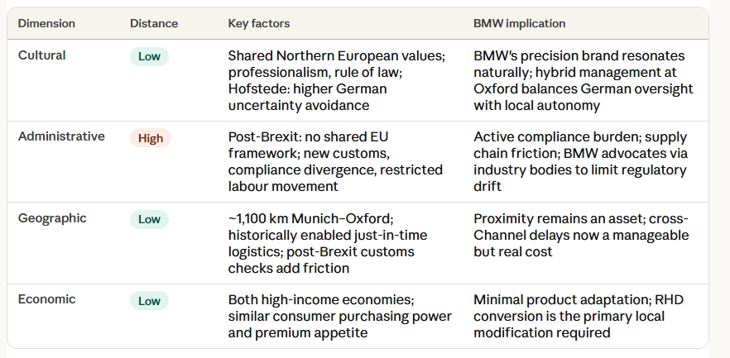

4.5 Market Attractiveness and Strategic Outlook
Putting the PESTEL and CAGE analysis together, the UK is clearly a strategically important market for BMW Group, but the environment is more complex and challenging than it was ten years ago.
BMW Group's response has been broadly proactive. The commitment to all-electric MINI production at Oxford from 2024, continued investment at Goodwood, and active engagement with UK government policy consultations all signal a long-term commitment to the UK manufacturing base. The approach reflects a considered balance between global efficiency — drawing on German R&D and platform engineering — and local responsiveness to UK regulatory and market conditions.
The Rules of Origin battery content challenge remains the most significant unresolved strategic risk. If the UK does not develop sufficient domestic battery manufacturing capacity, BMW and other UK EV producers could face tariffs on EU exports that fundamentally undermine the economics of UK production. This is not an unmanageable risk, but it requires coordinated and sustained action from both industry and government, and it represents arguably the defining strategic question facing BMW's UK operations over the coming decade.

5.0 Conclusion
This report has analysed the UK automotive industry and BMW Group's position within it, applying Porter's Diamond Model, the PESTEL framework, and the CAGE Distance Model as analytical tools. The UK automotive sector occupies a paradoxical position: it hosts some of the world's most prestigious brands and manufacturing facilities, yet faces real structural challenges — particularly around post-Brexit trade friction, supply chain gaps in EV battery production, and macroeconomic pressures — that demand both strategic agility and sustained policy support.
BMW Group's experience in the UK illustrates both the opportunities and the complications of operating in this environment. Its dual manufacturing footprint — Oxford and Goodwood — represents a genuine commitment to the UK, and the company's cultural alignment with British consumer preferences, strong brand equity, and proactive electrification strategy are meaningful assets for the long-term transition to zero-emission motoring.
The coming years will be defining. The commercial success of the electric MINI, the resolution of the battery content Rules of Origin challenge, and the stabilisation of the UK's macroeconomic environment will collectively shape whether BMW's UK operations can grow their contribution to both the company's global strategy and the UK economy. The evidence reviewed in this report suggests BMW is reasonably well-positioned to navigate these challenges — though much will depend on the policy environment providing the long-term consistency that major capital investment decisions require.
From a broader international business perspective, the BMW case offers useful lessons about managing political risk, regulatory complexity, and cultural distance in a major developed economy. The company's adaptive approach — global strategic coherence combined with local market responsiveness — offers a practical model of the kind of transnational management that operating in complex, changing environments requires.
SECTION 2: Reflective Account

Application of Gibbs' Reflective Cycle
The Gibbs Reflective Cycle (Gibbs, 1988) provides a structured framework for learning from experience through six sequential stages: Description, Feelings, Evaluation, Analysis, Conclusion, and Action Plan. This framework has guided my personal reflection on the process of researching, analysing, and producing the international business report on the UK automotive industry and BMW Group.

Description
This assignment analyse the competitive dynamics of the industry, the host country's competitive advantages, and the strategic situation of a foreign company operating there. This task focus on the UK automotive industry and BMW Group. Reasons of the task were partly practical — there is a lot of good public data available on both the UK car industry and BMW's UK operations — and partly because the topic is genuinely interesting to me. The UK automotive sector is going through a really significant transition right now because of Brexit and the push to electric vehicles, and BMW is right in the middle of that.
he methodology involved mapping out three primary analytical frameworks—porter’s diamond, pestel, and cage prior to conducting systematic research.academic journals, SMMT statistical reports, BMW Group annual reports, government policy documents, and reputable news sources. The writing process involved multiple drafts, with ongoing refinement to ensure the frameworks were applied analytically rather than used as superficial labels.

Feelings
At the outset, the topic was genuinely engaging, though also somewhat daunting. The intersection of Brexit and the EV transition creates an unusually complex analytical environment, and ensuring adequate coverage of the political, economic, legal, and cultural dimensions — without losing analytical coherence — required more careful planning than I initially anticipated.
As the research developed, in this task Porter's Diamond Model more valuable than I expected. It pushed me beyond surface observations about the UK's automotive heritage and forced engagement with the structural tensions that complicate any simple account of UK automotive competitiveness — particularly the supply chain gaps and energy cost disadvantages relevant to the EV transition. The CAGE framework was similarly productive, particularly in making explicit the significance of administrative distance as a driver of friction in BMW's UK operations.

Evaluation
The report came out reasonably well overall. The analysis covers the main areas and is grounded in evidence from real sources, and report tried to actually apply the frameworks rather than just mention them.
Areas for improvement include a more detailed examination of BMW's competitive position relative to JLR and Mercedes-Benz in the UK specifically, and more granular financial analysis of BMW's UK profitability. The latter was constrained by data availability, as BMW Group does not publish country-level profit and loss data. With more time, Task would also have wanted to engage more directly with primary trade policy documents, including the full text of the UK-EU TCA.

Analysis
Reflecting on the analytical process, the key insight is that complex real-world cases like BMW in the UK cannot be adequately understood through any single framework. The intersection of political disruption, technological change, macroeconomic volatility, and cultural dynamics requires a pluralistic approach. Using Porter's Diamond, PESTEL, and CAGE in combination — rather than applying a single model — produced a richer and more credible analysis than any one framework could have delivered alone.
The Porter's Diamond analysis was particularly revealing in surfacing the structural tension between the UK's genuine strengths — skilled workforce, research institutions, sophisticated consumers — and its factor disadvantages around energy costs and battery supply chain gaps. This tension is not merely academic; it is the central strategic challenge facing the UK's ambition to remain a significant automotive manufacturing nation in the electric vehicle era.

Conclusion

The principal learning from this assignment is that effective international business analysis requires both theoretical rigour and contextual depth. Frameworks like Porter's Diamond and PESTEL are genuinely useful, but they produce meaningful analysis only when applied with close attention to the specific industry, company, and political-economic context. The BMW-UK case demonstrates clearly that even well-established, deeply integrated multinationals face significant strategic challenges when the political-economic landscape shifts dramatically, as Brexit has shown.
This report developed a more grounded understanding of what the EV transition means in practical terms — particularly the Rules of Origin battery content challenge, which is now see as one of the most consequential industrial policy issues facing the UK. Engaging with it through international business theory has provided both analytical tools and substantive knowledge that expect to find useful in professional contexts.

Action Plan
Going forward, Understanding of trade policy, particularly around Rules of Origin and bilateral trade agreements, since this area came up repeatedly and knowledge was adequate but could be much deeper. Reading the actual text of key agreements like the UK-EU TCA would be a good starting point.
The assessment build stronger quantitative skills for this kind of analysis. Being able to work with financial statements from multinationals and to quantify things like the impact of exchange rate movements would significantly strengthen future work. The qualitative frameworks which used here are valuable, but they are more powerful when combined with solid numbers.

References

Make UK (n.d.) Make UK is the new name for EEF. [online] Available at: https://www.makeuk.org/ (Accessed: 18 March 2026).

Porter, M.E. (1998). Competitive Advantage of Nations : Creating and Sustaining Superior Performance. Riverside: Free Press.

Bank of England (2023). Home. [online] Bankofengland.co.uk. Available at: https://www.bankofengland.co.uk.

Bbc.co.uk. (2026). Welcome To Zscaler Directory Authentication. [online] Available at: https://www.bbc.co.uk/news/uk-politics-66874395 [Accessed 18 Mar. 2026].
‌
Which? (n.d.). Expert testing, reviews and advice from Which? [online] Available at: https://www.which.co.uk.
‌
(2023) FDI Statistics. New Delhi: Government of India.
Department for Transport (2022) Type Approval of Motor Vehicles and Trailers after Brexit. London: HM Government.

GOV.UK (2024). Pathway for zero emission vehicle transition by 2035 becomes law. [online] GOV.UK. Available at: https://www.gov.uk/government/news/pathway-for-zero-emission-vehicle-transition-by-2035-becomes-law.
‌
Faraday Institution (2023) UK Electric Vehicle and Battery Supply Chain Report. Harwell: Faraday Institution. [online] Available at: https://www.faraday.ac.uk (Accessed: 9 March 2024).

Pankaj Ghemawat (2001) 'Distance Still Matters: The Hard Reality of Global Expansion', Harvard Business Review, 79(8), pp. 137–147.

Gibbs, G. (1988). Learning by Doing: A Guide to Teaching and Learning Methods. Oxford: Further Education Unit.
‌
HM Government (2023) Automotive Transformation Fund. [online] Available at: https://www.gov.uk/guidance/automotive-transformation-fund (Accessed: 12 March 2024).

Hofstede, G. (2001). Culture’s Consequences : Comparing values, behaviors, institutions, and Organizations across Nations. 2nd ed. Thousand Oaks, Calif. ; London: Sage.
‌
Information Commissioner's Office (ICO) (2023) Guide to the UK GDPR. Wilmslow: ICO. [online] Available at: https://ico.org.uk (Accessed: 14 March 2024).

JLR (2023). Annual report 2023 | JLR Corporate Website. [online] Jlr.com. Available at: https://www.jlr.com/annual-report-2023.
‌
KPMG (2022) Automotive Sector Brexit Impact Assessment: Two Years On. London: KPMG LLP.

The European automotive industry Unlikely to return to normal Global Strategy Group. (n.d.). Available at: https://assets.kpmg.com/content/dam/kpmgsites/ch/pdf/kpmg-global-strategy-consulting-european-automotive-industry.pdf.
‌
Marshall, A. (1890). Principles of Economics.
‌
Office for National Statistics (ONS) (2023) Consumer Price Inflation, UK: October 2022. Newport: ONS. [online] Available at: https://www.ons.gov.uk (Accessed: 11 March 2024).

Oliver Wyman (2021) Brexit and the UK Automotive Industry: Supply Chain Impacts and Adaptation. Munich: Oliver Wyman GmbH.

Porter, M.E. (1998). Competitive Advantage of Nations : Creating and Sustaining Superior Performance. Riverside: Free Press.
‌
Michael E. Porter (1998) 'Clusters and the New Economics of Competition', Harvard Business Review, 76(6), pp. 77–90.

ICO (2023) UK GDPR Guidance and Resources. Wilmslow: Information Commissioner's Office.

Jaguar Land Rover (2023) JLR Annual Report and Financial Statements 2022/23. Coventry: Jaguar Land Rover Automotive plc.

Society of Motor Manufacturers and Traders (SMMT) (2022) Annual Report 2021: UK Automotive Production Review. London: SMMT.

SMMT (2023). The voice of the UK automotive industry. [online] SMMT. Available at: https://www.smmt.co.uk/.
‌
SMMT (2024). Automotive Insights Reports - SMMT. [online] SMMT. Available at: https://www.smmt.co.uk/automotive-insights-reports/.
‌
GOV.UK (2020). Agreements reached between the United Kingdom of Great Britain and Northern Ireland and the European Union. [online] GOV.UK. Available at: https://www.gov.uk/government/publications/agreements-reached-between-the-united-kingdom-of-great-britain-and-northern-ireland-and-the-european-union.
‌
Tata Motors (2023) Tata Motors Annual Report 2022–23. Mumbai: Tata Motors Limited.

UK-EU Trade and Cooperation Agreement (TCA) (2020) Trade and Cooperation Agreement between the European Union and the United Kingdom. Brussels: European Commission.

Unite the Union (2023) BMW Oxford Plant: Workforce Agreement on Electric Vehicle Transition. London: Unite the Union.
2024/.
‌

‌
Faraday Institution (2023) UK Electric Vehicle and Battery Supply Chain. Harwell: Faraday Institution.

HM Government (2023) Zero Emission Vehicle (ZEV) Mandate: Policy Statement. London: Department for Transport.

Hofstede, G. (2001) Culture's Consequences: Comparing Values, Behaviors, Institutions, and Organizations Across Nations. 2nd edn. Thousand Oaks, CA: Sage.

Ghemawat, P. (2001) 'Distance still matters: The hard reality of global expansion', Harvard Business Review, 79(8), pp. 137–147.

