

Mental Disorders and Psychopathology​
(BMHP_6006)

Assessment component 2 - Report

Student: Meliha Drenk
Student ID: 1922136

Lecturer: Bianca Sanfilippo

Table of contents

Introduction.................................................................................................................3
General Anxiety Disorder (GAD)
Definition...................................................................................................................................3
Classification within ICD-10 MANUAL......................................................................................3
GAD Statistics in the UK...........................................................................................................3
Causes of Anxiety.....................................................................................................................4
Signs and Symptoms................................................................................................................4
Diagnosis..................................................................................................................................5
Current treatment......................................................................................................................5
Advantages of the treatment.....................................................................................................5
Disadvantages of the treatment................................................................................................6
Measurements of rehabilitation.................................................................................................6
Recommendations for improvement.........................................................................................6
Principles of care for people with GAD.................................................................................... 6
Schizophrenia
Definition...................................................................................................................................7
Classification within ICD-10 MANUAL......................................................................................7
Statistics for Schizophrenia in the UK.......................................................................................7
Causes......................................................................................................................................8
Signs / Symptoms.....................................................................................................................8
Diagnosis..................................................................................................................................8
Current treatment .....................................................................................................................9
Advantages / Disadvantages of the treatment..........................................................................9
Measurements of rehabilitation.................................................................................................9
Recommendations for improvement.........................................................................................9
Principles of care for people with Schizophrenia....................................................................10
Autism
Definition.................................................................................................................................10
Classification within ICD-10 MANUAL....................................................................................10
Statistics for Autism in the UK............................................................................................... 11
Causes...................................................................................................................................11
Signs / Symptoms...................................................................................................................12
Diagnosis................................................................................................................................12
Current treatment ...................................................................................................................13
Advantages / Disadvantages of the treatment........................................................................14
Measurements of rehabilitation...............................................................................................14
Recommendations for improvement.......................................................................................14
Principles of care for people with Autism................................................................................15
Conclusion...........................................................................................................................15
References...........................................................................................................................16
Appendix 1...........................................................................................................................21
Appendix 2...........................................................................................................................22
Appendix 3...........................................................................................................................22

Introduction
This report will be exploring and critically examine the classification, causes, diagnosis and treatment of three of the most common mental disorders – General anxiety disorder (GAD), Schizophrenia and Autism. Also will be providing various recommendations for improvement and measurements of rehabilitation.

General Anxiety Disorder
Definition
The first symptoms of anxiety are described by Robert Burton in 1621. (Bandelow and Michaelis, 2022).
General anxiety disorder (GAD) is a long-term state (disorder) in which you are nervous and anxious about a wide range of circumstances and topics in a major way. People with a general anxiety disorder are worried, panicked and scared most of the time and are rarely ever comfortable or relaxed. GAD can have physical and mental consequences that are individual. (NHS, 2022).
Classification within ICD-10 MANUAL
GAD is classified within ‘Neurotic, stress-related and somatoform disorders’ (F40-F48), and it is with code F41.1 (WHO, 2010).
GAD Statistics in the UK
According to the current report for ‘Mental health statistics in England’, General anxiety disorder is the most common mental disorder. (See Figure 1). The disorder is common in many children, adults and even the elderly, from all backgrounds. (Baker, 2021).
Royal College of Psychiatrists (2022), describe that 1 in every 25 people experience some form of GAD. Over 8 million people, in the UK have an anxiety disorder, however less than 50% seek treatment for it. Men are two times less likely to be diagnosed than women. (Mental Health Foundation, 2022). Globally it affects more that 33% of the population in some point of their life. (Bandelow and Michaelis, 2022).
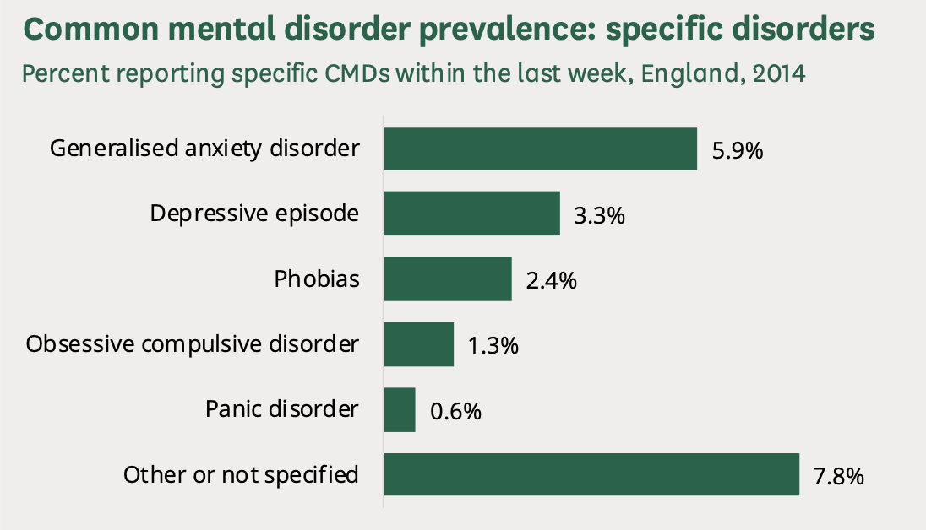
Figure 1. Photo credit:https://researchbriefings.files.parliament.uk/documents/SN06988/SN06988.pdf

Causes of Anxiety
Anxiety is an atypical disorder as it can be caused by a wide range of things that can lead to it. However, some of the most impactful ones are: having a previous or current drug addiction and alcohol misuse, sexual or physical abuse, imbalance of brain chemicals and the genes, which you inherit from parents. It is also possible for people to develop GAD for no specific reason and it could simply be caused by someone getting overwhelmed and stressed. It is a disorder caused by many factors, therefore it is difficult to diagnose and treat. (Mind, 2022).

Signs and symptoms
The severity of the psychological symptoms of a general anxiety disorder can depend on the individual. But in spite of that, some of the most common signs and symptoms are constant agitation and nervousness, constant feeling of impending doom, unable to focus and to be easily irritated and frustrated. The signs and symptoms can all lead to an increasing level of loneliness and a lack of social and communication skills. Moreover, it can lead to constantly feeling awkward and out of place. There are also a variety of physical symptoms such as: shaking, sweating or hot flushes during social interactions, dizziness, migraines and feeling unwell, or an irregular heartbeat. These are many signs similar to panic attacks. (MayoClinic, 2022).

Diagnosis
Diagnosing a general anxiety disorder can be difficult as the signs and symptoms are different depending on each person. It can be diagnosed if there is a recurring presence of worry and fear about a wide range of topics and events. Having said that, it can most commonly be diagnosed if you have been experiencing the signs and symptoms for over half a year. It can also be done by going to your GP and having a physical exam along with blood tests to rule out any other medical conditions that it can be such as hyperthyroidism or anaemia. (NHS, 2021).

Current Treatments (NHS)
A generalised anxiety disorder has a variety of treatments depending on the severity of the disorder. If the condition is mild the treatments for it can be done by guided self-help where you can learn how to cope and take care of your own mental health (anxiety). The first important thing that needs to be done is to seek help from your GP. This can also be accompanied by completing Cognitive Behavioural Therapy workbooks along with the help of your therapist in order to manage your anxiety. The treatment for moderate anxiety is again, Cognitive Behavioural Therapy however, instead of completing workbooks on your own, you have meetings with a therapist every week for an extended period of time. Cognitive behavioural therapy is the most effective and successful treatment for a generalised anxiety disorder. In addition to that, in the more severe cases of the condition, there is a combination of treatments that can be done in order to receive the optimum treatment and outcome. It is a mixture of cognitive behavioural therapy and applied relaxation where you can learn how to manage your anxiety and to reduce your own worries and stress. Additionally, along with complementary therapies medication can also be taken for a short or long period. Medications such as: antidepressants or serotonin inhibitors (sertraline, escitalopram, paroxetine, etc). If they don’t help stronger medication such as: duloxetine, pregabalin and benzodiazepines can be prescribed. However, if all the treatments listed above don’t help, your GP will provide you a referral for a mental health specialist. (NHS, 2021).

Advantages of the treatment
The treatment allows those struggling with GAD to manage their uneasiness and nerves without the constant feeling of panic and fear. Alongside that, other advantages of the treatment are the ability to socialise and express yourself without the nerves and social anxiety surrounding basic interactions and events. Moreover, treatment provides the chance to develop better coping and relaxing skills. Additionally, the medication which can be taken provides relief and it is also safe without affecting the other critical bodily functions. (NHS, 2021).
Disadvantages of the treatment
The disadvantage of the treatment is, that it may not be successful for many of those struggling, as some of the methods are unhelpful and lack proof of success. The prescribed medication can be highly addictive if taken for a long period of time and can have dangerous withdrawal symptoms. Medication also can have some side effects such as: constipation or diarrhoea, headache, dizziness, insomnia, weight gain, blood clots, etc. (NHS, 2021).
Measurements of rehabilitation
There are different tools to measure the effectiveness of the treatment. Main one is the self-report Generalised Anxiety Disorder Questionnaire (GAD-7), (see Appendix 1), which measures the patient’s progress and health status. Other useful tool is Penn State Worry Questionnaire, which also measures the effectiveness of the treatment of GAD, but it is mainly used in USA. (Williams, 2014).
Recommendations for improvement of anxiety
A lot of people are turning to different nonconventional methods to deal with anxiety. The use of complementary therapies is an effective tool for managing GAD. Also mind and body exercises, meditation, a self-hypnosis are beneficial to reduce your nerves and stress. Useful complementary therapies are: acupuncture, homeopathy, tai chi and yoga. Recent study has shown that yoga and meditation have extremely positive effect, reduce stress and improve symptoms of anxiety and uneasiness. (Saeed et al., 2019).

Principles of care for people with GAD
When working with patients suffering from GAD, NICE guidelines provide useful principles of care for the professionals.
Professionals need to build a bond with the patients as a way to gain their trust in order to ease their worries. This will allow the patients to feel comfortable about the provided treatment options, because it is a shared process. Most importantly the patients confidentiality, dignity and privacy have to be respected. Professionals have to treat all the patients equally, no matter their background or identity. If the patient’s family is involved they should be provided with all the necessary information surrounding their family member. (NICE, 2020).

Schizophrenia

Definition
A Schizophrenia disorder is a type of psychosis where people may be unable to distinguish between their own imagination and reality. Schizophrenia can range from mild to extremely severe and disabling. (NHS, 2019).
Schizophrenia is a major illness that affects the function of the brain and often causes significant disturbed behaviour that negatively impacts people’s daily lives. (Living with Schizophrenia, 2022).
Classification
Schizophrenia is classified under section ‘Mental and behavioural disorders’, group ‘Schizophrenia, schizotypal and delusional disorders (F20-F29)’, with code F20. (WHO, 2010).
Statistics for Schizophrenia
According to WHO (2022), schizophrenia affects 1 in 300 people, or around 24 million people globally and affects men more than women. (WHO, 2022).
Concentrating in the UK, Royal College of Psychiatrists (2022) pointed out that it affects every 1 in 100 people, in their early adolescence between 15 to 35 years old. (See Figure 2).
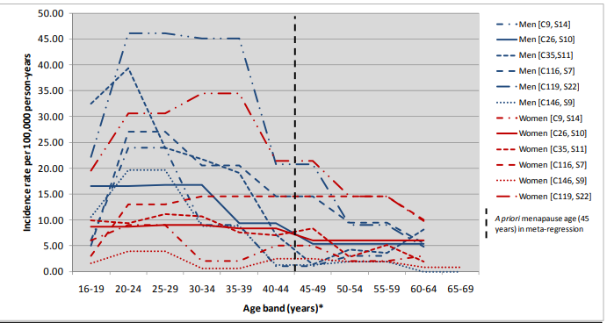

Figure 2. Photo credit: http://www.psychiatry.cam.ac.uk/files/2014/05/final-report-v1.05-jan-12.pdf
Causes
There are a variety of causes leading to Schizophrenia. It is not absolutely clear for the scientists the exact reasons, however different studies confirmed that there is a genetic predisposition, and can be inherited. Another researches have shown that drug addiction such as - cannabis, amphetamines, cocaine, lead to episodes of schizophrenia. (Living with Schizophrenia, 2022).
Infections during pregnancy or brain damage during birth can stop the correct development of the brain. Studies show that people with schizophrenia have abnormalities in the brain. Stressful life events such as: physical or sexual abuse in the childhood can also lead to schizophrenia. (Royal College of Psychiatrists, 2022).
Signs / symptoms
NHS (2019) describe that there are two types of symptoms - positive and negative.
Positive symptoms are hallucination, delusion, discombobulated thoughts and behavioural changes.
Hallucination are imaginary feeling, hearing voices, seeing or testing things that are not real. Even though they feel real for the person with schizophrenia, surroundings cannot experience them. Hearing voices often is described as nice and friendly, but mainly voices are violent, aggressive and abusive. (NHS, 2019).
Delusion affects people’s behaviour and is caused by false, unreal, conspiracy and odd reality. People experiencing delusion believe that they are being spied on, observed, and stalked by their relatives or the government. Some people believe that have super powers. (NHS, 2019).
Discombobulated Thoughts can cause difficult concentration and affect the ability to speak with others. Behavioural Changes they feel as though they are a puppets being manipulated by others. (NHS, 2019).
Negative symptoms often cause the person to segregate from others. The most common symptoms are: apathy, social withdraw, loss of interest, lack of motivation, changes of sleep patterns, avoiding home chores etc. (Royal College of Psychiatrists, 2022).
Diagnosis
Schizophrenia is a complex condition that is diagnosed after assessment by mental health specialist – GP, psychiatrists and psychologists. Early prevention and treatment gives hope for normal life. The specialist will use detailed check list to confirm the diagnosis based on your symptoms. Blood tests will be also required to exclude alcohol or drug misuse as a cause of the symptoms. Once you are diagnosed the specialist will provide you with advise to seek further treatment. (Living with schizophrenia, 2022).
Current treatments
Treating schizophrenia is a combination between the use of medication and therapies. Medications that help to prevent the crisis and control the symptoms are called antipsychotics. They can be taken on tablets or injections. They have to be used for long period of time. 4 of 5 patients with schizophrenia reported improvement after their use. Together with medication extremely important is psychological help and Cognitive Behavioural Therapy. This therapy will help patients to manage and control their disturbing thoughts and behaviour. NHS also provides family therapy, because most of the people with schizophrenia rely to their relatives. (NHS, 2019).

Advantages and Disadvantages of the treatment
Advantages – A review summarised that the use of both drugs and medication, improve and control the negative symptoms of schizophrenia. The most used medication is Clozapine. (Fleischhacker and Uchida, 2014). A study conducted in the UK with 113 patients with positive and negative symptoms of schizophrenia showed that the use of Cognitive behavioural therapy reduces their negative feeling and improve their self-esteem. (Barrowclough et al., 2018).
Disadvantages – The use of medication usually is accompanied with side effects. Antipsychotics increase the risk of blood clots and hearth attack, shaking and spasm of the muscles, weight gain and blurry vision. (NHS, 2019). A study confirmed severe cases where patients develop neuroleptic syndrome or dyskinesia after the use of antipsychotic injections. (Brissos et al., 2014).
Measurements of rehabilitation
Schizophrenia is a long term condition and people suffering from it experience many symptoms throughout their life. The tool used to measure the effectiveness of the treatment and quality of care is the Indicator for Rehabilitative Care (QuIRC-SA), (see Appendix 2). It specifically assesses the care provided by specialists. (NICE, 2020).
Recommendations
People are seeking complementary therapies as a more zen and natural way for treating their own disorder along with the traditional treatment and advice of therapists. A study showed that yoga is very beneficial as it improves the quality of life in those diagnosed with schizophrenia. (Visceglia and Lewis, 2011).
Society segregates from those suffering with the diagnosis and views them as psychotic monsters out of control. Therefore, people with schizophrenia have to fight against the discrimination and stigma surrounding them in order to enhance their wellbeing and standard of living. (WHO, 2022). It is critical that the human rights are respected and treated equally.
Principles of care for people with Schizophrenia
Professionals should treat all patients with dignity and respect all backgrounds and cultures as a way to provide equal and fair care to all that are struggling. The confidentiality of the patients should be taken into account and the patient’s wishes and concerns should always be put first and supported. Professionals should provide advice to their patients by influencing them to be independent and improve their way of life and wellbeing - this can be done by improving their diet or starting yoga and exercises. (NICE, 2014).

Autism

Definition
Autism spectrum disorder (ASD) is a disorder which prevents you from expressing yourself correctly in social interaction. Commonly many people who have the disorder have an obsession or are hyper-fixated on a specific thing such as maths or sequences etc. It means that the way your brain functions and processes things is very different to others. They may have a wide amount of knowledge based on topics which they are very passionate about. They can also be triggered often by loud sounds, buzzing or flashing lights. The autism spectrum means that autism is experienced in a wide range of ways by many different people who also have the disorder. Autism can affect how you grow and develop and the way you understand a variety of topics. (NHS inform, 2020).

Autism can be a wide range of conditions with social interactions, repetitive actions and behaviours and also refusal to communicate due to being unable to understand people and their feelings. (Autism Speaks, 2022).

Classification within ICD-10 MANUAL
Autism is classified under the group of ‘Mental and behavioural disorders’ section ‘Disorders of psychological development (F80-F89), with code F84.0. (WHO, 2010).
Statistics for Autism in the UK
According to World Health Organisation (2022) globally diagnosed with Autism spectrum disorder is 1 of 100 children.
In the UK statistics show that more than 700 000 adults and children have autism. (National Autistic Society, 2022). A study collected by Department of Education show that 120 000 children age between 2-21 years have autism. Boys are more likely to have autism than girls with prevalence 2.8%. (Roman-Urrestarazu, et al., 2021).
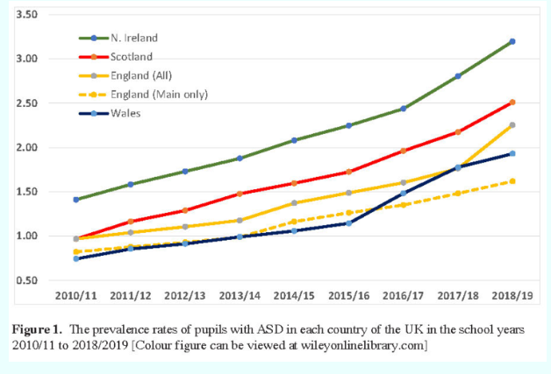

Figure 3. Photo credit: https://www.ncsautism.org/blog//prevalence-of-autism-spikes-in-uk-schools

Causes
Professionals believe that there is not a specific cause for autism however, there are possible reasons that can contribute to the development of the disorder. Firstly, it is most likely for those who have a very close family member who is autistic to develop the disorder. Genetic mutations are also a contributing factor towards the development of the disorder. Moreover, a low birth weight and exposure to toxins at an extremely young age can also initially cause the genetic mutations which lead to the evolution of the Autism Spectrum Disorder. (Lener et al., 2021).
Signs / Symptoms
In children, the symptoms and signs of Autism Spectrum Disorder can vary depending on the conditions and development of the individual. It is a lot easier to diagnose children as the symptoms are easier to notice and help treat. However, there are some typical signs that could imply that someone has the disorder. Firstly, if the child is not responding to their name or avoiding interactions with other children or adults. Additionally, this is also accompanied by constantly avoiding eye contact and being unable to express their emotions or responding correctly to others. Moreover, there are repetitive actions that are also done as a nervous symptom such as: involuntary fidgeting, obsession with patterns and sequences and also flapping. (Mayo Clinic, 2018).
In adults, the symptoms and signs are similar to those of children however, as they haven't been diagnosed for many years it could be harder to seek appropriate treatment for the disorder. A typical sign is that the individual may be unable to understand emotions or interpret social cues and sarcastic comments. The person could also prefer to be alone as they are unable to express emotions and have a specific routine which they choose to not adapt. This contributes to the fact that the adults could be extremely fussy and obsessive with certain things and topics that interest them. Alongside that, the person could also struggle to communicate with others. (Mayo Clinic, 2018).
Diagnosis
Diagnosing autism depends on the individuals and their age. People are born with autism, and most of the time autism can be diagnosed during childhood. However, sometimes it is hard to recognise the symptoms and get diagnosed as an adult.
If parents suspect that their child has autism they have to contact their GP or a health visitor. (NHS inform, 2020). If the child is at an age where they attend school, the team for special education in the school (SENCO) can give you a referral for an assessment with an autism specialist. (National Autistic Society, 2022). The autism specialist will observe the child's behaviour, skills and interaction with other children in school to conclude if the child is autistic.
Diagnosing adults can be done by having a specialist talk to someone that has known you since you were a child. Additionally, the specialist has to check your medical record from your GP for any other possible medical conditions or have the adult complete a questionnaire to try and diagnose some of the other symptoms. (NHS, 2022).
The following tools are used to recognise if someone has autism: Diagnostic Interview for Social and Communication Disorders (DISCO), the ADI-R (Autism Diagnostic Interview-Revised), the ADOS (Autism Diagnostic Observation Schedule) and 3Di (Developmental, Dimensional and Diagnostic Interview). (National Autistic Society, 2022).
Current treatment
There is no medical treatment for autism, however, some therapies and interventions are a very effective way to manage the symptoms and improve people’s well-being. Autism affects every individual differently, meaning that autistic people have different strengths and weaknesses. This is why different individuals require multiple professionals to be involved. Treatment can be divided into different approaches: behavioural, psychological, developmental, social-relational, pharmacological, complementary and alternative treatments. (CDCP, 2022).
The most effective behavioural therapy is Applied Behaviour Analysis (ABA), because it encourages children to develop new skills and learn a wide range of new things.
The developmental approach is done by focusing on improving children’s speaking and physical skill with the use of different therapies such as: Occupational therapy, Sensory-integration therapy, Physical therapy, etc. With the help of Social Skills Groups, autistic children can improve their communication skills and allow them to participate in different social events. Their parents also can also be included as a way to make the children feel more comfortable and safe.
Pharmacological approach - There is no medication that cures autism, however, some antipsychotics can control the symptoms and reduce their hyperactivity and make them feel calmer and at peace. (DeFilippis and Wagner, 2016).
Cognitive behavioural therapy is the psychological approach that helps autistic children cope with their discombobulated and rapid thoughts, helping with reducing their anxiety and depression.
Some parents decide to use non-traditional treatments along with the recommended therapies. They can use acupuncture, chiropractic, animal or art therapy, yoga, special diets including different supplements etc. (CDCP, 2022).

Advantages / Disadvantages of the treatment
Advantages
The advantages of the treatment are that they can help those with autism to improve their communication and social skills as a way to help them adapt better to new situations and environments. This allows the autistic person to live a comfortable and social life without the worries and limits that they had to experience and go through before. Alongside that, studies presented promising results after using complementary therapies such as: acupuncture, art and music therapy. (Brondino, et al., 2015)
Disadvantages
The disadvantages of the treatments are that not all therapies are suitable for autistic people because they have different approaches which may not work effectively for everyone. Some therapies such as Applied behavioural analysis therapy, aim to try and replace the child's identity and turn them into a stereotypical child that fits into society. This is not beneficial as it takes away from the child’s own personality and characteristics. (Bailey, 2013).
Measurements of rehabilitation
The tools used to measure the effectiveness of autism treatment are Childhood Autism Rating Scale (CARS), (see Appendix 3), and ADOS – Autism Diagnostic Observation Schedule. They specifically focus on monitoring the child's behaviour and how they behave in social interactions and the way they respond to or listen to their name. Additionally, ADOS measures and assesses the positive and negative behaviours of children and the way they socialise in new situations and experiences. This is done to measure their obsession with their routine and how they will adapt to a new environment. (Payakachat et al., 2012)
Recommendations for improvement
Complementary therapies are an effective tool which help improve the person's condition. It is typical for autistic children to have weird and bizarre eating preferences but studies confirmed that yoga can improve their behaviour, sleeping patterns and eating habits. It helps them gain peace and develop to their full potential. (Brondino et al., 2015).
Other studies show that physical activities are extremely beneficial for children with autism because they reduce their problematic behaviour and aggression. (Sowa and Meulenbroek, 2012).

Principles of care for people with Autism
Professionals should respect all of their patients equally without treating any of them differently, no matter their ethnic background or opinions. They should offer all services to their patients and allow them to have their own say on the type of treatment that they want and feel comfortable with. If the patient is a child, then their family will be involved in helping to select the correct treatment. Family interventions are an exceptional way for patients to open up to their doctors or psychiatrists with the care and support of their families. Additionally, even though family interventions are beneficial, professionals should still place the confidentiality and privacy of the patient first. (NICE, 2021).

Conclusion
In conclusion, millions of people all over the world deal with mental disorders. It is important to break the stigma against it and to treat people equally. This is especially important as we encounter many people who have mental illnesses on a daily basis. Everyone deserves to be treated with dignity and respect, without being judged for who they are.

References
Autism Speaks (2022) What is Autism? Available at: https://www.autismspeaks.org/what-autism (Accessed: 1 September 2022).
Bailey, E. (2013) Health central. Available at: https://www.healthcentral.com/article/pros-and-cons-of-applied-behavior-analysis-aba (Accessed: 3 September 2022).
Baker, C. (2021) Mental health statistics: Prevalence, services and funding in England. Available at: https://commonslibrary.parliament.uk/research-briefings/sn06988/#:~:text=The%20Survey%20of%20Mental%20Health,Prevalence%20has%20increased%20since%201993. (Accessed: 20 August 2022).
Bandelow, B. and Michaelis, S. (2022) ‘Epidemiology of anxiety disorder in 21st century’ Dialogues in clinical neuroscience. 17(3). pp. 327–335. Available at: https://www.tandfonline.com/doi/full/10.31887/DCNS.2015.17.3/bbandelow (Accessed: 23 August 2022).
Barrowclough, C. et al. (2006). ‘Group cognitive-behavioural therapy for schizophrenia: Randomised controlled trial’. British Journal of Psychiatry, 189(6), pp. 527-532. Available at: https://www.cambridge.org/core/journals/the-british-journal-of-psychiatry/article/group-cognitivebehavioural-therapy-for-schizophrenia/8B80782CD1957966630AB5E8F38A629B (Accessed: 26 August 2022).
Brissos, S. et al. (2014) ‘The role of long-acting injectable antipsychotics in schizophrenia: a critical appraisal’. Therapeutic Advance in Psychopharmacology. 4(5). pp.198-219. Available at: https://pubmed.ncbi.nlm.nih.gov/25360245/ (Accessed: 27 August 2022).
Brondino, N. et al. (2015) ‘Complementary and Alternative Therapies for Autism Spectrum Disorder’. Evidence Based Complement Alternative Medicine. 258589. Available at: https://www.ncbi.nlm.nih.gov/pmc/articles/PMC4439475/ (Accessed: 2 September 2022).
Centre for Disease Control and Prevention (2022) Treatment and Intervention Services for Autism Spectrum Disorder. Available at: https://www.cdc.gov/ncbddd/autism/treatment.html (Accessed: 3 September 2022).
DeFilippis, M. and Wagner, K.D. (2016) ‘Treatment of Autism Spectrum Disorder in Children and Adolescents’. Psychopharmacol Bulletin. 46(2). pp.18-41. Available at: https://www.ncbi.nlm.nih.gov/pmc/articles/PMC5044466/ (Accessed: 3 September 2022).

Fleischhacker, W. and Uchida, H. (2014) ‘Critical review of antipsychotic polypharmacy in the treatment of schizophrenia’, International Journal of Neuropsychopharmacology, 17(7), pp.1083–1093. Available at: https://academic.oup.com/ijnp/article/17/7/1083/721629 (Accessed: 26 August 2022).
Lener, M.S., Cherney, K. and Shulman, J. (2021) Everything you need to know about Autism Spectrum Disorder (ASD). Available at: https://www.healthline.com/health/autism (Accessed: 2 September 2022).
Living with Schizophrenia (2022) Causes. Available at: https://livingwithschizophreniauk.org/causes/ (Accessed: 24 August 2022).
Living with Schizophrenia (2022) How is schizophrenia diagnosed? Available at: https://livingwithschizophreniauk.org/information-sheets/how-is-schizophrenia-diagnosed/ (Accessed: 25 August 2022).
Living with Schizophrenia (2022) What is Schizophrenia. Available at: https://livingwithschizophreniauk.org/ (Accessed: 23 August 2022).
Mayo Clinic (2018) Autism spectrum disorder. Symptoms and causes. Available at: https://www.mayoclinic.org/diseases-conditions/autism-spectrum-disorder/symptoms-causes/syc-20352928 (Accessed: 3 September 2022).
MayoClinic (2022) Generalised Anxiety Disorder. Available at: https://www.mayoclinic.org/diseases-conditions/generalized-anxiety-disorder/symptoms-causes/syc-20360803#:~:text=Overview,sign%20of%20generalized%20anxiety%20disorder. (Accessed: 21 August 2022).
Mental Health Foundation (2022) People seeking help: statistics. Available at: https://www.mentalhealth.org.uk/explore-mental-health/mental-health-statistics/people-seeking-help-statistics (Accessed: 19 August 2022).
Mind (2022) Anxiety and panic attacks. Available at: https://www.mind.org.uk/information-support/types-of-mental-health-problems/anxiety-and-panic-attacks/causes/ (Accessed: 20 August 2022).
National Autistic Society (2022) Diagnostic criteria - a guide for all audiences. Available at: https://www.autism.org.uk/advice-and-guidance/topics/diagnosis/diagnostic-criteria/all-audiences (Accessed: 3 September 2022).
National Autistic Society (2022) Extra help at school in England. Available at: https://www.autism.org.uk/advice-and-guidance/topics/education/extra-help-at-school/england (Accessed: 2 September 2022).
National Autistic Society (2022) What is Autism? Available at: https://www.autism.org.uk/advice-and-guidance/what-is-autism#:~:text=One%20in%20100%20people%20are,and%20children%20in%20the%20UK. (Accessed: 1 September 2022).
National Health Service (2019) Overview – Schizophrenia. Available at: https://www.nhs.uk/mental-health/conditions/schizophrenia/overview/ (Accessed: 23 August 2022).
National Health Service (2019) Symptoms-Schizophrenia. Available at: https://www.nhs.uk/mental-health/conditions/schizophrenia/symptoms/ (Accessed: 24 August 2022).
National Health Service (2019) Treatment-Schizophrenia. Available at: https://www.nhs.uk/mental-health/conditions/schizophrenia/treatment/ (Accessed: 25 August 2022).
National Health Service (2021) Overview - Generalised anxiety disorder in adults. Available at: https://www.nhs.uk/mental-health/conditions/generalised-anxiety-disorder/overview/ (Accessed: 20 August 2022).
National Health Service (2022) What happens during an autism assessment. Available at: https://www.nhs.uk/conditions/autism/getting-diagnosed/assessments/ (Accessed: 3 September 2022).
National Health Service inform (2020) Autism spectrum disorder (ASD). Available at: https://www.nhsinform.scot/illnesses-and-conditions/brain-nerves-and-spinal-cord/autism-spectrum-disorder-asd#about-autism (Accessed: 1 September 2022).
National Health Services (2021) Diagnosis – Generalised Anxiety Disorder in adults. Available at: https://www.nhs.uk/mental-health/conditions/generalised-anxiety-disorder/diagnosis/ (Accessed: 21 August 2022).
National Health Services (2021) Treatment - Generalised anxiety disorder in adults. Available at: https://www.nhs.uk/mental-health/conditions/generalised-anxiety-disorder/treatment/#:~:text=You%20can%20get%20psychological%20therapies,a%20referral%20from%20a%20GP.&text=Or%20your%20GP%20can%20refer%20you%20if%20you%20prefer. (Accessed: 22 August 2022).
National Institute for Health and Care Excellence (2014) Psychosis and schizophrenia in adults: prevention and management. Available at: https://www.nice.org.uk/guidance/cg178/chapter/1-Recommendations (Accessed: 27 August 2022).
National Institute for Health and Care Excellence (2020) Generalised Anxiety Disorder and panic disorder in adults: management. Available at: https://www.nice.org.uk/guidance/cg113/chapter/Recommendations#principles-of-care-for-people-with-generalised-anxiety-disorder-gad (Accessed: 22 August 2022).
National Institute for Health and Care Excellence (2020) Rehabilitation in adults with complex psychosis and related severe mental health conditions. Available at: https://www.nice.org.uk/guidance/ng181/documents/evidence-review-6 (Accessed: 1 September 2022).
National Institute for Health and Care Excellence (2021) Autism spectrum disorder in under 19s: support and management. Available at: https://www.nice.org.uk/guidance/cg170/chapter/Recommendations#general-principles-of-care (Accessed: 2 September 2022).
Payakachat, N. et al. (2012) ‘Autism spectrum disorders: a review of measures for clinical, health services and cost-effectiveness applications’. Expert Rev Pharmacoecon Outcomes Res. 12(4). pp. 485-503. Available at: https://www.ncbi.nlm.nih.gov/pmc/articles/PMC3502071/ (Accessed: 3 September 2022).
Roman-Urrestarazu, A. et al. (2021) ‘Association of Race/Ethnicity and Social Disadvantage with Autism Prevalence in 7 Million School Children in England’. JAMA Paediatrics. 175(6). e210054. Available at: https://pubmed.ncbi.nlm.nih.gov/33779707/ (Accessed: 2 September 2022).
Royal College of Psychiatrists (2022) Anxiety and Generalised anxiety disorder (GAD). Available at: https://www.rcpsych.ac.uk/mental-health/problems-disorders/anxiety-and-generalised-anxiety-disorder-(gad)?searchTerms=gad (Accessed: 20 August 2022).
Royal College of Psychiatrists (2022) Schizophrenia. Available at: https://www.rcpsych.ac.uk/mental-health/problems-disorders/schizophrenia (Accessed: 23 August 2022).
Royal College of Psychiatrists (2022) Symptoms of schizophrenia. Available at: https://livingwithschizophreniauk.org/symptoms-of-schizophrenia/ (Accessed: 25 August 2022).
Saeed, S. A., Cunningham, K. and Bloch, R. M. (2019) ‘Depression and Anxiety Disorders: Benefits of exercise, yoga and meditation’. American Family Physician. 99(10). pp. 620-627. Available at: https://pubmed.ncbi.nlm.nih.gov/31083878/ (Accessed: 22 August 2022).
Sowa, M. and Meulenbroek, R. (2012) ‘Effects of physical exercise on Autism Spectrum Disorders: A meta-analysis’ Research in autism spectrum disorder. 6(1). pp. 46-57. Available at: https://www.sciencedirect.com/science/article/abs/pii/S1750946711001516 (Accessed: 3 September 2022).
Visceglia, E. and Lewis, S. (2011) ‘Yoga Therapy as an Adjunctive Treatment for Schizophrenia: A Randomized, Controlled Pilot Study’ Journal of alternative and complementary medicine.17(7). Available at: https://www.liebertpub.com/doi/full/10.1089/acm.2010.0075 (Accessed: 1 September 2022).
Williams, N. (2014) ‘The GAD-7 Questionnaire’ Occupational medicine. 64(3). p.224. Available at: https://academic.oup.com/occmed/article/64/3/224/1437718 (Accessed: 22 August 2022).
World Health Organisation (2010) ICD-10 - International Statistical Classification of Diseases and Related Health Problems 10th Revision. Available at: https://icd.who.int/browse10/2010/en#/V (Accessed: 19 August 2022).
World Health Organisation (2022) Autism. Available at: https://www.who.int/news-room/fact-sheets/detail/autism-spectrum-disorders (Accessed: 1 September 2022).
World Health Organisation (2022) Schizophrenia. Available at: https://www.who.int/news-room/fact-sheets/detail/schizophrenia#:~:text=Schizophrenia%20affects%20approximately%2024%20million,%25)%20among%20adults%20(2). (Accessed: 23 August 2022).

Appendix 1. Generalised Anxiety Disorder Questionnaire GAD –7.

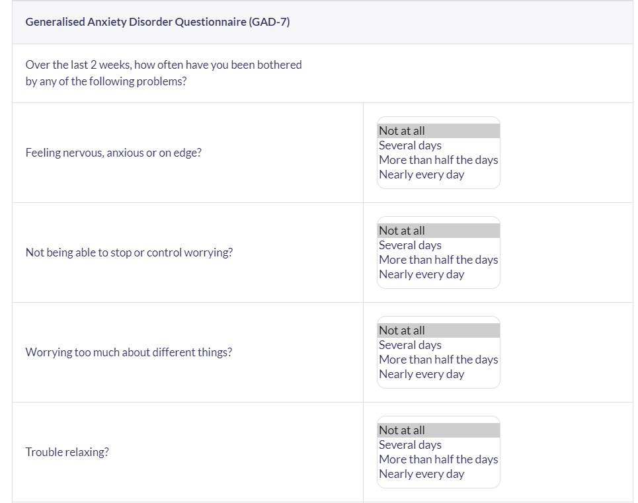

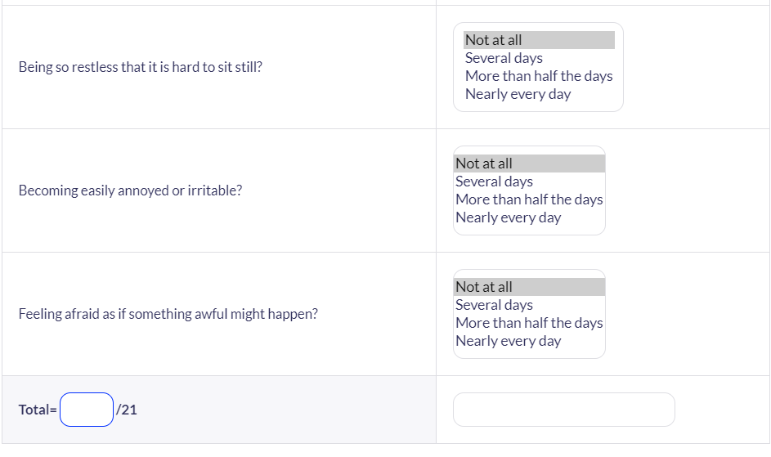

Appendix 2. Indicators for rehabilitative care
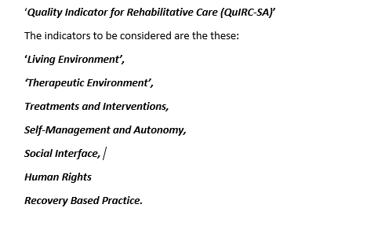

Appendix 3. Childhood Autism Rating Scale (Cars)


